# 4CS017 – Internet Software Architecture tutorial

## Connecting to a server

*What will you learn today?*

You will learn to connect to a server and publish web pages.

## Part 1 – Connecting to mi-linux via FTP

First, let’s use FTP (File Transfer Protocol) to **connect** to our student server, and **upload** your work so far onto the server:

1. You will need an **FTP client application**. The most common one is Filezilla, which is available on AppsAnywhere, or downloadable for free [here](https://filezilla-project.org/).
2. Once you start Filezilla, you will see this screen:

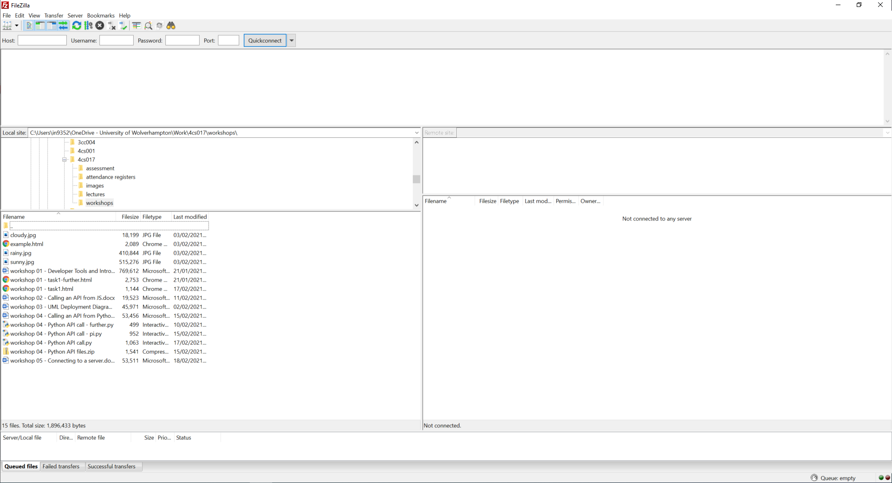

The **left**-hand side represent your **local** drive. The **right**-hand side represent your **remote** drive, i.e. the server. It currently says “Not connected to any server”, so let’s do that first!

1. Click on the “File” menu, then “Site Manager”.
2. Click on “New site”, then enter the following details and press “Connect”:
   * Protocol: SFTP (it won’t connect otherwise)
   * Host: mi-linux.wlv.ac.uk (exact spelling and case!)
   * Port: leave blank
   * Logon type: Normal
   * User: your student number
   * Password: your student password

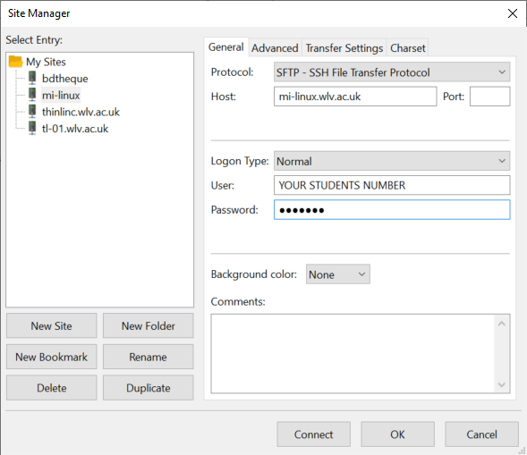

* + **If you cannot connect**, have a look at the error in the top window. “Authentication failed” means you’ve typed your student number and/or password wrong. If it says “Host does not exist” then you’ve typed the host name wrong.
  + Next time you want to connect, your “site” should be there, so you can just select it from the list and press “Connect”.

1. Once connected successfully, you will see your **remote** folder, which should be pretty empty, unless you have used the server on another module. It should, however, have a “public_html” folder. This folder is your “web root”, i.e. any files you copy into it will be made available publicly on the web! Exciting stuff, right?
2. Locate your files from prototype 1 on the left (your HTML file + possibly CSS, JavaScript and image files), and “upload” them to the server (you can simply drag and drop them from left to right), **inside the “public_html” folder**.
   * Take a moment to reflect on what you have just done: you have just “published” your web app on the web, and it is now bound by all British legislation including the Data Protection Act, the Equality Act, copyright and many more! Everyone you know can now access it (see URL below).
3. 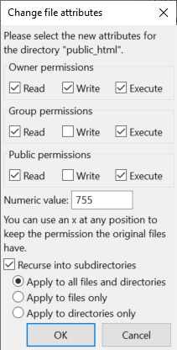One more thing: you might have to set the **permissions** of your files and folders to “publicly available”. Here is the easiest way to do this for all files and folders:
   * **Right** click on your “public_html” folder, and choose “File permissions”
   * Set the numeric value to 755 and tick “Recurse into subdirectories”
   * Press “Ok”.
4. Okay, let’s see if it works… your file will be located here:
   * https://mi-linux.wlv.ac.uk/~0123456/task1.html
   * “0123456” should be YOUR student number.
   * “task1.html” should be the name of YOUR file (and remember, Linux has a case-sensitive file system, so “task1.html” is different from “Task1.html”
   * Don’t forget the ~ in front of your student number.
   * If you get “permission denied” errors, then you have done step 7 above wrong.
5. All done! Your web app is now “online” and can be shared with friends and family 😊

## Part 2 – Upload and run a PHP script

The cool thing about mi-linux is that it supports PHP and MySQL, so we can do lots of interesting stuff… we will look at more advanced topics next week, but this week let’s at least get a PHP “Hello world” up and running:

1. Using Notepad++ or any text editor of your choice, create a new file called “hello.php”
   * **Important**: you can call it anything you like, but it **needs to have the .php extension**, or else it won’t run. Also please get into a habit of using **lowercase** file names.
2. Type in the following code:

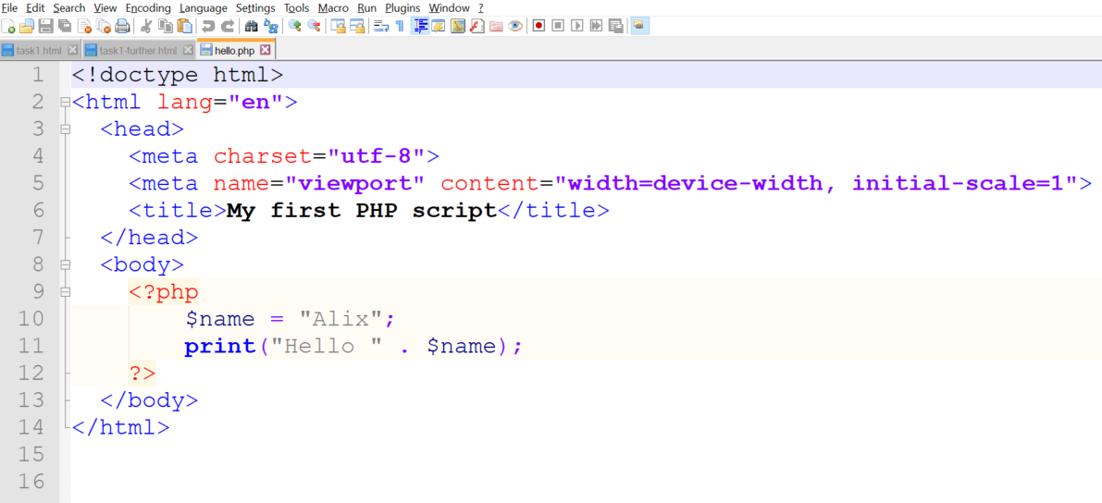

1. Note the <?php and ?> markers - they delimit the sections of your page that should be run by the PHP interpreter (just like <script> and </script> told your browser which bits were JS code to run)
2. Upload the file to your “public_html” folder (as per steps in part 1), and then browse to your file. I know it doesn’t look much for now, but you are running PHP code on a web server! Here’s mine: <http://mi-linux.wlv.ac.uk/~in9352/hello.php>
   * Try doing “right click”, then “View page source” on **your** page… can you see your PHP code? Why do you think that is?
   * Try running your php file **locally**, by dragging it onto your browser. What happens? Why?

## Part 3 – Going further (important: for fun - **not** required for the assessment)

*“I have finished all the work above, what shall I do next?”*

1. Experiment with the PHP code above: create and print more variables etc.
2. Take your knowledge of PHP further by working through a few sections of the W3schools website, starting here: <https://www.w3schools.com/php/php_syntax.asp>