<https://gateoverflow.in/118299/gate-cse-2017-set-1-question-19#a_list>

<https://gateoverflow.in/45660/isro-2013-71>[

<https://gateoverflow.in/2136/gate-cse-2011-question-34#a_list>

<https://gateoverflow.in/1577/gate-cse-2012-question-21#a_list>

<https://gateoverflow.in/2120/gate-cse-2011-question-18#a_list>

<https://gateoverflow.in/1162/gate-cse-2005-question-12-isro2009-64>

<https://gateoverflow.in/798/gate-cse-2009-question-21#a_list>

<https://gateoverflow.in/1162/gate-cse-2005-question-12-isro2009-64>

<https://gateoverflow.in/49507/isro2007-33>

<https://gateoverflow.in/948/gate-cse-2003-question-60-isro2007-45>

\*\*\*\* <https://gateoverflow.in/3499/gate-it-2007-question-57>

<https://gateoverflow.in/1222/gate-cse-2007-question-24#a_list>

DBMS:

<https://gateoverflow.in/1847/gate-cse-2006-question-69#a_list>

<https://gateoverflow.in/3848/gate-it-2005-question-82b>

Group:

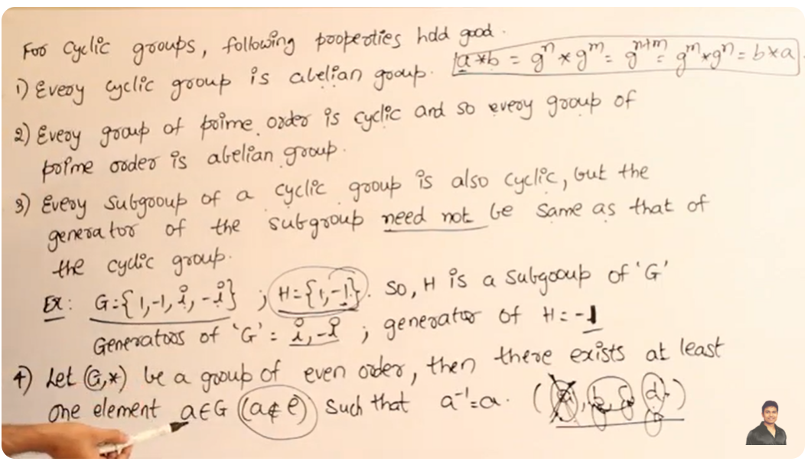

<https://gateoverflow.in/371919/gate-cse-2022-question-17#a_list_title>

s