CLAIMS WORKFLOW / CONCEPT DEMO

Laytime & Demurrage
Claim Agent
A document-driven assistant for preparing reviewable, evidence-linked laytime statements and draft claims.
IN ONE SENTENCE
The app brings voyage documents together, checks contractual terms and operational evidence, calculates laytime with deterministic code, and pauses for a claims professional to review before drafting a claim letter.

Why it exists
Laytime claims require analysts to reconcile charter-party clauses and amendments with Notices of Readiness (NORs), Statements of Facts (SOFs), weather records and supporting evidence. The agent organizes that work into a traceable sequence, flags conflicts, and produces a draft with source references for human review.

Typical user journey
- Upload case documents in the Streamlit sidebar, or select an already-ingested case.
- Run the agent. It extracts events and terms, searches contract evidence, resolves conflicts, and calculates the statement.
- Review the agent trace, laytime statement, terms and sources, and evidence tabs.
- Approve or reject at the mandatory checkpoint. Approval resumes the workflow and generates the cited draft claim letter and downloadable statement.
Current demo state: The app runs locally at http://localhost:8501 and uses synthetic sample cases. Mock mode works without provider credentials; real LLM use is optional and requires a key configured locally, not in this document or chat.

How the agent works
The workflow is deliberately multi-step. It retrieves and grades contract evidence, validates operational facts, and uses bounded repair loops instead of relying on a single generated answer.
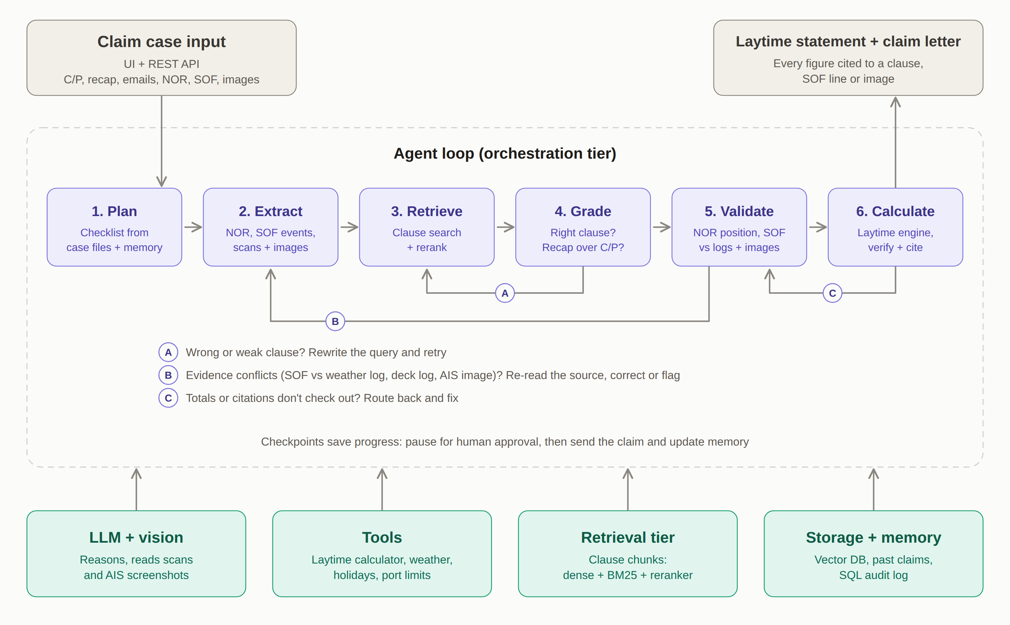
Figure 1. Agent workflow and supporting services (project architecture diagram).
Stage | What happens
Plan and extract | Build a case checklist; read NOR/SOF details, documents and available image evidence.
Retrieve and grade | Search contract clauses and assess whether they are binding, applicable, and authoritative. Recaps and riders can take precedence over printed terms.
Validate and calculate | Check NOR validity, timing, weather and other evidence; calculate laytime and demurrage/despatch in deterministic code.
Verify and approve | Independently check totals and citations, then pause for a person to approve or reject before drafting.

Checks, corrections and human control
Three bounded self-correction loops help the agent respond to common failure modes:
A Retrieval retry: If a retrieved clause is weak or irrelevant, revise the search query and try again.
B Evidence re-read: If sources disagree, re-read independent evidence such as weather logs, a signed scan, deck records or AIS imagery; correct or flag the conflict.
C Calculation verification: If independent arithmetic or citation checks fail, route the case back for repair.
Human approval is a control, not an optional suggestion. In the normal workflow, the letter is not drafted until an authorized user approves the calculated statement. A user can reject the run instead.

What the reviewer sees
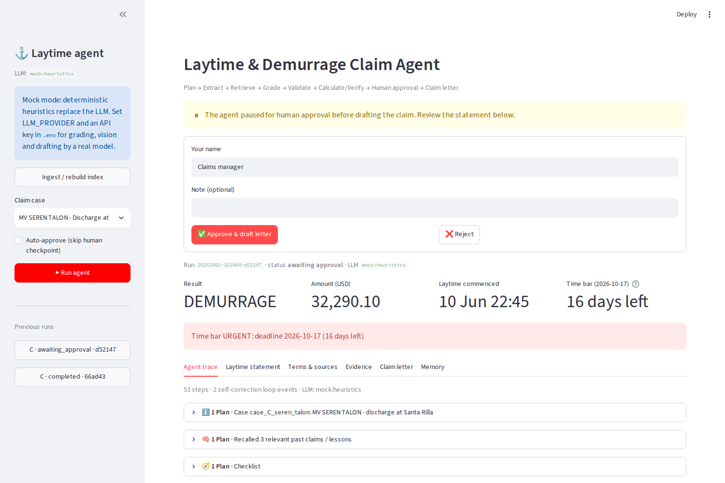
Figure 2. Sample Case C review checkpoint. This is a sample approval screen; the current UI also includes case document upload in the sidebar.

Outputs and operating model
- Laytime statement with commencement/expiry, counted and excluded periods, deductions, evidence and contract references.
- Draft claim letter with cited supporting clauses and evidence; downloadable as Markdown.
- CSV laytime statement for review and downstream handling.
- Run trace, checkpoint state and lessons retained in local project storage for audit and future recall.

What is in the current prototype
Interface | Streamlit UI and a separate FastAPI REST API.
Local case data | Uploaded and sample documents are stored in case folders; SQLite holds structured records and Chroma indexes searchable contract chunks.
LLM options | Mock/offline heuristics by default; Anthropic, OpenAI and Azure OpenAI can be configured with locally stored credentials.
Demo data | Three fictional cases and related reference data. Example benchmark results in the project plan are from the synthetic evaluation, not a guarantee for live claims.

Important boundaries before stakeholder or production use
- The current deployment is local to the developer machine; localhost is not a stakeholder-hosted service. A shared deployment needs an approved hosting environment and identity/access controls.
- The prototype uses local SQLite and Chroma. Production needs an agreed data platform, backup/retention policy, access boundaries and audit ownership.
- Scanned or unusual PDF layouts may require OCR or extraction tuning. Uploaded documents should be checked for completeness and legibility; reviewers remain responsible for the claim decision.
- Real LLM provider keys must be managed as secrets in the deployment environment. Never embed API keys in documents, source control or stakeholder materials.
Suggested next step: Run a controlled pilot with a small set of approved, non-sensitive cases; compare outputs with analyst-reviewed calculations; then confirm hosting, security, data retention and integration requirements before broader rollout.

