WEEK1
Task1
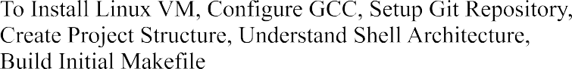

Output:
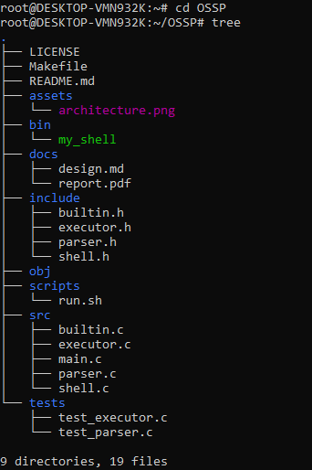

Task2
