**AIM: Ionic 4-Create and build first project or application(Android and iOS)**

Introduction:

Ionic is open source framework used for developing mobile applications. It provides tools and services for building Mobile UI with native look and feel.

**Steps to install Ionic and run the first Ionic Web Application:**

1. Go to command prompt.
2. Check if npm is installed or not, using the following command:

npm --v

This will show the version of the npm.

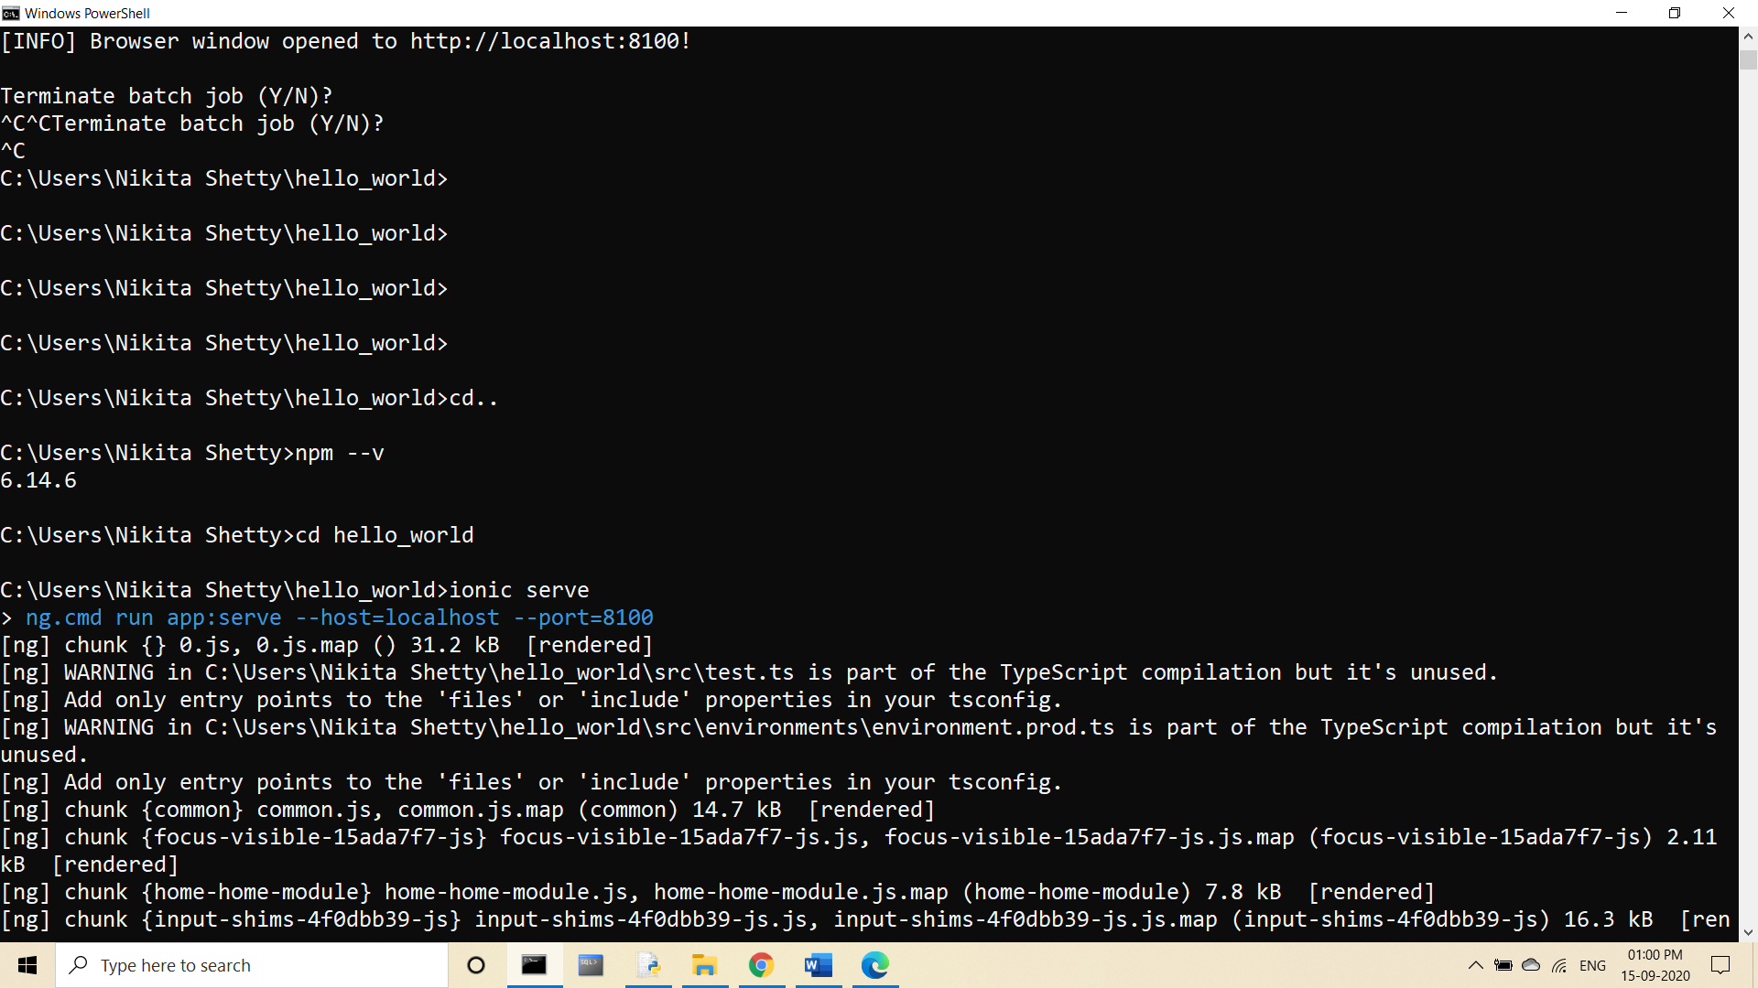

If not then we have to install npm.

1. Then type the following commands to install ionic cordova with the template:

* npm install -g ionic cordova
* ionic start hello_world blank

(Here, we have chosen blank as the template )

After this step hello_world folder will be downloaded .

1. Then in command prompt go to the hello_world folder using this command:

cd hello_world

1. Then type: ionic serve

This will give the following output:

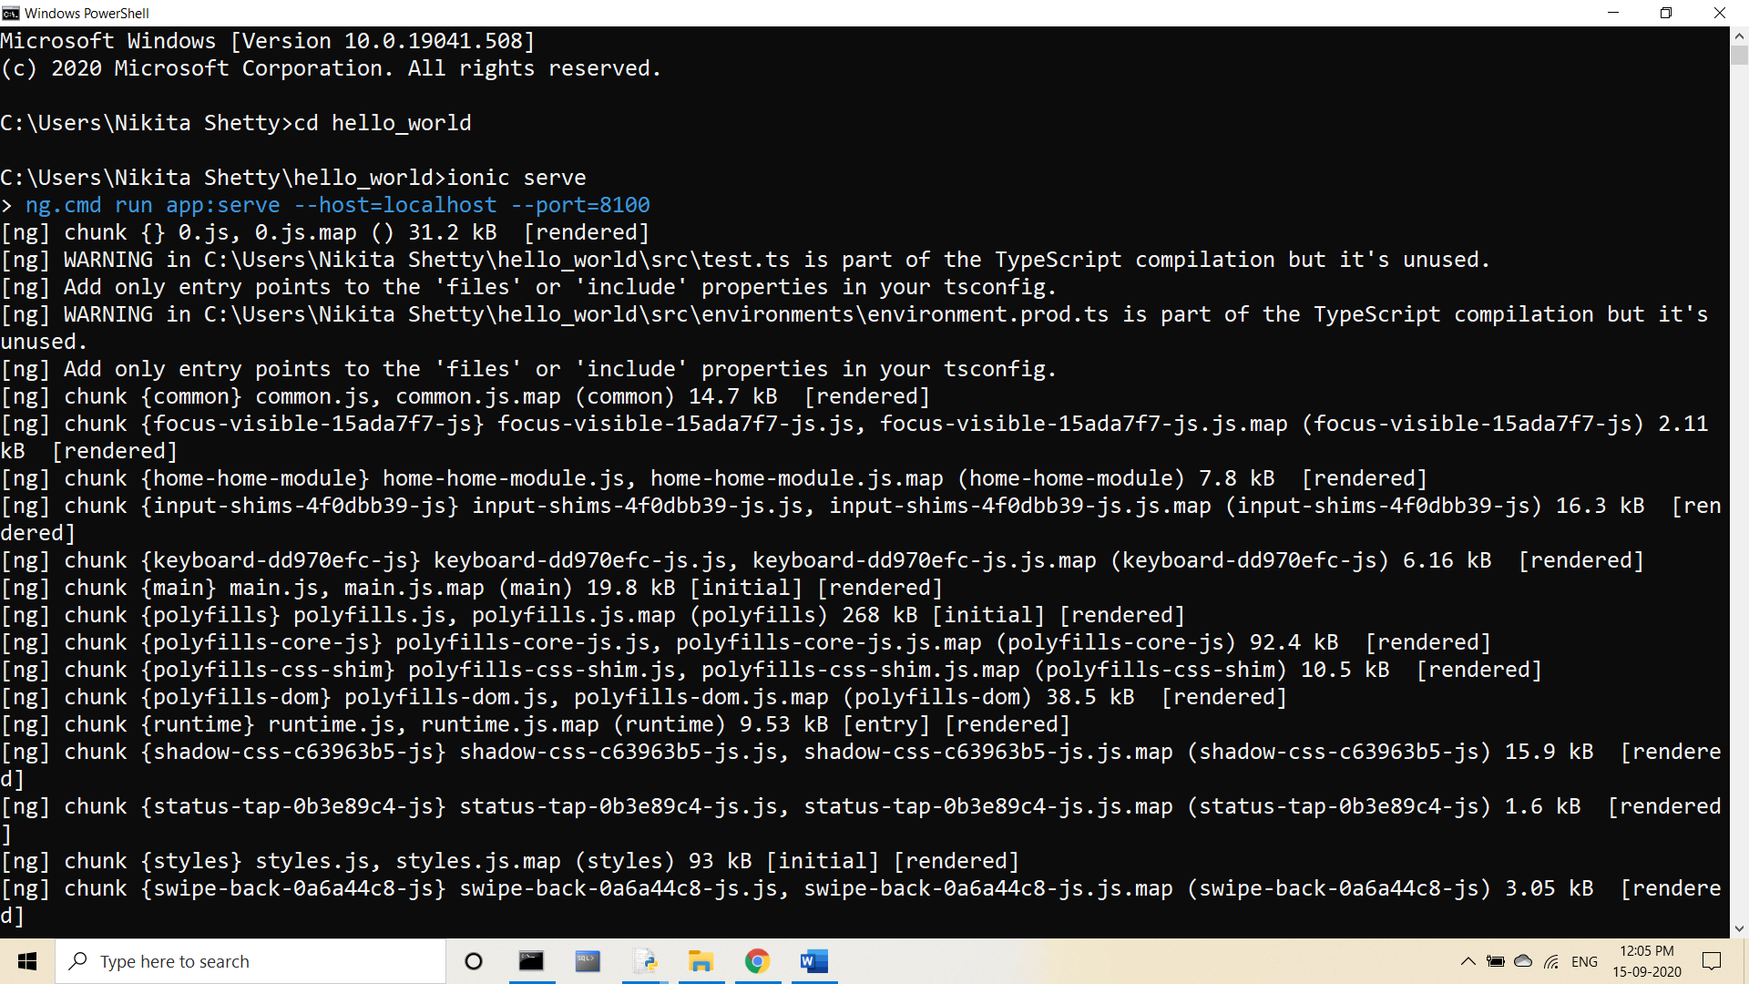

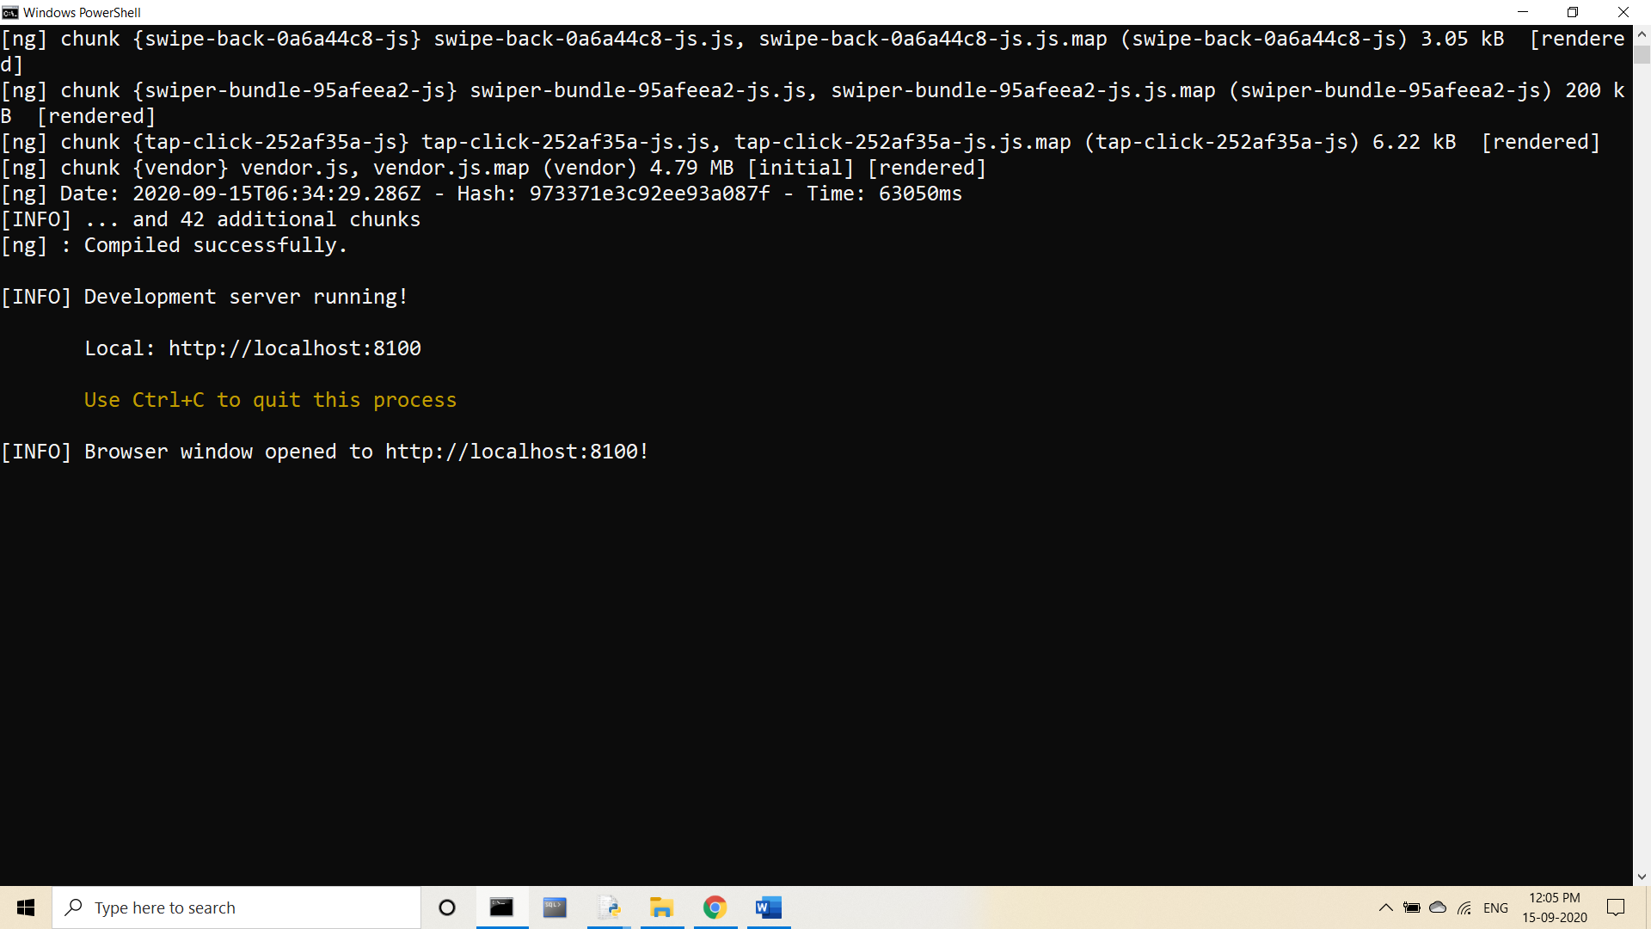

This will open the page in the browser and will display the following output:

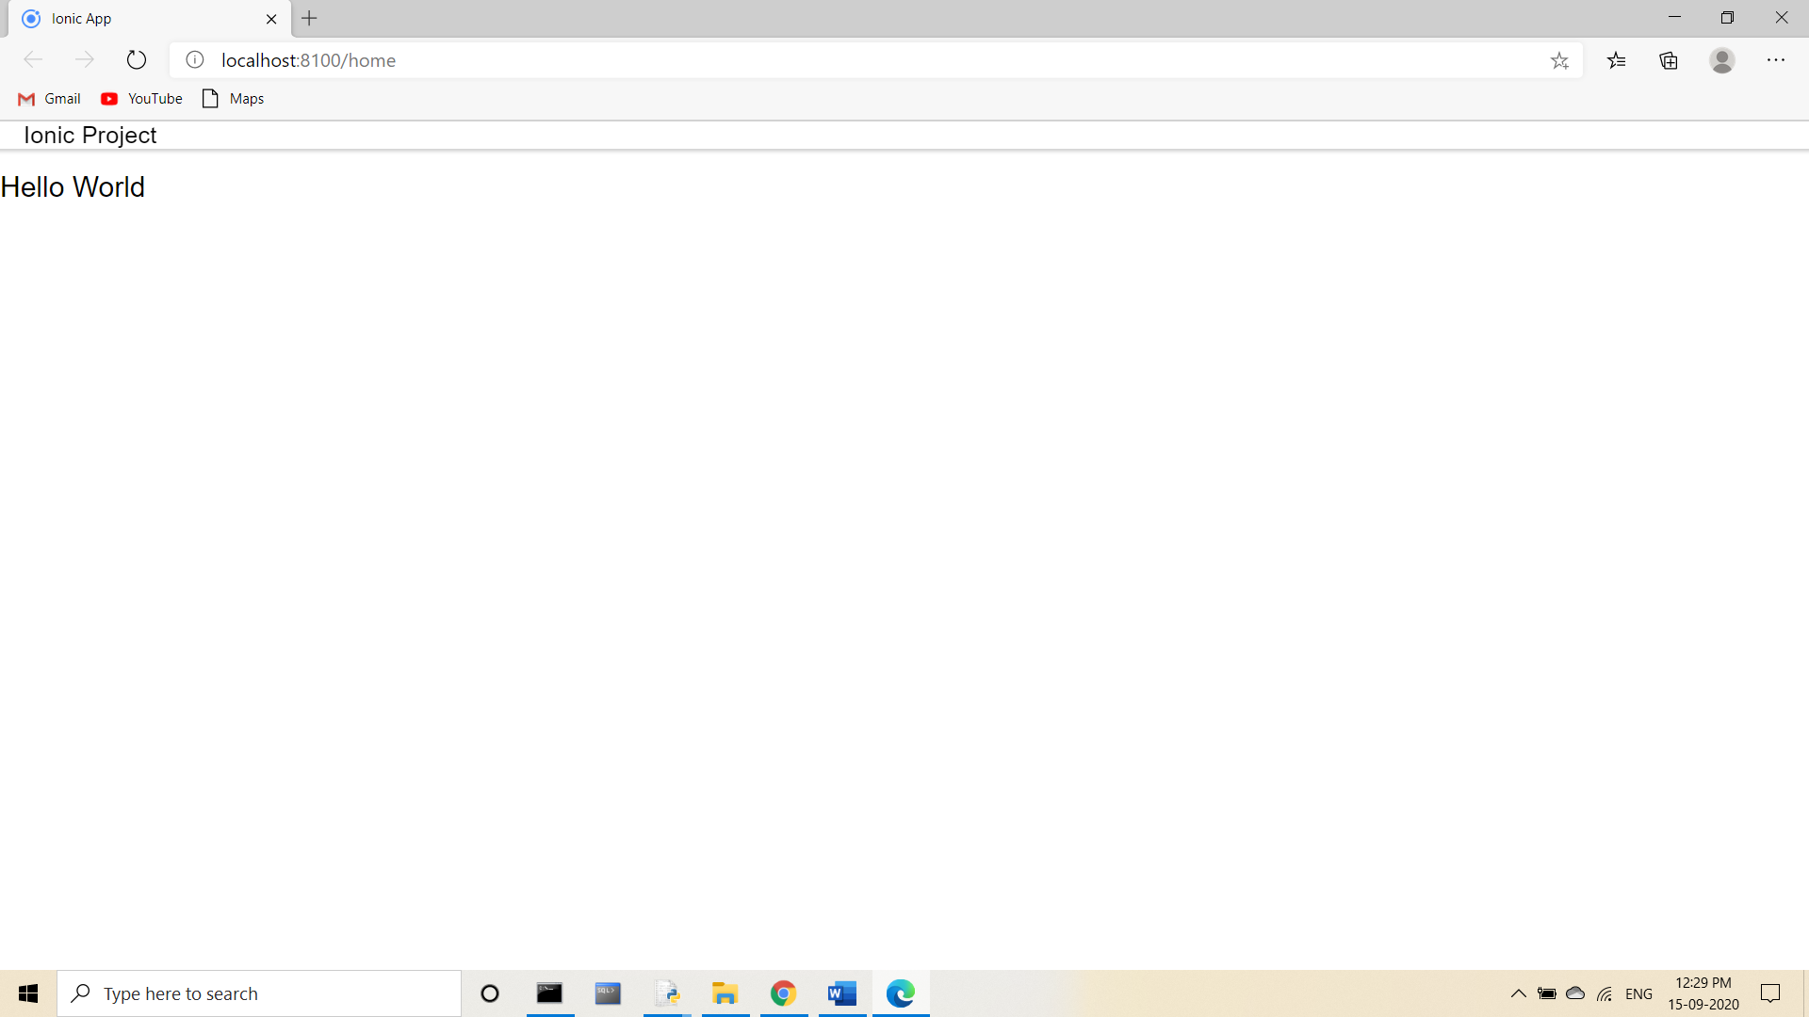

This is how the ionic web application looks. Now we have to run this application on android device.

**Steps to run the application on Android device:**

1. If you want you can run the commands on Android Studio or else, you can use Command prompt.
2. Then type the following command:

ionic platform add android

This will add the android platform to the directory.

1. Then type:

ionic cordova build android

This will build the android apk in the directory.

1. Then lastly, type:

ionic cordova run android

This will run the Android application.

If we have our phone connected to the machine, then we need to turn on the USB debugging under the Developer settings. This will export the app and will be viewable in your phone or you can run by setting up an emulator in the Android Studio.

This is the output of Application on Android Device.

