Assignment

The below screenshot illustrates a maven project. As per the maven project, all the tests are kept in the ‘***src/test/java***‘ and remaining files (such as log4j2.properties, element locators (POM classes), utility files, test data, etc.,) kept under ‘***src/main/java***‘.

Folder Structure

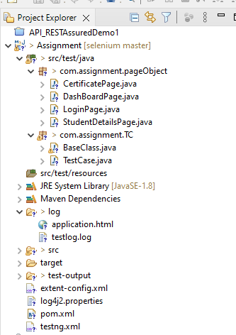

Explanation:-

1. Com.assignment.pageObject :- used this package to create java classed based on the number of pages to be handled in the application. Each page includes the objects and the methods to be performed on it.
2. Com.assignemnt.TC :- used this package to create test case and a base class. Test Case include all the function step-wise to be called to perform entire task and Base Class deals with all the common functions used by all the pages. This class is responsible for values to be passed, Initializing the WebDriver its quit process also.
3. **TestNG:** Using TestNG for Assertions, Grouping, and Parallel execution.
4. **Maven:** Using Maven for build, execution, and dependency purpose. Integrating the TestNG dependency in the POM.xml file.
5. **Log4j2 :**- this is used to generate logs. So, in case if scripts fails at any point then we can check the logs and debug it.

**Currently the values are hardcoded, we can either fetch them from config.**properties file by creating it or can read it from excel also with the help of Apache POI library also.

**On failure we can take screenshots as well and can add extent-**reports also in order to generate the reports