**EXPERIMENT NO. 1**

**SPATIAL AND TONAL RESOLUTION**

**EXPERIMENT NO. 1**

**AIM**: Spatial and tonal resolution

**OBJECTIVES:**

1. To understand concept of spatial resolution.
2. To understand concept of tonal resolution.

**EQUIPMENTS/SOFTWARE:** SCILAB orMATLAB 7.0

**THEORY:** **Spatial and Gray level resolution:** Sampling is the principal factor determining the spatial resolution of an image. Basically, spatial resolution is the smallest discernible detail in an image.

As an example, suppose we construct a chart with vertical lines of width W, and with space between the lines also having width W. A line-pair consists of one such line and its adjacent space. Thus, width of line pair is http://nptel.tvm.ernet.in/courses/Webcourse-contents/IIT-KANPUR/Digi_Img_Pro/chapter_1/images/image056.gifand there are http://nptel.tvm.ernet.in/courses/Webcourse-contents/IIT-KANPUR/Digi_Img_Pro/chapter_1/images/image058.gif line-pairs per unit distance. A widely used definition of resolution is simply the smallest number of discernible line pairs per unit distance; for es 100 lines pairs/mm.

Gray level resolution: This refers to the smallest discernible change in gray level. The measurement of discernible changes in gray level is a highly subjective process.

We have considerable discretion regarding the number of Samples used to generate a digital image. But this is not true for the number of gray levels. Due to hardware constraints, the number of gray levels is usually an integer power of two. The most common value is 8 bits. It can vary depending on application. When an actual measure of physical resolution relating pixels and level of details, they resolve in the original scene are not necessary, it is not uncommon to refer to an L-level digital image of size http://nptel.tvm.ernet.in/courses/Webcourse-contents/IIT-KANPUR/Digi_Img_Pro/chapter_1/images/image062.gifas having a spatial resolution of http://nptel.tvm.ernet.in/courses/Webcourse-contents/IIT-KANPUR/Digi_Img_Pro/chapter_1/images/image062.gif pixels and a gray level resolution of L levels.

**ALGORITHM SPATIAL RESOLUTION:**

1. Read the image.
2. Select alternate pixels for spatial resolution.
3. Show the output image.
4. Read the image.
5. Copy the rows and columns pixels to increase the size of the image.
6. Show the output image.

**ALGORITHM TONAL RESOLUTION:**

1. Divide the complete grey resolution in N no of tones. N=2n n-no of bits required to represent the grey color.
2. Assign one grey color for each of N bands.
3. Show the images in different tonal resolutions.

**PROGRAM OF SPATIAL RESOLUTION:**

*//Dikshita Kambri 118A2044*

*//IPMV -EXPERIMENT 1*

*//Spatial RESOLUTION*

clear all

clc;

a = imread("C:\Users\hp\Documents\Image Processing-Scilab\Images\coins.png");

[row , col] = size(a);

i = 1; j =1;

for x = 1:2 :row

for y = 1:2:col

c(i,j)= a(x,y);

j = j+1;

end

j=1;

i=i+1;

end

disp('size of input image');

disp(size(a));

disp('size of output image');

disp(size(c));

figure(2)

imshow(c)

**PROGRAM OF TONAL RESOLUTION:**

*//Dikshita Kambri 118A2044*

*//IPMV -EXPERIMENT 1*

*//TONAL RESOLUTION//*

clear all

clc;

a = imread("C:\Users\hp\Documents\Image Processing-Scilab\Images\coins.png");

a = double(a);

*//b = max(max(a);*

b = 256;

i =input("How many bits do you want? 1 2 4 8: ");

j = b/(2^i);

F = floor(a/j);

F1 = (F * 255)/max(max(F));

figure(1)

imshow(uint8(a))

figure(2)

imshow(uint8(F1))

**OUTPUT OF SPATIAL RESOLUTION:**

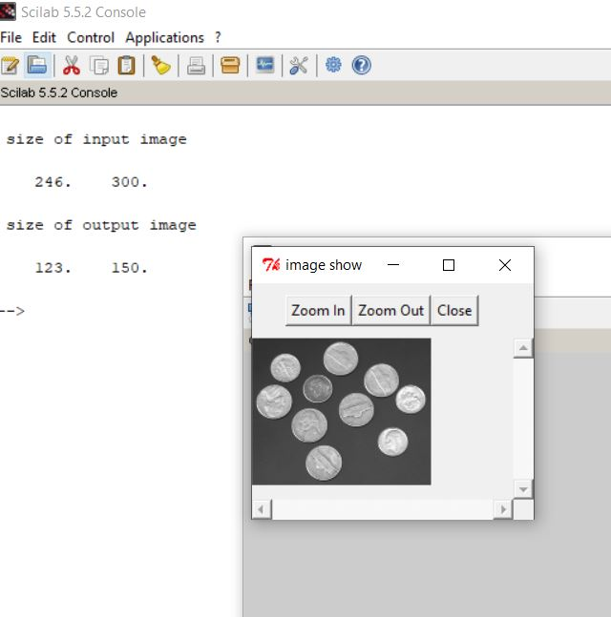

**OUTPUT OF TONAL RESOLUTION:**

1. **1-bit  
   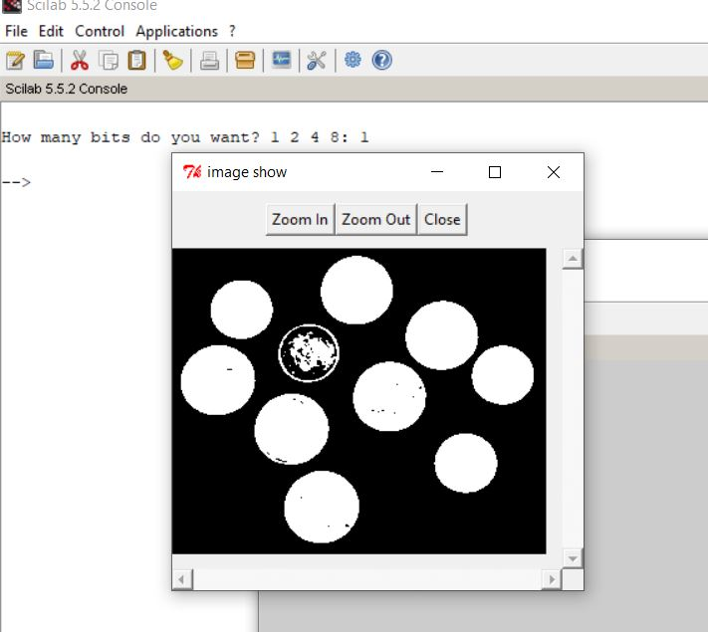**
2. **2-bit  
   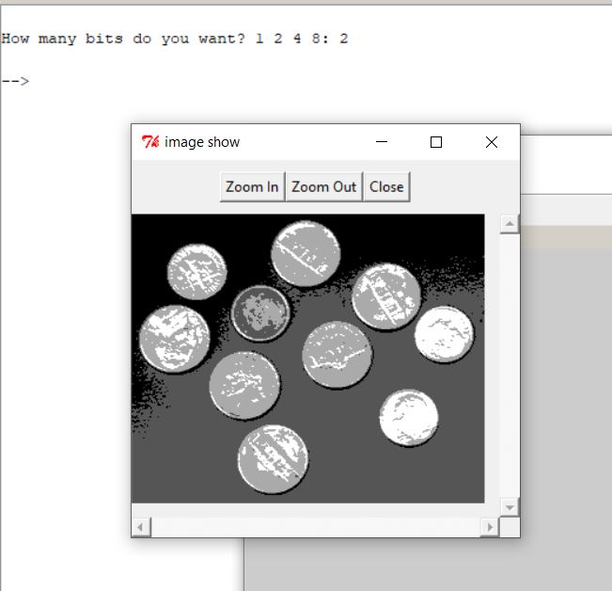**
3. **4-bit   
   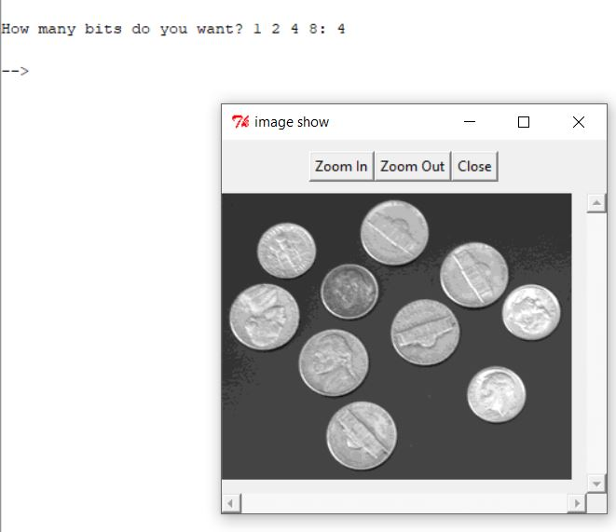**
4. **8-bit  
   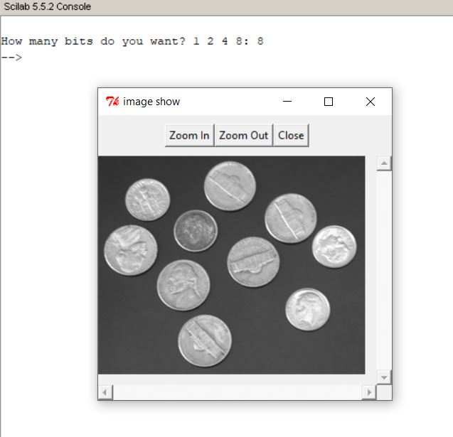**

**CONCLUSION:**

We studied that, In spatial resolution, the number of samples of digital image is changed as a power of two keeping the display area used for each image the same and maintaining constant gray level. Whereas, In tonal resolution, the quality of images is varied by decreasing the number of bits used to represent the no. of gray level in an image.