**EXPERIMENT NO. 4**

**TO APPLY DCT TRANSFORM TO AN IMAGE AND STUDY ITS APPLICATIONS EXPERIMENT NO 4**

**AIM**: To apply DCT transform to an image and study its applications

**OBJECTIVES:**

1. To obtain DCT of size equal to size of image
2. To apply the transform to the image
3. To obtain inverse DCT of the transformed image

**SOFTWARE used**: Scilab.

**Theory:** DCT has found application in image compression. All JPEG images uses discrete cosine transform as initial stage of compression. Just as fourier transform uses sine and cosine waves to represent signal DCT uses only cosine waves. Hence DCT is purely real unlike DFT which is complex (has magnitude as well as phase). DCT equation is given by

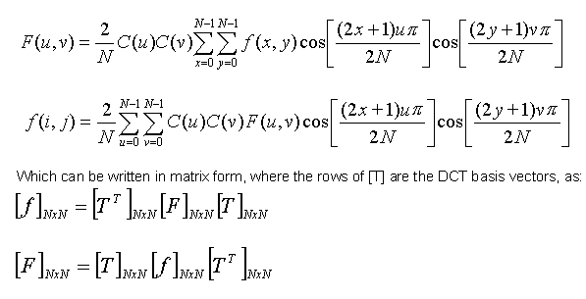

Sinusoidal transforms, like the Discrete Cosine Transforms (DCT) and Discrete Fourier

Transforms (DFT) use image-independent transformations. It is seen that DCT’s energy compaction performance closely resembles that of KLT. Moreover, fast algorithms and architectures are available for DCT and DFT. As compared to DFT, application of DCT results in less blocking artifacts due to the even symmetric extension properties of DCT. Also, DCT uses real computations, unlike the complex computations used in DFT. This makes DCT hardware simpler, as compared to that of DFT. These advantages have made DCT-based image compression a standard in still-image and multimedia coding standards.

**Limitations of DCT:**

Despite excellent energy compaction capabilities, mean-square reconstruction error performance closely matching that of KLT and availability of fast computational approaches, DCT offers a few limitations which restrict its use in very low bit rate applications. The limitations are listed below:

(i) Truncation of higher spectral coefficients results in blurring of the images, especially wherever the details are high

(ii) Coarse quantization of some of the low spectral coefficients introduces graininess in the smooth portions of the images.

(iii) Serious blocking artifacts are introduced at the block boundaries, since each block is independently encoded, often with a different encoding strategy and the extent of quantization.

Of all the listed problems, as above, blocking artifact is the most serious and objectionable one at low bit rates. Blocking artifacts may be reduced by applying an overlapped transform, like the Lapped Orthogonal Transform (LOT) or by applying post-processing. At lower bit rates, Discrete Wavelet Transforms (DWT) avoid the blocking artifacts of DCT and present better coding performance

**PROGRAM OF DCT TRANSFORM:**

*//DCT TRANSFORM*

*//118A2044 Dikshita Kambri*

clc;

clear all;

r = imread("C:\Users\hp\Documents\Image Processing-Scilab\Images\rice.png");

[r1 c1] = size(r);

n = min(r1, c1);

res = imresize(r, [n n]);

dres = double(res);

C = zeros(n,n);

for i =0 : n-1

for j=0: n-1

if i==0 then

C(i+1, j+1)= sqrt(1/n);

else

C(i+1,j+1)= sqrt(2/n)*cos((((2*j)+1)*i*%pi)/(2*n));

end

end

end

F = C*dres*C';

f = C'*F*C;

figure(1)

*//subplot(1,3,1)*

imshow(res);

title('Input original Image');

subplot(1,3,2)

figure(2)

imshow(uint8(F));

title("Image after applying DCT");

*//subplot(1,3,3)*

figure(3)

imshow(uint8(f));

title("reconstrcted image");

**OUTPUT OF DCT TRANSFORM:**

1. **Original Image:   
     
   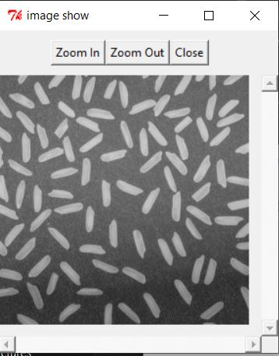**
2. **Image after applying DCT  
     
   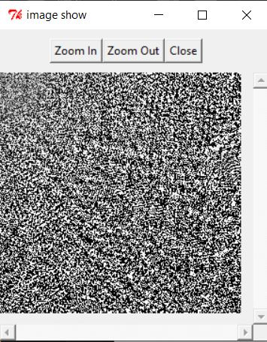**
3. **DCT reconstructed image  
     
   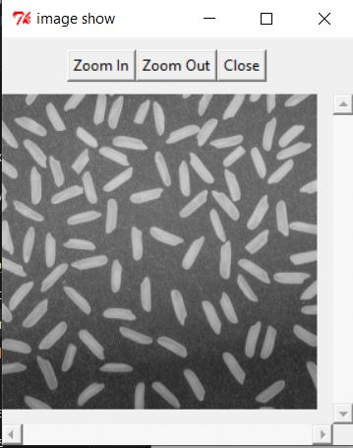**

**Conclusion:**

We studied that the discrete cosine transform (DCT) helps separate the image into parts of differing importance. DCT transforms an image from the spatial domain to the frequency domain.