**CSV DATA**

1. Application Configuration:
   1. Copy the source code into required destination
   2. create virtualenv Ubunu:
      1. sudo apt-get install python3-pip
      2. sudo pip3 install virtualenv
      3. virtualenv venv -p python3
      4. source venv/bin/activate
      5. How to activate?
         1. Deactivate
   3. Create Virtualenv Windows

### Install Virtualenv

In your Windows command shell prompt type in:

pip install virtualenv

#### Start virtualenv

In your windows command prompt, head to your project location:

cd my_project

 Once inside the project folder run:

virtualenv env

#### Activate virtualenv

On Windows, virtualenv (venv) creates a batch file called

\env\Scripts\activate.bat

To activate virtualenv on Windows, and activate the script is in the Scripts folder :

\pathto\env\Scripts\activate

Example:

C:\Users\'Username'\venv\Scripts\activate.bat

* 1. Install required packages:
     1. pip install -r requirements.txt
  2. run the application:
     1. python app.py
  3. Admin:
     1. localhost:5500/admin # Upload csv files here
  4. User:
     1. localhost:5500  
        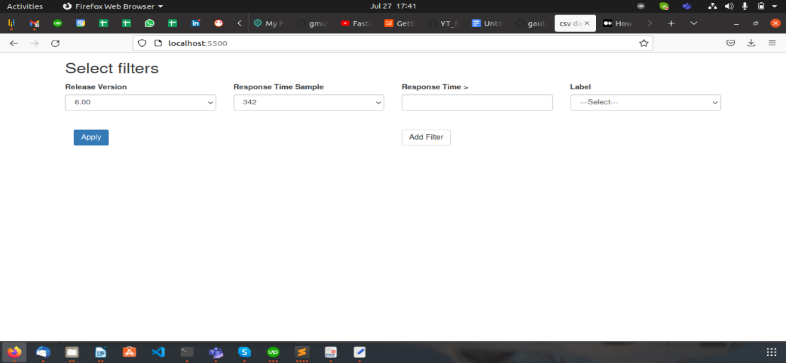
     2. Apply proper filter
        1. Response Time Sample : Is just showing the response time
        2. Response Time >: Apply actual filter here
  5. Database Settings: ***app.py***  
     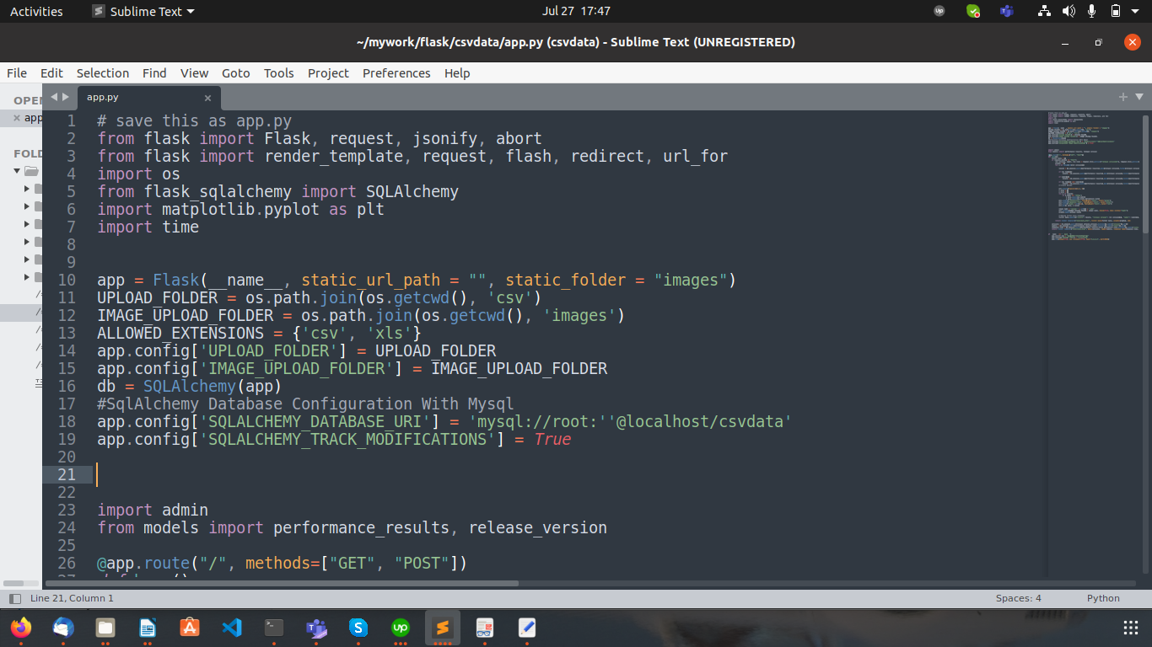  
     1. app.config['SQLALCHEMY_DATABASE_URI'] = 'mysql://root:''@localhost/csvdata'
        1. Make database changes here: <dbtype>://<user>:<password>@<host>/<dabasename>
  6. Graph Setting: ***app.py***  
     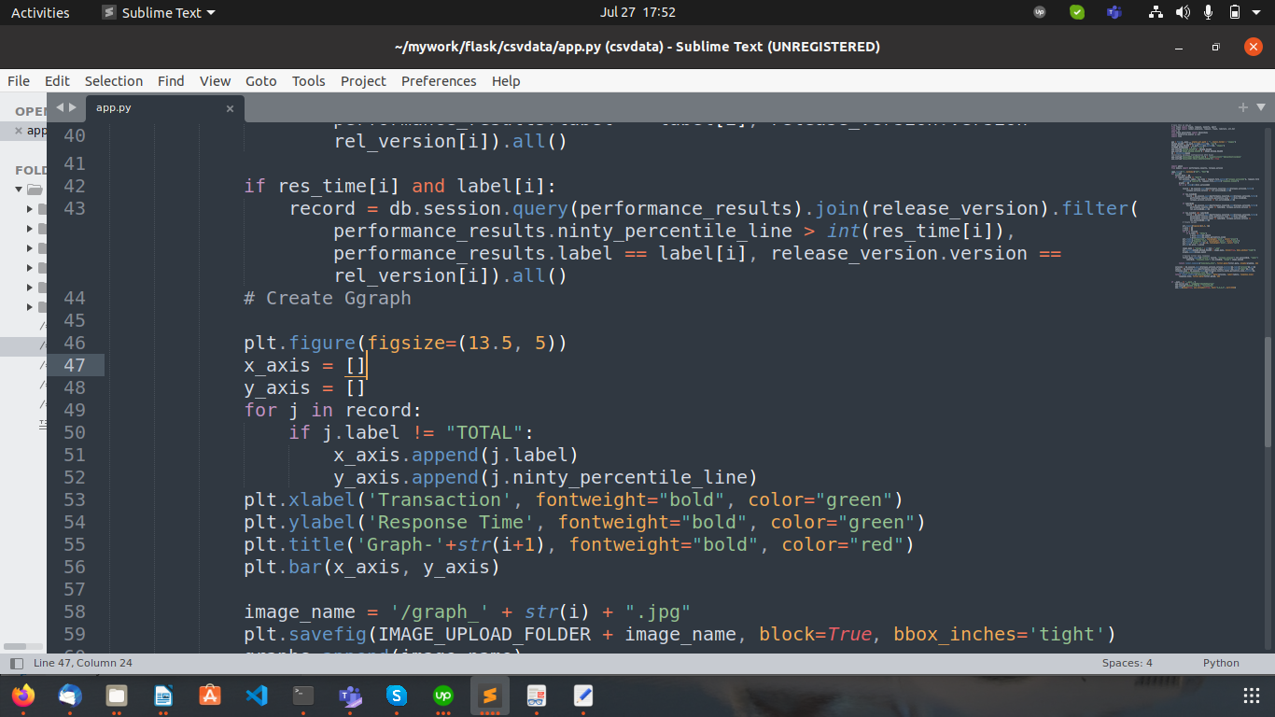  
        
     + 1. line number 46, plt.figure(figsize=(13.5, 5)). Change graph size
       2. line number 53, plt.xlabel('Transaction', fontweight="bold", color="green"). Change xlabel
       3. line number 54, plt.ylabel('Response Time', fontweight="bold", color="green"). Change ylabel
       4. line number 55, plt.title('Graph-'+str(i+1), fontweight="bold", color="red"). Change title of graph
  7. App Setting: 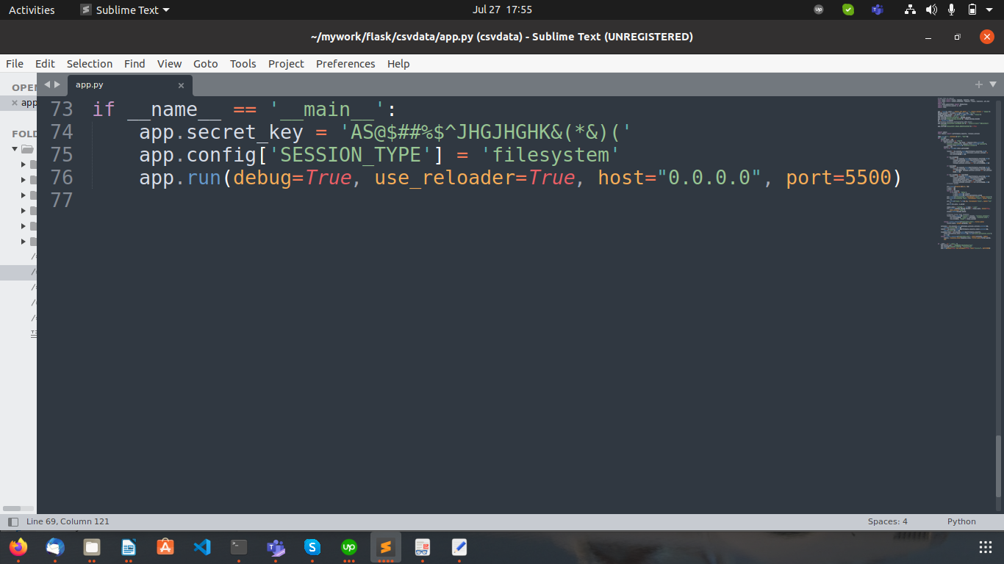***app.py***
     + 1. Change port number: line number 76: change port
  8. 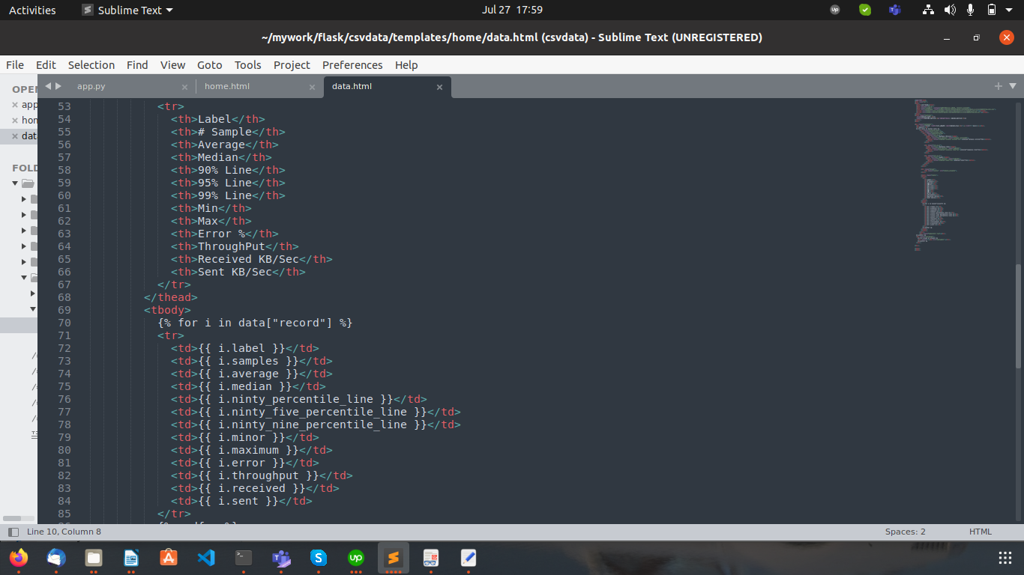User Interface Setting: templates/home/data.html  
       
       
     1. To make changes in table, you need to make changes in tbody and thead. In <thead> Its diplay the heading of table and in <tbody> its display the data comming from application.