 | Q.No. | Question | ExpectedTime  to complete
 | 1 | Lab 8: Documentation Generation: Automatic documentation and code comments  Lab Objectives:  - To understand the importance of documentation and code comments in software development.  - To explore how AI-assisted coding tools can generate meaningful documentation and inline comments.  - To practice generating function-level and module-level docstrings automatically.  - To evaluate the quality, accuracy, and limitations of AI-generated documentation.  - To develop a small automated tool for documentation generation in Python..  Lab Outcomes (LOs):  After completing this lab, students will be able to:  - Apply AI-assisted coding tools to generate docstrings and inline comments for Python code.  - Critically analyze AI-generated documentation for correctness, completeness, and readability.  - Create structured documentation (function-level, module-level) following standard formats.  - Design and implement a mini documentation generator tool to automate code commenting and docstring creation.  Task Description#1 Basic Docstring Generation  - Write python function to return sum of even and odd numbers in the given list.  - Incorporate manual docstring in code with Google Style  - Use an AI-assisted tool (e.g., Copilot, Cursor AI) to generate a docstring describing the function.  - Compare the AI-generated docstring with your manually written one.  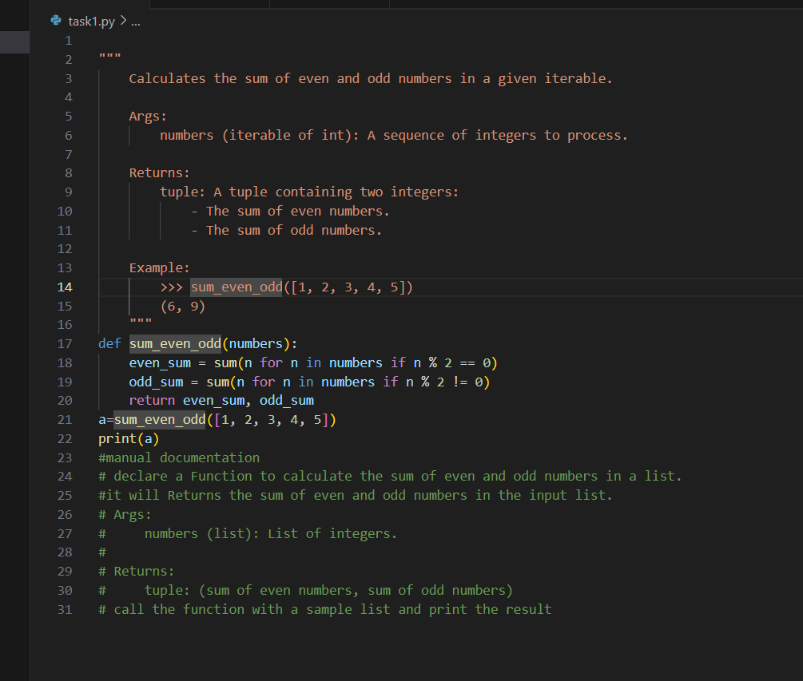  Expected Outcome#1: Students understand how AI can produce function-level documentation.  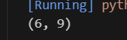  Task Description#2 Automatic Inline Comments  - Write python program for sru_student class with attributes like name, roll no., hostel_status and fee_update method and display_details method.  - Write comments manually for each line/code block  - Ask an AI tool to add inline comments explaining each line/step.  - Compare the AI-generated comments with your manually written one.  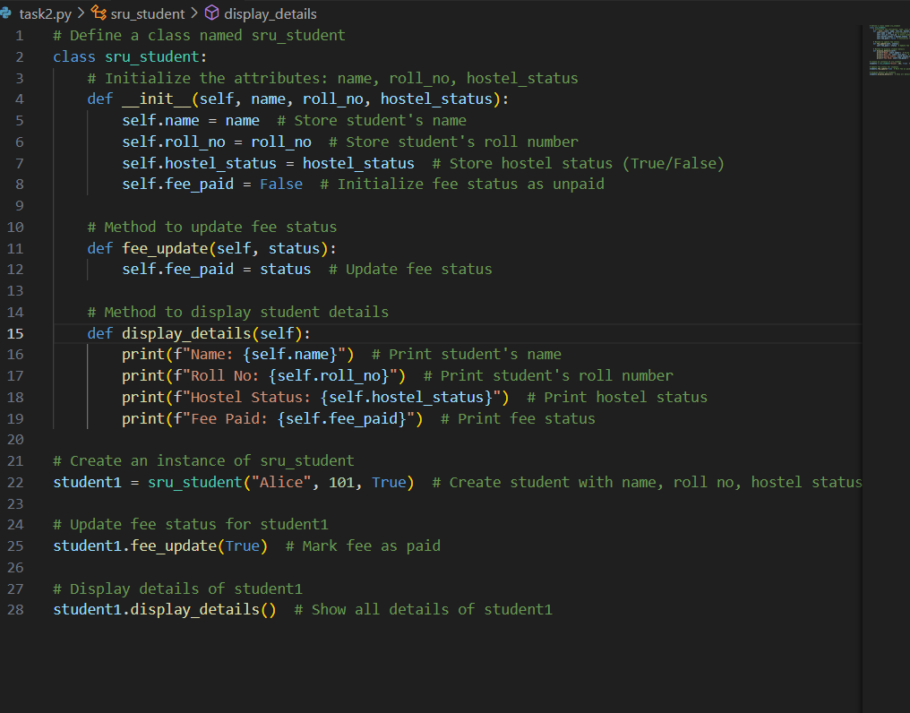  Expected Output#2: Students critically analyze AI-generated code comments.  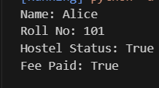  Task Description#3  - Write a Python script with 3–4 functions (e.g., calculator: add, subtract, multiply, divide).  - Incorporate manual docstring in code with NumPy Style  - Use AI assistance to generate a module-level docstring + individual function docstrings.  - Compare the AI-generated docstring with your manually written one.  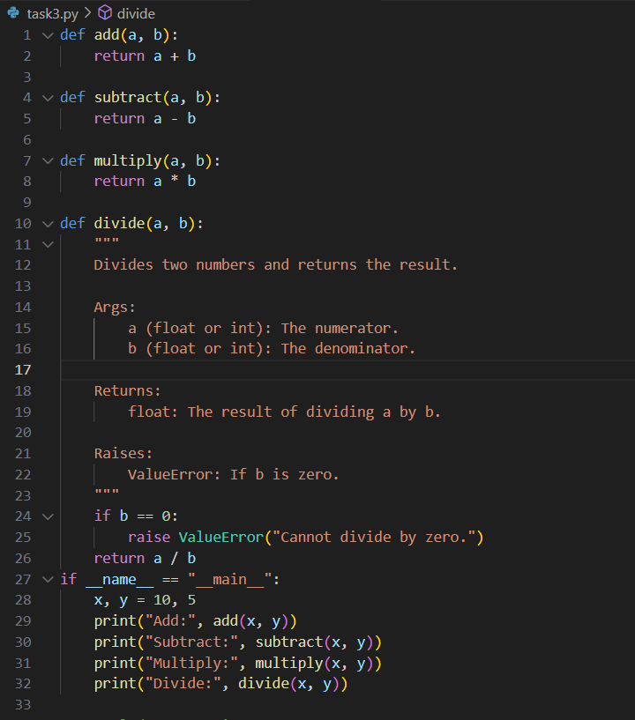  Expected Output#3: Students learn structured documentation for multi-function scripts  