SCHOOL OF COMPUTER SCIENCE AND ARTIFICIAL INTELLIGENCE |  |  |  |  | DEPARTMENT OF COMPUTER SCIENCE ENGINEERING
Program Name: B. Tech |  |  |  | Assignment Type: Lab |  |  | Academic Year:2025-2026
Course Coordinator Name |  |  |  | Venkataramana Veeramsetty
Instructor(s) Name |  |  |  | Dr. V. Venkataramana (Co-ordinator)  Dr. T. Sampath Kumar  Dr. Pramoda Patro  Dr. Brij Kishor Tiwari  Dr.J.Ravichander  Dr. Mohammand Ali Shaik  Dr. Anirodh Kumar  Mr. S.Naresh Kumar  Dr. RAJESH VELPULA  Mr. Kundhan Kumar  Ms. Ch.Rajitha  Mr. M Prakash  Mr. B.Raju  Intern 1 (Dharma teja)  Intern 2 (Sai Prasad)  Intern 3 (Sowmya)  NS_2 ( Mounika)
Course Code |  |  | 24CS002PC215 | Course Title |  | AI Assisted Coding
Year/Sem |  |  | II/I | Regulation |  | R24
Date and Day  of Assignment |  |  | Week9 - WednesDay | Time(s)
Duration |  |  | 2 Hours | Applicable to  Batches
AssignmentNumber:17.3(Present assignment number)/24(Total number of assignments)
 | Q.No. | Question |  |  |  |  |  | Expected Time  to complete
 | 1 | Lab 17 – AI for Data Processing: Data Cleaning and Preprocessing Scripts  Lab Objectives:  - Learn how to clean raw datasets using AI-assisted Python scripting.  - Apply preprocessing techniques such as handling missing values, encoding categorical data, and normalization.  - Automate repetitive data-cleaning tasks with AI-generated code.  - Understand how preprocessing impacts model performance.  Task 1 – Social Media Data Cleaning  Task: Clean raw social media posts dataset.  Instructions:  - Remove stopwords, punctuation, and special symbols from post text.  - Handle missing values in likes and shares columns.  - Convert timestamp to datetime and extract features (hour, weekday).  - Detect and remove spam/duplicate posts.  Expected Output: A cleaned dataset with structured features for sentiment/engagement analysis.  Task 2 – Financial Data Preprocessing  Task: Preprocess a stock market dataset.  Instructions:  - Handle missing values in closing_price and volume.  - Create lag features (1-day, 7-day returns).  - Normalize volume column using log-scaling.  - Detect outliers in closing_price using IQR method.  Expected Output: A time-series dataset ready for forecasting models.  Task 3 – IoT Sensor Data Preparation  Task: Clean and preprocess IoT temperature and humidity logs.  Instructions:  - Handle missing values using forward fill.  - Remove sensor drift (apply rolling mean).  - Normalize readings using standard scaling.  - Encode categorical sensor IDs.  Expected Output: A structured dataset optimized for anomaly detection.  Task 4 – Real-Time Application: Movie Reviews Data Cleaning  Task: A streaming platform wants to analyze customer reviews.  Instructions:  - Standardize text (lowercase, remove HTML tags).  - Tokenize and encode reviews using AI-assisted methods (TF-IDF or embeddings).  - Handle missing ratings (fill with median).  - Normalize ratings (0–10 → 0–1 scale).  - Generate a before vs after summary report.  Expected Output: A cleaned dataset ready for sentiment classification.  ✅ Deliverables (For All Tasks)  - AI-generated prompts for code and test case generation.  - At least 3 assert test cases for each task.  - AI-generated initial code and execution screenshots.  - Analysis of whether code passes all tests.  - Improved final version with inline comments and explanations.  - Compiled report (Word/PDF) with prompts, test cases, assertions, code, and output. |  |  |  |  |  | Week9 - Monday

Task 1 – Social Media Data Cleaning
Task: Clean raw social media posts dataset.
Instructions:
- Remove stopwords, punctuation, and special symbols from post text.
- Handle missing values in likes and shares columns.
- Convert timestamp to datetime and extract features (hour, weekday).
- Detect and remove spam/duplicate posts.
Remove stopwords, punctuation, and special symbols from post text.
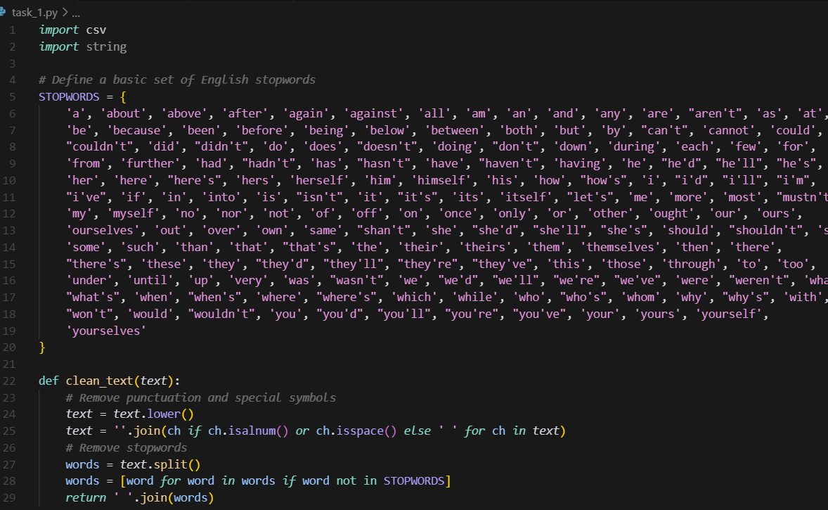

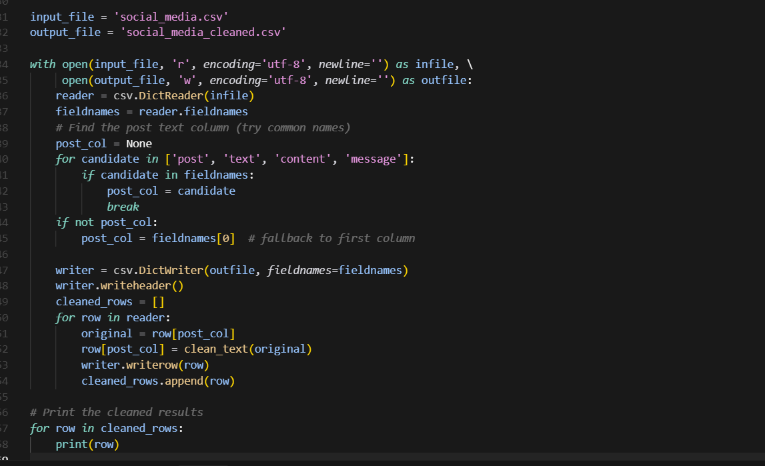

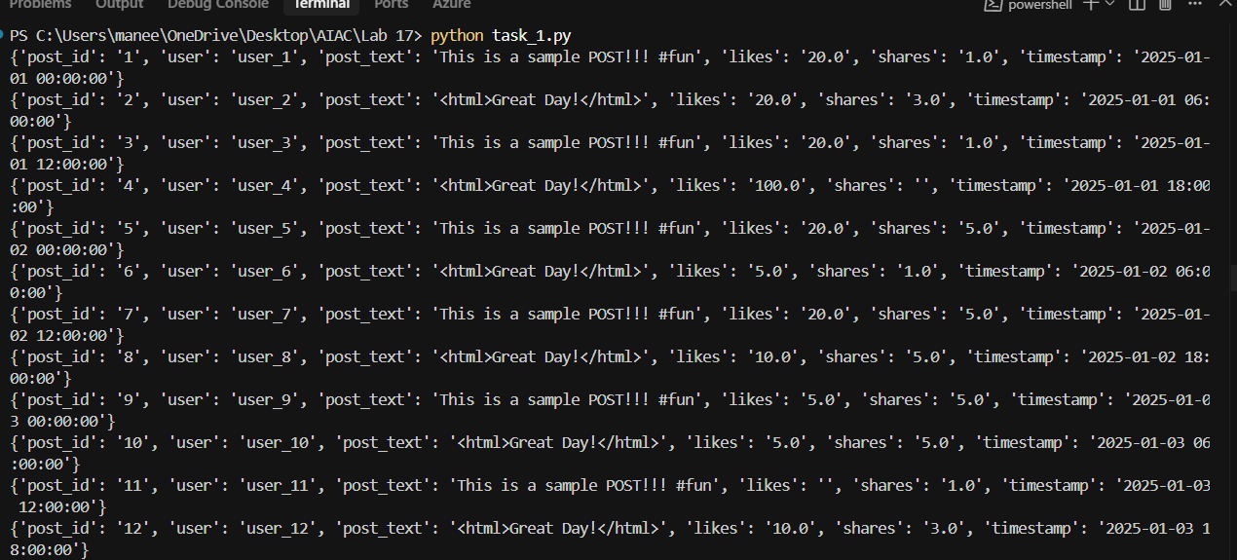

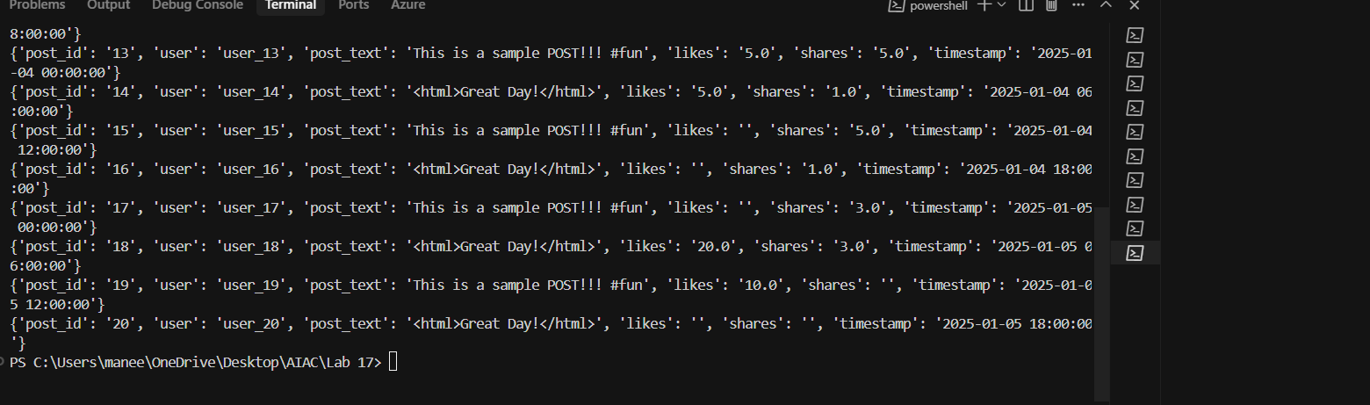

Handle missing values in likes and shares columns.

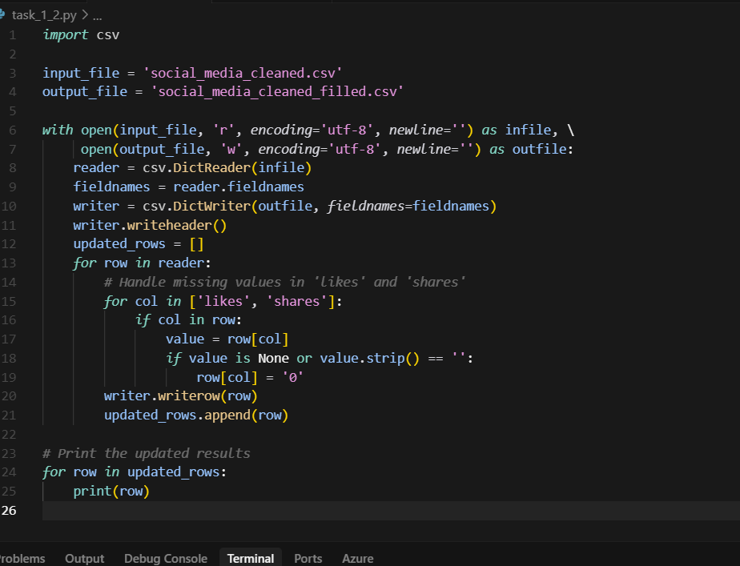

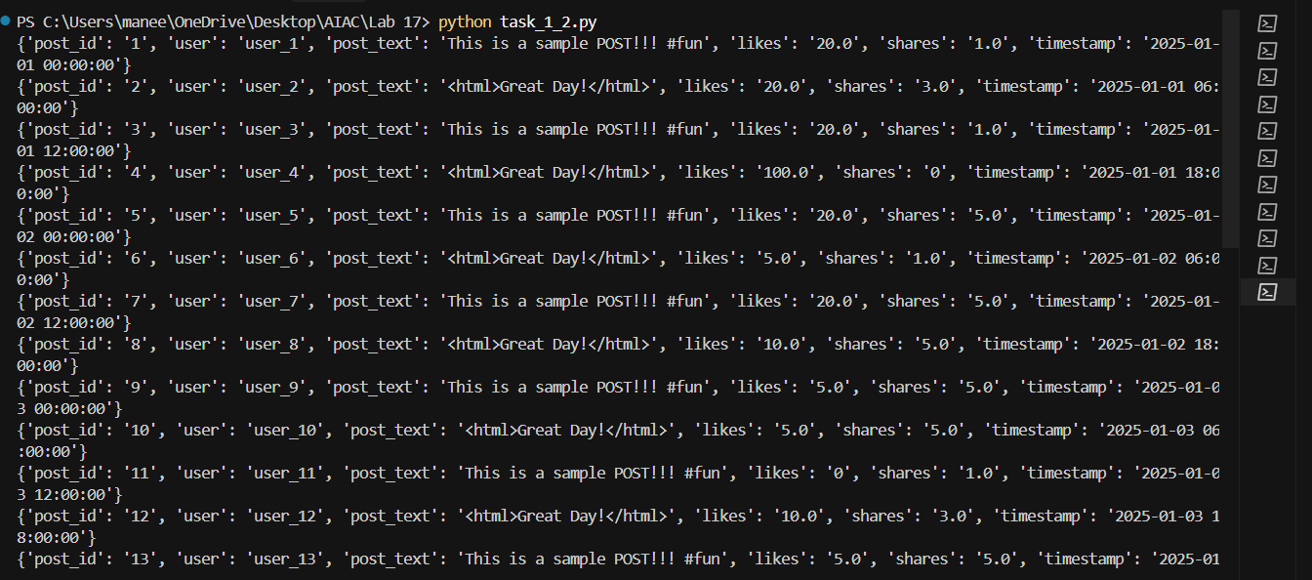

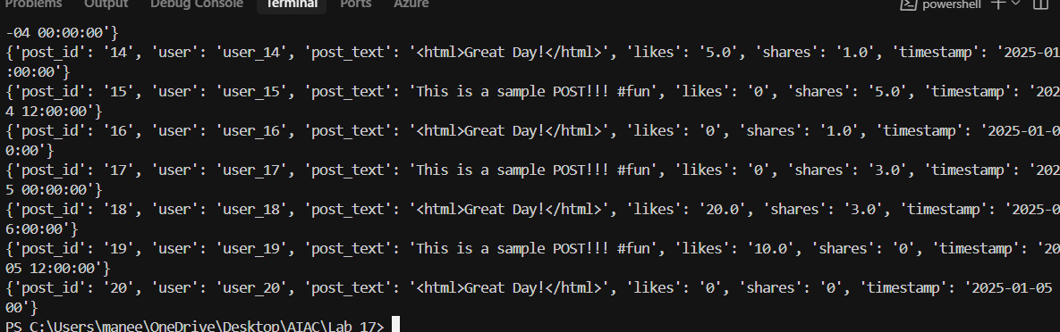

Convert timestamp to datetime and extract features (hour, weekday).

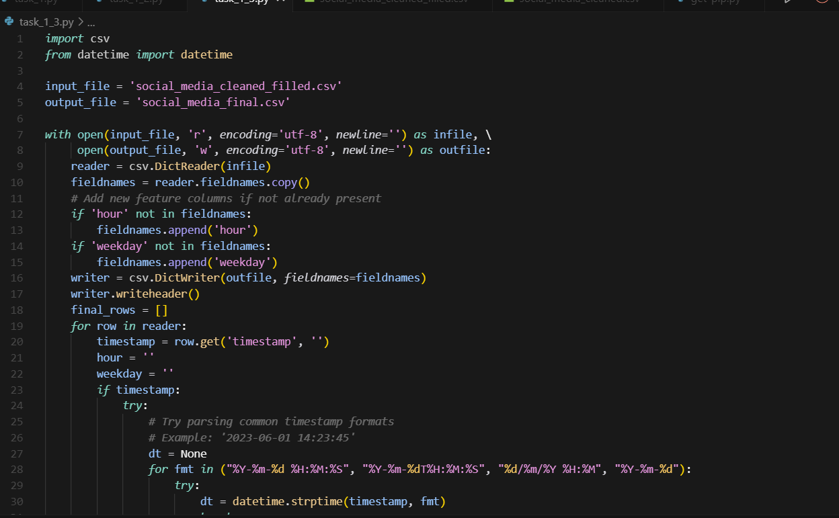

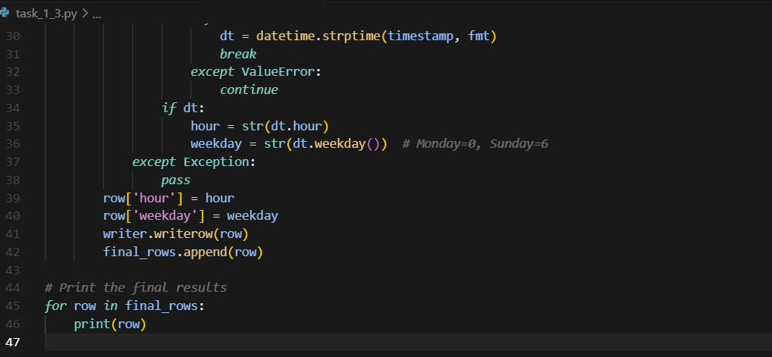

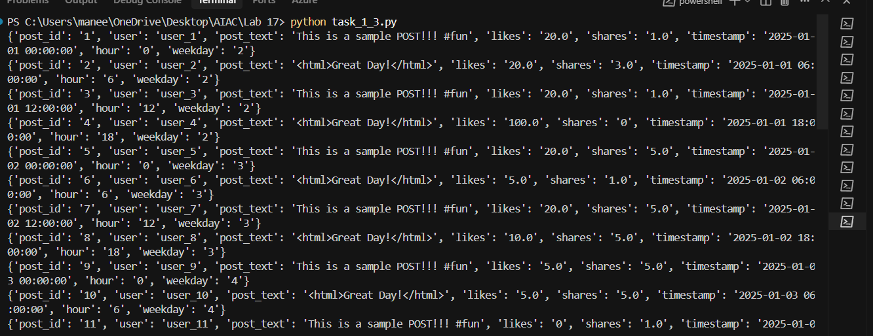

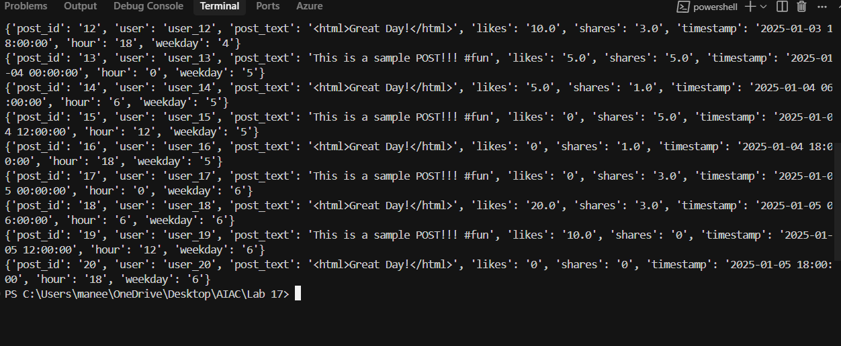

Detect and remove spam/duplicate posts.
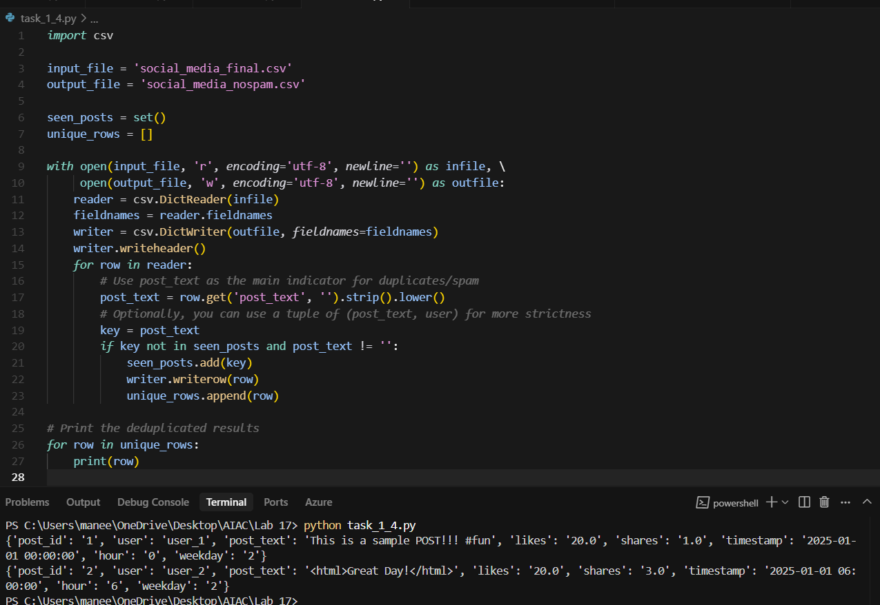

Task 2 – Financial Data Preprocessing
Task: Preprocess a stock market dataset.
Instructions:
- Handle missing values in closing_price and volume.
- Create lag features (1-day, 7-day returns).
- Normalize volume column using log-scaling.
- Detect outliers in closing_price using IQR method.
Expected Output: A time-series dataset ready for forecasting models

Handle missing values in closing_price and volume.

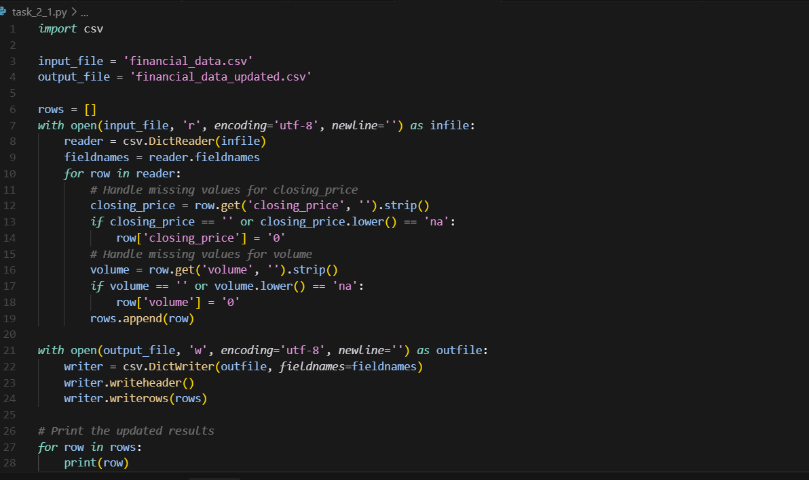

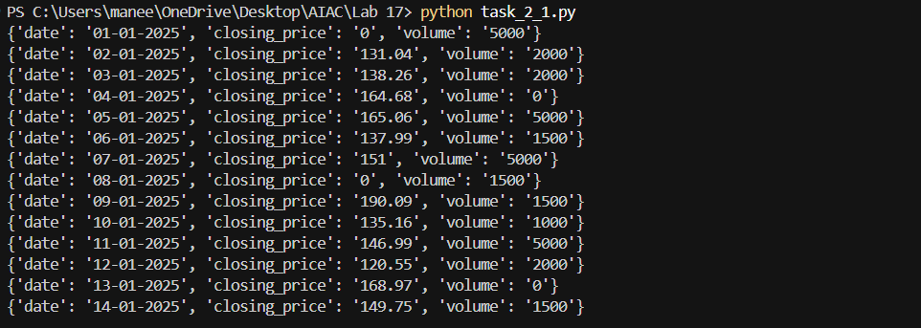

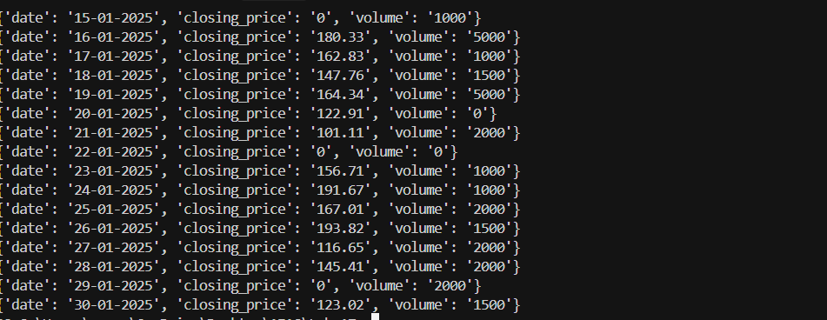
- Create lag features (1-day, 7-day returns).
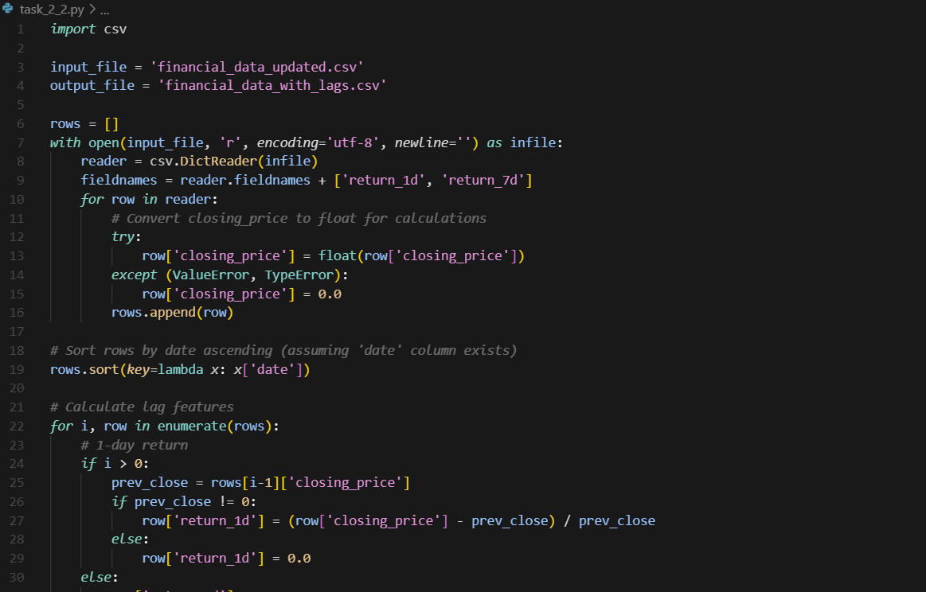

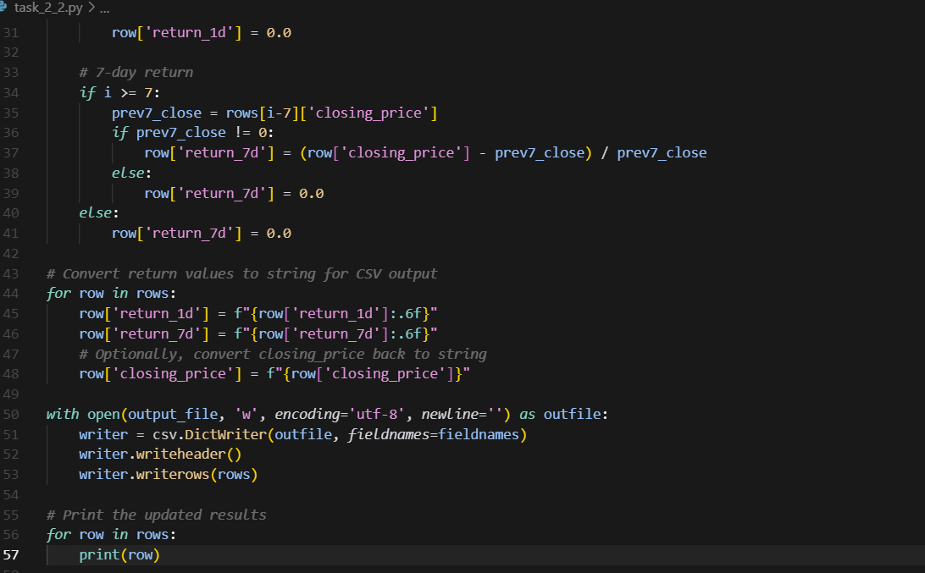

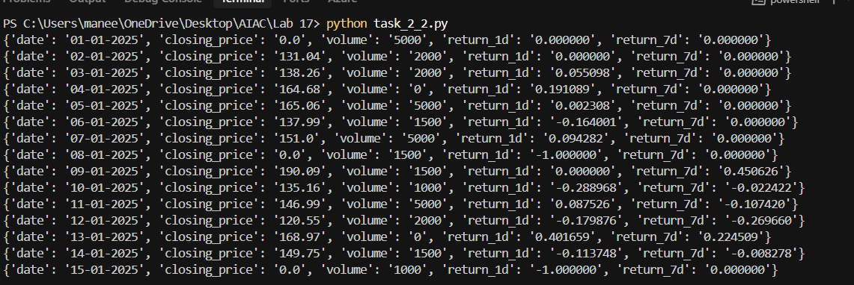

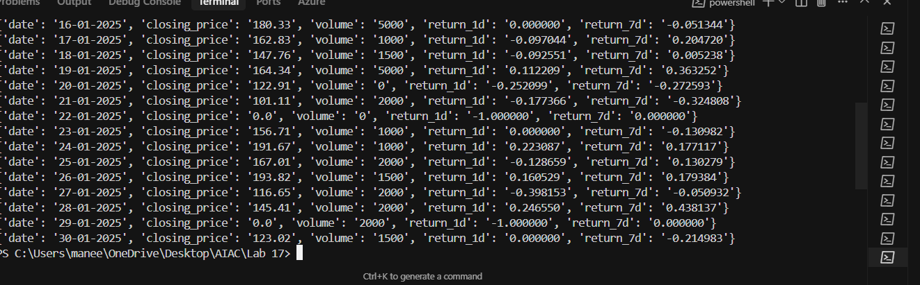

- Normalize volume column using log-scaling.

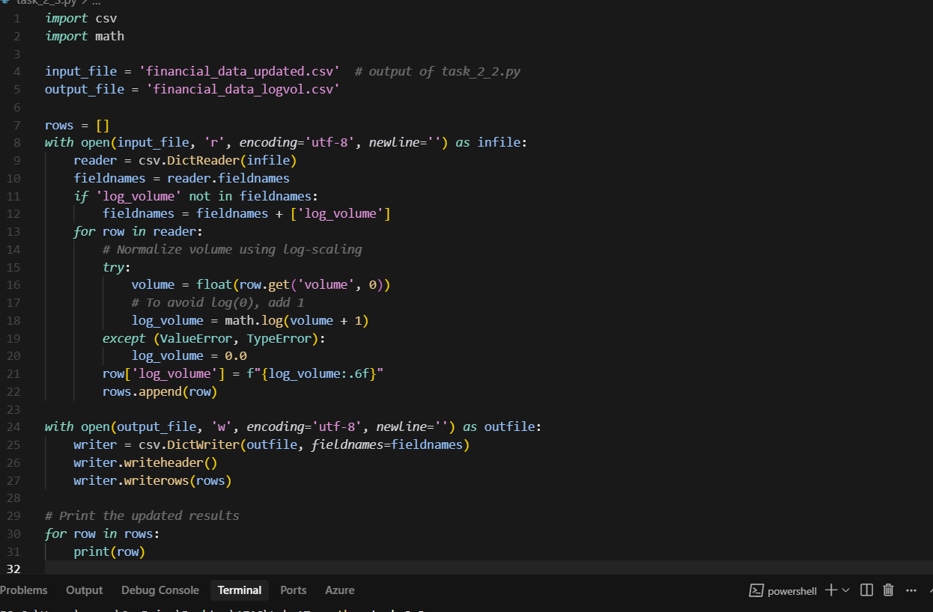

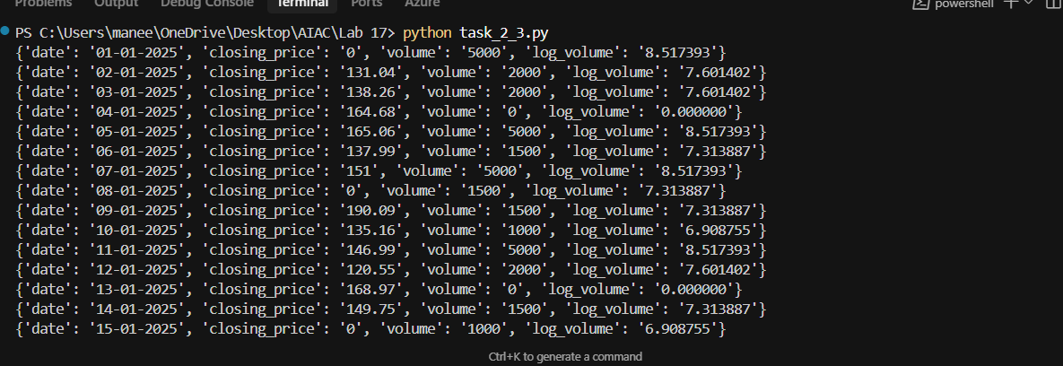

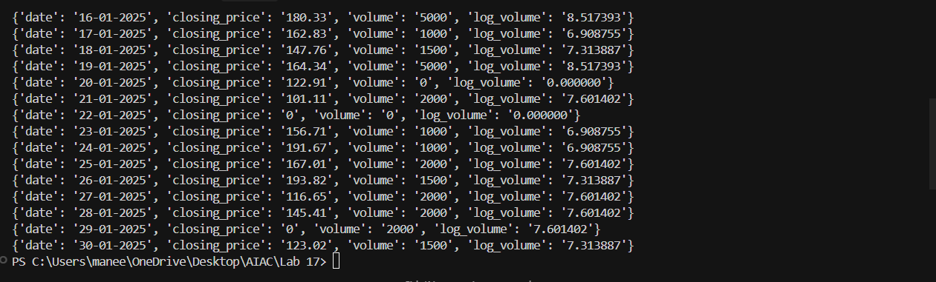

Detect outliers in closing_price using IQR method.

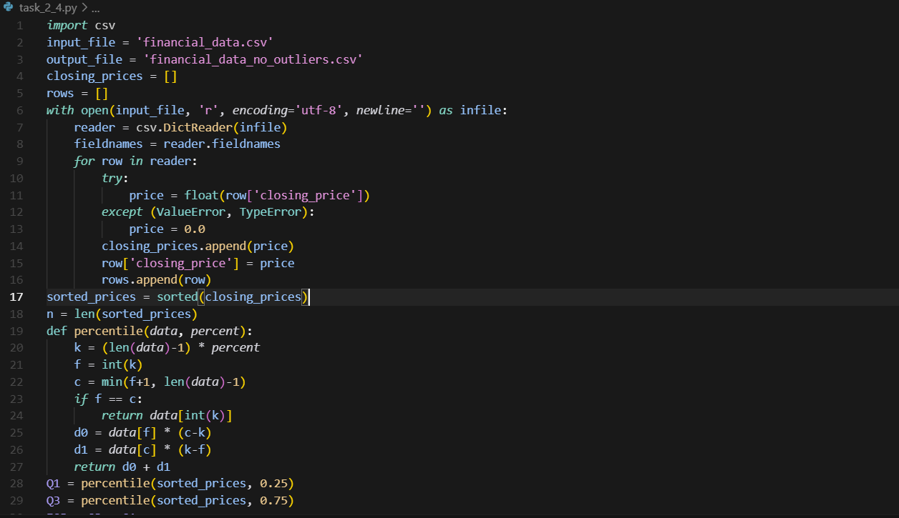

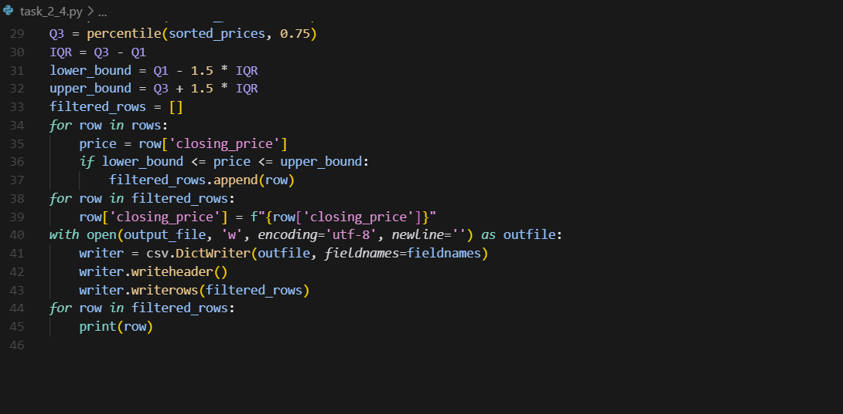

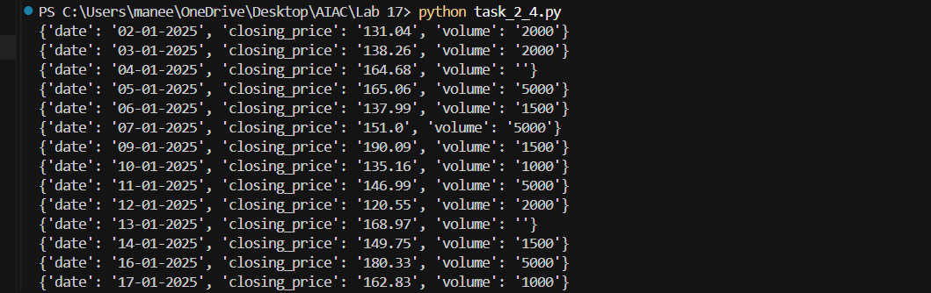
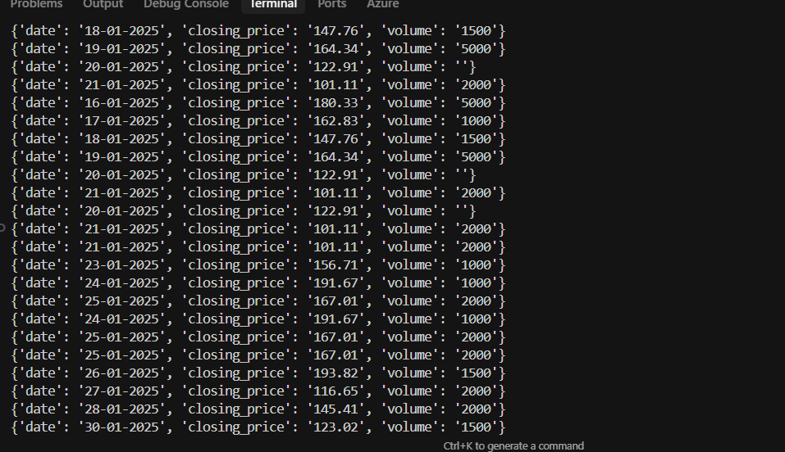

Task 3 – IoT Sensor Data Preparation
Task: Clean and preprocess IoT temperature and humidity logs.
Instructions:
- Handle missing values using forward fill.
- Remove sensor drift (apply rolling mean).
- Normalize readings using standard scaling.
- Encode categorical sensor IDs.

Expected Output: A structured dataset optimized for anomaly detection.

Handle missing values using forward fill.

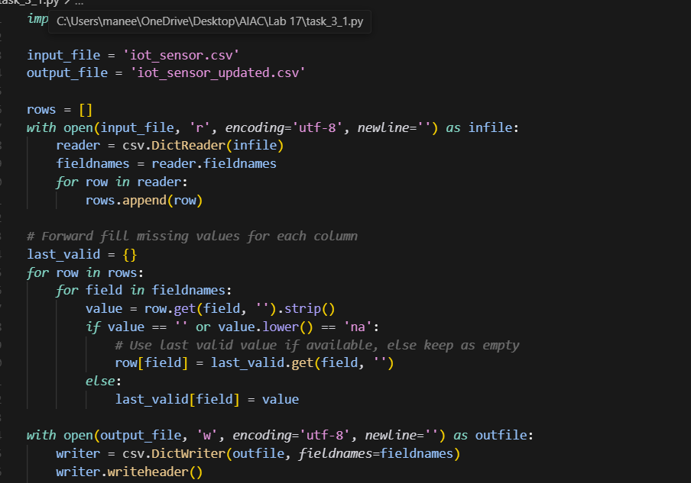

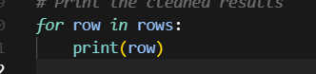

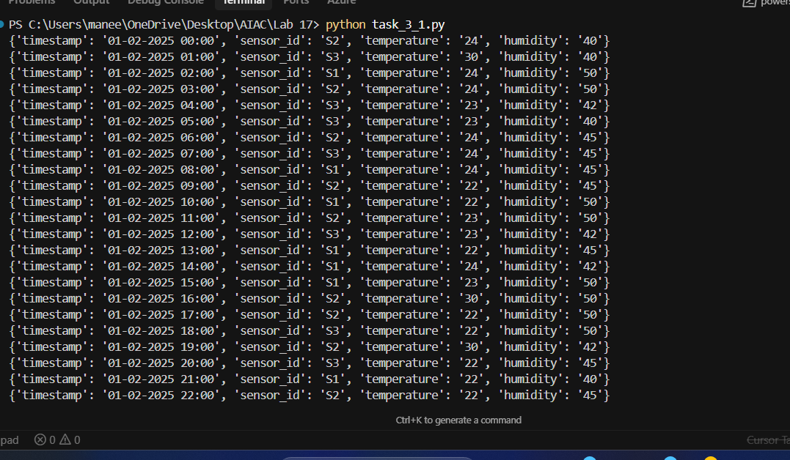
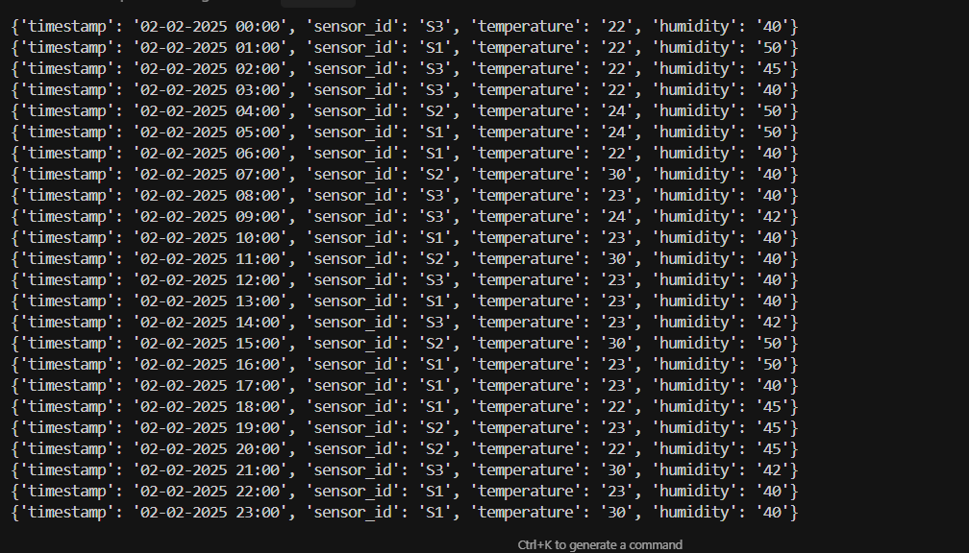
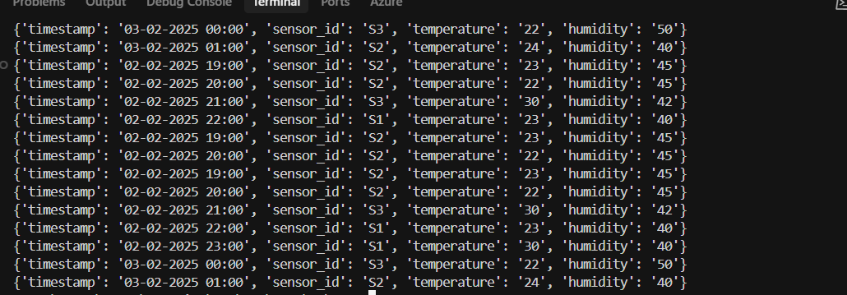

Remove sensor drift (apply rolling mean).
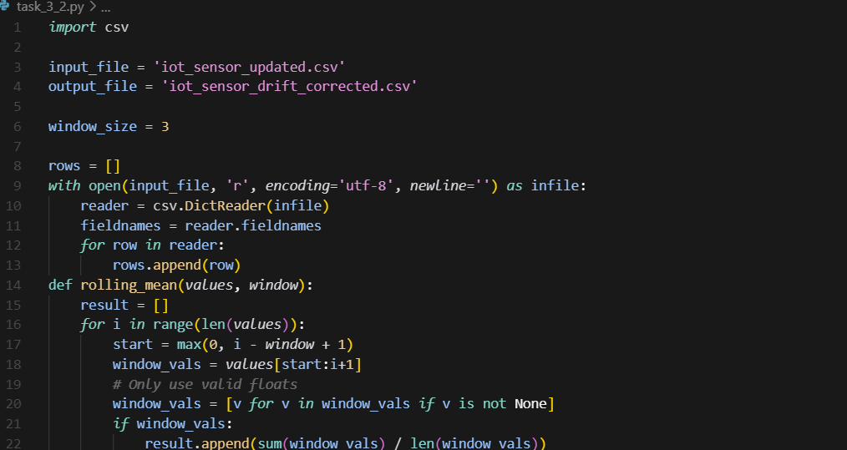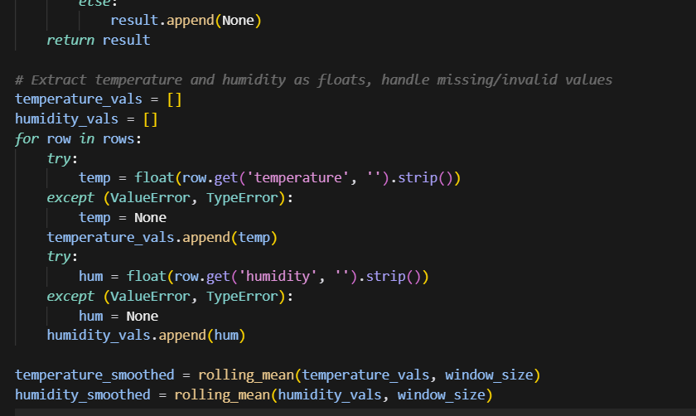
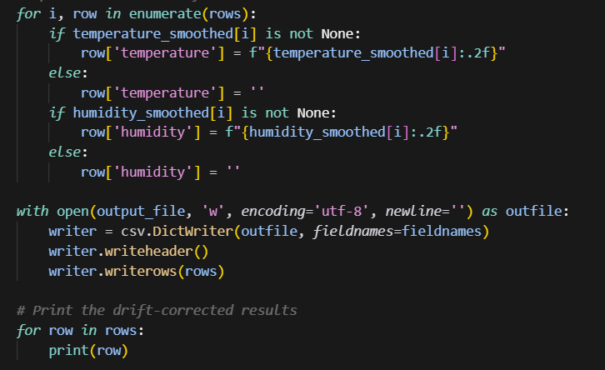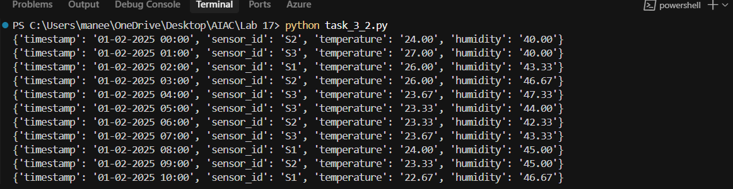
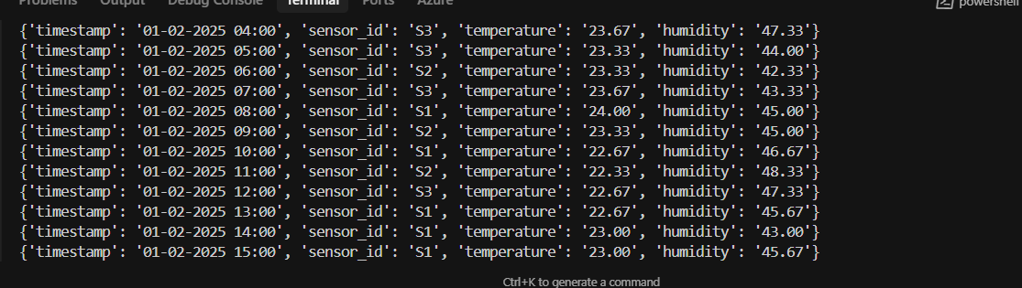
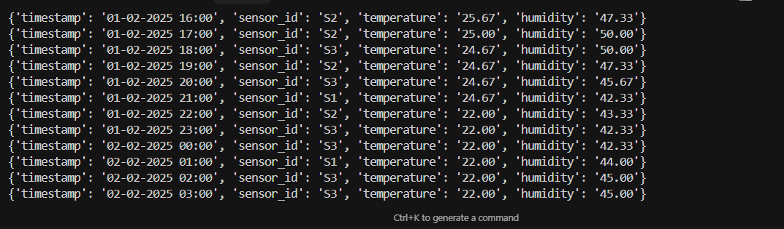
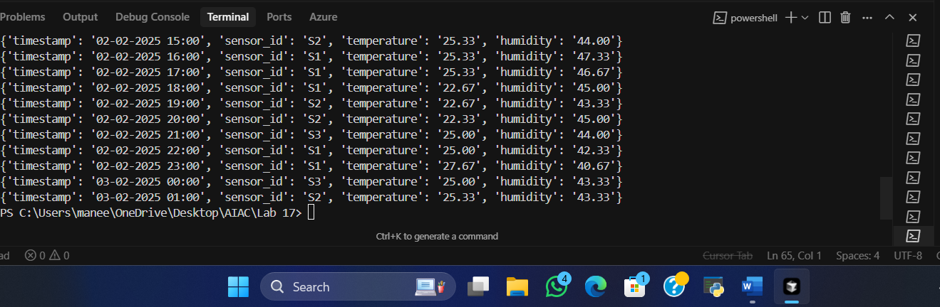

- Normalize readings using standard scaling.
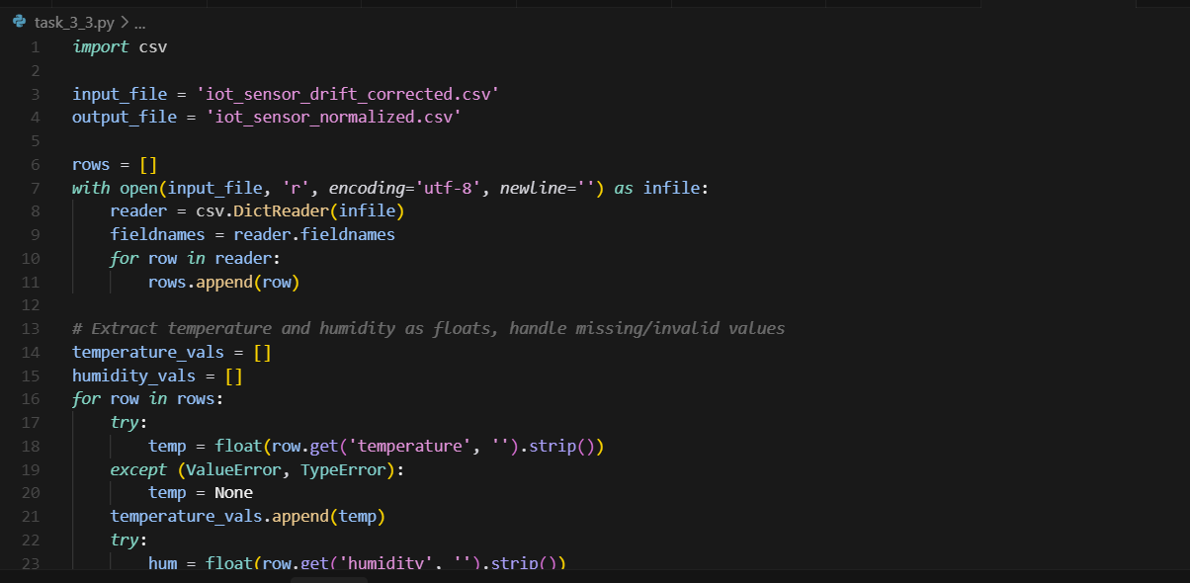
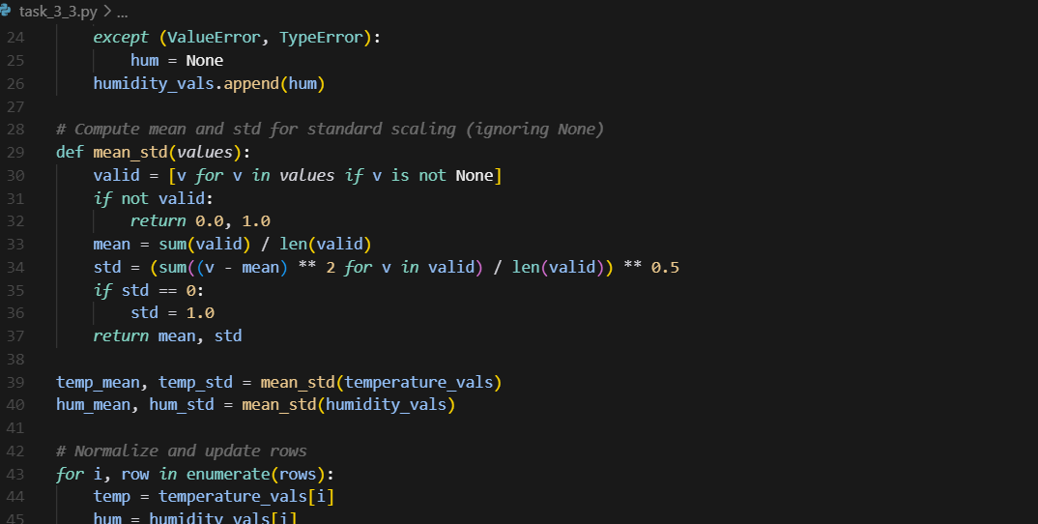
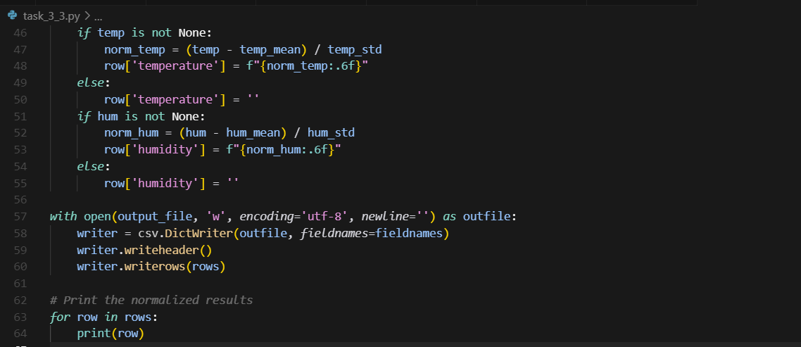
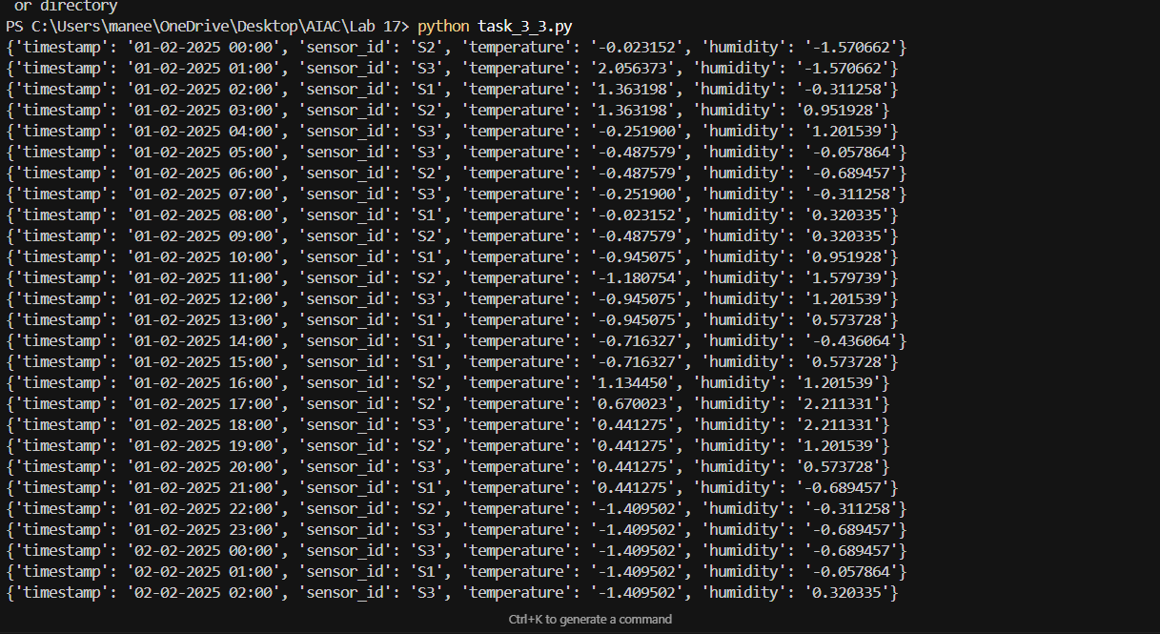
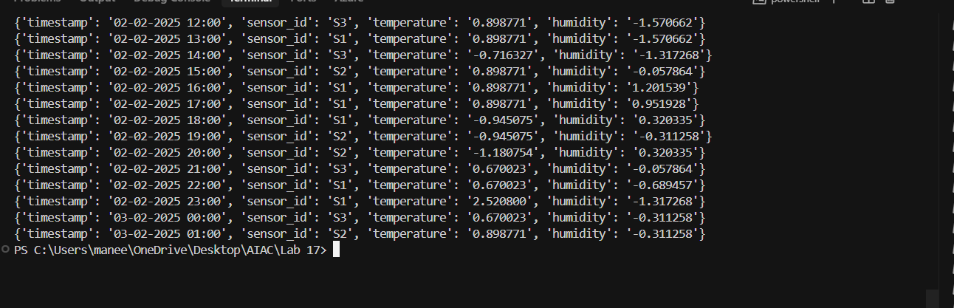
Encode categorical sensor IDs.
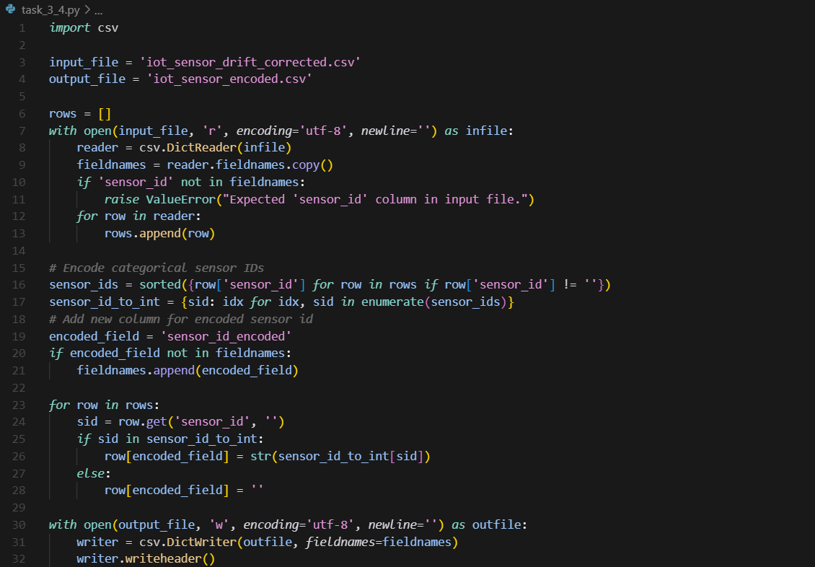
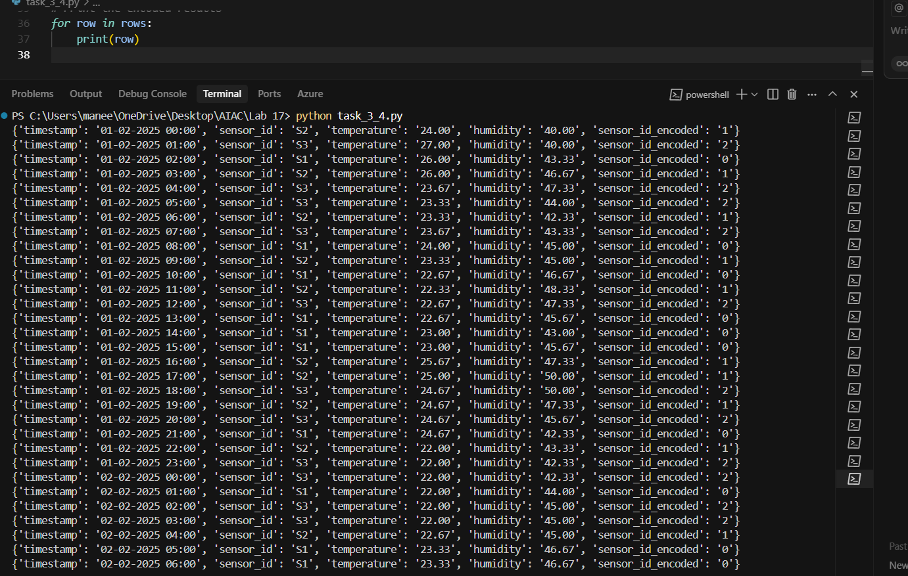
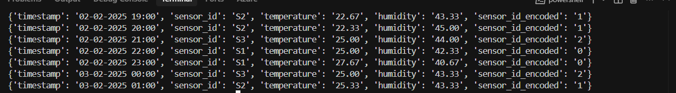

Task 4 – Real-Time Application: Movie Reviews Data Cleaning
Task: A streaming platform wants to analyze customer reviews.
Instructions:
- Standardize text (lowercase, remove HTML tags).
- Tokenize and encode reviews using AI-assisted methods (TF-IDF or embeddings).
- Handle missing ratings (fill with median).
- Normalize ratings (0–10 → 0–1 scale).
- Generate a before vs after summary report
Expected Output: A cleaned dataset ready for sentiment classification.
Standardize text (lowercase, remove HTML tags).

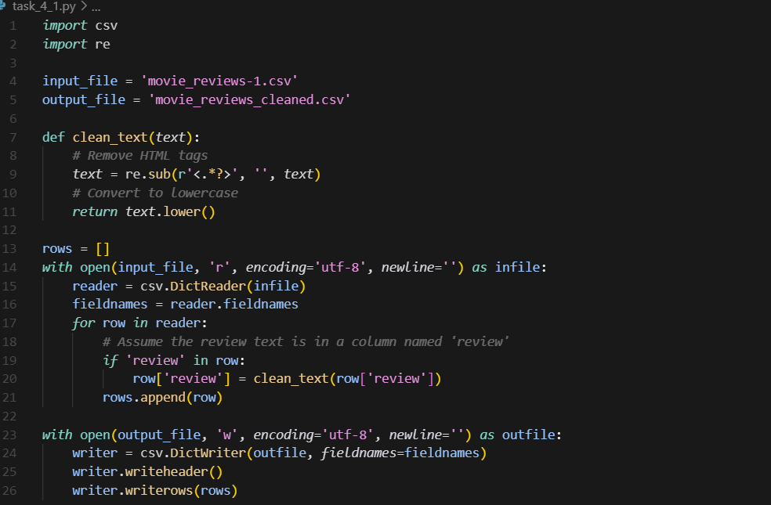
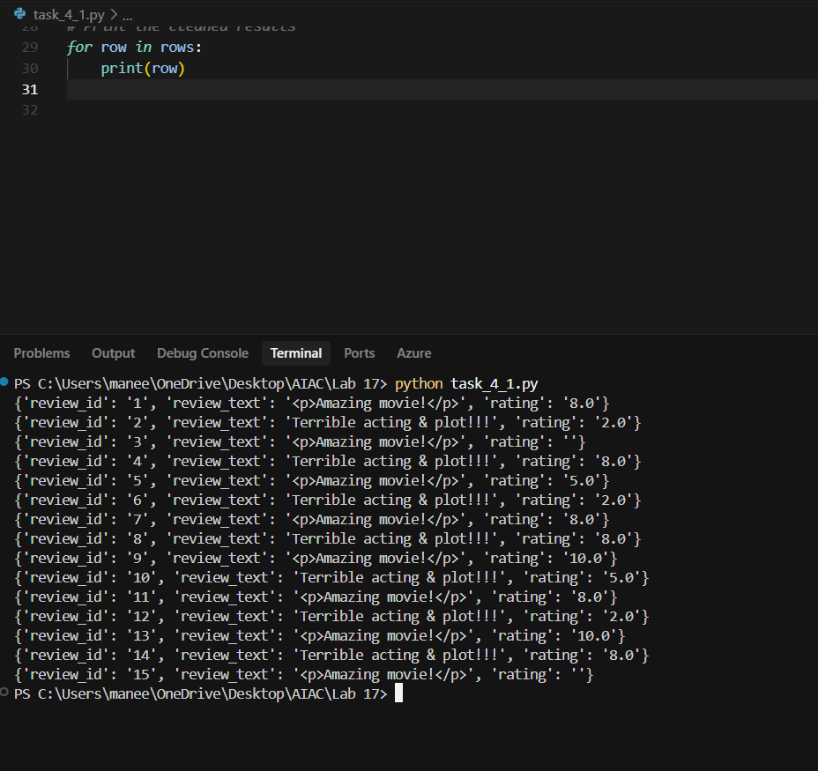
Tokenize and encode reviews using AI-assisted methods (TF-IDF or embeddings).
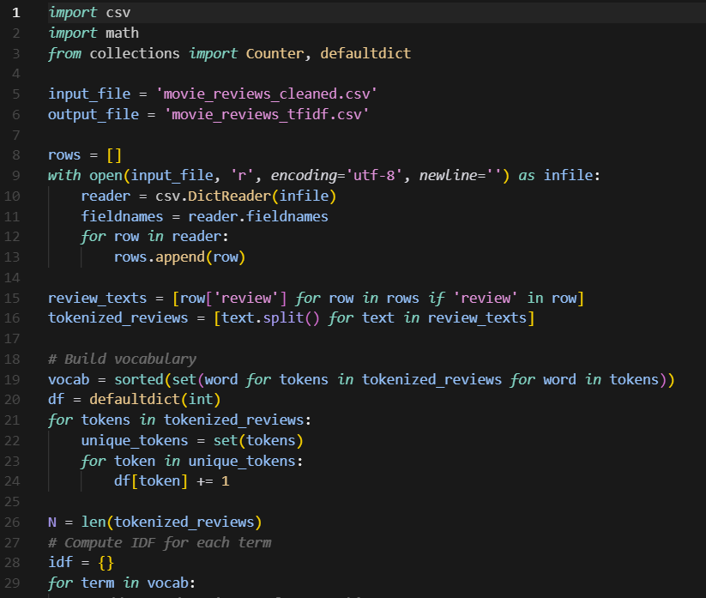
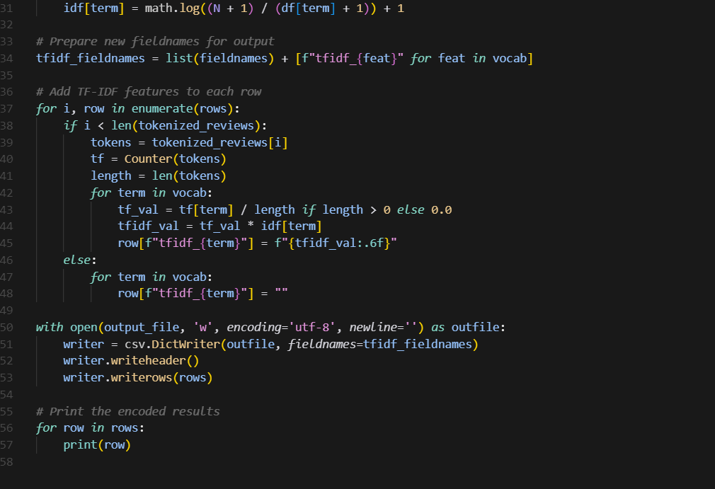
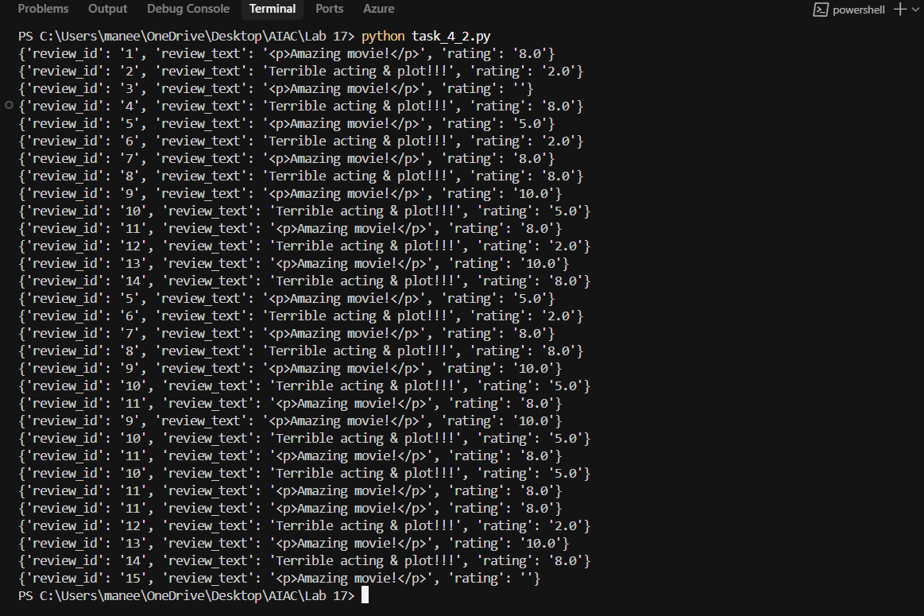
- Handle missing ratings (fill with median).

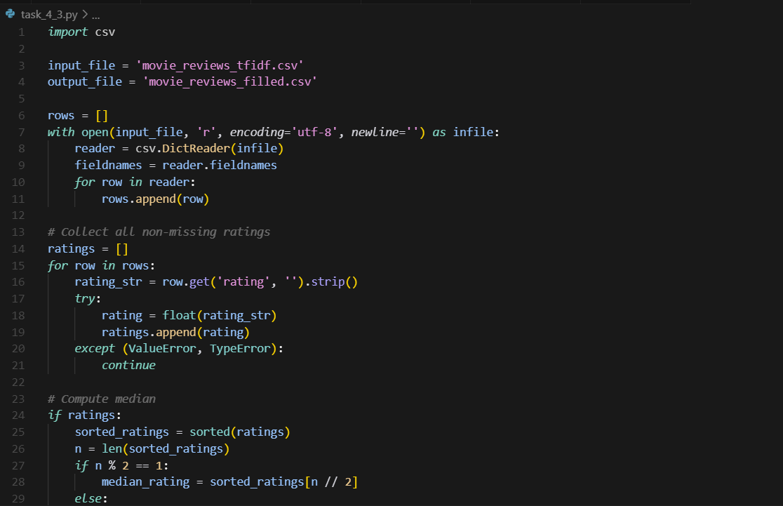
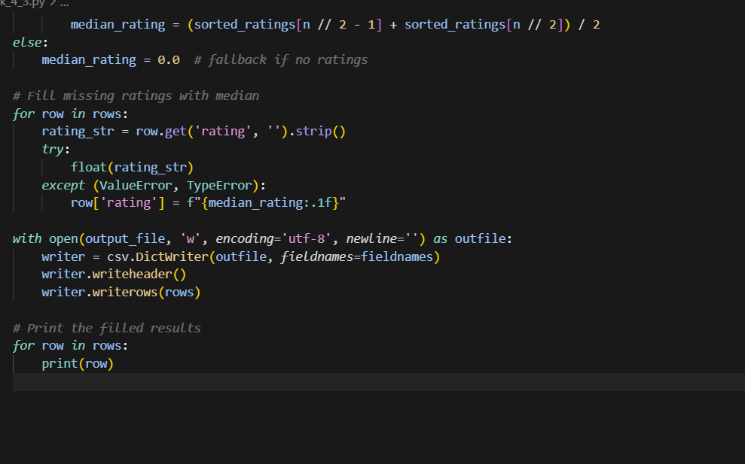
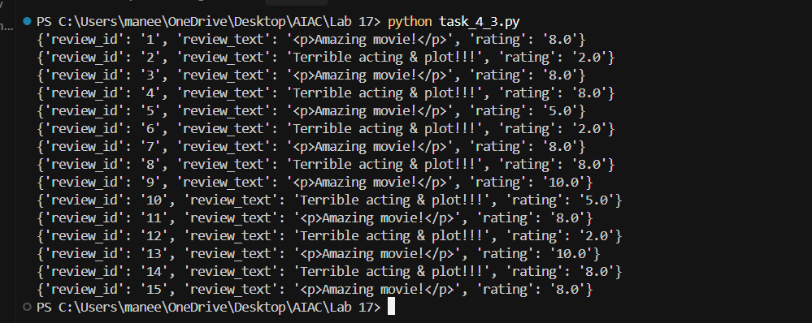

Normalize ratings (0–10 → 0–1 scale).
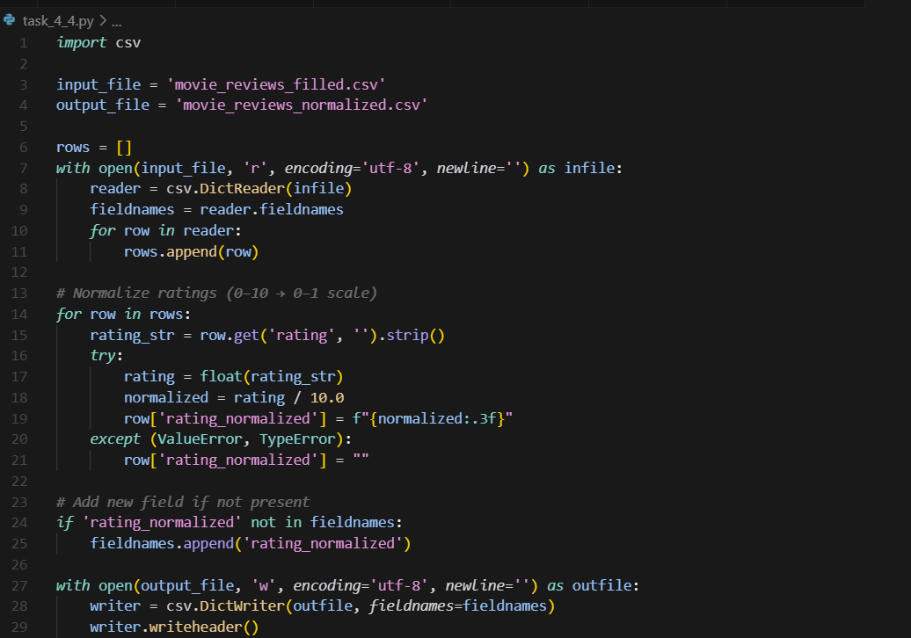
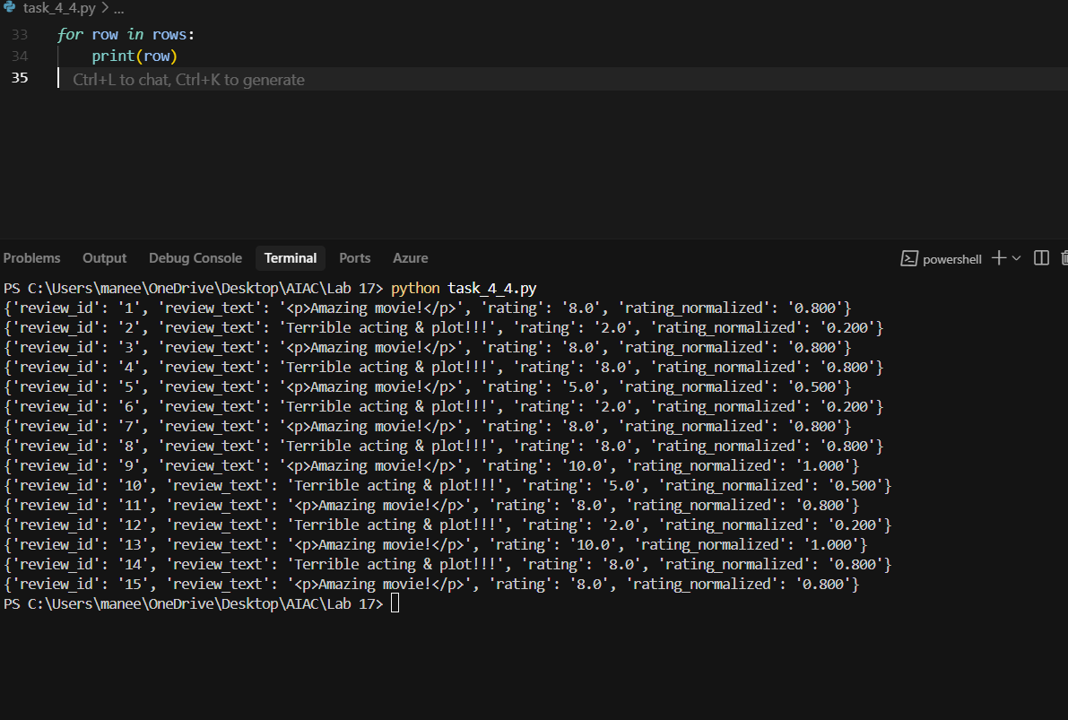

Generate a before vs after summary report
