Enroll:@403A51031
Batch:02
Labtest-2
Set-C
C.1:
Prompt:
Write a Python function deduplicate_emails(emails: list) -> list that removes duplicate email addresses from a list in a case-insensitive way, while keeping only the first occurrence of each email and preserving the original order. Also write unit tests using unittest to verify the correctness of the function.
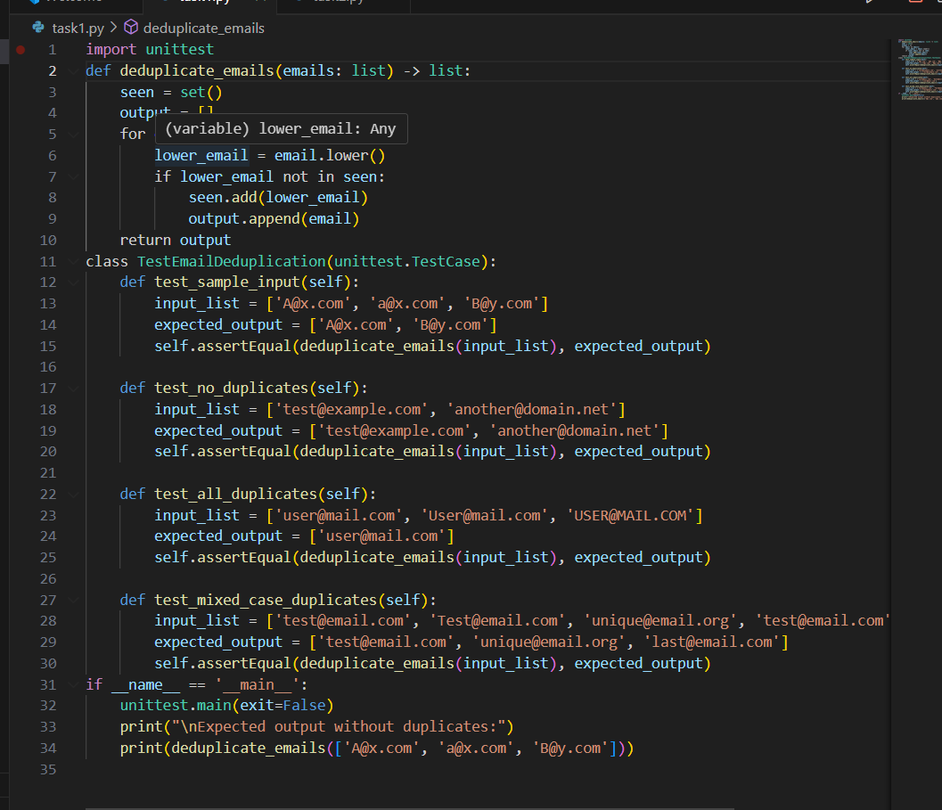
Expected Output:
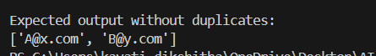

C.2:
Prompt:
Implement a Python function slugify(text: str) -> str that converts content titles into SEO-friendly slugs for use in URLs. The function must: (1) convert to lowercase, (2) remove all non-alphanumeric characters except hyphens, (3) replace spaces with hyphens, (4) collapse multiple consecutive hyphens into one, and (5) trim leading or trailing hyphens.
Write parameterized tests using pytest to cover normal cases, punctuation, multiple spaces, already-slugified input, empty strings, and boundary hyphens. Validate the function with sample inputs like ['Hello World!', 'AI & You', 'Set13-C2'] and ensure theoutputs are ['hello-world', 'ai-you', 'set13-c2']. All tests must pass.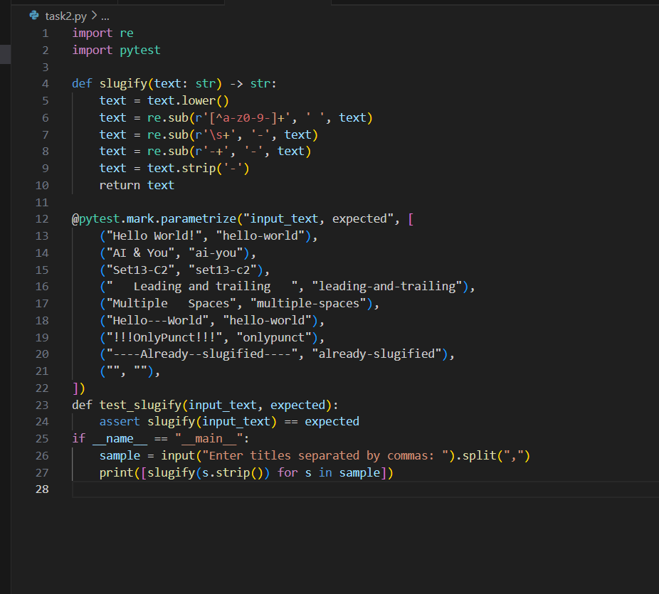
Expected Output:

