Task Description #2:

**•**Prompt:Display the largest number of three numbers which are input by the console.

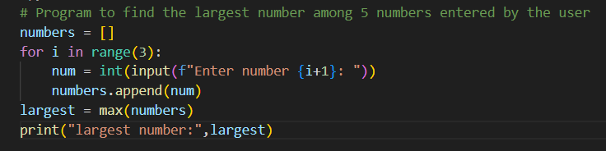

Expected Output #2:

Task Description#3:

**• Prompt:** Display the factorial of a number using recursion with input which is given by the console.

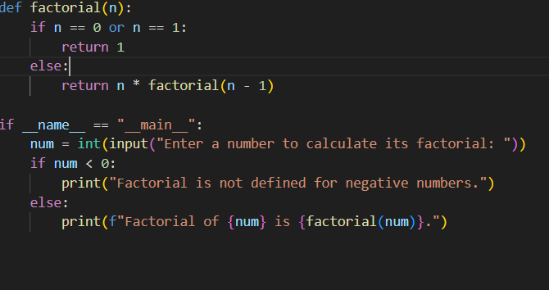

Expected output #3:



Task Description#4:

**• Prompt:** create a class named Student with attributes name, roll_no, and marks. Add a method to display student details.

**Expected Output #4:**

Task Description #5:

**• Prompt:** create a function that takes a string as input and returns and display the frequency of each word.

**Expected Output #4:**

