|  |  |
| --- | --- |
|  | SR UNIVERSITY  Campus Warangal |
| Program: II - B.Tech (CS& AI) |
| Professor(a): Dr. Venkataramana Veeramsetty, Professor |
| Department: Computer Science and AI Semester: I |
| AI Assisted Coding - Lab Test 1 - Set C |
| Instructions:   1. Use AI Tools like VScode+Github Copilot and Cursor AI for code generation 2. This Assignment will be evaluated for 15 Marks (10 Marks for Tasks and 5 Marks for viva based on regular lab activities) 3. Students need to submit assignment through canvas before due date 4. Students who are absent for lab will receive 0 Marks | |

1. (2 Marks) Write a Python program to extract all URLs (web links) from a block of text using regular expressions. Use the Cursor AI tool with zero-shot prompting to generate the solution

Prompt: Create a Python script that uses regular expressions to find and list all web links in a given text. The links should start with either http:// or https:// and include valid URL characters. Display each extracted link on a new line.

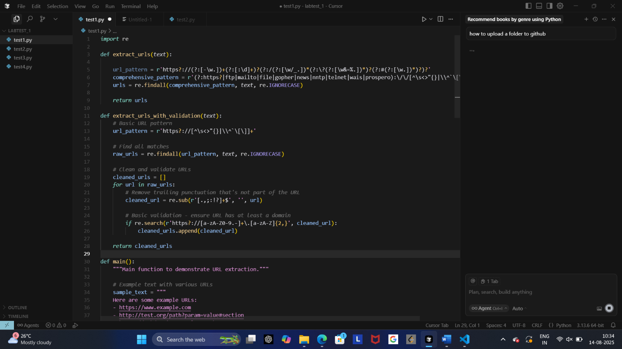

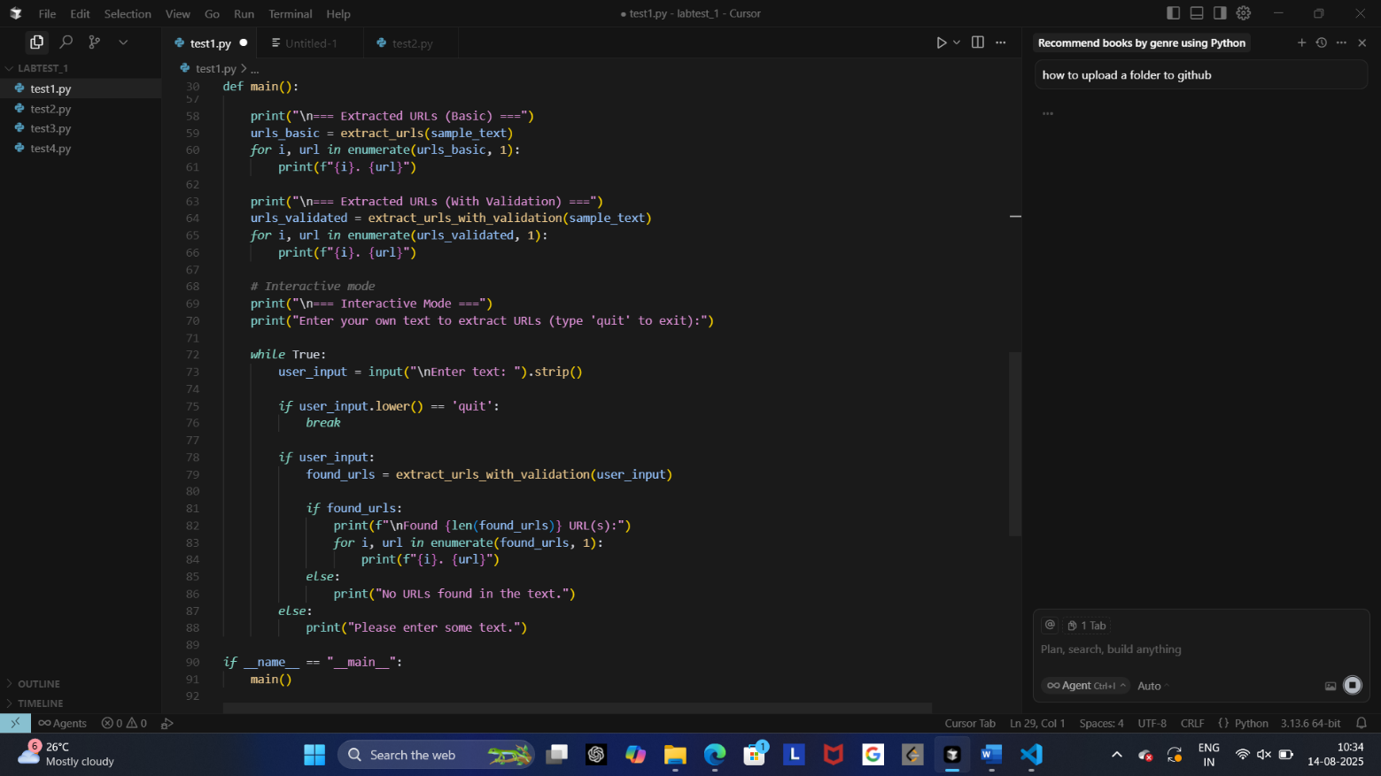

1. (2 Marks) Given a list of books with their genres, write a Python function that recommends books based on a user’s preferred genre. Use the Cursor AI tool. Use few shot prompting.

Prompt:

Example 1:

Input: books = [("Harry Potter", "Fantasy"), ("The Hobbit", "Fantasy"), ("Pride and Prejudice", "Romance")], preferred_genre = "Fantasy"

Output: ["Harry Potter", "The Hobbit"]

Example 2:

Input: books = [("Dune", "Science Fiction"), ("1984", "Dystopian"), ("Foundation", "Science Fiction")], preferred_genre = "Science Fiction"

Output: ["Dune", "Foundation"]

Now, write a Python function named recommend_books(books, preferred_genre) that takes a list of (book_title, genre) tuples and returns a list of books matching the preferred genre. The function should perform case-insensitive matching for genres.

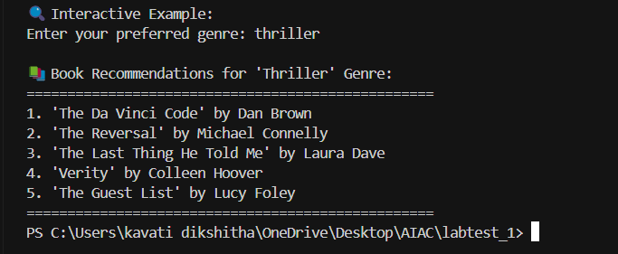

1. (2 Marks) Write a Python program that generates all prime numbers between start and end (both inclusive) entered by the user. Use GitHub Copilot along with VS Code. Use few shot prompting.

Prompt: Example:

Input: start = 10, end = 20

Output: [11, 13, 17, 19]

Write a Python program that takes start and end from the user and prints all prime numbers between them (inclusive).

1. (2 Marks) Write Python code that takes a list of student names and generates institutional email IDs in the format: <firstletter><lastname>@sru.edu.in Example: "Anita Sharma"→ asharma@sru.edu.in. Use GitHub Copilot along with VS Code. Use few shot prompting. Date: 20-08-14
2. Prompt:excample1:Rohith sharma
3. [Output=rsharma@sru.edu.in](mailto:Output=rsharma@sru.edu.in)
4. Example2:virat kohli
5. Output=vkohli@sru.edu.in

Write Python code that takes a list of student names and generates institutional email IDs in the format <firstletter><lastname>@sru.edu.in.

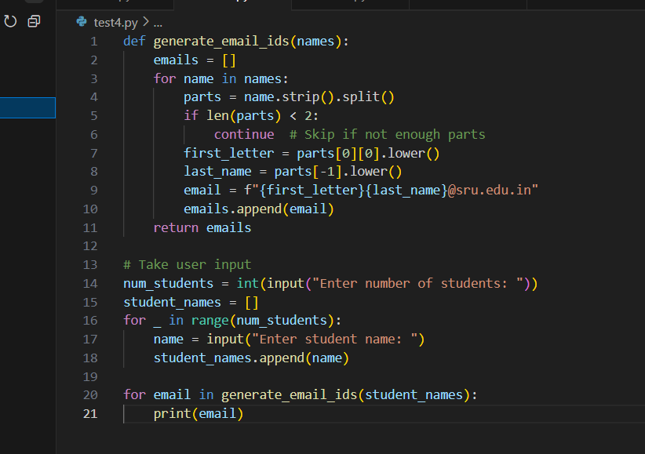

de 1