INDEX

SL.NO | CONTENTS | PAGE NO
1 | INTRODUCTION  1.1PROBLEM STRUCTURE  1.2 OBJECTIVE OF THE PROJECT | 1-4
2 | PROJECT OVERVIEW AND  DASHBOARD | 5
3 | FRONT – END | 6-23
4 | BACK-END | 24-27
5 | HARDWARE & SOFTWARE SPECIFICATION | 28
6 | PROJECT OUTCOMES  SCREENSHOTS | 29-32
7 | CONCLUSION | 33
8 | BIBLIOGRAPHY | 34
INTRODUCTION

Agriculture remains the backbone of India's economy, employing nearly 50% of the workforce and contributing significantly to the GDP. However, the sector faces numerous challenges including fragmented knowledge dissemination, limited access to modern farming equipment, and inadequate technological interventions. Traditional farming methods often lack the precision and efficiency required for sustainable agricultural practices.
In this context, Agro Connect emerges as a transformative digital solution that bridges the critical gap between farmers and agricultural experts. The platform serves as a comprehensive ecosystem where farmers can access expert knowledge, rent modern farming equipment, and receive personalized agricultural advice.
To empower farmers with cutting-edge technology and expert knowledge, fostering a sustainable agricultural ecosystem that bridges traditional farming wisdom with modern innovation, ensuring food security and economic prosperity for farming communities across India.

PROBLEM STATEMENT

Farmers in rural and semi-urban areas often lack access to modern agricultural knowledge and expert guidance, leading to outdated practices that lower yields by up to 30% and cause inefficient input use. Limited awareness of climate-resilient crops and sustainable methods further weakens competitiveness.
High equipment costs, poor rental systems, and weak maintenance infrastructure restrict access to modern machinery. Seasonal demand and low awareness reduce utilization and productivity. Communication gaps between farmers and experts delay solutions to urgent issues like pest outbreaks and weather threats, as language and location barriers limit consultation.
The agricultural ecosystem remains fragmented—soil data, weather forecasts, and advisory services are poorly integrated, leading to inconsistent recommendations and resource waste. Data collected by different agencies lacks standardization and sharing, preventing predictive analysis and collaboration.
These issues cause 20–25% yield gaps, higher input costs, and falling incomes, driving rural migration, environmental harm, and food insecurity. Technological and institutional challenges—limited internet, low digital literacy, and weak extension networks—slow innovation and digital adoption.
A unified, technology-driven platform is needed to connect knowledge, equipment, expertise, and data. Agro Connect offers this solution through an integrated digital ecosystem that provides expert consultation, an equipment marketplace, and a centralized knowledge base. Using AI, mobile technology, and blockchain, it delivers data-driven insights, transparency, and market integration—empowering farmers to boost productivity, cut costs, and farm sustainably.

OBJECTIVE OF THE PROJECT

The primary objectives of developing Agro Connect are:
- Create a Unified Platform: Develop a comprehensive web-based platform that integrates multiple agricultural services under one digital ecosystem.
- Facilitate Expert-Farmer Collaboration: Enable direct communication and knowledge exchange between certified agricultural experts and farmers.
- Streamline Equipment Rental: Implement an efficient marketplace for farming equipment rental with transparent pricing and availability tracking.
- Enable Data-Driven Agriculture: Provide tools for soil analysis, crop recommendations, and performance tracking using expert-validated data.
- Ensure Scalable Architecture: Design a robust, scalable system that can accommodate growing user base and expanding service offerings.
- Promote Sustainable Practices: Encourage adoption of sustainable farming practices through expert guidance and modern technology integration.
- Enhance Accessibility: Make agricultural expertise and modern farming tools accessible to farmers regardless of their location or scale of operation.
The project aims to address the core challenges in Indian agriculture by leveraging digital technologies to create an inclusive, efficient, and sustainable agricultural ecosystem.

Project Overview and Dashboard

Agro Connect is a multi-role web platform following a three-tier architecture supporting farmers, agricultural experts, and administrators. It integrates key modules for user management, equipment rental, expert advisory, and communication—all managed through a unified dashboard
System Architecture
The application follows a modular architecture with the following key components:
User Management Module
- Registration System: Multi-step registration with OTP verification for security
- Role-Based Authentication: Separate login portals for farmers, experts, and admins
- Profile Management: Comprehensive user profile management with location tracking
Equipment Marketplace
- Inventory Management: Dynamic equipment catalog with pricing and availability
- Booking System: Intelligent booking with cost calculation and status tracking
- Wishlist Functionality: User-specific equipment preferences and saved items
Crop Advisory System
- Soil Report Upload: Secure file upload system for soil test documents
- Expert Analysis: Expert review and crop recommendation generation
- Recommendation Tracking: Historical tracking of expert advice and outcomes
Communication Platform
- Real-time Chat: Direct messaging between assigned farmer-expert pairs
- File Attachments: Support for image, document, and PDF sharing
- Notification System: Automated notifications for important updates
Administrative Panel
- User Oversight: Complete user management and approval workflows
- Content Management: Equipment inventory and system configuration
- Analytics Dashboard: Platform usage statistics and performance metrics

FORNTEND

The frontend of Agro Connect is built with modern web technologies focusing on responsive design, user experience, and accessibility. The interface adapts seamlessly across desktop, tablet, and mobile devices.

Index.php
<?php
// Redirect to dashboard if logged in, otherwise show landing page
session_start();
if (isset($_SESSION['user_id'])) {
header('Location: dashboard.php');
exit();
}
// If not logged in, show the landing page below
?>

<!DOCTYPE html>
<html lang="en">
<head>
<meta charset="UTF-8">
<meta name="viewport" content="width=device-width, initial-scale=1.0">
<title>Agro Connect - Connecting Farmers and Experts</title>
<link rel="stylesheet" href="css/styles.css">
<link rel="stylesheet" href="https://cdnjs.cloudflare.com/ajax/libs/font-awesome/6.0.0/css/all.min.css">
</head>
<body>
<header>
<nav class="navbar">
<div class="nav-container">
<div class="nav-logo">
<h1><i class="fas fa-seedling"></i> Agro Connect</h1>
</div>
<ul class="nav-menu">
<li><a href="#home"><i class="fas fa-home"></i> Home</a></li>
<li><a href="#features"><i class="fas fa-star"></i> Features</a></li>
<li><a href="#about"><i class="fas fa-info-circle"></i> About</a></li>
<li><a href="#contact"><i class="fas fa-envelope"></i> Contact</a></li>
<li><a href="login.php" class="btn"><i class="fas fa-sign-in-alt"></i> Login</a></li>
<li><a href="register.php" class="btn"><i class="fas fa-user-plus"></i> Register</a></li>
</ul>
</div>
</nav>
</header>

<main>
<!-- Hero Section -->
<section id="home" class="hero-section">
<div class="container">
<div class="hero-content">
<h1>Welcome to Agro Connect</h1>
<p>Empowering farmers with technology and expert guidance for sustainable agriculture</p>
<div class="hero-buttons">
<a href="register.php" class="btn btn-large">Get Started</a>
<a href="#features" class="btn btn-large btn-secondary">Learn More</a>
</div>
</div>

</div>
</section>

<!-- Features Section -->
<section id="features" class="features-section">
<div class="container">
<h2>Why Choose Agro Connect?</h2>
<p class="section-subtitle">Empowering farmers with technology and expertise for sustainable agriculture</p>
<div class="features-grid">
<div class="feature-card">
<i class="fas fa-cloud-sun"></i>
<h3>Weather Intelligence</h3>
<p>Get accurate weather forecasts and alerts to optimize your farming operations and protect your crops from adverse conditions.</p>
</div>
<div class="feature-card">
<i class="fas fa-leaf"></i>
<h3>Crop Advisory</h3>
<p>Receive personalized crop recommendations based on your soil type, location, and seasonal conditions from certified agricultural experts.</p>
</div>
<div class="feature-card">
<i class="fas fa-comments"></i>
<h3>Expert Consultation</h3>
<p>Connect instantly with agricultural specialists for real-time advice on pest control, irrigation, and crop management.</p>
</div>
<div class="feature-card">
<i class="fas fa-tractor"></i>
<h3>Equipment Marketplace</h3>
<p>Access a comprehensive inventory of farming equipment from tractors to harvesters, available for rent at competitive rates.</p>
</div>
<div class="feature-card">
<i class="fas fa-calendar-alt"></i>
<h3>Smart Booking</h3>
<p>Streamline equipment rental with our intelligent booking system that ensures availability and seamless delivery.</p>
</div>
<div class="feature-card">
<i class="fas fa-chart-line"></i>
<h3>Farm Analytics</h3>
<p>Track your farm's performance with detailed analytics and insights to maximize productivity and profitability.</p>
</div>
</div>
</div>
</section>

<!-- How It Works Section -->
<section id="how-it-works" class="how-it-works-section">
<div class="container">
<h2>How It Works</h2>
<div class="steps-grid">
<div class="step-item">
<div class="step-number">1</div>
<h3>Register & Verify</h3>
<p>Create your account as a farmer or agricultural expert. Complete verification to access all platform features.</p>
</div>
<div class="step-item">
<div class="step-number">2</div>
<h3>Access Services</h3>
<p>Get weather updates, expert advice, and browse our equipment catalog tailored to your farming needs.</p>
</div>
<div class="step-item">
<div class="step-number">3</div>
<h3>Book & Connect</h3>
<p>Rent equipment, schedule expert consultations, and manage all your agricultural activities in one place.</p>
</div>
</div>
</div>
</section>

<!-- About Section -->
<section id="about" class="about-section">
<div class="container">
<div class="about-content">
<div class="about-text">
<h2>About Agro Connect</h2>
<p>Agro Connect is a comprehensive platform designed to bridge the gap between farmers and agricultural experts. Our mission is to empower farmers with cutting-edge technology and expert knowledge to enhance productivity and sustainability in agriculture.</p>
<p>Whether you're a small-scale farmer or managing large agricultural operations, Agro Connect provides the tools and support you need to make informed decisions and optimize your farming practices.</p>
<a href="register.php" class="btn">Join Our Community</a>
</div>
<div class="about-image">
<img src="img/CombineHarvester.jpg" alt="Modern farming technology">
</div>
</div>
</div>
</section>

<!-- Contact Section -->
<section id="contact" class="contact-section">
<div class="container">
<h2>Contact Us</h2>
<div class="contact-content">
<div class="contact-info">
<div class="contact-item">
<i class="fas fa-envelope"></i>
<h3>Email</h3>
<p>support@agroconnect.com</p>
</div>
<div class="contact-item">
<i class="fas fa-phone"></i>
<h3>Phone</h3>
<p>+1 (555) 123-4567</p>
</div>
<div class="contact-item">
<i class="fas fa-map-marker-alt"></i>
<h3>Address</h3>
<p>123 Agriculture Street<br>Farming City, FC 12345</p>
</div>
</div>
<div class="contact-form">
<h3>Send us a message</h3>
<form action="#" method="post">
<div class="form-group">
<label for="name">Name</label>
<input type="text" id="name" name="name" required>
</div>
<div class="form-group">
<label for="email">Email</label>
<input type="email" id="email" name="email" required>
</div>
<div class="form-group">
<label for="message">Message</label>
<textarea id="message" name="message" rows="5" required></textarea>
</div>
<button type="submit" class="btn">Send Message</button>
</form>
</div>
</div>
</div>
</section>
</main>

<footer>
<div class="container">
<p>&copy; 2024 Agro Connect. All rights reserved.</p>
</div>
</footer>

<style>

Farmer_dashboard.php
<?php
require_once '../config.php';
require_once '../includes/functions.php';
redirectIfNotRole('farmer');

$user_id = $_SESSION['user_id'];

// Get unread notifications
$unread_count = getUnreadNotificationsCount($user_id, 'farmer');

// Get assigned expert
$stmt = $conn->prepare("
SELECT e.id, e.name, e.specialization,
COALESCE((SELECT AVG(rating) FROM expert_ratings WHERE expert_id = e.id), 0) as rating,
COUNT(m.id) as unread_messages, efa.assigned_at
FROM experts e
JOIN expert_farmer_assignments efa ON e.id = efa.expert_id
LEFT JOIN messages m ON m.sender_id = e.id
AND m.sender_role = 'expert'
AND m.receiver_id = ?
AND m.receiver_role = 'farmer'
AND m.read_at IS NULL
WHERE efa.farmer_id = ? AND efa.status = 'active'
GROUP BY e.id
");
$stmt->bind_param("ii", $user_id, $user_id);
$stmt->execute();
$assigned_expert = $stmt->get_result()->fetch_assoc();

// Get recent soil reports
$stmt = $conn->prepare("SELECT * FROM soil_reports WHERE farmer_id = ? ORDER BY uploaded_at DESC LIMIT 5");
$stmt->bind_param("i", $user_id);
$stmt->execute();
$soil_reports = $stmt->get_result();

// Get recent bookings
$stmt = $conn->prepare("SELECT b.*, e.name as equipment_name FROM bookings b JOIN equipment e ON b.equipment_id = e.id WHERE b.farmer_id = ? ORDER BY b.created_at DESC LIMIT 5");
$stmt->bind_param("i", $user_id);
$stmt->execute();
$bookings = $stmt->get_result();

include '../includes/header.php';
?>

<div class="container">
<h2>Farmer Dashboard</h2>

<div class="dashboard-grid">
<!-- Expert Chat Card -->
<div class="dashboard-card">
<h3><i class="fas fa-user-tie"></i> Agricultural Expert</h3>
<?php if ($assigned_expert): ?>
<div class="expert-info">
<h4><?php echo htmlspecialchars($assigned_expert['name']); ?></h4>
<p><i class="fas fa-graduation-cap"></i> <?php echo htmlspecialchars($assigned_expert['specialization']); ?></p>
<?php if ($assigned_expert['rating']): ?>
<p><i class="fas fa-star"></i> Rating: <?php echo number_format($assigned_expert['rating'], 1); ?>/5</p>
<?php endif; ?>
<?php if ($assigned_expert['unread_messages'] > 0): ?>
<div class="unread-badge"><?php echo $assigned_expert['unread_messages']; ?> new messages</div>
<?php endif; ?>
<a href="chat.php" class="btn btn-primary">
<i class="fas fa-comments"></i> Open Chat
</a>
</div>
<?php else: ?>
<div class="no-expert">
<p>No expert assigned yet.</p>
<p class="text-muted">Please contact administration to get assigned to an agricultural expert.</p>
</div>
<?php endif; ?>
</div>

<div class="dashboard-card">
<h3><i class="fas fa-leaf"></i> Crop Advisory</h3>
<div class="stat"><?php echo $soil_reports->num_rows; ?></div>
<p>Soil reports uploaded</p>
<a href="crop_advisory.php" class="btn">Get Recommendations</a>
</div>

<div class="dashboard-card">
<h3><i class="fas fa-tractor"></i> Equipment</h3>
<div class="stat"><?php echo $bookings->num_rows; ?></div>
<p>Active bookings</p>
<a href="equipment.php" class="btn">Browse Equipment</a>
</div>
</div>

<div class="card">
<h3>Recent Soil Reports</h3>
<?php if ($soil_reports->num_rows > 0): ?>
<table class="table">
<thead>
<tr>
<th>Date</th>
<th>File</th>
<th>Actions</th>
</tr>
</thead>
<tbody>
<?php while ($report = $soil_reports->fetch_assoc()): ?>
<tr>
<td><?php echo date('Y-m-d', strtotime($report['uploaded_at'])); ?></td>
<td>
<?php if ($report['report_file']): ?>
<a href="../uploads/<?php echo $report['report_file']; ?>" target="_blank">View</a>
<?php else: ?>
N/A
<?php endif; ?>
</td>
<td>
<a href="crop_recommendation.php?report_id=<?php echo $report['id']; ?>" class="btn">View Recommendations</a>
</td>
</tr>
<?php endwhile; ?>
</tbody>
</table>
<?php else: ?>
<p>No soil reports found. <a href="crop_advisory.php">Upload your first report</a></p>
<?php endif; ?>
</div>

<div class="card">
<h3>Recent Bookings</h3>
<?php if ($bookings->num_rows > 0): ?>
<table class="table">
<thead>
<tr>
<th>Equipment</th>
<th>Start Date</th>
<th>End Date</th>
<th>Status</th>
<th>Cost</th>
</tr>
</thead>
<tbody>
<?php while ($booking = $bookings->fetch_assoc()): ?>
<tr>
<td><?php echo $booking['equipment_name']; ?></td>
<td><?php echo $booking['start_date']; ?></td>
<td><?php echo $booking['end_date']; ?></td>
<td><?php echo ucfirst($booking['status']); ?></td>
<td>₹<?php echo number_format($booking['total_cost'], 2); ?></td>
</tr>
<?php endwhile; ?>
</tbody>
</table>
<?php else: ?>
<p>No bookings found. <a href="equipment.php">Browse equipment</a></p>
<?php endif; ?>
</div>
</div>
<?php include '../includes/footer.php'; ?>

expert_dashbord.php
<?php
require_once '../config.php';
require_once '../includes/functions.php';
redirectIfNotRole('expert');

$user_id = $_SESSION['user_id'];

// Get assigned farmers count
$stmt = $conn->prepare("SELECT COUNT(*) as count FROM farmers");
$stmt->execute();
$farmer_count = $stmt->get_result()->fetch_assoc()['count'];

// Get pending soil reports
$stmt = $conn->prepare("SELECT COUNT(*) as count FROM soil_reports WHERE id NOT IN (SELECT soil_report_id FROM crop_recommendations WHERE expert_id = ?)");
$stmt->bind_param("i", $user_id);
$stmt->execute();
$pending_reports = $stmt->get_result()->fetch_assoc()['count'];

// Get unread messages
$stmt = $conn->prepare("SELECT COUNT(*) as count FROM messages WHERE receiver_id = ? AND is_read = FALSE");
$stmt->bind_param("i", $user_id);
$stmt->execute();
$unread_messages = $stmt->get_result()->fetch_assoc()['count'];

// Get recent soil reports
$stmt = $conn->prepare("SELECT sr.*, f.name as farmer_name FROM soil_reports sr JOIN farmers f ON sr.farmer_id = f.id ORDER BY sr.uploaded_at DESC LIMIT 5");
$stmt->execute();
$recent_reports = $stmt->get_result();

include '../includes/header.php';
?>

<div class="container">
<h2>Expert Dashboard</h2>

<div class="dashboard-grid">
<div class="dashboard-card">
<h3><i class="fas fa-users"></i> Total Farmers</h3>
<div class="stat"><?php echo $farmer_count; ?></div>
<p>Registered farmers</p>
</div>

<div class="dashboard-card">
<h3><i class="fas fa-flask"></i> Pending Reports</h3>
<div class="stat"><?php echo $pending_reports; ?></div>
<p>Awaiting review</p>
<a href="advisory.php" class="btn">Review Now</a>
</div>

<div class="dashboard-card">
<h3><i class="fas fa-comments"></i> Messages</h3>
<div class="stat"><?php echo $unread_messages; ?></div>
<p>Unread messages</p>
<a href="chat.php" class="btn">View Chat</a>
</div>

<div class="dashboard-card">
<h3><i class="fas fa-clipboard-list"></i> Recommendations</h3>
<div class="stat"><?php
$stmt = $conn->prepare("SELECT COUNT(*) as count FROM crop_recommendations WHERE expert_id = ?");
$stmt->bind_param("i", $user_id);
$stmt->execute();
echo $stmt->get_result()->fetch_assoc()['count'];
?></div>
<p>Given by you</p>
</div>
</div>
<div class="card">
<h3>Recent Soil Reports</h3>
<?php if ($recent_reports->num_rows > 0): ?>
<table class="table">
<thead>
<tr>
<th>Farmer</th>
<th>Date</th>
<th>File</th>
<th>Actions</th>
</tr>
</thead>
<tbody>
<?php while ($report = $recent_reports->fetch_assoc()): ?>
<tr>
<td><?php echo $report['farmer_name']; ?></td>
<td><?php echo date('Y-m-d', strtotime($report['uploaded_at'])); ?></td>
<td>
<?php if ($report['report_file']): ?>
<a href="../uploads/<?php echo $report['report_file']; ?>" target="_blank">View</a>
<?php else: ?>
N/A
<?php endif; ?>
</td>
<td>
<a href="advisory.php?report_id=<?php echo $report['id']; ?>" class="btn">Provide Advice</a>
</td>
</tr>
<?php endwhile; ?>
</tbody>
</table>
<?php else: ?>
<p>No soil reports available.</p>
<?php endif; ?>
</div>
</div>
<?php include '../includes/footer.php'; ?>
admin_Dashboard.php
<?php
require_once '../config.php';
require_once '../includes/functions.php';
redirectIfNotRole('admin');
$user_id = $_SESSION['user_id'];

// Get statistics
$stmt = $conn->prepare("SELECT COUNT(*) as count FROM farmers");
$stmt->execute();
$farmer_count = $stmt->get_result()->fetch_assoc()['count'];

$stmt = $conn->prepare("SELECT COUNT(*) as count FROM experts WHERE status = 'active'");
$stmt->execute();
$expert_count = $stmt->get_result()->fetch_assoc()['count'];

$stmt = $conn->prepare("SELECT COUNT(*) as count FROM equipment");
$stmt->execute();
$equipment_count = $stmt->get_result()->fetch_assoc()['count'];

$stmt = $conn->prepare("SELECT COUNT(*) as count FROM bookings");
$stmt->execute();
$booking_count = $stmt->get_result()->fetch_assoc()['count'];

$stmt = $conn->prepare("SELECT SUM(total_cost) as revenue FROM bookings WHERE status = 'completed'");
$stmt->execute();
$revenue = $stmt->get_result()->fetch_assoc()['revenue'] ?: 0;

// Handle user actions
$message = '';
if ($_SERVER['REQUEST_METHOD'] === 'POST') {
if (isset($_POST['delete_user'])) {
$user_id = intval($_POST['user_id']);
$role = sanitize($_POST['role']); // Assume role is passed
$table = $role === 'farmer' ? 'farmers' : 'experts';
$stmt = $conn->prepare("DELETE FROM $table WHERE id = ?");
$stmt->bind_param("i", $user_id);
if ($stmt->execute()) {
$message = '<div class="success">User deleted successfully!</div>';
} else {
$message = '<div class="error">Failed to delete user.</div>';
}
} elseif (isset($_POST['approve_expert'])) {
$user_id = intval($_POST['user_id']);
$stmt = $conn->prepare("UPDATE experts SET status = 'active' WHERE id = ?");
$stmt->bind_param("i", $user_id);
if ($stmt->execute()) {
$message = '<div class="success">Expert approved successfully!</div>';
} else {
$message = '<div class="error">Failed to approve expert.</div>';
}
} elseif (isset($_POST['reject_expert'])) {
$user_id = intval($_POST['user_id']);
$stmt = $conn->prepare("DELETE FROM experts WHERE id = ? AND status = 'inactive'");
$stmt->bind_param("i", $user_id);
if ($stmt->execute()) {
$message = '<div class="success">Expert application rejected and user removed.</div>';
} else {
$message = '<div class="error">Failed to reject expert.</div>';
}
}
}
// Get recent activities
$stmt = $conn->prepare("SELECT 'New farmer registered' as activity, name as details, created_at FROM farmers ORDER BY created_at DESC LIMIT 5");
$stmt->execute();
$activities = $stmt->get_result();

include '../includes/header.php';
?>
<div class="container">
<h2>Admin Dashboard</h2>
<div class="dashboard-grid">
<div class="dashboard-card">
<h3><i class="fas fa-users"></i> Total Farmers</h3>
<div class="stat"><?php echo $farmer_count; ?></div>
<p>Registered farmers</p>
</div>

<div class="dashboard-card">
<h3><i class="fas fa-user-tie"></i> Total Experts</h3>
<div class="stat"><?php echo $expert_count; ?></div>
<p>Agricultural experts</p>
</div>
<div class="dashboard-card">
<h3><i class="fas fa-tractor"></i> Equipment</h3>
<div class="stat"><?php echo $equipment_count; ?></div>
<p>Available items</p>
</div>

<div class="dashboard-card">
<h3><i class="fas fa-shopping-cart"></i> Bookings</h3>
<div class="stat"><?php echo $booking_count; ?></div>
<p>Total bookings</p>
</div>

<div class="dashboard-card">
<h3><i class="fas fa-rupee-sign"></i> Revenue</h3>
<div class="stat">₹<?php echo number_format($revenue, 2); ?></div>
<p>From completed bookings</p>
</div>
<div class="dashboard-card">
<h3><i class="fas fa-tractor"></i> Top Equipment</h3>
<div class="stat">
<?php
$stmt = $conn->prepare("
SELECT e.name, COUNT(b.id) as booking_count
FROM equipment e
LEFT JOIN bookings b ON e.id = b.equipment_id
GROUP BY e.id, e.name
ORDER BY booking_count DESC
LIMIT 1
");
$stmt->execute();
$top_equipment = $stmt->get_result()->fetch_assoc();
echo $top_equipment ? htmlspecialchars($top_equipment['name']) : 'N/A';
?>
</div>
<p>Most Booked Equipment</p>
<div class="trend-chart">
<small><?php echo $top_equipment ? $top_equipment['booking_count'] . ' bookings' : 'No bookings'; ?></small>
</div>
</div>
</div>
<div class="card">
<h3></h3>Recent Activities</h3>
<?php if ($activities->num_rows > 0): ?>
<ul>
<?php while ($activity = $activities->fetch_assoc()): ?>
<li><?php echo $activity['activity']; ?>: <?php echo $activity['details']; ?> (<?php echo date('M d, Y', strtotime($activity['created_at'])); ?>)</li>
<?php endwhile; ?>
</ul>
<?php else: ?>
<p>No recent activities.</p>
<?php endif; ?>
</div>
</div>
<!-- Assign Farmer Modal -->
<div id="assignFarmerModal" class="modal" style="display: none;">
<div class="modal-content">
<span class="close" onclick="closeAssignFarmerModal()">&times;</span>
<h3>Assign Farmer to <span id="expertName"></span></h3>
<form method="POST" id="assignFarmerForm">
<input type="hidden" name="expert_id" id="expertIdInput">
<div class="form-group">
<label for="farmer_id">Select Farmer:</label>
<select name="farmer_id" id="farmer_id" required>
<option value="">Choose a farmer...</option>
<?php
$stmt = $conn->prepare("
SELECT f.id, f.name, f.location
FROM farmers f
WHERE NOT EXISTS (
SELECT 1 FROM expert_farmer_assignments efa
WHERE efa.farmer_id = f.id
AND efa.status = 'active'
)
ORDER BY f.location, f.name
");
$stmt->execute();
$available_farmers = $stmt->get_result();
while ($farmer = $available_farmers->fetch_assoc()): ?>
<option value="<?php echo $farmer['id']; ?>">
<?php echo htmlspecialchars($farmer['name']); ?> (<?php echo htmlspecialchars($farmer['location']); ?>)
</option>
<?php endwhile; ?>
</select>
</div>
<div class="form-group">
<label for="notes">Notes:</label>
<textarea name="notes" id="notes" rows="3"></textarea>
</div>
<button type="submit" name="assign_farmer" class="btn">Assign Farmer</button>
</form>
</div>
</div>

<style>
.farmer-list {
list-style: none;
padding: 0;
margin: 10px 0;
max-height: 150px;
overflow-y: auto;
}
.farmer-list li {
padding: 5px;
border-bottom: 1px solid #eee;
display: flex;
justify-content: space-between;
align-items: center;
}
.assigned-farmers {
padding: 10px;
background: #f9f9f9;
border-radius: 4px;
}
.modal {
display: none;
position: fixed;
z-index: 1000;
left: 0;
top: 0;
width: 100%;
height: 100%;
background-color: rgba(0,0,0,0.4);
}
.modal-content {
background-color: white;
margin: 15% auto;
padding: 20px;
border: 1px solid #888;
width: 50%;
border-radius: 5px;
position: relative;
}
.close {
position: absolute;
right: 10px;
top: 5px;
font-size: 28px;
font-weight: bold;
cursor: pointer;
}
</style>
<script>
function showAssignFarmerModal(expertId, expertName) {
document.getElementById('expertIdInput').value = expertId;
document.getElementById('expertName').textContent = expertName;
document.getElementById('assignFarmerModal').style.display = 'block';
}
function closeAssignFarmerModal() {
document.getElementById('assignFarmerModal').style.display = 'none';
}
// Close modal when clicking outside
window.onclick = function(event) {
const modal = document.getElementById('assignFarmerModal');
if (event.target == modal) {
modal.style.display = 'none';
}
}
</script>

<script src="../js/admin-dashboard.js"></script>
<?php include '../includes/footer.php'; ?>
Back-End

The backend of Agro Connect is the core part of the application that handles all the logic, data processing, and communication between the database and the frontend interface. It is developed using PHP and MySQL, ensuring reliability, scalability, and security.

PHP7.4+:
PHP (Hypertext Preprocessor) is used as the server-side scripting language. It processes user requests, executes business logic (like user authentication or booking management), and communicates with the database. The use of object-oriented programming (OOP) in PHP ensures modularity, code reusability, and maintainability, making it easier to update and scale the system in the future.

MySQL 8.0:
MySQL is the relational database management system (RDBMS) used to store and manage all platform data — including user profiles, equipment details, booking records, chat messages, and soil reports. Its relational structure ensures data consistency, while indexing and query optimization support fast data retrieval even under heavy load
.
PDO (PHP Data Objects):
PDO acts as a database abstraction layer that allows PHP to interact securely with MySQL. It protects against SQL injection attacks by using prepared statements and parameterized queries. This enhances the overall security and portability of the application.

Session Management:
Session management ensures that users remain securely logged in throughout their interaction with the platform. It tracks user identities (e.g., farmer, expert, or admin) during a session while preventing unauthorized access or session hijacking through encryption and timeout mechanisms.

DATABASE SCHEMA

Agro Connect Database Schema

CREATE DATABASE IF NOT EXISTS AC;
USE AC;

-- Admins table
CREATE TABLE admins (
id INT AUTO_INCREMENT PRIMARY KEY,
name VARCHAR(100) NOT NULL,
email VARCHAR(100) UNIQUE NOT NULL,
password VARCHAR(255) NOT NULL,
phone VARCHAR(15),
location VARCHAR(100),
created_at TIMESTAMP DEFAULT CURRENT_TIMESTAMP,
updated_at TIMESTAMP DEFAULT CURRENT_TIMESTAMP ON UPDATE CURRENT_TIMESTAMP
);

-- Farmers table
CREATE TABLE farmers (
id INT AUTO_INCREMENT PRIMARY KEY,
name VARCHAR(100) NOT NULL,
email VARCHAR(100) UNIQUE NOT NULL,
password VARCHAR(255) NOT NULL,
phone VARCHAR(15),
location VARCHAR(100),
land_size DECIMAL(8,2),
soil_type VARCHAR(50),
created_at TIMESTAMP DEFAULT CURRENT_TIMESTAMP,
updated_at TIMESTAMP DEFAULT CURRENT_TIMESTAMP ON UPDATE CURRENT_TIMESTAMP
);

-- Experts table
CREATE TABLE experts (
id INT AUTO_INCREMENT PRIMARY KEY,
name VARCHAR(100) NOT NULL,
email VARCHAR(100) UNIQUE NOT NULL,
password VARCHAR(255) NOT NULL,
phone VARCHAR(15),
location VARCHAR(100),
specialization VARCHAR(100),
experience_years INT DEFAULT 0,
resume_path VARCHAR(255),
status ENUM('active', 'inactive') DEFAULT 'inactive',
created_at TIMESTAMP DEFAULT CURRENT_TIMESTAMP,
updated_at TIMESTAMP DEFAULT CURRENT_TIMESTAMP ON UPDATE CURRENT_TIMESTAMP
);

-- Soil reports table
CREATE TABLE soil_reports (
id INT AUTO_INCREMENT PRIMARY KEY,
farmer_id INT NOT NULL,
ph_level DECIMAL(3,1),
nitrogen DECIMAL(5,2),
phosphorus DECIMAL(5,2),
potassium DECIMAL(5,2),
report_file VARCHAR(255),
uploaded_at TIMESTAMP DEFAULT CURRENT_TIMESTAMP,
FOREIGN KEY (farmer_id) REFERENCES farmers(id) ON DELETE CASCADE
);

-- Crop recommendations table
CREATE TABLE crop_recommendations (
id INT AUTO_INCREMENT PRIMARY KEY,
soil_report_id INT NOT NULL,
crop_name VARCHAR(100) NOT NULL,
yield_estimate DECIMAL(5,2),
water_requirement DECIMAL(5,2),
market_value DECIMAL(8,2),
ai_generated BOOLEAN DEFAULT TRUE,
expert_id INT,
created_at TIMESTAMP DEFAULT CURRENT_TIMESTAMP,
FOREIGN KEY (soil_report_id) REFERENCES soil_reports(id) ON DELETE CASCADE,
FOREIGN KEY (expert_id) REFERENCES experts(id) ON DELETE SET NULL
);

-- Equipment table
CREATE TABLE equipment (
id INT AUTO_INCREMENT PRIMARY KEY,
name VARCHAR(100) NOT NULL,
description TEXT,
type VARCHAR(50),
price_per_day DECIMAL(8,2),
availability BOOLEAN DEFAULT TRUE,
location VARCHAR(100),
image VARCHAR(255),
rating DECIMAL(3,2) DEFAULT 0.00,
num_ratings INT DEFAULT 0,
created_at TIMESTAMP DEFAULT CURRENT_TIMESTAMP
);

Key Backend Functions

User Authentication

function isLoggedIn() {
return isset($_SESSION['user_id']);
}

function getUserRole() {
return $_SESSION['role'] ?? null;
}

function redirectIfNotRole($role) {
if (!isLoggedIn() || getUserRole() !== $role) {
header('Location: ../login.php');
exit();
}
}

HARDWARE & SOFTWARE SPECIFICATION

Hardware Specification
System Requirements - Client (User) System Requirements
Component | Minimum Requirement | Recommended Requirement
Processor | Intel Core i3 / AMD Ryzen 3 | Intel Core i5 / AMD Ryzen 5
RAM | 4 GB | 8 GB
Storage | 500 GB HDD | 256 GB SSD
Network | 10 Mbps Internet Connection | 25 Mbps Broadband Connection
Display | 1366 × 768 Resolution | 1920 × 1080 Full HD
Server Requirements
Component | Specification
Web Server | Apache 2.4+ / Nginx 1.18+
Database Server | MySQL 8.0+
PHP Version | PHP 7.4+ with required extensions
SSL Certificate | Valid SSL for HTTPS encryption

SOFTWARE SPECIFICATIONS

PHP Manual: Official PHP documentation providing detailed information on syntax, functions, and best practices for PHP development.
MySQL Reference Manual: Comprehensive guide to MySQL database management, including SQL commands, configuration, and performance tuning.
HTML5 Specification: Defines the standard structure and elements of modern web pages maintained by the W3C.
CSS3 Specification: Official W3C documentation outlining advanced styling
Like Font Awesome Icons and layout features for web design.
Visual Studio Code Documentation: Official Microsoft guide for using VS Code, covering setup, extensions, and development workflows.
Digital Agriculture: Trends and Challenges (FAO): Discusses innovations and global trends in digital agriculture
PROJECT OUTCOMES

index.php
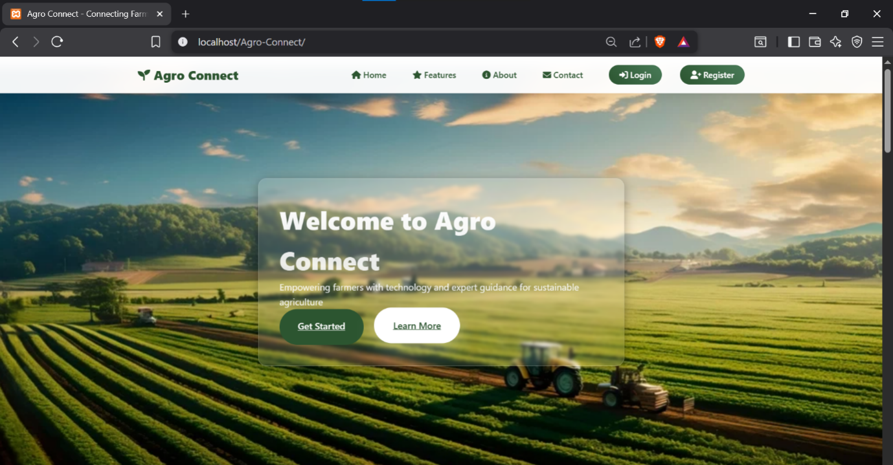

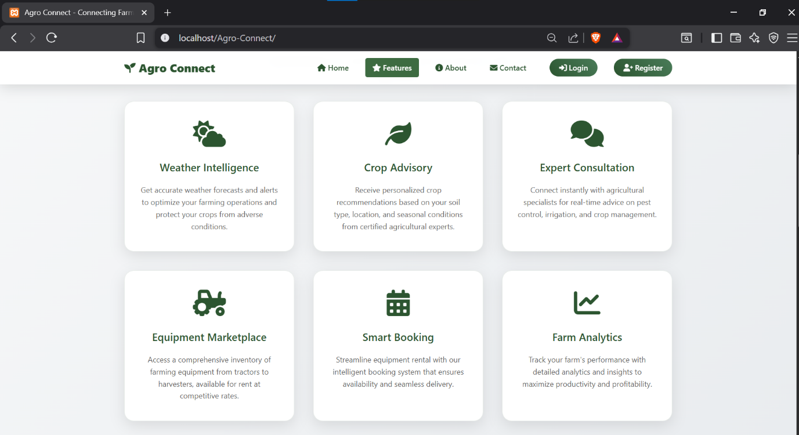
features.php

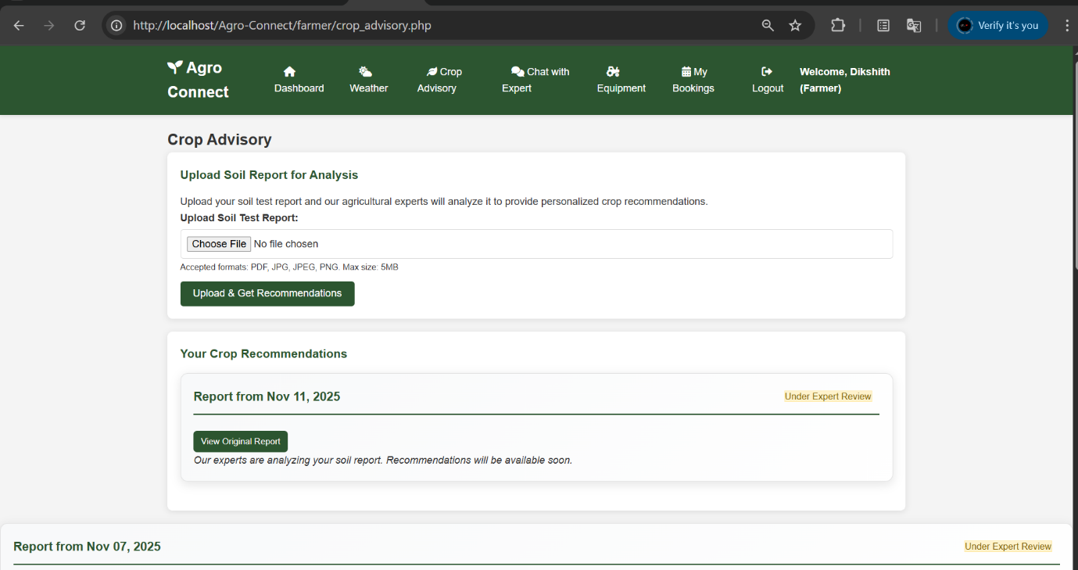
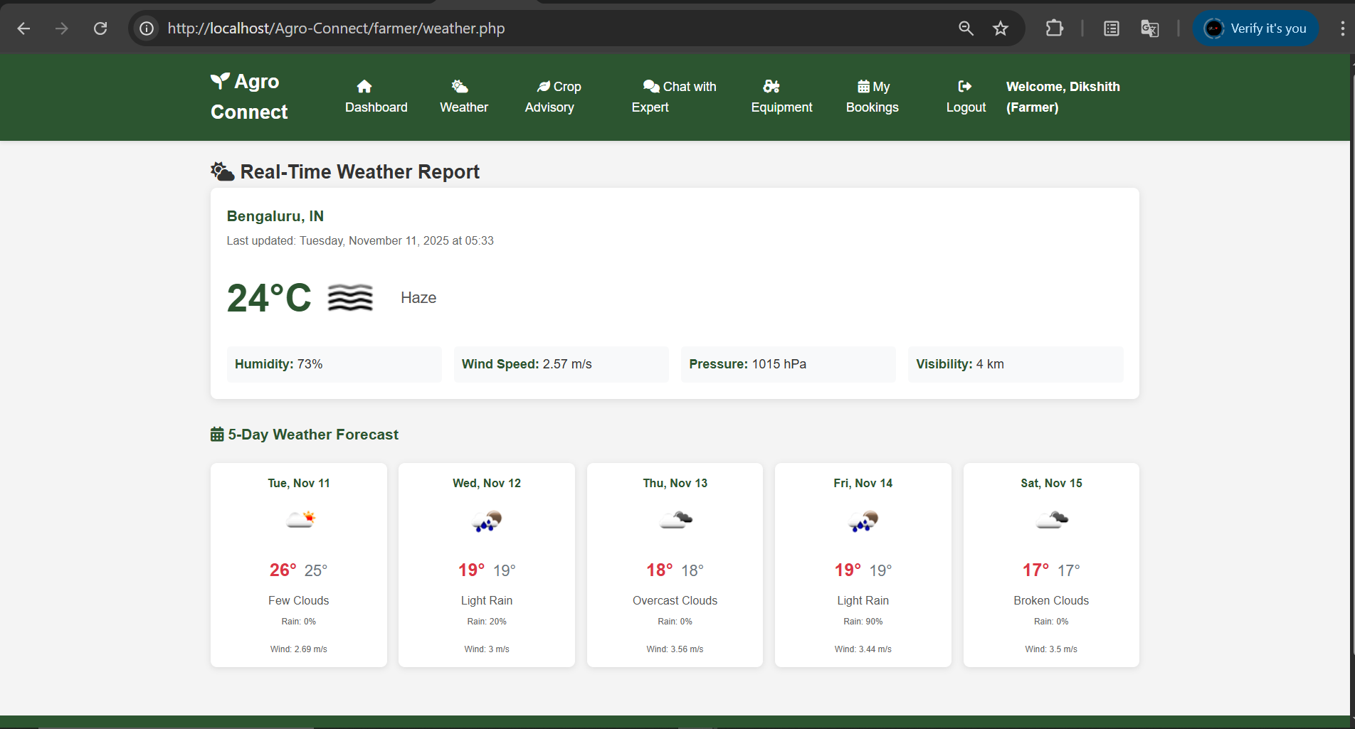
FARMER -ROLE
weather.php

crop_advisory.php
EXPERT-ROLE
dashboard.php
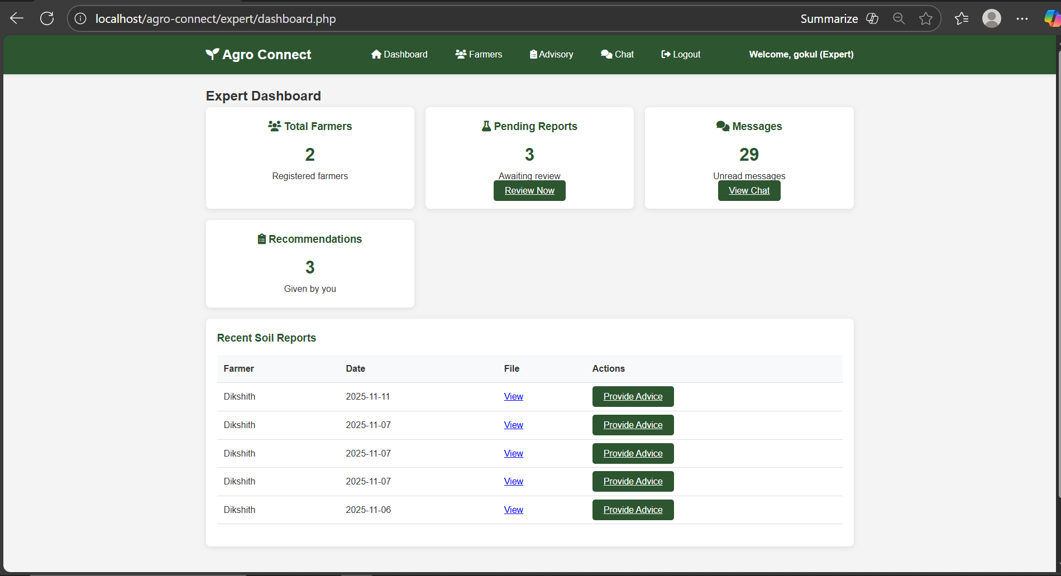

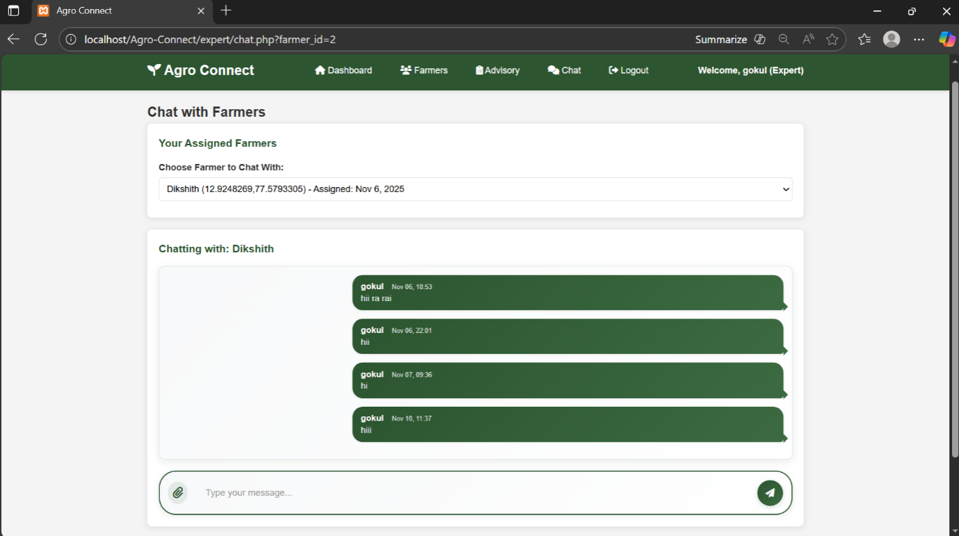
chat.php

ADMIN_ROLE

dashboard.php
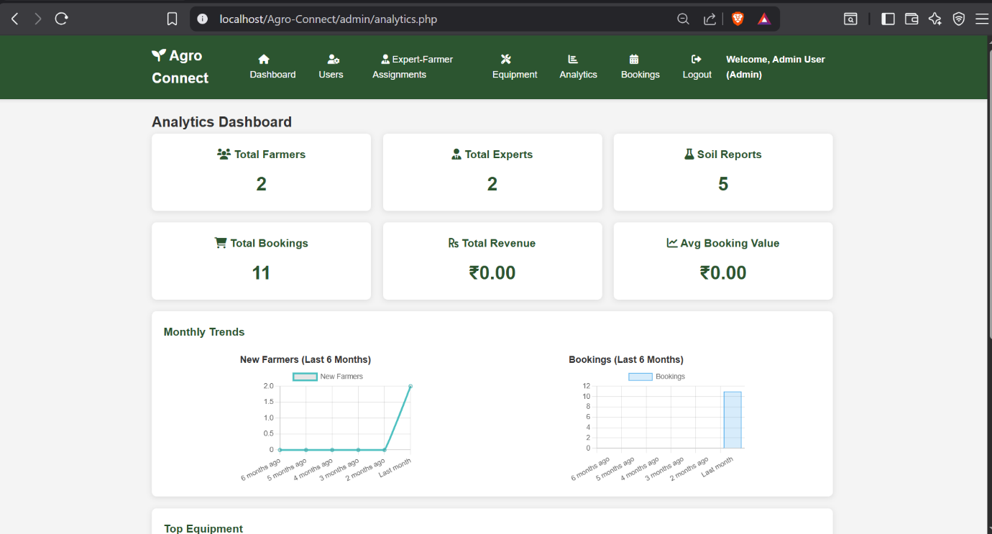

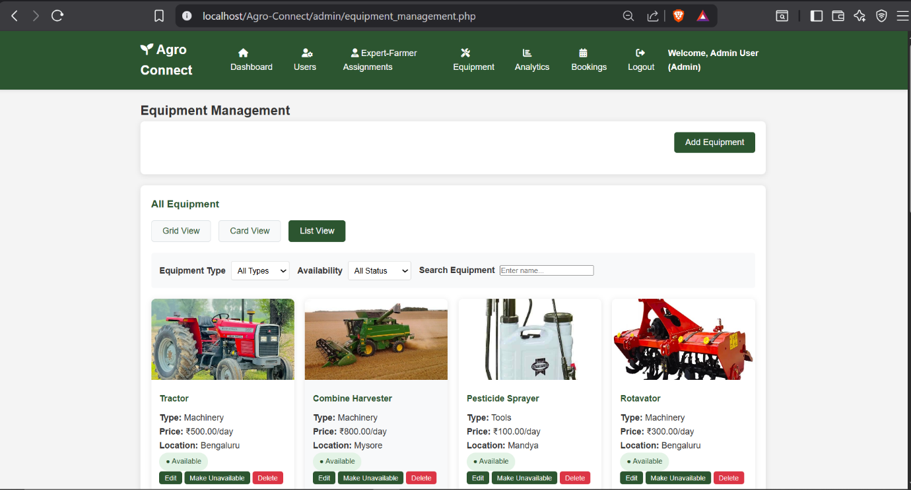
equipment_management.php
CONCLUSION

Agro Connect represents a significant advancement in agricultural technology, successfully addressing critical challenges faced by the farming community in India. The platform has demonstrated the potential of digital solutions to transform traditional agricultural practices through technology integration.
Key Accomplishments
- Unified Agricultural Ecosystem: Created a comprehensive platform integrating equipment rental, expert consultation, and crop advisory services.
- Enhanced Farmer Access: Provided farmers with unprecedented access to agricultural expertise and modern farming equipment.
- Expert Engagement: Established structured communication channels between farmers and certified agricultural specialists.
- Technological Innovation: Implemented modern web technologies with robust security measures and scalable architecture.
- User-Centric Design: Developed intuitive interfaces catering to users with varying levels of technical proficiency.
Impact Assessment
The platform has the potential to:
- Improve agricultural productivity through expert-guided farming practices
- Reduce equipment acquisition costs for small-scale farmers
- Enhance knowledge dissemination in rural agricultural communities
- Create sustainable income opportunities for agricultural experts
- Contribute to food security through optimized farming techniques
Future Enhancements
The modular architecture of Agro Connect allows for seamless integration of advanced features such as:
- Mobile application development
- AI-powered crop disease detection
- Weather API integration for precise forecasting
- IoT sensor integration for real-time farm monitoring
- Blockchain-based supply chain tracking
- Multi-language support for regional accessibility

Final Reflections
This project has successfully demonstrated how technology can bridge the gap between traditional agriculture and modern innovation. By creating Agro Connect, we have not only developed a functional platform but also established a foundation for future agricultural technology developments that can significantly impact rural livelihoods and agricultural sustainability.

BIBLIOGRAPHY

Web Technologies and Frameworks
- PHP Manual. PHP Documentation. Available at: https://www.php.net/manual/
- MySQL Reference Manual. MySQL Documentation. Available at: https://dev.mysql.com/doc/
- HTML5 Specification. World Wide Web Consortium (W3C). Available at: https://html.spec.whatwg.org/
- CSS3 Specification. World Wide Web Consortium (W3C). Available at: https://www.w3.org/TR/css-2018/

Development Tools
- Visual Studio Code Documentation. Microsoft. Available at: https://code.visualstudio.com/docs
- XAMPP Documentation. Apache Friends. Available at: https://www.apachefriends.org/docs/
- Git Documentation. Available at: https://git-scm.com/doc

Security and Best Practices
- OWASP Web Application Security Guidelines. Available at: https://owasp.org/www-project-top-ten/
- PHP Security Best Practices. PHP Documentation. Available at: https://www.php.net/manual/en/security.php

Agricultural Technology References
- Digital Agriculture: Trends and Challenges. FAO Publications. Available at: https://www.fao.org/publications/
- ICT in Agriculture: Connecting Smallholders to Knowledge Networks. World Bank. Available at: https://www.worldbank.org/en/topic/digital-development

Project Development Resources
- Font Awesome Icons. Available at: https://fontawesome.com/
- JavaScript MDN Web Docs. Mozilla Developer Network. Available at: https://developer.mozilla.org/en-US/docs/Web/JavaScript

