Introduction to Unified Modeling Language

"The Unified Modeling Language (UML) is a graphical language for visualizing,
specifying, constructing, and documenting the artifacts of a software-intensive system.
The UML offers a standard way to write a system's blueprints, including conceptual
things such as business processes and system functions as well as concrete things such
as programming language statements, database schemas, and reusable software
components."
The heart of object-oriented problem solving is the construction of a model. The model abstracts the essential details of the underlying problem from its usually complicated real world.
At the center of the UML are its nine kinds of modeling diagrams, which we describe here.
- Use case diagrams
- Class diagrams
- Object diagrams
- Sequence diagrams
- Collaboration diagrams
- Statechart diagrams
- Activity diagrams
- Component diagrams
- Deployment diagrams
UML gives everyone from business analyst to designer to programmer a common vocabulary to talk about software design.
The UML is applicable to object-oriented problem solving. Anyone interested in learning UML must be familiar with the underlying tenet of object-oriented problem solving -- it all begins with the construction of a model. A model is an abstraction of the underlying problem. The domain is the actual world from which the problem comes.
Models consist of objects that interact by sending each other messages. Think of an object as "alive." Objects have things they know (attributes) and things they can do (behaviors or operations). The values of an object's attributes determine its state.
Classes are the "blueprints" for objects. A class wraps attributes (data) and behaviors (methods or functions) into a single distinct entity. Objects are instances of classes.
The important point to note here is that UML is a 'language' for specifying and not a method or procedure. The UML is used to define a software system; to detail the artifacts in the system, to document and construct - it is the language that the blueprint is written in. The UML may be used in a variety of ways to support a software development methodology (such as the Rational Unified Process) - but in itself it does not specify that methodology or process
UML defines the notation and semantics for the following domains:
- The User Interaction or Use Case Model - describes the boundary and interaction between the system and users. Corresponds in some respects to a requirements model.
- The Interaction or Communication Model - describes how objects in the system will interact with each other to get work done.
- The State or Dynamic Model - State charts describe the states or conditions that classes assume over time. Activity graphs describe the workflows the system will implement.
- The Logical or Class Model - describes the classes and objects that will make up the system.
- The Physical Component Model - describes the software (and sometimes hardware components) that make up the system.
- The Physical Deployment Model - describes the physical architecture and the deployment of components on that hardware architecture.
The UML also defines extension mechanisms for extending the UML to meet specialized needs (for example Business Process Modeling extensions).

The Use Case Model

The Use Case Model describes the proposed functionality of the new system. A Use Case represents a discrete unit of interaction between a user (human or machine) and the system. A Use Case is a single unit of meaningful work; for example login to system, register with system and create order are all Use Cases. Each Use Case has a description, which describes the functionality that will be built in the proposed system. A Use Case may 'include' another Use Case's functionality or 'extend' another Use Case with its own behavior.
Use Cases are typically related to 'actors'. An actor is a human or machine entity that interacts with the system to perform meaningful work.
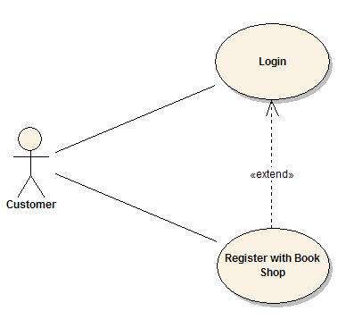
A Use Case description will generally include:
- General comments and notes describing the use case;
- Requirements - Things that the use case must allow the user to do, such as <ability to update order>, <ability to modify order> & etc.
- Constraints- Rules about what can and can't be done. Includes i) pre-conditions that must be true before the use case is run -e.g. <create order> must precede <modify order>; ii) post-conditions that must be true once the use case is run e.g. <order is modified and consistent>; iii) invariants: these are always true - e.g. an order must always have a customer number
- Scenarios - Sequential descriptions of the steps taken to carry out the use case. May include multiple scenarios, to cater for exceptional circumstances and alternate processing paths;
- Scenario diagrams -Sequence diagrams to depict the workflow - similar to (4) but graphically portrayed.
- Additional attributes such as implementation phase, version number, complexity rating, stereotype and status
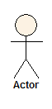
Actors
An Actor is a user of the system. This includes both human users and other computer systems. An Actor uses a Use Case to perform some piece of work, which is of value to the business. The set of Use Cases an actor has access to defines their overall role in the system and the scope of their action.
Requirements. These are the formal functional requirements that a Use Case must provide to the end user. They correspond to the functional specifications found in structured methodologies. A requirement is a contract that the Use Case will perform some action or provide some value to the system.
Constraints. These are the formal rules and limitations that a Use Case operates under, and includes pre- post- and invariant conditions. A pre-condition specifies what must have already occurred or be in place before the Use Case may start. A post-condition document what will be true once the Use Case is complete. An invariant specifies what will be true throughout the time the Use Case operates.
Scenarios. Scenarios are formal descriptions of the flow of events that occurs during a Use Case instance. These are usually described in text and correspond to a textual representation of the Sequence Diagram.
Includes and Extends relationships between Use Cases
One Use Case may include the functionality of another as part of its normal processing. Generally, it is assumed that the included Use Case will be called every time the basic path is run. An example may be to list a set of customer orders to choose from before modifying a selected order - in this case the <list orders> Use Case may be included every time the <modify order> Use Case is run.A Use Case may be included by one or more Use Cases, so it helps to reduce duplication of functionality by factoring out common behavior into Use Cases that are re-used many times.
One Use Case may extend the behavior of another - typically when exceptional circumstances are encountered. For example, if before modifying a particular type of customer order, a user must get approval from some higher authority, then the <get approval> Use Case may optionally extend the regular <modify order> Use Case.

Sequence Diagrams
UML provides a graphical means of depicting object interactions over time in Sequence Diagrams. These typically show a user or actor, and the objects and components they interact with in the execution of a use case. One sequence diagram typically represents a single Use Case 'scenario' or flow of events.
Sequence diagrams are an excellent way to document usage scenarios and to both capture required objects early in analysis and to verify object usage later in design. Sequence diagrams show the flow of messages from one object to another, and as such correspond to the methods and events supported by a class/object.
The diagram illustrated below shows an example of a sequence diagram, with the user or actor on the left initiating a flow of events and messages that correspond to the Use Case scenario. The messages that pass between objects will become class operations in the final model.
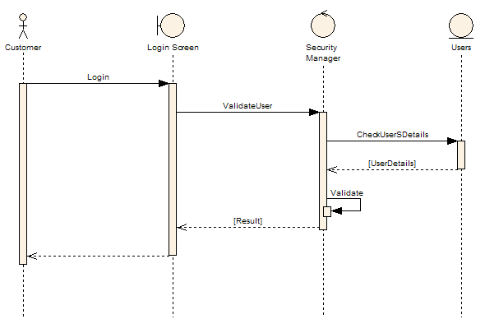
Implementation Diagram
A Use Case is a formal description of functionality the system will have when constructed. An implementation diagram is typically associated with a Use Case to document what design elements (eg. components and classes) will implement the Use Case functionality in the new system. This provides a high level of tractability for the system designer, the customer and the team that will actually build the system. The list of Use Cases that a component or class is linked to documents the minimum functionality that must be implemented by the component.
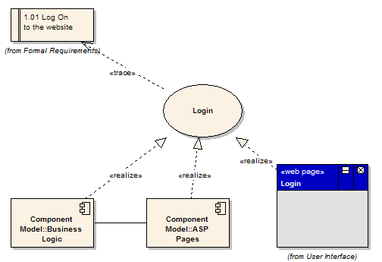
The example above shows that the Use Case "Login" implements the formal requirement "1.01 Log on to the website". It also states that the Business Logic component and ASP Pages component implement some or all of the Login functionality. A further refinement is to show the Login screen (a web page) as implementing the Login interface. These implementation or realization links define the tractability from the formal requirements, through Use Cases on to Components and Screens.

Use case diagrams describe what a system does from the standpoint of an external observer. The emphasis is on what a system does rather than how.
Use case diagrams are closely connected to scenarios. A scenario is an example of what happens when someone interacts with the system. Here is a scenario for a medical clinic.
"A patient calls the clinic to make an appointment for a yearly checkup. The receptionist finds the nearest empty time slot in the appointment book and schedules the appointment for that time slot. "

A use case is a summary of scenarios for a single task or goal. An actor is who or what initiates the events involved in that task. Actors are simply roles that people or objects play. The picture below is a Make Appointment use case for the medical clinic. The actor is a Patient. The connection between actor and use case is a communication association (or communication for short).
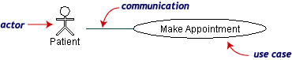
Actors are stick figures. Use cases are ovals. Communications are lines that link actors to use cases.
A use case diagram is a collection of actors, use cases, and their communications. We've put Make Appointment as part of a diagram with four actors and four use cases. Notice that a single use case can have multiple actors.
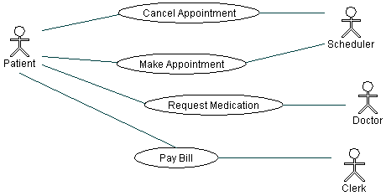
Use case diagrams are helpful in three areas.
determining features (requirements). New use cases often generate new requirements as the system is analyzed and the design takes shape.
Communicating with clients. Their notational simplicity makes use case diagrams a good way for developers to communicate with clients.
Generating test cases. The collection of scenarios for a use case may suggest a suite of test cases for those scenarios

Digging Deeper: Use Case Diagrams
Use case diagrams give an outsider's view of a system. Every use case diagram has actors, use cases, and communications. A simple use case diagram can be expanded with additional features to display more information.
This page covers the following UML™ use case features.
- System boundaries
- Generalizations
- Includes
- Extensions
The following use case diagram expands the original medical clinic diagram with additional features.

A system boundary rectangle separates the clinic system from the external actors.
A use case generalization shows that one use case is simply a special kind of another. Pay Bill is a parent use case and Bill Insurance is the child. A child can be substituted for its parent whenever necessary. Generalization appears as a line with a triangular arrowhead toward the parent use case.

Include relationships factor use cases into additional ones. Includes are especially helpful when the same use case can be factored out of two different use cases. Both Make Appointment and Request Medication include Check Patient Record as a subtask. In the diagram, include notation is a dotted line beginning at base use case ending with an arrows pointing to the include use case. The dotted line is labeled <<include>>.

An extend relationship indicates that one use case is a variation of another. Extend notation is a dotted line, labeled <<extend>>, and with an arrow toward the base case. The extension point, which determines when the extended case is appropriate, is written inside the base case.

