Unified Modeling Language
Table Of Contents
Contents Page No
Introduction to UML 3
Use Case Model 6
Logical Model 16
Dynamic Model 30
Component Model 44
Physical Model 50
UML Sample Modeling 53
UML 2 60
Some New UML 2 Diagrams 62

Introduction to Unified Modeling Language
The OMG specification states:
"The Unified Modeling Language (UML) is a graphical language for visualizing,
specifying, constructing, and documenting the artifacts of a software-intensive system.
The UML offers a standard way to write a system's blueprints, including conceptual
things such as business processes and system functions as well as concrete things such
as programming language statements, database schemas, and reusable software
components."
The heart of object-oriented problem solving is the construction of a model. The model abstracts the essential details of the underlying problem from its usually complicated real world. Several modeling tools are wrapped under the heading of the UML™, which stands for Unified Modeling Language™. The purpose of this course is to present important highlights of the UML.
At the center of the UML are its nine kinds of modeling diagrams, which we describe here.
- Use case diagrams
- Class diagrams
- Object diagrams
- Sequence diagrams
- Collaboration diagrams
- Statechart diagrams
- Activity diagrams
- Component diagrams
- Deployment diagrams
Some of the sections of this course contain links to pages with more detailed information. And every section has short questions. Use them to test your understanding of the section topic.
Why is UML important?
Let's look at this question from the point of view of the construction trade. Architects design buildings. Builders use the designs to create buildings. The more complicated the building, the more critical the communication between architect and builder. Blueprints are the standard graphical language that both architects and builders must learn as part of their trade.
Writing software is not unlike constructing a building. The more complicated the underlying system, the more critical the communication among everyone involved in creating and deploying the software. In the past decade, the UML has emerged as the software blueprint language for analysts, designers, and programmers alike. It is now part of the software trade. The UML gives everyone from business analyst to designer to programmer a common vocabulary to talk about software design.
The UML is applicable to object-oriented problem solving. Anyone interested in learning UML must be familiar with the underlying tenet of object-oriented problem solving -- it all begins with the construction of a model. A model is an abstraction of the underlying problem. The domain is the actual world from which the problem comes.
Models consist of objects that interact by sending each other messages. Think of an object as "alive." Objects have things they know (attributes) and things they can do (behaviors or operations). The values of an object's attributes determine its state.
Classes are the "blueprints" for objects. A class wraps attributes (data) and behaviors (methods or functions) into a single distinct entity. Objects are instances of classes.
The important point to note here is that UML is a 'language' for specifying and not a method or procedure. The UML is used to define a software system; to detail the artifacts in the system, to document and construct - it is the language that the blueprint is written in. The UML may be used in a variety of ways to support a software development methodology (such as the Rational Unified Process) - but in itself it does not specify that methodology or process
UML defines the notation and semantics for the following domains:
- | The User Interaction or Use Case Model - describes the boundary and interaction between the system and users. Corresponds in some respects to a requirements model.
- | The Interaction or Communication Model - describes how objects in the system will interact with each other to get work done.
- | The State or Dynamic Model - State charts describe the states or conditions that classes assume over time. Activity graphs describe the workflows the system will implement.
- | The Logical or Class Model - describes the classes and objects that will make up the system.
- | The Physical Component Model - describes the software (and sometimes hardware components) that make up the system.
- | The Physical Deployment Model - describes the physical architecture and the deployment of components on that hardware architecture.
The UML also defines extension mechanisms for extending the UML to meet specialized needs (for example Business Process Modeling extensions).

The Use Case Model

The Use Case Model describes the proposed functionality of the new system. A Use Case represents a discrete unit of interaction between a user (human or machine) and the system. A Use Case is a single unit of meaningful work; for example login to system, register with system and create order are all Use Cases. Each Use Case has a description, which describes the functionality that will be built in the proposed system. A Use Case may 'include' another Use Case's functionality or 'extend' another Use Case with its own behavior.
Use Cases are typically related to 'actors'. An actor is a human or machine entity that interacts with the system to perform meaningful work.
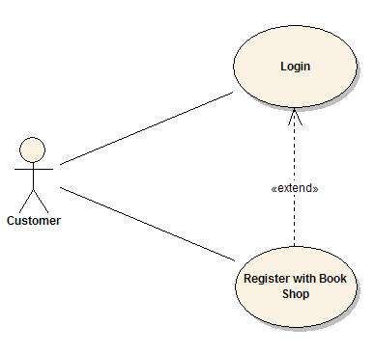
A Use Case description will generally include:
1. | General comments and notes describing the use case;
2. | Requirements - Things that the use case must allow the user to do, such as <ability to update order>, <ability to modify order> & etc.
3. | Constraints- Rules about what can and can't be done. Includes i) pre-conditions that must be true before the use case is run -e.g. <create order> must precede <modify order>; ii) post-conditions that must be true once the use case is run e.g. <order is modified and consistent>; iii) invariants: these are always true - e.g. an order must always have a customer number
4. | Scenarios - Sequential descriptions of the steps taken to carry out the use case. May include multiple scenarios, to cater for exceptional circumstances and alternate processing paths;
5. | Scenario diagrams -Sequence diagrams to depict the workflow - similar to (4) but graphically portrayed.
6. | Additional attributes such as implementation phase, version number, complexity rating, stereotype and status
Actors
An Actor is a user of the system. This includes both human users and other computer systems. An Actor uses a Use Case to perform some piece of work, which is of value to the business. The set of Use Cases an actor has access to defines their overall role in the system and the scope of their action.
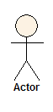
Constraints, Requirements and Scenarios
The formal specification of a Use Case includes:
1. | Requirements. These are the formal functional requirements that a Use Case must provide to the end user. They correspond to the functional specifications found in structured methodologies. A requirement is a contract that the Use Case will perform some action or provide some value to the system.
2. | Constraints. These are the formal rules and limitations that a Use Case operates under, and includes pre- post- and invariant conditions. A pre-condition specifies what must have already occurred or be in place before the Use Case may start. A post-condition document what will be true once the Use Case is complete. An invariant specifies what will be true throughout the time the Use Case operates.
3. | Scenarios. Scenarios are formal descriptions of the flow of events that occurs during a Use Case instance. These are usually described in text and correspond to a textual representation of the Sequence Diagram.

Includes and Extends relationships between Use Cases
One Use Case may include the functionality of another as part of its normal processing. Generally, it is assumed that the included Use Case will be called every time the basic path is run. An example may be to list a set of customer orders to choose from before modifying a selected order - in this case the <list orders> Use Case may be included every time the <modify order> Use Case is run.
A Use Case may be included by one or more Use Cases, so it helps to reduce duplication of functionality by factoring out common behavior into Use Cases that are re-used many times.
One Use Case may extend the behavior of another - typically when exceptional circumstances are encountered. For example, if before modifying a particular type of customer order, a user must get approval from some higher authority, then the <get approval> Use Case may optionally extend the regular <modify order> Use Case.

Sequence Diagrams
UML provides a graphical means of depicting object interactions over time in Sequence Diagrams. These typically show a user or actor, and the objects and components they interact with in the execution of a use case. One sequence diagram typically represents a single Use Case 'scenario' or flow of events.
Sequence diagrams are an excellent way to document usage scenarios and to both capture required objects early in analysis and to verify object usage later in design. Sequence diagrams show the flow of messages from one object to another, and as such correspond to the methods and events supported by a class/object.
The diagram illustrated below shows an example of a sequence diagram, with the user or actor on the left initiating a flow of events and messages that correspond to the Use Case scenario. The messages that pass between objects will become class operations in the final model.
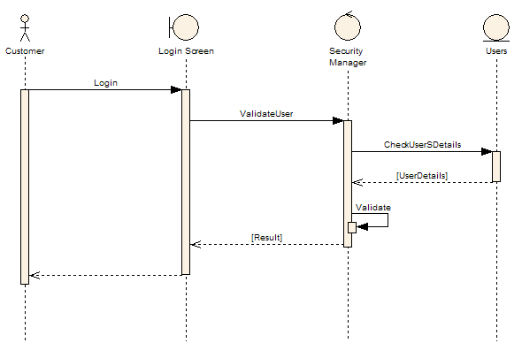
Implementation Diagram
A Use Case is a formal description of functionality the system will have when constructed. An implementation diagram is typically associated with a Use Case to document what design elements (eg. components and classes) will implement the Use Case functionality in the new system. This provides a high level of tractability for the system designer, the customer and the team that will actually build the system. The list of Use Cases that a component or class is linked to documents the minimum functionality that must be implemented by the component.
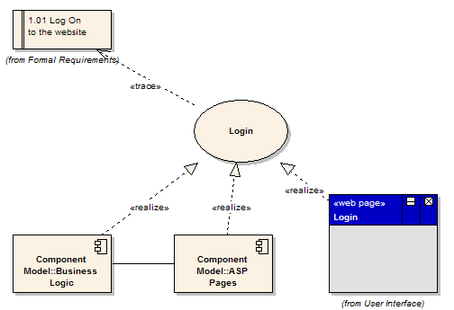
The example above shows that the Use Case "Login" implements the formal requirement "1.01 Log on to the website". It also states that the Business Logic component and ASP Pages component implement some or all of the Login functionality. A further refinement is to show the Login screen (a web page) as implementing the Login interface. These implementation or realization links define the tractability from the formal requirements, through Use Cases on to Components and Screens.
Use case diagrams describe what a system does from the standpoint of an external observer. The emphasis is on what a system does rather than how.
Use case diagrams are closely connected to scenarios. A scenario is an example of what happens when someone interacts with the system. Here is a scenario for a medical clinic.
"A patient calls the clinic to make an appointment for a yearly checkup. The receptionist finds the nearest empty time slot in the appointment book and schedules the appointment for that time slot. "
A use case is a summary of scenarios for a single task or goal. An actor is who or what initiates the events involved in that task. Actors are simply roles that people or objects play. The picture below is a Make Appointment use case for the medical clinic. The actor is a Patient. The connection between actor and use case is a communication association (or communication for short).
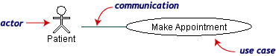
Actors are stick figures. Use cases are ovals. Communications are lines that link actors to use cases.
A use case diagram is a collection of actors, use cases, and their communications. We've put Make Appointment as part of a diagram with four actors and four use cases. Notice that a single use case can have multiple actors.
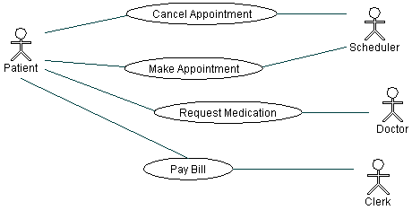
Use case diagrams are helpful in three areas.
determining features (requirements). New use cases often generate new requirements as the system is analyzed and the design takes shape.
Communicating with clients. Their notational simplicity makes use case diagrams a good way for developers to communicate with clients.
Generating test cases. The collection of scenarios for a use case may suggest a suite of test cases for those scenarios

Digging Deeper: Use Case Diagrams
Use case diagrams give an outsider's view of a system. Every use case diagram has actors, use cases, and communications. A simple use case diagram can be expanded with additional features to display more information.
This page covers the following UML™ use case features.
- System boundaries
- Generalizations
- Includes
- Extensions

Medical clinic diagram, expanded
The following use case diagram expands the original medical clinic diagram with additional features.
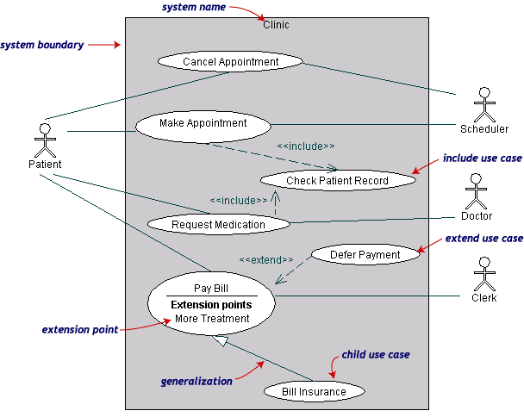
A system boundary rectangle separates the clinic system from the external actors.
A use case generalization shows that one use case is simply a special kind of another. Pay Bill is a parent use case and Bill Insurance is the child. A child can be substituted for its parent whenever necessary. Generalization appears as a line with a triangular arrowhead toward the parent use case.
Include relationships factor use cases into additional ones. Includes are especially helpful when the same use case can be factored out of two different use cases. Both Make Appointment and Request Medication include Check Patient Record as a subtask. In the diagram, include notation is a dotted line beginning at base use case ending with an arrows pointing to the include use case. The dotted line is labeled <<include>>.
An extend relationship indicates that one use case is a variation of another. Extend notation is a dotted line, labeled <<extend>>, and with an arrow toward the base case. The extension point, which determines when the extended case is appropriate, is written inside the base case.

The Logical Model

A logical model is a static view of the objects and classes that make up the design/analysis space. Typically, a Domain Model is a looser, high-level view of Business Objects and entities, while the Class Model is a more rigorous and design focused model. This discussion relates mainly to the Class Model
The Class Model
A Class is a standard UML construct used to detail the pattern from which objects will be produced at run-time. A class is a specification - an object an instance of a class. Classes may be inherited from other classes (that is they inherit all the behavior and state of their parent and add new functionality of their own), have other classes as attributes, delegate responsibilities to other classes and implement abstract interfaces.
The Class Model is at the core of object-oriented development and design - it expresses both the persistent state of the system and the behavior of the system. A class encapsulates state (attributes) and offers services to manipulate that state (behavior). Good object-oriented design limits direct access to class attributes and offers services, which manipulate attributes on behalf of the caller. This hiding of data and exposing of services ensures data updates are only done in one place and according to specific rules - for large systems the maintenance burden of code which has direct access to data elements in many places is extremely high.
The class is represented as below:
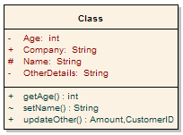

Note that the class has three distinct areas:
1. | The class name (and stereotype if applied)
2. | The class attributes area (that is internal data elements)
3. | The behavior - both private and public
Attributes and methods may be marked as
- | Private, indicating they are not visible to callers outside the class
- | Protected, they are only visible to children of the class
- | Public, they are visible to all
Class inheritance is shown as below: an abstract class in this case, is the parent of two children, each of which inherits the base class features and extends it with their own behavior.
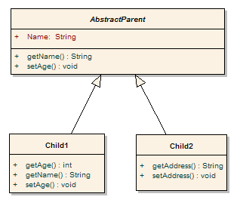
Class models may be collected into packages of related behavior and state. The diagram below illustrates this.
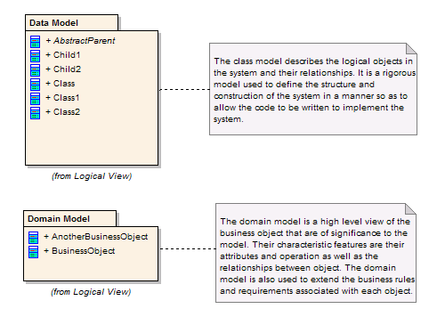

Class diagrams
A Class diagram gives an overview of a system by showing its classes and the relationships among them. Class diagrams are static -- they display what interacts but not what happens when they do interact.
The class diagrams below models a customer order from a retail catalog. The central class is the Order. Associated with it is the Customer making the purchase and the Payment. A Payment is one of three kinds: Cash, Check, or Credit. The order contains OrderDetails (line items), each with its associated Item.
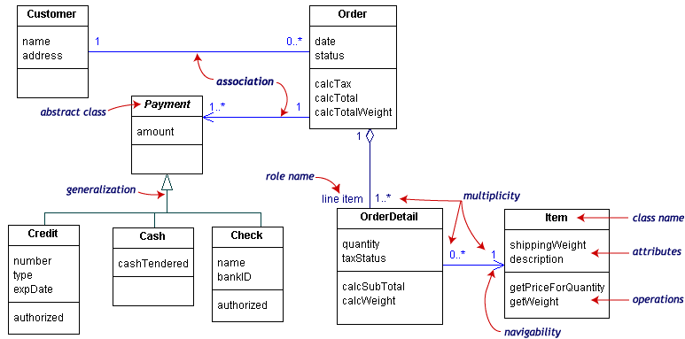
UML class notation is a rectangle divided into three parts: class name, attributes, and operations. Names of abstract classes, such as Payment, are in italics. Relationships between classes are the connecting links.
Our class diagram has three kinds of relationships.
Association -- a relationship between instances of the two classes. There is an association between two classes if an instance of one class must know about the other in order to perform its work. In a diagram, an association is a link connecting two classes.
Aggregation -- an association in which one class belongs to a collection. An aggregation has a diamond end pointing to the part containing the whole. In our diagram, Order has a collection of OrderDetails.
Generalization -- an inheritance link indicating one class is a super class of the other. A generalization has a triangle pointing to the superclass. Payment is a superclass of Cash, Check, and Credit.
An association has two ends. An end may have a role name to clarify the nature of the association. For example, an OrderDetail is a line item of each Order.
A navigability arrow on an association shows which direction the association can be traversed or queried. An OrderDetail can be queried about its Item, but not the other way around. The arrow also lets you know who "owns" the association's implementation; in this case, OrderDetail has an Item. Associations with no navigability arrows are bi-directional.
The multiplicity of an association end is the number of possible instances of the class associated with a single instance of the other end. Multiplicities are single numbers or ranges of numbers. In our example, there can be only one Customer for each Order, but a Customer can have any number of Orders.
This table gives the most common multiplicities.
Multiplicities | Meaning
0..1 | zero or one instance. The notation n. m indicates n to m instances.
0..* or * | No limit on the number of instances (including none).
1 | Exactly one instance
1..* | At least one instance
Every class diagram has classes, associations, and multiplicities. Navigability and roles are optional items placed in a diagram to provide clarity

Digging Deeper: Class Diagrams
All class diagrams have classes, links, and multiplicities. But a class diagram can show even more information. We've already looked at generalization, aggregation, and navigability. In this page, we will look at these additional items as well.
- Compositions
- Class member visibility and scope
- Dependencies and constraints
- Interfaces
Composition and Aggregation
Associations in which an object is part of a whole are aggregations. Composition is a strong association in which the part can belong to only one whole -- the part cannot exist without the whole. Composition is denoted by a filled diamond at the whole end.
This diagram shows that a BoxOffice belongs to exactly one MovieTheater. Destroy the MovieTheater and the BoxOffice goes away! The collection of Movies is not so closely bound to the MovieTheater.
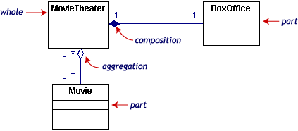
Class information: visibility and scope
The class notation is a 3-piece rectangle with the class name, attributes, and operations. Attributes and operations can be labeled according to access and scope. Here is a new, expanded Order class.
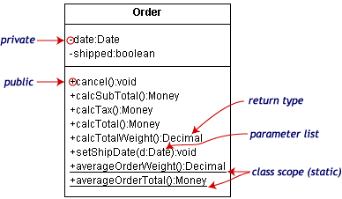
The illustration uses the following UML™ conventions.
- Static members are underlined. Instance members are not.
- The operations follow this form:
<access specifier> <name> ( <parameter list>) : <return type>
- The parameter list shows each parameter type preceded by a colon.
- Access specifiers appear in front of each member.
Symbol | Access
+ | public
- | private
# | protected
Dependencies and constraints
A dependency is a relation between two classes in which a change in one may force changes in the other. Dependencies are drawn as dotted lines. In the class diagram below, Co_op depends on Company. If you decide to modify Company, you may have to change Co_op too.

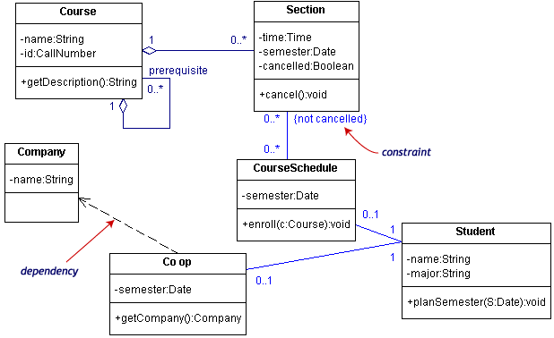
A constraint is a condition that every implementation of the design must satisfy. Constraints are written in curly braces { }. The constraint on our diagram indicates that a Section can be part of a CourseSchedule only if it is not canceled.

Interfaces and stereotypes

An interface is a set of operation signatures. In C++, interfaces are implemented as abstract classes with only pure virtual members. in Java, they're implemented directly.
The class diagram below is a model of a professional conference. The classes of interest to the conference are SessionTalk, which is a single presentation, and Session, which is a one-day collection of related SessionTalks. The ShuttleSchedule with its list of ShuttleStops is important to the attendees staying at remote hotels. The diagram has one constraint, that the ShuttleStops are ordered.
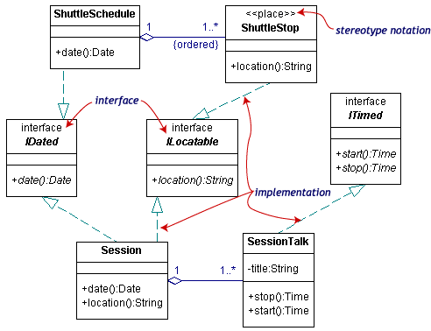
There are three interfaces in the diagram: IDated, ILocatable, and ITimed. The names of interfaces typically begin with the letter I. Interface names along with their (abstract) operations are written in italics.
A class such as ShuttleStop, with operations matching those in an interface, such as ILocatable, is an implementation (or realization) of the interface.
The ShuttleStop class node has the stereotype << place>>. Stereotypes, which provide a way of extending UML, are new kinds of model elements created from existing kinds. A stereotype name is written above the class name. Ordinary stereotype names are enclosed in guillemets, which look like pairs of angle-braces. An interface is a special kind of stereotype.
There are two acceptable notations for interfaces in the UML. The first is illustrated above. The second uses the lollipop or circle notation.
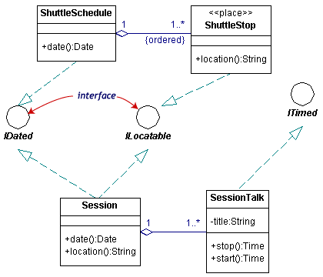
In circle notation, the interfaces are circles with lines connected to the implementing classes. Since it is more compact but leaves out some detail, the lollipop notation simplifies the original diagram.

Packages and object diagrams
To simplify complex class diagrams, you can group classes into packages. A package is a collection of logically related UML elements. The diagram below is a business model in which the classes are grouped into packages.
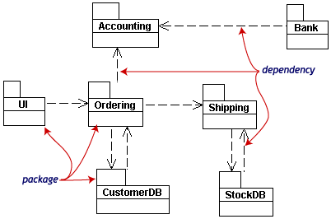
Packages appear as rectangles with small tabs at the top. The package name is on the tab or inside the rectangle. The dotted arrows are dependencies. One package depends on another if changes in the other could possibly force changes in the first.
Object diagrams show instances instead of classes. They are useful for explaining small pieces with complicated relationships, especially recursive relationships.
This small class diagram shows that a university Department can contain lots of other Departments.
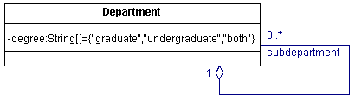
The object diagram below instantiates the class diagram, replacing it by a concrete example.
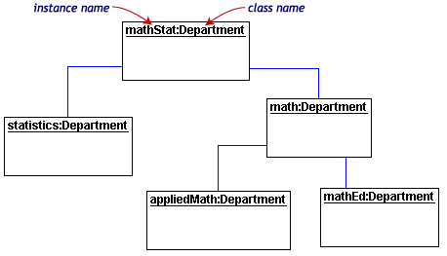
Each rectangle in the object diagram corresponds to a single instance. Instance names are underlined in UML diagrams. Class or instance names may be omitted from object diagrams as long as the diagram meaning is still clear.

The Dynamic Model
The dynamic model is used to express and model the behaviour of the system over time. It includes support for activity diagrams, state diagrams, sequence diagrams and extensions including business process Modeling.
Sequence Diagrams
Sequence diagrams are used to display the interaction between users, screens, objects and entities within the system. It provides a sequential map of message passing between objects over time. Frequently these diagrams are placed under Use Cases in the model to illustrate the use case scenario - how a user will interact with the system and what happens internally to get the work done. Often, the objects are represented using special stereotyped icons, as in the example below. The object labelled Login Screen is shown using the User Interface icon. The object labelled SecurityManager is shown using the Controller icon. The Object labelled users is shown using the Entity icon.
Activity Diagrams
Activity diagrams are used to show how different workflows in the system are constructed, how they start and the possibly many decision paths that can be taken from start to finish. They may also illustrate the where parallel processing may occur in the execution of some activities.
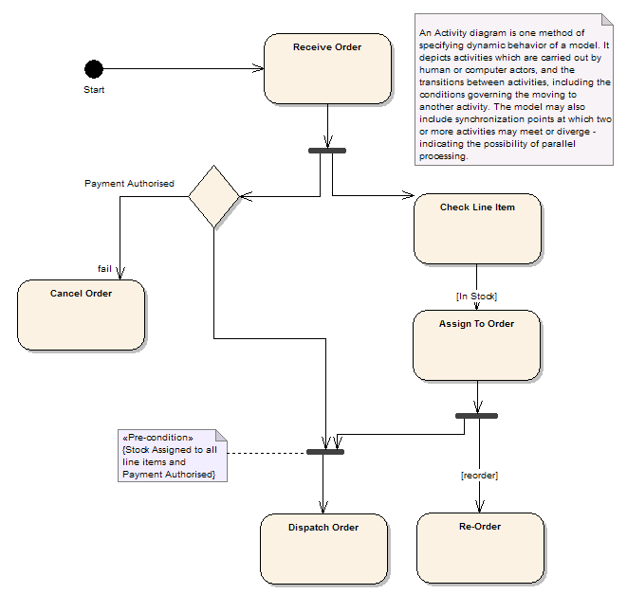
State Charts
State charts are used to detail the transitions or changes of state an object can go through in the system. They show how an object moves from one state to another and the rules that govern that change. State charts typically have a start and end condition.
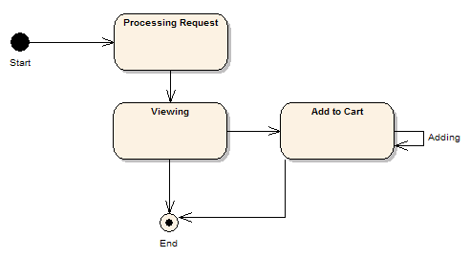
Process Model
A process model is a UML extension of an activity diagram used to model a business process - this diagram shows what goal the process has, the inputs, outputs, events and information that are involved in the process.
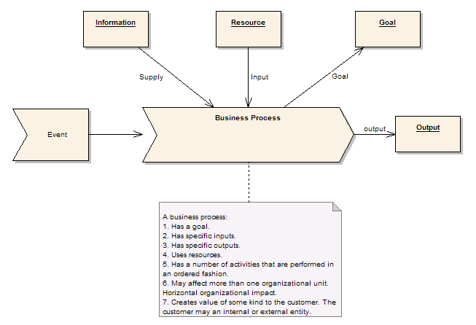

Sequence diagrams
Class and object diagrams are static model views. Interaction diagrams are dynamic. They describe how objects collaborate.
A sequence diagram is an interaction diagram that details how operations are carried out -- what messages are sent and when. Sequence diagrams are organized according to time. The time progresses as you go down the page. The objects involved in the operation are listed from left to right according to when they take part in the message sequence.
Below is a sequence diagram for making a hotel reservation. The object initiating the sequence of messages is a Reservation window.
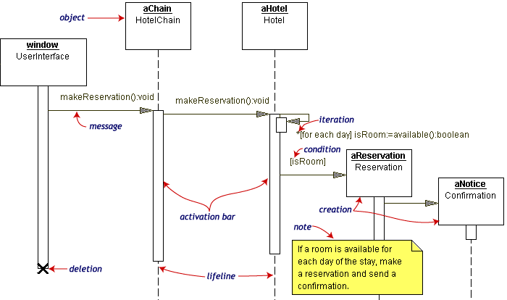
The Reservation window sends a makeReservation() message to a HotelChain. The HotelChain then sends a makeReservation() message to a Hotel. If the Hotel has available rooms, then it makes a Reservation and a Confirmation.
Each vertical dotted line is a lifeline, representing the time that an object exists. Each arrow is a message call. An arrow goes from the sender to the top of the activation bar of the message on the receiver's lifeline. The activation bar represents the duration of execution of the message.
In our diagram, the Hotel issues a self call to determine if a room is available. If so, then the Hotel creates a Reservation and a Confirmation. The asterisk on the self call means iteration (to make sure there is available room for each day of the stay in the hotel). The expression in square brackets, [ ], is a condition.
The diagram has a clarifying note, which is text inside a dog-eared rectangle. Notes can be put into any kind of UML diagram.
Collaboration diagrams
Collaboration diagrams are also interaction diagrams. They convey the same information as sequence diagrams, but they focus on object roles instead of the times that messages are sent. In a sequence diagram, object roles are the vertices and messages are the connecting links.
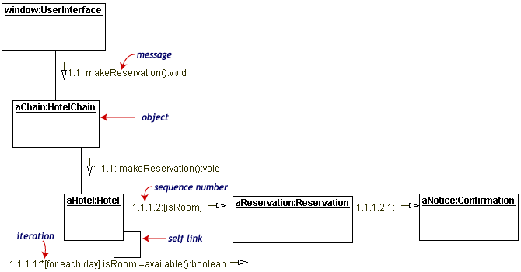
The object-role rectangles are labeled with either class or object names (or both). Class names are preceded by colons ( : ).
Each message in a collaboration diagram has a sequence number. The top-level message is numbered 1. Messages at the same level (sent during the same call) have the same decimal prefix but suffixes of 1, 2, etc. according to when they occur.

Statechart Diagrams
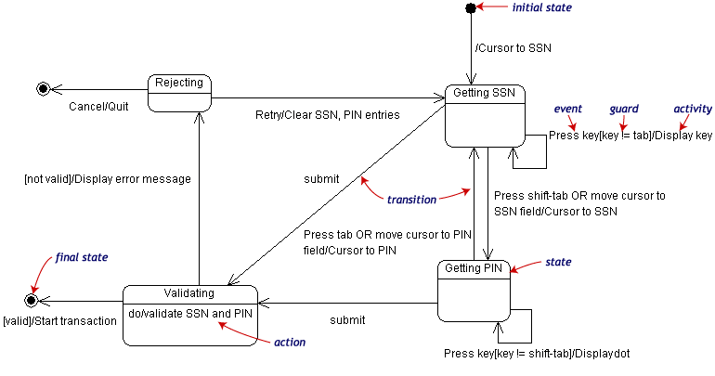
Objects have behaviors and state. The state of an object depends on its current activity or condition. A statechart diagram shows the possible states of the object and the transitions that cause a change in state.
Our example diagram models the login part of an online banking system. Logging in consists of entering a valid social security number and personal id number, then submitting the information for validation.
Logging in can be factored into four non-overlapping states: Getting SSN, Getting PIN, Validating, and Rejecting. From each state comes a complete set of transitions that determine the subsequent state.
States are rounded rectangles. Transitions are arrows from one state to another. Events or conditions that trigger transitions are written beside the arrows. Our diagram has two self-transition, one on Getting SSN and another on Getting PIN.
The initial state (black circle) is a dummy to start the action. Final states are also dummy states that terminate the action.
The action that occurs as a result of an event or condition is expressed in the form /action. While in its Validating state, the object does not wait for an outside event to trigger a transition. Instead, it performs an activity. The result of that activity determines its subsequent state.

Digging Deeper: Asynchronous or Concurrent Processes
Sequence diagrams, collaboration diagrams, activity diagrams, and statechart diagrams give dynamic views of a model. They let you look inside to the mechanism for action inside the model. Sequence diagrams and collaboration diagrams focus on the messages involved in completing a single process. Statechart diagrams focus attention on a single object. Activity diagrams focus on the flow of activities in performing a single task.
In this page, we will see how to how asynchronous or concurrent activities are modeled in sequence diagrams and state diagrams.

Sequence diagrams with asynchronous messages
A message is asynchronous if it allows its sender to send additional messages while the original is being processed. The timing of an asynchronous message is independent of the timing of the intervening messages.
The following sequence diagram illustrates the action of a nurse requesting a diagnostic test at a medical lab. There are two asynchronous messages from the Nurse: 1) ask the MedicalLab to reserve a date for the test and 2) ask the InsuranceCompany to approve the test. The order in which these messages are sent or completed is irrelevant. If the InsuranceCompany approves the test, then the Nurse will schedule the test on the date supplied by the MedicalLab.
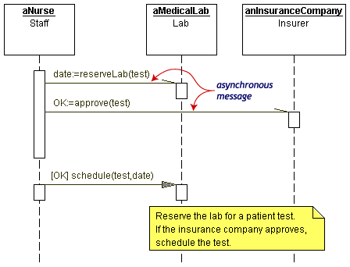
The UML™ uses the following message conventions.
Symbol | Meaning
 | simple message which may be synchronous or asynchronous
 | simple message return (optional)
 | a synchronous message
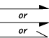 | an asynchronous message

Concurrency and asynchronization in statechart diagrams

States in statechart diagrams can be nested. Related states can be grouped together into a single composite state. Nesting states is necessary when an activity involves concurrent or asynchronous subactivities.
The following statechart diagram models an auction with two concurrent threads leading into two substates of the composite state Auction: Bidding and Authorizing Credit. Bidding itself is a composite state with three substates. Authorizing Credit has two substates.
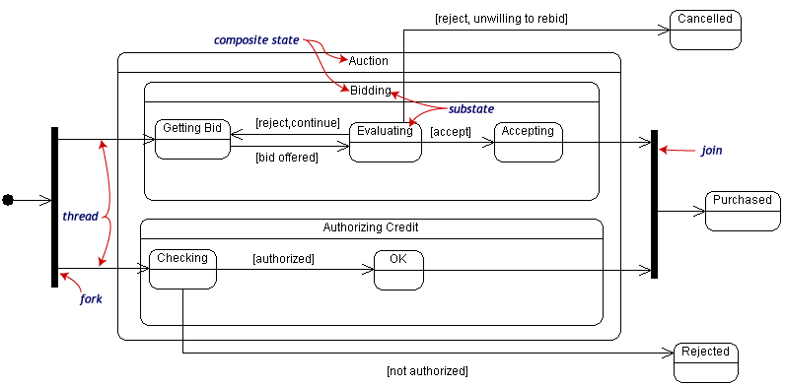
Entering the Auction requires a fork at the start into two separate threads. Unless there is an abnormal exit (Cancelled or Rejected), the exit from the Auction composite state occurs when both substates have exited.

Activity diagrams
An activity diagram is essentially a fancy flowchart. Activity diagrams and statechart diagrams are related. While a statechart diagram focuses attention on an object undergoing a process (or on a process as an object), an activity diagram focuses on the flow of activities involved in a single process. The activity diagram shows the how those activities depend on one another.
For our example, we used the following process.
"Withdraw money from a bank account through an ATM."
The three involved classes (people, etc.) of the activity are Customer, ATM, and Bank. The process begins at the black start circle at the top and ends at the concentric white/black stop circles at the bottom. The activities are rounded rectangles.
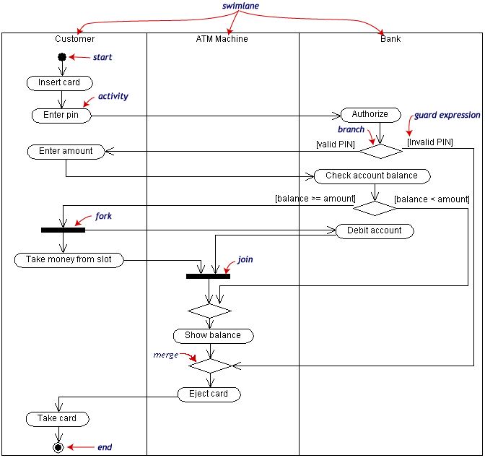
Activity diagrams can be divided into object swimlanes that determine which object is responsible for which activity. A single transition comes out of each activity, connecting it to the next activity.
A transition may branch into two or more mutually exclusive transitions. Guard expressions (inside [ ]) label the transitions coming out of a branch. A branch and its subsequent merge marking the end of the branch appear in the diagram as hollow diamonds.
A transition may fork into two or more parallel activities. The fork and the subsequent join of the threads coming out of the fork appear in the diagram as solid bars.

The Component Model

The component model illustrates the software components that will be used to build the system. These may be built up from the class model and written from scratch for the new system, or may be brought in from other projects and 3rd party vendors. Components are high level aggregations of smaller software pieces, and provide a 'black box' building block approach to software construction.
Component Notation
A component may be something like an ActiveX control - either a user interface control or a business rules server. Components are drawn as the following diagram shows:
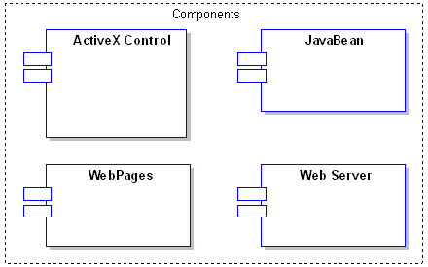
The Component Diagram
The component diagram shows the relationship between software components, their dependencies, communication, location and other conditions.
Interfaces
Components may also expose interfaces. These are the visible entry points or services that a component is advertising and making available to other software components and classes. Typically a component is made up of many internal classes and packages of classes. It may even be assembled from a collection of smaller components.
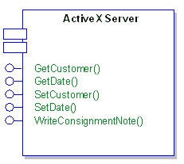

Components and Nodes
A deployment diagram illustrates the physical deployment of the system into a production (or test) environment. It shows where components will be located, on what servers, machines or hardware. It may illustrate network links, LAN bandwidth & etc.
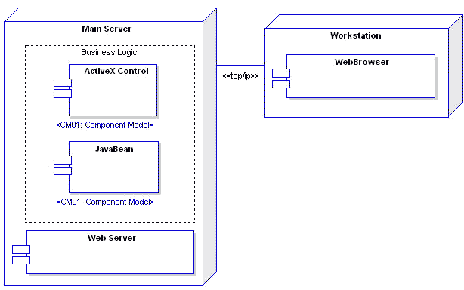
Requirements
Components may have requirements attached to indicate their contractual obligations - that is, what service they will provide in the model. Requirements help document the functional behaviour of software elements.
Constraints
Components may have constraints attached which indicate the environment in which they operate. Pre-conditions specify what must be true before a component can perform some function; post-conditions indicate what will be true after a component has done some work and Invariants specify what must remain true for the duration of the components lifetime.
Scenarios
Scenarios are textual/procedural descriptions of an objects actions over time and describe the way in which a component works. Multiple scenarios may be created to describe the basic path (a perfect run through) as well as exceptions, errors and other conditions.
Traceability
You may indicate traceability through realisation links. A component may implement another model element (eg. a use case) or a component may be implemented by another element (eg. a package of classes). By providing realisation links to and from components you can map the dependencies amongst model elements and the traceability from the initial requirements to the final implementation.
An Example
The following example shows how components may be linked to provide a conceptual/logical view of a systems construction. This example is concerned with the server and security elements of an on-line book store. It includes such elements as the web server, firewall, ASP pages & etc.
Server Components
This diagram illustrates the layout of the main server side components that will require building for an on-line book store. These components are a mixture of custom built and purchased items which will be assembled to provide the required functionality.
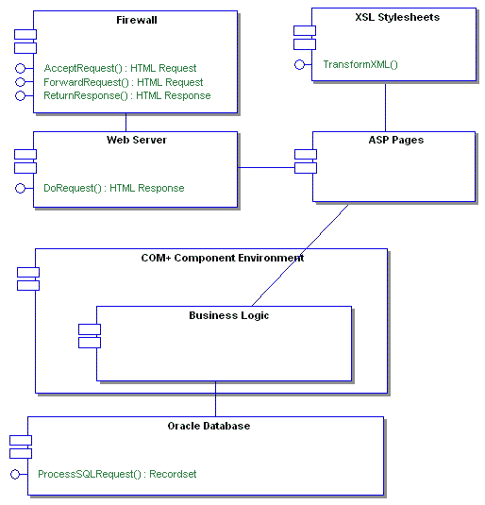
Security Components
The security components diagram shows how security software such as the Certificate Authority, Browser, Web server and other model elements work together to assure security provisions in the proposed system.
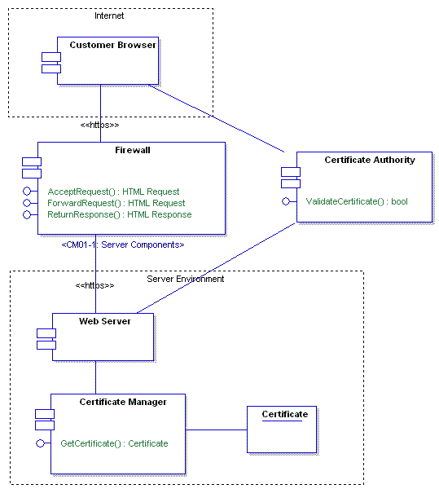

The Physical Model

The Physical/Deployment Model provides a detailed model of the way components will be deployed across the system infrastructure. It details network capabilities, server specifications, hardware requirements and other information related to deploying the proposed system.
Deployment View
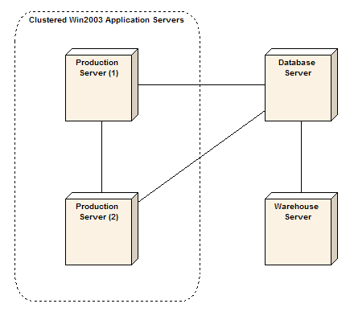
PM01: Physical Model
The physical model shows where and how system components will be deployed. It is a specific map of the physical layout of the system. A deployment diagram illustrates the physical deployment of the system into a production (or test) environment. It shows where components will be located, on what servers, machines or hardware. It may illustrate network links, LAN bandwidth & etc.
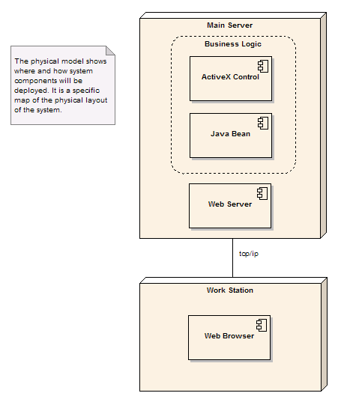

Component and deployment diagrams
A component is a code module. Component diagrams are physical analogs of class diagram. Deployment diagrams show the physical configurations of software and hardware.
The following deployment diagram shows the relationships among software and hardware components involved in real estate transactions.
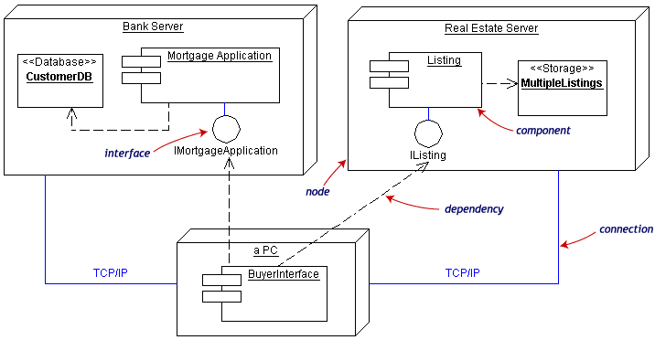
The physical hardware is made up of nodes. Each component belongs on a node. Components are shown as rectangles with two tabs at the upper left.

UML Tutorial - Part2 Sample Modeling

We have established in Part 1 that the UML is a language for specifying the artifacts and interactions of a software system. We have also seen that it deals with 6 major domains - from Use Case models, through dynamic and logical models to the final physical deployment model - and that extension mechanisms have been included to allow for specialised additions to the model notation.
So... How do you use the UML?
The UML is typically used as a part of a software development process, with the support of a suitable CASE tool, to define the requirements, the interactions and the elements of the proposed software system. The exact nature of the process depends on the development methodology used. An example process might look something like the following:
1. | Capture a Business Process Model. This will be used to define the high level business activities and processes that occur in an organization and to provide a foundation for the Use Case model. The Business Process Model will typically capture more than a software system will implement (ie. it includes manual and other processes).
2. | Map a Use Case Model to the Business Process Model to define exactly what functionality you are intending to provide from the business user perspective. As each Use Case is added, create a traceable link from the appropriate business processes to the Use Case (ie. a realisation connection). This mapping clearly states what functionality the new system will provide to meet the business requirements outlined in the process model. It also ensures no Use Cases exist without a purpose.
3. | Refine the Use Cases - include requirements, constraints, complexity rating, notes and scenarios. This information unambiguously describes what the Use Case does, how it is executed and the constraints on its execution. Make sure the Use Case still meets the business process requirements. Include the definition of system tests for each use case to define the aceptance criteria for each use case. Also include some user acceptance test scripts to define how the user will test this functionality and what the acceptance criteria are.
4. | From the inputs and outputs of the Business Process Model and the details of the use cases, begin to construct a domain model (high level business objects), sequence diagrams, collaboration diagrams and user interface models. These describe the 'things' in the new system, the way those things interact and the interface a user will use to execute use case scenarios.
5. | From the domain model, the user interface model and the scenario diagrams create the Class Model. This is a precise specification of the objects in the system, their data or attributes and their behaviour or operations. Domain objects may be abstracted into class hierarchies using inheritance. Scenario diagram messages will typically map to class operations. If an existing framework or design pattern is to be used, it may be possible to import existing model elements for use in the new system. For each class define unit tests and integration tests to thoroughly test i) that the class functions as specified internally and that ii) the class interacts with other related classes and components as expected.
6. | As the Class Model develops it may be broken into discrete packages and components. A component represents a deployable chunk of software that collects the behaviour and data of one or more classes and exposes a strict interface to other consumers of its services. So from the Class Model a Component Model is built to define the logical packaging of classes. For each component define integration tests to confirm that the component's interface meets the specifcation given it in relation to other software elements.
7. | Concurrent with the work you have already done, additional requirements should have been captured and documented. For example - Non Functional requirements, Performance requirements, Security requirements, responsibilities, release plans & etc. Collect these within the model and keep up to date as the model matures.
8. | The Deployment model defines the physical architecture of the system. This work can be begun early to capture the physical deployment characteristics - what hardware, operating systems, network capabilities, interfaces and support software will make up the new system, where it will be deployed and what parameters apply to disaster recovery, reliability, back-ups and support. As the model develops the physical architecture will be updated to reflect the actual system being proposed.
9. | Build the system: Take discrete pieces of the model and assign to one or more developers. In a Use Case driven build this will mean assigning a Use Case to the development team, having them build the screens, business objects, database tables, and related components necessary to execute that Use Case. As each Use Case is built it should be accompanied by completed unit, integration and system tests. A Component driven build may see discrete software components assigned to development teams for construction.
10. | Track defects that emerge in the testing phases against the related model elements - eg. System test defects against Use Cases, Unit Test defects against classes & etc. Track any changes against the related model elements to manage 'scope creep'.
11. | Update and refine the model as work proceeds - always assessing the impact of changes and model refinements on later work. Use an iterative approach to work through the design in discrete chunks, always assessing the current build, the forward requirements and any discoveries that come to light during development.
12. | Deliver the complete and tested software into a test then production environment. If a phased delivery is being undertaken, then this migration of built software from test to production may occur several times over the life of the project.
Note that the above process is necessarily brief in description, leaves much unsaid and may not be how you work or follow the process you have adopted. It is given as an example of how the UML may be used to support a software development project.

The Business Process Model

An introduction to the terminology and icons used in the Business Process Model. Provides a quick introduction to some Unified Modeling Language (UML) concepts and how they are applied in Enterprise Architect's Business Process Model.
A business process:
1. | Has a Goal
2. | Has specific inputs
3. | Has specific outputs
4. | Uses resources
5. | Has a number of activities that are performed in some order
6. | May affect more than one organizational unit. Horizontal organizational impact
7. | Creates value of some kind for the customer. The customer may be internal or external.
Process Models
Business Process:
A business process is a collection of activities designed to produce a specific output for a particular customer or market. It implies a strong emphasis on how the work is done within and organization, in contrast to a product's focus on what. A process is thus a specific ordering of work activities across time and place, with a beginning, an end, and clearly defined inputs and outputs: a structure for action.
Connections
• | Supply link from object Information. A supply link indicates that the information or object linked to the process is not used up in the processing phase. For example, order templates may be used over and over to provide new orders of a certain style - the templates are not altered or exhausted as part of this activity.
• | Supply link from object Resource. An input link indicates that the attached object or resource is consumed in the processing procedure. As an example, as customer orders are processed they are completed and signed off, and typically are used only once per unique resource (order).
• | Goal link to object Goal. A goal link indicates the attached object to the business process describes the goal of the process. A goal is the business justification for performing the activity.
• | Stateflow link to object Output
• | Stateflow link from event Event. A stateflow link indicates some object is passed into a business process. It captures the passing of control to another entity or process, with the implied passing of state or information from activity to activity.
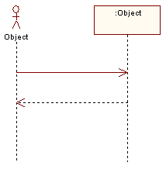
Figure 1 : Workflow
Goal
Object:
A business process has some well defined goal. This is the reason the organization does this work, and should be defined in terms of the benefits this process has for the organization as a whole and in satisfying the business needs.
Connections
Goal link from activity Business Process. A goal link indicates the attached object to the business process describes the goal of the process. A goal is the business justification for performing the activity.
Information
Object:
Business processes use information to tailor or complete their activities. Information, unlike resources, is not consumed in the process - rather it is used as part of the transformation process. In formation may come from external sources, from customers, from internal organizational units and may even be the product of other processes.
Connections
Supply link to activity Business Process. A supply link indicates that the information or object linked to the process is not used up in the processing phase. For example, order templates may be used over and over to provide new orders of a certain style - the templates are not altered or exhausted as part of this activity.
Output
Object:
A business process will typically produce one or more outputs of value to the business, either for internal use of to satisfy external requirements. An output may be a physical object (such as a report or invoice), a transformation of raw resources into a new arrangement (a daily schedule or roster) or an overall business result such as completing a customer order.
An output of one business process may feed into another process, either as a requested item or a trigger to initiate new activities.
Connections
Stateflow link from activity Business Process
Resource
Object:
A resource is an input to a business process, and, unlike information, is typically consumed during the processing. For example, as each daily train service is run and actuals recorded, the service resource is 'used up' as far as the process of recording actual train times is concerned.
Connections
Supply link to activity Business Process. An input link indicates that the attached object or resource is consumed in the processing procedure. As an example, as customer orders are processed they are completed and signed off, and typically are used only once per unique resource (order

UML 2 Tutorial

UML 2 builds on the already highly successful UML 1.x standard, which has become an industry standard for modeling, design and construction of software systems as well as more generalized business and scientific processes.

UML 2 defines 13 basic diagram types, divided into two general sets:
1. Structural Modeling Diagrams
Structure diagrams define the static architecture of a model. They are used to model the 'things' that make up a model - the classes, objects, interfaces and physical components. In addition they are used to model the relationships and dependencies between elements.
- | Package diagrams are used to divide the model into logical containers or 'packages' and describe the interactions between them at a high level
- | Class or Structural diagrams define the basic building blocks of a model: the types, classes and general materials that are used to construct a full model
- | Object diagrams show how instances of structural elements are related and used at run-time.
- | Composite Structure diagrams provide a means of layering an element's structure and focusing on inner detail, construction and relationships
- | Component diagrams are used to model higher level or more complex structures, usually built up from one or more classes, and providing a well defined interface
- | Deployment diagrams show the physical disposition of significant artefacts within a real-world setting.

2. Behavioral Modeling Diagrams
Behavior diagrams capture the varieties of interaction and instantaneous state within a model as it 'executes' over time.
- | Use Case diagrams are used to model user/system interactions. They define behavior, requirements and constraints in the form of scripts or scenarios
- | Activity diagrams have a wide number of uses, from defining basic program flow, to capturing the decision points and actions within any generalized process
- | State Machine diagrams are essential to understanding the instant to intant condition or "run state" of a model when it executes
- | Communication diagrams show the network and sequence of messages or communications between objects at run-time during a collaboration instance
- | Sequence diagrams are closely related to Communication diagrams and show the sequence of messages passed between objects using a vertical timeline
- | Timing diagrams fuse Sequence and State diagrams to provide a view of an object's state over time and messages which modify that state
- | Interaction Overview diagrams fuse Activity and Sequence diagrams to provide allow interaction fragments to be easily combined with decision points and flows

Some new diagrams of UML 2
UML 2 Composite Structure Diagram

Composite Diagrams
A composite structure diagram is a diagram that shows the internal structure of a classifier, including its interaction points to other parts of the system. It shows the configuration and relationship of parts that together perform the behaviour of the containing classifier.
Class elements have been described in great detail in the section on class diagrams. This section describes the way that classes can be displayed as composite elements exposing interfaces and containing ports and parts.
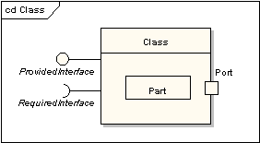
Part
A part is an element that represents a set of one or more instances which is owned by a containing classifier instance. So for example, if a diagram instance owned a set of graphical elements, then the graphical elements could be represented as parts, if it were useful to do so to model some kind of relationship between them. Note that a part can be removed from its parent before the parent is deleted, so that the part isn’t deleted at the same time.
A part is shown as an unadorned rectangle contained within the body of a class or component element.
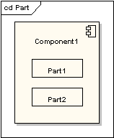
Port
A port is a typed element that represents an externally visible part of a containing classifier instance. Ports define the interaction between a classifier and its environment. A port can appear on the boundary of a contained part, a class or a composite structure. A port may specify the services a classifier provides as well as the services that it requires of its environment.
A port is shown as a named rectangle on the boundary edge of its owning classifier.
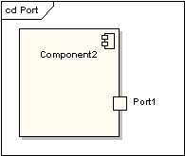
Interfaces
An interface is similar to a class but with a number of restrictions. All interface operations are public and abstract, and do not provide any default implementation. All interface attributes must be constants. However, while a class may only inherit from a single super-class, it may implement multiple interfaces.
An interface, when standing alone in a diagram, is either shown as a class element rectangle with the «interface» keyword and with its name italicised to denote it is abstract, or it is shown as a circle.
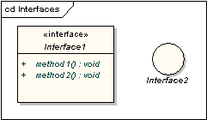
Note that the circle notation does not show the interface operations. When interfaces are shown as being owned by classes, they are referred to as exposed interfaces. An exposed interface can be defined as either provided or required. A provided interface is an affirmation that the containing classifier supplies the operations defined by the named interface element and is defined by drawing a realisation link between the class and the interface. A required interface is a statement that the classifier is able to communicate with some other classifier which provides operations defined by the named interface element and is defined by drawing a dependency link between the class and the interface.
A provided interface is shown as a “ball on a stick” attached to the edge of a classifier element. A required interface is shown as a “cup on a stick” attached to the edge of a classifier element.
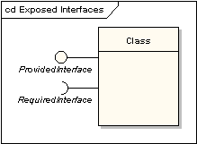
Delegate
A delegate connector is used for defining the internal workings of a component’s external ports and interfaces. A delegate connector is shown as an arrow with a «delegate» stereotype. It connects an external contract of a component as shown by its ports to the internal realisation of the behaviour of the component’s part.
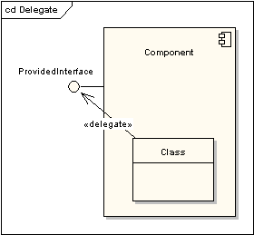
Collaboration
A collaboration defines a set of co-operating roles used collectively to illustrate a specific functionality. A collaboration should only show the roles and attributes required to accomplish its defined task or function. Isolating the primary roles is an exercise in simplifying the structure and clarifying the behaviour, and also provides for re-use. A collaboration often implements a pattern.
A collaboration element is shown as an ellipse.
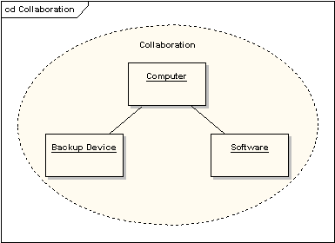
Role Binding
A role binding connector is drawn from collaboration to the classifier that fulfils the role. It is shown as a dashed line with arrowhead and the stereotype «role binding».
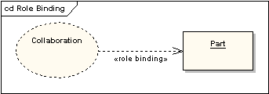
Represents
A represents connector may be drawn from collaboration to a classifier to show that a collaboration is used in the classifier. It is shown as a dashed line with arrowhead and the stereotype «represents».
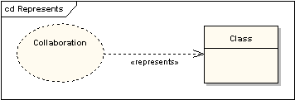

Occurrence
An occurrence connector may be drawn from a collaboration to a classifier to show that a collaboration represents(sic) the classifier. It is shown as a dashed line with arrowhead and the stereotype «occurrence».
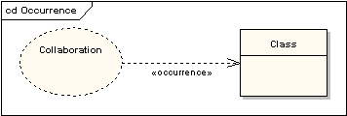

UML 2 Communication Diagram

Communication Diagrams
A communication diagram, formerly called a collaboration diagram, is an interaction diagram that shows similar information to sequence diagrams but its primary focus in on object relationships.
On communication diagrams, objects are shown with association connectors between them. Messages are added to the associations and show as short arrows pointing in the direction of the message flow. The sequence of messages is shown through a numbering scheme.
The following two diagrams show a communication diagram and the sequence diagram that shows the same information. Although it is possible to derive the sequencing of messages in the communication diagram from the numbering scheme, it isn’t immediately visible. What the communication diagram does show quite clearly though is the full set of messages passed between adjacent objects.
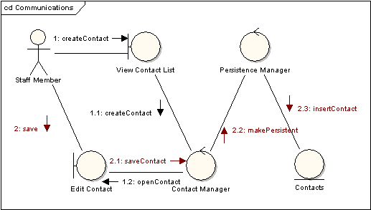
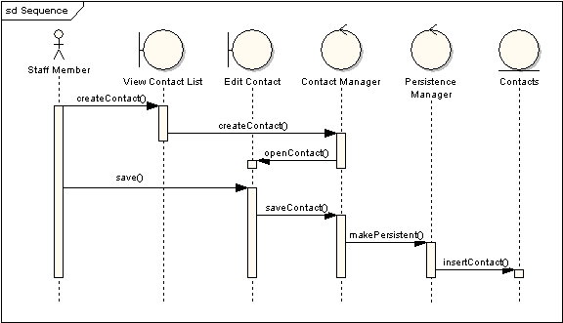

UML 2 Timing Diagram

Timing Diagrams
UML timing diagrams are used to display the change in state or value of one or more elements over time. It can also show the interaction between timed events and the time and duration constraints that govern them.
State Lifeline
A state lifeline shows the change of state of an item over time. The X-axis displays elapsed time in whatever units are chosen while the Y-axis is labelled with a given list of states. A state lifeline is shown below.
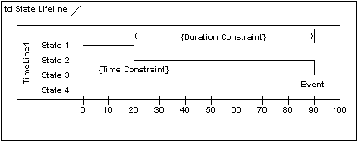
Value Lifeline
A value lifeline shows the change of value of an item over time. The X-axis displays elapsed time in whatever units are chosen, the same as for the state lifeline. The value is shown between the pair of horizontal lines which crosses over at each change in value. A value lifeline is shown below.
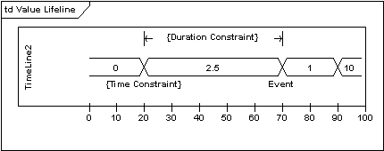
Putting it all together
State and Value Lifelines can be stacked one on top of another in any combination. They must have the same X-axis. Messages can be passed from one lifeline to another. Each state or value transition can have a defined event, a time constraint which indicates when an event must occur, and a duration constraint which indicates how long a state or value must be in effect for. Once these have all been applied, a timing diagram may look like the following.
