Configuring JBoss Container Managed
Data Source

Version 1.0
Date 02/11/10

Copyright notice
Copyright © 2010, Cognizione consulting & solutions Pvt Ltd
All rights reserved.

These materials are confidential and proprietary to Cognizione consulting & solutions pvt
ltd/its licensors and no part of these materials should be reproduced, published, transmitted
or distributed in any form or by any means, electronic, mechanical, photocopying, recording or
otherwise, or stored in any information storage or retrieval system of any nature nor should the
materials be disclosed to third parties without the prior express written authorization of
Cognizione consulting & solutions Pvt ltd/its licensors
Revision history

Doc No: | Version no. | Change reference no. | Author | Published date | Sections changed | Description of changes
 | 1.0 |  |  | 02/11/10 |  | Base Document

CONTENTS

Purpose of the document 4

Scope of the document 4

Desired outcome 4

Targeted recipient 4

Prerequisite 4

Required Software 4

About Container Managed Datasource 5

Creating and Deploying a datasource in JBoss AS 5

Configuring the Datasource in the Web Application 7

Purpose of the document

To demonstrate the following

- How to create and configure a data source managed by JBoss Application Server (AS) Container.

Scope of the document

This document covers how to create and configure a JBoss managed data source that can be used in a web application. It doesn’t cover the following points.

- Installation and configuration of JBoss.
- Details of database and datasource fine tuning.
- Details of JNDI.
- Different types of database transactions.

Desired outcome

It is expected that after going through this document the reader will be proficient in the following

- Creating a datasource for JBoss.
- Deploying and configuring the datasource to be used in web applications.

Targeted recipient

- Developers working with JBoss AS.
- Implementers who will be responsible for installing and maintaining web applications at Client side.

Prerequisite

- Knowledge of JBoss AS.
- Ability to create and run database driven web applications under JBoss.

Required Software
- JBoss AS 5.0.1.

About Container Managed Datasource

Most of the applications developed in general and in particular all the applications developed by us are database driven. For this we require some mechanism to establish connectivity and perform various CRUD operation on the database.

The common and in fact the only basic way is to use JDBC ( ORM tools like Hibernate also ultimately uses JDBC as the underlying technology) to connect and create all the database related configurations in our application directly.

But this approach has a fairly major problem – establishing a connection with the database is an expensive operation. And with a web application, we might find that a significant amount of time is spent hitting the database, so we need to avoid frequently reestablishing connections with the database.

The solution to this problem is to let the application server manage your database connections using a data source. The application server can then manage the database connections by pooling them and by providing connections to the application when it needs them.

Creating and Deploying a datasource in JBoss AS
A data source is created in JBoss AS using a *-ds.xml file i.e. a XML file with suffix “-ds” inside the “JBOSS_HOME/server/xxx/deploy” folder.

Format of datasource as created for R+Plus application is given below with a description of different parts

File Name :- reconplus-ds.xml

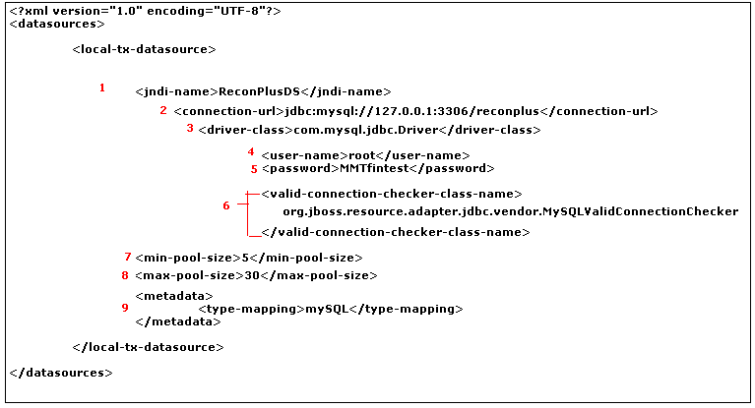

Figure 1 :- Datasource file as used for R+Plus

Description of different parts

- jndi-name – JNDI name that is used by the web application for connection. The java: prefix is automatically added to this name.

- connection-url –The URL used by the JDBC driver to establish a database connection. This URL is specific to the database and the driver for the database. In the example, the name of the database is reconplus, which must be a valid database in MySQL.

- driver-class –The class name for the JDBC driver.

- user-name – User name for database access.

- password - Password for database access for the given user.

- valid-connection-checker-class-name – Identifies a class that can be used when the connection is established to verify the connection’s validity. The class specified must implement the org.jboss.resource.adapter.jdbc.ValidConnectionChecker interface. Use this option instead of <check-valid-connection-sql> when you want to use more than a single SQL statement to check the connection’s validity. Be aware that any application making a connection request that causes a connection to be established must wait until the connection checker is finished.

- min-pool-size – The minimum number of open connections maintained by the application server. Note that the application server doesn’t open any connections until the first request for a connection, at which time it opens the specified number of connections. To establish connections when the application server is started, you can write a simple service that does nothing but ask for a connection.

- max-pool-size – The maximum number of open connections maintained by the application server. If the application server runs out of connections, it allocates a new connection to fulfill that request, until it hits the maximum number of connection. At that point, it queues the requests until connections are freed. Therefore, it’s important that applications close any connections that they obtain.

- metadata – Information on type of database.

Configuring the Datasource in the Web Application

To use the above created datasource from the web application, follow the steps below

- In the jboss-web.xml file add the following lines (example given below is for R+Plus app, change relevant sections for other applications)

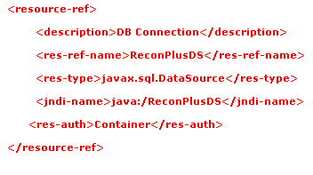
- Add the following lines in the web.xml file

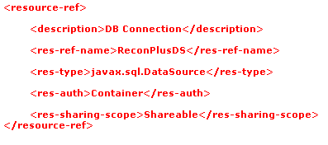
It is to be noted, as evident from the above two files that value of “<res-ref-name>” in the web.xml file should be same as that of “<res-ref-name>” in the “jboss-web.xml” file

