**UCS 1412 - DATABASE LAB**

**ASSIGNMENT - 3 - ADVANCED DML**

**DIKSHITHA VANI V**

**205001032**

**SCHEMA DIAGRAM:**

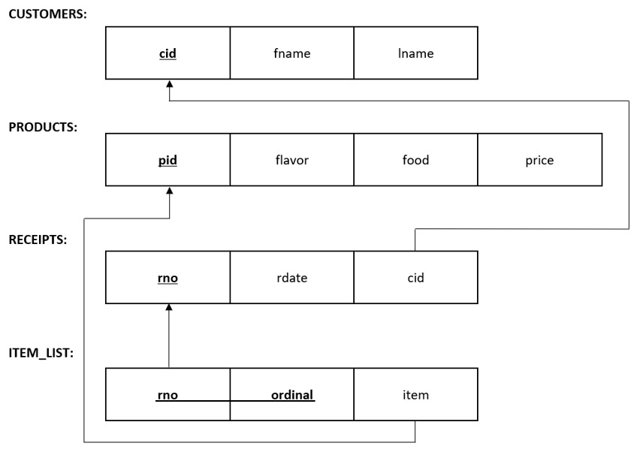

**SCRIPT FILE:**

SQL> set echo on;

SQL> @ Z:\csea_a_1032\assig3\assig3.sql

SQL> REM Assignment 3

SQL>

SQL> REM ***SSN COLLEGE OF ENGINEERING***

SQL> REM ***DEPARTMENT OF COMPUTER SCIENCE ENGINEERING***

SQL> REM ***DATABASE MANAGEMENT SYSTEMS LAB***

SQL> REM ***Name:DIKSHITHA VANI V***

SQL> REM ***Register No.: 205001032***

SQL> REM ***Date: 06.04.2022***

SQL> REM ** DROPPING ALL TABLES **

SQL>

SQL> drop table item_list;

Table dropped.

SQL> drop table Receipts;

Table dropped.

SQL> drop table products;

Table dropped.

SQL> drop table customers;

Table dropped.

SQL>

SQL> REM ** creation of customer table **

SQL>

SQL> create table customers (

2 cid int CONSTRAINT pk_cust PRIMARY KEY ,

3 fname varchar2(20),

4 lname varchar2(20)

5 );

Table created.

SQL>

SQL> REM ** creation of products table **

SQL>

SQL> create table products (

2 pid varchar2(20) CONSTRAINT pk_prod PRIMARY KEY,

3 flavor varchar2(20) ,

4 food varchar2(20) ,

5 price Decimal(5,2)

6 );

Table created.

SQL>

SQL> REM ** creation of Receipts table **

SQL>

SQL> create table Receipts (

2 rno Number(5) CONSTRAINT pk_receipts PRIMARY KEY,

3 rdate date,

4 cid int Constraint fk_rec references customers(cid)

5 );

Table created.

SQL>

SQL>

SQL> REM ** creation of item_list table **

SQL>

SQL> create table item_list (

2 rno Number(5) CONSTRAINT fk_it_list references Receipts(rno),

3 ordinal int ,

4 item varchar2(20) CONSTRAINT fk2_it_list references products(pid),

5 CONSTRAINT pk_it_list PRIMARY KEY(rno,ordinal)

6 )

7 ;

Table created.

SQL>

SQL>

SQL> REM Population of Bakery Database

SQL> REM --------------------------------------------------------------------------

> REM CUSTOMERS ( customer number, Last name, First name)

SQL> REM --------------------------------------------------------------------------

>

SQL> insert into customers values(1, 'LOGAN', 'JULIET');

1 row created.

SQL> insert into customers values(2, 'ARZT', 'TERRELL');

1 row created.

SQL> insert into customers values(3, 'ESPOSITA', 'TRAVIS');

1 row created.

SQL> insert into customers values(4, 'ENGLEY', 'SIXTA');

1 row created.

SQL> insert into customers values(21, 'JOHN', 'DAVID');

1 row created.

SQL>

SQL>

SQL> REM --------------------------------------------------------------------------

> REM PRODUCTS (product number, Flavor, Food, Price)

SQL> REM --------------------------------------------------------------------------

>

SQL> insert into products values('20-BC-C-10','Chocolate','Cake',8.95);

1 row created.

SQL> insert into products values('20-BC-L-10','Lemon','Cake',8.95);

1 row created.

SQL>

SQL> REM --------------------------------------------------------------------------

> REM RECEIPTS(receipt number, receipt Date, Customer)

SQL> REM --------------------------------------------------------------------------

>

SQL> INSERT INTO Receipts values(18129, '28-Oct-2007', 15);

1 row created.

SQL> INSERT INTO Receipts values(51991, '17-Oct-2007', 14);

1 row created.

SQL> INSERT INTO Receipts values(83085, '12-Oct-2007', 7);

1 row created.

SQL> INSERT INTO Receipts values(70723, '28-Oct-2007', 20);

1 row created.

SQL> INSERT INTO Receipts values(13355, '19-Oct-2007', 7);

1 row created.

SQL>

SQL> REM --------------------------------------------------------------------------

> REM ITEM_LIST (receipt number, Ordinal, Item)

SQL> REM --------------------------------------------------------------------------

>

SQL> insert into item_list values(18129, 1, '70-TU');

1 row created.

SQL> insert into item_list values(51991, 1, '90-APIE-10');

1 row created.

SQL> insert into item_list values(51991, 2, '90-CH-PF');

1 row created.

SQL> insert into item_list values(51991, 3, '90-APP-11');

1 row created.

SQL> insert into item_list values(51991, 4, '26-8x10');

1 row created.

SQL> insert into item_list values(83085, 1, '25-STR-9');

1 row created.

SQL> insert into item_list values(83085, 2, '24-8x10');

1 row created.

SQL> insert into item_list values(83085, 3, '90-APR-PF');

1 row created.

SQL>

SQL> REM ******************** END OF FILE ******************************************************

SQL>

SQL>

SQL> REM **1.Display the food details that is not purchased by any of customers**

SQL> select * from products where pid not in (select item from item_list);

PID FLAVOR FOOD PRICE

-------------------- -------------------- -------------------- ----------

20-BC-C-10 Chocolate Cake 8.95

SQL> select item from item_list where item='20-BC-C-10';

no rows selected

SQL>

SQL> REM **2.Show the customer details who had placed more than 2 orders on the same date **

SQL> select * from customers where cid in

2 (select cid from (select cid,rdate

3 from Receipts group by(cid,rdate) having count(*)>2)

4 );

CID FNAME LNAME

---------- -------------------- --------------------

14 SOPKO RAYFORD

8 HELING RUPERT

SQL>

SQL> REM **3.Display the products details that has been ordered maximum by the customers. (use ALL) **

SQL> select * from products where pid in

2 ( select item from item_list group by(item) having count(item) >=

3 all(select count(item) from item_list group by (item))

4 );

PID FLAVOR FOOD PRICE

-------------------- -------------------- -------------------- ----------

90-APP-11 Apple Tart 3.25

SQL>

SQL>

SQL> REM ** 4.Show the number of receipts that contain the product whose price is more than the **

SQL> REM ** average price of its food type. **

SQL>

SQL> select count(distinct(rno)) from products p, item_list i where p.pid=i.item and price>(select avg(price) from

2 products ip where p.food=ip.food group by food);

COUNT(DISTINCT(RNO))

--------------------

137

SQL>

SQL> REM ** 5.Display the customer details along with receipt number and date for the receipts that**

SQL> REM ** are dated on the last day of the receipt month.**

SQL> select customers.cid,fname,lname ,rno,rdate from customers JOIN Receipts ON

2 customers.cid=Receipts.cid and rdate=last_day(rdate);

CID FNAME LNAME RNO RDATE

---------- -------------------- -------------------- ---------- ---------

1 LOGAN JULIET 85858 31-OCT-07

3 ESPOSITA TRAVIS 39829 31-OCT-07

11 STADICK MIGDALIA 60270 31-OCT-07

12 MCMAHAN MELLIE 70796 31-OCT-07

19 STENZ NATACHA 36343 31-OCT-07

20 ZEME STEPHEN 49845 31-OCT-07

6 rows selected.

SQL>

SQL>

SQL> REM ** 6.Display the receipt number(s) and its total price for the receipt(s) that contain Twist **

SQL> REM ** as one among five items. Include only the receipts with total price more than $25. **

SQL>

SQL> select distinct(i.rno) , sum(p.price) from item_list i join products p on i.item=p.pid group by(i.rno)having sum(price)>25 and count(*)=5 and i.rno in (select rno from item_list where item in (select pid from products where food='Twist'));

RNO SUM(P.PRICE)

---------- ------------

83085 48.25

64477 25.35

17729 25.55

SQL> REM ** 7.Display the details (customer details, receipt number, item) for the product that was **

SQL> REM **purchased by the least number of customers.**

SQL>

SQL> select r.rno, c.cid,c.fname,c.lname,i.item from Receipts r join item_list i on r.rno=i.rno join customers c on r.cid=c.cid

2 where i.item in (

3 select item from item_list group by(item) having count(*) =

4 (select min(count(item)) from item_list group by(item) ));

RNO CID FNAME LNAME

---------- ---------- -------------------- --------------------

ITEM

--------------------

73716 18 DOMKOWSKI ALMETA

50-CH

95962 8 HELING RUPERT

50-CH

99994 6 SLINGLAND JOSETTE

50-CH

RNO CID FNAME LNAME

---------- ---------- -------------------- --------------------

ITEM

--------------------

82056 18 DOMKOWSKI ALMETA

50-CH

77032 14 SOPKO RAYFORD

50-CH

49845 20 ZEME STEPHEN

50-CH

6 rows selected.

SQL>

SQL>

SQL> REM ** 8.Display the customer details along with the receipt number who ordered all the **

SQL> REM ** flavors of Meringue in the same receipt. **

SQL> select c.cid,c.fname,c.lname , r1.rno from customers c join Receipts r1 on(r1.cid=c.cid)

2 where r1.rno=(

3 select r2.rno from Receipts r2 join item_list i on(r2.rno=i.rno) join products p on(p.pid=i.item)

4 where p.food='Meringue' group by r2.rno having count(distinct flavor)=(

5 select count(distinct flavor) from products where food='Meringue')

6 );

CID FNAME LNAME RNO

---------- -------------------- -------------------- ----------

8 HELING RUPERT 61797

SQL>

SQL> REM ** 9.Display the product details of both Pie and BEAR CLAW**

SQL>

SQL> select * from products where food = 'Pie'

2 union

3 select * from products where food = 'Bear Claw';

PID FLAVOR FOOD PRICE

-------------------- -------------------- -------------------- ----------

51-BC Almond Bear Claw 1.95

90-APIE-10 Apple Pie 5.25

SQL>

SQL> REM **10.Display the customers details who haven't placed any orders.**

SQL>

SQL> (select * from customers)

2 minus

3 (select cid, fname, lname

4 from customers natural join receipts);

CID FNAME LNAME

---------- -------------------- --------------------

21 JOHN DAVID

SQL>

SQL>

SQL> REM ** 11.Display the food that has the same flavor as that of the common flavor between the **

SQL> REM ** Meringue and TARt **

SQL>

SQL> select food from products

2 where flavor in (select flavor from products

3 where food = 'Meringue'

4 intersect

5 select flavor from products

6 where food = 'Tart');

FOOD

--------------------

Cake

Eclair

Tart

Meringue

Croissant

SQL>

SQL> spool off;

**OUTPUT VERIFICATION:**

