**UCS 1412 - DATABASE LAB**

**Assignment 4 -Views**

**DIKSHITHA VANI V**

**205001032**

**INDEX PAGE:**

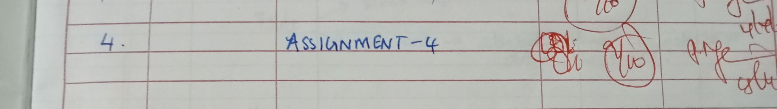

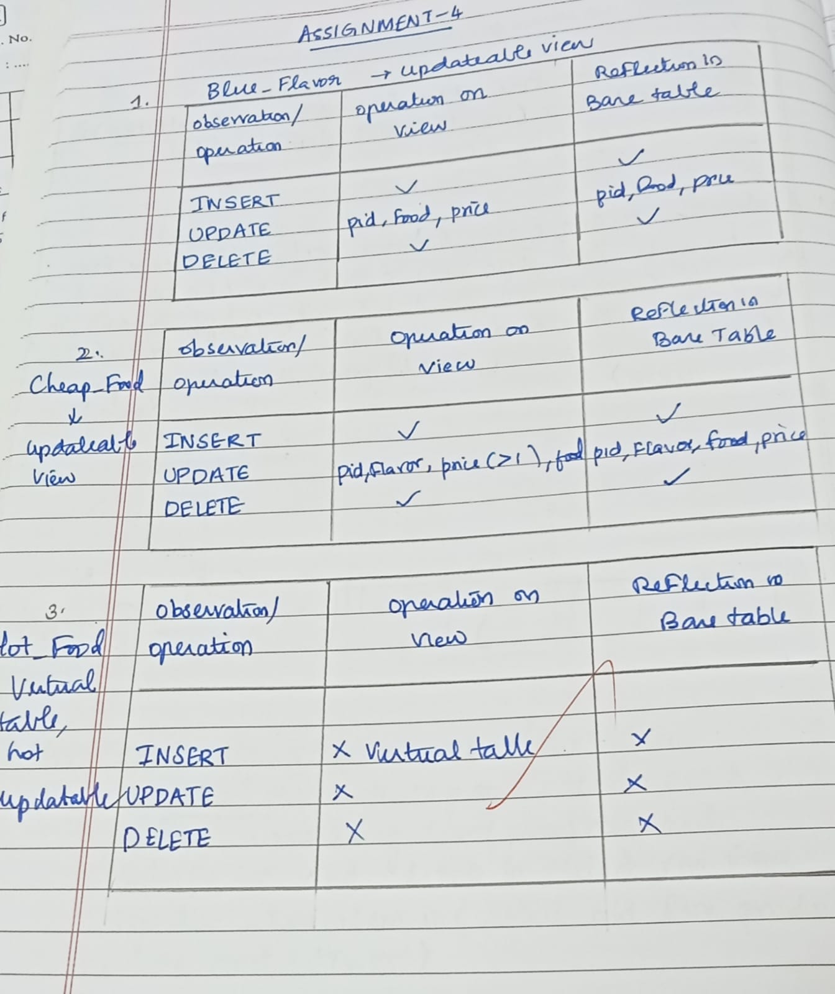

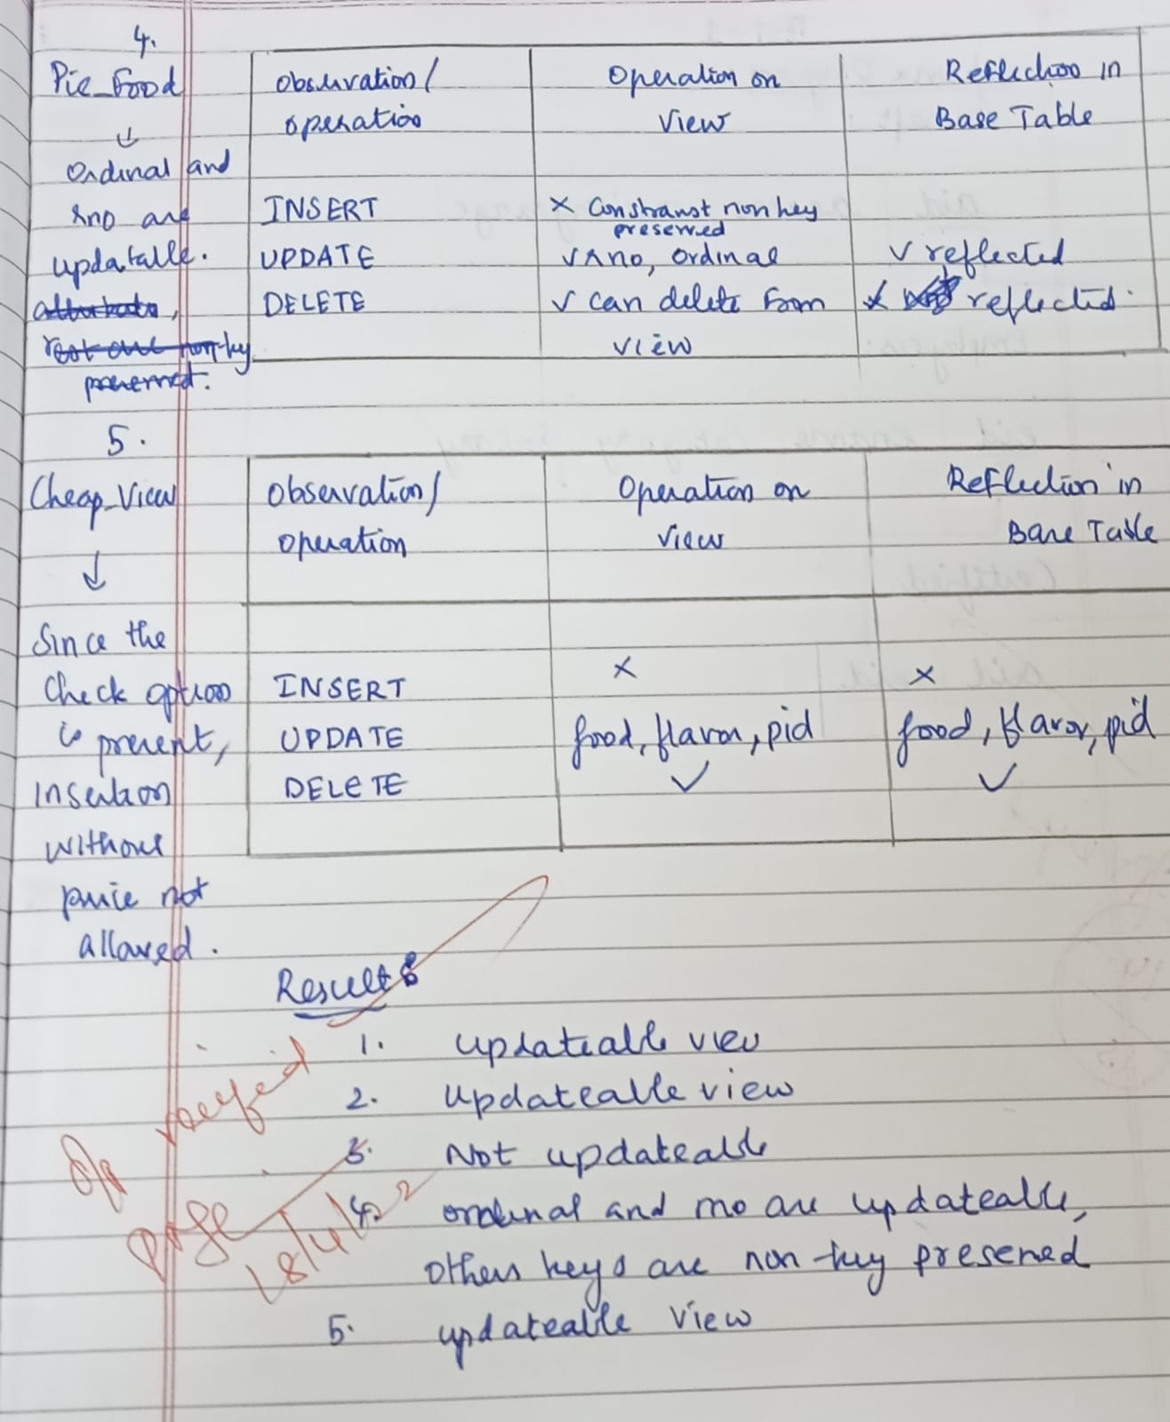

**SCRIPT FILE:**

SQL> set echo on;

SQL> @ Z:\csea_a_1032\assig4\check.sql

SQL> REM ***SSN COLLEGE OF ENGINEERING***

SQL> REM ***DEPARTMENT OF COMPUTER SCIENCE ENGINEERING***

SQL> REM ***DATABASE MANAGEMENT SYSTEMS LAB***

SQL> REM ***Name:DIKSHITHA VANI V***

SQL> REM ***Register No.: 205001032***

SQL> REM ***Date: 18.04.2022***

SQL> REM ** 1. **

SQL> REM Create a view named Blue_Flavor, which display the product details (product id,

SQL> REM food, price) of Blueberry flavor. **

SQL>

SQL> create or replace view Blue_flavor as select pid,food ,price from products where flavor='Blueberry';

View created.

SQL> select * from Blue_flavor;

PID FOOD PRICE

-------------------- -------------------- ----------

90-BLU-11 Tart 3.25

51-BLU Danish 1.15

SQL>

SQL> savepoint pt1;

Savepoint created.

SQL>

SQL> insert into products values('P103','Blueberry','cupcake',1.5);

1 row created.

SQL> select * from Blue_Flavor;

PID FOOD PRICE

-------------------- -------------------- ----------

90-BLU-11 Tart 3.25

51-BLU Danish 1.15

P103 cupcake 1.5

SQL> select * from products where food='cupcake';

PID FLAVOR FOOD PRICE

-------------------- -------------------- -------------------- ----------

P103 Blueberry cupcake 1.5

SQL>

SQL> insert into Blue_Flavor Values('Ptmp-100','vada',2);

1 row created.

SQL> select * from Blue_Flavor;

PID FOOD PRICE

-------------------- -------------------- ----------

90-BLU-11 Tart 3.25

51-BLU Danish 1.15

P103 cupcake 1.5

SQL> select * from products where food='vada';

PID FLAVOR FOOD PRICE

-------------------- -------------------- -------------------- ----------

Ptmp-100 vada 2

SQL>

SQL> REM ** price column is updatable**

SQL> update Blue_flavor set price=1.4 where food='Tart';

1 row updated.

SQL> select * from Blue_flavor;

PID FOOD PRICE

-------------------- -------------------- ----------

90-BLU-11 Tart 1.4

51-BLU Danish 1.15

P103 cupcake 1.5

SQL> select * from products where food='Tart' and flavor='Blueberry';

PID FLAVOR FOOD PRICE

-------------------- -------------------- -------------------- ----------

90-BLU-11 Blueberry Tart 1.4

SQL>

SQL> REM ** food column is updatable**

SQL> update Blue_flavor set food='Dosa' where food='Tart';

1 row updated.

SQL> select * from Blue_flavor;

PID FOOD PRICE

-------------------- -------------------- ----------

90-BLU-11 Dosa 1.4

51-BLU Danish 1.15

P103 cupcake 1.5

SQL> select * from products where food='Dosa' and flavor='Blueberry';

PID FLAVOR FOOD PRICE

-------------------- -------------------- -------------------- ----------

90-BLU-11 Blueberry Dosa 1.4

SQL>

SQL> REM ** pid column is updatable **

SQL> update Blue_Flavor set pid='P1003' where pid='P103';

1 row updated.

SQL> select pid,food from Blue_flavor;

PID FOOD

-------------------- --------------------

90-BLU-11 Dosa

51-BLU Danish

P1003 cupcake

SQL> select pid,food from products where pid='P1003';

PID FOOD

-------------------- --------------------

P1003 cupcake

SQL>

SQL> REM ** Deletion is possible for the newly created value **

SQL> delete from Blue_Flavor where food='cupcake';

1 row deleted.

SQL> select * from Blue_Flavor;

PID FOOD PRICE

-------------------- -------------------- ----------

90-BLU-11 Dosa 1.4

51-BLU Danish 1.15

SQL> select * from products where food='cupcake';

no rows selected

SQL>

SQL> rollback to pt1;

Rollback complete.

SQL>

SQL> select COLUMN_NAME,UPDATABLE,INSERTABLE,DELETABLE FROM USER_UPDATABLE_COLUMNS WHERE TABLE_NAME='BLUE_FLAVOR';

COLUMN_NAME UPD INS DEL

------------------------------ --- --- ---

PID YES YES YES

FOOD YES YES YES

PRICE YES YES YES

SQL> REM RESULT: ALL INSERTIONS ,UPDATIONS POSSIBLE

SQL> REM updatable VIEW

SQL> REM **2.**

SQL> REM Create a view named Cheap_Food, which display the details (product id, flavor,

SQL> REM food, price) of products with price lesser than $1. Ensure that, the price of these

SQL> REM food(s) should never rise above $1 through view.

SQL>

SQL> create or replace view Cheap_Food as select * from products where price<1 with check option;

View created.

SQL> select* from Cheap_Food;

PID FLAVOR FOOD PRICE

-------------------- -------------------- -------------------- ----------

70-LEM Lemon Cookie .79

70-W Walnut Cookie .79

SQL>

SQL> savepoint pt2;

Savepoint created.

SQL>

SQL> Select * from Cheap_Food;

PID FLAVOR FOOD PRICE

-------------------- -------------------- -------------------- ----------

70-LEM Lemon Cookie .79

70-W Walnut Cookie .79

SQL>

SQL> REM **INSERTION**

SQL> insert into Cheap_Food values('P1006','Strawberry','Candy',0.05);

1 row created.

SQL> Select * from Cheap_Food;

PID FLAVOR FOOD PRICE

-------------------- -------------------- -------------------- ----------

70-LEM Lemon Cookie .79

70-W Walnut Cookie .79

P1006 Strawberry Candy .05

SQL> Select * from products where food='Candy';

PID FLAVOR FOOD PRICE

-------------------- -------------------- -------------------- ----------

P1006 Strawberry Candy .05

SQL>

SQL> REM ** price column is updatable with check condition **

SQL> update Cheap_Food set price=0.45 where pid='P1006';

1 row updated.

SQL> select * from Cheap_Food ;

PID FLAVOR FOOD PRICE

-------------------- -------------------- -------------------- ----------

70-LEM Lemon Cookie .79

70-W Walnut Cookie .79

P1006 Strawberry Candy .45

SQL> select * from products where food='Candy';

PID FLAVOR FOOD PRICE

-------------------- -------------------- -------------------- ----------

P1006 Strawberry Candy .45

SQL>

SQL> REM ** price column is updatable with check condition **

SQL> update Cheap_Food set price=1.45 where pid='P1006';

update Cheap_Food set price=1.45 where pid='P1006'

*

ERROR at line 1:

ORA-01402: view WITH CHECK OPTION where-clause violation

SQL> select * from Cheap_Food ;

PID FLAVOR FOOD PRICE

-------------------- -------------------- -------------------- ----------

70-LEM Lemon Cookie .79

70-W Walnut Cookie .79

P1006 Strawberry Candy .45

SQL> select * from products where food='Candy';

PID FLAVOR FOOD PRICE

-------------------- -------------------- -------------------- ----------

P1006 Strawberry Candy .45

SQL>

SQL>

SQL> REM ** food column is updatable**

SQL> update Cheap_Food set food='Tart' where food='Dosa';

0 rows updated.

SQL> select * from Cheap_Food ;

PID FLAVOR FOOD PRICE

-------------------- -------------------- -------------------- ----------

70-LEM Lemon Cookie .79

70-W Walnut Cookie .79

P1006 Strawberry Candy .45

SQL> select * from products where food='Tart' ;

PID FLAVOR FOOD PRICE

-------------------- -------------------- -------------------- ----------

90-ALM-I Almond Tart 3.75

90-APP-11 Apple Tart 3.25

90-APR-PF Apricot Tart 3.25

90-BER-11 Berry Tart 3.25

90-BLK-PF Blackberry Tart 3.25

90-BLU-11 Blueberry Tart 3.25

90-CH-PF Chocolate Tart 3.75

90-CHR-11 Cherry Tart 3.25

90-LEM-11 Lemon Tart 3.25

90-PEC-11 Pecan Tart 3.75

10 rows selected.

SQL>

SQL> REM ** pid column is updatable **

SQL> update Cheap_Food set pid='new_P1006' where pid='P1006';

1 row updated.

SQL> select * from Cheap_Food ;

PID FLAVOR FOOD PRICE

-------------------- -------------------- -------------------- ----------

70-LEM Lemon Cookie .79

70-W Walnut Cookie .79

new_P1006 Strawberry Candy .45

SQL> select * from products where food='Candy';

PID FLAVOR FOOD PRICE

-------------------- -------------------- -------------------- ----------

new_P1006 Strawberry Candy .45

SQL>

SQL>

SQL> REM ** flavor column is updatable **

SQL> update Cheap_Food set flavor='chocolate' where pid='new_P1006';

1 row updated.

SQL> select * from Cheap_Food ;

PID FLAVOR FOOD PRICE

-------------------- -------------------- -------------------- ----------

70-LEM Lemon Cookie .79

70-W Walnut Cookie .79

new_P1006 chocolate Candy .45

SQL> select * from products where food='Candy';

PID FLAVOR FOOD PRICE

-------------------- -------------------- -------------------- ----------

new_P1006 chocolate Candy .45

SQL>

SQL>

SQL> REM ** DELETION **

SQL> Delete from Cheap_Food where pid='new_P1006';

1 row deleted.

SQL> select * from Cheap_Food ;

PID FLAVOR FOOD PRICE

-------------------- -------------------- -------------------- ----------

70-LEM Lemon Cookie .79

70-W Walnut Cookie .79

SQL> select * from products where food='Candy';

no rows selected

SQL>

SQL>

SQL> select COLUMN_NAME,UPDATABLE,INSERTABLE,DELETABLE FROM USER_UPDATABLE_COLUMNS WHERE TABLE_NAME='CHEAP_FOOD';

COLUMN_NAME UPD INS DEL

------------------------------ --- --- ---

PID YES YES YES

FLAVOR YES YES YES

FOOD YES YES YES

PRICE YES YES YES

SQL>

SQL>

SQL> rollback to pt2;

Rollback complete.

SQL> REM RESULT: ALL INSERTIONS ,UPDATIONS POSSIBLE

SQL> REM updatable VIEW

SQL> REM **3.**

SQL> REM Create a view called Hot_Food that show the product id and its quantity where the

SQL> REM same product is ordered more than once in the same receipt.

SQL>

SQL> create or replace view Hot_Food (pid,quantity) as select item,count(*) from item_list group by(rno,item) having count(*)>1;

View created.

SQL>

SQL> savepoint pt3;

Savepoint created.

SQL>

SQL> REM **INSERTION**

SQL> Insert into Hot_Food values('P109',15);

Insert into Hot_Food values('P109',15)

*

ERROR at line 1:

ORA-01733: virtual column not allowed here

SQL>

SQL> REM **UPDATION**

SQL> Update Hot_Food set pid='new_value' where pid='90-APR-PF';

Update Hot_Food set pid='new_value' where pid='90-APR-PF'

*

ERROR at line 1:

ORA-01732: data manipulation operation not legal on this view

SQL> Update Hot_Food set quantity=100 where pid='90-APR-PF';

Update Hot_Food set quantity=100 where pid='90-APR-PF'

*

ERROR at line 1:

ORA-01732: data manipulation operation not legal on this view

SQL>

SQL> REM **DELETION**

SQL> Delete from Hot_Food where pid='90-APR-PF';

Delete from Hot_Food where pid='90-APR-PF'

*

ERROR at line 1:

ORA-01732: data manipulation operation not legal on this view

SQL>

SQL>

SQL> select *from Hot_Food;

PID QUANTITY

-------------------- ----------

70-R 2

90-APR-PF 2

50-APP 2

51-ATW 2

90-ALM-I 2

90-BER-11 2

90-PEC-11 2

70-M-CH-DZ 2

46-11 2

70-M-CH-DZ 2

90-CHR-11 2

PID QUANTITY

-------------------- ----------

90-BLU-11 2

50-CHS 2

70-M-CH-DZ 2

70-R 2

90-APP-11 2

70-MAR 2

50-APR 2

51-BC 2

50-ALM 2

20 rows selected.

SQL> select COLUMN_NAME,UPDATABLE,INSERTABLE,DELETABLE FROM USER_UPDATABLE_COLUMNS WHERE TABLE_NAME='HOT_FOOD';

COLUMN_NAME UPD INS DEL

------------------------------ --- --- ---

PID NO NO NO

QUANTITY NO NO NO

SQL>

SQL> rollback to pt3;

Rollback complete.

SQL> REM CANNOT INSERT,UPDATE OR DELETE

SQL> REM RESULT - NOT AN updatable VIEW

SQL>

SQL> REM **4.**

SQL> REM Create a view named Pie_Food that will display the details (customer lname, flavor,

SQL> REM receipt number and date, ordinal) who had ordered the Pie food with receipt details.

SQL>

SQL>

SQL> create or replace view Pie_Food as select c.lname,p.flavor,i.rno,r.rdate,i.ordinal from Receipts r join item_list i on r.rno=i.rno join products p on p.pid=i.item join customers c on c.cid=r.cid where p.food='Pie';

View created.

SQL> select * from Pie_Food;

LNAME FLAVOR RNO RDATE ORDINAL

-------------------- -------------------- ---------- --------- ----------

JULIET Apple 39685 28-OCT-07 4

JULIET Apple 66227 10-OCT-07 2

TRAVIS Apple 48647 09-OCT-07 2

JOSETTE Apple 87454 21-OCT-07 1

JOSETTE Apple 47353 12-OCT-07 2

RUPERT Apple 53376 30-OCT-07 3

CUC Apple 50660 18-OCT-07 2

KIP Apple 11548 21-OCT-07 2

RAYFORD Apple 29226 26-OCT-07 2

RAYFORD Apple 51991 17-OCT-07 1

ARIANE Apple 39109 02-OCT-07 1

LNAME FLAVOR RNO RDATE ORDINAL

-------------------- -------------------- ---------- --------- ----------

ARIANE Apple 44798 04-OCT-07 3

CHARLENE Apple 98806 15-OCT-07 3

13 rows selected.

SQL>

SQL> REM ** Only attributes of key preserved table can be changed **

SQL>

SQL> savepoint pt4;

Savepoint created.

SQL>

SQL> REM ** INSERTION **

SQL> insert into Pie_Food values ('KIP','Strawberry',78179, '24-Oct-2007',1);

insert into Pie_Food values ('KIP','Strawberry',78179, '24-Oct-2007',1)

*

ERROR at line 1:

ORA-01779: cannot modify a column which maps to a non key-preserved table

SQL>

SQL> REM **UPDATION**

SQL> REM **updating rno and ordinal **

SQL> update Pie_Food set ordinal=5 where rdate='28-OCT-07';

1 row updated.

SQL> select * from Pie_Food where rdate='28-OCT-07';

LNAME FLAVOR RNO RDATE ORDINAL

-------------------- -------------------- ---------- --------- ----------

JULIET Apple 39685 28-OCT-07 5

SQL> update Pie_Food set rno =66227 where rdate='28-OCT-07';

1 row updated.

SQL> select * from Pie_Food ;

LNAME FLAVOR RNO RDATE ORDINAL

-------------------- -------------------- ---------- --------- ----------

JULIET Apple 66227 10-OCT-07 2

JULIET Apple 66227 10-OCT-07 5

TRAVIS Apple 48647 09-OCT-07 2

JOSETTE Apple 87454 21-OCT-07 1

JOSETTE Apple 47353 12-OCT-07 2

RUPERT Apple 53376 30-OCT-07 3

CUC Apple 50660 18-OCT-07 2

KIP Apple 11548 21-OCT-07 2

RAYFORD Apple 29226 26-OCT-07 2

RAYFORD Apple 51991 17-OCT-07 1

ARIANE Apple 39109 02-OCT-07 1

LNAME FLAVOR RNO RDATE ORDINAL

-------------------- -------------------- ---------- --------- ----------

ARIANE Apple 44798 04-OCT-07 3

CHARLENE Apple 98806 15-OCT-07 3

13 rows selected.

SQL>

SQL> REM **updating lname or rdate or flavor **

SQL> update Pie_Food set flavor='Pineapple';

update Pie_Food set flavor='Pineapple'

*

ERROR at line 1:

ORA-01779: cannot modify a column which maps to a non key-preserved table

SQL> update Pie_Food set lname='ROY';

update Pie_Food set lname='ROY'

*

ERROR at line 1:

ORA-01779: cannot modify a column which maps to a non key-preserved table

SQL> update Pie_Food set rdate='28-OCT-07';

update Pie_Food set rdate='28-OCT-07'

*

ERROR at line 1:

ORA-01779: cannot modify a column which maps to a non key-preserved table

SQL>

SQL> REM ** Deletion **

SQL> delete from Pie_food where lname='RAYFORD';

2 rows deleted.

SQL> select rno,ordinal from item_list where rno='29226' and ordinal=2;

no rows selected

SQL>

SQL> select COLUMN_NAME,UPDATABLE,INSERTABLE,DELETABLE FROM USER_UPDATABLE_COLUMNS WHERE TABLE_NAME='PIE_FOOD';

COLUMN_NAME UPD INS DEL

------------------------------ --- --- ---

LNAME NO NO NO

FLAVOR NO NO NO

RNO YES YES YES

RDATE NO NO NO

ORDINAL YES YES YES

SQL>

SQL> rollback to pt4;

Rollback complete.

SQL>

SQL> REM RESULT: CANNOT INSERT

SQL> REM CAN UPDATE A FEW ATTRIBUTES

SQL> REM CAN DELETE FROM VIEW NOT FROM ORIGINAL TABLE

SQL> REM UPDATABLE VIEW WRT ITEM_LIST TABLE ATTRIBUTES ALONE

SQL> REM **5.**

SQL> REM Create a view Cheap_View from Cheap_Food that shows only the product id, flavor and food.

SQL>

SQL> create or replace view Cheap_View as select pid,food,flavor from Cheap_Food;

View created.

SQL> select * from Cheap_View;

PID FOOD FLAVOR

-------------------- -------------------- --------------------

70-LEM Cookie Lemon

70-W Cookie Walnut

SQL>

SQL> savepoint pt5;

Savepoint created.

SQL>

SQL> REM ** INSERTION **

SQL> REM ** INSERTION IS NOT POSSIBLE BECAUSE OF CHECK CONSTRAINT IN Cheap_Food view **

SQL> insert into Cheap_view Values('P1007','Vanilla','choco');

insert into Cheap_view Values('P1007','Vanilla','choco')

*

ERROR at line 1:

ORA-01402: view WITH CHECK OPTION where-clause violation

SQL>

SQL>

SQL> REM ** food column is updatable**

SQL> update Cheap_Food set food='Tart' where food='Cookie';

2 rows updated.

SQL> select * from Cheap_view ;

PID FOOD FLAVOR

-------------------- -------------------- --------------------

70-LEM Tart Lemon

70-W Tart Walnut

SQL> select * from products where food='Tart' ;

PID FLAVOR FOOD PRICE

-------------------- -------------------- -------------------- ----------

90-ALM-I Almond Tart 3.75

90-APP-11 Apple Tart 3.25

90-APR-PF Apricot Tart 3.25

90-BER-11 Berry Tart 3.25

90-BLK-PF Blackberry Tart 3.25

90-BLU-11 Blueberry Tart 3.25

90-CH-PF Chocolate Tart 3.75

90-CHR-11 Cherry Tart 3.25

90-LEM-11 Lemon Tart 3.25

90-PEC-11 Pecan Tart 3.75

70-LEM Lemon Tart .79

PID FLAVOR FOOD PRICE

-------------------- -------------------- -------------------- ----------

70-W Walnut Tart .79

12 rows selected.

SQL>

SQL>

SQL> REM ** flavor column is updatable **

SQL> update Cheap_view set flavor='chocolate' where pid='new_P1007';

0 rows updated.

SQL> select * from Cheap_View;

PID FOOD FLAVOR

-------------------- -------------------- --------------------

70-LEM Tart Lemon

70-W Tart Walnut

SQL> select * from products where food='choco';

no rows selected

SQL>

SQL>

SQL> REM ** DELETION **

SQL> Delete from Cheap_view where pid='new_P1007';

0 rows deleted.

SQL> select * from Cheap_view ;

PID FOOD FLAVOR

-------------------- -------------------- --------------------

70-LEM Tart Lemon

70-W Tart Walnut

SQL> select * from products where food='choco';

no rows selected

SQL>

SQL> select COLUMN_NAME,UPDATABLE,INSERTABLE,DELETABLE FROM USER_UPDATABLE_COLUMNS WHERE TABLE_NAME='CHEAP_VIEW';

COLUMN_NAME UPD INS DEL

------------------------------ --- --- ---

PID YES YES YES

FOOD YES YES YES

FLAVOR YES YES YES

SQL>

SQL> rollback to pt5;

Rollback complete.

PpSQL> REM CANNOT INSERT,DELETE OR UPDATE BECAUSE OF THE CHECK CONSTRAINT IN SQL> REM CHEAP_FOOD

SQL> REM RESULT: UPDATABLE VIEW

SQL> REM IT'S UPDATABLE BECAUSE UPDATION IS RESTRICTED ONLY DUE TO CHECK CONSTRAINT

SQL> REM **6.**

SQL> REM Drop the view Cheap_View

SQL> drop view Cheap_View;

View dropped.

SQL> spool off;