**UCS 1412 - DATABASE LAB**

**Assignment 8 -EXCEPTION HANDLING**

**DIKSHITHA VANI V**

**205001032**

**INDEX PAGE:**

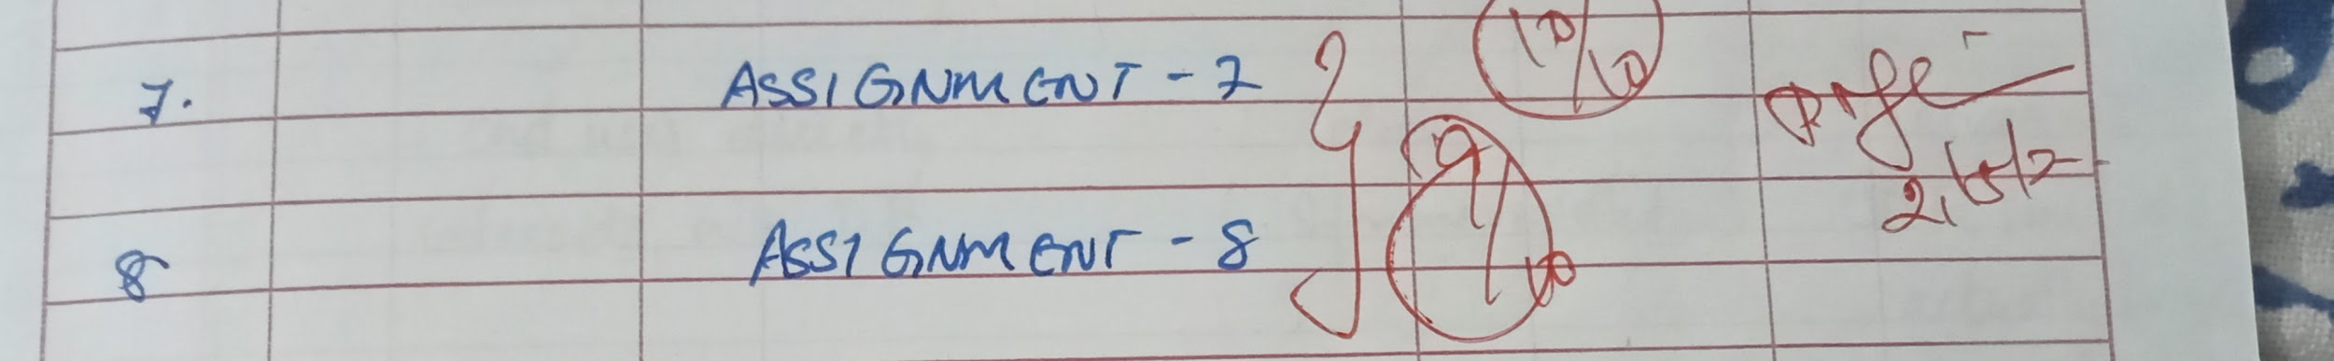

**SPOOL FILE:**

SQL> @ C:\sql_sums\ex8\ex8.sql

SQL> REM #1. For the given receipt number, if there are no rows then display as No order with the

SQL> REM given receipt <number> . If the receipt contains more than one item, display as

SQL> REM The given receipt <number> contains more than one item . If the receipt contains

SQL> REM single item, display as The given receipt <number> contains exactly one item. Use

SQL> REM predefined exception handling

SQL>

SQL> alter table receipts drop column amt;

Table altered.

SQL>

SQL> create or replace procedure excep1(rec_in IN receipts.rno%type) is

2 count_ int;

3 countG exception;

4 count1 exception;

5 count0 exception;

6 begin

7 select count(*) into count_ from item_list where rno=rec_in;

8 if count_>1 then

9 raise countG;

10 elsif count_=1 then

11 raise count1;

12 else

13 raise count0;

14 end if;

15 EXCEPTION

16 WHEN countG then

17 raise_application_error(-20000,'The given receipt '||rec_in||' contains more than one item');

18 WHEN count1 then

19 raise_application_error(-20001,'The given receipt '||rec_in||' contains exactly one item');

20 WHEN count0 then

21 raise_application_error(-20002,'No order with the The given receipt '||rec_in);

22 end;

23 /

Procedure created.

SQL>

SQL> insert into Receipts VALUES(12345,'12-JAN-05',12);

1 row created.

SQL>

SQL>

SQL> begin

2 excep1(12345);

3 end;

4 /

begin

*

ERROR at line 1:

ORA-20002: No order with the The given receipt 12345

ORA-06512: at "SYSTEM.EXCEP1", line 21

ORA-06512: at line 2

SQL>

SQL> begin

2 excep1(10013);

3 end;

4 /

begin

*

ERROR at line 1:

ORA-20001: The given receipt 10013 contains exactly one item

ORA-06512: at "SYSTEM.EXCEP1", line 19

ORA-06512: at line 2

SQL>

SQL>

SQL> REM #2. While inserting the receipt details, raise an exception when the receipt date is greater

SQL> REM than the current date.

SQL>

SQL>

SQL> REM #2. While inserting the receipt details, raise an exception when the receipt date is greater

SQL> REM than the current date.

SQL> create or replace procedure excep2(rec_no IN receipts.rno%type, rdate_ receipts.rdate%type, cusno receipts.cid%type) is

2 insertion_error EXCEPTION;

3 curr date;

4 begin

5 select SYSDATE into curr from Dual;

6 if (curr < rdate_) then

7 raise insertion_error;

8 else

9 insert into receipts VALUES(rec_no,rdate_,cusNo);

10 end if;

11 EXCEPTION

12 WHEN insertion_error then

13 raise_application_error(-20003,'Receipt date is greater than current date');

14 end;

15 /

Procedure created.

SQL>

SQL>

SQL> begin

2 excep2(12567,'29-MAY-2022',2);

3 end;

4 /

begin

*

ERROR at line 1:

ORA-20003: Receipt date is greater than current date

ORA-06512: at "SYSTEM.EXCEP2", line 13

ORA-06512: at line 2

SQL>

SQL> spool off;