**GRU** **Code**

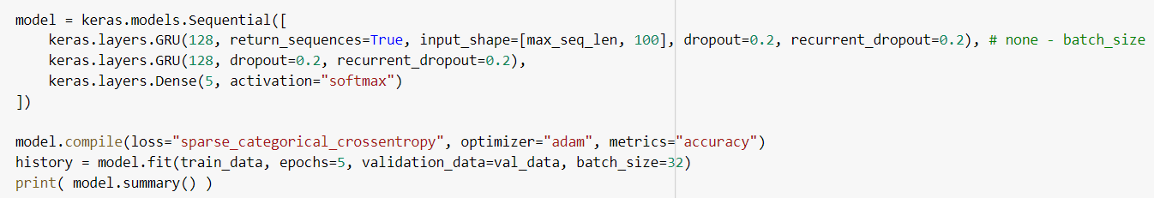

**LSTM Code**

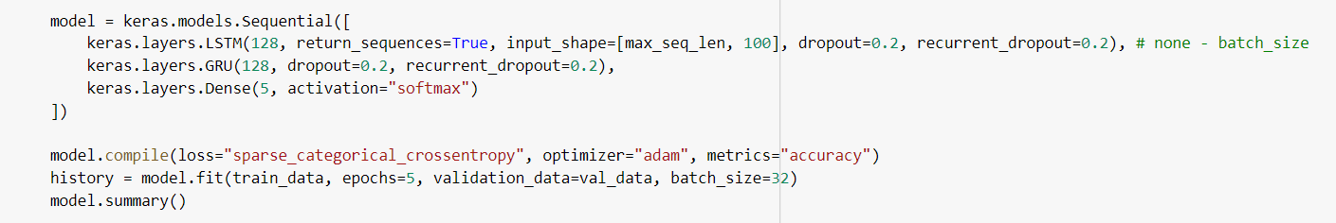

**Performance Comparison**

**Fold 1:**

|  |  |  |  |  |
| --- | --- | --- | --- | --- |
|  | Accuracy | Precision | Recall | Number of Parameters |
| GRU | 0.51 | 0.52 | 0.51 | 188,037 |
| LSTM | 0.55 | 0.69 | 0.55 | 216,965 |

**Fold 2:**

|  |  |  |  |  |
| --- | --- | --- | --- | --- |
|  | Accuracy | Precision | Recall | Number of Parameters |
| GRU | 0.50 | 0.55 | 0.51 | 188,037 |
| LSTM | 0.78 | 0.77 | 0.79 | 216,965 |

**Fold 3:**

|  |  |  |  |  |
| --- | --- | --- | --- | --- |
|  | Accuracy | Precision | Recall | Number of Parameters |
| GRU | 0.70 | 0.76 | 0.71 | 188,037 |
| LSTM | 0.53 | 0.53 | 0.53 | 216,965 |

**Performance Comparison of Activation Functions**

|  |  |  |  |  |  |
| --- | --- | --- | --- | --- | --- |
|  | Weighted F1-Score using various Activation Functions | | | | |
| Model | ReLU | Sigmoid | eLU | LeakyReLU | Tanh |
| GRU | 0.52 | 0.45 | 0.77 | 0.71 | 0.51 |
| LSTM | 0.21 | 0.27 | 0.07 | 0.28 | 0.48 |

**Observations:**

1. GRU performed best in Fold 3 and LSTM in fold 2 with accuracy as a measure.

2. The best activation for GRU is eLU and LSTM is Tanh.