

**BANGLA CHATBOT FOR**

**E-GOVERNANCE (RURAL BANK)**

**PROJECT REPORT**

***Submitted by***

***DIKSHYA SHAW (12621010014)***

***RUMITA GOPE (12622010034)***

***SANJANA MANDAL (12621010038)***

***SHIBRAJ SAHA (12621010041)***

***SRISHTI SENGUPTA (12621010050)***

***in partial fulfillment for 3rd Semester Minor Project of***

**MASTER OF COMPUTER APPLICATION**

**DEPARTMENT OF COMPUTER APPLICATIONS**

**HERITAGE INSTITUTE OF TECHNOLOGY, KOLKATA**

## MAULANA ABUL KALAM AZAD UNIVERSITY OF TECHNOLOGY

## WEST BENGAL

## DECEMBER, 2023

# DEPART MENT OF COMPUTER APPLICATIONS

# HERITAGE INSTITUTE OF TECHNOLOGY, KOLKATA

**BONAFIDE CERTIFICATE**

Certified that this project report **“Bangla ChatBot for E-Governance (Rural Bank)”** is the bonafide work of Dikshya Shaw, Rumita Gope, Sanjana Mandal, Shibraj Saha, Srishti Sengupta, students of MCA 3rd Semester of Heritage Institute of Technology, Kolkata, who carried out the project work under the supervision of Prof. Sandipan Ganguly.

**Prof. (Dr.) Souvik Basu**

Head,

Department of Computer Applications

Heritage Institute of Technology, Kolkata

**Prof. Sandipan Ganguly**

Mentor

Asst. Prof. & Departmental Coordinator

Department of Computer Applications

Heritage Institute of Technology, Kolkata

**EXAMINER**

DECLARATION BY STUDENTS

This is to declare that this report, “**Bangla ChatBot for E-Governance (Rural Bank)**”, has been written by us. No part of the report is plagiarised from other sources. All information included from other sources have been duly acknowledged. We confirm that if any part of the report is found to be plagiarized, we shall take full responsibility for it.

Dikshya Shaw

Roll No - 12622010014

Rumita Gope

Roll No - 12622010034

Sanjana Mandal

Roll No - 12622010038

Shibraj Saha

Roll No - 12622010041

Srishti Sengupta

Roll No - 12622010050

**ACKNOWLEDGMENT**

We are highly indebted to our project guide Prof. *Sandipan Ganguly* for guiding us and providing constant supervision and necessary information regarding the project & also for support in completing the project. We would also like to thank Prof.(Dr.) *Souvik Basu (HoD, Master of Computer Application*) for guiding us along the way. We are also thankful to the Department of Computer Applications for providing us easy access to the project laboratory and other facilities.

Dikshya Shaw

Roll No - 12622010014

Rumita Gope

Roll No - 12622010034

Sanjana Mandal

Roll No - 12622010038

Shibraj Saha

Roll No - 12622010041

Srishti Sengupta

Roll No - 12622010050

**TABLE OF CONTENTS**

|  |  |  |
| --- | --- | --- |
| **Sl. No.** | **Index** | **Page No.** |
| 1. | Introduction | 6 |
| 2. | Methodology and Implementation | 8 |
| 3. | Data Collection and Corpus | 11 |
| 4. | Adapters and Flowchart | 14 |
| 5. | Website | 17 |
| 6. | Use Case Diagram | 22 |
| 7. | Final Look | 23 |
| 8. | Technologies Used | 27 |
| 9. | Conclusion | 28 |
| 10. | Future Scope | 29 |
| 11. | References | 30 |

6

CHAPTER I

# INTRODUCTION

# 1.1 Introduction

One of the primary goals of Artificial Intelligence research is to build a machine which can converse with a human such that no one can differentiate it from a real human being. After Alan Turing proposed his Turing Test in 1950 in his famous work "**Computing Machinery and Intelligence**" (Turing, 1950), it has been almost 60 years that researchers are trying to pass the test. As a part of the research to develop an intelligent conversational agent, in 1964, **Eliza** (Weizenbaum, 1966) was capable of replying the sentences used by the users back to them. It was the beginning of the research on the conversational agent.

A chatbot is one of the main concerns of the study of Human-Computer Interaction (HCI). With the rise of smartphones and other high computational devices, chatbots have become one of the hot topics of Natural Language Processing (NLP) research. This is to be noted that all research was based on only one language, which is English. Although some works have been done on Chinese and Spanish languages, there are very few in number. According to Ethnologue, Bengali varies from fourth to seventh position in the linguistic ethnological distribution. It is the mother tongue of some parts of India, such as Calcutta, and also the people of Bangladesh. This language is considered to be a low-resourced language because insufficient digitized text material is available in the language even though millions of people speak the language. Therefore, this very notion motivates us to create a chatbot in Bengali.

We call it “**Bangla ChatBot for E-Governance (Rural Bank)**”. As chatbot will be as good as its knowledge base, which matches the user’s input with the

best-matched response in its database, due to lack of quality corpus in Bengali, the job becomes even more complicated.

In this work, for the implementation, we create an appropriate Bengali corpus from scratch and design it in such a way that it is able to provide us with a generated Bengali corpus. Since it is the first attempt, we are using the retrieval based system based on a pattern matching mechanism between the inputs and the hand crafted rules predetermined in the knowledge base with a learning feature. Learning here means saving new phrases and then using them later to give appropriate answers for similar phrases.

The contribution of this paper is twofold.

(1) We start the research of a Bengali chatbot or conversational agent.

(2) Our system is able to provide a Bengali corpus, which can be used for other Bengali Language Processing research in future. We evaluate the chatbot based on user’s satisfaction. The main task of our research is to interact with the user in fluent and syntactically correct Bengali. It is to be mentioned that our chatbot replies in syntactically correct Bengali. So, we can state that our chatbot is able to achieve its main goal. We believe our work will inspire a lot of researchers to come forward for the development of resources in Bengali Language Processing.

# 

# 1.2 Objective

1. To create a chatbot in Bengali which gives options to users in Bengali and also replies   
 in Bengali

2. To develop a Bengali corpus for training the chatbot and with the learning feature,

making the system able to generate a corpus for future use

3. To generate consistent, coherent and orderly responses

4. To render some meaningful service to the digitally-challenged marginalize section of

our society so that they can get the adequate banking services even in an insufficient   
 digital environment.

**CHAPTER II**

# METHODOLOGY AND IMPLEMENTATION

## 2.1 Proposed Method

Most of the works related to conversational agents are done on a retrieval based model. The key to the success of response selection lies in accurately matching input messages with proper responses. Our approach for response generation is retrieval based.

Retrieval-based model is a model for chatbots which retrieve responses from its knowledge base. It generates a response based on the heuristics, the user’s input and the context.

Suppose,

The input to a retrieval-based model is a text t,

A potential response is r,

Then,

The output of the model is a confidence score C for the response.

C is a function of ConfidenceValue (t, r).

The r with the highest score, C, is the response which will be sent to the output adapter.

The workflow of the chatbot is simple and effective. It is as follows:

1. We will get input from the conversational platform or chat platform.

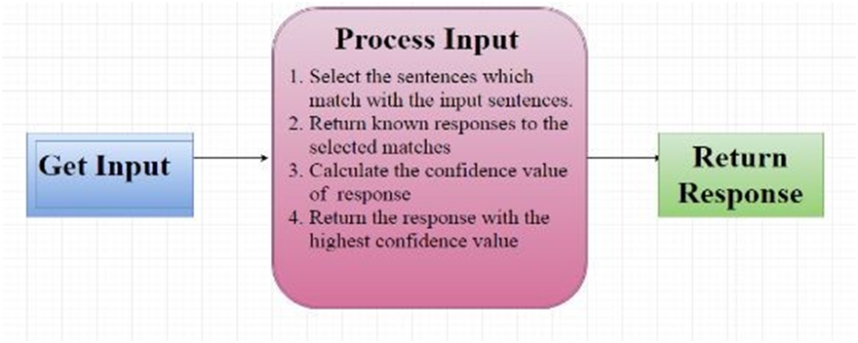

**Fig.1** **Schematic diagram of the workflow of the proposed system**

9

2. We will process the received input. The input statement will be processed by an algorithm, which will find the best likelihood valued response for the query. The algorithm will select all the known statements that most closely match the input statement. It will return the known responses to the selected match and a confidence score value based on matching after computation of each of the responses. Here, the confidence score is the likelihood value of the response. The algorithm will return the response that generated the highest likelihood value for itself.

3. Finally, the response to the input will be returned to the user. For successful completion of user goals, it is also necessary to equip the dialogue policy with real-world knowledge from a database.

## 2.2 Chatterbot

Based on machine learning, Chatterbot is a conversational dialog engine powered by Python, which is capable of giving responses based on a knowledge base. Since Chatterbot has no language dependency in its design, it is allowed to be trained to speak any language.

It is a Python library that makes it easy to generate automated responses to a user’s input for the creation of chatbot in any language. To produce different types of responses,

Chatterbot applies a selection of machine learning algorithms. This very feature makes it easy for developers to create chatbots and automate conversations with users.

An untrained instance of Chatterbot starts off with no knowledge of how to communicate. Each time a user enters a statement, the library saves the text that they entered and the text that the statement was in response to. As ChatterBot receives more input, the number of responses that it can reply and the accuracy of each response in relation to the input statement increase.

The program selects the closest matching response by searching for the closest 5 matching known statements that match the input; the chatbot then chooses a response from the selection of known responses to that statement.

## 2.3 Implementation

For the implementation of Bangla chatbot, we have to go through some steps

sequentially.

1. The required environmental setup to run the JSON has been done in

our laboratory.

2. We prepare a Bengali corpus for building up the knowledge base of the

system.

3. There is a particular format to input data in the JSON storage, so we

have to format the corpus in that format.

4. We write a program which simulates Bangla Chatbot for Rural Bank.

CHAPTER III

# DATA COLLECTION AND CORPUS

# 3.1 Data Collection & Corpus

In the development of our chatbot for the project, it was imperative to collect responsiveness. To accomplish this, a comprehensive data collection strategy was employed, focusing on Bengali language interactions to align with the project's linguistic context.

The information gathering process involved extracting conversations, queries, and responses in Bengali from various sources, including online forums, social media, and domain-specific texts. The collected data was then structured and organized in a JSON (JavaScript Object Notation) format. JSON was chosen for its simplicity, ease of readability, and widespread compatibility with programming languages.

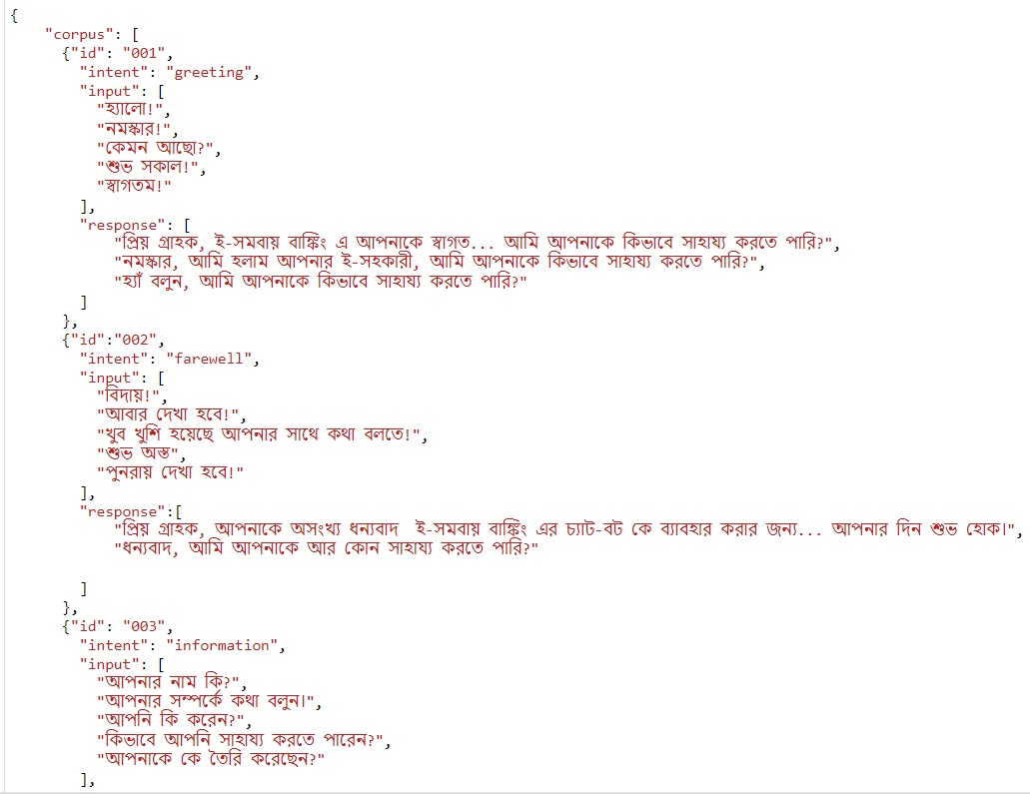

**Fig.2.a Demo of our corpus (bangla_corpus_new.json)**

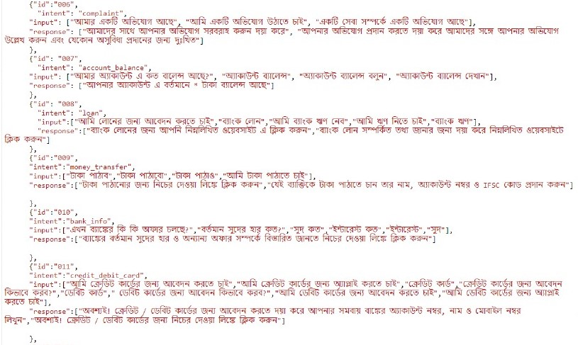

**Fig.2.b Demo of our corpus (bangla_corpus_new.json)**

This structured corpus became the backbone of our chatbot's training dataset, enabling the machine learning model to comprehend and respond effectively to user inputs in Bengali. The incorporation of a Bengali-language corpus not only reflects our commitment to linguistic diversity but also ensures that the chatbot is tailored to the specific needs and nuances of Bengali speakers.

# 

# 

# 

# 3.2 Training

For our implementation, we used the List Trainer Class of Chatterbot. First, we have to create a Bangla corpus and add the folder with the Bangla Chatbot with a predefined JSON format. From here, we start training our model. Here, we are providing snippet of the code:

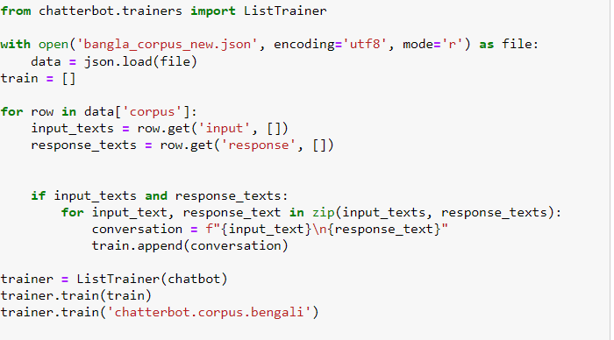

**Fig.3 Code Snippet of the Bengali Chatterbot’s Training Class**

**CHAPTER IV**

# ADAPTERS & FLOW CHART

## 4.1 Storage Adapters

ChatterBot comes with built-in adapter classes that allow it to connect to different types

of databases. For our implementation, we will be using the SQL Storage Adapter, which is

a simple storage adapter that stores data in a JSON formatted file on the hard disk.

This functionality makes this storage adapter very good for testing and debugging.

## 4.2 Input Adapters

ChatterBot’s input adapters are designed to allow a chat bot to have a versatile method

of receiving or retrieving input from a given source. After getting input, the main job is

to classify the text as a known or an unknown statement and pass it to the logic adapter

after labeling the sentence as “known” or “unknown”. The goal of an input adapter is to

get input from some source and then to convert it into a format that ChatterBot can

understand.

## 4.3 Logic Adapters

Logic adapters determine the logic for how ChatterBot selects responses to a given

input statement. The logic adapter that your bot uses can be specified by setting

the logic_adapters parameter to the import path of the logic adapter you want to use.

The logic_adapters parameter is a list of logic adapters. In Chatterbot, a logic adapter is a

class that takes an input statement and returns a response to that statement.

15

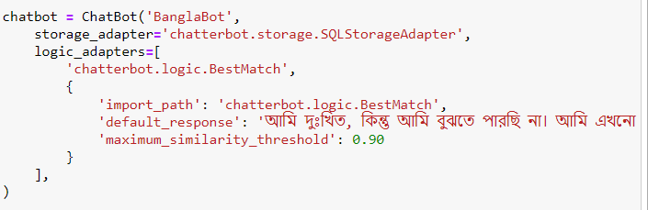

**Fig.4 Code Snippet of the Adapters used**

# 4.2 Flowchart

For interaction, first the system shows some options, and accordingly the user chooses a

suitable one, and then the input adapters take it and send it to the logic adapters for

proper choice of replies. The response which gets the maximum threshold is returned to

the user as response. If more logic adapters are added, the confidence rate increases.

Here, we are providing a basic workflow of our Chatbot.

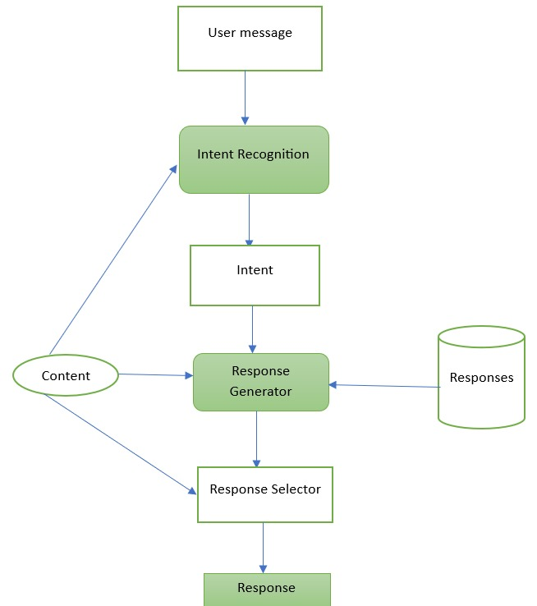

**Fig.5 Schematic diagram of the workflow of the proposed system**

CHAPTER V

# WEBSITE

# 5.1 HTML

For creating a chatbot website we integrated HTML, CSS, and JavaScript to design the

user interface and implement the chatbot functionality.

The HTML document defines the basic structure of our webpage. Create a container for

the chat interface. This container holds the chat messages, input field, and send button. Set

up divisions for displaying messages, user input, and the send button.

# 5.2 CSS

CSS is used for styling our chat container, messages, input field, and button to create

an appealing interface. Styles are set for the incoming and outgoing messages,

differentiate them visually.

CSS Flexbox or Grid has been used to arrange the elements in a clean and organized way.

## 5.3 JavaScript

JavaScript functions are used to handle user input, send messages, and receive responses

from the chatbot. It is used for providing options with clickable access and providing

responses to the user.

Below is a general description of the steps:

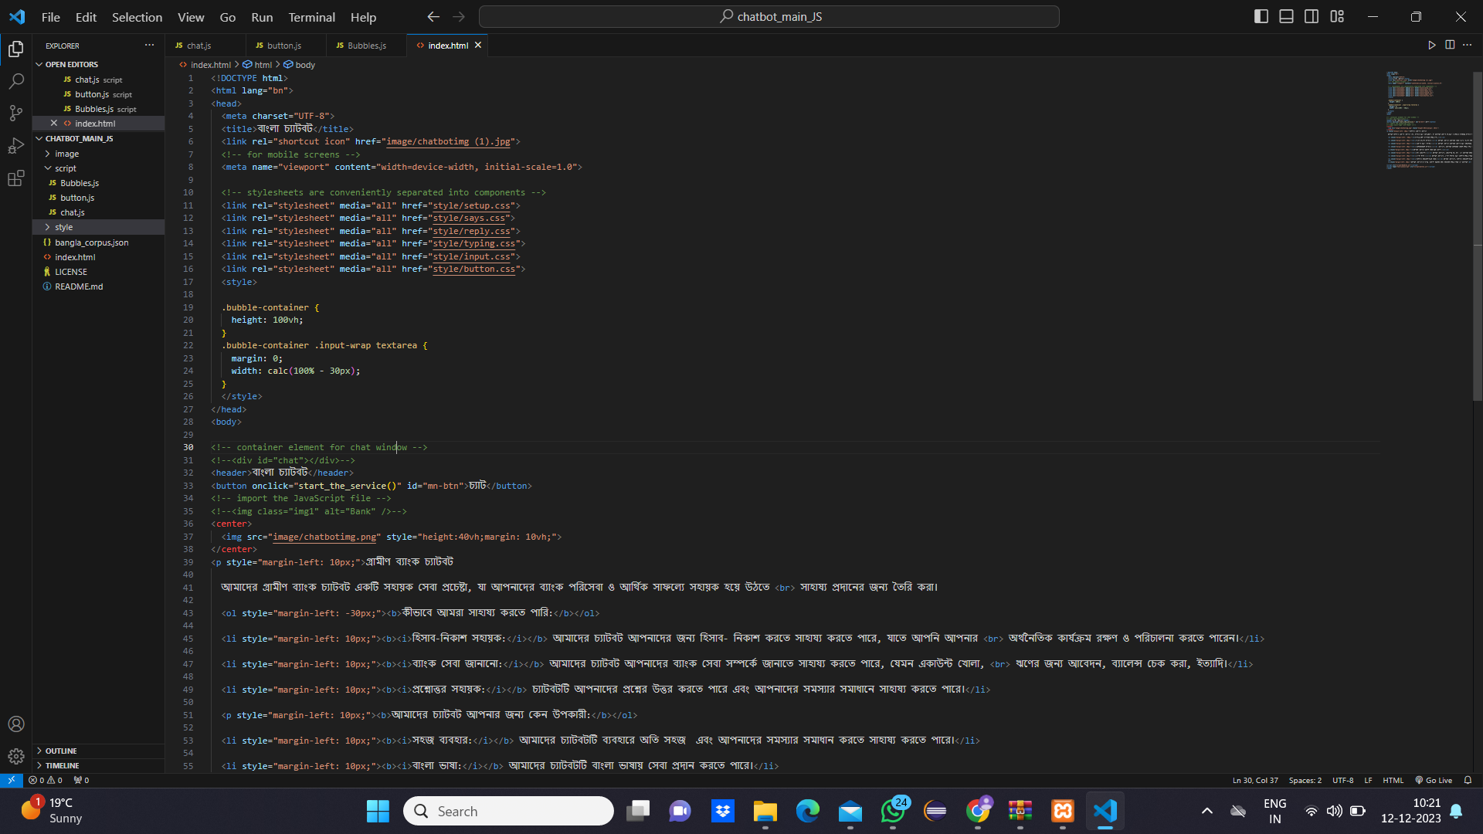

**Fig.6 The index page of the proposed system called index.html**

**1**

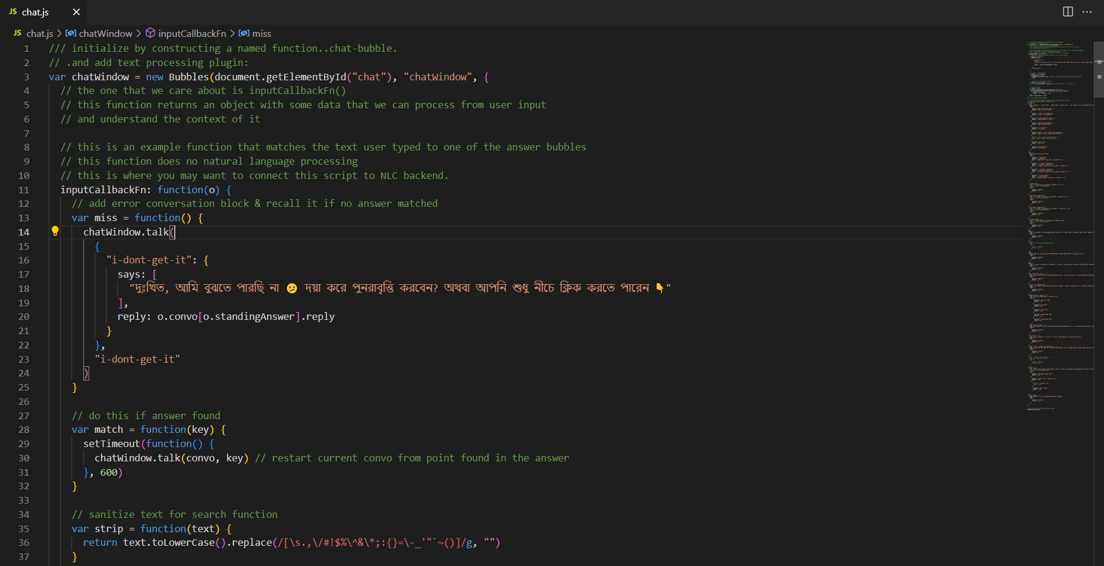

**Fig.7.a The index page of the proposed system called chat.js**

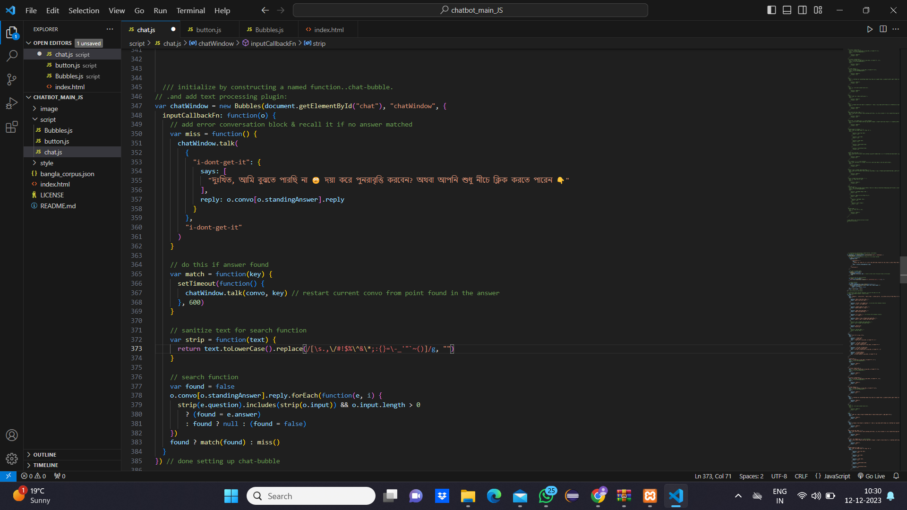

**Fig.7.b The index page of the proposed system called chat.js**

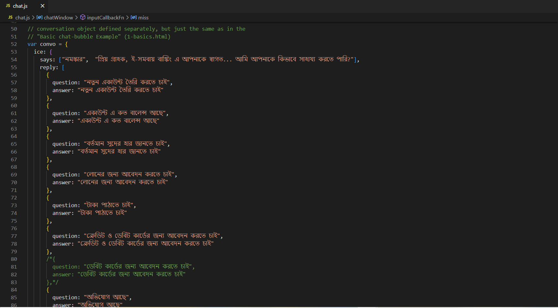

**Fig.7.c The chat page of the proposed system called chat.js**

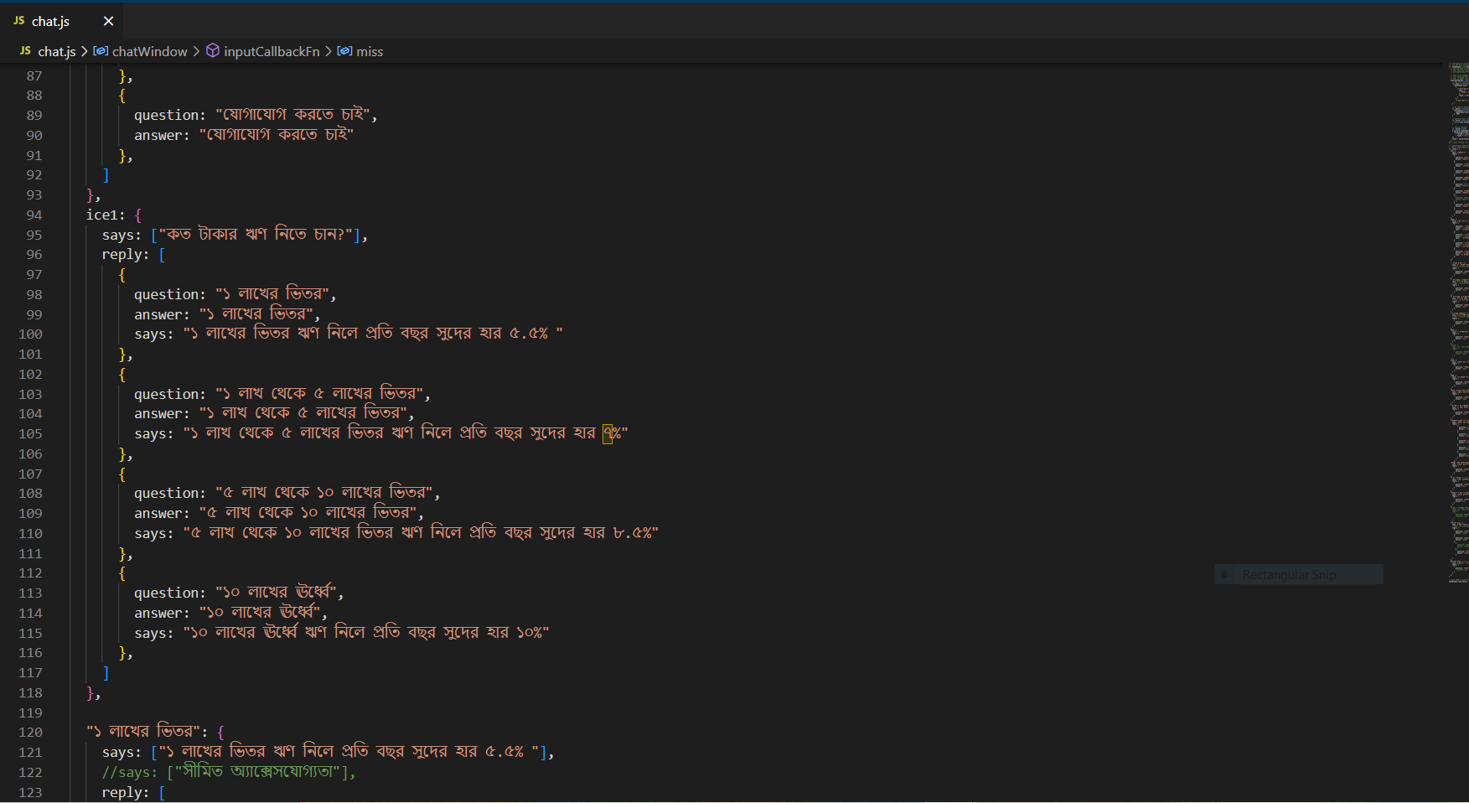

**Fig.7.d The chat page of the proposed system called chat.js**

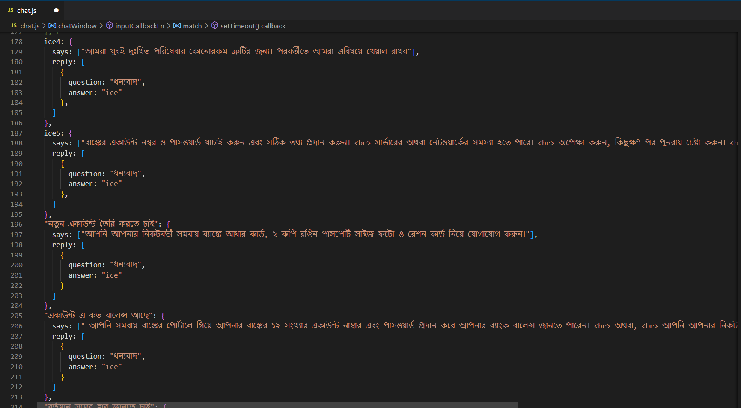

**Fig.7.e The chat page of the proposed system called chat.js**

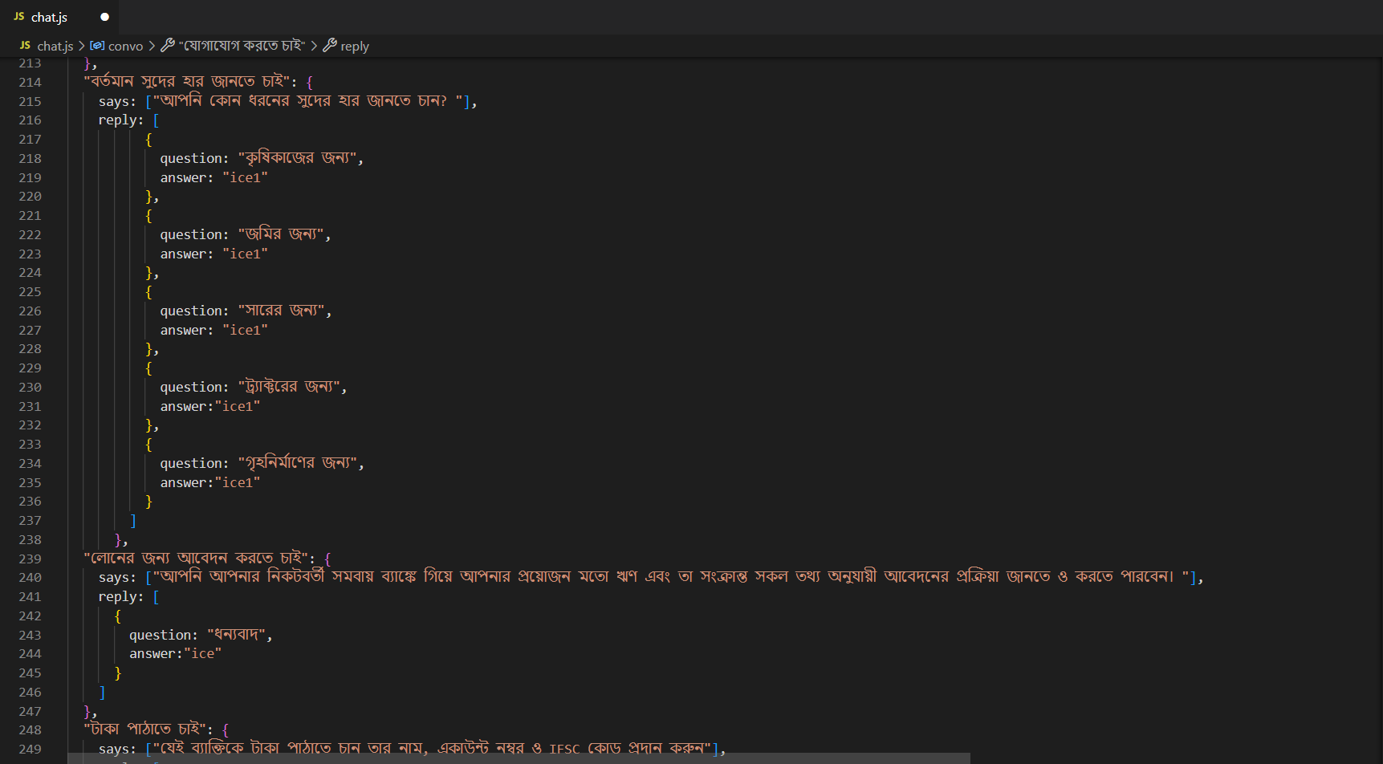

**Fig.7.f The chat page of the proposed system called chat.js**

**USE CASE DIAGRAM**

**19** 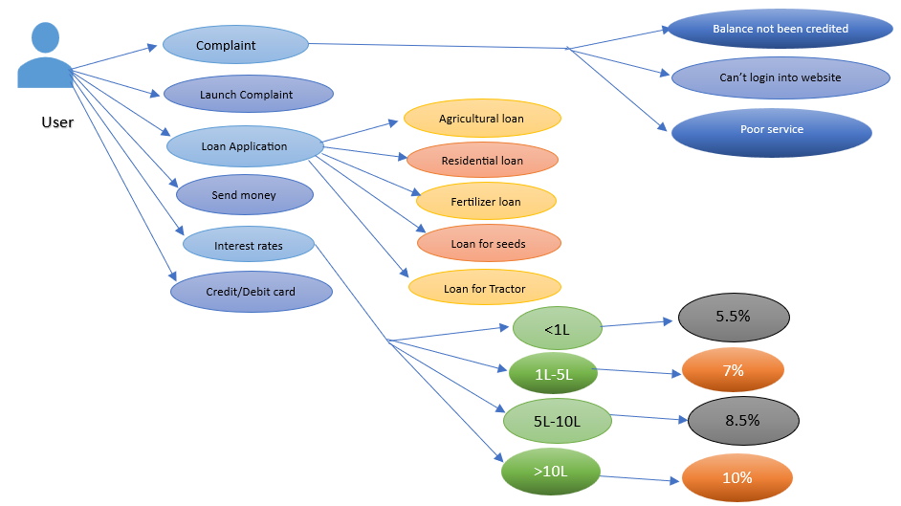

**Fig.8 Use case diagram depicting the process flow of Chatbot**

CHAPTER VI

# FINAL LOOK

The final look of our chatbot website is a seamless blend of modern design and intuitive functionality. The user interface is clean and inviting, featuring a well-organized layout that ensures a user-friendly experience. The color scheme is carefully chosen to be visually appealing, and the typography is both clear and readable. The website is responsive, ensuring a seamless transition between different devices and screen sizes.

At the right of the webpage is the chatbot interface, providing users with a conversation-like experience. The chat window is neatly designed, with chat bubbles for the user and the bot, making it easy to distinguish between messages. The overall design reflects a balance between simplicity and sophistication, creating an inviting space for users to interact with the chatbot effortlessly.

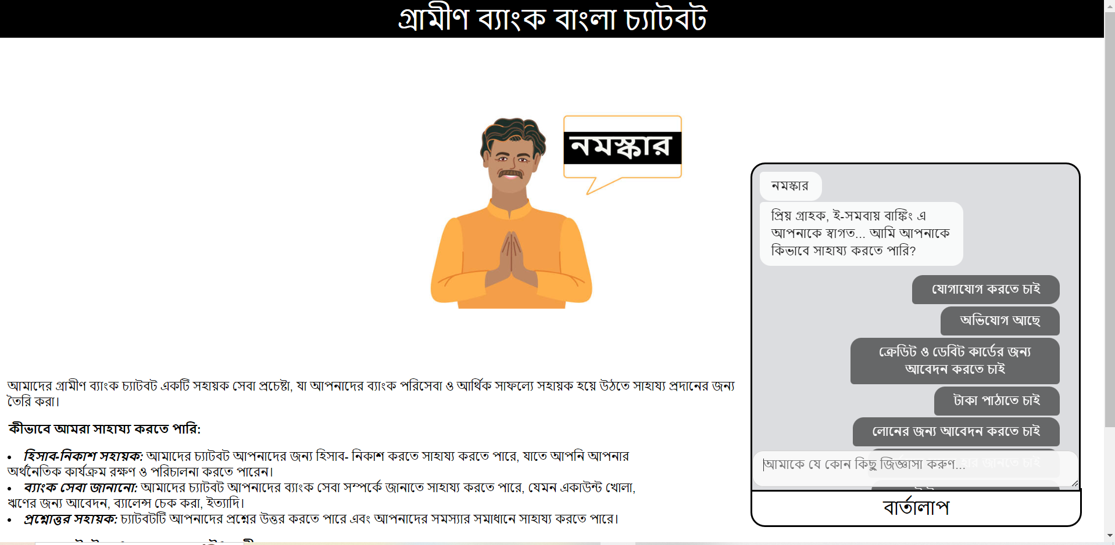

**Fig.9** **Bangla ChatBot for E-Governance of Rural Banking**

## 6.1 Interactions

The interaction is tailored to cater to the specific needs and challenges of individuals in rural areas. The chatbot is designed to provide a user-friendly and accessible interface, ensuring that even those with limited digital literacy can comfortably engage with the platform.

Upon entering the website, users are greeted with a warm and inviting message, guiding them through the available services. The chatbot employs straightforward language and employs visual elements to facilitate understanding. The primary goal is to create a seamless experience, allowing users to easily inquire about account balances, transaction history, and other banking-related information.

## 6.2 Interaction snippets for interest rate query

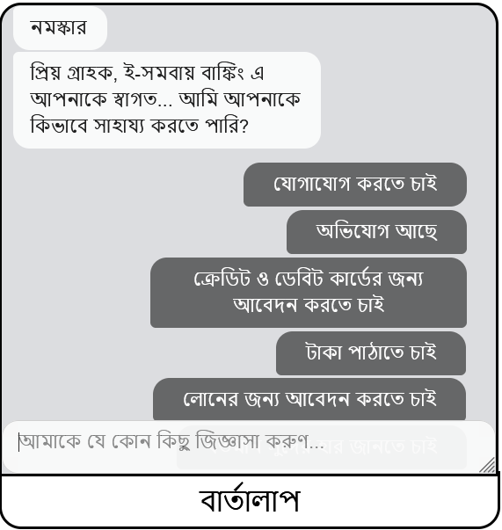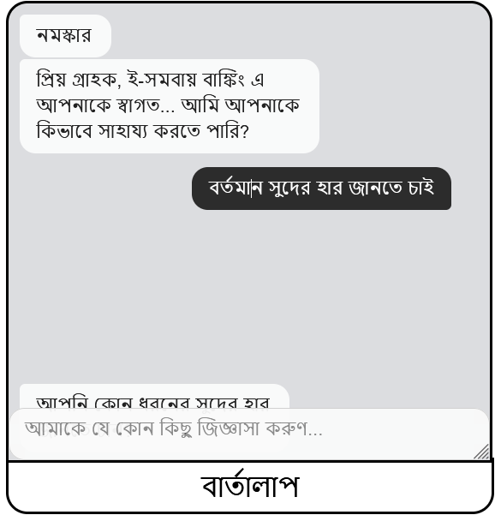

**Fig.10.a** **Interaction procedure Fig.10.b** **Interaction procedure**

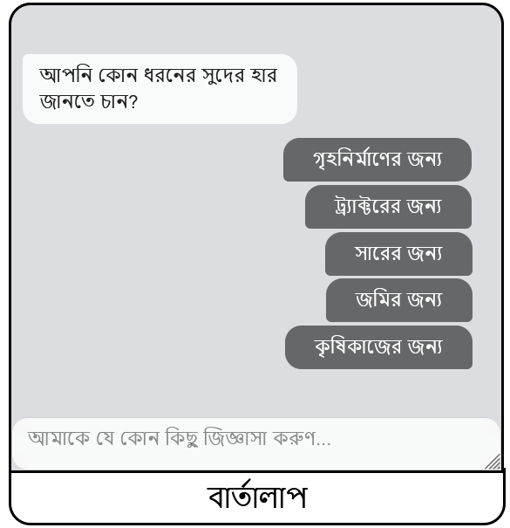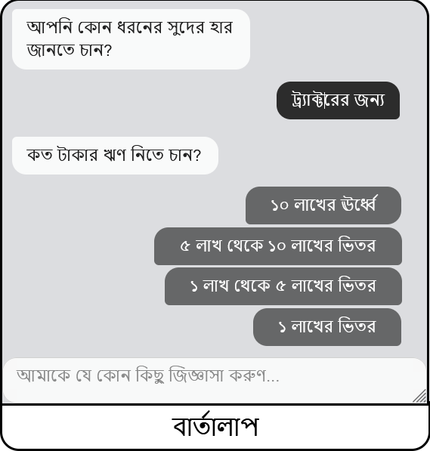

**Fig.10.c** **Interaction procedure Fig.10.d** **Interaction procedure**

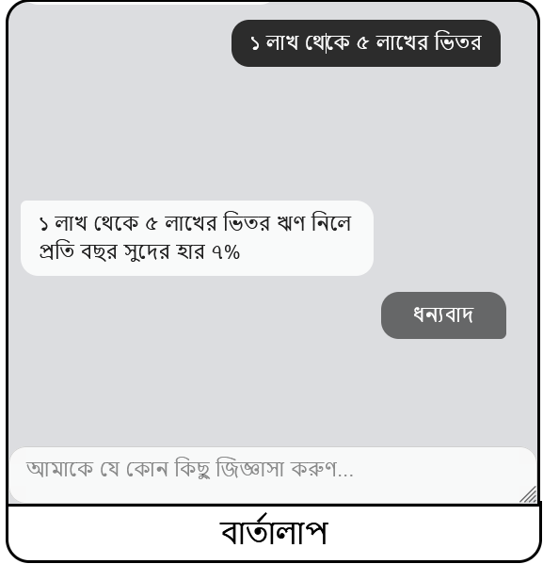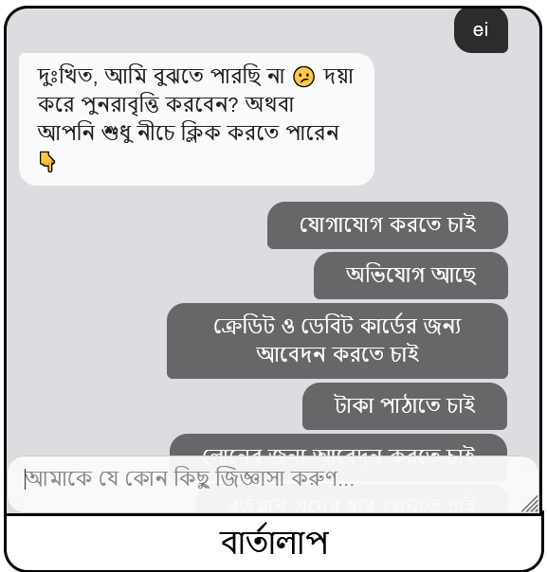

**Fig.10.e** **Interaction procedure Fig.10.f** **Interaction procedure**

## 6.3 Interaction snippets for complaint query

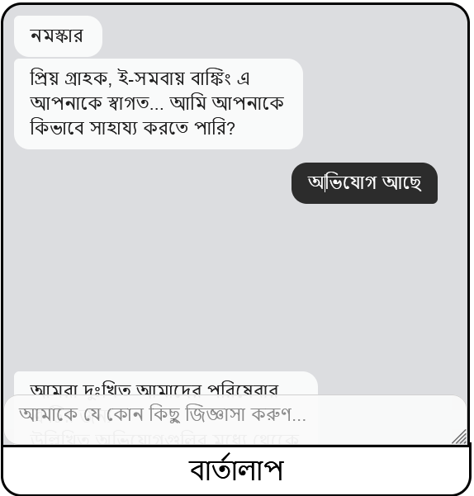 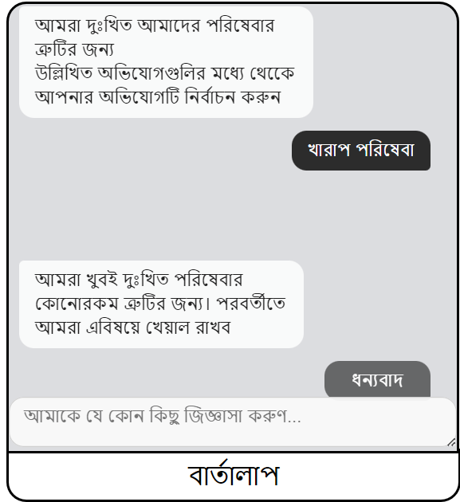

**Fig.11.a** **Interaction procedure Fig.11.b** **Interaction procedure**

## 6.4 Interaction snippets for basic query

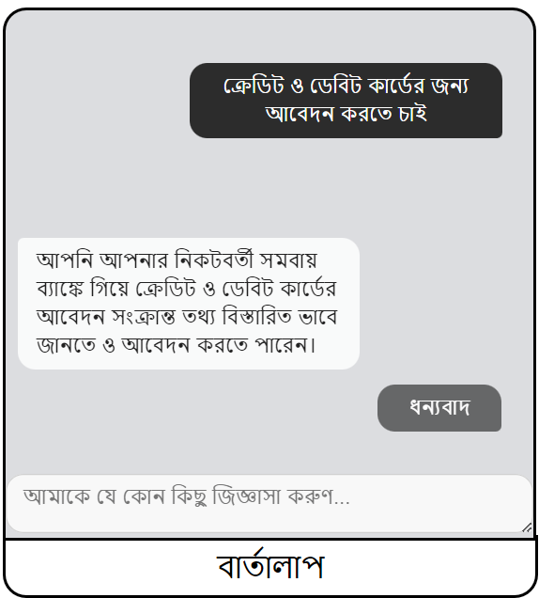

**Fig.11.c** **Interaction procedure Fig.11.d** **Interaction procedure**

CHAPTER VII

# TECHNOLOGIES USED

## 7.1 Editors used to write code

Jupyter Notebook

Visual Studio Code

## 7.2 Tools used for dataset creation

JSON file

**7.3** **The code is written in**

### Python:

Chatterbot

BNLP

BNLTK

### Web development:

Javascript

HTML

CSS

CHAPTER VIII

# CONCLUSION

Creating a Bangla chatbot holds significant potential for enhancing communication and accessibility in the Bengali-speaking community. As technology continues to evolve, integrating a chatbot capable of understanding and responding in Bangla can facilitate smoother interactions, provide information, and offer support in various domains.

This attempt is significant work in the field of dialogue systems in Bengali. The main challenge of this work is to create a chatbot based on an accurate knowledge base. Due to the lack of a large dataset, we implemented a retrieval based closed domain chatbot which will converse with the user based on the pattern matching algorithm and will improve its performance measure by learning from the interaction. Our work will provide a Bengali conversation corpus which will help in the development of tools for Bengali Language Processing research.

By leveraging natural language processing and machine learning, a Bangla chatbot can adapt to diverse user inputs, making it a valuable tool for businesses, customer service, education, and more. The chatbot can bridge language barriers, making information and services more accessible to a wider audience.

However, successful implementation requires careful consideration of linguistic nuances, cultural context, and user expectations specific to the Bengali language. Regular updates and improvements based on user feedback are essential to ensure the chatbot remains relevant and effective.

In conclusion, a Bangla chatbot has the potential to revolutionize communication and enhance user experiences for Bengali speakers. Its successful development and deployment depend on a thorough understanding of the language and its users, coupled with ongoing refinement to meet evolving needs in the digital landscape.

CHAPTER IX

FUTURE SCOPE

* One aspect to enhance the knowledge base of Bangla ChatBot is to host it on an

E-Governance platform.

* To adopt AI-enabled smart chatbots that will be designed to simulate

near-human interactions with customers

* To incorporate speech recognition in bengali

* To include a mechanism to produce pictorial representation for better understanding

for people with low literacy

* To enhance sensible responses, systems may need to incorporate linguistic context
* To incorporate such mechanism that will provide some related links along with

the response that will help users to get more detailed information

* To incorporate learning mechanisms into the system so that it can cater to user’s

off-go needs

CHAPTER X

**REFERENCES**

1. Implementation Of a Bangla Chatbot, supervised by Dr. Mahbub Alam

Majumdar, Department of Computer Science and Engineering, BRAC

University, April 2017.

**2.**<https://www.researchgate.net/publication/358157013_Transformer_Based_Bengali_Chatbot_Using_General_Knowledge_Dataset>

**3.** <https://www.youtube.com/@codebasics>

**4.** <https://simpletransformers.ai/>

**5.** <https://app.banglachatbot.com/>

**6.** <https://chatterbot.readthedocs.io/>

**7.** https://www.academia.edu/42249889/Bengali_Informative_Chatbot