Author Bio:
Comparing Parallel Functional Array Languages:
Programming and Performance

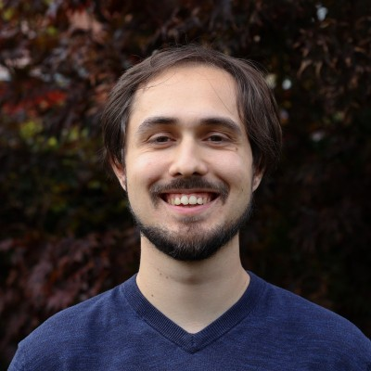

David van Balen is a scientific programmer at the University of Twente, where he's working on model-based testing. His Ph.D. at Utrecht University is on fusion systems for functional array languages.

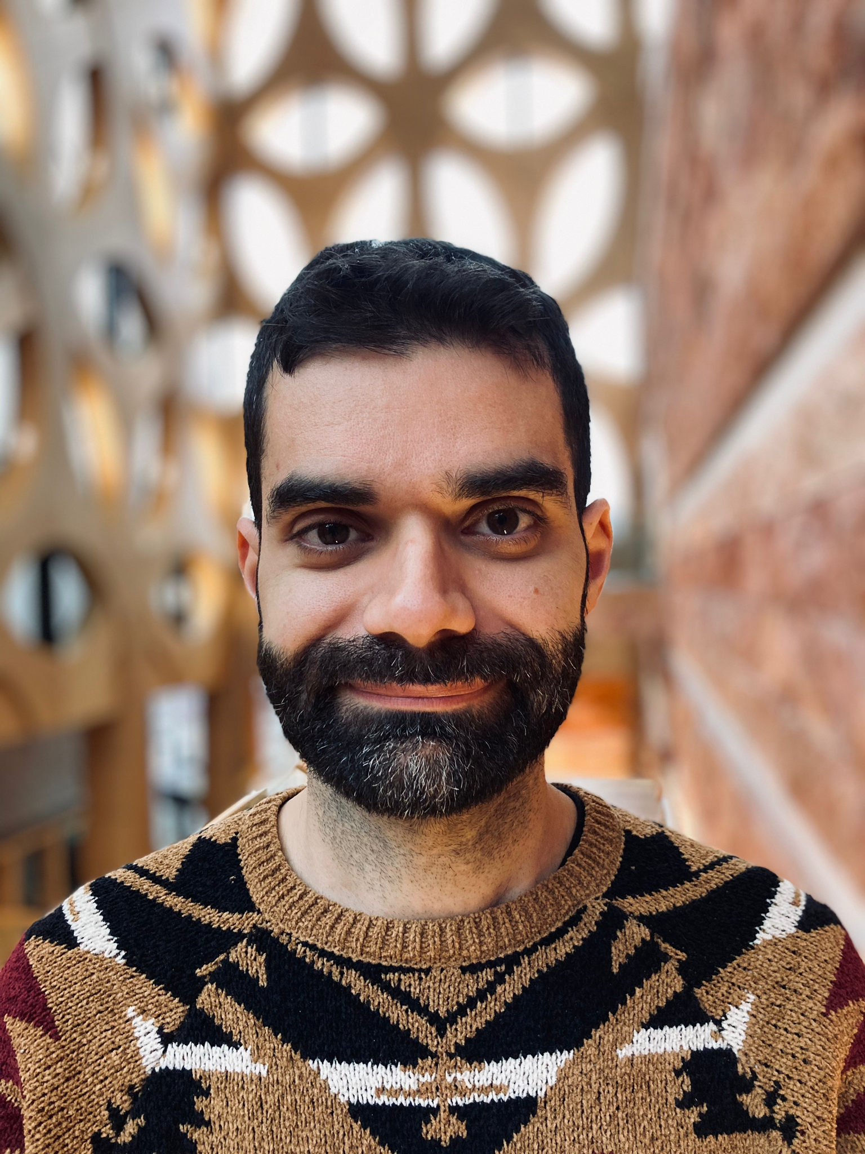
Tiziano De Matteis is an Assistant Professor at the Computer Science Department of Vrije Universiteit Amsterdam. His principal research interests are related to Parallel and Distributed Computing, with a focus on systems and programming models for spatial and reconfigurable computing for HPC, post-Moore architectures, and sustainability in modern computing systems.

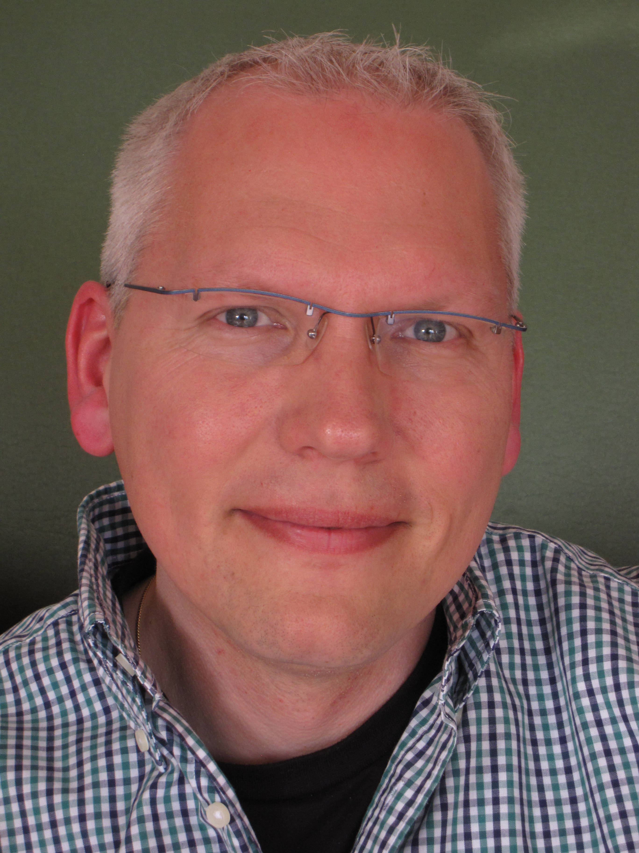
Clemens Grelck is a (full) professor for system software at Friedrich Schiller University Jena, Germany. After obtaining his PhD from the Unversity of Kiel in 2001, he held academic positions at the University of L\"ubeck, the University of Hertfordshire and the University of Amsterdam. His research interests are in high-level (functional) parallel programming, programming language design and implementation, compiler optimization and adaptive runtime systems. He is a co-designer of and long-term contributor to the SaC programming language.

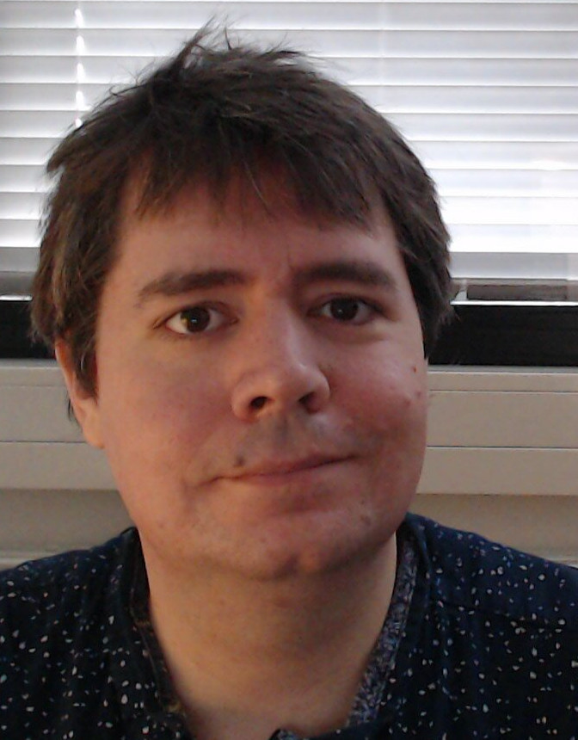

Troels Henriksen is a tenure-track assistant professor at the University of Copenhagen, where he conducts research into all aspects of data parallelism, including algorithms, language design, and compiler optimisations.

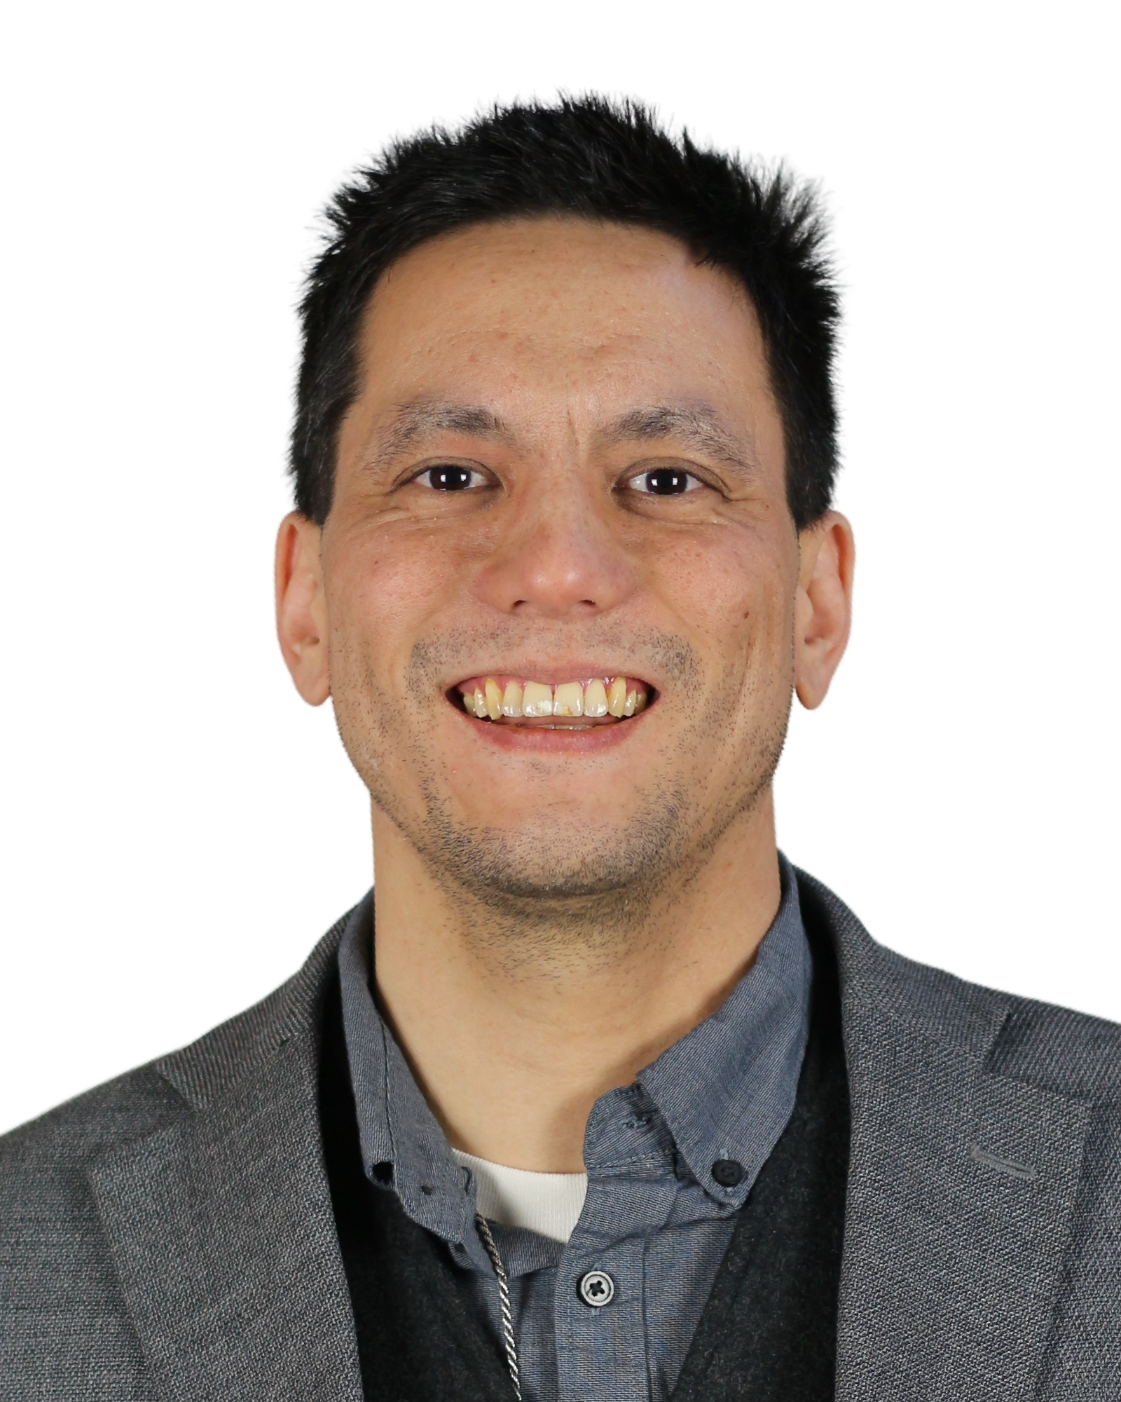
Aaron Hsu is a researcher at Dyalog, Ltd. specializing in human-centered programming languages. He focuses on APL and Iversonian languages, particularly compilers and the impact of such languages on how humans understand, communicate, and work with computational domains. His work includes a data-parallel compiler for APL written in APL, called Co-dfns, which is intended to be self-hosted on the GPU.

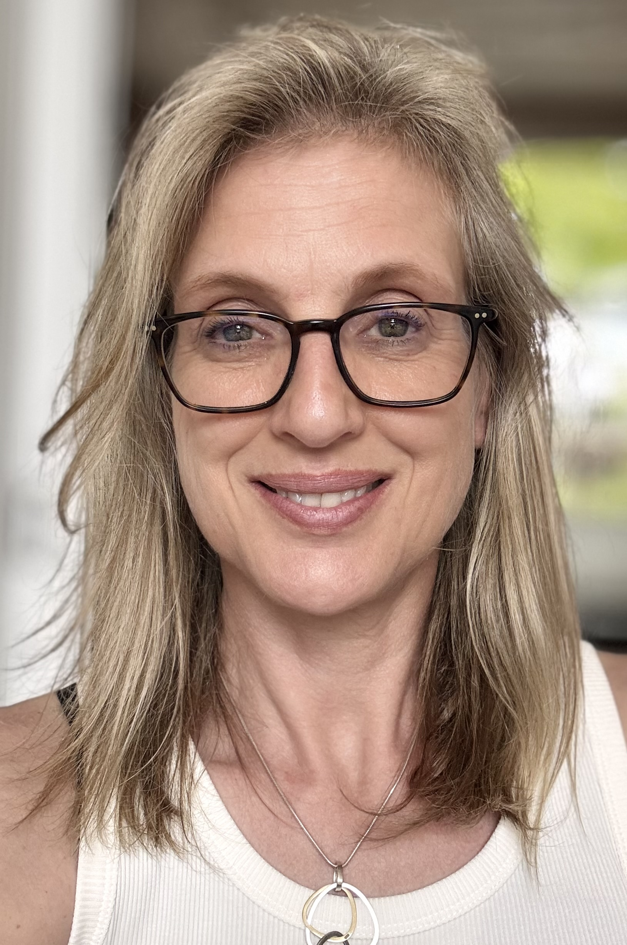
Professor Gabriele Keller is the chair of the Software Technology Group at Utrecht University in the Netherlands. Her research is on type systems, programming languages, in particular functional and parallel languages, as well as verified compilation. She is also interested in the application of programming language research, which has led to publications in journals outside of computer science, such as Springer Nature Communications Earth and Environment, Elsevier Signal Processing, and Macromolecular Theory and Simulation, in addition to publications programming language conferences and journals.
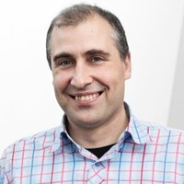
Cosmin Oancea is an Associate Professor with DIKU, University of Copenhagen. His research is focused on language and compiler technology for parallel architectures. He has designed analyses ranging from static to dynamic in compilers of imperative and functional languages such as Polaris and Futhark. As well, he has contributed to inter-disciplinary projects aimed at high-performance implementation of algorithms from remote sensing, financial pricing, ML, and computer algebra.

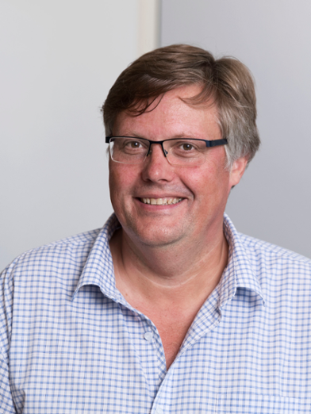
Prof. Sven-Bodo Scholz holds a chair in Software Science at Radboud University, Nijmegen, Netherlands. Sven-Bodo Scholz's expertise spans from programming languages across compiler technology to High-Performance Computing. His research is primarily driven by the goal to develop compiler technology that enables the creation of tools that combine high-productivity of programmers with high-performance executions on a wide variety of parallel hardware platforms. This has led to numerous contributions, theoretical as well as practical, that affect the interplay of these goals. He is a key contributor to the design and implementation of the functional data-parallel array programming language SaC which has served as demonstrator vehicle throughout various projects with academic as well as with industrial partners.

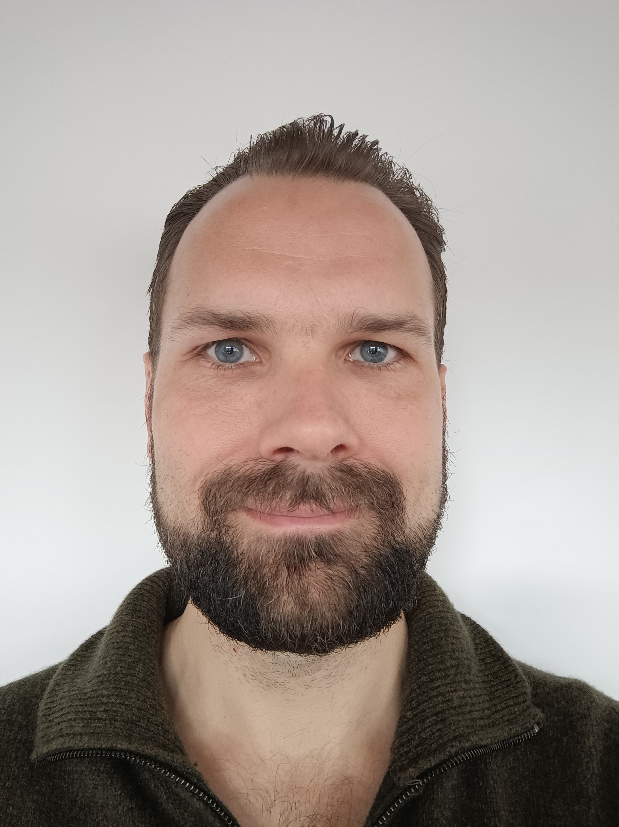
Dr. Artjoms Sinkarovs is an Assistant Professor at the University of Southampton. His expertise spans type theory, high-performance computing, and compiler technology. His key research interest lies in applying dependent type theory to high-performance programming languages to achieve both formal correctness and efficient execution on parallel architectures. He develops research systems in which the Agda programming language serves as a frontend for specifying correct-by-construction array programs, which are then translated into array languages such as SaC or Futhark for high-performance execution.

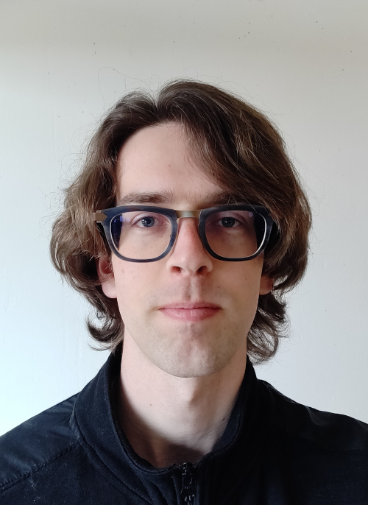
Tom Smeding is a postdoctoral research associate at the University of Edinburgh with research interests in compilers, functional programming, program optimisation and array programming. His Ph.D. at Utrecht University was on automatic differentiation for functional array languages. His current research is on optimisation techniques for array programs with statically known sparse structure.

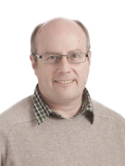
Professor Phil Trinder has been an active researcher in parallel and distributed technologies for over 30 years. He has been an investigator on 20 major research projects. Professor Trinder holds a DPhil from Oxford University and has over 140 publications in journals, books, or refereed conferences. Professor Trinder’s key research interest is in designing, implementing, and evaluating high-level distributed and parallel programming models. For example he co-designed and co-implemented Glasgow parallel Haskell, and works on improving the scalability of, and tooling for, Erlang.

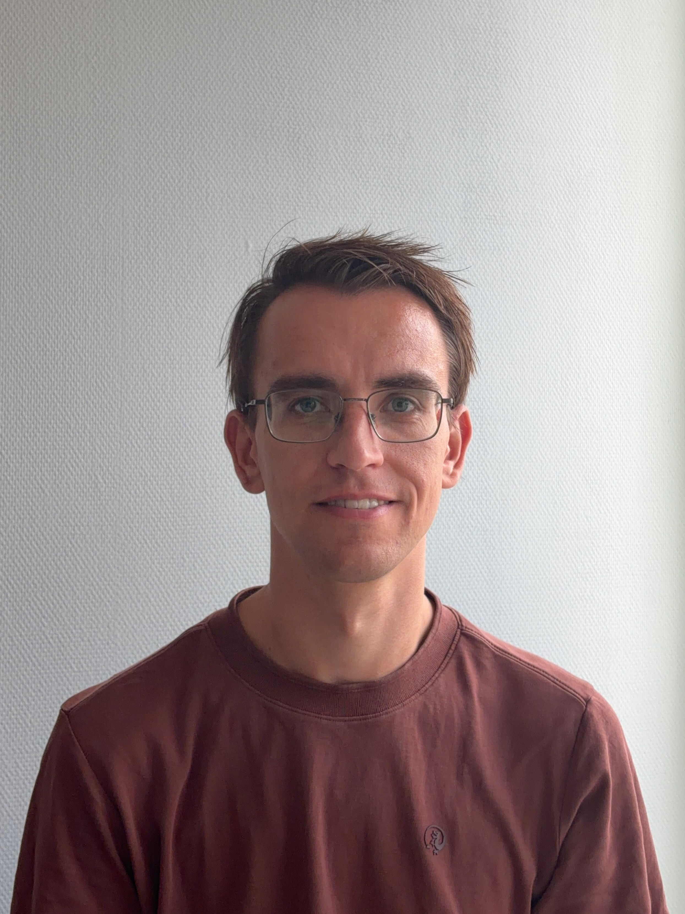
Ivo Gabe de Wolff is a lecturer at Utrecht University and developer of Accelerate. He researches parallel algorithms and runtimes to improve their scalability and reduce their overhead. He applies this in a new version of the Accelerate, working both on its compiler and its runtime systems.

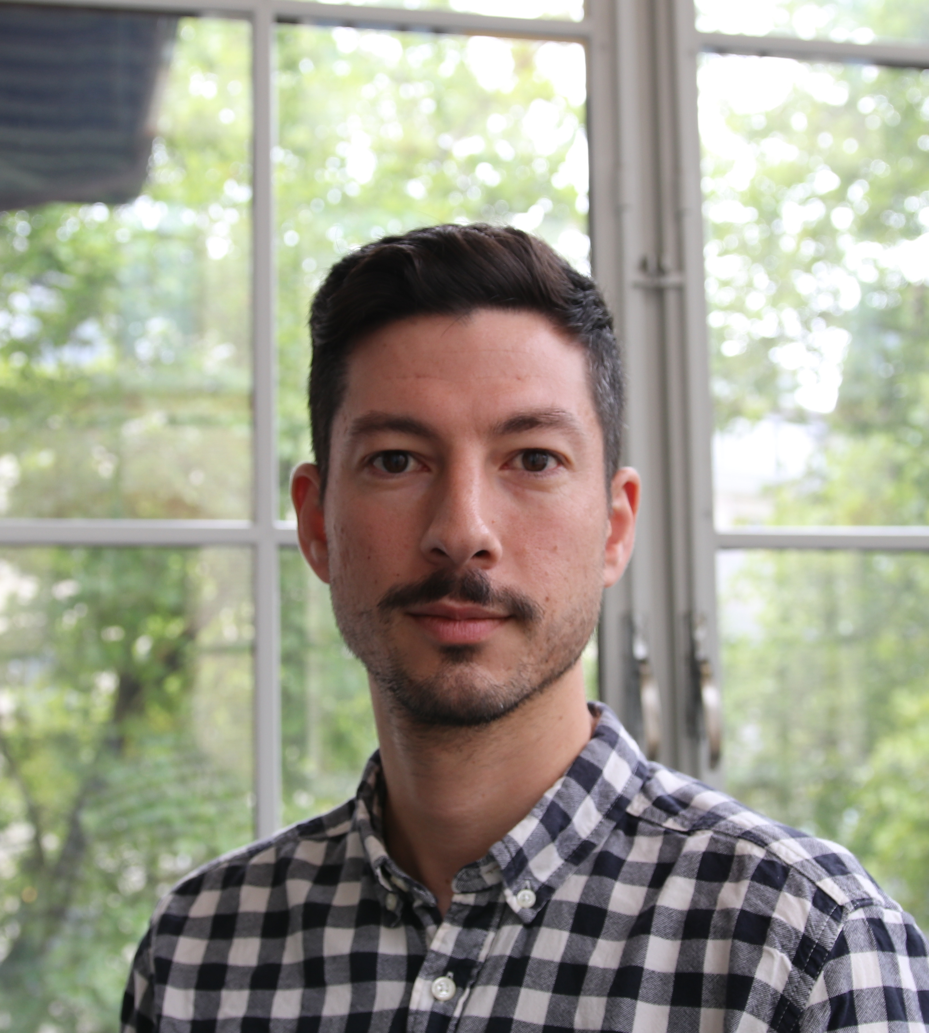
Alexandros Nikolaos Ziogas is a postdoctoral researcher at ETH Zurich. His research interests lie in algorithms, programming models, performance modeling, and performance optimization for high-performance computing and how these apply to relevant scientific applications, such as computational nanoelectronics. His work has been recognized with the ACM Gordon Bell Prize (2019, 2025).

