Calibrating the Camera and Drone

Camera Calibration:

Output of USB cameras have a fish-eye effect. However, this is undesirable as it affects the
Whycon coordinates. We need a flat image output from the USB camera and hence it is
necessary to calibrate the USB camera. Notice the difference between Figure 1 and Figure 2.
Figure 2 is the desirable image frame we need.

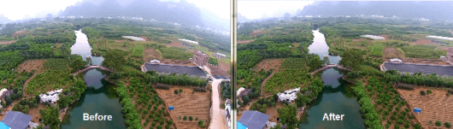
Camera Calibration Process:
1. You will need a checkerboard in order to calibrate your camera. Print out the image
given in checkerboard.pdf. This tutorial uses an 8x6 checkerboard with 108mm squares.

2. You must install the camera calibration package in ROS. Open a terminal and type the
following commands:
1. rosdep install camera_calibration
2. sudo apt-get install ros-indigo-image-proc

3. Once completed, run the following two commands on separate terminals:
1. roslaunch usb_cam usb_cam-test.launch
2. rostopic list

You should see “/usb_cam/image_raw” and “/usb_cam/camera_info”. If you face any
difficulties, refer Camera_testing.pdf of Hardware Testing.

4. Next, run the following command in another terminal: (singal line command)
rosrun camera_calibration cameracalibrator.py --size 8x6 --square 0.108 image:=/usb_cam/image_raw camera:=/usb_cam

5. You should now see a new window shoing figure with fish eye effect.

6. Hold up the checkerboard in front of the camera. A zig-zag line should be displayed on
the checkerboard. You must now complete the following calibrations using the given
steps:
a. X axis – Move the checkerboard left to right and right to left.
b. Y axis – Move the checkerboard top to bottom and bottom to top.
c. Size – Move the checkerboard close to away and away to close from the
camera.
d. Skew – Tilt the checkerboard in all directions.

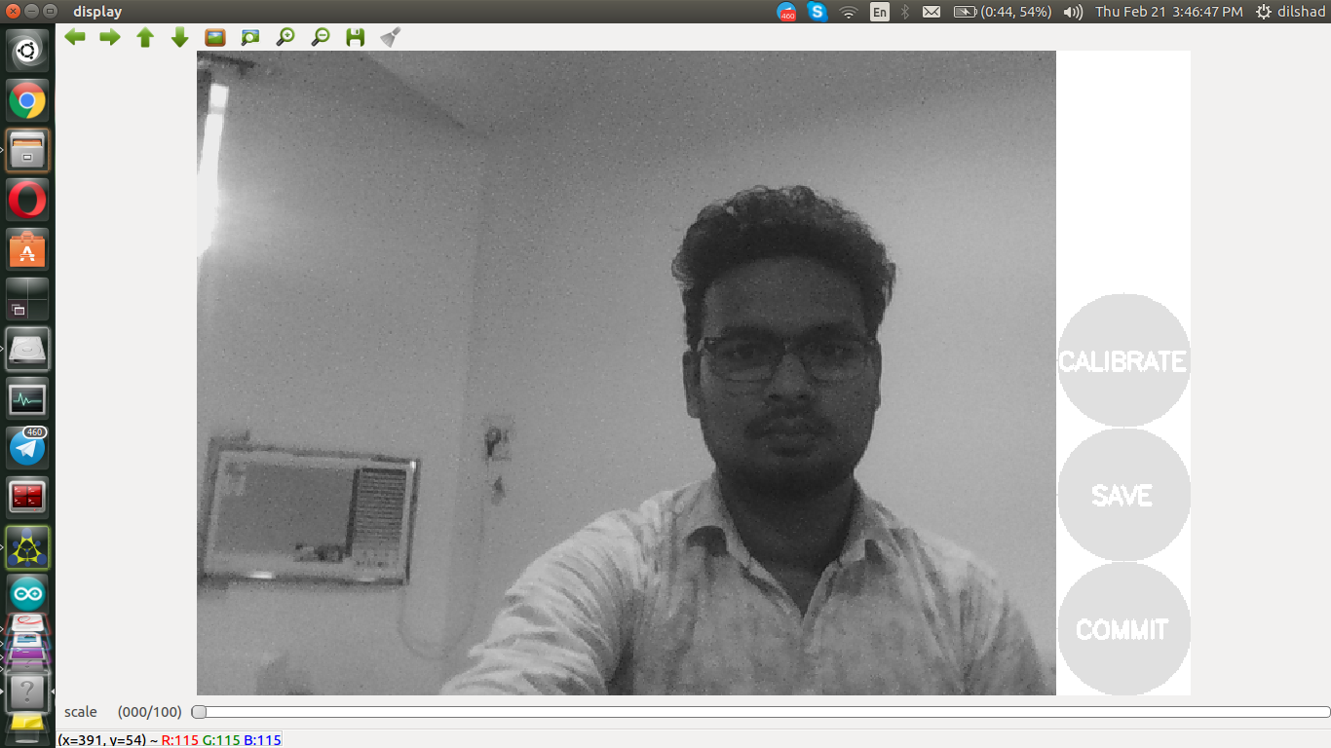
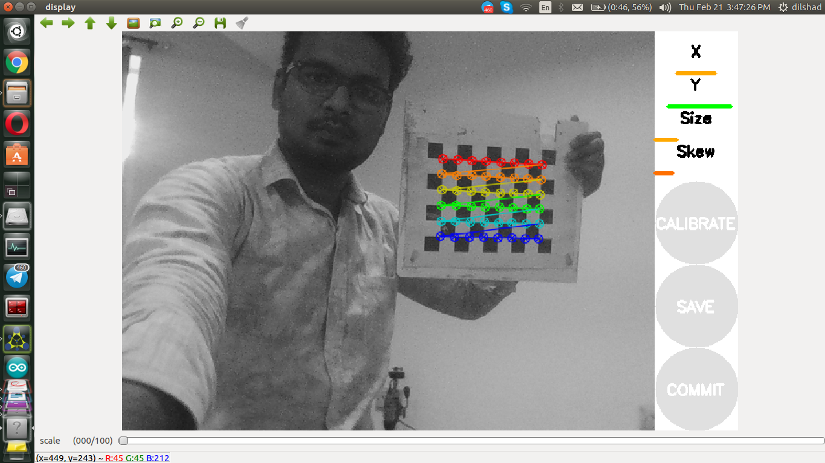

8. Perform the above process till „CALIBRATE‟ button is highlighted. Once
„CALIBRATE‟ button is highlighted, click the button in order to calibrate the camera.
Note: This calibration process takes time, it might appear your computer is stuck, but
that is not the case, have patience.
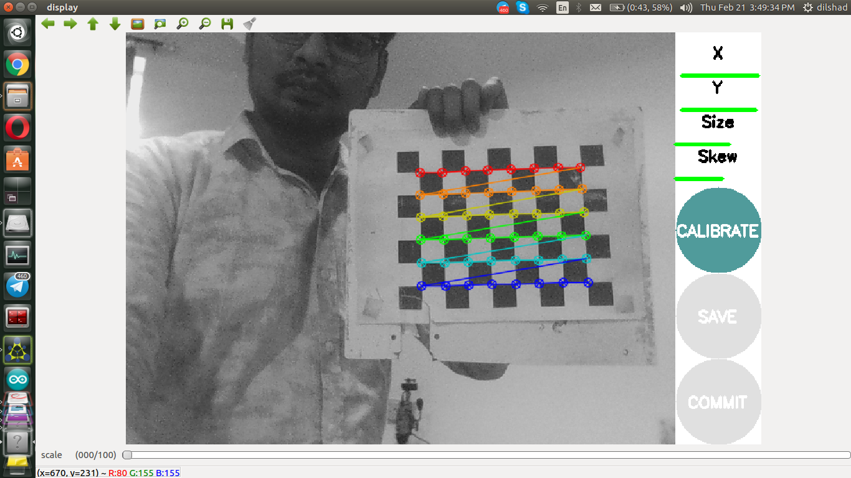

9. Once calibration is complete, „SAVE‟ and „COMMIT‟ buttons get highlighted. Click
„SAVE‟ and then „COMMIT‟.
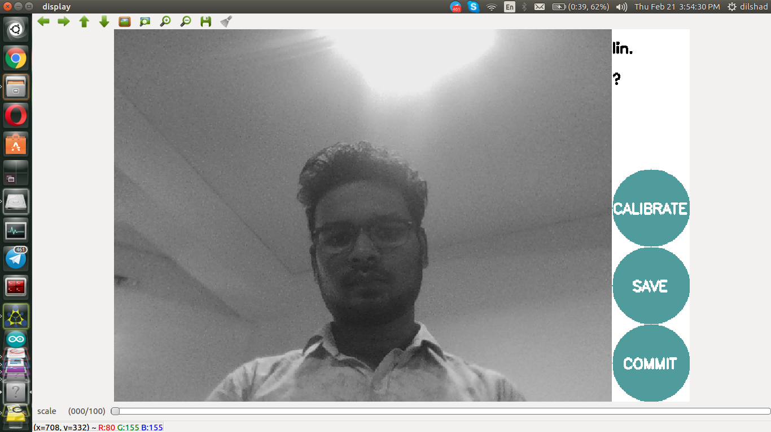

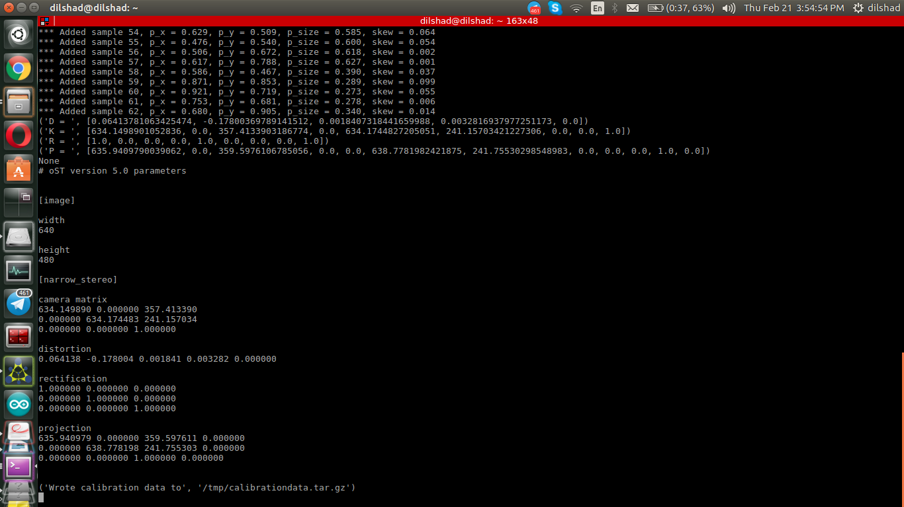

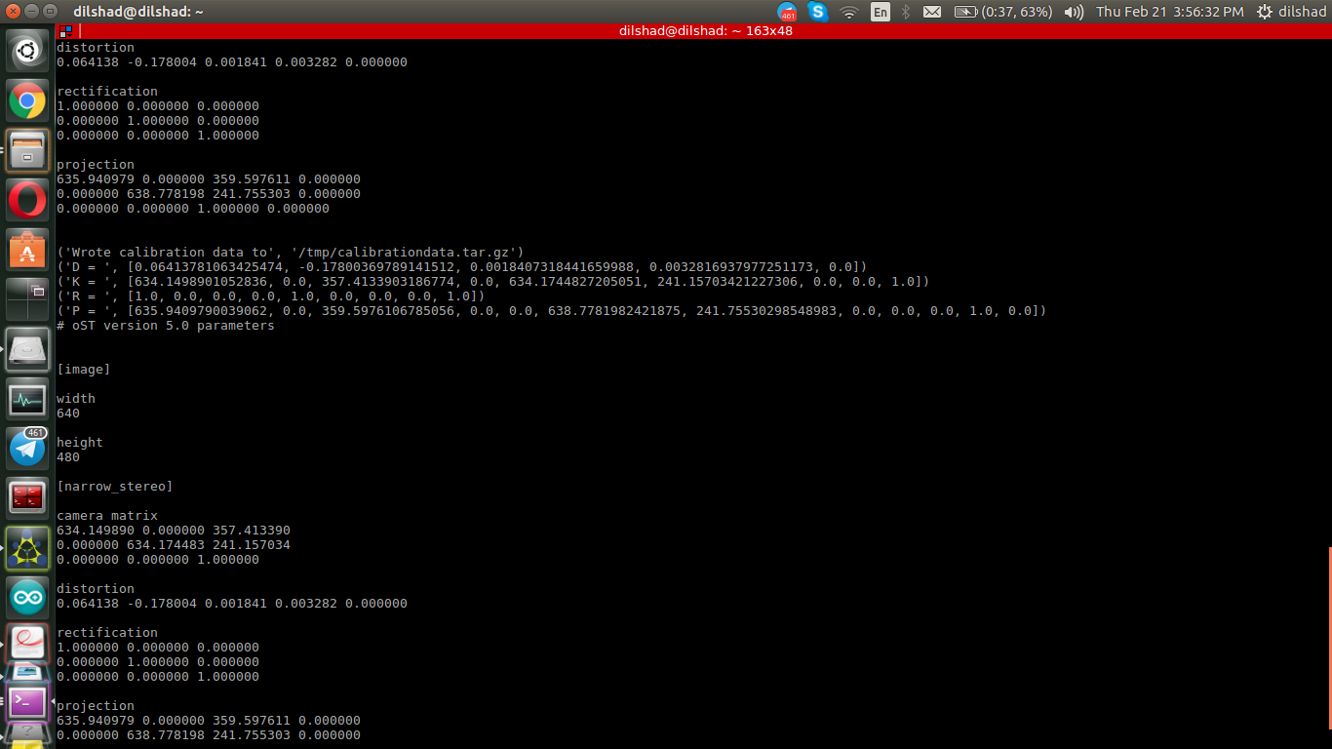

11. Open a terminal and run the command in terminal:
roslaunch usb_cam usb_cam.launch
You should get a flat image output.
12. If feed from desigred camera is not showing then change the port in lauchfil.

