Does Balancing Pay? BST vs AVL
How our code works: concepts, files and every step
Kanan Gasimzada (Person 1) · Dilruba Guliyeva (Person 2)
Project Work 1 · Topic T13 · Advanced Data Structures and Algorithms · UFAZ · Fall 2026

1. The project in simple words
Every student in a social network has a list of friends. We want to answer one question very fast and many times: “Are these two students friends?”
To do that, every student keeps their friends in a search tree. We compare two kinds of search tree:
- a plain BST (binary search tree): simple, but it can become a long chain;
- an AVL tree: a BST that repairs itself with rotations, so it always stays short.
Research question: how does the order in which friendships arrive (real, sorted, nearly sorted, random) change the height of the trees, the cost of the questions, and the time, and how much work do the AVL rotations cost?
Our answer in one sentence
The AVL tree is faster unless friendships arrive in almost random order. With sorted arrival the BST is 2.6× slower; with the real arrival order it is 1.14× slower; with random order both trees are about equal.

2. The main concepts
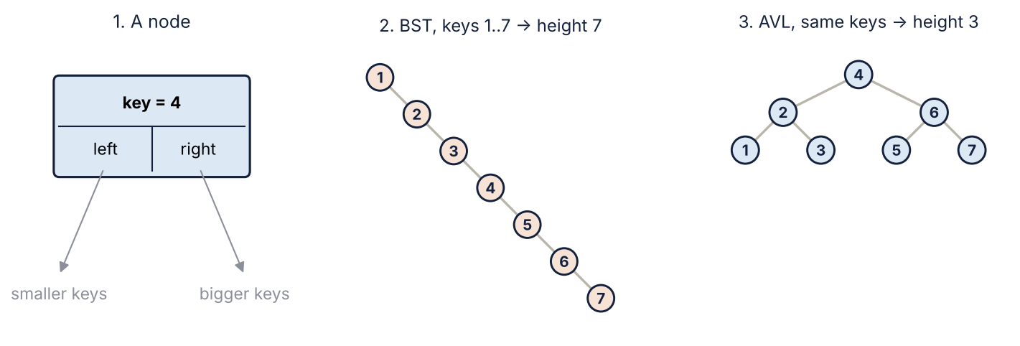
Figure 1. A node holds a key and two links. The same 7 keys, inserted in sorted order, give a BST chain of height 7 but an AVL tree of height 3.
Concept | Meaning | Where in the code
Node | One box of a tree: a key, a left link (smaller keys) and a right link (bigger keys). | Node in person1_trees.py
BST | A tree where smaller keys go left and bigger keys go right. Insert and search walk down from the root. | BST class
Height | The number of levels from the root to the deepest node. A search costs at most “height” steps. | tree_height()
Balance | Height of the left side minus height of the right side of a node. AVL allows only −1, 0 or +1. | get_balance()
Rotation | A small re-linking of three links that makes one side shorter but keeps the keys in order. | rotate_left(), rotate_right()
AVL tree | A BST that checks the balance after each insert and rotates when it is ±2. | AVL class
Step | One node we look at during an insert or a search. Our main counter. | self.steps
Adjacency structure | A dictionary: student → tree of their friends. | build() in person2_experiment.py
Arrival order | The order in which the edges (friendships) are inserted. | make_orders()
Sortedness | Share of pairs of friends that arrive in the “wrong” order: 0 = sorted, 0.5 = random. | sortedness()
Triangle | Three students who are all friends with each other. Counting them asks the trees many questions. | count_triangles()
Median of runs | We time 3 runs and keep the middle value, so one slow run does not change the result. | measure()

3. The files and who did what
File | Person | What it does
person1_trees.py | Person 1: Kanan | Node, BST, AVL tree, rotations, check_avl
person1_tests.py | Person 1: Kanan | 4 tests that must pass before we measure anything
person2_experiment.py | Person 2: Dilruba | Reads the real graph, makes the orders, builds the trees, counts triangles, measures time, writes results.csv
person2_plots.py | Person 2: Dilruba | Reads results.csv and draws two pictures
data/collegemsg.csv.gz | data | The real graph (SNAP CollegeMsg)

How the files connect:
person1_trees.py ──> person1_tests.py (tests the trees)
│
└──────────> person2_experiment.py ──> results.csv ──> person2_plots.py
▲ │
data/collegemsg.csv.gz ┘ heights.png, time_ratio.png
Person 2’s code never needs to know how a tree works inside. It only calls three functions that both tree classes have: insert(key), search(key) and tree_height(). That is why the same experiment code works with BST and with AVL.

How to run
In VS Code: File → Open Folder (the T13_easy folder), then open a terminal with Ctrl + ` and type:
python3 person1_tests.py # 1. tests first (1 second) -> ALL TESTS PASSED
python3 person2_experiment.py # 2. experiment (about 1 minute) -> results.csv
python3 person2_plots.py # 3. pictures (needs: pip3 install matplotlib)

The data
SNAP CollegeMsg (https://snap.stanford.edu/data/CollegeMsg.html, Panzarasa, Opsahl and Carley, 2009): 59,835 private messages between 1,899 students of the University of California, Irvine. Each line is sender, receiver, time. A friendship (edge) appears with the first message between two students, so the edges have a real arrival order. That is exactly what our question needs. After reading the file we have 13,838 edges; the most popular student has 255 friends.

4. Person 1 (Kanan): the trees, step by step

4.1 Node
class Node:
def __init__(self, key):
self.key = key # the number we store
self.left = None # child with a smaller key
self.right = None # child with a bigger key
self.height = 1
A node is just four values. left and right are links to other nodes, or None when there is nothing there.

4.2 BST.insert: putting a key in its place
def insert(self, key):
new_node = Node(key)

# empty tree: the new node is the root
if self.root is None:
self.root = new_node
self.max_depth = 1
return

current = self.root
depth = 1
while True:
self.steps += 1
if key == current.key: # already in the tree
return
if key < current.key: # go left
if current.left is None:
current.left = new_node
break
current = current.left
else: # go right
if current.right is None:
current.right = new_node
break
current = current.right
depth += 1

# the new node is one level below "current"
if depth + 1 > self.max_depth:
self.max_depth = depth + 1
What happens, step by step:
- If the tree is empty, the new node becomes the root.
- Otherwise start at the root (current = self.root).
- Compare the key with current.key: smaller → go left, bigger → go right. Each comparison adds 1 to self.steps.
- If the place where we want to go is empty (None), put the new node there and stop (break).
- If the key is already there, do nothing (no duplicates).
- Remember the deepest level we ever reached in self.max_depth: that is the height.
Why a while loop and not recursion?
If the keys come in sorted order (1, 2, 3, …), every new key goes to the right and the tree becomes a chain. 100,000 keys give 100,000 levels. Python stops recursion at about 1,000 levels and crashes. A while loop has no such limit.
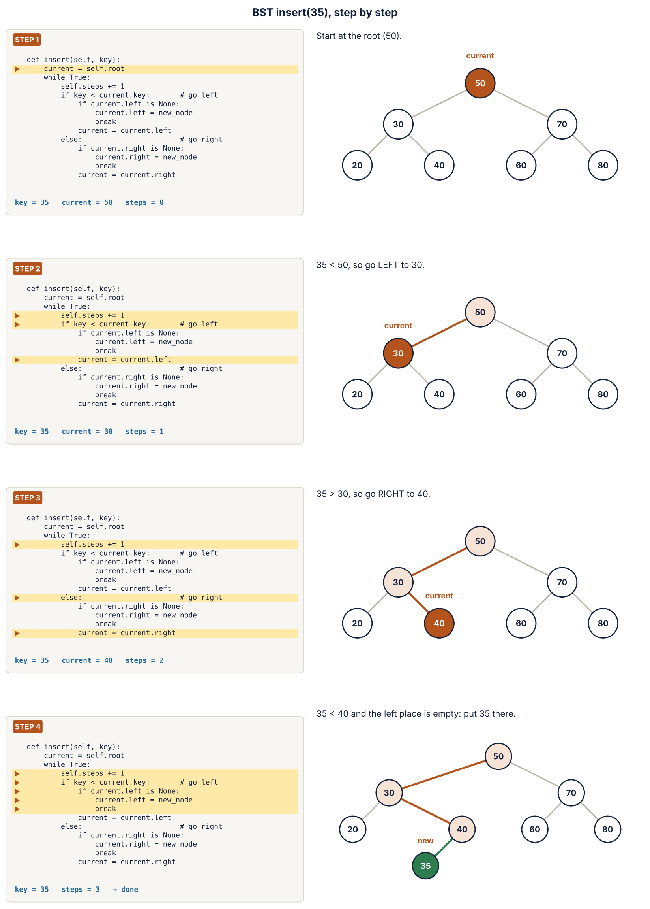
Figure 2. insert(35): the code line that runs (left, highlighted) and the tree at that moment (right).

4.3 BST.search: is the key in the tree?
def search(self, key):
current = self.root
while current is not None:
self.steps += 1
if key == current.key:
return True
if key < current.key:
current = current.left
else:
current = current.right
return False
The same walk as insert, but it never changes the tree. It returns True when it finds the key and False when it reaches an empty place. The number of steps is at most the height of the tree, so a short tree means fast questions.
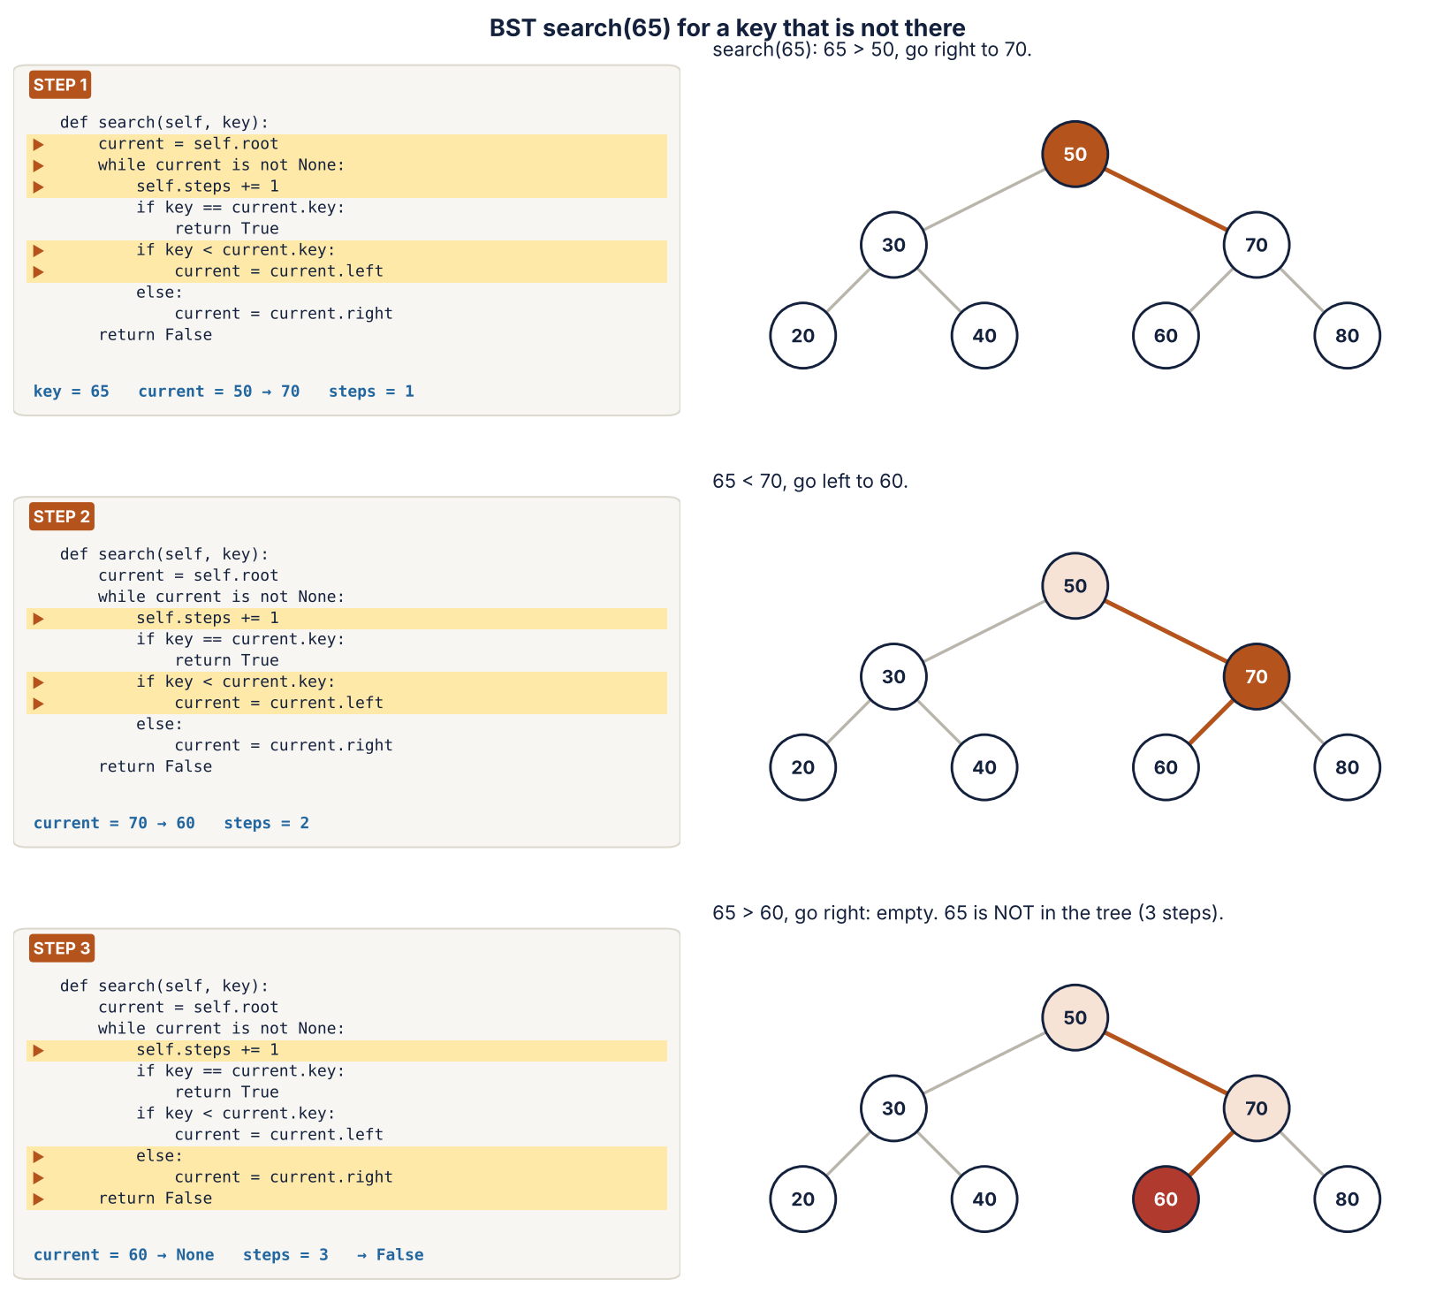
Figure 3. search(65) for a key that is not in the tree: 3 steps, then False.

4.4 Three small AVL helpers
def get_height(node):
if node is None:
return 0
return node.height

def update_height(node):
node.height = 1 + max(get_height(node.left), get_height(node.right))

def get_balance(node):
# left height minus right height; AVL allows only -1, 0 or 1
return get_height(node.left) - get_height(node.right)
- get_height(node): the stored height, or 0 for an empty place.
- update_height(node): height = 1 + the taller child.
- get_balance(node): left height − right height. +2 means the left side is too tall, −2 means the right side is too tall.

4.5 Rotations
def rotate_right(y):
x = y.left
y.left = x.right
x.right = y
update_height(y)
update_height(x)
return x

def rotate_left(x):
y = x.right
x.right = y.left
y.left = x
update_height(x)
update_height(y)
return y
A rotation changes only three links. In rotate_right(y) the left child x moves up, y moves down to the right, and the middle part B changes parent. The keys stay in the same order (A < x < B < y < C), so the tree is still a correct BST, but one level shorter on the left. rotate_left is the mirror image.
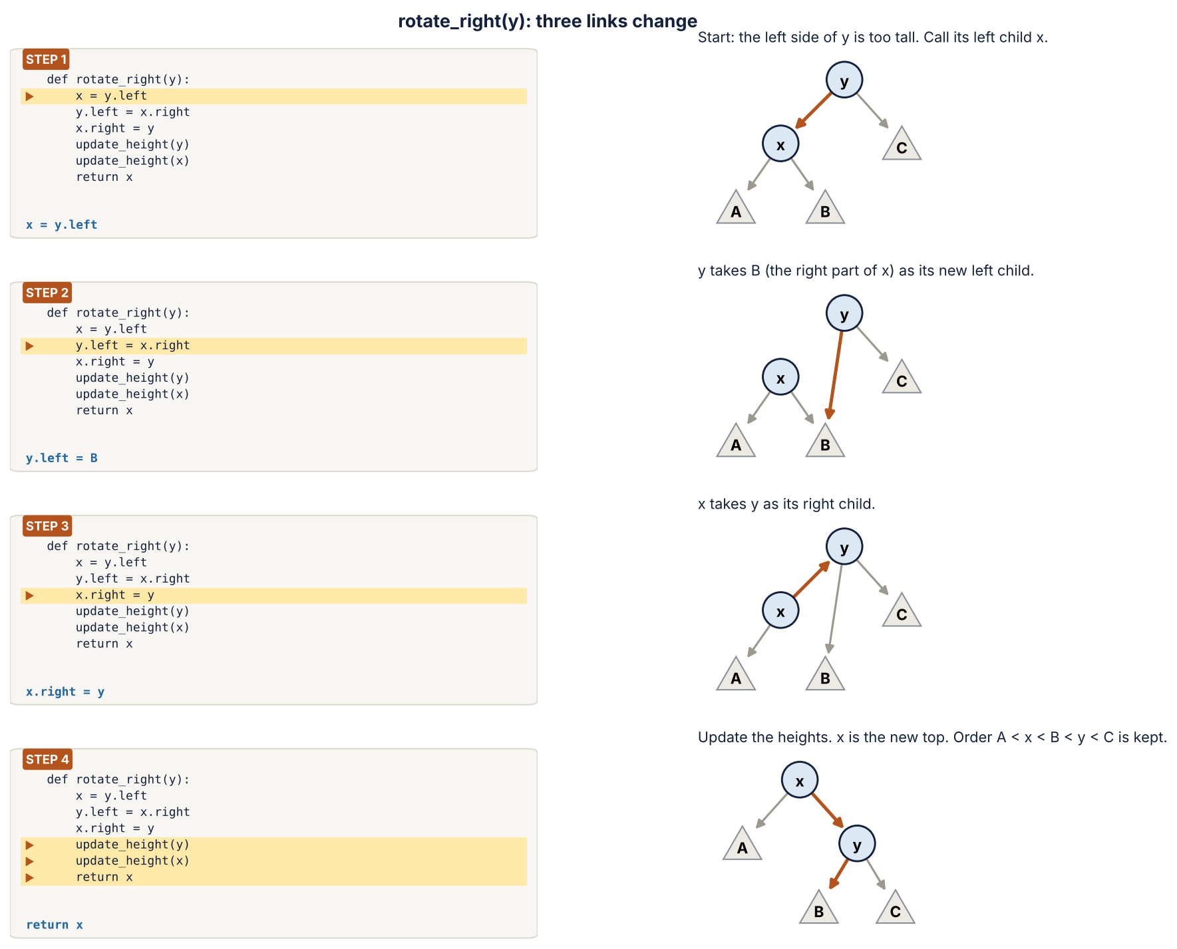
Figure 4. rotate_right(y) line by line: the orange arrow is the link that changes in that line.

4.6 AVL.insert_at: insert, then repair
def insert_at(self, node, key):
# 1) normal BST insert
if node is None:
return Node(key)
self.steps += 1
if key == node.key:
return node
if key < node.key:
node.left = self.insert_at(node.left, key)
else:
node.right = self.insert_at(node.right, key)

# 2) new height of this node
update_height(node)

# 3) fix the balance if needed (4 cases)
balance = get_balance(node)

if balance > 1 and key < node.left.key: # Left-Left
self.rotations += 1
return rotate_right(node)

if balance < -1 and key > node.right.key: # Right-Right
self.rotations += 1
return rotate_left(node)

if balance > 1 and key > node.left.key: # Left-Right
self.rotations += 2
node.left = rotate_left(node.left)
return rotate_right(node)

if balance < -1 and key < node.right.key: # Right-Left
self.rotations += 2
node.right = rotate_right(node.right)
return rotate_left(node)

return node
What happens, step by step:
- Go down like a BST. The function calls itself on the left or right child (recursion) until it finds an empty place, and creates the new node there.
- Come back up. After each call returns, we are back at the parent node. We update its height.
- Check the balance of that node. If it is between −1 and +1, nothing to do: return the node.
- If it is ±2, rotate. Which rotation depends on where the new key went (the four cases below).
Case | When | What the code does
Left-Left | balance > 1 and the key went left, then left | rotate_right(node) (1 rotation)
Right-Right | balance < −1 and the key went right, then right | rotate_left(node) (1 rotation)
Left-Right | balance > 1 and the key went left, then right | rotate_left on the left child, then rotate_right (2)
Right-Left | balance < −1 and the key went right, then left | rotate_right on the right child, then rotate_left (2)

Why is recursion safe here?
An AVL tree is always short: about 1.44 × log₂(n) levels at most. With 100,000 keys our AVL tree has only 17 levels, far below Python’s limit of about 1,000.
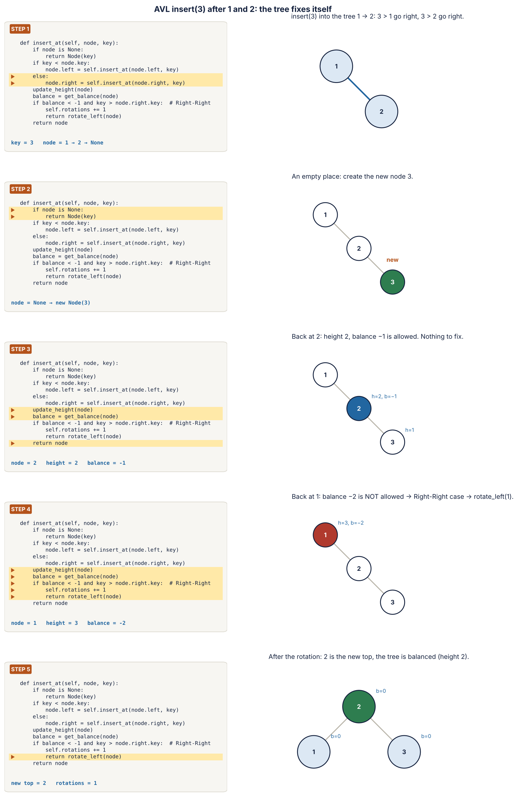
Figure 5. insert(3) into the AVL tree 1 → 2: going down, creating the node, coming back up, and the Right-Right rotation.
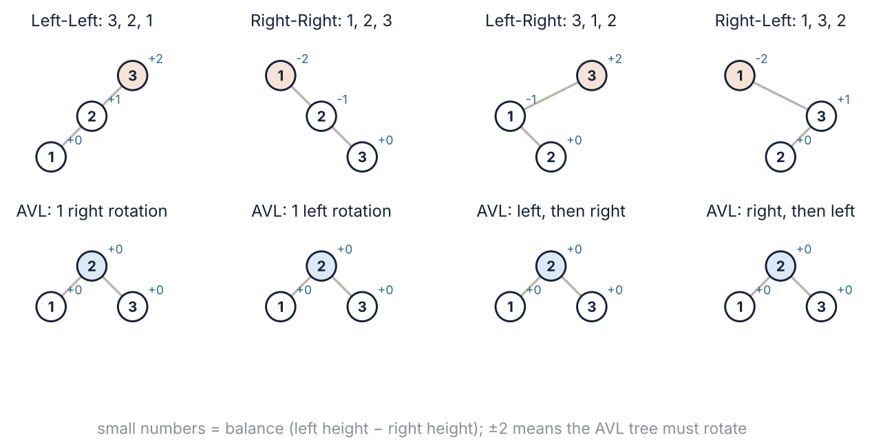
Figure 6. The four cases with three keys. Top: what a plain BST would look like (balance ±2). Bottom: the AVL tree after rotating.

4.7 check_avl: is the tree correct?
def check_avl(node, low=None, high=None):
if node is None:
return True
if low is not None and node.key <= low:
return False
if high is not None and node.key >= high:
return False
if node.height != 1 + max(get_height(node.left), get_height(node.right)):
return False
if abs(get_balance(node)) > 1:
return False
return check_avl(node.left, low, node.key) and check_avl(node.right, node.key, high)
It visits every node and checks three things: the key is between low and high (smaller keys left, bigger keys right), the stored height is correct, and the balance is −1, 0 or +1. If any node fails, the whole answer is False.

4.8 The tests (person1_tests.py)
Rule of the project: correctness first. We only measure time after these tests pass.
Test | What it checks
1. Keys 1..7 | We solved this on paper: the BST becomes a chain of height 7; the AVL tree has height 3, root 4, and needs exactly 4 rotations.
2. Double rotations | 3, 1, 2 (Left-Right) and 1, 3, 2 (Right-Left) both give root 2 after 2 rotations.
3. Random numbers | 500 random numbers into both trees. For every number 0–999 the trees must give the same answer as Python’s own set. Then check_avl must say True.
4. Many sorted keys | A BST with 2,000 sorted keys has height 2,000 and does not crash. An AVL tree with 100,000 sorted keys has height 17 and is valid.

5. Person 2 (Dilruba): the graph and the experiment, step by step
The file person2_experiment.py is divided into numbered steps. Here is each one.

STEP 1: load_edges, read the real graph
def load_edges():
edges = []
seen = set()
file = gzip.open(DATA_FILE, "rt")
file.readline() # skip the header line
for line in file:
parts = line.strip().split(",")
u = int(parts[0])
v = int(parts[1])
if u == v: # a message to yourself is not an edge
continue
if u > v: # (7, 3) and (3, 7) are the same edge
u, v = v, u
if (u, v) not in seen: # keep only the first message
seen.add((u, v))
edges.append((u, v))
file.close()
return edges
- Open the file and skip the first line (the header).
- For every line, take the sender u and the receiver v.
- Skip messages a student sent to themselves (u == v).
- Write every pair with the smaller number first, so 7→3 and 3→7 are the same friendship.
- Keep only the first message of each pair (the seen set). The list edges is then in real time order.
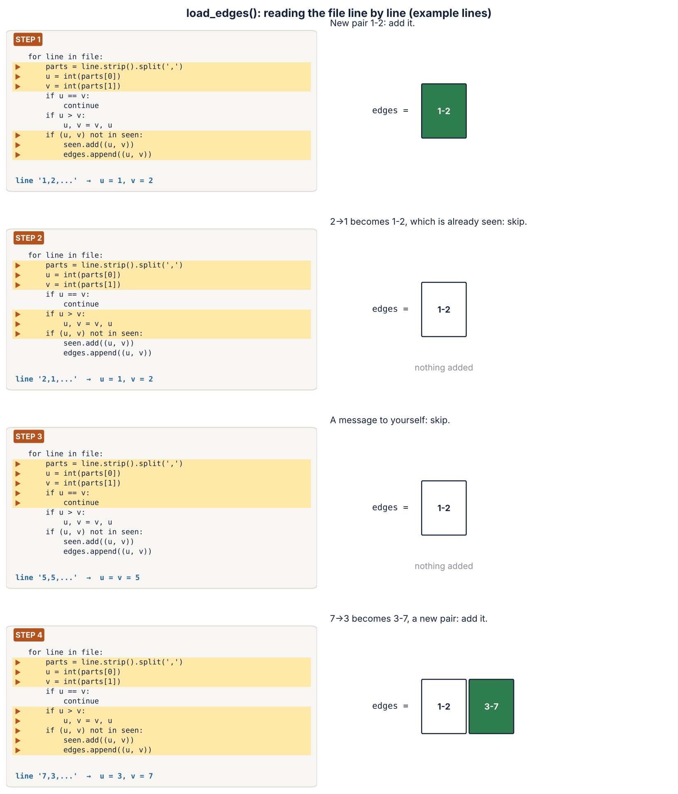
Figure 7. load_edges() on four example lines: added, already seen, message to yourself, new pair.

STEP 2: make_orders, four arrival orders
def nearly_sorted(edges, share):
result = sorted(edges)
random.seed(1)
swaps = int(share * len(result))
for k in range(swaps): # swap a few random pairs
i = random.randrange(len(result))
j = random.randrange(len(result))
result[i], result[j] = result[j], result[i]
return result

def make_orders(edges):
random_order = list(edges)
random.seed(1)
random.shuffle(random_order)
return {
"real": edges,
"sorted": sorted(edges),
"nearly sorted 5%": nearly_sorted(edges, 0.05),
"nearly sorted 20%": nearly_sorted(edges, 0.20),
"random": random_order,
}
Order | How we make it
real | The edges as they arrived in time.
sorted | sorted(edges): every student gets friends in increasing number order. The worst case for a BST.
nearly sorted 5% / 20% | Sorted, then swap a few random pairs (5 % or 20 % of the edges).
random | random.shuffle with a fixed seed, so the result is the same every time we run.

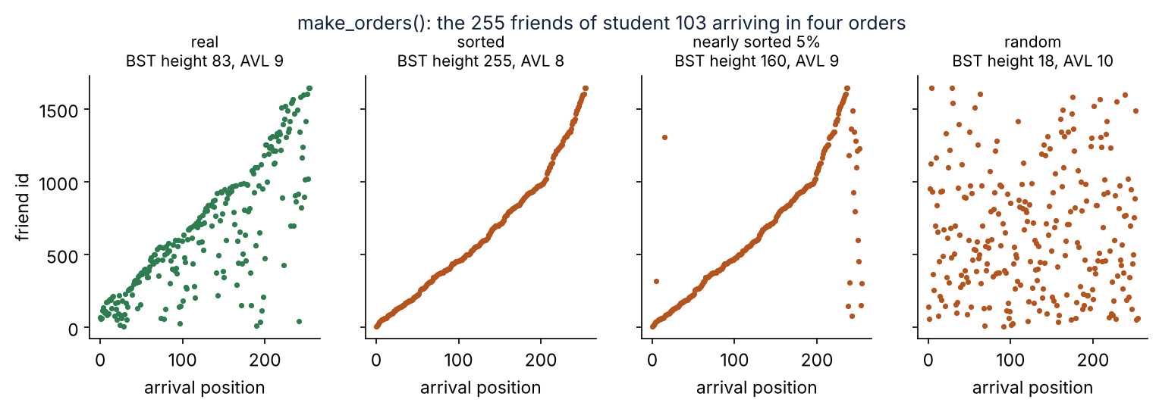
Figure 8. The 255 friends of the most popular student arriving in four orders, and the tree height each order gives.

STEP 3: sortedness, how sorted is an order?
def sortedness(order):
arrivals = {}
for u, v in order:
arrivals.setdefault(u, []).append(v)
arrivals.setdefault(v, []).append(u)
wrong = 0
total = 0
for friends in arrivals.values():
for i in range(len(friends)):
for j in range(i + 1, len(friends)):
total += 1
if friends[i] > friends[j]:
wrong += 1
return wrong / total
For each student we write down their friends in the order they arrive. Then we look at every pair: if a bigger number comes before a smaller number, the pair is “wrong”. Sortedness = wrong pairs ÷ all pairs. So 0 means perfectly sorted and about 0.5 means random. The real order of CollegeMsg gives about 0.30.
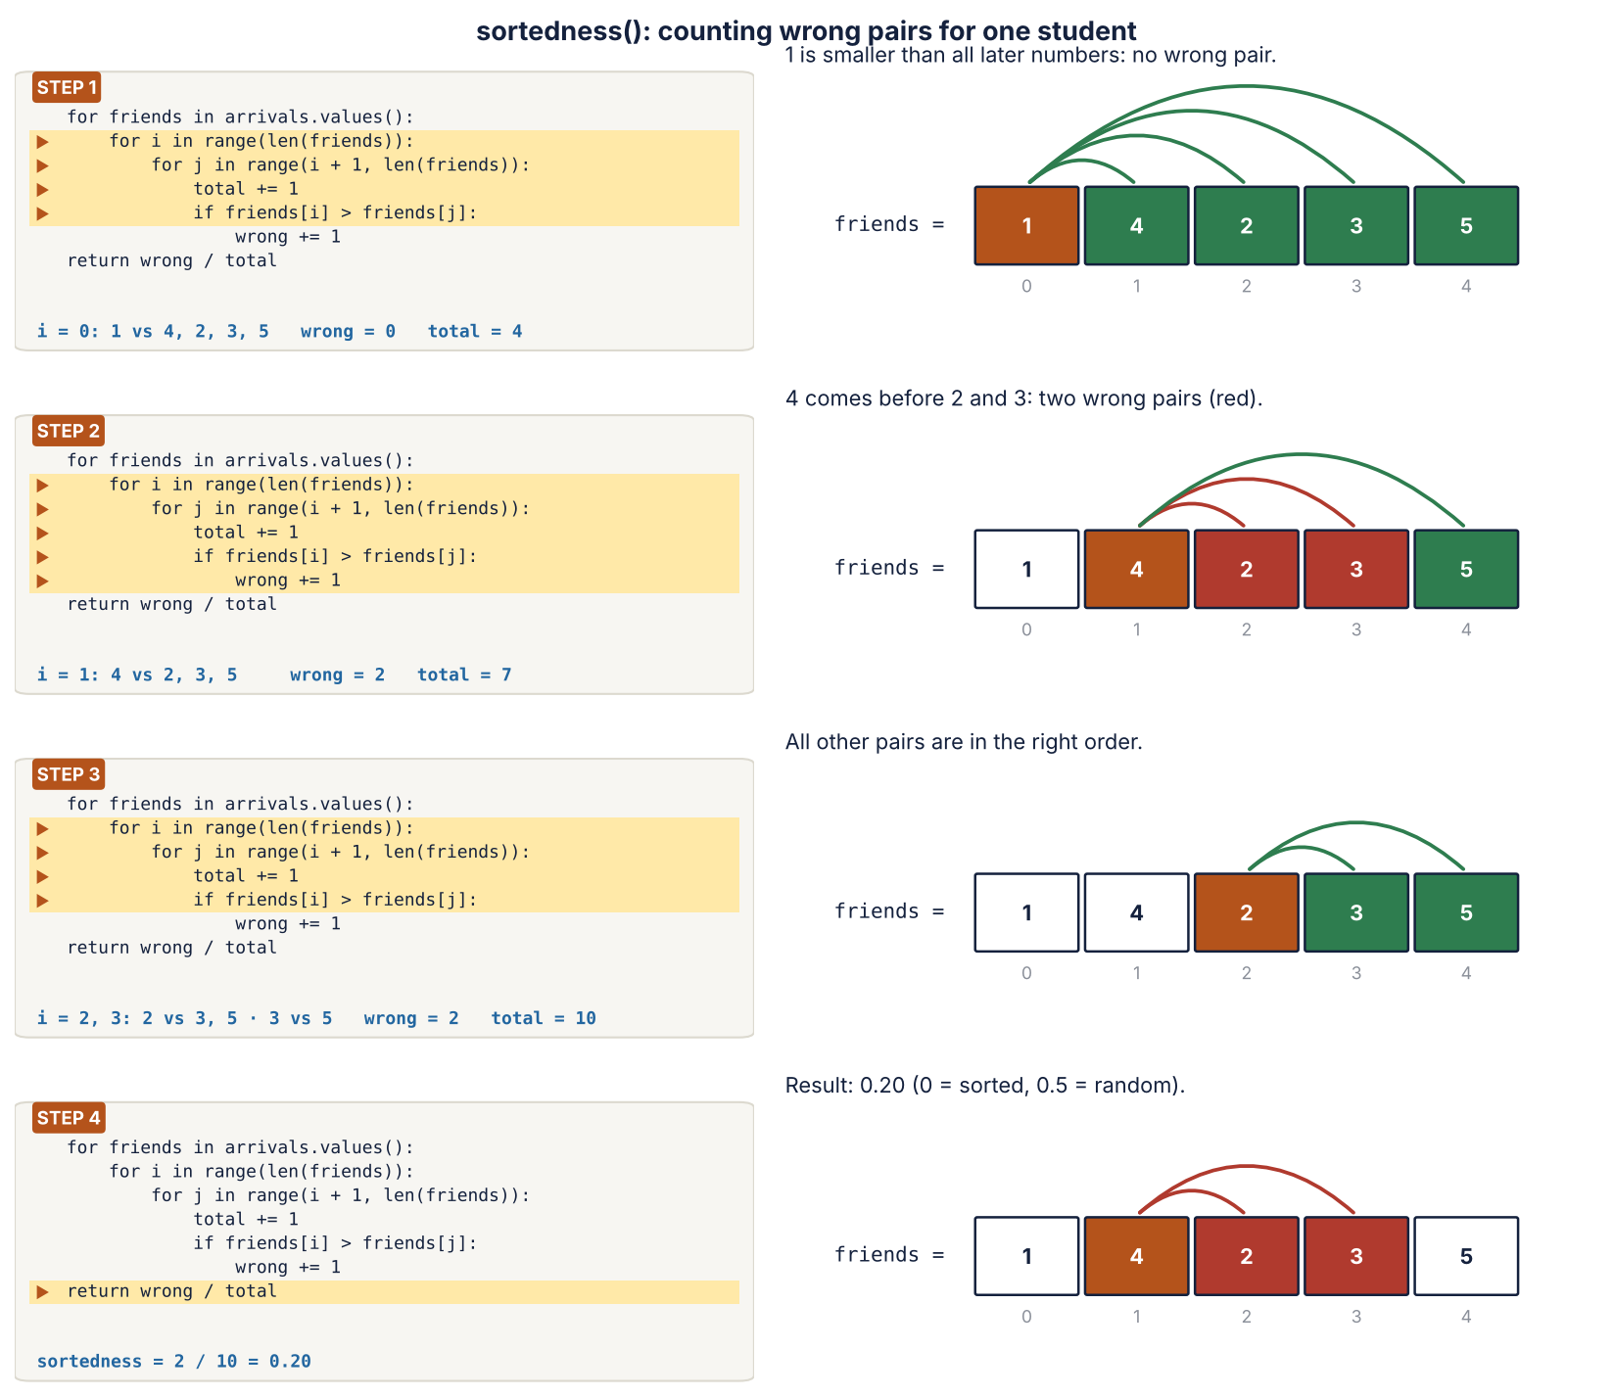
Figure 9. sortedness() on one student whose friends arrive as 1, 4, 2, 3, 5: 2 wrong pairs out of 10 = 0.20.

STEP 4: build, one tree per student
def build(order, TreeClass):
adj = {}
for u, v in order:
if u not in adj:
adj[u] = TreeClass()
if v not in adj:
adj[v] = TreeClass()
adj[u].insert(v)
adj[v].insert(u)
return adj
adj is a dictionary. For every edge (u, v) we make sure both students have a tree, then put v in the tree of u and u in the tree of v. TreeClass is BST or AVL, so the same function builds both structures.
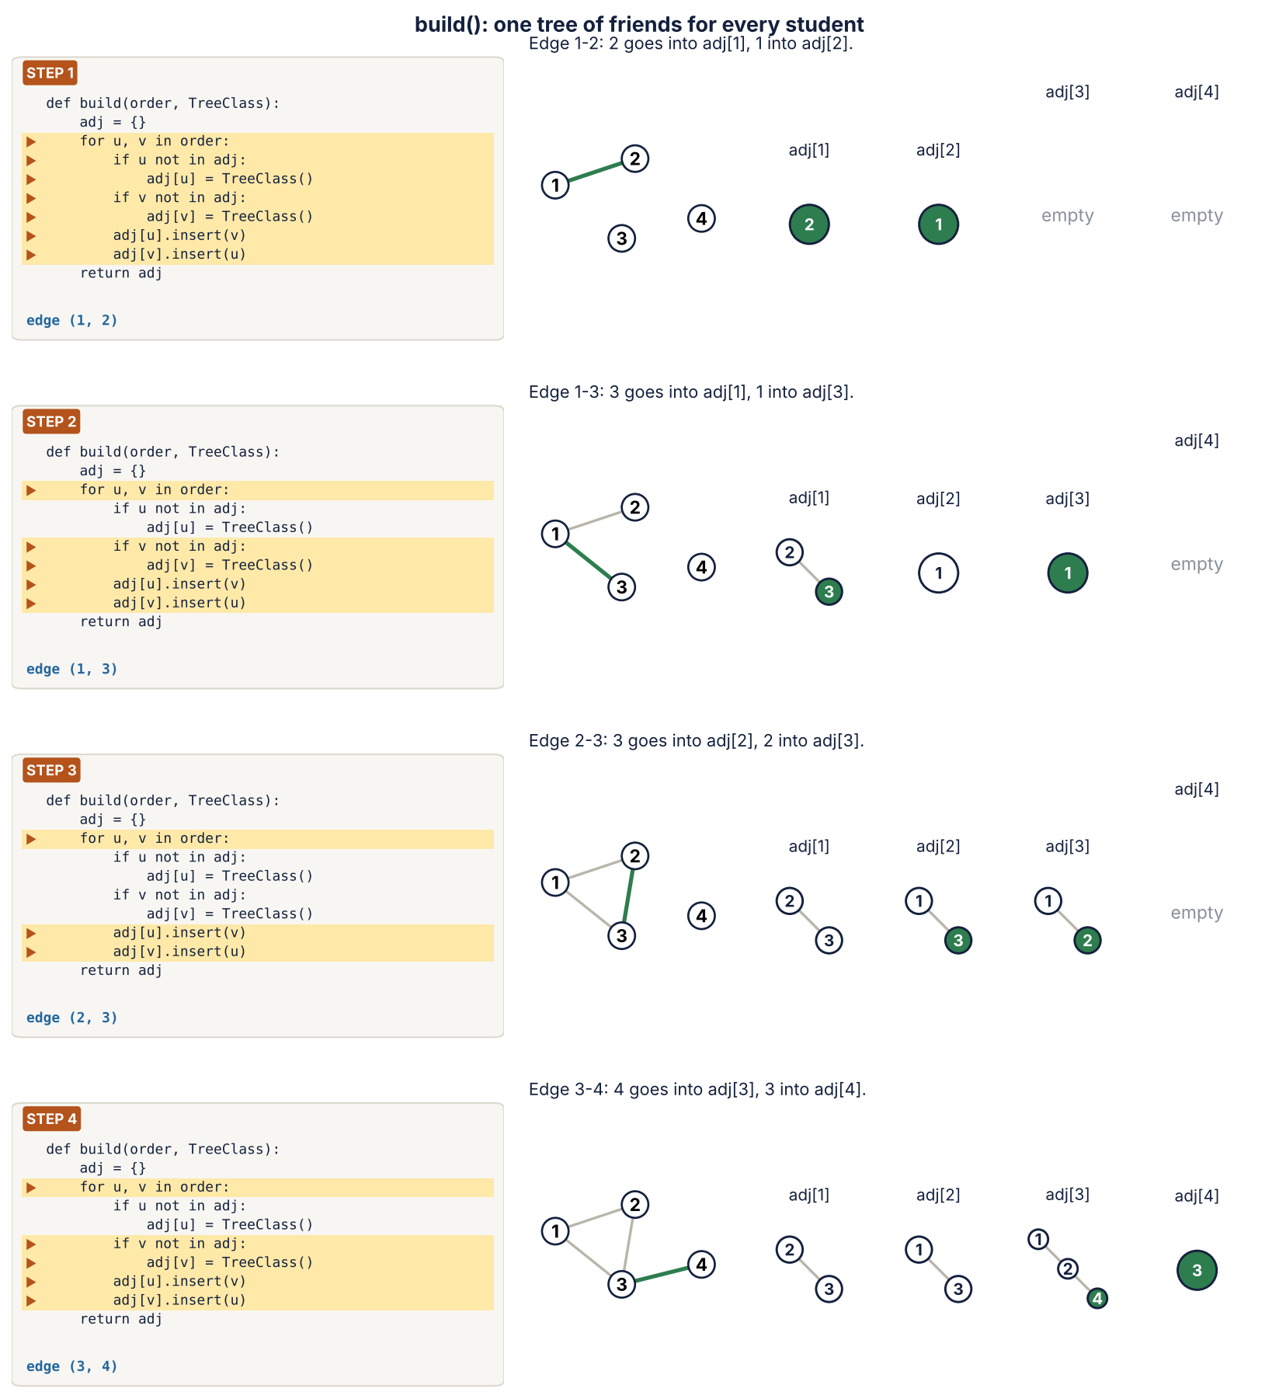
Figure 10. build() on four edges: the graph (left) and the tree of each student (right). The green node is the one just inserted.

STEP 5: count_triangles, the graph algorithm
def friend_lists(edges):
friends = {}
for u, v in edges:
friends.setdefault(u, []).append(v)
friends.setdefault(v, []).append(u)
return friends

def count_triangles(adj, edges, friends):
found = 0
for u, v in edges:
for w in friends[u]:
if w != v and adj[v].search(w):
found += 1
return found // 3

def count_triangles_with_sets(edges, friends):
# a second, independent way (only Python sets) to check our answer
found = 0
for u, v in edges:
found += len(set(friends[u]) & set(friends[v]))
return found // 3
- Take an edge (u, v): u and v are friends.
- For every other friend w of u, ask the tree of v: adj[v].search(w). “Is w also a friend of v?”
- If yes, u, v and w form a triangle. Count it.
- Every triangle is found 3 times (once from each of its edges), so we divide by 3.
This asks the trees hundreds of thousands of questions, and most answers are “no”. So we test both successful and unsuccessful searches. count_triangles_with_sets gets the same number in a completely different way (only Python sets). We use it as a check: our tree answer must be equal to it.
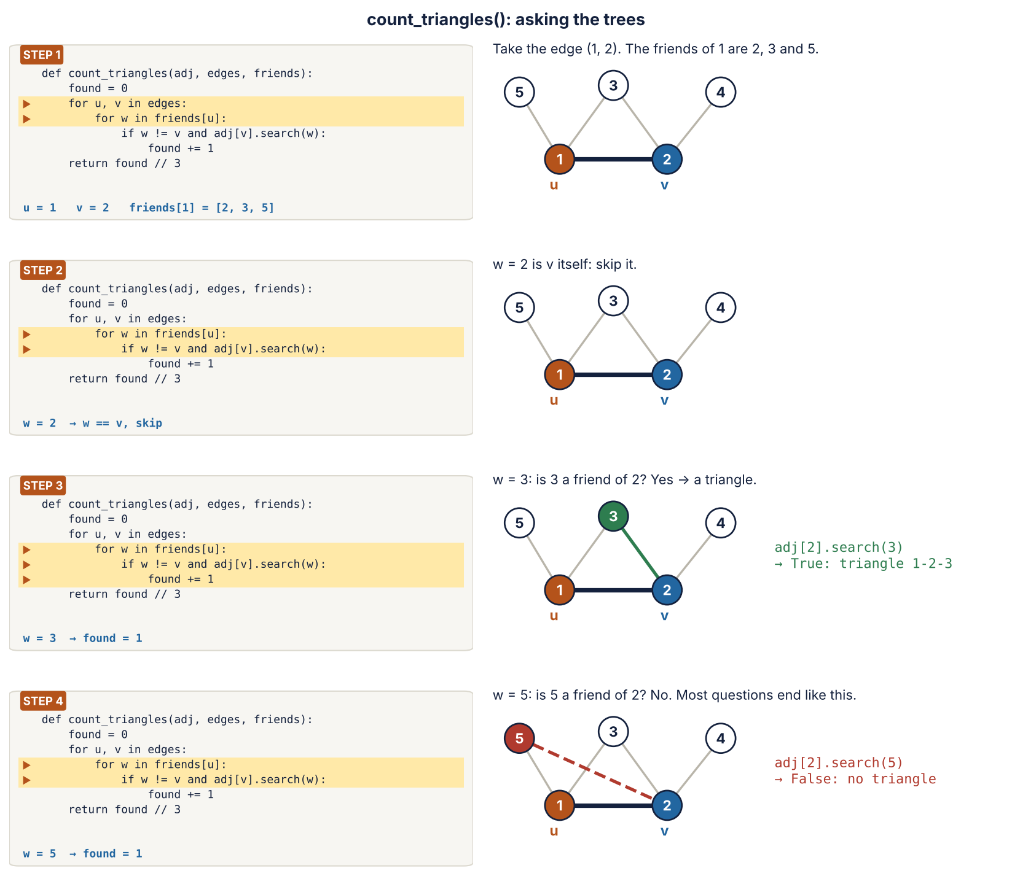
Figure 11. count_triangles() for the edge (1, 2): skip 2, find the triangle 1-2-3, and get “no” for 5.

STEP 6: measure, timing one tree on one order
def measure(order, TreeClass, edges, friends, correct_triangles):
# warm-up run (not timed) + correctness check
adj = build(order, TreeClass)
assert count_triangles(adj, edges, friends) == correct_triangles

build_times = []
query_times = []
for r in range(REPEATS):
start = time.perf_counter()
adj = build(order, TreeClass)
middle = time.perf_counter()
count_triangles(adj, edges, friends)
end = time.perf_counter()
build_times.append(middle - start)
query_times.append(end - middle)

# numbers from one extra run, with the step counters
adj = build(order, TreeClass)
build_steps = sum(tree.steps for tree in adj.values())
count_triangles(adj, edges, friends)
all_steps = sum(tree.steps for tree in adj.values())
questions = sum(len(friends[u]) - 1 for u, v in edges)
rotations = 0
if TreeClass == AVL:
rotations = sum(tree.rotations for tree in adj.values())

return {
"max height": max(tree.tree_height() for tree in adj.values()),
"steps per question": (all_steps - build_steps) / questions,
"rotations": rotations,
"build ms": statistics.median(build_times) * 1000,
"query ms": statistics.median(query_times) * 1000,
"total ms": (statistics.median(build_times) + statistics.median(query_times)) * 1000,
}
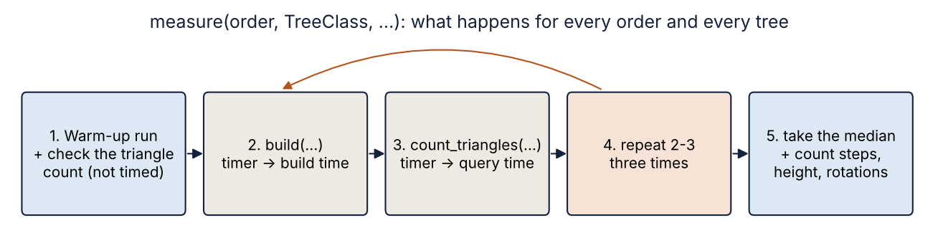
Figure 12. The order of work inside measure().
- Warm-up and check: build once and count triangles once. The answer must be correct (assert). This run is not timed.
- Timed runs: 3 times, measure the time to build the trees and the time to count the triangles.
- Median: keep the middle of the 3 times, so one slow run does not change the result.
- Counters: one more run to read the steps, the height of the tallest tree and the AVL rotations.

STEP 7: main, the whole experiment
For each graph size (the first 25 %, 50 % and 100 % of the edges in time order) and for each of the 5 orders, main() calls measure() for the BST and for the AVL tree on exactly the same data, prints a line, and writes it to results.csv. The last column, BST time ÷ AVL time, is above 1 when the AVL tree is faster.

STEP 8: sorted_keys_test, the worst case
def sorted_keys_test():
print("\n=== sorted keys 0, 1, 2, ... into one tree ===")
last_time = 0
for n in [1000, 2000, 4000, 8000, 16000, 100000]:
if n == 100000:
guess = last_time * (n / 16000) ** 2 # BST time grows like n * n
print(f"BST n={n:6d}: not run, would take about {guess:.0f} s (over our 60 s limit = TIMEOUT)")
else:
tree = BST()
start = time.perf_counter()
for key in range(n):
tree.insert(key)
last_time = time.perf_counter() - start
print(f"BST n={n:6d}: {last_time:7.3f} s, height {tree.tree_height()}")
tree = AVL()
start = time.perf_counter()
for key in range(n):
tree.insert(key)
print(f"AVL n={n:6d}: {time.perf_counter() - start:7.3f} s, height {tree.tree_height()}")
We insert 0, 1, 2, … n−1 into one tree. The BST needs n·(n−1)/2 steps, so when n doubles the time grows 4 times. For n = 100,000 we do not run the BST: from the 16,000 run we estimate about 309 seconds, which is over our 60-second limit, so we write it down as a timeout (we never hide it). The AVL tree does 100,000 keys in under half a second.
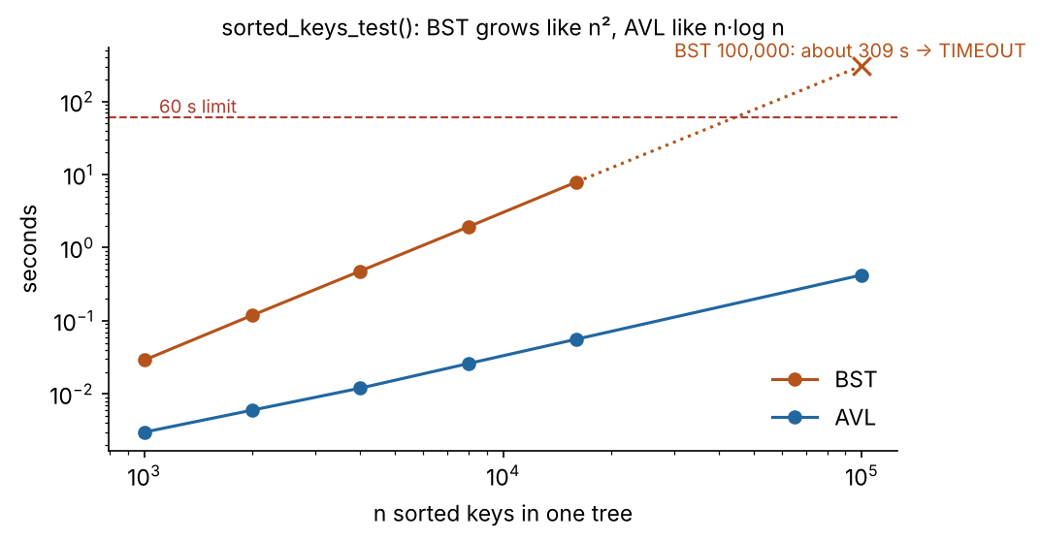
Figure 13. Sorted keys into one tree: the BST time grows like n², the AVL time like n·log n.

person2_plots.py
It reads results.csv line by line into a list of rows and draws two pictures with matplotlib: the tree heights for each order (heights.png) and BST time ÷ AVL time against sortedness (time_ratio.png). They are Figures 14 and 15 below.

6. Results
Full graph: 13,838 edges. Time = build + triangle counting, median of 3 runs, in milliseconds. “Steps” = nodes looked at per question.
Order | Sortedness | Height BST / AVL | Steps BST / AVL | Time BST / AVL | BST ÷ AVL
sorted | 0.00 | 255 / 8 | 17.8 / 4.5 | 947 / 360 | 2.63
nearly sorted 5% | 0.08 | 163 / 10 | 11.2 / 4.5 | 650 / 355 | 1.83
nearly sorted 20% | 0.24 | 119 / 10 | 7.1 / 4.5 | 453 / 361 | 1.25
real | 0.30 | 96 / 10 | 6.2 / 4.5 | 409 / 359 | 1.14
random | 0.50 | 19 / 10 | 5.3 / 4.5 | 373 / 355 | 1.05

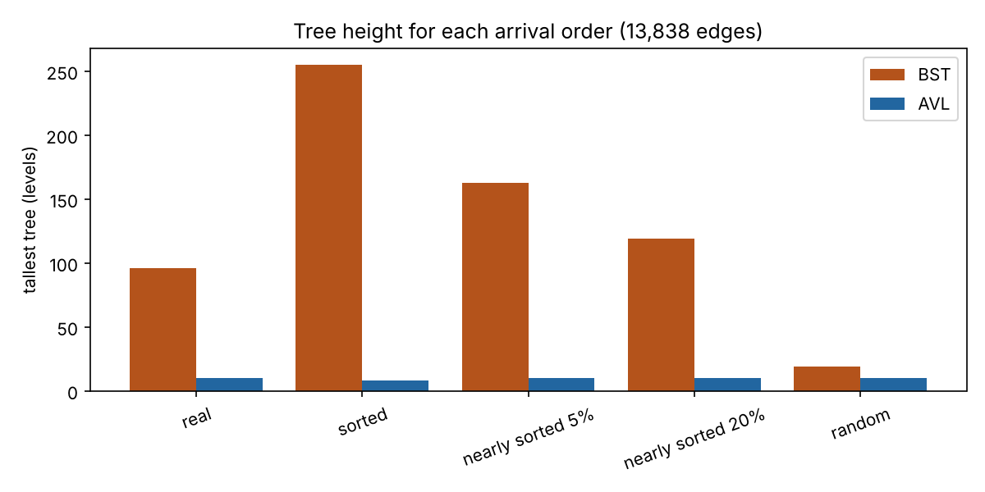
Figure 14. Height of the tallest tree for each order (from person2_plots.py).
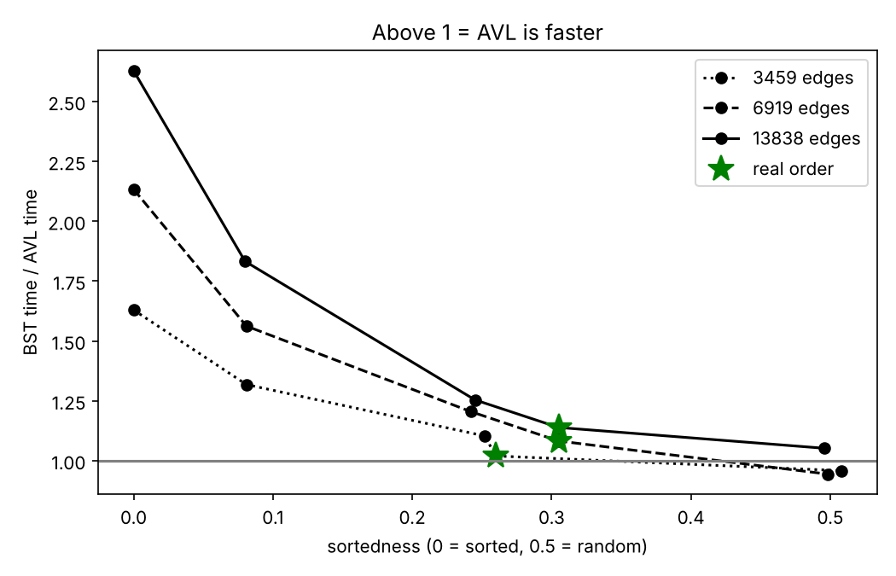
Figure 15. BST time ÷ AVL time for the three graph sizes. Above 1 = AVL is faster. Stars = real order.

Effect of the graph size
Edges | sorted | nearly sorted 5% | nearly sorted 20% | real | random
3,459 | 1.63 | 1.32 | 1.10 | 1.02 | 0.96
6,919 | 2.13 | 1.56 | 1.21 | 1.08 | 0.94
13,838 | 2.63 | 1.83 | 1.25 | 1.14 | 1.05
Numbers are BST time ÷ AVL time. The bigger the graph, the more the BST loses on sorted and real orders, because popular students have more friends and their BST chains get longer.

Price of balancing
The AVL tree makes 16,008 rotations on random input and 21,460 on sorted input, for 27,676 insertions (0.58 and 0.78 per insertion). Its build time is 44 ms against 21 ms for the BST on random input, but building is a small part of the total: the questions take most of the time.

7. Conclusion
- Sorted arrival: the BST becomes a chain (height 255 = the largest number of friends) and is 2.63× slower than the AVL tree (height 8).
- Real arrival: the BST is 1.14× slower. New students get bigger id numbers, so popular students receive their friends almost in sorted order.
- Random arrival: both trees are about equal (BST ÷ AVL between 0.94 and 1.05). Here the rotations cost about as much as they save.
- When does the BST start to lose? As soon as the order is clearly more sorted than random (sortedness below about 0.4), and earlier for bigger graphs.
So: balancing pays on this real graph. Limitations: one real graph (at most 255 friends per student), Python timing (C would be faster, but the ratios show the same picture), 3 timed runs, and one kind of question workload.

8. Questions the teacher may ask
Q: Why is BST insert a loop but AVL insert recursive?
A: A BST can be 100,000 levels deep and recursion would crash. An AVL tree has at most about 1.44·log₂ n levels (17 for 100,000 keys), so recursion is safe and easier to read.
Q: What exactly is a “step”?
A: One node whose key we compare with the key we look for (self.steps += 1).
Q: How do you know your trees are correct?
A: person1_tests.py: hand-checked examples, comparison with Python’s set on 1,000 numbers, and check_avl. In the experiment every run also checks the triangle count against the set-based count.
Q: Is the comparison fair?
A: Yes: both trees get the same edge order and exactly the same questions, the data is prepared before timing, there is a warm-up run, and we use the median of 3 runs.
Q: Why is sorted order the worst case?
A: Every new key is bigger than all keys before it, so it always goes right: the tree becomes a chain and a search may look at every node.
Q: Why count a double rotation as 2?
A: It really is two rotations: first on the child, then on the node.
Q: What is the real order’s sortedness and why?
A: About 0.30. Student ids were given in order of first appearance, so new friends usually have bigger ids.

