**EPIC ENGINEERS (PVT)LTD Gampaha**

Hot line 0712505005

483 / 01 , Colombo Road Gampaha . [www.epicengs.com](http://www.epicengs.com)

**පරිශීලක මාර්ගෝපදේශය**

* fuu Wmdx.h SMS mKsúvhla u.ska ls%hd;aul l< yel'
* Wmdx.h ls%hd;aul ùfïoS Bg fmr úÿ,sh úikaÈ lrk wjia:dfõ ;snQ mßos Relay ls%hd;aul fõ'
* Wmdx.h ls%hd;aul lr ;;amr 10lska miq îma kdohla f.k§ cd,h yd iïnkao fõ'bkamiq ßf,a iaùp j, wjia:dj flá mKsúvhla u.ska okajhs'
* my; wdldrhg flá mKsúvjla heùu u.ska Wmdx.fhA ßf,a iaùp md,kh l, yel'

<fmda¾Ü wxlh><úOdkh>

Wod(

1ON , 2on , 5OFF , 6off

* ish¨u ßf,a iaúp tljr jqjo ls%hd;aul l, yel'

All<úOdkh>

Wod( ALLON , allon , Alloff , alloff

* ßf,a iaúp j, wjia:dj flá mKsúvhlska f.kajd.ekSu

State

by; ish¨u úOdk ioyd Wmdx.h simple CAPITAL fíohlska f;drj m%;spdr olajhs'

ms<s;=re mKsúvh

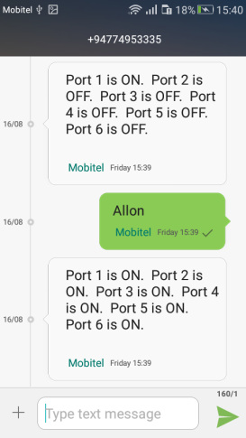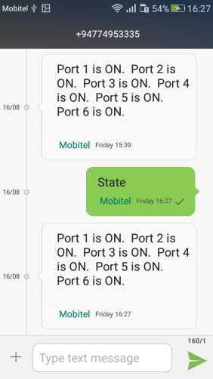iEu úOdkhlau id¾:lj ls%hd;aul jQ miq **Administrator ÿrl:k wxlhg** ms<s;=re mKsúvhla tjk= ,nhs'fï i|yd ;;amr 5la muK .;fõ'

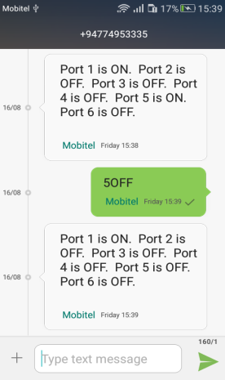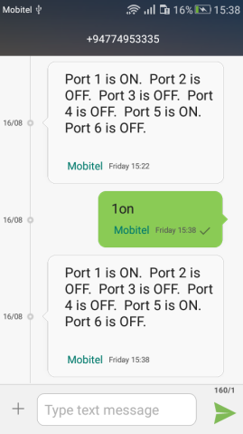

* **Administrator ÿrl:k wxlh** fjkia lsÍu'

my; wdldrhg flá mKsúvhla heùu u.ska Administrator ÿrl:k wxlh fjkia lr.; yel'

<AD><ysi;ekla><ÿrl:k wxlh>

Wod(

AD 0713673133

* ksjerosj Administrator ÿrl:k wxlh fjkia jQ úg ms<s;=re mKsúvhla u.ska th ±kqï foa'

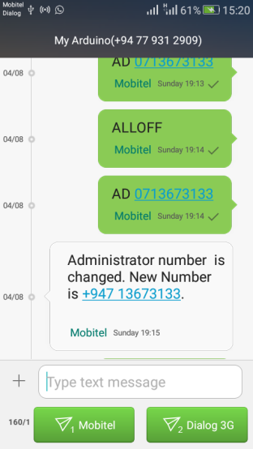

* **Android** uDÿldx.h

wmf.A **Android** uDÿldx.h u.ska b;d myiqfjka Wmdx.h yd iïnkaO úh yel'

m<uqj Wmdx.fha ieliqï ielish hq;=h'

mshjr

1' C:\Users\Epic\Downloads\setting-icon-2.jpg u; la,sla lrkak'

2'Device Number we;=,;a lr add lrkak'

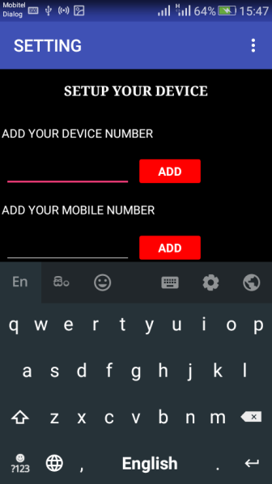 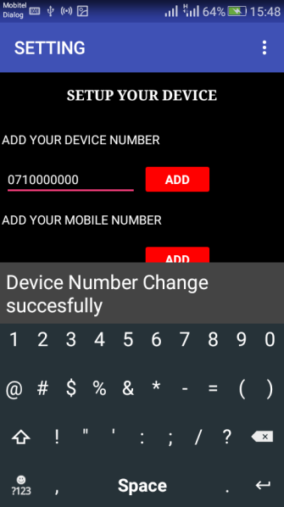

3'Mobile Number we;=,;a lr add lrkak'id¾:lj we;=,;a l, miq ÿrl:k wxl my<ska Èiajkq we;'

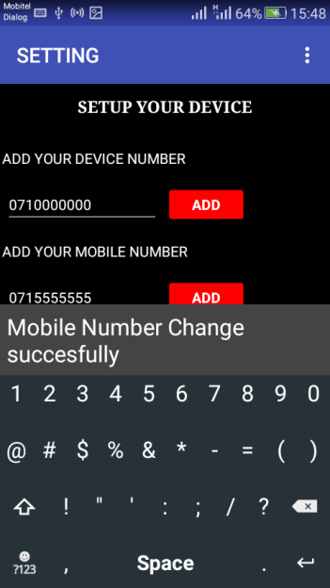 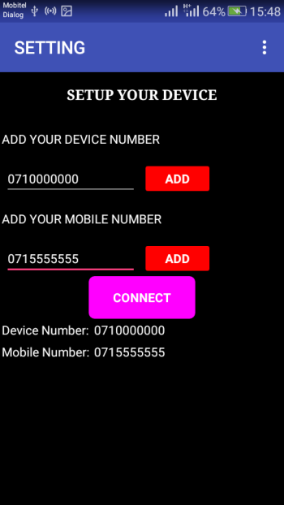

4'Connect lrkak'

uDÿldx.h u.ska b;d myiqfjka ßf,a md,kh l, yel'

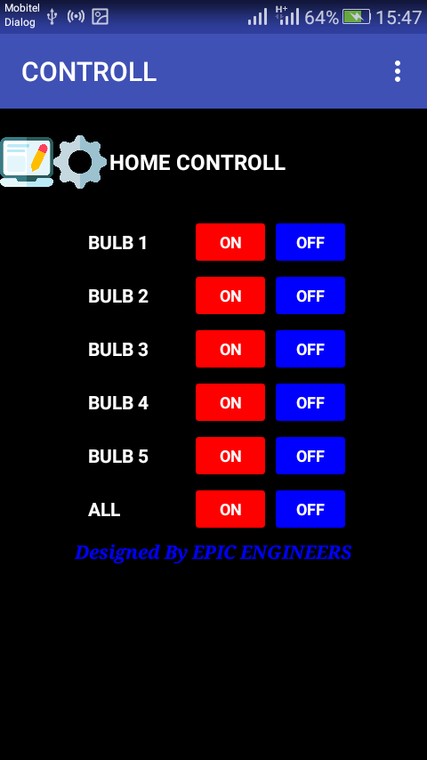

* isïm; we;=¨ lsÍu

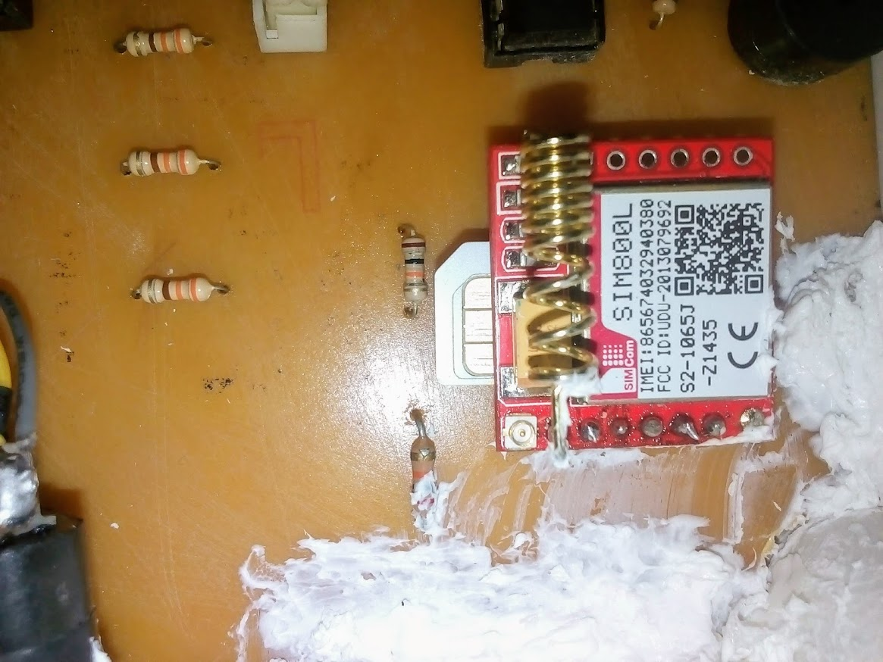

* Relay iaùp ÈYdj'

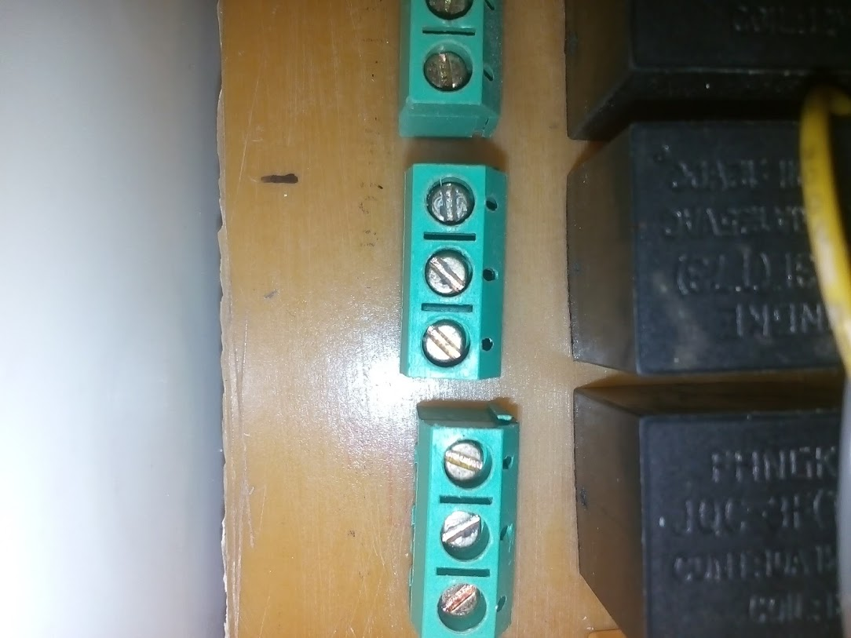

Normally Open

Normally Open

Common