PLANE DETECTION IN POINT CLOUDS VIA RANSAC

Dilan Oguz 378195

dilan.oguz@campus.tu-berlin.de

Master Program “Geodesy and Geoinformation Science”

Technical University of Berlin, Germany

**KEY WORDS:** Laser Scanner, Point Clouds, RANSAC

**Abstract:**  3D point clouds are becoming more tool for acquiring model description, monitoring deformation processes. The demand to detect planes from point cloud data in an effective way has increased sorely. Random Sample Consensus(RANSAC) as a widely known techniques is presented in this paper. RANSAC is an algorithm that allows the user extract planes for even a very large datasets. RANSAC was chosen to implement plane detection for this study due to its reliability and satisfying result.

**1. INTRODUCTION**

Random Sample Consensus, first introduced as an algorithm for fitting a model to experimental data. It is a Hypothesize and verify approach and its major advantage is that it can tolerate a significant amount of blunders in the data that has to fit to the model.

This is one of the most important reasons that made RANSAC popular among data analysis. This study shows RANSAC is really efficient in terms of accuracy and consumption, in creating 3D models of buildings.

**2. METHODOLOGY AND APPROACH**

RANSAC algorithm is implemented and tested on “Charite-2planes.ptx” file, contains about 30000 points and on “Charite-large.ptx” file that contains about 400000 points.  
For the current implementation, the parameters which mentioned below were selected:

* The minimum number of points that should be compatible with the plane being tested, in order to assume that a plane has been found.

.

* The minimum number of remaining points to check. If the remaining points are less than this number, they are considered as unclassified.
* The maximum distance of a point from the plane considered, in order to assume that the point belongs to the plane.
* The maximum number of planes to be detected
* The maximum number of tries that the algorithm should select random points and check the model produced, before aborting the procedure.

Additional data can be selected depending on the dataset. The complexity of the dataset, the number of planes it contains, the accuracy of the measurements when acquiring the point cloud play a major role when deciding the values of the tunable parameters. For instance, when the accuracy of the 3D coordinates of the points is above than 1cm, it is very reasonable to select the distance from the plane. This point should lie within in order to be assumed to being to the plane, above 1cm as well. That is because, for a point originally belongs to a plane, due to lack of accuracy better than

1 cm, its distance from the plane calculated from points belonging to the same plane, will also probably be above 1 cm.

Furthermore, if we have to deal with a dataset that contains only few planes and the majority of the points are just points lying randomly in the3D space, it is reasonable to select the parameter specifying the minimum number of points forming the plane much lower, in comparison to a dataset that contains two planes also, but all the points are lying on one of the two planes.

**3. RESULTS AND CONCLUSION**

**3.1 Small Dataset of RANSAC**

Firstly, a trial run was done using a small data set of two planes, choosing three points from the point cloud, and visualizing the resulting planes using Cloud Compare. Figure 1 shows the original image with 2 planes.

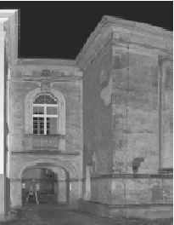

Figure 1: Original image with 2 planes

Two different thresholds 1cm and 0,1cm are used during the running of algorithm. Results can be seen on Figure 2 and Figure 3.

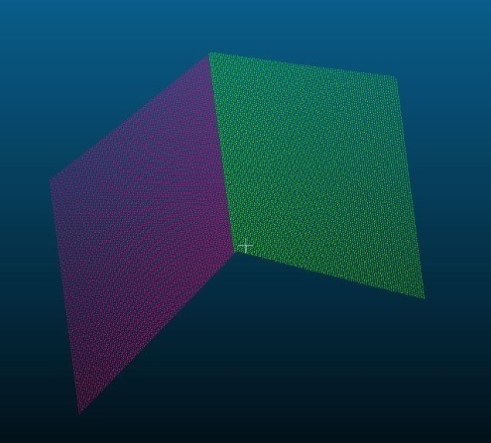

Figure 2: Detected Planes(0.01m)

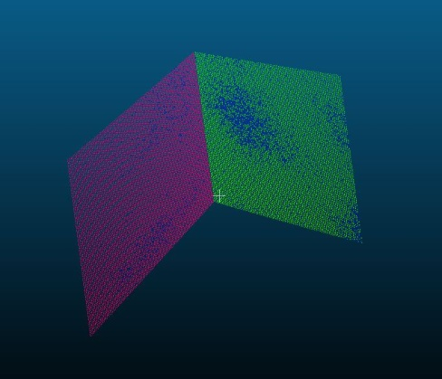

Figure 3: Detected Planes(0.001m)

After the algorithm was run, the second image shows a roughly equal distribution of points, that means the region of overlap contains of points accounted to either plane. As conclusion, using a lower tolerance value will result more accurate results, taking into account the plane shape.

**3.2 Large Dataset of RANSAC**

In this section, a large dataset of point cloud data acquired from a building.Using RANSAC on a large dataset is a great problem for the time that take to analyse and detect the individual planes.

The result of tolerant distant 10cm is in figure 4. The algorithm detects five planes which we can take many information of the shape.

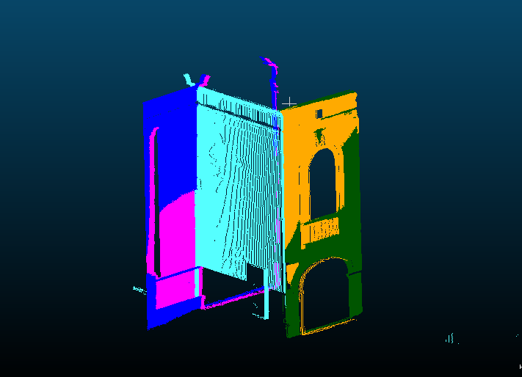

Figure 4: threshold:0.1m, 5planes formed

When the threshold descreased to 2cm, the planes that were detected increased to 6 but with less details and information. (Figure 5)

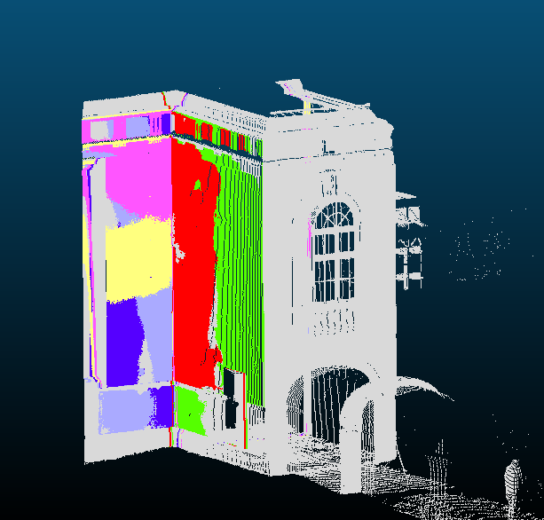

Figure 5: threshold:0.2m, 6planes formed

It can be said that increasing number of to be detected planes will result in a better coverage, which subsequently will give a better representation of the image.

But also it must be noted, when the tolerance level to 0.2 m, it will result in a much coverage of the building as shown in figure 5.

Looking at these results, it can be said that RANSAC produces good and reliable results in terms o plane detection from point cloud data.

**4. SUMMARY-CONCLUSIONS**

In the present report,we perform a short discussion regarding plane detection in 3D point cloud and test an experimental algorithm following the RANSAC principle.The final results were visualized in 3D and shown in different colour.If we consider the low computational cost of the algorithm, the results were satisfying. Further improvements could be done using least square adjustment algorithm with RANSAC to generalize the planes to a simpler and more accurate state.

Improving predefined parameters will result in a wide range of characteristic such as windows and walls in a higher level of detail.

As a final conclusion, RANSAC is a simple, but still very efficient algorithm for simple geometric shape detection.

**4. REFERENCES**

Fischler, M., Bolles, R., 1980. Random Sample Consensus: A Paradigm for Model Fitting with Applications to Image Analysis and Automated Cartography

Yang, M., Förstner, W., 2010. Plane Detection in Point Cloud Data. Technical Report, Institute of Geodesy and Geoinformation, Department of Photogrammetry. University of Bonn, Germany.

Meagher, D., 1982. Geometric modelling using octree encoding. In: *Computer Graphics and Image Processing*, Vol. 19, No. 2 (June 1982), pp.129-147.