FACE DETECTION

Dilara Karstarlı

Information Systems Engineering

Piri Reis University

20200205011

dilara.karstarli@pru.edu.tr

*Abstract*— The most crucial feature in identifying anybody is their face. Face recognition aids in the authentication of every person's identity utilizing its unique personal traits because it serves as a distinct identity for everyone. The entire process of authenticating any face data is divided into two phases. The first phase involves quickly detecting faces, with the exception of situations where the object is placed quite far away. The second phase then begins, during which the faces are identified as belonging to specific people. The entire procedure is then repeated, assisting in the development of a face recognition model, one of the most carefully examined biometric technologies.

Keywords—Face detection, Python

1. INTRODUCTION

Artificial intelligence is the ability of a machine to exhibit human-like skills such as reasoning, learning, planning and creativity. It allows technical systems to perceive their environment, deal with what they perceive, solve problems, and act to achieve a specific goal. The computer receives – processes and responds to data already prepared or collected through its own sensors, such as a camera. AI systems are capable of adapting their behavior to a certain degree by analyzing the effects of previous actions and operating autonomously. One of the application areas of artificial intelligence is face recognition.

Face recognition is a way to identify or verify a person's identity using their face. Facial recognition systems can be used to identify people in photos, videos or in real time .Facial recognition is a category of biometric security. Other forms of biometric software include voice recognition, fingerprint recognition, and retina or iris recognition. Although this technology is mostly used in security and safety applications, the interest in technology is increasing day by day in other areas of use. Face recognition is a fast and efficient verification system. It is faster and more convenient than other biometric technologies such as fingerprint or retinal scanning. Also, facial recognition has fewer touchpoints than entering a password or PIN. Supports multi-factor authentication for additional security verification.[1]

Facial recognition systems use computer algorithms to select specific, distinctive details about a person's face. These details, such as the distance between the eyes or the shape of the chin, are then converted into a mathematical representation and compared with data on other faces collected in a face recognition database. Data for a particular face is often called a face template and differs from a photograph in that it is designed to contain only certain details that can be used to distinguish one face from another.

# 2. Theory

## A. Python

## Guido van Rossum created Python, an interpreted, object-oriented, high-level programming language with dynamic semantics. It was first made available in 1991. The name "Python" is a tribute to the British comedy group Monty Python and is meant to be both simple and entertaining. Because it manages much of the complexity for the user, Python has a reputation for being a beginner-friendly language, displacing Java as the most popular beginning language and allowing beginners to concentrate on completely understanding programming ideas rather than minute details.

## Python is a popular language for Rapid Application Development and as a scripting or glue language to tie existing components together because of its high-level, built-in data structures, dynamic typing, and dynamic execution. Python is also used for server-side web development, software development, mathematics, and system scripting.[2]

## B. OpenCV

OpenCV is a sizable open-source library for image processing, machine learning, and computer vision. It now plays a significant part in real-time operation, which is crucial in modern systems. Using it, one may analyze pictures and movies to find faces, objects, and even human handwriting. Python is able to handle the OpenCV array structure for analysis when it is integrated with different libraries, such as NumPy. We use vector space and apply mathematical operations to these features to identify visual patterns and their various features.

OpenCV's initial release was 1.0. OpenCV is free for both academic and commercial use because it is distributed under a BSD license. It supports Windows, Linux, and Python and offers C++, C, and Java interfaces.The template is used to format your paper and style the text. All margins, column widths, line spaces, and text fonts are prescribed; please do not alter them. You may note peculiarities. For example, the head margin in this template measures proportionately more than is customary. This measurement and others are deliberate, using specifications that anticipate your paper as one part of the entire proceedings, and not as an independent document. Please do not revise any of the current designations.[3]

3. Face Detection Algorithms

## First, the computer examines either a photo or a video image and tries to distinguish faces from any other objects in the background. There are methods that a computer can use to achieve this, compensating for illumination, orientation, or camera distance. Yang, Kriegman, and Ahuja presented a classification for face detection methods. These methods are divided into four categories, and the face detection algorithms could belong to two or more groups.[4]

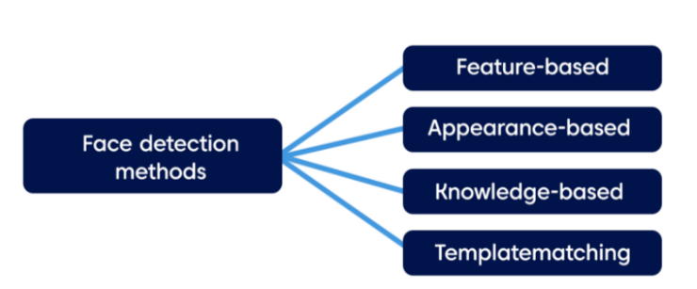

Figure 1 : Face detection methods[5]

## 1.Feature Based Detection

The structural features of the face are extracted using the feature-based technique. It is used to distinguish between facial and non-facial regions after being trained as a classifier. Color-based face detection is an illustration of this technique; it examines colored photos or videos for regions with typical skin tones before looking for face segments.

In order to find matches from facial features, Haar Feature Selection uses similarities between human faces, including the position and size of the eyes, the mouth, the nasal bridge, and the oriented gradients of pixel intensities. To get the total of 6061 characteristics from each frontal face, there are 38 layers of cascaded classifiers. Here are a few pre-trained classifiers. A feature extractor for object detection is called Histogram of Oriented Gradients (HOG). The attributes

## 2.Appearance Based Detection

The more advanced appearance-based method depends on a set of delegate training face images to find out face models. It relies on machine learning and statistical analysis to find the relevant characteristics of face images and extract features from them. This method unites several algorithms: Eigenface-based algorithm efficiently represents faces using Principal Component Analysis (PCA). PCA is applied to a set of images to lower the dimension of the dataset, best describing the variance of data. In this method, a face can be modeled as a linear combination of eigenfaces (set of eigenvectors). Face recognition, in this case, is based on the comparing of coefficients of linear representation.

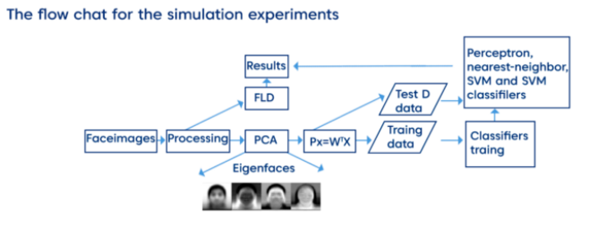

Figure 2 : Appearance Based Detection[6]

After the text edit has been completed, the paper is ready for the template. Duplicate the template file by using the Save As command, and use the naming convention prescribed by your conference for the name of your paper. In this newly created file, highlight all of the contents and import your prepared text file. You are now ready to style your paper; use the scroll down window on the left of the MS Word Formatting toolbar.

## 3.Knowledge Based Detection

This method relies on the set of rules developed by humans according to our knowledge. We know that a face must have a nose, eyes, and mouth within certain distances and positions with each other. The problem with this method is to build an appropriate set of rules. If the rules are too general or too detailed, the system ends up with many false positives. However, it does not work for all skin colors and depends on lighting conditions that can change the exact hue of a person’s skin in the picture.

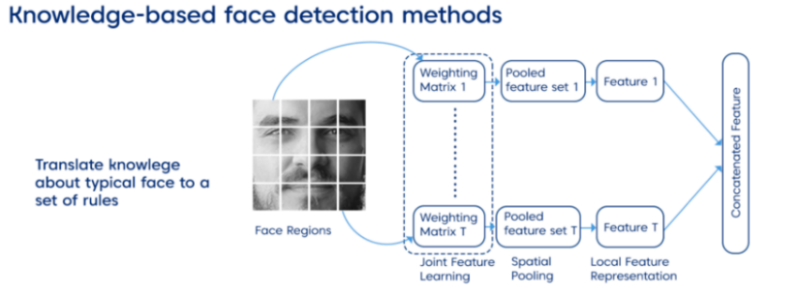

Figure 3 : Knowledge Based Detection[7]

## 4.Template Matching

The template matching method uses predefined or parameterized face templates to locate or detect the faces by the correlation between the predefined or deformable templates and input images. The face model can be constructed by edges using the edge detection method.provided by the drop down menu to differentiate the head from the text.

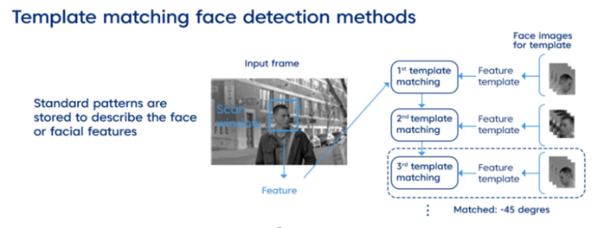

Figure 4 : Template Matching[8]

A variation of this approach is the controlled background technique. If you are lucky to have a frontal face image and a plain background, you can remove the background, leaving face boundaries. For this approach, the software has several classifiers for detecting various types of front-on faces and some for profile faces, such as detectors of eyes, a nose, a mouth, and in some cases, even a whole body. While the approach is easy to implement, it is usually inadequate for face detection.

metin, ekran görüntüsü, ekran içeren bir resim

Açıklama otomatik olarak oluşturuldu 4. Figures

##### References

1. https://ieeexplore.ieee.org/document/9074838,
2. <https://www.teradata.com/Glossary/What-is-Python>
3. https://www.geeksforgeeks.org/opencv-overview
4. <https://medium.com/nerd-for-tech/face-detection-recognition-how-machine-learning-approaches-and-algorithms-make-it-possible-4b5896aefb88>
5. https://medium.com/sciforce/face-detection-explained-state-of-the-art-methods-and-best-tools-f730fca16294.
6. https://medium.com/sciforce/face-detection-explained-state-of-the-art-methods-and-best-tools-f730fca16294.
7. https://medium.com/sciforce/face-detection-explained-state-of-the-art-methods-and-best-tools-f730fca16294.
8. https://medium.com/sciforce/face-detection-explained-state-of-the-art-methods-and-best-tools-f730fca16294.

metin içeren bir resim

Açıklama otomatik olarak oluşturuldu Figure 5

Figure 6