Charting and Reporting: Aumentum flow and development phases
Nov 6, 2026 · @workspace 2

Source
Two phone recordings made at PLAGIS on 3 Nov 2026 show the whole charting and reporting step for one file, PL68605. Charting is done by hand in ArcMap, and the report is typed into a local HTML form. Neither tool writes back to Aumentum or the Registry.
Recording | Length | Time on screen | What it shows
PXL_20261103_153755119.mp4 | 7 min 48 s | 4:57 to 5:04 PM | Charting in ArcMap 10.x, map document Cadastral_Maps - Copy1
PXL_20261103_155646619.mp4 | 2 min 48 s | 5:14 to 5:17 PM | The report, file:///C:/Survey Charting Report.html in Firefox
The recordings are kept out of git (5.2 GB). Frames were read at full resolution. Names of the officers and the applicant are kept as shown, because the form prints them.

Where it sits in the workflow
Charting and reporting is step 6 of the PLAGIS workflow review. It comes after SQCO and before town planning and the R of O office, and it is the step this Cadastre still has to build.
- Application, scanning and fee payment (Registry)
- Digitising and commit, which gives the UPIN (this Cadastre)
- SQCO checks the survey (separate system)
- Charting: the officer plots the plot's beacons on the cadastral sheets and checks what is already there (ArcMap today)
- Reporting: the charting officer fills the Survey Report on Right of Occupancy, and a second officer completes the Final Survey Report (HTML form today)
- Town planning, then the R of O office, the recommendation and C of O processing (Registry)
The report answers the questions the later offices ask: is the ground open, is it beaconed, does it clash with a town plan, a title, a railway or a major road. Nothing in today's tools sends those answers to Aumentum or the Registry.

Charting flow, as recorded
Charting puts the plot's beacons and outline on the cadastral sheets, so that the officer can see what the plot falls on. It takes about 7 minutes for a 4-beacon plot, and every value is typed by hand from the SQCO schedule.
- Open the map. ArcMap opens Cadastral_Maps - Copy1. It holds the charting layers and about 60 georeferenced scans of the old cadastral sheets, named by sheet (for example 487_1089_NW_172.TIF, 483_1092_NE_133.TIF, Bukuru sheet10.jpg).
- Start editing the shared layer. Editor > Start Editing, then choose Willams. This is the point layer "we just created so that we can be using" it. The officers' own layers (Maffy_points, Jgomos_P_Merge) are kept, but some are corrupt; ArcMap reports "Unexpected operation [Jgomos_P_Merge]". The data sits in a file geodatabase on \\PRODUCTIONMC\Image\Shapefile\Minna….
- Take the coordinates from the SQCO schedule. SQCO has already converted them to UTM zone 32. Without that conversion the plot "will throw 100, 150 meters away from the real property".
- Enter the first beacon. Point tool, right-click, Absolute X, Y, then type the Easting and Northing (example: 488134.461, 1097202). The map moves to the plot.
- Enter the other beacons. Press F6 and type the next pair, once per beacon.
- Check against the sheet. The scans carry the earlier charting in pen: file numbers (PL49519, PL43035, PL17544) and beacon numbers (PJ8233, PJ2041, PG156). Existing parcels show as outlines with their beacons (PL82763 with K7964B–K7967B). The officer checks the new points against these and against the survey plan.
- Draw the plot. Choose the jgomos_parcel_3 polygon template in the JGOMOS layer, connect the points with snapping, and press F2 to finish. Save the edits.
- Name the beacons. Open the Willams attribute table (36,625 points) and type each beacon number into Point_Num (PM935, PM936, PM937, PM938), checking the order against the plan.
- Name the plot. Open the JGOMOS attribute table (8,081 polygons) and type the file number into Property_n (PL…). Save.
- Read off what the plot falls on. The officer notes the sheet and what lies under the plot, ready for the report.
During the recording an officer was asked whether one window could take all the coordinates at once instead of F6 per beacon. The officer's worry was that one wrong coordinate would put the plot in the wrong place. The answer given was that a wrong coordinate shows at once as a point far from the others.

Reporting flow, as recorded
The report is the Survey Report on Right of Occupancy (Survey Ordinance CAP 120). It is a local HTML page with typed fields and Yes/No lists, and the officer said: "It's manually… It's not automated yet." The example is file PL68605.
- Open the form. Firefox opens C:/Survey Charting Report.html; the tab is titled "Survey Report on RofO". The heading box at the top is empty (its image does not load).
- Officer details. The charting officer types their name and rank (C.T.O. Carto).
- File details, typed from the file. Ref no and Property No (PL68605), Name of Applicant, Area from the survey plan (237.419 Sq.m, "the area is from the schedule"), Place/Location ("Situated at No. 57/3 Bakano Street Jos, Jos North L.G.A Plateau State").
- Charting answers. Questions 1 to 8 are answered from what the charting showed (list below).
- Tracing No. The officer types the beacon series ("PM") for the plot's beacons.
- Final Survey Report. A second officer (also C.T.O. Carto) completes the final part with their name.
- Sign and date. Signed and Date are left for the paper copy.
Part | Question | Answer type
Charting | 1. Have you correctly identified this land? | Yes/No
Charting | 2. Is the ground open? If no, what title or application lies on the land | Yes/No + text
Charting | 3. Is the plot completely beaconed? If yes: (a) Tracing No, (b) Deposited plan No, (c) lies on Government property, item No, (d) separate survey is required | Yes/No + numbers
Charting | 4. Does it lie in an area covered by a Town Plan? If yes, TPO No; (a) does the shape contravene the TOP plan; (b) the application is for | Yes/No + TPO No + land use (Residential, …)
Charting | 5. Is the plot held under title? If yes, revoked/expired details and Title No | Yes/No + text
Charting | 6. Does a rail line traverse the plot? | Yes/No
Charting | 7. Is the plot on a major road? | Yes/No
Charting | 8. Is the plot in a settlement area? | Yes/No
Charting | Charting officer: name, rank, signed, date | Text
Final | The ground is opened | Yes/No
Final | The application is completely satisfactory with regards to survey requirement | Yes/No + text
Final | 2. The correct description of the plot is | Text
Final | 3. Check survey will be necessary on approval | Yes/No
Final | 4. In addition | Text
Final | 5. The application is recommended to proceed to title subject to | Yes/No + text
Final | Officer: name, rank, signed, date | Text

Data, forms and outputs
Most of what the officers type is already in this Cadastre once the plot is digitised and committed. The beacons, their numbers, the outline, the area and the file number are all captured at commit. The gaps are the reference layers the questions depend on (sheet scans, town plans, rail, roads, settlements) and the applicant's details.
Value | Typed from today | Source in this Cadastre | Status
Beacon coordinates (UTM 32N) | SQCO schedule | Beacons of the committed parcel | Have
Beacon numbers (PM935…) | Survey plan | Beacon names typed at commit | Have
Plot outline | Drawn by snapping | Committed parcel | Have
File / Property No, Ref no (PL68605) | File cover | Job's Registry file (Job-<file number>) | Have
Area (237.419 Sq.m) | Schedule | Parcel area, computed | Have
Tracing No (beacon series, "PM") | Survey plan | Prefix of the parcel's beacon names | Have (rule to confirm)
Applicant name | File | Registry file, read live from LRS43 | To build
Place / Location | File | Registry property address, or typed | To confirm
Old cadastral sheets (about 60 scans) | Cadastral_Maps map | Georeferenced rasters on the map | To load
Earlier charting (Willams 36,625 points, JGOMOS 8,081 plots, officers' layers) | PRODUCTIONMC file geodatabase | Reference layers, matched to our parcels | To load
What the plot falls on (Q2, Q5) | Officer's eye on the sheet | Overlap with parcels, retired shapes and Registry titles | To build
Government property (Q3c) | Officer | A Government land layer | Missing
Town plan, TPO No, land use (Q4) | Officer | Town planning layouts | Missing
Rail line, major road, settlement (Q6–8) | Officer | Reference layers | Missing
Officer name and rank | Typed | Signed-in user, rank on the user | To build
Outputs today: points and plots in the shared file geodatabase, plus a report filled on screen. As seen in the recordings, nothing saves the report or sends it to the Registry. Production also has a chartingMinna database (seen in the Aumentum inventory, purpose unknown), which may be the store behind the charting layers.

Development phases
The plan builds charting and reporting in seven phases, C0 to C6. Charting becomes a review of the parcel already committed at digitising, so nothing is typed twice. The report is filled in advance from the Cadastre and the Registry, and the officers confirm it. C2 and C3 can run side by side once the reference data is loaded.
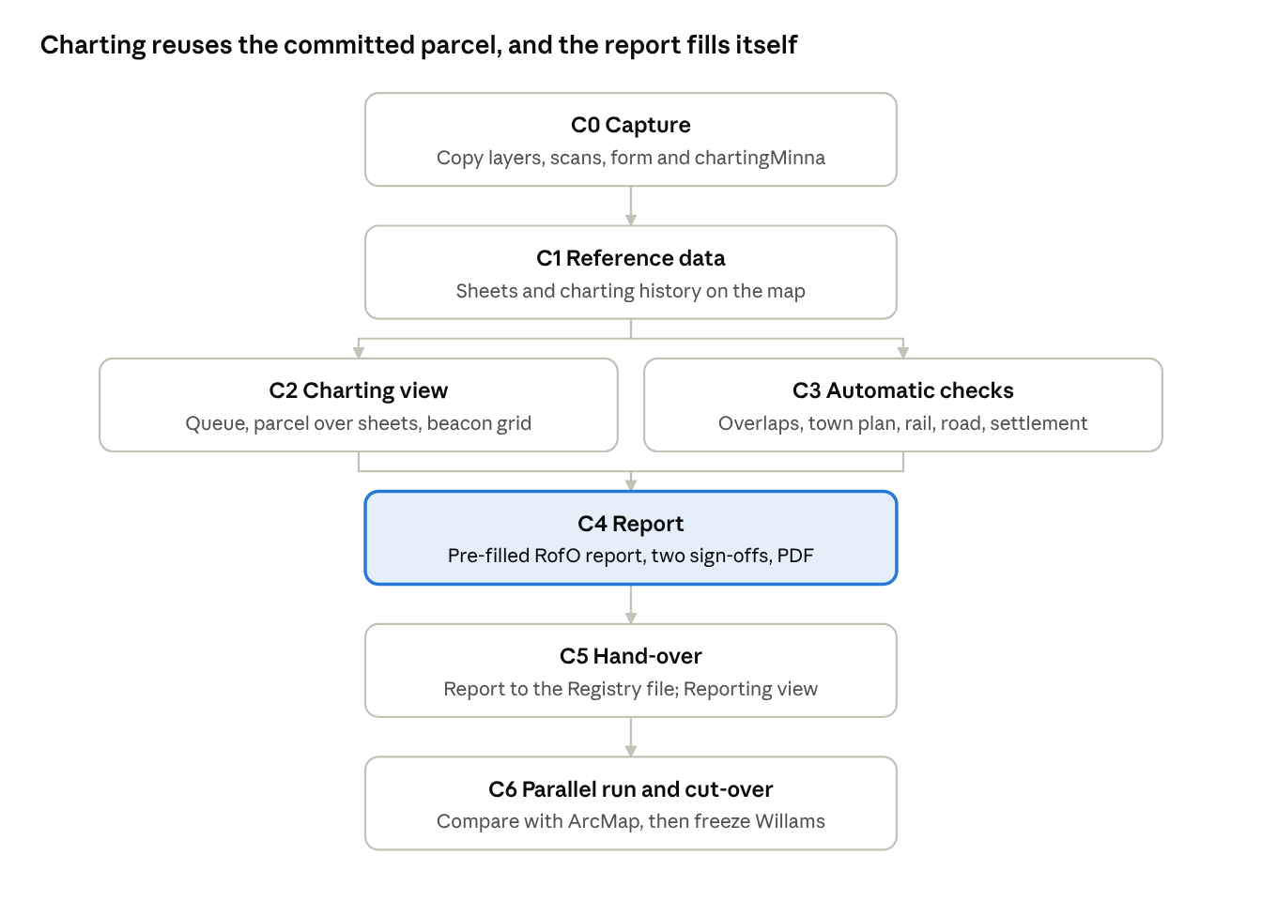
charting and reporting · 7 phases, C2 and C3 side by side
- C0 Capture (read-only). Copy Cadastral_Maps (the .mxd and its layer list), the Willams, JGOMOS, Maffy_* and Jgomos_* layers from the PRODUCTIONMC file geodatabase, the sheet scans with their world files, the chartingMinna database structure and Survey Charting Report.html. Use the same kind of read-only kit as Phase 0.
  - Done when: every layer and scan is listed with its count and coordinate system, and PLAGIS has answered the C0 questions below.
- C1 Reference data. Load the sheet scans as map rasters in UTM 32N. Load the charting history (points and plots) as read-only layers. Match Property_n and Point_Num against our file numbers, UPINs and beacons, and list the mismatches for PLAGIS. No new tables without approval; this needs a decision on where the rasters and history live.
  - Done when: any sheet can be shown under the parcels, and the match report is in PLAGIS's hands.
- C2 Charting view. A Charting unit view (like Digitising and Title Deed) with a queue of files that have passed SQCO. Opening a file zooms to its committed parcel over the sheets, the charting history and the neighbouring parcels.
  - For a file not yet digitised: one grid takes all beacons at once (number, Easting, Northing), draws them live and flags a point far from the others. This is what the officers asked for instead of F6 per beacon. It records a charting sketch, never a UPIN.
  - Done when: an officer can chart PL68605 without ArcMap.
- C3 Automatic checks. For the parcel, work out: overlap with active and retired parcels, the charting history and Registry titles (Q2, Q5); beacon completeness and Tracing No (Q3); Government land, town plan, TPO No and land use (Q3c, Q4); rail, major roads and settlement (Q6–8). Each answer carries its evidence (which parcel, which layer).
  - Done when: each question has a suggested answer, or says which layer is missing.
- C4 Report. The Survey Report on Right of Occupancy in the editor, laid out like the HTML form, pre-filled from C3 and the Registry (applicant, location). It is saved per file with versions. The charting officer signs the first part and a second officer the Final Survey Report; the signed-in users and their ranks fill the names. It prints as a PDF with the heading image, and appears in the file's history and audit.
  - Done when: the report for PL68605 matches the paper copy, field for field.
- C5 Hand-over. The Reporting view lists reports by state (to chart, to report, to finalise, done). The signed report is sent to the Registry file as a document, following the same path as the title deed plan, once PLAGIS names its document type. The workflow step is marked complete.
  - Done when: town planning and the R of O office can open the report from the Registry file.
- C6 Parallel run and cut-over. Chart and report a set of files in both ArcMap and the new view, and compare the answers. Then freeze the Willams layer and the HTML form.
  - Done when: PLAGIS signs off and charting stops in ArcMap.

Open questions for PLAGIS
These decide C0 and C1. The first two decide whether charting re-enters beacons at all.
- ☐ Is every file digitised and committed before it reaches charting? If so, can charting start from the committed parcel instead of re-typing the schedule?
- ☐ Is PL68605 (beacons PM935–PM938) already a parcel in this Cadastre? Reading the live database needs your permission for that query.
- ☐ Which layers are the record: Willams and JGOMOS only, or the officers' layers too? Which ones are corrupt?
- ☐ What is in the chartingMinna database, and is it the store behind these layers?
- ☐ Where are the sheet scans and their world files kept? Are any sheets missing from Cadastral_Maps?
- ☐ Tracing No: is it always the beacon series ("PM"), or a tracing sheet number?
- ☐ Where do Government land, town plan layouts with TPO numbers, rail lines, major roads and settlement areas come from? Does any office hold them as digital layers?
- ☐ Which Registry stage is charting and reporting ("Raise Site Analysis Report"?), and under which document type should the signed report be sent to the file?
- ☐ Who signs the Final Survey Report: any C.T.O. Carto, or a named head of unit? Is a scanned signature wanted on the PDF?
- ☐ What image belongs in the form's empty heading box?
- ☐ In the reporting recording the officer reads numbers off the file (heard as "cc8, cc9… it's also a sheet"). Is a sheet number meant to be on the report?

