LAPORAN PENGERJAAN UJI KOMPETENSI KEJURUAN SMK MAHARDHIKA BATUJAJAR

TAHUN PELAJARAN 2022-2023

KOMPETENSI KEAHLIAN : Rekayasa Perangkat Lunak KELAS : XII Rpl 1

NAMA LENGKAP : Dila Septiyani

NIS :

PAKET SOAL : 2

JENIS APLIKASI : Web

ALOKASI WAKTU : 24 jam

# PENJADWALAN KEGIATAN

*Silahkan buat form penjadwalan dengan excel seperti yang pernah dicontohkan*

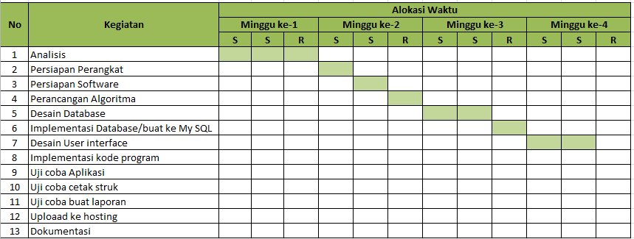

# PERSIAPAN PERANGKAT KERAS

*Silahkan isikan deskripsi/spesifikasi dari komputer/laptop yang kamu gunakan*

*Nama PC : DESKTOP-58E5CEM*

*Edisi : Windaws 10 Home Single Language*

*Prosesor : Intel(R) Celeron(R) CPU N3350 @ 1.10GHz*

*RAM terinstal : 4,00 GB (3,87 GB dapat digunakan)*

# PERSIAPAN PERANGKAT LUNAK

*Silahkan isikan perangkat lunak yang terlibat dalam pembuatan project ini*

*-Xampp Control Panel*

*-Visual Studio Code*

*-Chrome / Firefox*

*-Astah Pro*

*-Balsamiq mockups*

*-Mysql*

*-Microsoft Word*

# PERANCANGAN ALGORITMA APLIKASI

*Silahkan gambarkan activity diagram aplikasi yang kamu buat*

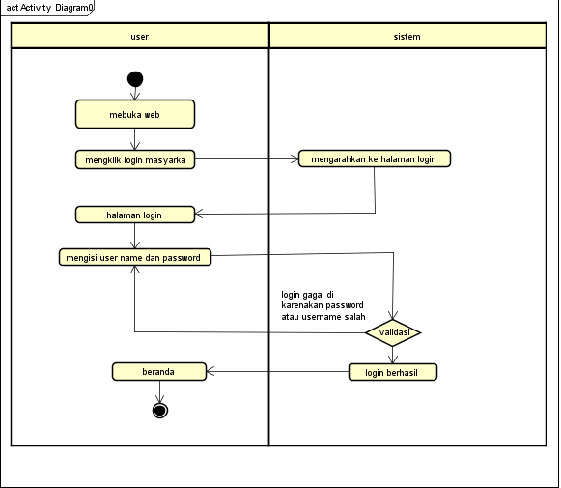

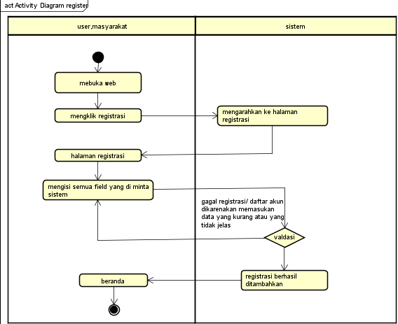

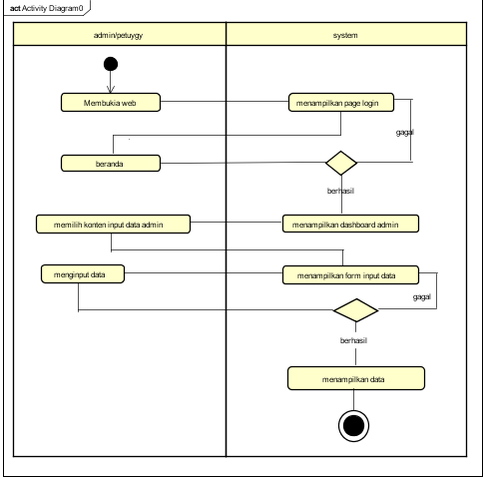

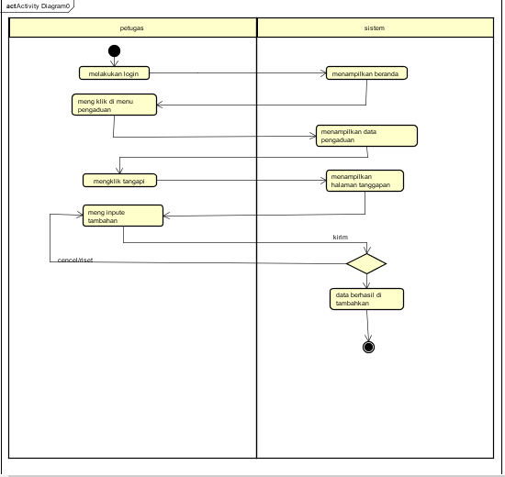

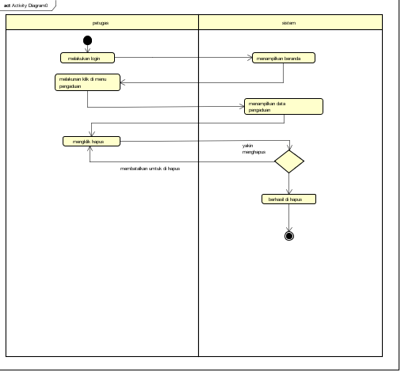

# PERANCANGAN DESAIN BASIS DATA

*Silahkan gambarkan ERD/DFD/class diagram atau desain basis data pada phpMyAdmin beserta relasinya*

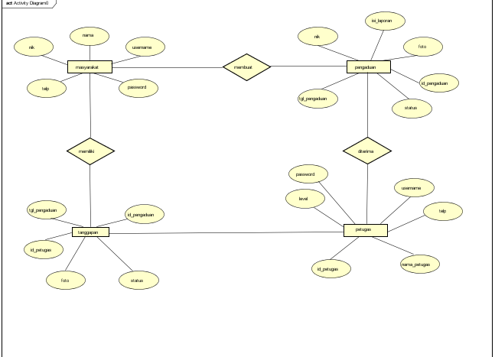

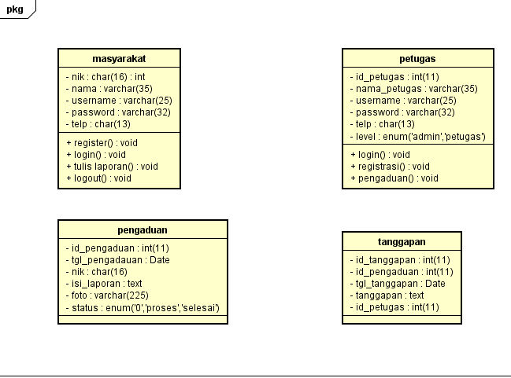

# DUMMY DATA

*Buat data dummy/bohongan yang dipersiapkan untuk nanti dimasukkan*

*Masyarakat*

|  |  |  |  |  |
| --- | --- | --- | --- | --- |
| *NIK* | *NAMA* | *USERNAME* | *PASSWORD* | *TELP* |
| *2345678987654322* | *DILA SEPTIYANI* | *DILL* | *765* | *083843712517* |
| *8765432345678987* | *TRESNA NIN* | *NIN* | *143* | *088765432123* |
| *5678987654321234* | *DINDA AMARA* | *DIN* | *987* | *087654567654* |
| *3456787654345676* | *MUHAENIAH* | *MOEH* | *786* | *087654323456* |
| *1234567898765432* | *ZHAFIRA* | *FILA* | *387* | *087654329876* |

*Data­_admin*

|  |  |  |  |  |  |
| --- | --- | --- | --- | --- | --- |
| *Id_admin* | *Nama_admin* | *Username* | *Password* | *Telp_admin* | *Level* |
| *1* | *Kokom* | *Kom* | *556* | *087654345678* | *Admin* |
| *4* | *Tatangg* | *Tang* | *123* | *098765456765* | *Admin* |
| *17* | *Jodi* | *Jod* | *898* | *087654345676* | *Admin* |
| *12* | *Rifky* | *Ky* | *256* | *098765434567* | *Admin* |
| *7* | *Ahmadd* | *Mad* | *124* | *087698767987* | *Admin* |

*Data_petugas*

|  |  |  |  |  |  |
| --- | --- | --- | --- | --- | --- |
| *Id_petugas* | *Nama_petugas* | *Usernme* | *Password* | *Tel_petugas* | *Level* |
| *4* | *Firman aldry* | *Man* | *123* | *098765342565* | *Petugas* |
| *6* | *Sopian septi* | *Sep* | *145* | *098765432345* | *Petugas* |
| *9* | *Cinta laura* | *Laur* | *167* | *098765432123* | *Petugas* |
| *7* | *Bunga lestari* | *Lestar* | *198* | *098765432123* | *Petugas* |
| *9* | *Agus setiawan* | *Gus* | *178* | *098767876545* | *Petugas* |

# PEMBUATAN BASIS DATA (MySQL Code)

*Silahkan buat basis data di PHPMyAdmin, jika sudah selesai bisa di copykan filenya di sini sebagai lampiran (*screenshot struktur tabel pada basis data yg dibuat)*

*Masyarakat*

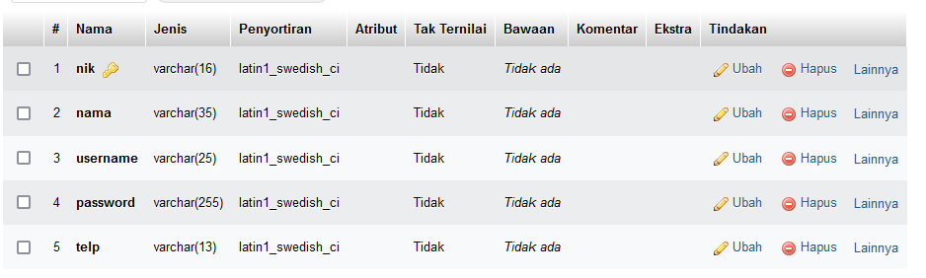

*Pengaduan*

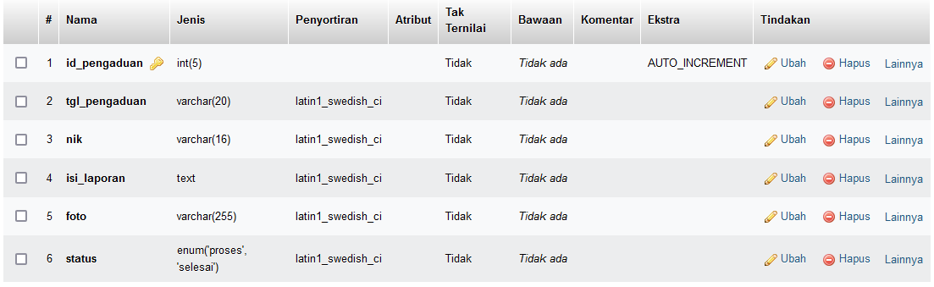

*Petugas*

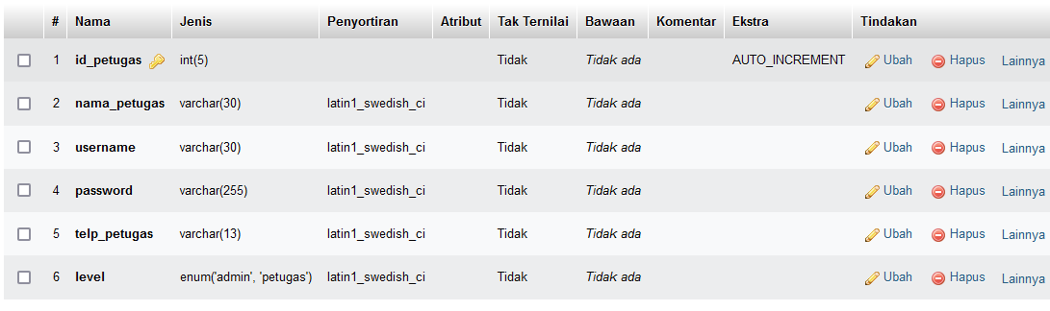

*Tangggapan*

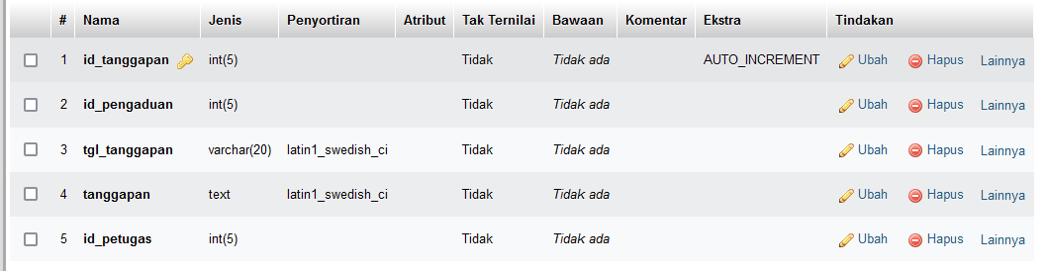

# PERANCANGAN TAMPILAN ANTARMUKA (UI) WEB

* + **Aplikasi pengaduan masyarakat**

1. *Silahkan gambarkan use case diagram aplikasi yang kamu buat*

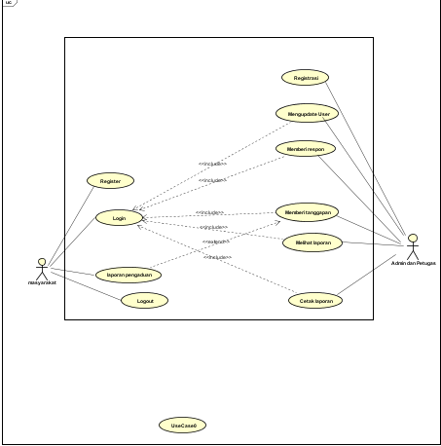

1. Admin dashboard

Tampilan untuk full manage semua data, buatkan sketsa/mockup-nya

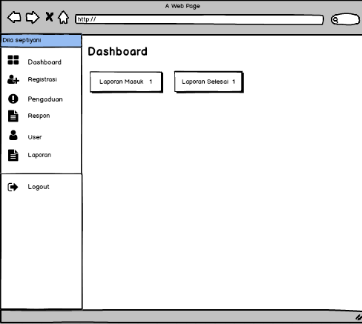

1. Tampilan Petugas buatkan sketsa/mockup-nya

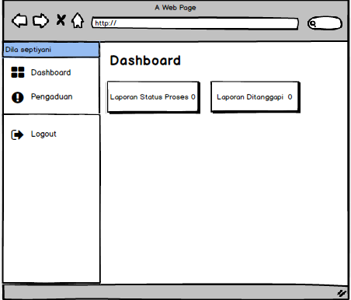

1. Tampilan masyarakat

Dashboard,about,tambah laporan,daftar komentar, tanggapan, buatkan sketsa/mockup-nya

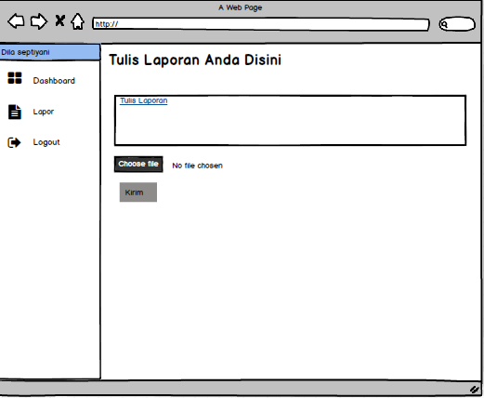

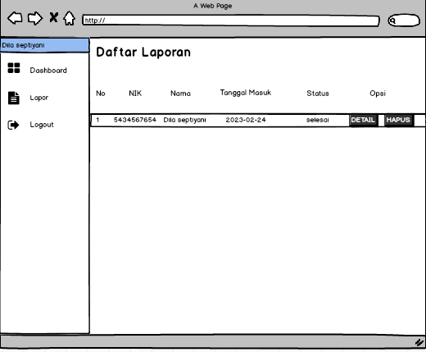

# PEMBUATAN STRUKTUR WEB (HTML)

1. PEMBUATAN STYLE WEB (CSS) File style.css

|  |
| --- |
| /* GLOBAL STYLES  -------------------------------------------------- */  /* Padding below the footer and lighter body text */  body {    padding-top: 3rem;    padding-bottom: 3rem;    color: #5a5a5a;  }  /* CUSTOMIZE THE CAROUSEL  -------------------------------------------------- */  /* Carousel base class */  .carousel {    margin-bottom: 4rem;  }  /* Since positioning the image, we need to help out the caption */  .carousel-caption {    bottom: 3rem;    z-index: 10;  }  /* Declare heights because of positioning of img element */  .carousel-item {    height: 32rem;  }  /* MARKETING CONTENT  -------------------------------------------------- */  /* Center align the text within the three columns below the carousel */  .marketing .col-lg-4 {    margin-bottom: 1.5rem;    text-align: center;  }  /* rtl:begin:ignore */  .marketing .col-lg-4 p {    margin-right: .75rem;    margin-left: .75rem;  }  /* rtl:end:ignore */  /* Featurettes  ------------------------- */  .featurette-divider {    margin: 5rem 0; /* Space out the Bootstrap <hr> more */  }  /* Thin out the marketing headings */  /* rtl:begin:remove */  .featurette-heading {    letter-spacing: -.05rem;  }  /* rtl:end:remove */  /* RESPONSIVE CSS  -------------------------------------------------- */  @media (min-width: 40em) {    /* Bump up size of carousel content */    .carousel-caption p {      margin-bottom: 1.25rem;      font-size: 1.25rem;      line-height: 1.4;    }    .featurette-heading {      font-size: 50px;    }  }  @media (min-width: 62em) {    .featurette-heading {      margin-top: 7rem;    }  } |

1. PEMBUATAN KODE WEB (PHP/JS) File index.php

|  |
| --- |
| <?php    session_start();    error_reporting(0);    include '../conn/koneksi.php';    if(!isset($_SESSION['username'])){      header('location:../index.php');    }    elseif($_SESSION['level'] != "masyarakat"){      header('location:../index.php');    }   ?>    <!DOCTYPE html>    <html>      <head>        <title>Aplikasi Pengaduan masyarakat</title>        <!--Import Google Icon Font-->        <link href="https://fonts.googleapis.com/icon?family=Material+Icons" rel="stylesheet">        <!--Import materialize.css-->        <link type="text/css" rel="stylesheet" href="../css/materialize.min.css"  media="screen,projection"/>        <!-- Compiled and minified CSS -->        <link rel="stylesheet" href="https://cdnjs.cloudflare.com/ajax/libs/materialize/1.0.0/css/materialize.min.css">        <!-- Compiled and minified JavaScript -->        <script src="https://cdnjs.cloudflare.com/ajax/libs/materialize/1.0.0/js/materialize.min.js"></script>        <script src="https://ajax.googleapis.com/ajax/libs/jquery/3.4.1/jquery.min.js"></script>        <!--Let browser know website is optimized for mobile-->        <meta name="viewport" content="width=device-width, initial-scale=1.0"/>        <link rel="stylesheet" type="text/css" href="https://cdn.datatables.net/1.10.19/css/jquery.dataTables.css">          <script src="https://ajax.googleapis.com/ajax/libs/jquery/3.4.1/jquery.min.js"></script>          <script type="text/javascript" charset="utf8" src="https://cdn.datatables.net/1.10.19/js/jquery.dataTables.js"></script>            <script type="text/javascript">          $(document).ready( function () {            $('#example').DataTable();            $('select').formSelect();          } );          </script>      </head>      <body style="background:url(../img/pnga.png); background-size: cover;">      <div class="row">        <div class="col s12 m3">            <ul id="slide-out" class="sidenav sidenav-fixed">                <li>                    <div class="user-view">                        <div class="background">                            <img src="../img/pnga.png">                        </div>                        <a href="#name"><span class="black-text name"><b><?php echo ucwords($_SESSION['data']['nama']); ?></b></span></a>                    </div>                </li>                <li><a href="index.php?p=dashboard"><i class="material-icons black-text">dashboard</i><b>Dashboard</b></a></li>                <li><a href="index.php?p=laporan"><i class="material-icons black-text">book</i><b>Lapor</b></a></li>                <li>                  </li>                <li><a class="waves-effect" href="../index.php?p=logout"><i class="material-icons black-text">logout</i><b>Logout</b></a></li>            </ul>          </div>        <div class="col s12 m9">      <?php      if(@$_GET['p']==""){        include_once 'dashboard.php';      }      elseif(@$_GET['p']=="dashboard"){        include_once 'dashboard.php';      }      elseif(@$_GET['p']=="laporan"){        include_once 'lapor.php';      }      elseif(@$_GET['p']=="pengaduan_hapus"){        $query=mysqli_query($koneksi,"SELECT * FROM pengaduan WHERE id_pengaduan='".$_GET['id_pengaduan']."'");        $data=mysqli_fetch_assoc($query);        unlink('../img/'.$data['foto']);        if($data['status']=="proses"){          $delete=mysqli_query($koneksi,"DELETE FROM pengaduan WHERE id_pengaduan='".$_GET['id_pengaduan']."'");          header('location:index.php?p=dashboard');        }        elseif($data['status']=="selesai"){          $delete=mysqli_query($koneksi,"DELETE FROM pengaduan WHERE id_pengaduan='".$_GET['id_pengaduan']."'");          if($delete){            $delete2=mysqli_query($koneksi,"DELETE FROM tanggapan WHERE id_pengaduan='".$_GET['id_pengaduan']."'");            header('location:index.php?p=dashboard');          }        }      }      elseif(@$_GET['p']=="more"){        include_once 'more.php';      }     ?>        </div>      </div>          <!--JavaScript at end of body for optimized loading-->        <script type="text/javascript" src="../js/materialize.min.js"></script>        <script type="text/javascript" src="https://cdnjs.cloudflare.com/ajax/libs/materialize/1.0.0/js/materialize.min.js"></script>        <script type="text/javascript">          document.addEventListener('DOMContentLoaded', function() {            var elems = document.querySelectorAll('.sidenav');            var instances = M.Sidenav.init(elems);          });          document.addEventListener('DOMContentLoaded', function() {            var elems = document.querySelectorAll('.modal');            var instances = M.Modal.init(elems);          });        </script>      </body>    </html> |

File koneksi.php

|  |
| --- |
| <?php $koneksi= mysqli_connect("localhost","root","","db_pengaduan"); ?> |

CRUD file

1. UJI COBA

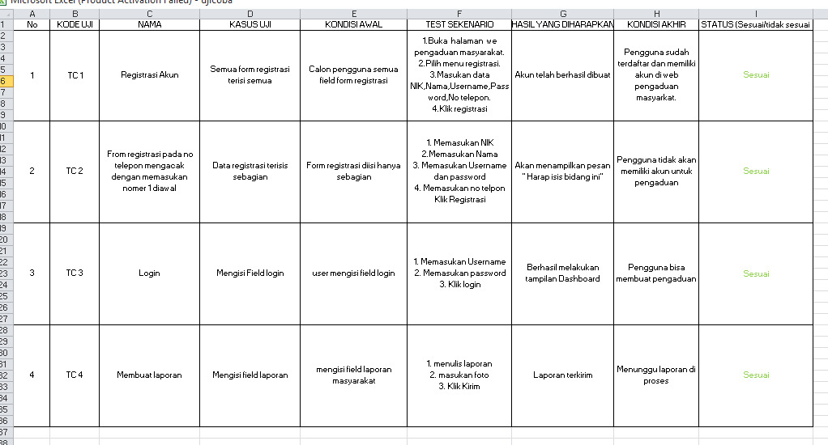

1. REVISI
2. PENENTUAN DOMAIN DAN HOSTING
3. UPLOAD WEB KE HOSTING
4. UPLOAD WEB KE GITHUB
5. PEMBUATAN USER GUIDANCE