Task:-

-------

* + - Create a process/workflow that performs following:-
      * When summary control file arrives, perform record count check between the data file and the summary control file.
      * Identify matched and unmatched files as well as missing files.
      * If any files are missing, keep looking for the file availability and do the reconciliation again when the file arrives. Keep running this for 10 times with some wait time looking for the missing file.

Steps:-

----------

* Create a lambda function that triggers a work flow (step function machine state) when the summary control file arrives in inbound.
* Create a lambda function that will perform the reconciliation checks using the summary control file and .ctl files created and identify the missing, matched and unmatched files. The function also increments the loop counter and decides whether to end the execution or wait for missing file.
* Create a step function machine state that orchestrate the entire reconciliation process.

Lambda_trigger_machine_state:

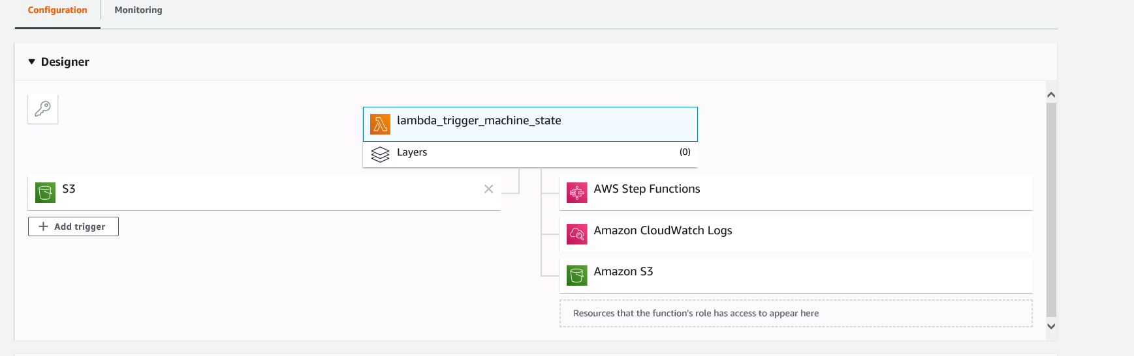

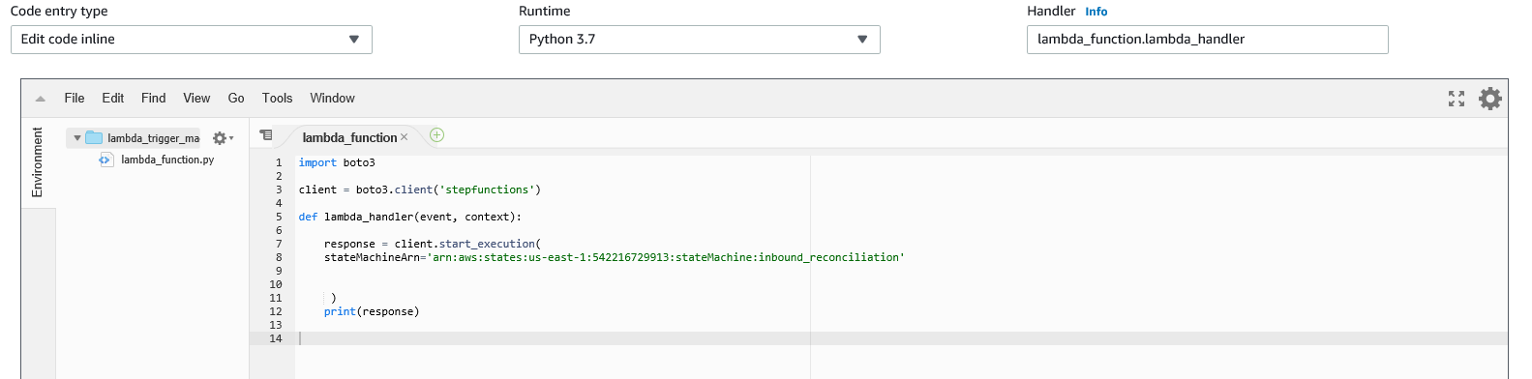

**Lambda inbound Reconciliation:-**

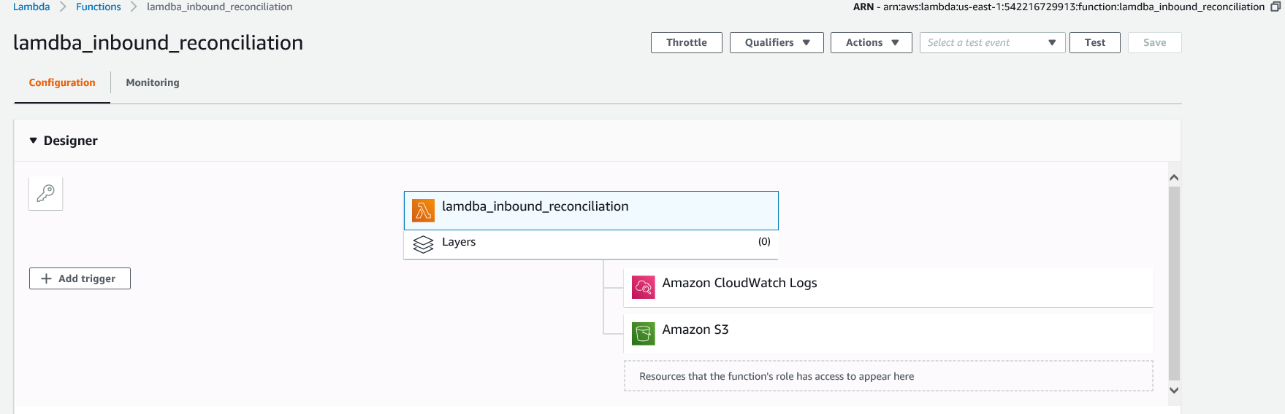

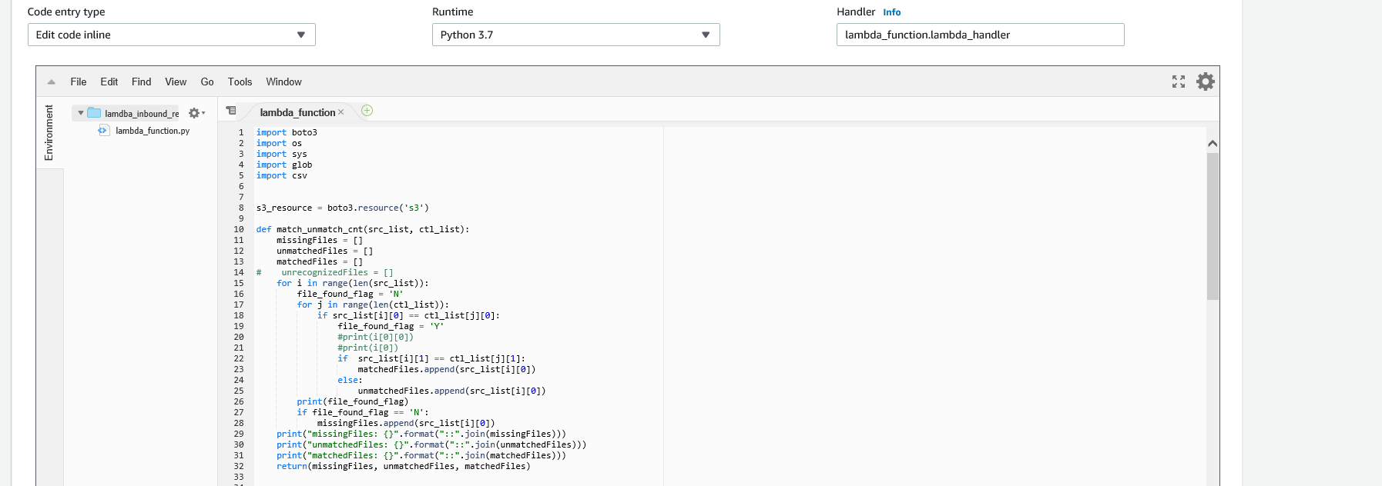

**Machine State (step function work flow)**

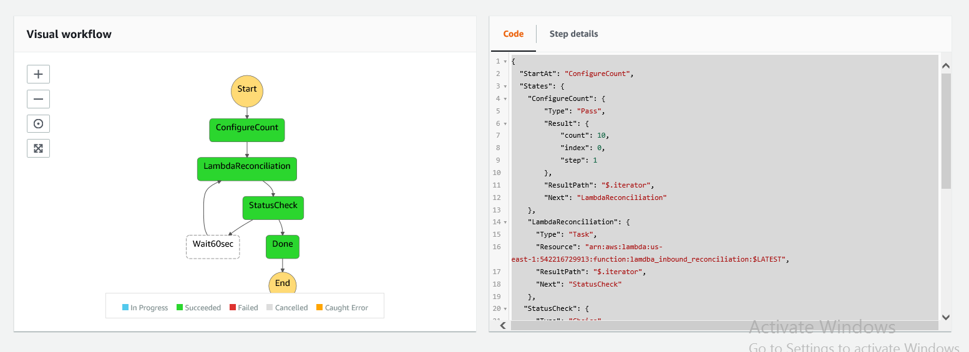

Task 2:-

* Create Alert Notifications whenever there is a mismatch or missing files.
* Create a SQS message for each file in the summary control file if the reconciliation passes successfully (all matching and no missing files)

1. Create a SNS topic “InboundReconcileAlert”
2. Have [digestdiblert@gmail.com](mailto:digestdiblert@gmail.com) to subscribe to this topic and confirm the subscription.
3. Grant necessary SNS permission to the role used in Lambda Reconcile function.
4. Expand the lambda reconcile function to publish a message to this topic whenever missing/unrecognized file arrives.
5. Create an SQS queue.
6. Grant necessary permissions for Lambda role to publish messages to SQS.
7. Expand the Lambda Reconciliation function to publish messages to SQS.

