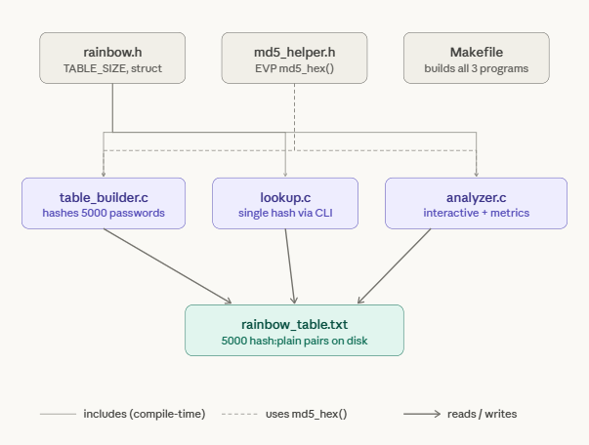

rainbow.h — the shared contract
This is just a header, not a program. It defines two things that all three programs need to agree on: the RainbowEntry struct (which holds one hash + its plaintext), and TABLE_SIZE (set to 5000). Because all three .c files #include "rainbow.h", they all use the exact same struct layout and size. If you change TABLE_SIZE here, it changes everywhere automatically.
md5_helper.h — the hashing function
Also just a header, not a program. It contains one function — md5_hex() — which takes a plaintext string and writes its MD5 hash as a 32-character hex string. It uses OpenSSL's modern EVP API internally. Both table_builder.c and analyzer.c include this because they're the two programs that actually need to compute hashes. lookup.c doesn't need it because it only reads hashes from the file — it never computes one.
table_builder.c — program 1, run first
This is the setup step. It has a hardcoded array of 5000 common passwords baked directly into the source code. When you run it, it calls md5_hex() on every single one of them and writes the results to rainbow_table.txt in hash:plaintext format — one pair per line. You only need to run this once. After that, the table file exists on disk and the other two programs read from it.
lookup.c — program 2, the simple tool
Takes a single MD5 hash as a command-line argument (./lookup 5f4dcc3b5...), opens rainbow_table.txt, reads it line by line into memory, and does a linear scan looking for a match. Reports cracked or not found. No hashing happens here — it's a pure lookup. This program is clean and focused: one job, one input, one output.
analyzer.c — program 3, the main event
This is the most complex program and the one you'd demo. It loads the table the same way lookup.c does, but then runs an interactive loop. For each input it does several things in sequence: detects whether the input is a raw MD5 hash, a plaintext, or a salted hash (bcrypt etc.). If it's salted, it immediately flags it as defeated — no lookup needed. If it's a hash or plaintext, it computes or uses the hash, runs the lookup while timing it with clock_gettime(), then calculates entropy, detects keyboard walk patterns, scores the password 0–100, estimates GPU brute-force crack time, and prints the strength bar. Type stats at any point and it shows you the session summary across everything you've tested.
rainbow_table.txt — the output file, not source code
This file doesn't exist until you run ./table_builder. It's the actual "rainbow table" — 5000 lines of hash:plaintext. Both lookup and analyzer depend on it being present. It's what gets searched during every lookup.
Makefile — the build script
Runs all three compilations with one make command. It also knows which files depend on which headers, so if you edit rainbow.h it recompiles everything that includes it. The -lssl -lcrypto flags tell the linker to bring in OpenSSL, and -lm brings in the math library that analyzer.c needs for log2() and pow() in the entropy calculation.
The execution order is always: make → ./table_builder → then either ./lookup <hash> or ./analyzer as many times as you want.

