Ideation Phase
Define the Problem State
Date
Team ID
Project Name | Credit Card Approval Prediction
Maximum marks
Problem Statement
Banks and financial institutions receive a large number of credit card applications every day. Evaluating each application manually is time-consuming, costly, and may lead to inconsistent decisions due to human error. The approval process requires analyzing several factors, such as the applicant's income, employment status, credit history, family status, and financial background.
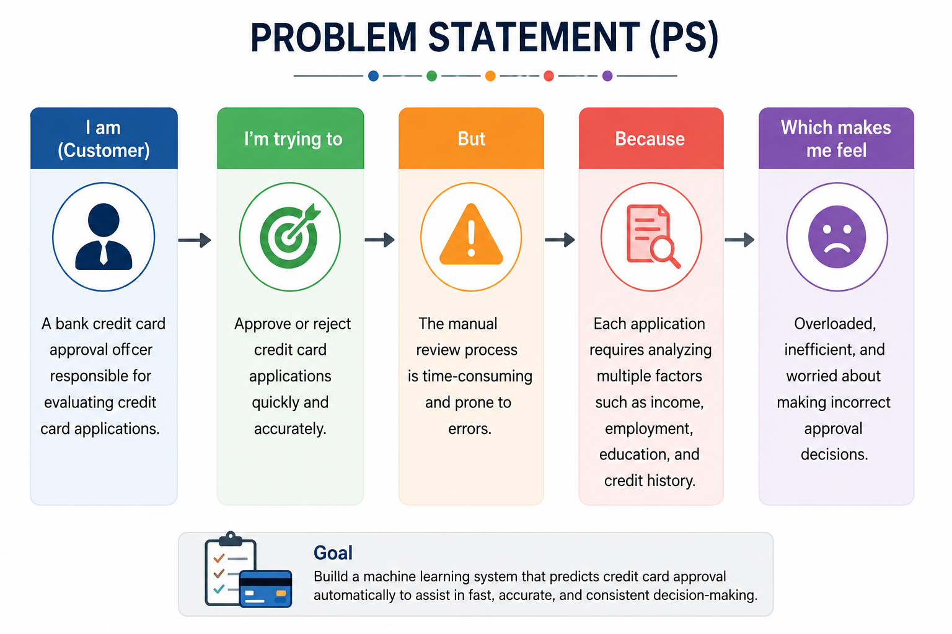
The objective of this project is to develop a machine learning-based Credit Card Approval Prediction System that can automatically predict whether a credit card application is likely to be approved or rejected based on historical applicant data. The system aims to assist banks in making faster, more accurate, and consistent approval decisions while reducing manual effort and improving customer service.Prob

Ideation Phase
Brainstorm & Idea Prioritization Template
Date
Team ID
Project Name | Credit Card Approval Prediction
Maximum marks

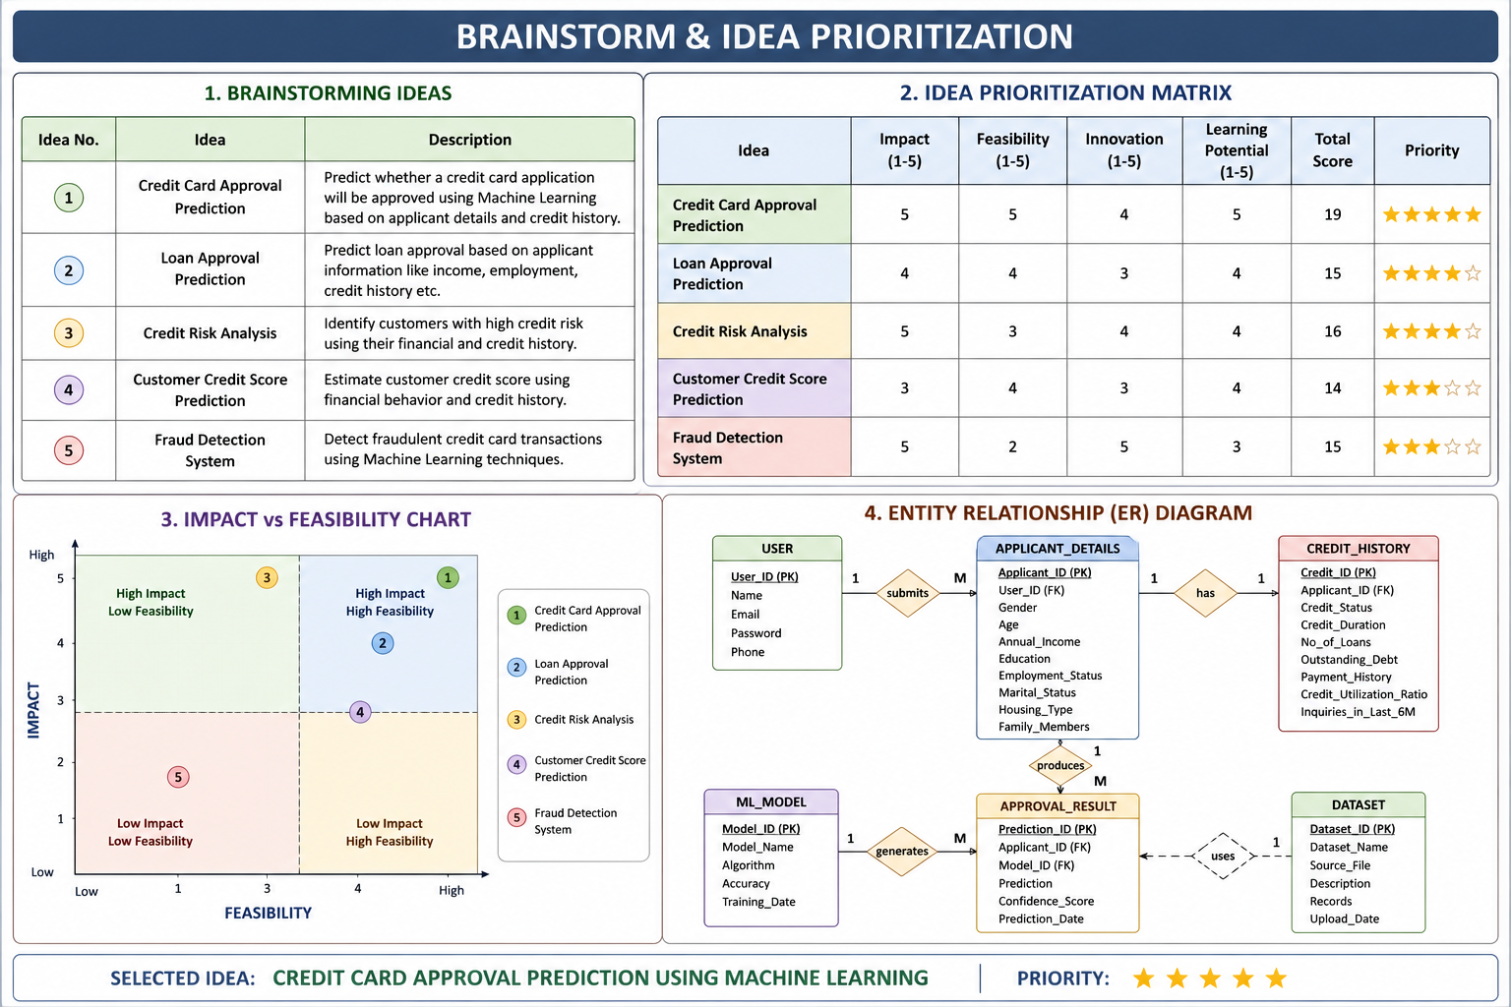
Final Selected Idea
Project Title: Credit Card Approval Prediction using Machine Learning
Why this idea was selected
- Solves a real-world banking problem.
- Automates the credit card approval process.
- Reduces manual effort and human errors.
- Uses machine learning for accurate predictions.
- Can be deployed as a Streamlit web application.
- Suitable for learning data preprocessing, exploratory data analysis, model building, and deployment.

Ideation Phase
Empathize & Discover
Date
Team ID
Project Name | Credit Card Approval Prediction
Maximum marks

Introduction
The Credit Card Approval Prediction System is designed to assist banks and financial institutions in making faster and more accurate credit card approval decisions. The system analyzes applicant information such as income, employment status, education, family status, housing type, and credit history using machine learning techniques to predict whether a credit card application is likely to be approved or rejected.
Empathy map
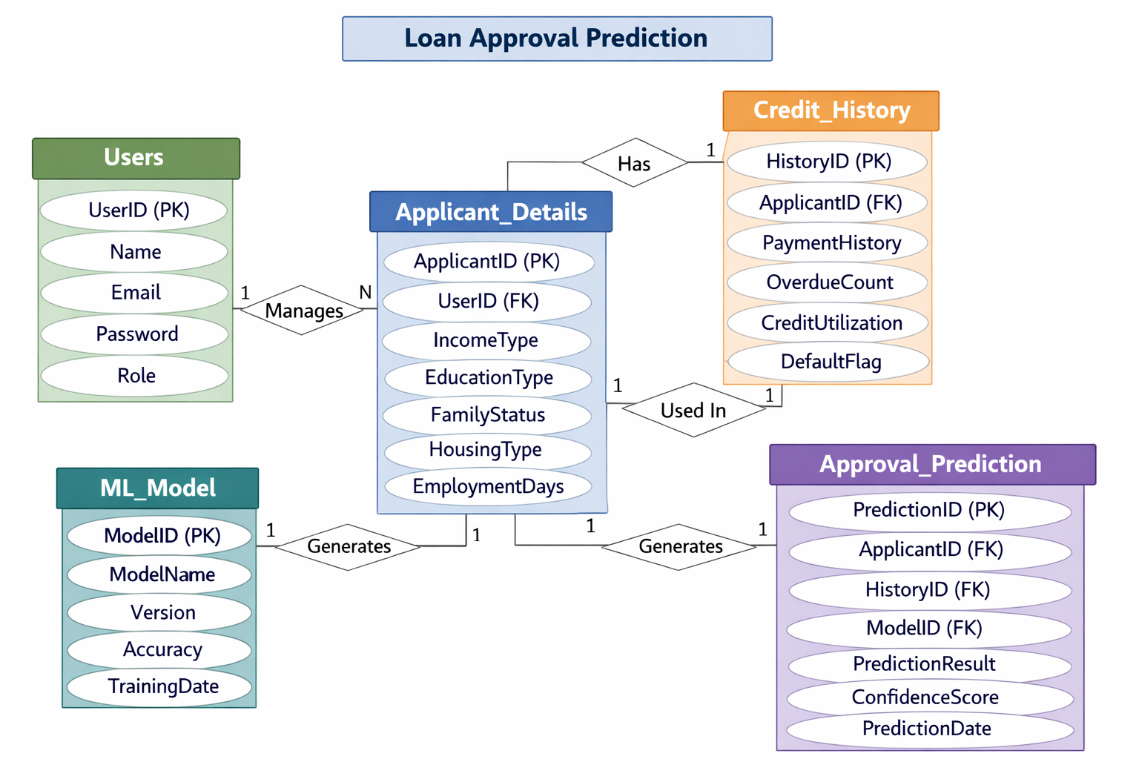
THINKS
- Need accurate approval decisions.
- Reduce financial risk.
- Improve customer satisfaction.
- Speed up the approval process.

💬 SAYS
- Manual verification takes too much time.
- We need a faster approval system.
- Accuracy is important.
- Automation can improve efficiency.
❤️ FEELS
- Overloaded with many applications.
- Concerned about human errors.
- Responsible for making correct decisions.
- Wants a reliable prediction system.
👀 DOES
- Reviews applicant information.
- Checks income and employment details.
- Verifies credit history.
- Approves or rejects applications.
Bottom Section
- Pain Points: Manual processing, delays, inconsistent decisions, human error.
- Needs: Fast approval, accurate predictions, automation, consistent decision-making.
Design Style
- Modern flat design
- Blue and white banking theme
- Icons for thinking, speaking, feeling, and doing
- Professional presentation suitable for a final-year machine learning project
- High resolution (16:9)

Project Design Phase-II
Technology Stack (Architecture & Stack)
Date
Team ID
Project Name | Credit Card Approval Prediction
Maximum marks
Technology Stack (Architecture & Stack)
Introduction
The Credit Card Approval Prediction System is developed using Python and Machine Learning. It predicts whether a credit card application will be approved or rejected based on the applicant's information and credit history.

Technology Stack
Component | Technology Used | Purpose
Frontend | Streamlit | User Interface
Backend | Python | Application Logic
Machine Learning | Scikit-learn | Model Training and Prediction
Data Processing | Pandas, NumPy | Data Cleaning and Analysis
Data Visualization | Matplotlib, Seaborn | Charts and Graphs
Model Storage | Joblib | Save and Load Model
Development Tool | VS Code, Jupyter Notebook | Coding and Testing
Version Control | Git, GitHub | Source Code Management
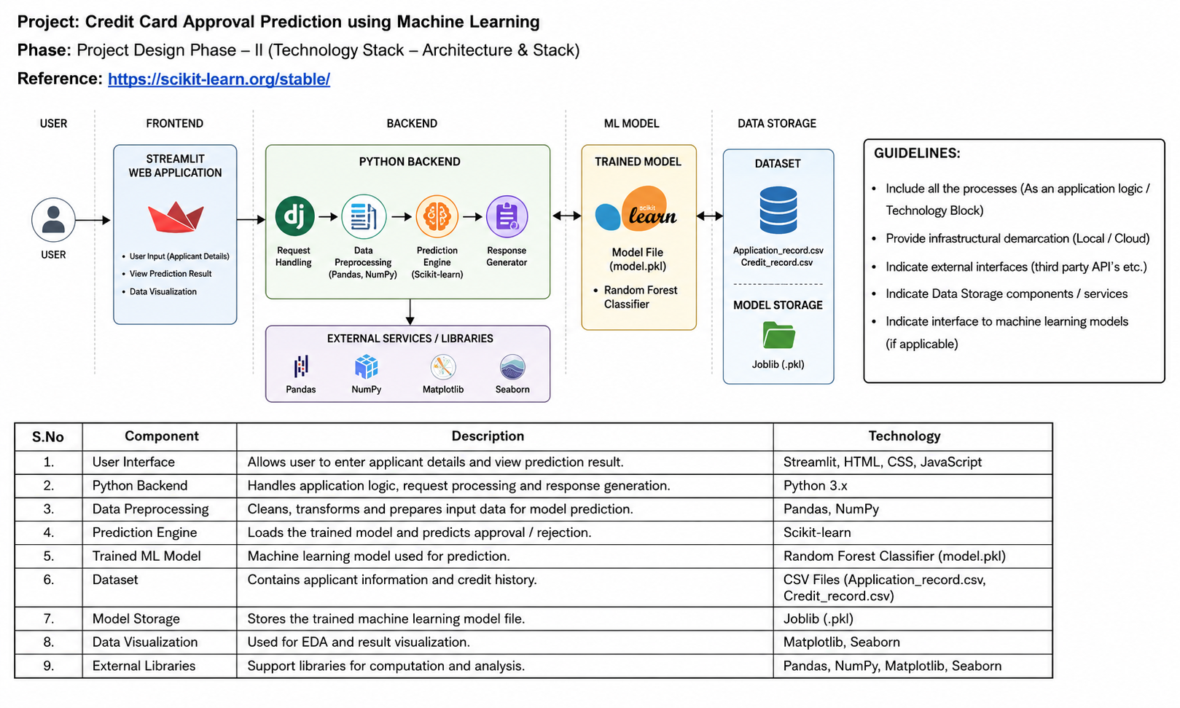

Advantages
- Easy to use.
- Fast prediction process.
- Accurate machine learning model.
- User-friendly web interface.
- Reduces manual effort in credit card approval.

Conclusion
This technology stack provides a simple, efficient, and reliable solution for predicting credit card approval. It combines data processing, machine learning, and a user-friendly interface to improve the decision-making process.

Project Design Phase – II
Solution Requirements (Functional & Non-functional)
Date
Team ID
Project Name | Credit Card Approval Prediction
Maximum marks
Functional Requirements
Functional requirements describe what the system should do.
Requirement ID | Functional Requirement
FR1 | The system should allow users to enter applicant details.
FR2 | The system should validate the entered information.
FR3 | The system should preprocess the input data before prediction.
FR4 | The system should load the trained machine learning model.
FR5 | The system should predict whether the credit card application is Approved or Rejected.
FR6 | The system should display the prediction result to the user.
FR7 | The system should allow users to make multiple predictions.

Non-Functional Requirements
Non-functional requirements describe how the system should perform.
Requirement ID | Non-Functional Requirement
NFR1 | The system should provide prediction results within a few seconds.
NFR2 | The application should have a simple and user-friendly interface.
NFR3 | The system should provide accurate prediction results.
NFR4 | The application should be reliable and stable.
NFR5 | The system should be easy to maintain and update.
NFR6 | The application should protect user data during processing.
Project Design Phase-II
Data Flow Diagram & User Stories
Date
Team ID
Project Name | Credit Card Approval Prediction
Maximum marks

Data Flow (Simplified Process)
This sequence outlines how data moves from the user through the prediction system:
2
- User Authentication: User logs into the portal to access the application form.
- Data Submission: User enters financial details (income, credit score, debt, etc.) and uploads necessary documents.
- Data Preprocessing: The system cleans the input data and handles missing values for the machine learning model.
- Prediction Engine: The preprocessed data is passed to the trained Machine Learning model to evaluate approval probability.
- Result Visualization: The approval status (Approved/Rejected) and risk score are displayed to the user on the dashboard.
User Stories
Following the provided template, here are the user stories for the credit card approval system:
3
User Type | Functional Requirement (Epic) | User Story Number | User Story / Task | Acceptance Criteria | Priority | Release
Applicant | Registration | USN-1 | As a user, I can register using my email and personal details. | I can access my applicant dashboard. | High | Sprint-1
Applicant | Application Submission | USN-2 | As a user, I can fill out and submit my financial details for credit card approval. | System confirms successful submission. | High | Sprint-1
System / ML Model | Prediction | USN-3 | As a system, I want to process applicant data through a model to predict approval status. | Prediction is generated within seconds of submission. | High | Sprint-2
Applicant | Dashboard | USN-4 | As a user, I want to view the status of my application (Pending/Approved/Rejected). | Status is clearly visible on the main dashboard. | Medium | Sprint-2
Admin / Bank Staff | Data Management | USN-5 | As an admin, I can view all submitted applications and the model's risk assessment. | Access to a list of all applicants and their scores. | Medium | Sprint-3
Applicant | Notification | USN-6 | As a user, I want to receive an email notification once a decision is made. | Email is sent automatically upon status change. | Low | Sprint-3

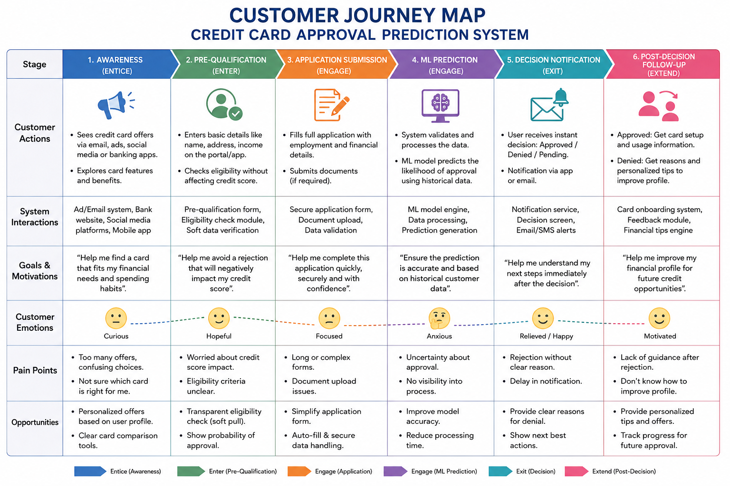

Project Design Phase
Problem – Solution Fit Template
Date
Team ID
Project Name | Credit Card Approval Prediction
Maximum marks

Problem – Solution Fit Template
Problem | Current Challenges | Proposed Solution | Benefits
Manual credit card approval is slow and time-consuming. | Bank staff spend significant time reviewing every application manually. | Use a Machine Learning model to automatically predict credit card approval. | Faster processing and reduced workload.
Human errors in approval decisions. | Manual verification may lead to inconsistent decisions. | Train the model using historical applicant and credit data for consistent predictions. | Improved accuracy and reliability.
Large number of credit card applications. | High application volume delays approval. | Automate the approval process using the prediction system. | Quick response to customers.
Difficulty identifying eligible applicants. | Banks must analyze multiple applicant attributes. | Use features such as income, employment, education, and credit history for prediction. | Better applicant evaluation.
Poor customer experience due to delays. | Customers wait a long time for approval results. | Provide instant prediction through a Streamlit web application. | Improved customer satis

Problem–Solution Fit Summary
Problem
- Manual credit card approval process
- Time-consuming verification
- Human errors
- Delayed customer response
- Inconsistent approval decisions
⬇
Solution
Credit Card Approval Prediction using Machine Learning
- Data preprocessing
- Feature engineering
- Random Forest prediction model
- Streamlit web application
- Instant prediction results
⬇
Benefits
- Faster approval process
- Improved prediction accuracy
- Reduced manual effort
- Better decision-making
- Enhanced customer experience

Project Design Phase
Solution Architecture
Date
Team ID
Project Name | Credit Card Approval Prediction
Maximum marks

Solution Architecture
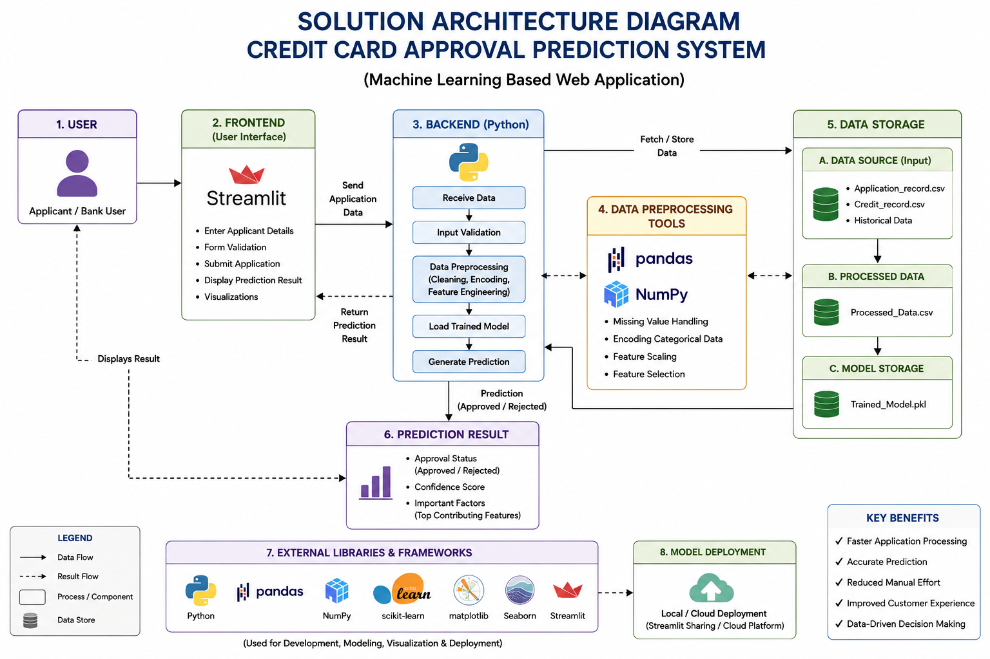
The Credit Card Approval Prediction System is developed to automate the process of predicting whether a credit card application is likely to be approved or rejected. The system uses machine learning algorithms to analyze applicant information and provide quick, accurate, and reliable predictions.
Advantages of the Solution
- Faster prediction process.
- Reduces manual verification.
- Improves prediction accuracy.
- Easy-to-use web interface.
- Reliable and scalable system.
- Saves time for banks and customers.

Technologies Used
Component | Technology
Frontend | Streamlit
Backend | Python
Data Processing | Pandas, NumPy
Machine Learning | Scikit-learn
Algorithm | Random Forest Classifier
Visualization | Matplotlib, Seaborn
Model Storage | Joblib
Version Control | Git & GitHub

Conclusion
- The proposed solution architecture combines Python, Machine Learning, and Streamlit to build an efficient credit card approval prediction system. The system automates the approval process, reduces manual effort, and provides quick and accurate predictions, improving the overall decision-making process for financial institutions

Functional & Performance Testing Template
Model Performance Test

Date
Team ID
Project Name | Credit Card Approval Prediction
Maximum marks

Test Scenarios & Results
Test Case ID | Scenario (What to test) | Test Steps (How to test) | Expected Result | Actual Result | Pass/Fail
FT-01 | Text Input Validation (e.g., topic, job title) | Enter valid and invalid text in input fields | Valid inputs accepted, errors for invalid inputs | As Expected | pass
FT-02 | Number Input Validation (e.g., word count, size, rooms) | Enter numbers within and outside the valid range | Accepts valid values, shows error for out-of-range | As Expected | pass
FT-03 | Content Generation (e.g., blog, resume, design idea) | Provide complete inputs and click "Generate" | Correct content is generated based on input | As Expected | pass
FT-04 | API Connection Check | Check if API key is correct and model responds | API responds successfully | As Expected | pass
PT-01 | Response Time Test | Use a timer to check content generation time | Should be under 3 seconds | As Expected | pass
PT-02 | API Speed Test | Send multiple API calls at the same time | API should not slow down | As Expected | pass
PT-03 | File Upload Load Test (e.g., PDFs) | Upload multiple PDFs and check processing | Should work smoothly without crashing | As Expected | pass

Acceptance Testing
UAT Execution & Report Submission
Date
Team ID
Project Name | Credit Card Approval Prediction
Maximum marks

Software Testing Documentation
1. Purpose of the Document
The purpose of this document is to describe the testing activities performed for the Credit Card Approval Prediction Using Machine Learning project before the final release. It summarizes the testing process, defects identified and resolved, and the overall quality of the application. The document also ensures that the system meets the functional and non-functional requirements before deployment.

2. Defect Analysis
The following table summarizes the defects identified during testing.
Resolution | Critical (S1) | High (S2) | Medium (S3) | Low (S4) | Total
Fixed | 3 | 2 | 4 | 3 | 12
By Design | 0 | 1 | 1 | 2 | 4
Duplicate | 0 | 0 | 1 | 0 | 1
Not Reproduced | 0 | 0 | 1 | 0 | 1
Won't Fix | 0 | 0 | 0 | 1 | 1
Total | 3 | 3 | 7 | 6 | 19
Common Defects Identified
- Invalid input validation.
- Missing value handling.
- Incorrect prediction display.
- UI alignment issues.
- Minor formatting problems.
Most defects were corrected before the final release.

3. Test Case Analysis
Module | Total Test Cases | Not Tested | Failed | Passed
User Interface | 6 | 0 | 0 | 6
Applicant Data Validation | 5 | 0 | 0 | 5
Data Preprocessing | 4 | 0 | 0 | 4
Machine Learning Prediction | 5 | 0 | 0 | 5
Streamlit Application | 4 | 0 | 0 | 4
Result Display | 3 | 0 | 0 | 3
Performance Testing | 3 | 0 | 0 | 3
Total | 30 | 0 | 0 | 30

4. Test Summary
Metric | Value
Total Test Cases | 30
Passed | 30
Failed | 0
Not Executed | 0
Pass Percentage | 100%
Result
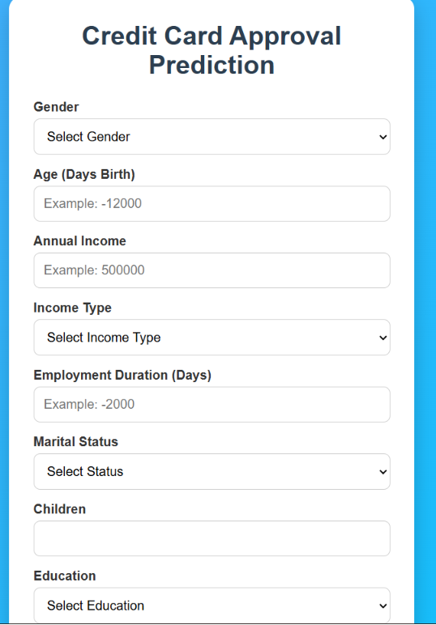
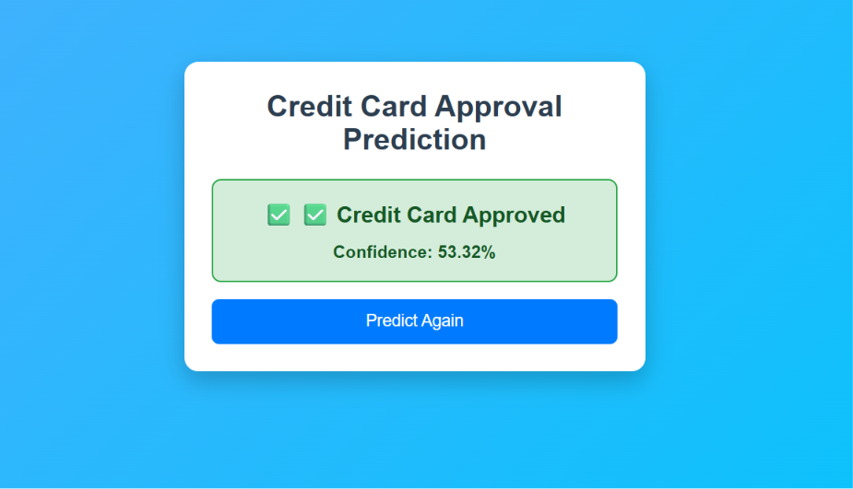
Result

CONCLUSION

The Credit Card Approval Prediction Using Machine Learning project successfully demonstrates how machine learning can automate the credit card approval process. By analyzing applicant information such as income, employment status, education, family details, and credit history, the system predicts whether a credit card application is likely to be approved or rejected.
The project involved data collection, preprocessing, exploratory data analysis, model training, and deployment using a Streamlit web application. Among the models evaluated, the Random Forest Classifier provided reliable prediction performance and was selected for the final application.
This system helps reduce manual effort, speeds up the approval process, improves consistency in decision-making, and supports financial institutions in making data-driven decisions. The user-friendly interface allows applicants or bank staff to enter information and receive prediction results quickly.
In the future, the system can be enhanced by using larger datasets, testing advanced machine learning or deep learning models, integrating real-time banking data, and deploying the application on a cloud platform for wider accessibility.
Overall, this project demonstrates the practical application of machine learning in the banking sector and provides an efficient solution for credit card approval prediction.

This conclusion is suitable for your Skill Wallet project report and can be directly included in your final documentation.

