Create folder and add git to that folder

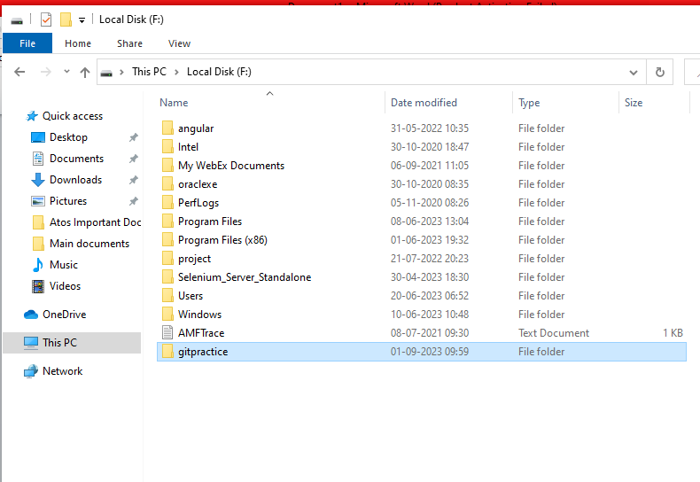

Open that folder and click right button see git bash click on it

Initialize git to the folder use command git init

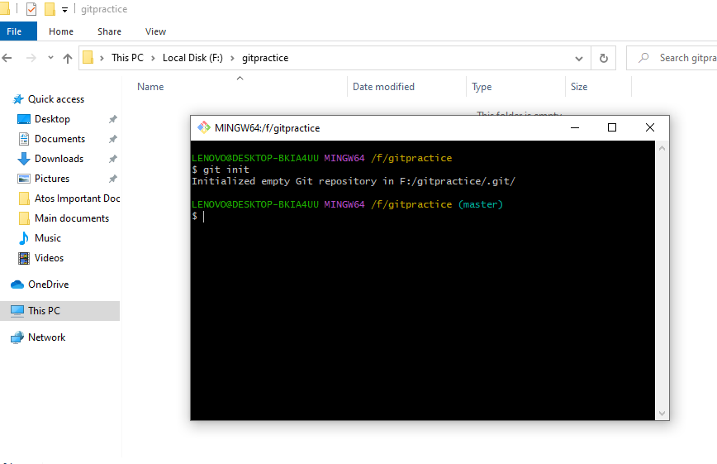

connect both git and git hub now

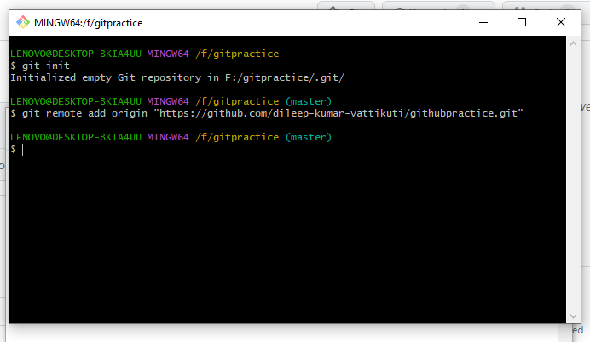

Master 🡪 is the main branch

Githubpractice project is in main branch

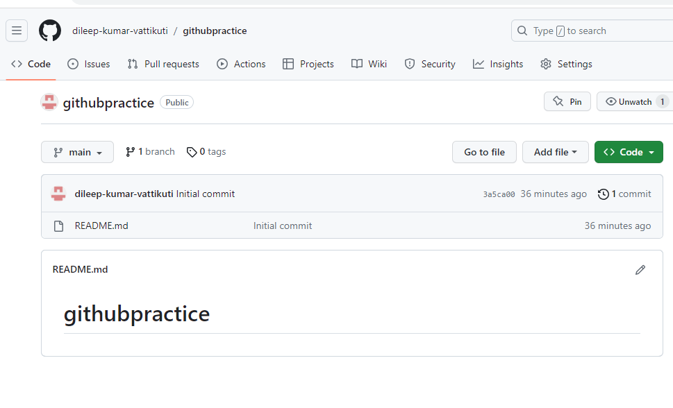

We are now pulling readme.md file from github to git

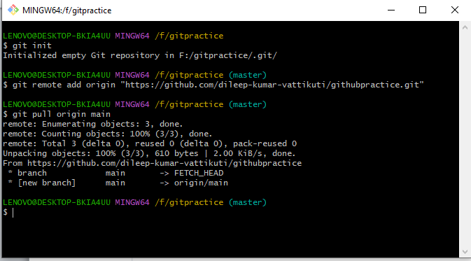 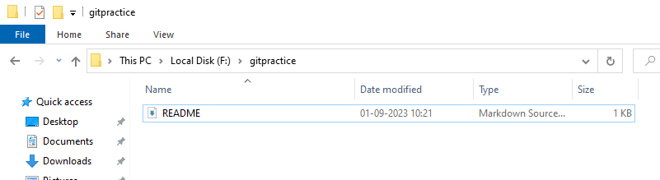

Adding new file ->sql in the folder we need check that new file is part of git

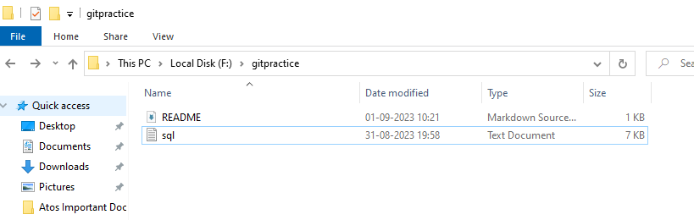

Sql file is not part of git

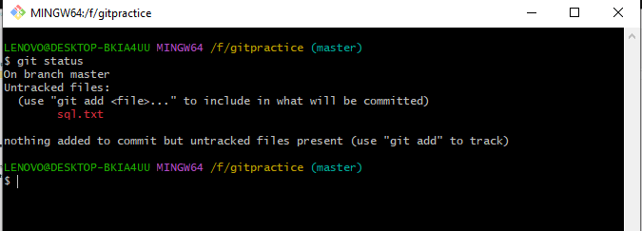

We need to commit this file to git ,but before commiting you need to add that file to index

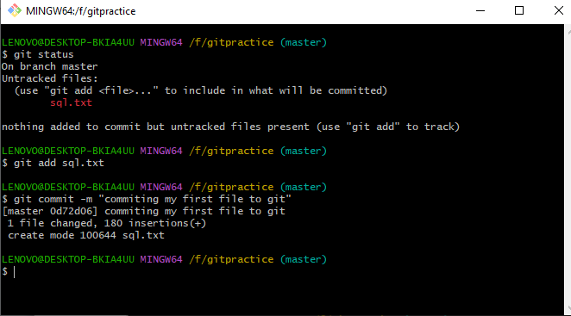

After check git status any thing need to commit files to git

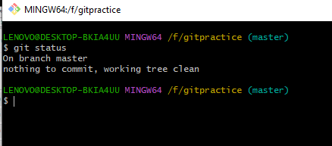

Adding and commiting multiple files at a time and modify the existing file

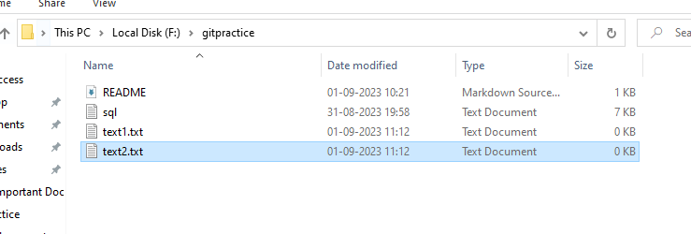

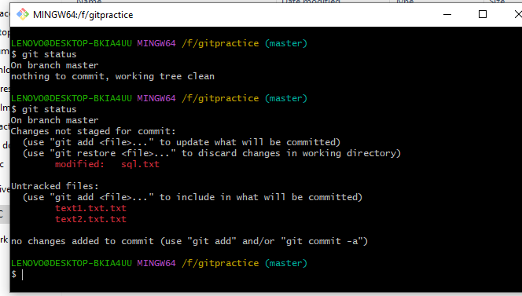

Addind to index all files at a time use git add –A

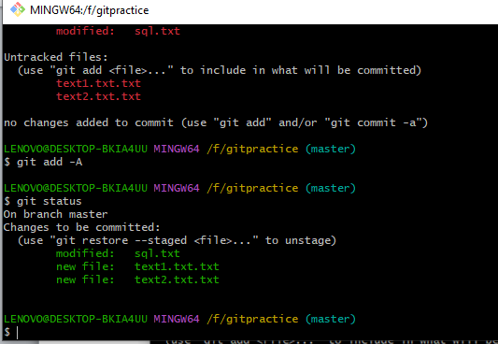

Commit all file to git use git commit –a –m “commiting all files to git”

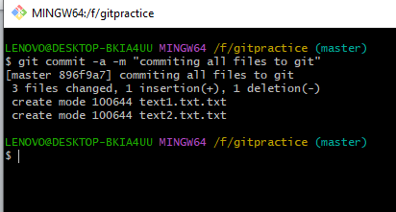

Check git status any file is not send to git

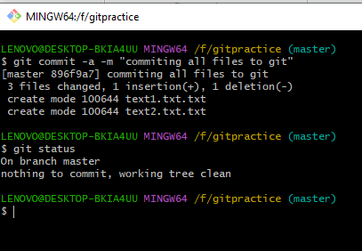

Check what are the actions we done previously using git log

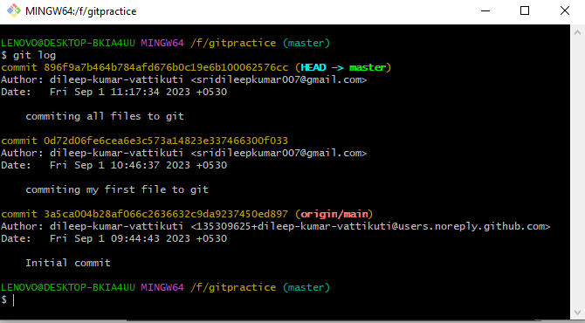

After commiting all files in to git push those files to github

