Jenkins:

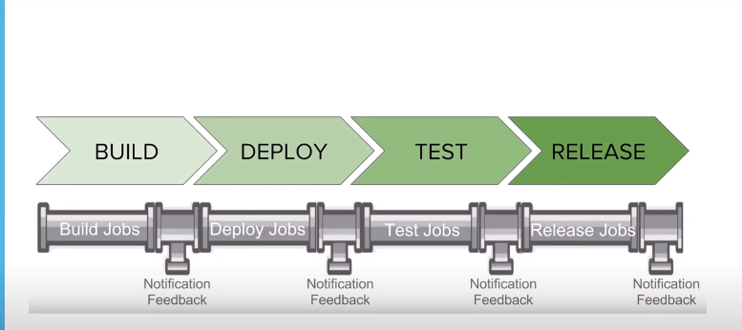

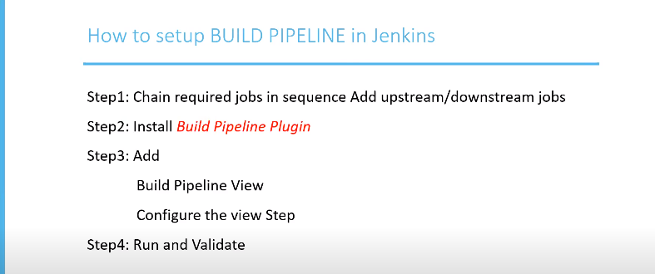

Step1: create chain based jobs some of jobs are build jobs some of them are deploy jobs etc

First create new job click new item

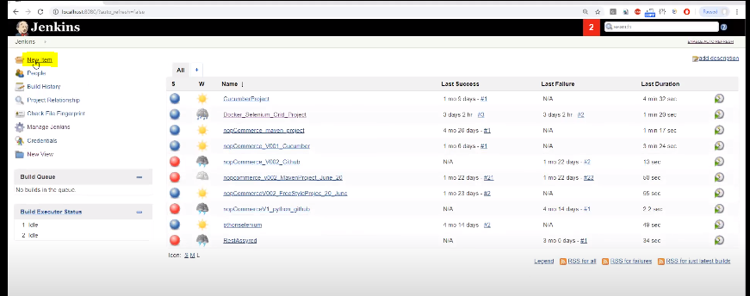 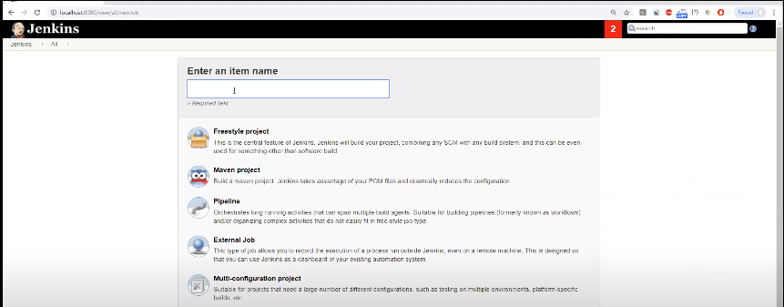

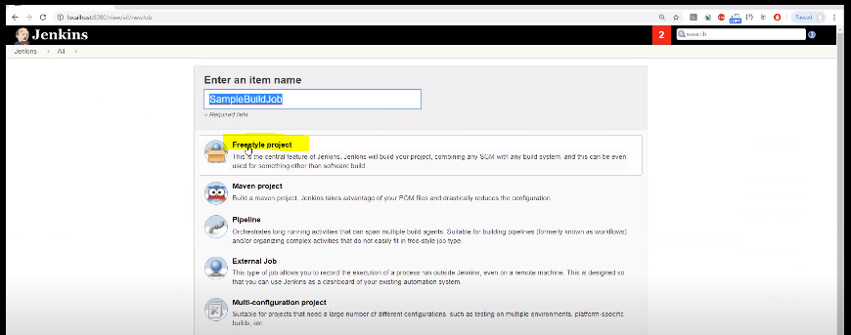

Click on ok button

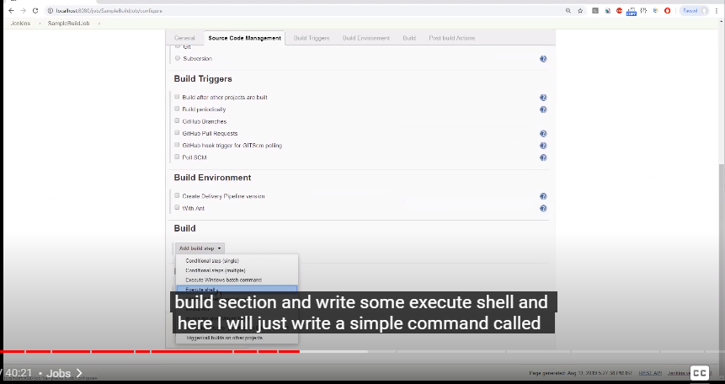

Click on execute shell

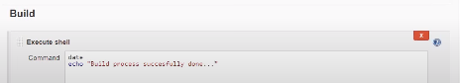

Apply and save it

And go to back to dashboard

Fallow same process remaining process – deploy,test,release jobs

We need to form chain now based on jobs which job should run first

We created jobs for build ,deploy,test,release jobs each phase

Deploy jobs depends on build jobs,test jobs depends on deploy jobs,release jobs depends on test jobs

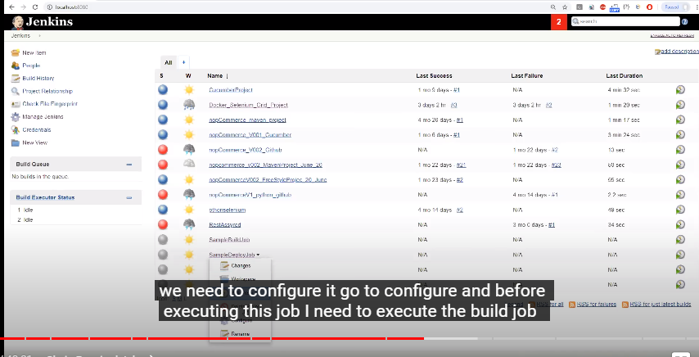

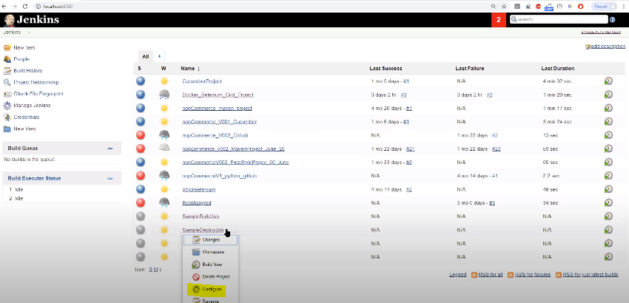

Click on configure

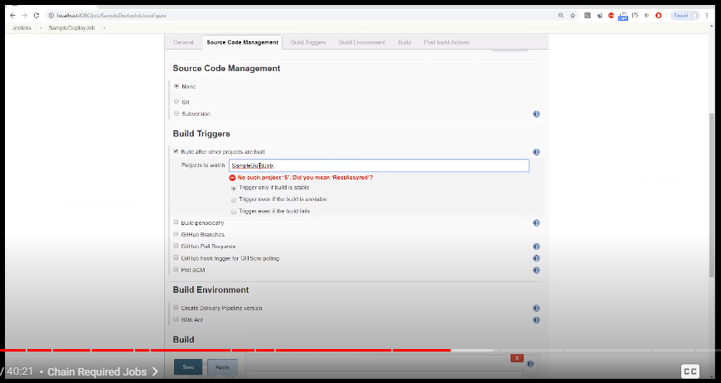

Checkbox the Build after other projects are built in that field select we have to give which job job should execute first sample build job and now click apply and save

Fallow same process remaining jobs

Once jobs are linked with each other now we execute only first job🡪sample build jobs remaining jobs will execute automatically

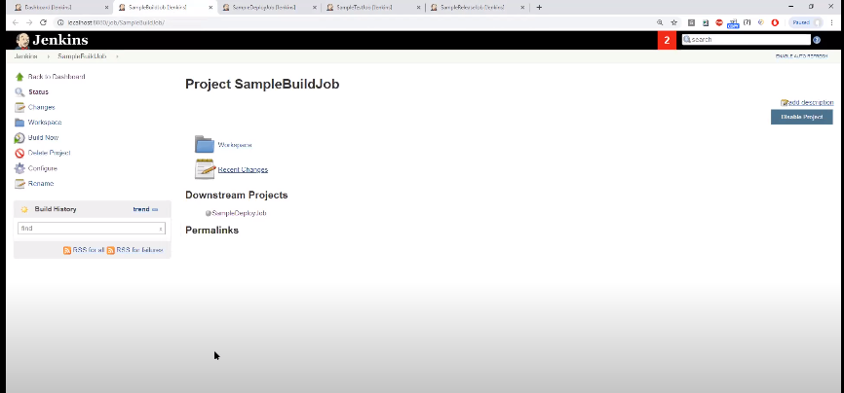

Click on build now

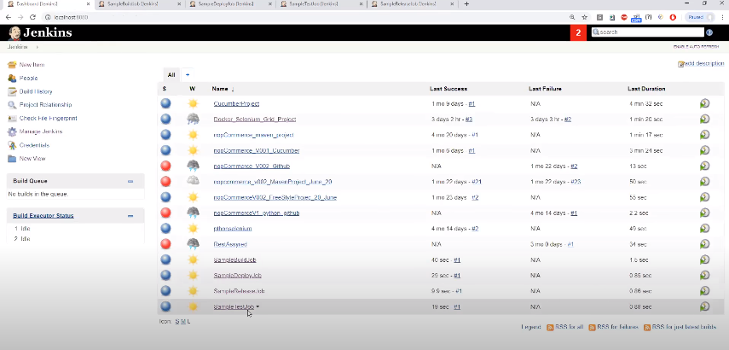

And see all jobs are passed

Step2: Install Build Pipeline plugin

We can execute multiple jobs as a sequencial manner

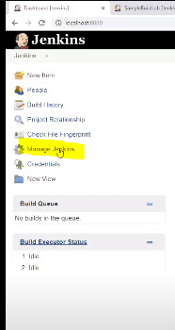

Click manage Jenkins

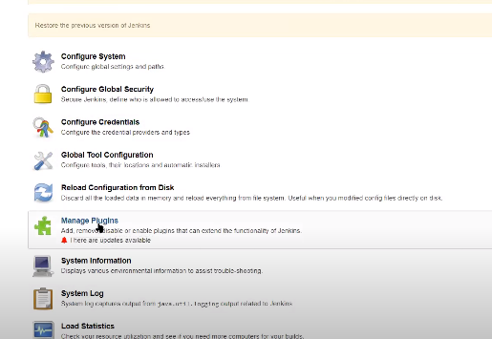

Scroll down see manage plugins

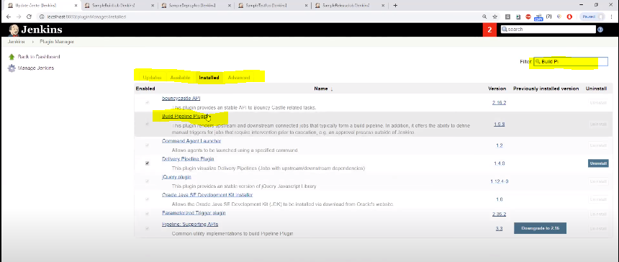

Search build pipeline and click on it

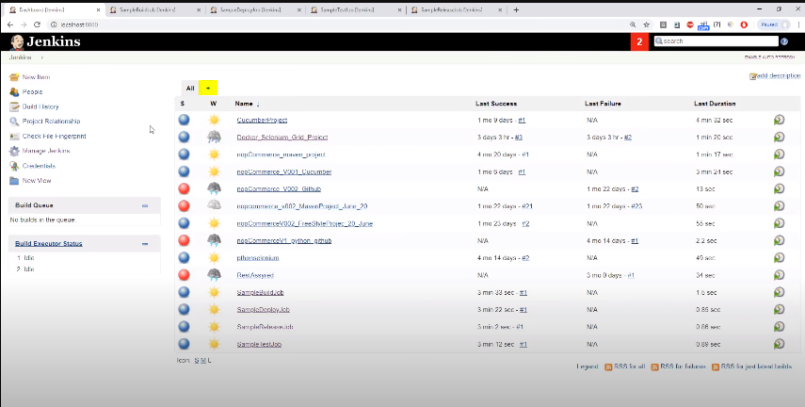

Create pipeline see + sign click on it

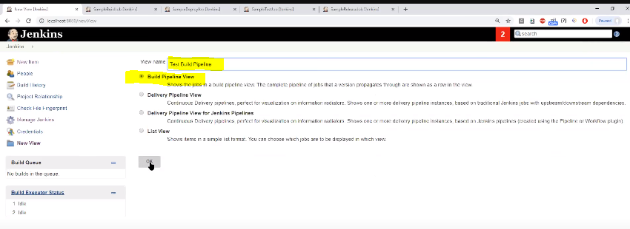

Select build pipeline view and give any name for that pipeline

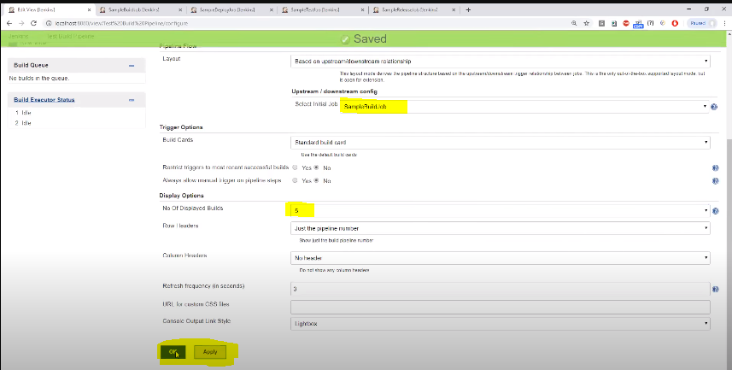

Select the main job and select the no of displayed builds and apply and save

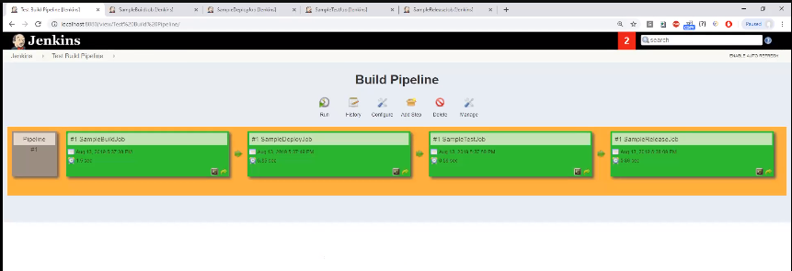

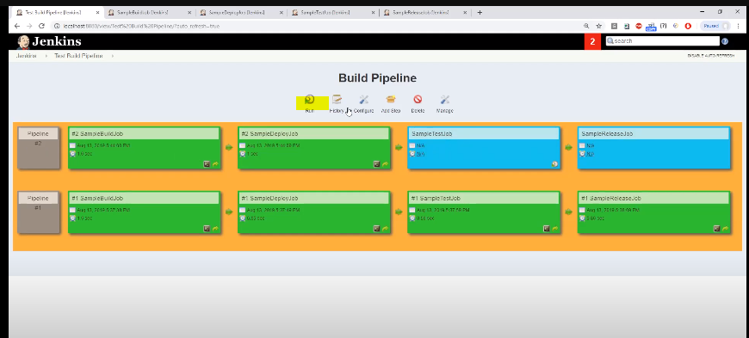

Blue color representing in progess

Delivary pipeline

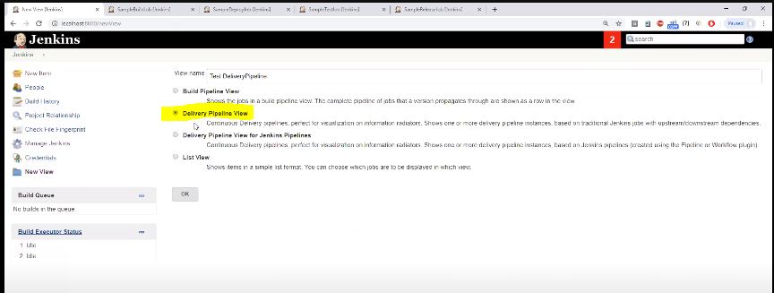

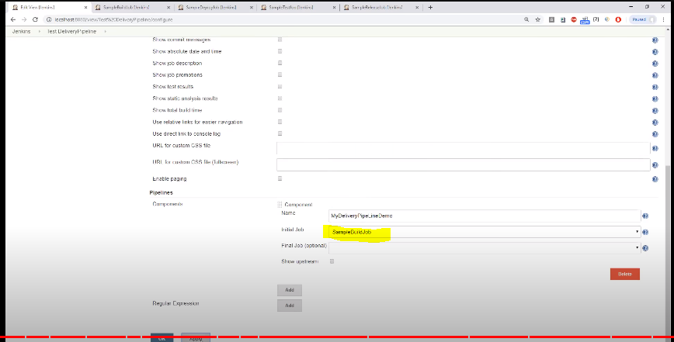

Apply and save it

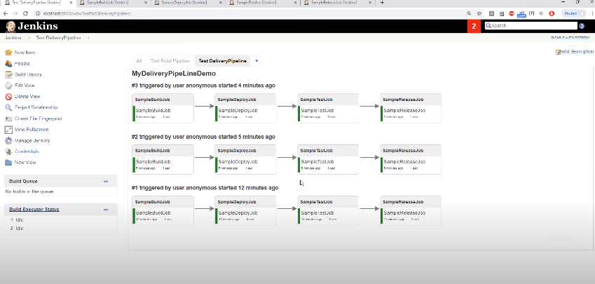

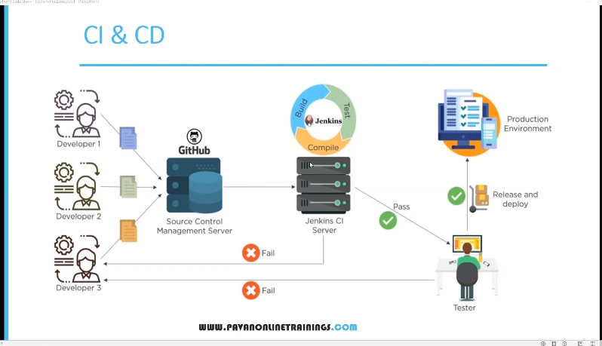

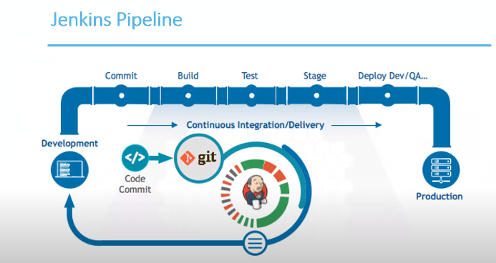

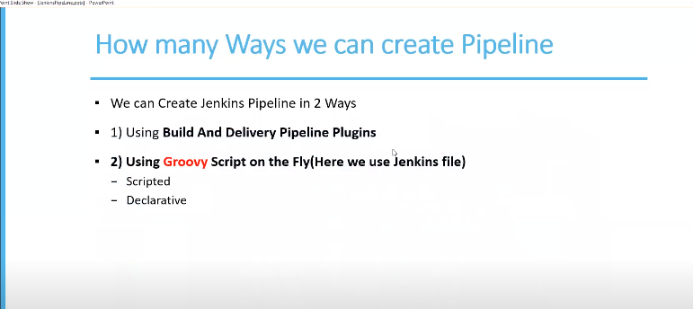

Using Groovey script for complex project they are many jobs for each phase it is very difficult to link all the jobs so that is the reason we use groovy script

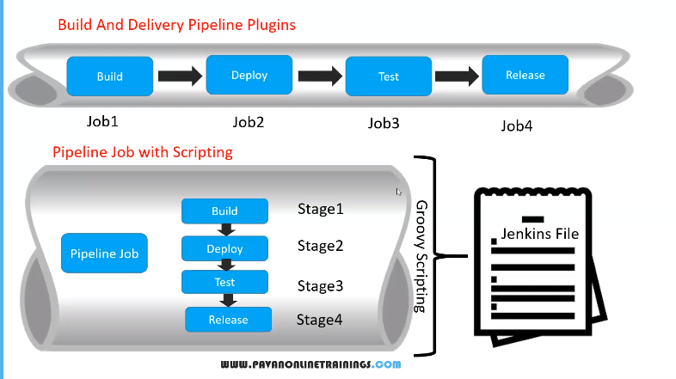 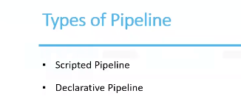

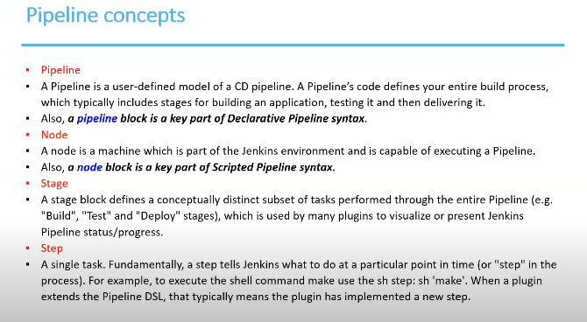 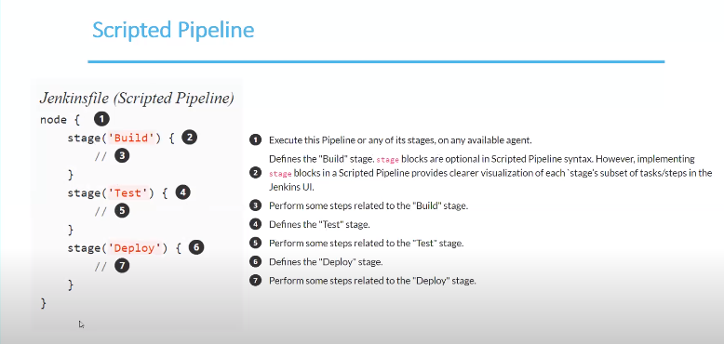Creating scripted pipeline

Select new item enter name ->give any name

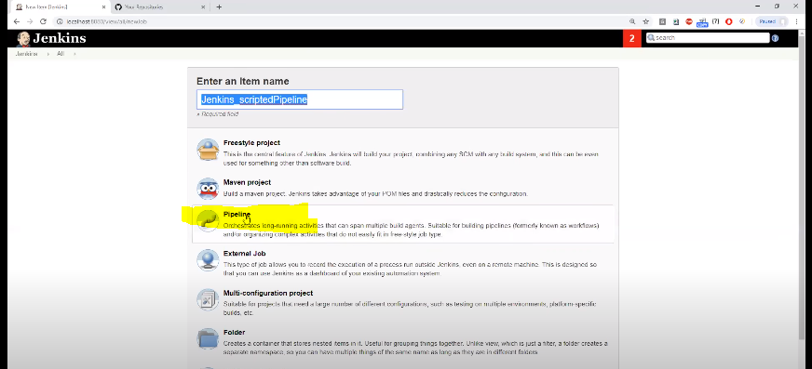 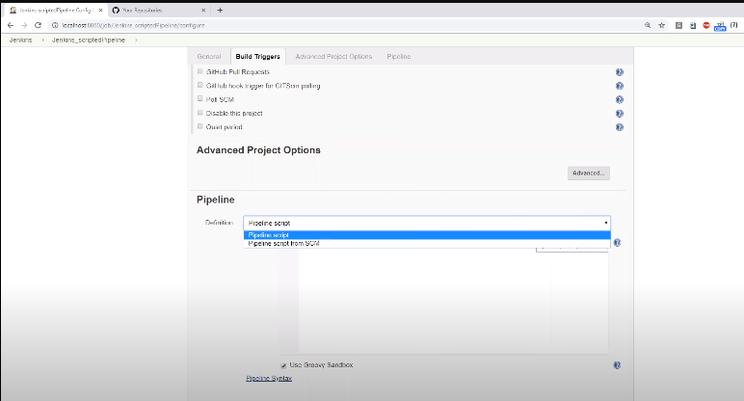for scripted pipeline select pipeline script

After selecting write inside white box

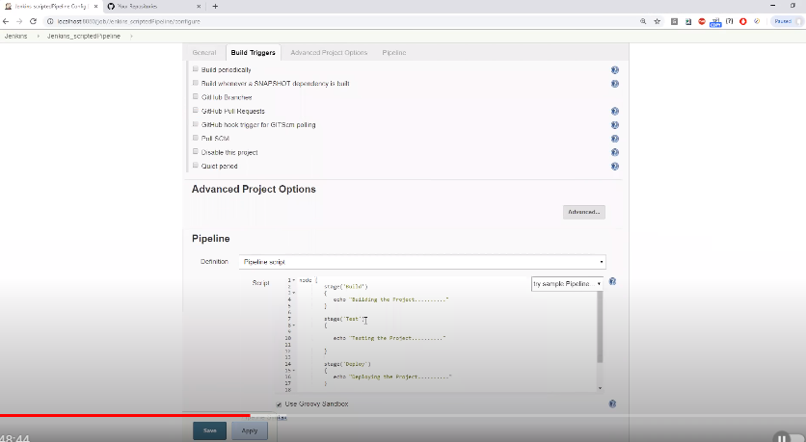

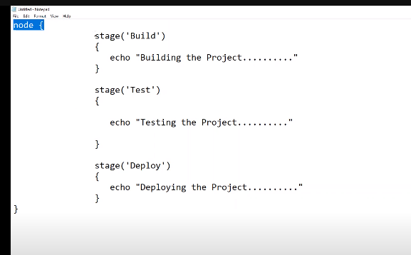

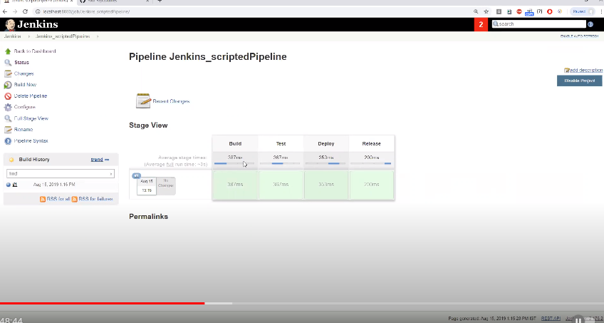

Job itself is a pipeline we are running only one job in the job have pipeline in the pipeline have jobs in different stages

2nd type 🡪Declarative pipeline

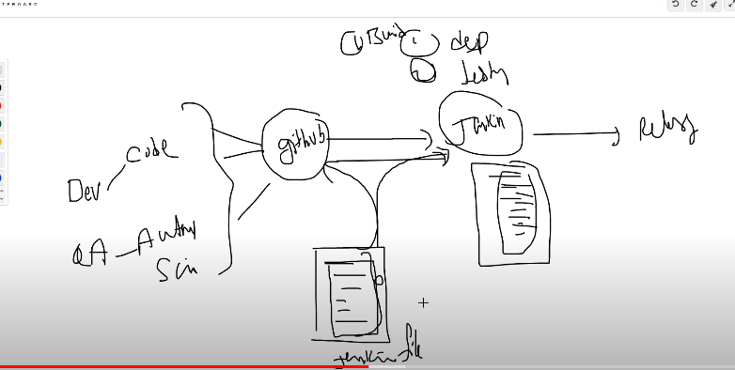

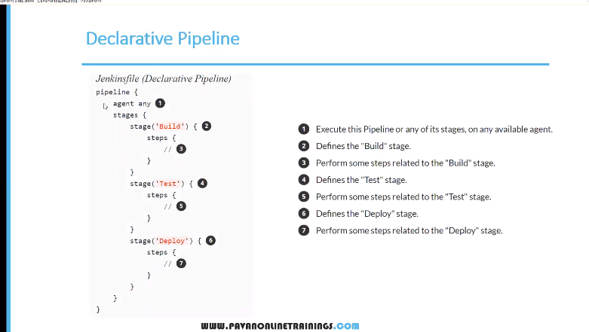

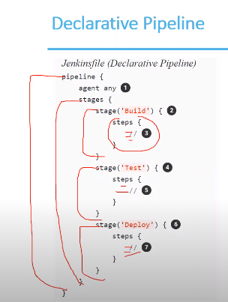

Write this script in github in a file

