Liverpool John Moores University
Faculty of Engineering and Technology


“Neurological Disorders Detection from Speech Emotions Using
Convolutional Neural Network”

By
Dileep Yadav

A final thesis submitted for the degree of
MSc Artificial Intelligence (Machine Learning)
Feb 2021

THESIS COMMITTEE

Thesis supervisor: Sujith Viswanathan
Platform Partner: upGrad Education Private Limited
Committee member: A Faculty of Engineering and Technology, LJMU



DEDICATION

I would like to dedicate this thesis to millions of people who are suffering from a mental health problem in the world. They are living life without control of the brain. I pray for them and I hope our scientists and researchers reach the goal to diagnose this problem with the help of new technologies. I am forever thankful to my parents, teachers, and supervisor, who provide me the chance to work on this kind of research. I will try my level best to contribute to this research.
I also want to dedicate this thesis to the doctor, scientists, and researchers who are working in this field to solve the mental health problem.

ACKNOWLEDGEMENTS

I would like to express my gratitude to my thesis supervisor Mr. Sujith Sir for the proper guidance from time to time and the right direction of my research. The most important thing for me provides great feedback for the improvement of my research. Moreover, I would like to thanks again for his endless help and support during my thesis writing. I would also like to thanks to upGrad and IIIT Bangalore faculty members who provide me technical sessions about my course. The best thing about my student mentor provides me best support for technical and non-technical to complete my post-graduate diploma from IIIT Bangalore.
At the time of my master’s dissertation research stage, I would like to very much thank the LJMU faculty of engineering and technology members and I wish to extend my special thanks to Dr. Manoj Jayabalan who provides weekly live Q&A sessions for completing my masters. That was very helpful for me. The appreciate assistance provided by the cohort fellow in this course and research. Of course, I would like to thank my parents and relatives for their endless love and support and for believing in me. Thank you so much for always being by my side, making my daily life beautiful, and helping me overcome the problems and becoming a better person.

ABSTRACT

Good health is a key to any success, as per the world health organization (WHO) 264 million people suffering from the illness of depression or neurological disorder worldwide. Sometimes this kind of illness can lead to suicide. A neurological disorder is completely different from the same old mood fluctuations and ephemeral responses to challenges in the standard of living. Particularly once long and with moderate or severe intensity, this kind of illness may become a serious health condition. This research focuses on neurological disorders detection from speech emotions using a neural network. The voice of music and movies are generating electrical signals in the brain. Electroencephalography (EEG) is the most popular method of monitoring and recording the electrical activity of the brain. Using Electroencephalography (EEG) features, computers can recognize human emotions (Alarcão & Fonseca, 2019). This research uses the DEAP dataset for analysis of brain activity by music, movies, and eye blink data. The objective is to achieve high accuracy using the combined classifier designed (Ieracitano et al., 2019). At the initial stage, we extract CNN and Statistical features from signals, after that we merge the RNN and LSTML with CNN, using the Softmax function, we try to achieve good accuracy of the model. Extracting features from EEG signals and building a predictive model Using machine learning, will be helpful for the diagnosis or treatment of neurological disorders(Affect Recognition Using Electroencephalography Features, 2017).

CONTENTS

CONTENTS 5
LIST OF TABLES 8
LIST OF FIGURES 8
LIST OF ABBREVIATIONS 9
Chapter 1 CHAPTER 1: INTRODUCTION 10
1.1 Background of the Study 10
1.2 Problem Statement 14
1.3 Aim and Objectives 14
1.4 Research Questions (IF ANY) 14
1.5 Scope of the Study 15
1.6 Significance of the Study 16
1.7 Structure of the Study 16
CHAPTER 2: LITERATURE REVIEW 18
2.1 Introduction 18
2.2 Data Analytics in Neurological Disorder 20
2.3 Data Mining in Diagnosis of Neurological Disorder Diseases 21
2.4 Data Mining in Prediction of Common Types of Neurological Disorder 23
2.5 Predictive Modeling in Neurological Disorder Diagnosis with following Datasets 24
2.6 Visual Analytics in Neurological Disorder 26
2.7 Related Research Publications 27
2.8 Discussion 28
2.9 Summary 29
CHAPTER 3: RESEARCH METHODOLOGY 31
3.1 Introduction 31
3.2 Research Methodology 31
3.2.1 Data Selection 33
3.2.2 Data Pre-processing 33
3.2.3 Data Transformation 34
3.2.4 Interactive Visual Analytics 36
3.2.5 Class Balancing 37
3.2.6 Data Mining 37
3.2.7 Interpretation/Evaluation 38
3.3 Proposed Method (Classification) 39
3.4 Summary 40
CHAPTER 4: IMPLEMENTATION 41
4.1 Introduction 41
4.2 Dataset 41
4.2.1 Online ratings 42
4.2.2 Video list 42
4.2.2 Participant ratings 43
4.2.3 Face video 43
4.2.4 Original Data 44
4.3 Exploratory Data Analysis 44
4.3.1 Experiment protocol 45
4.3.1 Contributor self-assessment 46
4.3.2 Evaluation of Subjective Ratings 46
4.3.3 Correlates of EEG and Ratings 48
4.4 Data cleaning 50
4.5 Data Partitioning 50
4.6 Model Implementation 51
4.6.1 Data Staging (Pre-Processing) 52
4.6.2 Model Building 52
4.6.3 Generating Model Result in Excel sheet 53
4.6.3 Summary 53
CHAPTER 5: RESULTS AND EVALUATION 54
5.1 Introduction 54
5.2 Model Output 54
5.3 Summary 55
CHAPTER 6: CONCLUSIONS AND RECOMMENDATIONS 57
5.1 Introduction 57
5.2 Discussion and Conclusion 57
5.3 Contributions 58
5.3 Future Work 59
REFERENCES 60
APPENDIX A: RESEARCH PROPOSAL 64
Neurological disorders detection from speech emotions using Convolutional Neural Network 64
A research proposal 64
Abstract 65
1. Introduction 67
2. Background and related research 68
3. Research Questions (If any) 70
4. Aim and Objectives 70
5. Research Methodology 71
6. Expected Outcomes 72
7. Requirements/resources 73
8. Research Plan 73
References 76
APPENDIX B: ETHICS FORMS 81

LIST OF TABLES
Table 1.1 the frequency and Amplitude of EEG rhythms 12

Table 3. 1 EEG channels 32

Table 4. 1 Online ratings 42
Table 4. 2 Column of List of video 43
Table 4. 3 List of Participant ratings 43
Table 4. 4 Original data status code 44
Table 4. 5 Correlates of EEG and Ratings 48
Table 4. 6 Pre-Processed data 50

Table 5. 1 Model output in percentage 55

LIST OF FIGURES
Figure 1. 1 System of electroencephalography. 10
Figure 1. 2 Electrodes signals reading brain activity 11
Figure 1. 3 Emotion scales 13

Figure 2. 1 Extraction Signal-Based Approach 22
Figure 2. 2 Filtering and De-Noising data set 25
Figure 2. 3 Region-level and Voxel-level network 26

Figure 3. 1 Flowchart of pre-processing for signals 34
Figure 3. 2 Flowcharts for data transformation 35
Figure 3. 3 EEG data analyses with deep learning 36

Figure 4. 2 The arousal-valence plane for the 4 conditions 46
Figure 4. 3 the sensors correlate significantly (p < .05) with the ratings 49
Figure 4. 4 Parallel convolutional recurrent neural networks 51

Figure 5. 1 Model accuracy by previous research 56

LIST OF ABBREVIATIONS

NLP Natural Language Processing
EEG Electroencephalogram
EOG Electrooculography
BVP Blood Volume Pressure
DBN Deep Belief Network
DSM Distributional Semantic Models
CDSMs Compositional Distributional Semantic Models
VSM Vector Space Model
SAM Semantic-Affective Model
WT Wavelet Transform

CHAPTER 1: INTRODUCTION

Background of the Study
Emotions are created by explicit circumstances and the acknowledgment of feelings is an extremely troublesome assignment in the research of human-computer interfaces to detect neurological disorder illness with people(Janga & Reddy, 2017). In modern science, machine learning technologies can detect emotion from various human activities. Emotions are shown in a variety of ways, like facial expressions, voices, physiological signals (Kumar, Khaund, and Hazarika, 2016). Physiological signs contain noteworthy information about emotion. Physiological signs change quickly at whatever point changing emotions, Scholars have utilized various physiological signals using electroencephalogram (EEG) to perceive feelings, recently artificial and machine learning technologies are very popular fields of research, especially the evolution of deep-learning technologies. The deep learning model can extract several features from electroencephalography (EEG) of the brain. Recording the neural activity correlated with a certain function requires placing the electrodes directly above the corresponding brain area (Aldayel, Ykhlef, and Al-Nafjan, 2020).
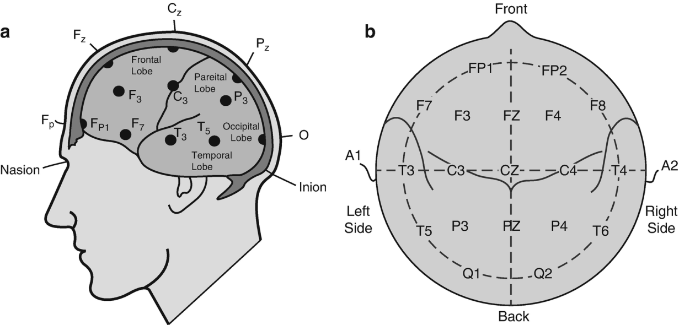

Figure 1. 1 System of electroencephalography.

As you can see in figure 1.1, the placement of electrodes around the scalp, each electrode adjusted in a specific area of the scalp. The electrodes reading brain waves from pre-frontal (Fp), frontal (F), temporal (T), parietal (P), occipital (O), and central(C). Every electrode wave has specific information about brain activity. You can see in Figure 2.1.
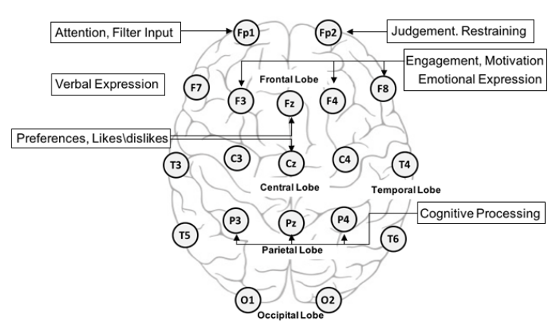

Figure 1. 2 Electrodes signals reading brain activity

Deep learning algorithms are used to classify emotions from these waves. DBN (Deep Belief Network) based emotions have been driven using EEG signals(Dhanapal & Bhanu, 2020), and CNN is used to extricate the highlights of fluctuated bio-signal (Zheng and Lu, 2015). This kind of signal is related to the central nervous system and supplies the features of a strong feeling. If required we will also use LSTM to classify emotions. The rectified RNN architecture is called LSTM, the setting data for processing 1D information vectors. Amazing strategy for feature extraction relies upon deep learning technologies where the important features are extricated utilizing the distinctive neural network methodologies for Model building(Cao et al., 2018). Like that (RNN) and CNN for extracting meaningful features from EEG signals. Auto Encoder technologies also use remaking the breath signal. Deep learning is the perfect methodology to extract important features automatically for model building. However, the deep learning features cannot consider statistical calculations just like the mean and standard deviation. Moreover, the features extracted from a deep-learning model do not contain information about the frequency domain (Lee et al., 2020).
This research focuses on neurological disorders detection from speech emotions, the electrical or biochemical abnormal condition in the brain, spinal cord, or other nerves that can produce a range of symptoms (Performance, 2015). The symptoms include muscle weakness, paralysis, poor coordination, failure of sensation, seizures, conciseness, pain, and altered levels of consciousness. The EEG is a generally applied instrument that psychoanalyzes the human neural structure functionality. The electrical fluctuations are measuring on the skull by assessing the electric frequency of neurons terminating in the mind. These electrical frequency exercises are recorded over differences using different electrodes put across the scalp licitly over the cortex. Electrodes cap-like instrumentation is connected with the computer system. Electroencephalogram has the accompanying key advantage; it is relatively easy to use, portable, and cost-effective. The distance between electrodes should become either 10% or 20% of the scalp dimension, as appeared in Figure. 1. The 10 to 20 of the standards have consistently used various EEG signals to construct the quality of the frequency and fall the signal-to-commotion proportion (Malmivuo, 2017). The human brain produces neural movement, which can be decoded electroencephalogram signals for the BCI. The brain neural movement produces two kinds(Aldayel et al., 2020):
- Rhythms
- Transient

The EEG activity can be also arranged dependent on these sorts of exercises.
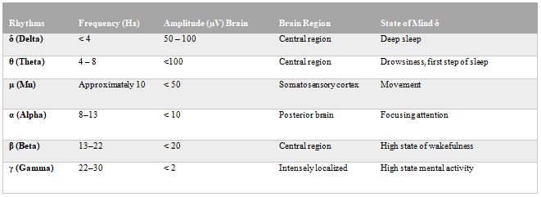
Table 1.1 the frequency and Amplitude of EEG rhythms

Emotion classification is a difficult task from normal and patient person data. Hence, it's hard to indicate or mark emotions as parameters. For the most part, to solve this issue there are two ways to find emotion. The simple and essential classification of emotions is discrete labels like Depressed, Calm, Excited, Sad, Afraid, and Peaceful, etc.(Swati Sharma, 2013). It is basic. This technique can not constitute a blended level of emotions. The second method is to use multiple parameters as an emotional indicator; these parameters have continuous scales (Lee et al., 2020).
The perfect well-known strategy is predicated on Russell's circumflex hypothesis. During this hypothesis, emotion comprises a 2-dimensional space with “valence” and “arousal”. Arousal and Valence are plotted respectively on a vertical line and a horizontal line on a circle graph. Emotion is frequently communicated as a medium of arousal and valence; for instance, happiness has increase arousal and valence, while depression has decrease arousal and valence (Paulmann, Bleichner, and Kotz, 2013) So, we picked the valence and arousal enthusiastic model and led 2 paired characterizations as high qualities or low qualities. See figure 3.1.

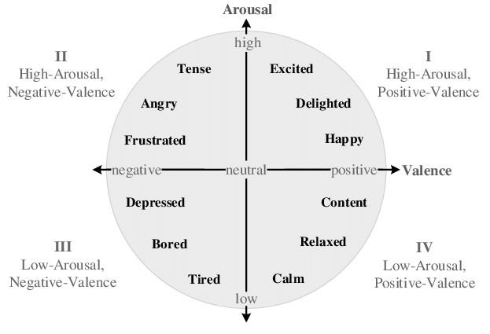

Figure 1. 3 Emotion scales

Problem Statement
The human brain is the most complex part of the body, so neurological disorder is the big health problem in the world. The specific cause of this kind of illness varies but can include lifestyle or environmental help problems, genetic disorder, infections, congenital abnormalities, brain injury, nerve injury, spinal cord injury, and gluten sensitivity, etc.
So our problem is, how to detect neurological disorders in person using their emotions and eye activity using machine learning technologies. This kind of research can help doctors or health care manufacturers for diagnosing neurological disorders. Here are using DEAP data set for EEG, video, audio, and eye blinking data. With the help of this data, we will analyze human emotion as high arousal, low arousal, and high valence, low valence using CNN and RNN with LSTM machine learning methodologies.

Aim and Objectives
The main aim of this research is neurological disorders detection from speech emotions using machine learning technologies, the identification of the brain neuron damage or disorder. This research will help to diagnose neurological disorders kind of illness and also this will be a contribution to further research. The aim and objectives of this study are the following.
- To analyze the pattern and relationship between the Hybrid neural network (CNN+RNN model)
- To evaluate the performance of Multi-Modal using EEG and Video Data
- To compare the predictive models and find good accuracy of the model.
- Find out good accuracy to detect low or high valence and arousal using deep learning.

Research Questions (IF ANY)
How to help a hybrid neural network for the diagnosis of neurological disorder patients?
How to find delayed sleep phase disorder or syndrome?
How to classify emotions for neurological disorders or a normal person?
How do identified best-fit algorithms solve emotion classifications

Scope of the Study
Mental issues or neurological problems are expanding at high movement on the planet. According to WHO, one among four individuals on the planet will be influenced by mental or neurological problems eventually of time in their life, Neurological problems will be the second driving reason for worldwide infection trouble by the year 2020, falling behind ischemic heart ailment however driving the wide range of various illnesses (Janga & Reddy, 2017). The expansion in the number of experts who treat psychological illness is extremely less when contrasted with the development in the number of individuals who are experiencing mental issues. Emotional wellness analysis includes steps like exceptionally planned meetings about manifestations and clinical information and at times actual assessment of the patient. A few mental tests may likewise be led to ensure the indications are expected of psychological wellness issues and not due to some other illness. Likeness in the indications of a few emotional wellness issues has made finding a muddled undertaking. Determinations of emotional wellness issues in youngsters are unmistakably more troublesome than diagnosing them in grown-ups. In this manner, one should be mindful to determine the emotional well-being issues to have precision. It's realized that mental/neurological issues influence cerebrum capacity and structure(Speed Emotions, n.d.).
In any case, to date, the interpretation of neuroimaging research discoveries into analytic apparatuses has been extremely restricted because of the absence of sufficient examination devices. In the most recent years, there has been a considerable expansion in the utilization of AI/design acknowledgment ways to deal with investigating neuroimaging information. Computerized reasoning can empower the PC to think. PCs are made substantially more clever by AI. ML is the subfield of AI study. Different specialists imagine that without learning, knowledge can't be created. There are numerous kinds of Machine Learning Techniques that are. Regulated, Unsupervised, Semi-Supervised, Reinforcement, Evolutionary Learning, and Deep Learning are sorts of AI strategies. These strategies are utilized to characterize the informational index.
So, the scopes of the study in this field are very broad. Special deep learning methodologies in focus at the time, a lot of researchers already working in this field(Zheng & Lu, 2015).

Significance of the Study
In the current research, we have created multi-channel EEG through parallel CNN and RNN with LSTM including a link with Softmax that determined neurological mind issues to have high accuracies. Distinctive component extraction and EEG grouping strategies are researched to help nervous system specialists in the determination of those neurological brain problems. In the wake of applying the preprocessing procedure, the main strategy for highlight extraction, a basic and computational modest pre-handling technique has been proposed to consider the benchmark signals lastly change the crude 1D chain EEG signals into 2D edge arrangements (Zhao et al., 2020).
When planning a 1D vector into a 2D edge, the standard is, signals producing from truly neighboring direct are as yet contiguous in the edge, therefore the spatial data can be held after changing over a crossover deep learning design that coordinates the CNN and RNN is received to direct feeling acknowledgment assignments in a single system. Uncommonly, CNN is utilized to extricate spatial highlights from information outlines. RNN is utilized to remove worldly highlights from electroencephalogram succession. The getting ready of CNN and RNN, an element combination strategy is put in intertwine the special highlights and transient highlights. We have looked over our strategy on the DEAP dataset and accomplished the cutting edge execution.
Thus, the significance of this research is accomplishing high accuracy with cutting edge execution of models to the finding of neurological problem sickness easily.

Structure of the Study
Machine learning includes various standards or PC models that portray issues based on classifiers and examples. ML gives strategies, procedures, and apparatuses that help taking care of indicative and prognostic issues in an assortment of clinical spaces and uniquely in brain issues additionally that characterize various instruments and techniques to treat mental turmoil or neurological issues. ML deals in supervised learning strategy, unsupervised learning, and semi-supervised learning strategies are basic for the clinical conclusion, as they permit evaluating changes in volume, shape, structure, area and so on Division strategy can likewise be valuable in discovering markers in ailments, for example, formative or neurological issues, assisting with diagnosing any medical condition identified with brain issue or some other medical condition. AI methods have been utilized for a long time in EEG designs to make the clinical methodology.
Human feelings can be identified by outward appearances, discourse, eye squinting, and physiological signs. Regardless, the underlying three procedures are vulnerable to digest the effects of the individuals, that is, individuals can deliberately veil their sentiments. While the physiological signs, for instance, EEG, EOG, and BVP are conveyed abruptly by the human body.
As of late, deep learning has attracted wide consideration because of its incredible accomplishment in the visual field. The deep learning-based methodologies have additionally accomplished serious precision in electroencephalogram based acknowledgment tasks. Convolutional Neural Network was utilized to separate time, recurrence, and area data highlights of EEG, and SAE was utilized to improve the arrangement precision. The planned both course and equal convolutional repetitive neural organization for EEG based development aim acknowledgment and accomplished an ideal execution.

CHAPTER 2: LITERATURE REVIEW

2.1 Introduction
In the 19th and start of the 20th century, the brain analysis happened to several different approaches and targets in these areas, methodology, and targets like that physiological, morphological, etc. I mean the wrong direction of research in the areas that. The latter, researcher considers that the brain is the only medium of input and output like a black box. But not understanding of any neuronal function and components in deep. The way of connected emotions with each other
At the starting of the 21st century, due to advanced technologies development, neurologic disorders researches are reached much deep in the brain, like neurons level and scientifically from molecular to behavioral levels, it carries on many different technologies and methodologies but still, we have a lot of scopes to research on that with the help of machine learning and deep learning technologies for good accuracy and fast diagnoses of neurological disorder. Researches are interconnected and convergent based on the scientific sector, not in an isolated way, which was happened at starting brain research. In the last decade, a lot of focus on artificial intelligence and machine learning technologies for research on neurological disorder detection. Here is the most advanced is neurological disorder emotion classification using EEG signals, which can help to diagnoses this kind of illness with the help of deep learning technologies. In human life, emotion performs an essential role day to day, that show feelings about things. The mentally prepared fitness situation also influences human interpersonal interplay and choice thinking (Selvaraj et al., 2016). In clinical over brain research and nervous system science, the recognized emotional states viewing patients can keep receiving as like a pointer over the guaranteed highlight of emotional disorder, certain horrendous problems then prevalent discouragement. In as of late, a few analysts dissected the emotive characteristics of a cell phone overuse by one gathering than a sound gathering through EEG signals.
Human feelings are detected via facial expressions, eye blinking, voice, and physiological frequency. However, the preceding three strategies are inclined by subjective influences about the participants, members execute intentionally cover their feeling. While the psychological frequency certain as like EEG, EOG (electrooculography), BAS (blood aggregate stress) have resulted from easily through the human brain (Ullah et al., 2018). Accordingly, the brain physiological frequency is the extra aim and dependable among taking pictures of human actual emotive states entire regarding its physiological frequency. The electrooculography signal comes without delay out of the human brain, which ability adjustments of EEG signals can without delay replicate changes within human emotive states. For that reason, researchers choose per instruction ethnical sense via EEG signals. Stability There meanwhile exits significant research on the usage of machine learning under pick out sentiment states along with electroencephalogram signals. Present-day ML-based systems have demonstrated high caliber in characterizing feeling states, while the shortage about these sorts of procedures is as the scientists should submit various endeavors after find and plan an assortment of feeling related capacities other than starting interfering with signals. Furthermore, the check over these capacities is epoch consuming. A range regarding characteristic extraction techniques is proposed in current years. While the almost many times old strategies are PSD, WT, and Fourier Transform (FT) in contrast twins extraordinary characteristic extraction strategies and four one-of-a-kind machine learning classifiers and located up to expectation nonlinear potential capabilities leading according to greater accuracy. The proposed switch recursive characteristic removal (T-RFE) strategy so much choose features over EEG according to decide the best feature subset concerning a pass situation emotion classification issue(Yang et al., 2018).
In the current, deep learning has constant gigantic consideration due to its generous accomplishment inside the visual field. Some deep learning-based techniques hold furthermore finished forceful exactness among EEG-based undertaking. CNN utilized by recurrence, kill time, district realities, highlights of SAE (stacked autoencoders), and EEG(Yin, Zhao, et al., 2017). It used to be connected to improve the characterization precision, proposed each arrangement and CNN as a result of EEG fundamentally based movement want to center and achieved an ideal execution. They propose a pre-preparing procedure so much change EEG information as multi-channel inside 2D casing outline and combination with CNN and RNN to discernment sense situation in the preliminary level, and concentrate power unearthly thickness out of remarkable EEG diverts and planning it as per two-dimensional level after assembling the EEG multi-dimensional component and thereafter CNN used to be embrace to dissect transient picture designs with EEG MFI arrangements, while the RNN and LSTM were utilized in similarity with extraction human sentiments utilized Bimodal Deep Diagnosing Bimodal LSTM and Auto Encoder to characterize feeling states and the cutting edge execution.

2.2 Data Analytics in Neurological Disorder
In the most recent decade, bunches of neuropsychological exploration or studies have distributed and revealed the relationship between EEG waves and Emotions. After investigation of this examination, we found that there are two fundamental pieces of brain-related to feeling or feeling activities. One is Amygdala and the second is the Prefrontal Cortex. Amygdala is situated close to the hippocampus with a frontal bit of worldly flap, and the prefrontal cortex is covered by part of the frontal projection. Albeit even is no agreement about attainable lateralization concerning the amygdala, its activation looks in conformity with keep greater related to bad feelings than effective ones(Alarcão & Fonseca, 2019).
Variation into alpha limit and asymmetry among the hemispheres regarding the brain is associated according to emotions. A relative appropriate frontal activation is related together with transfer stimuli or bad emotions, such as fear or disgust. A comparably larger left frontal activation is related together with a strategy stimuli or positive emotions, certain as like pleasure or happiness. Thus, the asymmetrical frontal EEG activation might also replicate modifications over the valence(Placidi et al., 2016). Beta bands are also associated with imitation of valence. Pre-frontal and parietal lopsidedness inside the alpha band and fleeting deviation among the gamma band is current for valence acknowledgment, while pre-frontal unevenness between the alpha band and worldly imbalance in the gamma band is overt for arousal acknowledgment.
Variety of the gamma band is related to the feelings of carelessness and trouble and thus lessens the alpha tension of particular sides concerning the regular citizen projection (left because of sadness, and appropriate because of happiness). At long last, the ERP factors concerning short N100 and P100 incongruity with focus N200 and P200 latencies have been demonstrated as per relate along with valence, as the components of focus as per extensive P300 and SCP latencies have appeared as per associate including excitement.

Our assessment of feeling pushing ahead as per deep analysis for neurological turmoil, so infers that the frontal and parietal projections are the most useful as respects the emotional states, while the alpha, gamma, and beta waves appear to be the most discriminative. The gender-related discoveries are predictable with the basic trust so ladies are more noteworthy emotive than men, which proposes doable sexual orientation-related neural reactions as per emotional upgrades(Alarcão & Fonseca, 2019).

2.3 Data Mining in Diagnosis of Neurological Disorder Diseases
Neurological issues are the sicknesses related to the periphery and central focal nervous systems. The typical appearances consolidate muscle deficiency, loss of motion, seizures, periphery, and central focal nervous systems. The typical results join muscle weakness, loss of movement, seizures, torture, defenseless strategy, and loss of mindfulness. Signs join muscle deficiency, loss of motion, seizures, torture, vulnerable coordination, and loss of perception. There are > 600 afflictions related to the central focal nervous systems.
Creators have been supporting the assessment theory that a PC helped end (CAD) structure arranged using heaps of patient data and physiological signals and pictures subject to skilled compromise of forefront signal dealing with and man-made cognizance (AI)/AI (ML) methods in an electronic plan can help sensory system neurosurgeons, trained professionals, radiologists, and other clinical providers to make better clinical decisions. Assessment around there has been creating at an animating rate in the earlier decade.
In this study, the researcher reviewed research on the usages of AI-based CAD systems for the assurance of 5 huge neurological issues: epilepsy, AD, PD, MS, and ischemic psyche stroke. Figure 1 shows the utilitarian square diagram of a normal ML-based CAD system containing 5 stages: (1) signal change, (2) feature extraction, (3) incorporate dimensionality decline, (4) ideal segment decision/situating, and (5) course of action, ML-Based Computer-Aided Diagnosis (CAD), Input information for a CAD framework are ordinarily flags or potentially pictures.
For PD, numerous CAD frameworks use discourse and EEG for the conclusion. Picture based methodologies regularly use MRI and single-photon discharge registered tomography filters. For epilepsy, most creators have utilized Bonn University EEG informational collection.
In MS, T1 and T2 weighted MRI pictures are usually utilized for the analysis, where T1 and T2 allude to the time taken between attractive heartbeats and the picture is taken.
The greater part of the AD frameworks has utilized T2-weighted MRI pictures from Alzheimer Disease neuron Imaging and Open Access Series of Imaging Studies information bases.
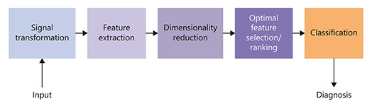
Figure 2. 1 Extraction Signal-Based Approach

When all is said in done, picture change is performed first where the repetitive data is taken out and afterward includes are separated from the changed pictures. This progression helps in social occasion critical data that can be utilized for highlight extraction.
Highlight Extraction Signal-Based Approach, Discrete wavelet change (DWT) is frequently used to change the sign over to low-and high-recurrence parts. The curvelet change that is a higher dimensional DWT speaks to the pictures in numerous points and scales. The higher-request spectra (HOS) highlights are likewise utilized to include portrayal and extraction. The removed highlights must speak to the shrouded enlightens present the info information(Raghavendra et al., 2020).
An Image-Based Approach, preprocessing strategies, power standardization, versatile histogram adjustment, and back-ground deductions are performed preceding level set division to distinguish the locale of premium The dark level co-event framework highlights are most usually utilized for the pictures The entropy and energy highlights are additionally utilized in numerous articles The wavelet-based energy and entropy highlights are likewise utilized. Different factual measures, for example, Hu's minutes, Zernike minutes, focal minutes, and factual minutes are utilized as highlights both in sign and picture-based methodologies for creating CAD frameworks for neurological turmoil.
In Dimensionality Reduction, Feature extraction strategies regularly yield an enormous number of highlights that might be repetitive and result in inordinate computational necessities which thusly may make their continuous application illogical or pointlessly troublesome. Subsequently, different element dimensionality decrease methods are regularly utilized. The most ordinarily utilized strategies are head segment investigation (PCA), straight discriminant examination, and autonomous segment investigation. Broadened forms of PCA, for example, part PCA have likewise been utilized in the writing.
In Optimal Feature Selection and Ranking, the Majority of highlights display excess data, which should be taken out to get ideal arrangement execution? The investigation of difference is the most normally utilized strategy when at least 3 classes are included. Other regularly utilized ideal element selection methods are Student t-test, entropy, Wilcoxon rank tests, Bhattacharyya distance, collector working trademark, hereditary calculation, molecule swarm streamlining, and subterranean insect state advancement. Various researchers have consolidated diverse determination strategies to acquire the main highlights. The fluffy rationale based min-repetition and max-importance include determination have been utilized for analysis of PD
In Feature Classification, methods, for the most part, have 2 stages: (I) preparing and (ii) testing. They should be prepared to utilize recently gathered information. When prepared, they can be utilized for the order of new cases.

2.4 Data Mining in Prediction of Common Types of Neurological Disorder
Data Mining and data set innovation, demonstrating strategies, measurable analysis, design acknowledgment, and AI. It utilizes progressed devices for enormous data sets the board and programmed/self-loader investigations to distinguish critical patterns and affiliations considered instructive because the novel, understood to the information and of possible help in the forecast and dynamic(Maggiotti, 2019). Methodological importance and application in medical services and biomedicine are expanding, with suggestions in fields as various as data the board in medical services association, general wellbeing, the study of disease transmission, persistent observing and the executives, signals, and pictures analysis. It speaks to a powerful and effective arrangement giving new prescient measures to early finding and forecast or supporting clinical staffs inpatient administration, for example, in treatment arranging and personalization. Information removed from relevant clinical information bases through information mining methods might be new or appropriate for reconciliation with combined information and improve dependability while lessening subjectivity in dynamic cycles. In this part, we examine the overall reasoning of basic Data Mining and its quirks of utilization in the clinical field, eminently in the neurological area. Important dynamic issues, proposed arrangements, and open issues are summed up and the cutting edge of Data Mining in medication and nervous system science is examined in context. This audit can't and isn't intended to be thorough, yet should lay out the possible utilization of Data Mining for supporting clinicians in their dynamic.
Herskovitz and Gerring (Herskovitz and Gerring, 2003) recommended that Data Mining procedures might be applied for a superior comprehension of the current connections among factors obtained from injury deficiency examination (LDA). Bayesian strategies demonstrated computationally manageable, powerful in speaking to the non-direct relationship among LDA factors, and more touchy and explicit than techniques dependent on Chi-square and Fisher accurate measurements. LDA gives broad data about the relationship between the cerebrum structure and capacity, however for the most part produces enormous companions of factors, in this manner making the displaying of information relations by conventional measurable methodologies troublesome.
Choice in the administration of horrendous mind injury patients might be urgent. Specifically, nervous system specialists and neurosurgeons as a rule need to settle on choices in a brief timeframe and based on a few patients' information. A few investigations broke down genomic information, clinical boundaries at an affirmation, and research center tests while looking at changed Data Mining procedures. PC helped frameworks for pictures and signals understanding help brief choices and decrease subjectivity of the evaluation. Liao and associates proposed a novel strategy dependent on a blend of machine vision with Data Mining to naturally identify intracranial hematomas through the examination of CT mind outputs and EEG.

2.5 Predictive Modeling in Neurological Disorder Diagnosis with following Datasets
There is a lot of interest today in emotion recognition, as it is an area with very broad applications to a large number of systems, such as human-computer interaction (HCI) systems, machine emotional intelligence, health industry, etc. Emotion recognition is intrinsically a very challenging problem, with its main difficulties stemming from the fact that the problem itself is very subjective and hard to quantify. There are many popular emotion definitions and models, both in terms of discrete emotion subsets, as well as mappings in two- and three-dimensional spaces. In this work, we assume a 3D emotional model. With increasing interest in the area, new and large datasets are being collected, enabling new insights to be discovered in the area. These datasets necessitate distributed processing for enhanced scalability and performance. Popular distributed machine learning libraries can augment the process of training accurate classifiers offline, to build prediction models based on large amounts of data(Kumar et al., 2016). We used Mahout on distributed mode to train a random forest classifier, on the DEAP dataset. Using a distributed approach allows us to process the data in a reasonable time and conducts many iterations to experiment with different model parameters and convergence criteria.
2.5.1 Deap Datasets for Music, Videos, and Eye Blink
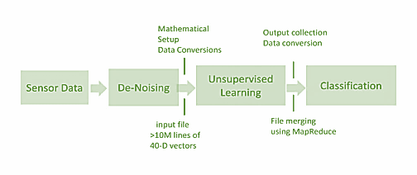
The DEAP dataset is a large dataset from a controlled setup experiment, where each subject is exposed to several pre-rated one-minute extracts of music videos, selected to provoke different emotional states. During the experiment, the electroencephalogram (EEG), peripheral physiological sensors, and video, in some cases, are collected, along with the individuals’ rankings on valence, arousal, dominance, familiarity, and liking. The biosignals for the preprocessed part contain 40 physiological channels (EEG and peripheral signals)(Guo et al., 2017). The preprocessing includes artifact and baseline removal, filtering, reordering, and down-sampling. A detailed description of the dataset can be found in the DEAP-dataset description.

Figure 2. 2 Filtering and De-Noising data set

That is a multimodal informational collection for the analysis of human emotional states. The electroencephalogram (EEG) and fringe physiological signal of 32 members were recorded as each watched 40 one-minute-long extracts of music recordings(Yin, Zhao, et al., 2017). Members evaluated every video regarding the degrees of excitement, valence, similar to/aversion, predominance, and commonality. For 22 of the 32 members, frontal face video was likewise recorded. A tale strategy for improvement determination is proposed utilizing recovery by emotional labels from the last. the site, video feature recognition, and an online evaluation apparatus. A broad examination of the members' evaluations during the analysis is introduced. Connects between the EEG signal frequencies and the members' evaluations are researched. Strategies and results are introduced for the single-preliminary arrangement of excitement, valence, and like/detest appraisals utilizing the modalities of EEG, fringe physiological signal, and sight and sound substance investigation. At long last, a choice combination of the order results from various modalities is performed. The informational collection is made openly accessible and we urge different analysts to utilize it for testing their own full of feeling state assessment strategies(Qing et al., 2019).

2.6 Visual Analytics in Neurological Disorder
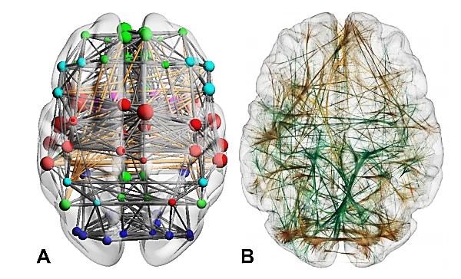
Behavioral neuroscience is the study of mental processes and their biological principles. Scientific advances in this area do not only contribute to the knowledge about the mind and consciousness but also the understanding of many medical disorders, such as Alzheimer’s disease, schizophrenia, autism, anxiety, etc. To find neuronal representations of behavioral patterns, a highly heterogeneous set of neurobiological spatial data, including imaging data (3D imaging data on voxel/brain region-level) and networks (structural, functional, and genetic relations between brain voxels/regions) has to be investigated and put into the context of their mental effects. Recent advances in neuroimaging allowed big brain initiatives and consortia to create vast resources [all19, hum19, VESB+13, mPlDI+16] of this data that covers genes, function, anatomy, and behavior.

Figure 2. 3 Region-level and Voxel-level network

In-circuit neuroscience, spatial imaging data is used to relate a structural, functional, or genetic property to spatial locations. This allows researchers to draw conclusions about which brain regions contribute to a behavior, which function a certain brain region has, and which molecular mechanisms might be involved (from genetic data). One can distinguish these spatial locations on two different anatomical levels: on a brain region-level, where the data is associated to anatomical or non-anatomical brain regions, and on a voxel-level, where voxels refer to grid points in a regular 3D space on a sub-brain region-level.
(A) Region-level network visualization via 3D node-link diagram in the BrainNet Viewer Colors represent different subnetworks, node size represents node strength (number of connections of a node). Orange edges represent long-distance connections.
(B) Voxel-level network visualization of functional connectivity (orange: negative correlation, green: positive correlation) with edge-bundling
BrainGL open source software for the interactive exploration of structural and functional brain data with edge-bundling. By grouping geometrically similar edges to bundles, the overall structure of the network can be clarified. To visualize the termination points of these edges, various types of glyphs can be projected to the surface of the brain. The glyphs provide a visual summary of all connections from their respective position, which can be interactively manipulated by the user. Similar to the Connectome Visualization Utility, visualizations can be viewed in multiple linked views with synchronized selections, thresholds, and coloring.

2.7 Related Research Publications
The deep learning methods are assuming an undeniably vital function in neurological exploration, handling issues inside a few subdomains. To start with, radiological picture characterization and division has been a customary locus of deep learning improvement endeavors. Picture order and division undertakings are interestingly fit deep learning because of the high-dimensional nature of neuroimaging information which is negative to the manual investigation, joined with the normally computerized nature of most current imaging. Furthermore, deep learning has been applied to useful mind planning and correlational investigations utilizing practical attractive reverberation imaging (fMRI) information for errands, for example, the expectation of postoperative seizure. Finally, demonstrative guess with deep getting the hang of utilizing numerous information types, including lab esteems, pictures, notes, among others, has been utilized to relegate infection hazard.
As talked about above passage, there are bunches of explores and distributions accessible identified with neurological turmoil, as of late investigates are deep learning-based neurological problem recognition.

2.8 Discussion
In our study, we created after using the deep CNN for grouping of feelings dependent on behavioral signals produced in the human brain upon any passionate elicitation. We utilized DEAP information for our trials. The proposed strategy produced empowering results on the dataset. They likewise indicated how our outcome outperforms past functions done utilizing DEAP.
To examine speculation, it can check that the model prepared on female behavioral information functioned admirably here, tried on female data, and didn't give great outcomes when tried on male information. Also, the model prepared on male physiological information functioned admirably when tried on male information, and didn't give great outcomes when tried on female information. Curiously, a past report takes note that physiological signs are comparable during comparative feelings in males and females; notwithstanding, our outcomes show that they are not quite the same as an AI outlook(Anderson & McOwan, 2006). These outcomes are upheld by another investigation that noticed that the neurons stream in various pieces of the cerebrum in people during feeling elicitation. For ladies, these neurons associate the pieces of the cerebrum that manages interior territories of the body that affect circulatory strain, breath, and physical changes, such as men, their neurons interface with the regions of the mind it deals with vision and development. That can cause the distinction in physiological signs in people. That logical inconsistency requires more itemized investigation(Zhuang et al., 2017).
We can likewise notice females are somewhat in a way that is better than the outcomes for information for guys; that can be due to females having the too extraordinary articulation of feelings than guys. This study discusses the distinction in the impression of feelings in people saying that ladies feel a similar feeling more extravagantly and extraordinarily than men. Pushing ahead, we can see that for the DEAP information base, we got great outcomes for deep frequency and joining EEG with deep frequency and our outcomes for all the procedure outflanks the present status of craftsmanship. The deep CNN performed in a way that is better than past investigations which utilized different strategies like single-preliminary twofold arrangement for every one of four passionate measurements, or late work utilizing DEAP which was finished utilizing Bi-modal Deep autoencoder (BDAE) for highlight feature and deep learning for preparing.
Noticing past research, we can see that outcomes for fringe information and a mix of EEG with frame information are the acceptable output of EEG alone are not tantamount to other arrangements of modalities. The comparable way that the outcomes got with EEG information is less predictable and circulated over a huge scope from half to full precision, although the consequences of fringe information and the mix of EEG with fringe information are considerably more study. The explanation might be because EEG information may have a few curios while getting captured, for instance, there are chances that heart pulsates can be confused as a mind action which can present clamor although recording information. These outcomes with EEG information might be enhanced by attempting various techniques for post preparation and commotion evacuation(Soleymani et al., 2015). Further investigation is required for improving outcomes with EEG information. Another perception can be made after looking at the resulting DEAP information bases for physiological information. DEAP information base has an alternate blend of physiological information for example EOG, EMG, GSR, breath, pulse, and internal heat level. Because of our proposed technique and test plan, it tends to be said that the main blend of physiological information is superior to the subsequent mix. Nonetheless, the more itemized examination of these information types whenever needed to verify or refute this. Our work can be utilized as a gauge for future investigations.

2.9 Summary
Full of feeling registering is a profoundly encouraging field of study because of profitable applications that can improve individuals' lives. Different strategies are being pursued, feeling acknowledgment. In their trials, we research the ability of behavioral signals to decide human feelings. For the arrangement of feelings, we utilized deep realizing which the most recent condition of workmanship in characterization strategies is. The objective of our examination is to decide whether the blend of multimodal information alongside deep learning can be valuable for grouping feelings with high precision. The outcomes we have from our trials are extremely energizing and edify some immaculate viewpoints like the sex explicit correlation utilizing physiological signs. We have built up another technique for feeling acknowledgment that is a multi-modal way that combines diverse physiological signs of an individual to order their passionate state. We utilized the DEAP dataset for our analyses and deep learning as the grouping strategy(Qing et al., 2019). We likewise contrasted our outcomes and the present status of workmanship on DEAP, which is outflanked by our technique. The work we did opens entryways for extremely energizing examinations for the arrangement of feelings utilizing physiological signals particularly mind information. We are accomplishing more investigation of EEG signals and chipping away at preparing classifiers with information of channels from specific pieces of the cerebrum that are liable for feelings explicitly, for instance, frontal and worldly projections. We are additionally intending to take a stab at building various grouping models utilizing a solitary EEG channel, to analyze the commitment of various EEG channels for the arrangement of feelings(Sharma, 2018).
Further investigations should be possible utilizing multimodal combination for example how extraordinary EGG channels can be consolidated to improve results with EEG information. Joining EEG and other physiological signs can be gone after for additional investigations. We are likewise intending to attempt heterogeneous information connections for example consolidating pictures, sound, warm and physiological information. We will do a detailed examination concerning age, sexual orientation, and identity for feeling acknowledgment. We are likewise chipping away at improving outcomes for EEG signals and making it more study by attempting more preprocessing procedures for commotion expulsion and intending to attempt diverse deep net designs for additional investigations.

CHAPTER 3: RESEARCH METHODOLOGY

3.1 Introduction
The human body creates different signals while working on its behavioral frameworks. These signs are called physiological signals and incorporate however are not restricted to pulse, beat rate, muscle development, skin conductance, and mind exercises. Dynamic changes in these signs impact perceptual, full of feeling, and psychological state. Physiological signs can be a convincing methodology in perceiving inward intellectual and passionate states. Due to the high worldly goal of these signs, a lot of valid and pertinent information can be assembled. For our examinations, we are utilizing the DEAP dataset.

3.2 Research Methodology
An effective physiological frequency that straightforwardly identifies with feelings is cerebrum movement which is estimated regarding the stream of neurons as the enormous quantities of dynamic neurons create electrical action at the outside of the scalp and recorded with EEG terminals. EEG gadgets read these electrical mind exercises from the scalp with the high worldly goal. The dataset contains EEG information which depends on the Valence-Arousal feeling model portrayed in Figure 3.1.
The information base additionally has arrangements of fringe information which incorporates EOG (eye developments), EMG (muscle development), and GSR, breath, circulatory strain, and temperature. The information was gathered from 32 members (19-37 years old, half male and half female) playing all-out 40 one-minute-long music videos to inspire feelings. 32 EEG channels dependent on the 10–20 frameworks for recording EEG information and 8 channels for fringe physiological information were utilized(Kim & Kang, 2018).
In this table, the initial 32 channels are the EEG channels and the last 8 channels are the peripheral channel utilized in the dataset (Pan et al., 2020). These signs were recorded with an examining pace of 512 Hz which was down inspected to 128 Hz in the wake of preprocessing. The information was named with excitement, valence, strength, and preferring values going from 1 to 9 indicating the force of each enthusiastic state. Figure 3.1 shows the impact of the powers of these feelings on the emotional state (Kim & Kang, 2018).
Deep learning procedures, CNN utilizing separate time, recurrence, and area data highlights of EEG and SAE for development of order precision. Equal CNN and RNN for EEG development aim to acknowledge an ideal mix for accomplishing execution. The power spectral frequency is separated from various channels of EEG and planned to the 2D position to build the electroencephalogram MFI (multi-dimensional feature image) at that point convolutional neural network was embraced to take in impermanent picture designs from electroencephalogram MFI successions, while the RNN and LSTM were utilized to characterize human feelings.
Channel No. | Channel Name | Channel No. | Channel Name
1 | Fp1 | 21 | CP6
2 | AF3 | 22 | CP2
3 | F7 | 23 | C4
4 | F3 | 24 | T8
5 | FC1 | 25 | FC6
6 | FC5 | 26 | FC2
7 | T7 | 27 | F4
8 | C3 | 28 | F8
9 | CP1 | 29 | AF4
10 | CP5 | 30 | FP2
11 | P7 | 31 | Fz
12 | P3 | 32 | Cz
13 | Pz | 33 | hEOG (horizontal EOG, hEOG1 - hEOG2)
14 | PO3 | 34 | vEOG (vertical EOG, vEOG1 - vEOG2)
15 | O1 | 35 | zEMG (Zygomaticus Major EMG, zEMG1 - zEMG2)
16 | Oz | 36 | tEMG (Trapezius EMG, tEMG1 - tEMG2) 37
17 | O2 | 37 | GSR (Ohm)
18 | PO4 | 38 | Respiration belt
19 | P4 | 39 | Plethysmograph
20 | P8 | 40 | Temperature

Table 3. 1 EEG channels

3.2.1 Data Selection
DEAP is an openly accessible dataset for feeling investigation, which recorded EEG and peripheral physiological signs of 32 members as they watched 40 music recordings. All the music video cuts keep going for 1 moment, speaking to various feeling visual improvements, with the grade from 1 to 9. Among the 40 music recordings, 20 are high valence visual upgrades and 20 are low valence visual boosts(Zhuang et al., 2017). The circumstance is the equivalent of excitement measurement. After viewing the music video, members played out a self-appraisal of their levels of excitement, valence, loving, strength, and commonality, with evaluations from 1 to 9. EEG was recorded with 32 terminals, putting as per the worldwide 10-20 framework. Every cathode recorded 63 s EEG signals, with a 3 s pattern signal before the preliminary. We utilizing the preprocessed EEG information for the study, with a test rate 128Hz and band range 4–45Hz. EOG curios were eliminated as a strategy. The information was sectioned into 60-second preliminaries and a 3-second pretrial pattern was eliminated. The double groupings of valence and excitement measurement are thought of. We used the members' self-evaluation as a name. On the off chance that the member's appraising was <5, the mark of valence/excitement is low, and if the rating was ≥5, the name of valence/excitement is high. Every music video goes on for 1 moment, and 5 s EEG signals are extricated as an example. So for each subject who watched 40 music recordings, we get 480 marked examples. The deliberately chosen 40 1-min recordings were utilized as feeling elicitation materials. The 2D valence-excitement feeling model was utilized to quantitatively depict enthusiastic states. The main measurement, valence, goes from disagreeable to wonderful, and the subsequent measurement, excitement, change from exhausted to energize. Along these lines, the valence-excitement model can portray most varieties in human feeling changes(Petrushin, 1999).

3.2.2 Data Pre-processing
To enhance the recognition reliability, that is use pre-fundamental data to evaluate the diversity between check frequencies a ton that are recorded while individuals are below actuation. In the first place, that comes along pre-starter frequency with each C channel and separates it into N partitions with a comparable length L. Subsequently the underlying advance, we can achieve N (C × L) grids. Further, that is doing the segment-wise development for the particular cross-sections and determines the mean worth. This movement can be arranged as:
$$\frac{BaseMean=\sum_{1}^{N}{}{mat}_{i} }{N}$$
Here mati ∈ indicates the $i^{th}$ after these two phases, it get a C×L structure called BaseMean, That is used to address the objects of the essential energetic state with no prompting. Third, we partition the rough EEG frequency into M (C ×L) systems name is called RawEEG and a short time later less the BaseMean for very matrices. The data used to address the qualification between test frequency and measure frequency is called BaseRemoved, which is made as follows:
BaseRemovedj = RawEEGj － BaseMean
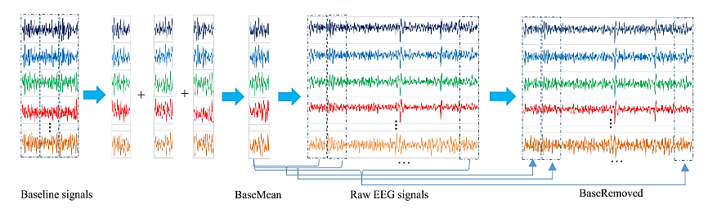
Figure 3. 1 Flowchart of pre-processing for signals
The last advance is linking these BaseRemoved grids into a major network of which size is equivalent to crude EEG signals(Yang et al., 2018).

3.2.3 Data Transformation
The general EEG information procurement and change flowchart has appeared in Figure 3.4. The electroencephalogram based BCI framework utilizes a wearable electrode cap with numerous nodes to catch EEG frequency. The Global 10-20 structure is a universally perceived strategy for depicting and putting it on the area of the scalp terminal and the fundamental region of the analytical layer. The 10% and 20% indicate the way that the real difference between the neighboring nodes is the absolute front back or right left difference of the skull (Malmivuo, 2017). The information of EEG frequency securing framework at time filet is a 1 dimensions information vector $V_{t}$ = [$S_{t }^{1}, S_{t }^{2}, S_{t }^{3}, …….S_{t }^{n}]^{T}$. Where, $S_{t}^{i}$ is pre-handled information of the $i^{th}$ electrode carrier and the procurement structure added n channels. The dataset provides the, n equals to 32. For the perception time frame [t, t + L], that is (L + 1) 1D information trajectory, every one of those created with n components compared to n anodes of the securing headset. That can observe with the lower-left corner of Figure 3.4 That is the arrangement perspective on the global 20 and 10 System, here the EEG cathodes hovered in red are the test focuses utilized in the DEAP dataset.
Here in research, we summed up the Global 10 and 20 structure with assessment terminals utilized in the pre-handled dataset to frame a network (h × w), where the most extreme count number of the straight-up test focuses and w is the greatest count number of the flat test. The DEAP dataset provides, h rises to w rises to 9. About the EEG terminal guide, every anode is genuinely neighboring different cathodes which record the EEG frequency in a specific region of the cerebrum, while the components of the chain as 1D EEG information vector are confined to two acquaintances. To keep up spatial data among various contiguous carriers, we change the 1 dimensions EEG information vectors to 2 dimensions EEG outlines as indicated by the cathode dispersion map. The relating 2 dimension information outline ft of the 1 dimension information vectors vt at time list t is signified as follows:
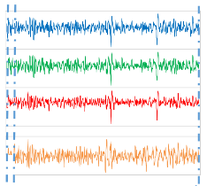
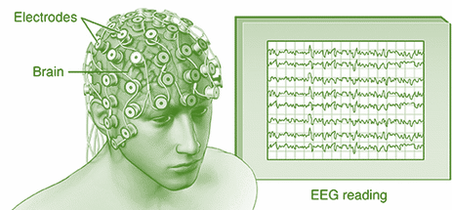

Pre-Processing
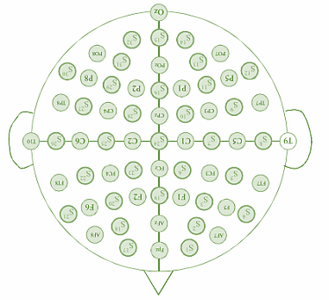
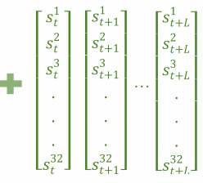

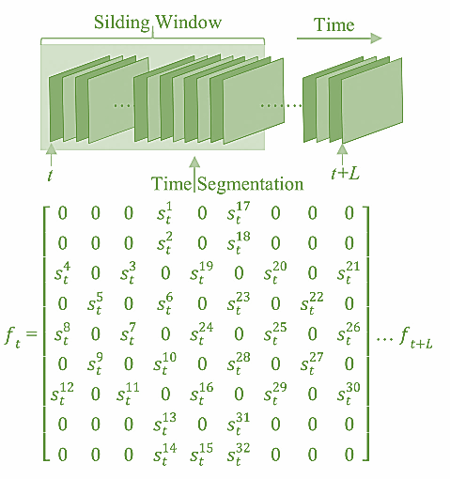

Figure 3. 2 Flowcharts for data transformation

Zero is utilized to speak to the frequency captured with channels that are without use in the DEAP dataset, which affects the neural network. The pre-prepared 1D information vector arrangements [vt, vt+1, … , vt+L] is changed over to 2D information outline groupings [ft, ft+1, … , ft+L], for the perception length [t, t + L], the amount of 2D information outlines is still (L + 1). After the change, every information outline is standardized over the non-zero components utilizing Z-score standardization by the accompanying condition:
Z = $\frac{x-μ}{σ}$
Where x signifies a non-component from a specific situation of the edge, μ indicates the mean of all non-components and σ means the standard deviation of these components. At last, it is processed with a sliding window way to deal with a portion of the streaming 2D casings to singular edge gathering.

3.2.4 Interactive Visual Analytics
These difficulties have not prevented analysts and professionals from utilizing deep learning, and the most recent 10 years have seen a quick increment of results over all the fields identified with EEG information. There has been an expanding interest in utilizing this sort of strategy. An intriguing survey of more than 100 papers reveals insight into the present status of the workmanship. Figure 3.3 shows how the primary fields of the utilization of EEG information investigation have attempted deep realizing and what deep models are the most well-known. There is still no unmistakable prevailing engineering. A significant number of those applied to EEG have been straightforwardly acquired from past applications, for example, PC vision. Hence, convolutional neural organizations (CNNs) are the most widely recognized design, while autoencoders and repetitive organizations are likewise utilized frequently.
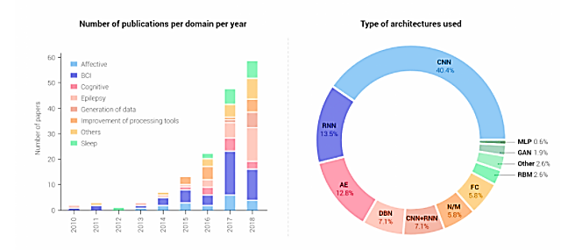
Figure 3. 3 EEG data analyses with deep learning

3.2.5 Class Balancing
In EEG pattern recognition for emotion classification, a popular approach is to label data in two dimensions: valence and arousal. Valence refers to how positive or negative is the emotion. Arousal refers to how intense the emotion is. In experiments reported in this paper, classifiers were trained and tested for arousal and valence separately. In the DEAP dataset, psychological responses of emotion were labeled as valence and arousal using a gradation of 9 levels x ∈ {1...9}. In the experiments presented in the next section, these levels have been thresholded to produce 2 or 3 reduced response classes, named y. For 2 classes, y=1 if x<5, and y=0, otherwise. For 3 classes, y=1 if x<4; y=2 if 4≤x<6; and y=3, otherwise.
Existing work using the DEAP dataset does not provide a proper method for dealing with the imbalance of sample labels. First, let us consider the two-class problem. For instance, in the arousal dimension, data from only four subjects in the dataset are balanced (equal number of samples): subjects 16, 28, 30, and 31. For valence, data from only five subjects are balanced: 10, 14, 15, 22, and 32. The extreme imbalanced cases are arousal for subject 13 (only 15% of the samples is in class y=1) and valence for subjects 6 and 27 both with one of the classes having only 25% of the samples. That is a serious issue for measuring the accuracy of classifiers. There are 5 subjects' data whose percentage of arousal labels are lower than 25%, subjects 12, 13,20,21, and 24. Moreover, data from subjects 6 and 27, with valence label y=1, are lower than or equal to 25%. Label distributions for the three classes are even more imbalanced. For instance, class 2 arousal in data from subject 1 represents only 3% of the arousal samples, corresponding to about a tenth of an ideal scenario of equal balance (33%). Valence labels for subject 1, y=2, represent 10%. There are 11 subjects having labels for arousal in a 3-class configuration with less than half of the ideal fraction, subjects: 1, 2, 3, 9, 12, 13, 18, 20, 21, 24, and 29. In the three-class configuration, valence labels have 12 subjects with a percentage of labels for a specific class lower than or equal to half of the ideal, subjects: 1, 3, 6, 7, 14, 18, 23, 26, 27, 28, 29, and 30.

3.2.6 Data Mining
Research has confirmed that frontal projection is key when estimating feelings. It has critical action during the experience of feelings, emotional responses, and feeling guidelines. We decided to utilize just the EEG signal from positions Af3, Af4, F3, and F4 (identified with the prefrontal cortex and frontal flaps). These signs were gained with an Emotiv EPOC headset. This choice likewise intends to contemplate the viability of a decreased number of anodes to examine full of feeling states. This would give more straightforward and easier to use information procurement for later use in the wild and progressively circumstances.
Parks–McClellan calculation and Chebyshev Finite Impulse Response channel were applied to the EEG signal to get the brainwaves Delta (δ), Theta (θ), Alpha (α), and Beta (β). The recurrence reaches to get each wave were as per the following: Delta (δ) from 0.5 to 4 Hz; Theta (θ) from 4 to 8 Hz; Alpha (α) from 8 to 12 Hz; and Beta (β) 12 to 30 Hz During the cleaning cycle, the signs were down inspected to 125 Hz and high-pass sifted with a cut-off recurrence of 2 Hz by utilizing Matlab. Various types of highlights were then determined from EEG signals. Here, measurable and power band boundaries were thought of. Such measures and the development of highlight vectors are additionally clarified beneath. For this situation, there isn't any information blending the four terminals during the extraction of the attributes.

3.2.7 Interpretation/Evaluation
To approve the viability of our scheduled pre-handling technique, it is lead two studies. The fundamental is to utilize crude EEG frequency to play out the acknowledgment assignment without considering the part of the three-second long standard signals. What's more, the second one is to perform the scheduled pre-processing strategy before taking care of them into the model. The proposed pre-preparing strategy can altogether improve the acknowledgment precision on arousal and valence acknowledgment tasks, which demonstrates the high viability of this methodology. The pre-measure strategy takes the baseline frequencies as an essential passionate portrayal state first, and afterward figures the contrast among that and genuine feelings frequency and uses distinction to speak to the feeling state. The test result shows this portrayal is helpful. Something else, the standard deviation of acknowledgment precision is more modest than the trial that without applying the pre-measure. We additionally contrast our model and five unique methodologies on the DEAP dataset. The mean exactness of 10 folds cross-approval is utilized by a deep conviction organization (DBN) to consequently extricate significant level highlights from crude EEG signals(Lee et al., 2020). We created move recursive element disposal t-rfe to decide a bunch of the most vigorous EEG markers with stable mathematical appropriation over a gathering of preparing subjects and a particular testing subject built up The Bimodal-LSTM model to lead feeling acknowledgment task utilizing both EEG signs and peripheral physiological signals and attempting to accomplish a cutting edge result with a mean exactness.

3.3 Proposed Method (Classification)
The pre-handling technique and a mixture of deep learning methodologies to arrange feeling states, named "Equal CNN with RRN". The model is an arrangement of two sorts of deep learning structures. It consolidates the incredible capacity of CNN and RNN in removing spatial and transient highlights individually. The CNN algorithms work for filtering cross-channel connection and extricating highlights from 2D frames. The exact RNN structure is called "Long Short-Term Memory (LSTM)" which models the setting data for streaming 1D information vectors. Those two units, a component combination strategy are utilized to meld the separated highlights finally for definite feeling acknowledgment.
For the Convolutional neural network part, there are three persistent 2 dimension convolutional layers with an equivalent portion size of 4×4 for spatial element extraction. While the 3×3 piece is broadly utilized in the PC vision field, we pick the 4×4 channel as the signal in the 2D EEG outline is meager. So, 4 by 4 channels can mine the connection among a greater number of channels than 3 by 3 pieces. In each convolutional layer, we utilize zero-cushioning to forestall missing data at the edge of the info information outline. At that point, beginning the first convolutional layer with 32 element guides and twofold the component mapped in every one of the accompanying convolutional layers. Subsequently, those are 64 and 128 components mapped in the second and the third convolutional layers individually. Albeit a convolutional layer is frequently trailed by a pooling layer in traditional CNN designs, it isn't vital in our model. The pooling layer is normally added for diminishing information dimensional at the expense of missing some data. While in this EEG acknowledgment task, the size of the information outline is a lot more modest than that utilized in the PC vision field. In this manner, to keep all data, we don't utilize pooling activity in our model. Following every convolution activity, cluster standardization (BN) activity is applied to quicken the model preparation. After these three convolutional layers, to intertwine spatial component vectors and transient element vectors which are separated by RNN, a profundity connect activity is applied to consolidate the spatial element maps into an enormous 3D shape. And afterward, we utilize 13 1×1 convolution bits to recoil the 3D shape into 13×9×9, and further smooth it into a spatial element vector SFV ∈ 1053. The motivation behind 1 by 1 convolution activity is to meld highlight maps on various occasions and assume a function in dimensionality decrease(Soleymani et al., 2015).

3.4 Summary

In this exploration, the pattern signals were considered and a straightforward, calculation modest pre-handling strategy has been expected to improve acknowledgment accuracy. Moreover, we applied a mixture neural organization to characterize human feeling states by viably learning hybrid spatial-worldly portrayal of crude EEG streams. Finally, the public DEAP dataset was utilized to assess the pre-planned pre-handling technique and neural organization model. Trial results have indicated that the pre-handling access can enhance the accuracy and the model could accomplish a high precision for valence and arousal classification tasks, individually.

CHAPTER 4: IMPLEMENTATION

4.1 Introduction
The mental health diagnosis process involves lots of special steps, just like some of the interviews concerning symptoms and medical information, generally, the patient has to give a physical examination. Many psychological tests may also have to be conducted to make sure the symptoms due to mental health or due to some other kind of illness. The similarity in both kinds of illness has the complicated task to find out mental. The diagnosis of mental illness is a very complicated task in children as compared to adult patients. So, researchers have to diagnose mental health disorders very carefully with accuracy. We know that neurological disorders affect brain functionality and structure. Therefore, finding the neuroimaging research into diagnostic tools has been very limited due to a lack of advanced analysis tools. In the last few years, there has been a substantial increase in the use of machine learning technologies for pattern recognition approaches to analyze neuroimaging data. Machine learning is the subfield of Artificial Intelligence technologies; Machine learning can enable the computer to think. The computer is made much more intelligent by AI. Special deep learning is more popular these days. Some scientists and researchers always say that intelligence can be developed only on learning. So, here I am implementing a hybrid model using CNN, RNN, LSTM, and GRU to get good accuracy for detecting or diagnosing neurological disorders.

4.2 Dataset
The Deap dataset is a multimodal dataset for the analysis of human affective states. The electroencephalogram (EEG) and peripheral-physiological signals of 32 participants were recorded as each watched 40 one-minute-long excerpts of music videos. Participants rated each video in terms of the levels of arousal, valence, like/dislike, dominance, and familiarity. This dataset is used in this implementation or model building.
The DEAP dataset comprises two sections: First one, the appraisals from an online self-evaluation where 120 one-minute concentrates of music recordings were each appraised by 14-16 volunteers dependent on excitement, valence, and predominance. Second, The member evaluations, physiological accounts, and face video of a trial where 32 volunteers watched a subset of 40 of the above music recordings. EEG and physiological signs were recorded and every member likewise appraised the recordings as above. For 22 members frontal face video was additionally recorded. Data capture in various files. The following files contain a table of Columns.

4.2.1 Online ratings
The ratings were collected using an online self-assessment tool. Participants rated arousal, valence, and dominance using SAM mannequins on a discrete 9-point scale. Besides, participants also rated the felt emotion using an emotion wheel.
Title of column | Explanation
Online_id | This column is used for video id as the same column in the video_list file.
Valence | The rating for valence (rating 1 to 9).
Arousal | The rating for arousal (rating 1 to 9).
Dominance | The rating for dominance (rating 1 to 9).
Wheel_slice | The cut chose on the feeling wheel. For certain members, the feeling wheel rating was not appropriately recorded. In these cases, the Wheel_slice esteem is 0. Something else, the planning of feelings on the wheel to numbers given here is:  - Pleasure  - Excitement  - Joy  - Satisfaction  - Relief  - Hope  - Interest  - Surprise  - Sadness  - Fear

Table 4. 1 Online ratings

4.2.2 Video list
This file has the list of videos which was used at the time of self-assessment and test in a table. This table has one row per video.
Title of column | Explanation
Online_id | The Online id is the unique id for online self-assessment.
Experiment_id | The selected video for the experiment lists the unique id used in the experiment. Blank if not selected.
Lastfm_tag | If this video was selected via last. FM effective tags, this lists the affective tag. Blank otherwise.
Artist | The artist of the song.
Title | The title of the song.
Youtube_link | The original YouTube link where the video was downloaded. Note that due to copyright restrictions we are unable to provide the videos we used and these links may have been removed or may be unavailable in your country.
Highlight_start | The time in seconds where the extracted one-minute highlight begins as determined by MCA analysis. For some videos, the highlight was manually overridden.
Num_ratings | The number of volunteers that rated this video in the online self-assessment
VAQ_Estimate | The valence/arousal quadrant this video was selected for by the experimenters. For each quadrant, 15 videos were selected by last. FM and 15 by manual selection.
VAQ_Online | The valence/arousal quadrant is determined by the average ratings of the volunteers in the online self-assessment. Note that these can and sometimes do differ from the estimated quadrants.

Table 4. 2 Column of List of video

4.2.2 Participant ratings
This document contains all the member video ratings gathered during the trial. The start_time values were logged by the introduction programming. Valence, excitement, strength, and preferring were evaluated straightforwardly after every preliminary on a consistent 9-point scale utilizing a standard mouse. SAM Mannequins were utilized to envision the ratings for valence, arousal, and strength. For enjoying, approval and disapproval symbols were utilized. The commonality was evaluated after the finish of the examination on a 5-point whole number scale.
Title of column | Explanation
Participant_id | The unique id of the participant is 1 to 32.
Trial | This is the trial number.
Experiment_id | The video id for the same column in the video_list file.
Start_time | The starting time in microseconds for the trial video playback.
Valence | The rating for valence (1 to 9).
Arousal | The rating for arousal (1 to 9).
Dominance | The rating for dominance (1 to 9).
Liking | The rating for liking (1 to 9).
Familiarity | The rating for familiarity (1 to 5). Blank if missing.

Table 4. 3 List of Participant ratings

4.2.3 Face video
Face_video contains the frontal face recordings recorded in the analysis for the initial 22 members, fragmented into trials. Recordings were recorded from the amount set behind the screen in DV PAL design utilizing a SONY DCR-HC27E camcorder. The recordings were then portioned by the trials and transcoded to a 50 fps deinterlaced video utilizing the h264 codec. The synchronization of the video is precise to around 1/25 second.

4.2.4 Original Data
Data_original are the original data recordings. There are 32 .bdf files (BioSemi's information design created by the Actiview recording programming), each with 48 recorded channels at 512Hz. (32 EEG channels, 12 fringe channels, 3 unused channels, and 1 status channel). The .bdf records can be perused by an assortment of programming tool stash, including EEGLAB for Matlab and the BIOSIG tool compartment. See Table 4. 3
The status channel contains markers sent from the improvements introduction PC, demonstrating when trials start and end. The accompanying status markers were utilized:
Status code | Event duration | Event Explanation
1 First occurrence | N/A | Start of the experiment
1 Second occurrence | 120000 ms | Start of baseline recording
1 Further occurrence | N/A | Start of a rating screen
2 | 1000 ms | Video synchronization screen (before the first trial, before and after the break, after the last trial)
3 | 5000 ms | Fixation screen before the beginning of the trial
4 | 60000 ms | Start of music video playback
5 | 3000 ms | Fixation screen after music video playback
7 | N/A | End of experiment

Table 4. 4 Original data status code

4.3 Exploratory Data Analysis
The trials were performed in two lab conditions with controlled enlightenment. EEG and peripheral physiological signs were recorded utilizing a Biosemi ActiveTwo system4 on a devoted chronicle PC (Pentium 4, 3.2 GHz). Improvements were introduced utilizing a devoted upgrade PC (Pentium 4, 3.2 GHz) that sent synchronization markers straightforwardly to the chronicle PC. For the introduction of the improvements and recording the clients' evaluations, the "Introduction" programming by Neurobehavioral systems5 was utilized. The music recordings were introduced on a 17-inch screen (1280 × 1024, 60 Hz), and to limit eye developments, all video boosts were shown at 800 × 600 goals, filling roughly 2/3 of the screen. Subjects were situated roughly 1 meter from the screen. Sound system Philips speakers were utilized and the music volume was set at a moderately noisy level, nonetheless, every member was asked before the trial whether the volume was agreeable and it was changed when essential.
EEG was recorded at a testing pace of 512 Hz utilizing 32 dynamic AgCl terminals (set by the worldwide 10-20 framework). Thirteen peripheral physiological signals (which will be additionally examined in area 6.1) were likewise recorded. Moreover, for the initial 22 of the 32 members, frontal face video was recorded in DV quality utilizing a Sony DCR-HC27E purchaser grade camcorder. The face video was not utilized in the investigations in this paper however is made openly accessible alongside the remainder of the information. outlines the terminal position for the obtaining of the peripheral physiological signals.

4.3.1 Experiment protocol
32 Healthy members (half female), matured somewhere in the range of 19 and 37 (mean age 26.9), partook in the analysis. Before the investigation, every member marked an assent structure and rounded out a poll. Then, they were given a bunch of directions to pursue educating them regarding the test convention and the importance of the various scales utilized for self-evaluation. An experimenter was likewise present there to respond to any inquiries. At the point when the guidelines were obvious to the member, he/she was driven into the investigation room. After the sensors were set and their signs checked, the members played out a training preliminary to acclimate themselves with the framework. In this unrecorded preliminary, a short video was appeared, trailed by a self-appraisal by the member. Then, the experimenter began the physiological signs recording and left the room, after which the member began the analysis by squeezing a key on the console. The test began with a 2-minute benchmark recording, during which an obsession cross was shown to the member (who was approached to unwind during this period). At that point the 40 recordings were introduced in 40 preliminaries, each comprising of the accompanying advances: A 2-second screen showing the current preliminary number to illuminate the members regarding their advancement, A 5-second benchmark recording (obsession cross), and The 1-minute showcase of the music video, Self-evaluation for excitement, valence, enjoying, and predominance.
After 20 trials, the members enjoyed a short reprieve. Throughout the break, they were offered a few treats and non-juiced, non-mixed refreshments. The experimenter at that point checked the nature of the signs and the terminal arrangement and the members were approached to proceed with the second 50% of the test. Fig. 4.1 shows a member instantly before the beginning of the analysis.

4.3.1 Contributor self-assessment
Toward the finish of every trial, members played out a self-appraisal of their degrees of excitement, valence, enjoyment, and predominance. Self-appraisal puppets (SAM) were utilized to envision the scales. For the preferring scale, disapproval/approval images were utilized. The puppets were shown on the screen with the numbers 1-9 printed underneath. Members moved the mouse carefully evenly underneath the numbers and clicked to demonstrate their self-evaluation level. Members were educated they could click anyplace straightforwardly underneath or in the middle of the numbers, making the self-evaluation a nonstop scale. The valence scale goes from troubled or tragic to glad or cheerful. The excitement scale goes from quiet or exhausted to invigorated or energized. The strength scale goes from accommodating (or "without control") to prevailing (or "in charge, engaged"). A fourth scale requests members' enjoyment of the video. This last scale ought not to be mistaken for the valence scale. This measure asks about the members' preferences, not their sentiments. For instance, it is conceivable to like recordings that drive one to feel tragic or mad. At last, after the examination, members were approached to rate their knowledge of every one of the tunes on a size of 1 ("Never heard it before the test") to 5 ("Knew the tune quite well").

4.3.2 Evaluation of Subjective Ratings
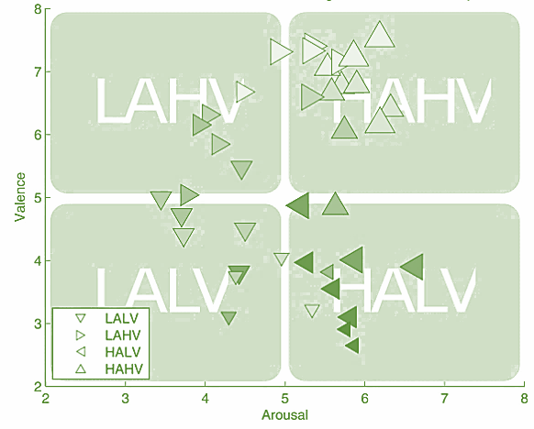
In this segment, we portray the impact the emotional incitement had on the abstract evaluations acquired from the members. Right off the bat, we will give spellbinding insights to the recorded appraisals of enjoying, valence, excitement, strength, and commonality. Also, we will examine the discussion of the various appraisals with one another. Improvements were chosen to actuate feelings in the four quadrants of the valence-excitement space (LALV, HALV, LAHV, and HAHV).

Figure 4. 2 The arousal-valence plane for the 4 conditions
The upgrades from these four influence elicitation conditions commonly brought about the elicitation of the objective feeling focused on when the improvements were chosen, guaranteeing that enormous pieces of the excitement valence plane (AV plane) are covered. Wilcoxon marked position tests demonstrated that low and high excitement upgrades prompted diverse valence evaluations (p < .0001 and p < .00001). Likewise, low and high valence upgrades initiated distinctive excitement appraisals (p < .001 and p < .0001).
The feeling elicitation functioned admirably for the high stimulating conditions, yielding relative outrageous valence evaluations for the particular improvements. The upgrades in the low stimulating conditions were less effective in the elicitation of solid valence reactions. Besides, a few boosts of the LAHV condition incited higher excitement than anticipated depending on the online investigation. Strangely, these outcomes in a C-state of the improvements on the valence-excitement plane additionally saw in the all-around approved appraisals for the worldwide full of feeling picture framework (IAPS) and the global emotional computerized sound's framework (IADS), demonstrating the overall trouble to instigate feelings with solid valence yet The dissemination of evaluations for the various scales and conditions recommends an intricate connection between evaluations. We investigated the mean between the connections of the various scales over members as they may be characteristic of conceivable puzzles or undesirable impacts of adjustment or weakness. We noticed high certain connections amongst loving and valence, and among strength and valence. Apparently, without inferring any causality, individuals loved music which gave them a good inclination and additionally a sensation of strengthening. Medium positive connections were seen among excitement and predominance, and the excitement and preferring. The commonality is associated respectably sure with preferring and valence. As effectively seen over, the sizes of valence and excitement are not autonomous, but rather their positive connection is somewhat low, recommending that members had the option to separate between these two significant ideas. Boost requests had just a little impact on loving and strength appraisals, and no huge relationship with different evaluations, proposing that impacts of adjustment and weakness were kept to a worthy minimum.
The effect elicitation was in general successful, though the low valence conditions were partially biased by moderate valence responses and higher arousal. High scale inter-correlations observed are limited to the scale of valence with those of liking and dominance, and might be expected in the context of musical emotions. The rest of the scale inter-correlations are small or medium in strength, indicating that the scale concepts were well distinguished by the participants.

4.3.3 Correlates of EEG and Ratings
For the examination of the relations of the abstract evaluations with the EEG flags, the EEG information was basic normal referred to, down-tested to 256 Hz, and high-pass separated with a 2 Hz cutoff-recurrence utilizing the EEGlab6 tool kit. We eliminated eye antiquities with a visually impaired source partition technique7. At that point, the signs from the most recent 30 seconds of every preliminary (video) were extricated for additional examination. To address for improvement irrelevant varieties in control over the long haul, the EEG signal from the five seconds before every video was extricated as the standard. The recurrence force of preliminaries and baselines somewhere in the range of 3 and 47 Hz was separated with Welch's technique with windows of 256 examples. The pattern power was then deducted from the preliminary force, yielding the difference in force comparative with the pre-improvement time frame. These progressions of force have arrived at the midpoint of the recurrence groups of theta (3 - 7 Hz), alpha (8 - 13 Hz), beta (14 - 29 Hz), and gamma (30 - 47 Hz). For the connection measurement, we figured the Spearman associated coefficients between the force changes and the abstract evaluations, and registered the p-values for the left-(positive) and right-followed (negative) relationship tests. This was accomplished for every member independently and, accepting autonomy, the 32 coming about p-values per connection course (positive/negative), recurrence band, and terminal were then joined to one p-esteem through Fisher's technique. Fig. 8 shows the (normal) relationships with essentially (p < .05) corresponding anodes featured. Underneath we will report and talk about just those impacts that were critical with p < .01. A thorough rundown of the impacts can be found in Table 4. 1
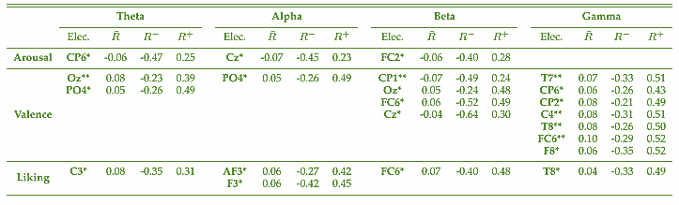
Table 4. 5 Correlates of EEG and Ratings
For arousal, we discovered negative connections in the theta, alpha, and gamma band. The focal alpha force decline for higher excitement coordinates the discoveries from our prior pilot study and a backward connection between alpha force and the overall degree of excitement has been accounted for previously. For the beta recurrence band, we found a focal diminishing; additionally saw in the pilot and an occipital and right transient increment of force. Expanded beta control over right transient locales was related to positive passionate self-acceptance and outside incitement. Likewise, has detailed a positive connection of valence and high-recurrence power, including beta and gamma groups, exuding from foremost fleeting cerebral sources. Correspondingly, we noticed a profoundly critical increment of left and particularly right transient gamma power. However, it ought to be referenced that EMG (muscle) action is additionally unmistakable in the high frequencies, particularly over foremost and transient cathodes.
The loving associates were found in totally dissected recurrence groups. For theta and alpha force we noticed increments over left front focal cortices. Preferring may be related to approach inspiration. Notwithstanding, the perception of an expansion of left alpha force for higher preferring clashes with discoveries of a left frontal enactment, prompting lower-alpha over this locale, frequently revealed for feelings related with approach inspirations. This inconsistency may be accommodated when considering that some loathed pieces may incite an irate inclination (due to tuning in to them, or basically because of the substance of the verses), which is likewise identified with a methodology inspiration and may henceforth bring about a leftward diminishing of alpha. The correct transient builds found in the beta and gamma groups are like those noticed for valence, and a similar alert ought to be applied. All in all, the conveyance of valence and enjoying relationships appeared in Fig. 8 appears to be very much like, which may be a consequence of the high between relationships of the scales examined previously. Summing up, we can express that the relationships noticed halfway agree with perceptions made in the pilot study and different investigations investigating the neurophysiological associates full of feeling states. They may consequently be taken as substantial markers of enthusiastic states with regards to multi-modular melodic incitement. However, the meaningful connections are rarely greater than ±0.1, which may be because of high between member changeability regarding mind terms, as individual relationships between ±0.5 were noticed for a given scale connection at a similar anode/recurrence blend. The presence of this high between member inconstancy legitimizes a member's explicit order approach, as we utilize it, as opposed to a solitary classifier for all members.
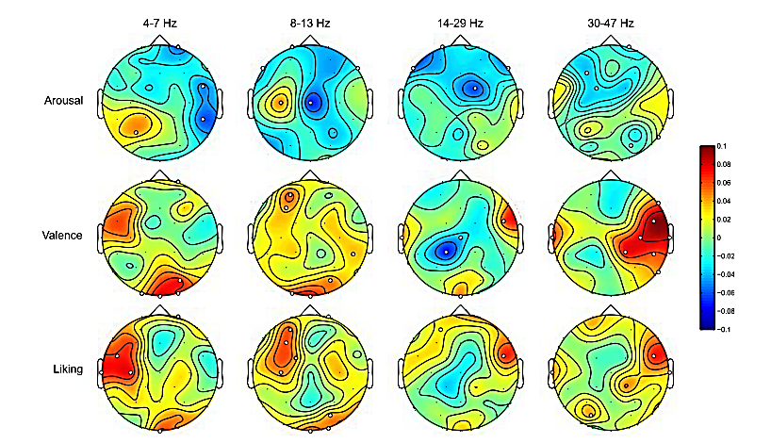
Figure 4. 3 the sensors correlate significantly (p < .05) with the ratings

4.4 Data cleaning
DEAP EEG emotion signal dataset is available in various formats. If the dataset used in this was unprocessed. The dataset is clean from artifacts and power line disturbance using a bandpass filter of 4-45 Hz. The signals are then downsampled to 128 Hz. It is necessary to clean the signal to increase the Signal Noise Ratio. If the signal to noise ratio is good the signal can be easily understood. The clean signal will have many frequency components in it. So, it is necessary to break down the signal into a particular frequency band to increase the ease of understanding the EEG signal. The breaking down of the Signal is performed using the wavelet decomposition or by the connection of the filter bank. Wavelet decomposition is used to break the EEG signal into 5 frequency band as shown in Table 1.1
By the way, I am using a pre-processed data set in this research to reduce time constraints. These documents contain a downsampled (to 128Hz), preprocessed, and fragmented version of the information in Matlab (data_preprocessed_matlab.zip) and cured python/numpy (data_preprocessed_python.zip) designs. This form of information is appropriate to those wishing to rapidly test a characterization or regression procedure without the issue of handling all the information first. Each compress record contains 32 .dat (python) or .tangle (Matlab) files, one for every member. Some example code to stack a python information file is below. Each participant file contains two arrays:
Array name | Array shape | Array contents
data | 40 x 40 x 8064 | video/trial x channel x data
labels | 40 x 4 | video/trial x label (valence, arousal, dominance, liking)

Table 4. 6 Pre-Processed data

4.5 Data Partitioning
The three-dimensional element space was the contribution to cross-approving various models: growing a solitary order tree, a gathering of 100 arrangement trees utilizing bootstrap totaling, k closest neighbor classifier. Every one of these classifiers had their hyperparameters tuned with the iterative inquiry. Cross-approval was figured in a 12 K-overlay style with an information segment of 90% for training and 10% for approval. We additionally incorporated a feed-forward neural organization based on Bayesian regularization (two layers of 10 and 5 neurons, max learning ages 80, learning rate deicide contingent 1e-4, 5e-5, and 5e-6) and a group of 100 neural organizations with similar attributes. The normal exactness of each run of cross-approval is put away in a dominant document.

4.6 Model Implementation
A fitting term window length is essential for portrayal execution on streaming data. Wang et al. have discovered that a one second prolonged stretch of the term window is the most reasonable window length for feeling acknowledgment. Thus, one is picked as the term window length in this research. The signals were down-inspected to 128 Hz, the pre-preliminary pattern signals are portioned to 3 32×128 frameworks to ascertain the BaseMean network. At that point, the pre-measure activity is fine-tuning to preliminary signs, as demonstrated in Fig. 4.4. After the pre-handling stage, in every preliminary, we get 32 channels' pre-prepared EEG signals and utilize a sliding window to separate them into 60 sections with 1 s length, which implies the window size S is 128. After portioning, we get a sum of 2400 examples (40 trials×60 fragments) for each subject. At that point, the 2D information outlines are changed with the size of 9×9 as demonstrated in Fig. 2. We utilize 10-overlap cross-approval to assess the presence of our methodology. The normal exhibition of the 10-overlap approval measures is taken as the test's eventual outcomes.
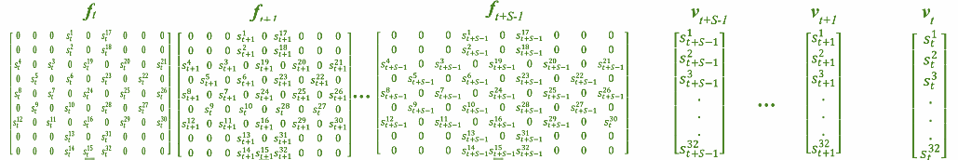
BN
ELU
LSTM
LSTM
LSTM
BN
ELU
BN
ELU

CNN RNN
LSTM
LSTM
LSTM
9 x 9 x 64
BN
ELU
9 x 9 x 64
BN
ELU
9 x 9 x 64
BN
ELU
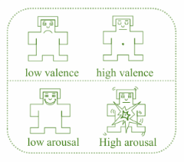

9 x 9 x 128
BN
ELU
9 x 9 x 128
BN
ELU
9 x 9 x 128
BN
ELU
SOFTMAX
TFV
Concatenated

9×9×(128×(t+S-1))
SFV

Figure 4. 4 Parallel convolutional recurrent neural networks

The model was executed with the Tensorflow system and prepared on an NVIDIA GPU. The Adam analyzer is received to limit the cross-entropy misfortune work. The keep likelihood of dropout activity is 0.5. The punishment strength of L2 is 0.5. The shrouded conditions of the LSTM cell ‘d’ are 32. All completely associated layers have a similar size of 1024. The underlying learning rate is 10-4, while the preparation precision outperforms 80% yet under 85%, the learning rate is set to 5×10-5, while the preparation exactness outperforms 85%, and it was changed to 5×10-6.

4.6.1 Data Staging (Pre-Processing)
EEG is a very sensitive signal; it can be highly affected by any kind of noise. Analysis of the EEG signal becomes difficult due to the presence of those kinds of noise. There are many steps to reduce the noise in the EEG signal. We can improve the EEG signal to noise ratio (SNR) with the help of a good EEG acquisition system. The EEG signal is recorded with a good instrument so the chance of noise addition at the time of recording was minimized. The noise from the EEG signal is also removed at the pre-processing unit. We know that there are many artifacts produced by a different kind of activity such as blinking of the eye, movement of muscles, etc. have a frequency less than 3 Hz. There are other noises like power line interface and many others that have a frequency range greater than 45 Hz. The signal of interest to us is 4 - 45 Hz. We can obtain this band of frequency by using a bandpass filter. The bandpass filter is designed to pass 4-45 Hz of frequency and block the rest of the frequency.

4.6.2 Model Building
In this research, we are focusing on hybrid model building for high arousal and valence, low arousal low valence for detecting neurologic disorder patients with high accuracy, I am using a pre-processed Deap data set. That is available in various file formats. Here, I am using the .mat file format. First of all, we are loading a pre-processed .mat file for 32 users in the list. The data set table has two column data and levels. The loaded .mat files data transpose with 0, 2, 1 parameters. Here levels conditional 0 for valence, 1 for arousal, 2 for dominance, and 3 for linking. In this process loading data shape for 0th index assigned to trials, which was for 32 users. After that with the help of a loop, it was pre-processed for creating a pickle file for each user with baseline and without baseline; data are shuffled for CNN and RNN level for arousal and valence. To train the model loading the CNN data set from loading CNN suffix pickle file, RNN dataset from loading RNN suffix pickle file, and levels from pickle file.
In this experiment, building models with tuning various hyperparameters like input parameter is 32, and windows size is 128, the input channel number is 1, input height and width are 9. Model training parameters like lambda lose amount 0.5, training epoch is 80, and batch size is 280. Kernel parameters using like, kernel height and width are 4 for 1st, 2nd, and 3rd. The 4th is using 1. Kernel stride is using 1and Convolution channel using 32. We are building hybrid model, so first of all added four convolution layer conv_1, conv_2, conv_3, conv_4 parallel to network and flatten (13*9*9) cube into a 1053 vector. The next step is that LSTM adds parallel to the network and defines the LSTM cell. That is the fully connected neural network. Finally, fuse parallels Convolutional Neural Network and LSTM. Here we are applying 12 cross-fold validation to achieve high accuracy of the model.

4.6.3 Generating Model Result in Excel sheet
In our model building process, we are storing the results with a .xlsx file. We are training the model batch by batch by passing the parameter for every volunteer data set. Just like first, we train the model for s01…..s032 users with baseline and without a baseline for arousal and the same thing for valence. So basically, here we are generating a result .xlsx file for every s01……s032 user. The following table has result folders
- Cv_arousal folder has result .xlsx file s01…s032 with the baseline for arousal.
- Cv_valence folder has the result .xlsx file s01…s032 with the baseline for arousal.
- Origin_arousal folder has result .xlsx file s01…s032 without a baseline for arousal.
- Origin_valence folder has result .xlsx file s01…s032 without a baseline for arousal.
Each file has 12 cross-fold validation so generating separate result files for each. So, the final result is stored in an accuracies.xls file after calculating from all .xls files.

4.6.3 Summary
In this chapter, we have explained the Deap dataset. We have used pre-processed data due to saving lots of time for research. Data collected from various sources to achieve the goal of the research. Here we have also explained about exploratory data analysis of EEG data. Various kinds of experiment protocols are used in this research. We have also seen the correlation between EEG and ratings in this chapter. Finally, I explained the model implementation and model building stage with result storing in an excel file.

CHAPTER 5: RESULTS AND EVALUATION

5.1 Introduction
In this research, we have validated the capability of our scheduled pre-processing approach. We are using two strategies of research. The first one has used the raw signals for understanding the task without the role of three seconds long-baseline frequency. And another one is to apply the scheduled pre-process approach before supplying them into the model, after getting the result of both experiments, moving to the final analysis of the research.

5.2 Model Output
As demonstrated in Table 5.1, the proposed pre-handling strategy can essentially improve the acknowledgment precision by almost 34% and 31% both on valence and arousal acknowledgment task, which shows the high adequacy of this methodology. The pre-handling technique takes the gauge signals as an essential emotional status first, and afterward figures the contrast among it and genuine feeling signs, and uses this distinction to address the feeling state. The examination result shows this portrayal is valuable. Something else, the standard deviation of acknowledgment precision is more modest than the examination without applying the pre-measure.
We have also analyzed six distinct methodologies for model building with the DEAP data set. The mean precision of 10 cross-validation folds is utilized. Li et al. used a deep belief network (DBN) to spontaneously extract significant measure features from raw EEG signals (“Open Research Online,” 2014). I also found another research on Deap data that used SVMs. In 2016, Atkinson and Campos utilized a shared data minimization strategy and SVMs as the feeling classifier (Atkinson and Campos, 2016).
In research of Yin et al, They created move repeated features disposal (T-RFE) to decide a bunch of the most powerful EEG markers with stable mathematical dissemination across a gathering of preparing subjects and a particular testing subject(Yin, Wang, et al., 2017). After that, I moved to Tang et al' s research, Here we found that Tang et al. built up a Bimodal LSTM model to direct feeling acknowledgment task utilizing both EEG signals and exterior corporal signals and accomplished a cutting edge result with a mean exactness of 83.53% on DEAP dataset(Ranganathan et al., 2016). I also analyzed bimodal deep autoencoders (BDAE) with EEG and Eye signals. Here, Liu et al. worked on it, they achieved a mean accuracy of approx. 82.85%. They classified valence and arousal with low and high range.
Acknowledgment Accuracy (%) Comparison for Each Subject on "Valence"(pre-measure with baseline and without pre-measure )
Sub | without | with | Sub | without | with | Sub | without | with | Sub | without | with
1 | 51.75 | 88.01 | 9 | 55.25 | 82.67 | 17 | 47.00 | 89.03 | 25 | 55.50 | 87.67
2 | 58.50 | 79.58 | 10 | 66.25 | 88.03 | 18 | 64.25 | 81.67 | 26 | 63.25 | 91.03
3 | 48.00 | 87.91 | 11 | 52.50 | 80.67 | 19 | 43.75 | 86.17 | 27 | 72.75 | 88.17
4 | 55.50 | 83.61 | 12 | 51.75 | 85.17 | 20 | 52.75 | 81.67 | 28 | 65.25 | 85.67
5 | 56.25 | 84.12 | 13 | 56.00 | 89.03 | 21 | 57.00 | 88.17 | 29 | 56.50 | 90.03
6 | 71.75 | 88.19 | 14 | 60.25 | 81.67 | 22 | 58.25 | 91.03 | 30 | 77.75 | 87.67
7 | 59.75 | 87.42 | 15 | 56.25 | 89.03 | 23 | 69.00 | 87.67 | 31 | 53.50 | 90.17
8 | 54.00 | 87.48 | 16 | 57.75 | 86.17 | 24 | 55.00 | 89.17 | 32 | 59.75 | 92.03
Acknowledgment Accuracy (%) Comparison for Each Subject on " Arousal "(pre-measure with baseline and without pre-measure )
Sub | without | with | Sub | without | with | Sub | without | with | Sub | without | with
1 | 59.75 | 55.15 | 9 | 55.50 | 85.55 | 17 | 58.00 | 92.01 | 25 | 69.25 | 92.03
2 | 55.75 | 83.27 | 10 | 56.50 | 85.71 | 18 | 55.00 | 93.03 | 26 | 58.00 | 93.03
3 | 76.75 | 94.02 | 11 | 64.25 | 82.65 | 19 | 63.75 | 94.03 | 27 | 64.25 | 92.01
4 | 57.25 | 82.55 | 12 | 73.75 | 89.20 | 20 | 75.75 | 95.05 | 28 | 57.25 | 94.03
5 | 58.00 | 84.84 | 13 | 87.25 | 93.02 | 21 | 76.50 | 93.02 | 29 | 59.75 | 93.07
6 | 62.25 | 86.80 | 14 | 53.00 | 93.02 | 22 | 47.00 | 92.01 | 30 | 65.25 | 92.01
7 | 65.00 | 86.13 | 15 | 52.50 | 94.03 | 23 | 78.25 | 93.02 | 31 | 49.00 | 94.03
8 | 66.00 | 87.04 | 16 | 49.00 | 93.03 | 24 | 76.75 | 94.02 | 32 | 68.75 | 94.32
Average accuracy results across subjects on “Valence” and “Arousal” (mean± std. dev.)
 |  |  |  | Valence |  |  |  | Arousal
without pre-process |  |  |  | 59.06 ± 6.13 |  |  |  | 63.79 ± 8.42
pre-process with baseline |  |  |  | 92.03 ± 3.09 |  |  |  | 94.04 ± 3.80

Table 5. 1 Model output in a percentage

5.3 Summary
The contrastive outcomes on the DEAP dataset have appeared in the examination represent the adequacy of our model. The prospective model beats the EEG based just methodologies altogether, which is about 30% focuses higher than Li ("Open Research Online," 2014), 18% focuses higher than (Atkinson and Campos, 2016), and 12% focuses higher than (Yin, Wang, et al., 2017). The exhibition of our model likewise outperforms these techniques embraced by Liu (Liu et al., 2016) and Tang (Liu et al., 2019). While contrasted with these two methodologies, both of them consider the eye development data, also, both Power Spectral Density (PSD) and Differential Entropy (DE) features are isolated from EEG data and eye development data, which implies, we accomplish the better however utilize less information. Something else, contrasted with our pre-handling technique, PSD and DE highlights are tedious.

Figure 5. 1 Our model accuracy with previous researches
After 80 epochs our accuracy:
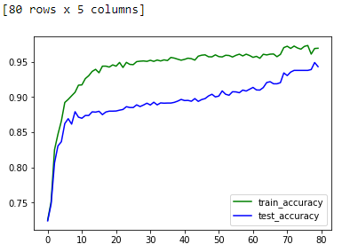

Figure 5. 1 Our training and test accuracy

CHAPTER 6: CONCLUSIONS AND RECOMMENDATIONS

5.1 Introduction
The got results indicated that however characterizing distinctive capabilities for various channels, a large portion of the deliberate channels permitted high order precision. This was genuine both by contrasting every feeling and "relax" and by looking at the two emotions. To feature if there was lateralization between the mind sides of the equator when exposed to inverse feelings, we likewise thought about the information of the primary feeling with those of the second after the flipping of the correct half of the hemisphere information with those of the left half of the hemisphere of the subsequent feeling. The outcomes demonstrated that being the arrangement precision high for the greater part of the channels, the initiation was not contrastingly appropriated between halves of the hemisphere for various feelings. The got results exhibited that the proposed arrangement strategy could be effectively applied both to find the neurophysiological instruments of various enthusiastic states and to productively perceive the negligible channels/highlights set for perceiving every one of the thought about feelings from the others and the loosening upstate. Besides, the strategy could be proficiently utilized for the order of a steady number of feelings through the further presentation of a bunch of twofold classifiers and a legitimate surveying plan.

5.2 Discussion and Conclusion
In this study, our approach was very effective to reach our goal, signal processing plays an important role in biological data analysis. It has a strong impact on the accuracy of downstream operations leading up to the analysis output. The baseline signals were treated as a straightforward, calculation modest pre-handling technique that has been planned to enhance acknowledgment accuracy. Also, we used a Convolutional neural network and a recurrent neural network with LSTM methodologies with perfect tuning with hyperparameters for the model-building to reach our goal after comparing with previous research. We used a fusion of neural network methodologies to segregate human emotional states by adequately learning architecture dimensional fleeting representation of crude EEG frequency. Finally, DEAP dataset was utilized to assess the proposed pre-preparing technique and neural network model. Trial results have demonstrated that the pre-preparing approach can improve the exactness by approx. 35% and the model could accomplish a high precision around 92.03% and 94.32% for valence and arousal classification tasks, respectively. So on behalf of the accuracy our model can detect accurately patients are normal or neurological disorder. This prediction can help to diagnose the patients without wasting time.

5.3 Contributions
This research systematically investigated from the previous research on neurological disorder detection. First of all, I would to like to say thanks for Deap data set contribution team and above all else, we'd prefer to thank the 32 members in this investigation for having the persistence and generosity to allow us to record their information. See fig. 6.1

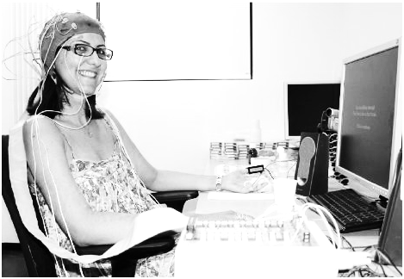
Figure 6. 1 a participant while recording Deap dataset

Also, I would like to thanks for researchers, who working on Deap dataset for emotion classification using various deep leaning methodologies in past few years. There researches motivate me while I move forward in this domain. Here, I want to mention some researchers who most motivated me. Li was great work on deep belief network (DBN), Atkinson and Campos utilized a shared data minimization strategy and SVM as the feeling classifier. Yilong Yang was well implemented multi-channel EEG model building with CNN.

5.3 Future Work
EEG signal-analysis techniques have been improved in recent years because the EEG reflects neurological brain activity and is an important tool for diagnosing neurological brain disorders, such as autism, epilepsy, and Alzheimer’s disease. In this research, we just tried to improve in accuracy for the hybrid model with CNN, RNN, LSTM, GRU, etc.
In some of the previous research, the results confirm the rigidity of the proposed methods despite the increase in the number of classes. In general, to distinguish neurotypical, epileptic, and autistic patients, single-channel EEG signals provide better accuracy than multi-channel EEG signals. Overall, the combination of DWT + (Entropy or LBP) + SVM and DWT + (Entropy or LBP) + ANN achieved the highest accuracies for single-channel and multi-channel data, respectively. In future work, we will test and evaluate our proposed methods with other datasets. Another neurological disorder will be included in our study. If possible, our dataset will be recorded in our lab for several types of neurological brain disorders with the help of experts.
Future work will be spent in refining the strategy of subject selection, mapping the channels/features pattern of new emotional states, inserting the previous emotional states in the classification process, and classifying the considered emotional states in groups (more than two emotions at once). I would like to work on exploring a deeper wavelet pre-filtering and assuming the decomposition that better enhances the significant part of the elicited signal selecting the most informative subset of channels. Also, I will work on selecting a strategy of self-induction of a set of emotions to allow also the usage of the neglected channels. I will also work on applying the obtained channels-features maps to implement a classification strategy for multi-emotions based BCIs to be used for communication purposes

REFERENCES
Affect Recognition Using Electroencephalography Features. (2017). May.
AFFECT RECOGNITION USING ELECTROENCEPHALOGRAPHY FEATURES. (2017). May.
Alarcão, S. M., & Fonseca, M. J. (2019). Emotions recognition using EEG signals: A survey. IEEE Transactions on Affective Computing, 10(3), 374–393. https://doi.org/10.1109/TAFFC.2017.2714671
Aldayel, M., Ykhlef, M., & Al-Nafjan, A. (2020). Deep learning for EEG-based preference classification in neuromarketing. Applied Sciences (Switzerland), 10(4), 1–23. https://doi.org/10.3390/app10041525
Anderson, K., & McOwan, P. W. (2006). A real-time automated system for the recognition of human facial expressions. IEEE Transactions on Systems, Man, and Cybernetics, Part B: Cybernetics, 36(1), 96–105. https://doi.org/10.1109/TSMCB.2005.854502
Atkinson, J., & Campos, D. (2016). Improving BCI-based emotion recognition by combining EEG feature selection and kernel classifiers. Expert Systems with Applications, 47, 35–41. https://doi.org/10.1016/j.eswa.2015.10.049
Cao, L., Tao, W., An, S., Jin, J., Yan, Y., Liu, X., Ge, W., Sah, A., Battle, L., Sun, J., Chang, R., Westover, B., Madden, S., & Stonebraker, M. (2018). Smile: A system to support machine learning on EEG data at scale. Proceedings of the VLDB Endowment, 12(12), 2230–2241. https://doi.org/10.14778/3352063.3352138
Dhanapal, R., & Bhanu, D. (2020). Electroencephalogram classification using various artificial neural networks. Journal of Critical Reviews, 7(4), 891–894. https://doi.org/10.31838/jcr.07.04.170
Guo, K., Candra, H., Yu, H., Li, H., Nguyen, H. T., & Su, S. W. (2017). EEG-based emotion classification using innovative features and combined SVM and HMM classifier. Proceedings of the Annual International Conference of the IEEE Engineering in Medicine and Biology Society, EMBS, 489–492. https://doi.org/10.1109/EMBC.2017.8036868
Ieracitano, C., Mammone, N., Bramanti, A., Marino, S., Hussain, A., & Morabito, F. C. (2019). A Time-Frequency based Machine Learning System for Brain States Classification via EEG Signal Processing. Proceedings of the International Joint Conference on Neural Networks, 2019-July(July), 1–8. https://doi.org/10.1109/IJCNN.2019.8852240
Janga, V., & Reddy, P. E. S. (2017). A review on Machine Learning Techniques for Neurological disorders estimation by Analyzing EEG Waves. International Journal of Trend in Scientific Research and Development, Volume-2(Issue-1), 824–831. https://doi.org/10.31142/ijtsrd7082
Kim, S. K., & Kang, H. B. (2018). An analysis of smartphone overuse recognition in terms of emotions using brainwaves and deep learning. Neurocomputing, 275, 1393–1406. https://doi.org/10.1016/j.neucom.2017.09.081
Kumar, N., Khaund, K., & Hazarika, S. M. (2016). Bispectral Analysis of EEG for Emotion Recognition. Procedia Computer Science, 84, 31–35. https://doi.org/10.1016/j.procs.2016.04.062
Lee, M. S., Lee, Y. K., Lim, M. T., & Kang, T. K. (2020). Emotion recognition using convolutional neural network with selected statistical photoplethysmogram features. Applied Sciences (Switzerland), 10(10). https://doi.org/10.3390/app10103501
Liu, W., Qiu, J. L., Zheng, W. L., & Lu, B. L. (2019). Multimodal emotion recognition using deep canonical correlation analysis. ArXiv, October 2017. https://doi.org/10.1007/978-3-319-70093-9
Liu, W., Zheng, W. L., & Lu, B. L. (2016). Emotion recognition using multimodal deep learning. Lecture Notes in Computer Science (Including Subseries Lecture Notes in Artificial Intelligence and Lecture Notes in Bioinformatics), 9948 LNCS(October 2016), 521–529. https://doi.org/10.1007/978-3-319-46672-9_58
Maggiotti, G. A. (2019). Automated Brain Disorders Diagnosis through Deep Neural Networks. February.
Malmivuo, J. (2017). Bioelectromagnetism. January 1995.
Open Research Online. (2014). Choice Reviews Online, 51(06), 51-2973-51–2973. https://doi.org/10.5860/choice.51-2973
Pan, C., Shi, C., Mu, H., Li, J., & Gao, X. (2020). EEG-based emotion recognition using logistic regression with gaussian kernel and laplacian prior and investigation of critical frequency bands. Applied Sciences (Switzerland), 10(5). https://doi.org/10.3390/app10051619
Paulmann, S., Bleichner, M., & Kotz, S. A. (2013). Valence, arousal, and task effects in emotional prosody processing. Frontiers in Psychology, 4(June), 1–10. https://doi.org/10.3389/fpsyg.2013.00345
Performance, G. (2015). Measuring human capabilities: An agenda for basic research on the assessment of individual and group performance potential for military accession. In Measuring Human Capabilities: An Agenda for Basic Research on the Assessment of Individual and Group Performance Potential for Military Accession. https://doi.org/10.17226/19017
Petrushin, V. A. (1999). Emotion in speech: Recognition and application to call centers. Intelligent Engineering Systems Through Artificial Neural Networks, 9, 1085–1092.
Placidi, G., Di Giamberardino, P., Petracca, A., Spezialetti, M., & Iacoviello, D. (2016). Classification of emotional signals from the DEAP dataset. NEUROTECHNIX 2016 - Proceedings of the 4th International Congress on Neurotechnology, Electronics and Informatics, Neurotechnix, 15–21. https://doi.org/10.5220/0006043400150021
Qing, C., Qiao, R., Xu, X., & Cheng, Y. (2019). Interpretable Emotion Recognition Using EEG Signals. IEEE Access, 7, 94160–94170. https://doi.org/10.1109/ACCESS.2019.2928691
Raghavendra, U., Acharya, U. R., & Adeli, H. (2020). Artificial Intelligence Techniques for Automated Diagnosis of Neurological Disorders. European Neurology, 82(1–3), 41–64. https://doi.org/10.1159/000504292
Ranganathan, H., Chakraborty, S., & Panchanathan, S. (2016). Multimodal emotion recognition using deep learning architectures. 2016 IEEE Winter Conference on Applications of Computer Vision, WACV 2016. https://doi.org/10.1109/WACV.2016.7477679
Selvaraj, M., Bhuvana, R., & Padmaja, S. (2016). Human speech emotion recognition. International Journal of Engineering and Technology, 8(1), 311–323.
Sharma, A. (2018). Emotion Recognition Using Deep Convolutional Neural Network with Large Scale Physiological Data. ProQuest Dissertations and Theses, October, 52. https://search.proquest.com/docview/2169469020?accountid=15928%0Ahttp://onesearch.unifi.it/openurl/39UFI/39UFI_Services?tabs=viewOnlineTab&?url_ver=Z39.88-2004&rft_val_fmt=info:ofi/fmt:kev:mtx:dissertation&genre=dissertations+%26+theses&sid=ProQ:ProQuest+
Soleymani, M., Pantic, M., & Pun, T. (2015). Multimodal emotion recognition in response to videos (Extended abstract). 2015 International Conference on Affective Computing and Intelligent Interaction, ACII 2015, 3(2), 491–497. https://doi.org/10.1109/ACII.2015.7344615
Speed Emotions. (n.d.). https://www.hindawi.com/journals/mpe/2014/749604/
Swati Sharma, S. S. (2013). An Approach to Improve Brain Disorder Using Machine Learning Techniques. IOSR Journal of Computer Engineering, 11(2), 77–84. https://doi.org/10.9790/0661-01127784
Ullah, I., Hussain, M., Qazi, E., & Aboalsamh, H. (2018). An Automated System for Epilepsy Detection using EEG Brain Signals based on Deep Learning Approach Insight Centre for Data Analytics , National University of Ireland , Galway , Ireland Visual Computing Lab , Department of Computer Science , College of Com. Expert Systems with Applications, 107, 61–71.
Yang, Y., Wu, Q., Qiu, M., Wang, Y., & Chen, X. (2018). Emotion Recognition from Multi-Channel EEG through Parallel Convolutional Recurrent Neural Network. Proceedings of the International Joint Conference on Neural Networks, 2018-July. https://doi.org/10.1109/IJCNN.2018.8489331
Yin, Z., Wang, Y., Liu, L., Zhang, W., & Zhang, J. (2017). Cross-subject EEG feature selection for emotion recognition using transfer recursive feature elimination. Frontiers in Neurorobotics, 11(APR), 1–16. https://doi.org/10.3389/fnbot.2017.00019
Yin, Z., Zhao, M., Wang, Y., Yang, J., & Zhang, J. (2017). Recognition of emotions using multimodal physiological signals and an ensemble deep learning model. Computer Methods and Programs in Biomedicine, 140, 93–110. https://doi.org/10.1016/j.cmpb.2016.12.005
Zhao, W., Zhao, W., Wang, W., Jiang, X., Zhang, X., Peng, Y., Zhang, B., & Zhang, G. (2020). A Novel Deep Neural Network for Robust Detection of Seizures Using EEG Signals. Computational and Mathematical Methods in Medicine, 2020. https://doi.org/10.1155/2020/9689821
Zheng, W. L., & Lu, B. L. (2015). Investigating Critical Frequency Bands and Channels for EEG-Based Emotion Recognition with Deep Neural Networks. IEEE Transactions on Autonomous Mental Development, 7(3), 162–175. https://doi.org/10.1109/TAMD.2015.2431497
Zhuang, N., Zeng, Y., Tong, L., Zhang, C., Zhang, H., & Yan, B. (2017). Emotion Recognition from EEG Signals Using Multidimensional Information in EMD Domain. BioMed Research International, 2017. https://doi.org/10.1155/2017/8317357

APPENDIX A: RESEARCH PROPOSAL

Neurological disorders detection from speech emotions using Convolutional Neural Network

A research proposal

By
Dileep Yadav

Submitted to
Liverpool John Moores University

For
Fulfillment of the requirements for the degree of
MSc in Machine Learning & Artificial Intelligence

Platform Partner
UpGrad Education Private Limited

Research Proposal Supervisor: Sujith Viswanathan Date: 18-09-2020

Abstract

Good health is key to any success, as per the world health organization (WHO) 264 million people suffering from the illness of depression or neurological disorder worldwide. Sometimes this kind of illness can lead to suicide. A neurological disorder is completely different from the same old mood fluctuations and ephemeral responses to challenges in the standard of living. Particularly once long and with moderate or severe intensity, this kind of illness may become a serious health condition. This research focuses on neurological disorders detection from speech emotions using a neural network. Listening to speech, music, and watching movies is generating an electrical signal in the brain. Electroencephalography (EEG) is the most popular method for monitoring and recording the electrical activity of the brain. Using Electroencephalography (EEG) features, computers can recognize human emotions. The objective is to achieve high accuracy using the combined classifier designed. At the initial stage, we extract CNN and Statistical features from signals. The process of first extracting features from the EEG signals using signal processing and then constructing a predictive model via machine learning(AFFECT RECOGNITION USING ELECTROENCEPHALOGRAPHY FEATURES, 2017). Using this machine learning model will help diagnose or treat neurological disorders.

Table of Contents

Abstract
1. Introduction
2. Background and related research
3. Research Questions (If any)
4. Aim and Objectives
5. Research Methodology
6. Expected Outcomes
7. Requirements / resources
8. Research Plan
References

1. Introduction

Emotions are created by explicit circumstances and the acknowledgment of feelings is an extremely troublesome assignment in the research of human-computer interfaces to detect neurological disorder illness with people. In modern science, machine learning technologies can detect emotion from various human activities. Emotions are shown a variety of the way, like facial expressions, voices, physiological signals(Kumar et al., 2016). Physiological signs contain noteworthy information about emotion. Physiological signs change quickly at whatever point changing emotions,
Analysts have utilized various physiological signals, for example, electroencephalogram (EEG) to perceive feelings, recently artificial and machine learning technologies were reloaded in the field of research, especially the evolution of deep-learning technologies. A deep learning model can extract the number of features from electroencephalography (EEG) of the brain. Recording the neural activity correlated with a certain function requires placing the electrodes directly above the corresponding brain area(Aldayel, Ykhlef, and Al-Nafjan, 2020).
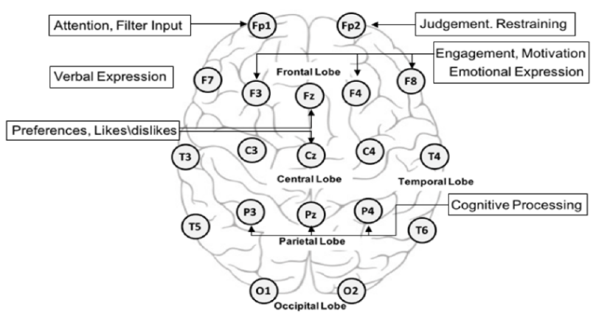
figure.1
Deep learning algorithms are used to classify emotions from these waves. DBN (Deep Belief Network) based emotions have been driven using EEG signals, and CNN is used to extricate the highlights of fluctuated bio-signal(Zheng & Lu, 2015). This kind of signal is related to the central nervous system and supplies the features of a strong feeling. If required we will also use LSTM to classify emotions.
Amazing strategy for feature extraction relies upon deep learning technologies where the important features are extricated utilizing the distinctive neural network methodologies for model building. Like that (RNN) and CNN for extracting meaningful features from EEG signals. Auto Encoder
Technologies are also used to remaking the breath signal. Deep learning is the perfect methodology to extract important features automatically for model building. However, the deep learning features cannot consider statistical calculations just like the mean and standard deviation. Moreover, the features extracted from a deep-learning model do not contain information about the frequency domain(Lee et al., 2020).

2. Background and related research

This research focuses on neurological disorders detection from speech emotions. The electrical or biochemical abnormal condition in the brain, spinal cord, or other nerves can produce a range of symptoms(Performance, 2015). The symptoms include muscle weakness, paralysis, poor coordination, failure of sensation, seizures, conciseness, pain, and altered levels of consciousness, a lot of researchers working on the same research to variously solve this problem.
The EEG is a generally applied instrument that psychoanalyzes the human neural structure functionality. The electrical fluctuations are measuring on the skull by assessing the electric frequency of neurons terminating in the mind. These electrical frequency exercises are recorded over difference using different electrodes put across the scalp licitly over the cortex. Electrodes cap-like instrumentation is connected with the computer system. Electroencephalogram has the accompanying key advantage, it is relatively easy to use, portable, and cost-effective. The distance between electrodes should become either 10% or 20% of the scalp dimension, as appeared in Figure. 1. The 10 to 20 of the standards have consistently used various EEG signals to construct the quality of the frequency and fall the signal-to-commotion proportion(Malmivuo, 2017). The human brain produces neural movement, which can be decoded electroencephalogram signals for the BCI.
The brain neural movement produces two kinds:
- rhythms
- transient.
The EEG activity can be also arranged depending on these sorts of exercises.
Rhythms | Frequency (Hz) | Amplitude (µV) Brain | Brain Region | State of Mind δ
δ (Delta) | < 4 | 50 – 100 | Central region | Deep sleep
θ (Theta) | 4 – 8 | <100 | Central region | Drowsiness, first step of sleep
µ (Mu) | Approximately 10 | < 50 | Somatosensory cortex | Movement
α (Alpha) | 8 – 13 | < 10 | Posterior brain | Focusing attention
β (Beta) | 13 – 22 | < 20 | Central region | High state of wakefulness
γ (Gamma) | 22 – 30 | < 2 | Intensely localized | High state mental activity

Table1. The frequency and amplitude EEG rhythms.
Classification of Emotion:
Emotion classification is a difficult task from normal and patient person data. Hence, it's hard to indicate or mark emotions as parameters. For the most part, to solve this issue there are two ways to find emotion. The simple and essential classification of emotions is discrete labels like Depressed, Calm, Excited, Sad, Afraid, and Peaceful, etc. It is basic. This technique can not constitute the blended level of emotions. The second method is to use multiple parameters as an emotional indicator; these parameters have continuous scales (Lee et al., 2020). The perfect well-known strategy is predicated on Russell's circumflex hypothesis. During this hypothesis, emotion comprises a 2-dimensional space with “valence” and “arousal”.
Arousal and Valence are plotted respectively on a vertical line and a horizontal line on a circle graph. Emotion is frequently communicated as a medium of arousal and valence; for instance, happiness has increased arousal and valence, while depression has decreased arousal and valence(Paulmann et al., 2013).

So, we picked the valence and arousal enthusiastic model and led 2 paired characterizations as high qualities or low qualities. See figure 2.
Angry Arousal Excited
9
Afraid Happy

1
Valence
9

Sad Content
1
Depressed Calm
Note: Rating it with 1 to 9.
Figure. 2

3. Research Questions (If any)

How to help hybrid neural networks diagnose neurological disorder patients?
How to find delayed sleep phase disorder or syndrome?
How to classify emotions for neurological disorders or a normal person?
How do identified best-fit algorithms solve emotion classifications?

4. Aim and Objectives

The main aim of this research is neurological disorders detection from speech emotions using machine learning technologies. The identification of brain neurological damage or disorder, this research will help to diagnose neurological disorders kind of illness. The research objectives are formulated based on the aim of this study which is as follows:

- To analyze the pattern and relationship between the Hybrid neural network (CNN+RNN model)
- To evaluate the performance of Multi-Modal using EEG and Video Data
- To compare between the predictive models and find good accuracy of the model.

5. Research Methodology

In this research, the primary objective is to collect data to perform operations for diagnosing neurological disorder patients. At the initial stage, we use preprocessed DEAP dataset, if required further we use other datasets, which are usually utilized in emotion recognition research. The DEAP dataset comprises two sections, to be specific the web rating and subsequently the member evaluations. The web self-evaluation collected the online rating of 120 one-min video and music recordings by 14 to 16 volunteers concerning predominance, arousal and valence, and loving the recordings. Furthermore, the 32 members watched the 40 recordings video for recording different physiological emotion; they are additionally rating the recordings regarding predominance arousal and valence. They are also rated from 1 to 9. The DEAP dataset includes different physiological frequencies, like EEG, EMG, PPG, and EDA. As arousal and valence were rated from one to nine and our purpose was a binary classification, we divided the arousal and valence classes consistent with the median.
See the full architecture of emotion recognition in the figure. Human emotion detected using PPG signal, PPG signal, and NN interval both are used to procedure feature extraction. Here NN interval for the utilized time-domain feature and the Photoplethysmogram (PPG) frequency was utilized to gain the recurrence features of the domain. The CNN algorithm is generally used for capturing features and solving classification. The feature extraction segment comprises progressive CNN layers, and sharing layers with nonlinear capacities. The classification is completely achieved by the connected layer, and the Softmax function using the output layer to isolate the likelihood of sophistication. The convolutional neural network (CNN) model has extracted features with fragmented PPG signal and RNN intervals. After that, CNN and statistical features with feature fusion model, using neural network we classified fused features and detected the valence and arousal values.

Feature Fusion = CNN feature + RNN feature + Statistical Feature
Here, Feature fusion is the fully connected network for classification for valence and arousal.
See. Figure. 3.
PPG Signals
CNN
Feature Fusion
CNN Features
Statistical Features
Classification
Segmented
PPG Signals
RNN Interval
LSTM

Figure. 3

This is the initial architecture to solve the problem, if we require other Architectures like SVM etc. we will work on it for further improvement of the model. If the classification of the frequency was executed through Support Vector Machine (SVM) by using the leftover features The SVM determined the optimum hyperplane to separate data in two classes, Class 1 and Class 2, and the requirement of maximizing the Euclidean distance between the closest points and the requirement of minimizing the error on misclassified points(Placidi et al., 2016).

6. Expected Outcomes

Our research expected outcomes to solve the problem of neurological disorder detection to diagnose illness of patients using machine learning technologies. We are expecting this research to achieve a quality and accurate machine learning model with help of various technologies or algorithms of machine learning. Our expected outcomes are that, after analysis of extracted features, will improve the results/prediction. A few deep learning techniques and physiological waves were utilized to locate better evaluation of the model to detect neurological disorder illness, for instance, the multimodal deep learning methodologies, DBN. Auto-encoder is too helpful for the same. The quality gained, and the interval shortened.

7. Requirements/resources

- The dataset for EEG, physiological music and video signals, etc.
- Python 3.7 programming language
- Google Colab, Google Drive. etc.
- Locally using Anaconda package manager.

8. Research Plan

Our research plan is to make a high accuracy model to solve the problem of neurological disorder detection using emotion using a multi data set and multiple machine learning algorithms. Data set may be EEG signals and various human activity, audio, video, eye blank data. So, the research plan is in the following Gantt chart.

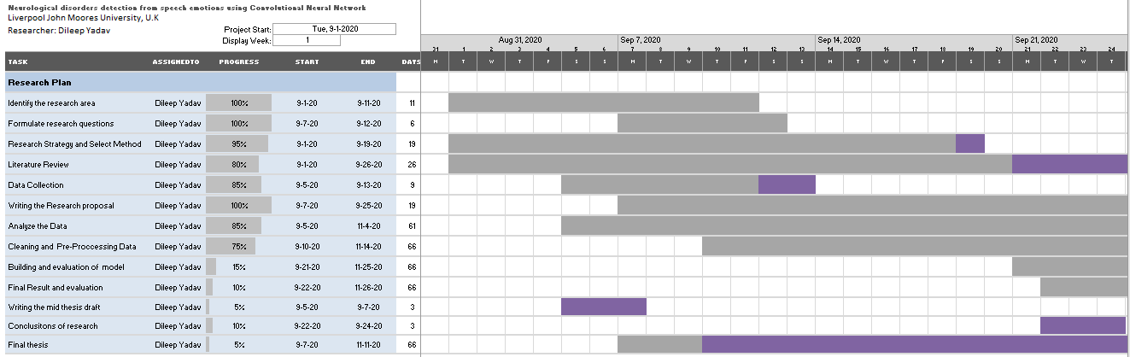

Affect Recognition Using Electroencephalography Features. (2017). May.
AFFECT RECOGNITION USING ELECTROENCEPHALOGRAPHY FEATURES. (2017). May.
Alarcão, S. M., & Fonseca, M. J. (2019). Emotions recognition using EEG signals: A survey. IEEE Transactions on Affective Computing, 10(3), 374–393. https://doi.org/10.1109/TAFFC.2017.2714671
Aldayel, M., Ykhlef, M., & Al-Nafjan, A. (2020). Deep learning for EEG-based preference classification in neuromarketing. Applied Sciences (Switzerland), 10(4), 1–23. https://doi.org/10.3390/app10041525
Anderson, K., & McOwan, P. W. (2006). A real-time automated system for the recognition of human facial expressions. IEEE Transactions on Systems, Man, and Cybernetics, Part B: Cybernetics, 36(1), 96–105. https://doi.org/10.1109/TSMCB.2005.854502
Atkinson, J., & Campos, D. (2016). Improving BCI-based emotion recognition by combining EEG feature selection and kernel classifiers. Expert Systems with Applications, 47, 35–41. https://doi.org/10.1016/j.eswa.2015.10.049
Cao, L., Tao, W., An, S., Jin, J., Yan, Y., Liu, X., Ge, W., Sah, A., Battle, L., Sun, J., Chang, R., Westover, B., Madden, S., & Stonebraker, M. (2018). Smile: A system to support machine learning on EEG data at scale. Proceedings of the VLDB Endowment, 12(12), 2230–2241. https://doi.org/10.14778/3352063.3352138
Dhanapal, R., & Bhanu, D. (2020). Electroencephalogram classification using various artificial neural networks. Journal of Critical Reviews, 7(4), 891–894. https://doi.org/10.31838/jcr.07.04.170
Guo, K., Candra, H., Yu, H., Li, H., Nguyen, H. T., & Su, S. W. (2017). EEG-based emotion classification using innovative features and combined SVM and HMM classifier. Proceedings of the Annual International Conference of the IEEE Engineering in Medicine and Biology Society, EMBS, 489–492. https://doi.org/10.1109/EMBC.2017.8036868
Ieracitano, C., Mammone, N., Bramanti, A., Marino, S., Hussain, A., & Morabito, F. C. (2019). A Time-Frequency based Machine Learning System for Brain States Classification via EEG Signal Processing. Proceedings of the International Joint Conference on Neural Networks, 2019-July(July), 1–8. https://doi.org/10.1109/IJCNN.2019.8852240
Janga, V., & Reddy, P. E. S. (2017). A review on Machine Learning Techniques for Neurological disorders estimation by Analyzing EEG Waves. International Journal of Trend in Scientific Research and Development, Volume-2(Issue-1), 824–831. https://doi.org/10.31142/ijtsrd7082
Kim, S. K., & Kang, H. B. (2018). An analysis of smartphone overuse recognition in terms of emotions using brainwaves and deep learning. Neurocomputing, 275, 1393–1406. https://doi.org/10.1016/j.neucom.2017.09.081
Kumar, N., Khaund, K., & Hazarika, S. M. (2016). Bispectral Analysis of EEG for Emotion Recognition. Procedia Computer Science, 84, 31–35. https://doi.org/10.1016/j.procs.2016.04.062
Lee, M. S., Lee, Y. K., Lim, M. T., & Kang, T. K. (2020). Emotion recognition using convolutional neural network with selected statistical photoplethysmogram features. Applied Sciences (Switzerland), 10(10). https://doi.org/10.3390/app10103501
Liu, W., Qiu, J. L., Zheng, W. L., & Lu, B. L. (2019). Multimodal emotion recognition using deep canonical correlation analysis. ArXiv, October 2017. https://doi.org/10.1007/978-3-319-70093-9
Liu, W., Zheng, W. L., & Lu, B. L. (2016). Emotion recognition using multimodal deep learning. Lecture Notes in Computer Science (Including Subseries Lecture Notes in Artificial Intelligence and Lecture Notes in Bioinformatics), 9948 LNCS(October 2016), 521–529. https://doi.org/10.1007/978-3-319-46672-9_58
Maggiotti, G. A. (2019). Automated Brain Disorders Diagnosis through Deep Neural Networks. February.
Malmivuo, J. (2017). Bioelectromagnetism. January 1995.
Open Research Online. (2014). Choice Reviews Online, 51(06), 51-2973-51–2973. https://doi.org/10.5860/choice.51-2973
Pan, C., Shi, C., Mu, H., Li, J., & Gao, X. (2020). EEG-based emotion recognition using logistic regression with gaussian kernel and laplacian prior and investigation of critical frequency bands. Applied Sciences (Switzerland), 10(5). https://doi.org/10.3390/app10051619
Paulmann, S., Bleichner, M., & Kotz, S. A. (2013). Valence, arousal, and task effects in emotional prosody processing. Frontiers in Psychology, 4(June), 1–10. https://doi.org/10.3389/fpsyg.2013.00345
Performance, G. (2015). Measuring human capabilities: An agenda for basic research on the assessment of individual and group performance potential for military accession. In Measuring Human Capabilities: An Agenda for Basic Research on the Assessment of Individual and Group Performance Potential for Military Accession. https://doi.org/10.17226/19017
Petrushin, V. A. (1999). Emotion in speech: Recognition and application to call centers. Intelligent Engineering Systems Through Artificial Neural Networks, 9, 1085–1092.
Placidi, G., Di Giamberardino, P., Petracca, A., Spezialetti, M., & Iacoviello, D. (2016). Classification of emotional signals from the DEAP dataset. NEUROTECHNIX 2016 - Proceedings of the 4th International Congress on Neurotechnology, Electronics and Informatics, Neurotechnix, 15–21. https://doi.org/10.5220/0006043400150021
Qing, C., Qiao, R., Xu, X., & Cheng, Y. (2019). Interpretable Emotion Recognition Using EEG Signals. IEEE Access, 7, 94160–94170. https://doi.org/10.1109/ACCESS.2019.2928691
Raghavendra, U., Acharya, U. R., & Adeli, H. (2020). Artificial Intelligence Techniques for Automated Diagnosis of Neurological Disorders. European Neurology, 82(1–3), 41–64. https://doi.org/10.1159/000504292
Ranganathan, H., Chakraborty, S., & Panchanathan, S. (2016). Multimodal emotion recognition using deep learning architectures. 2016 IEEE Winter Conference on Applications of Computer Vision, WACV 2016. https://doi.org/10.1109/WACV.2016.7477679
Selvaraj, M., Bhuvana, R., & Padmaja, S. (2016). Human speech emotion recognition. International Journal of Engineering and Technology, 8(1), 311–323.
Sharma, A. (2018). Emotion Recognition Using Deep Convolutional Neural Network with Large Scale Physiological Data. ProQuest Dissertations and Theses, October, 52. https://search.proquest.com/docview/2169469020?accountid=15928%0Ahttp://onesearch.unifi.it/openurl/39UFI/39UFI_Services?tabs=viewOnlineTab&?url_ver=Z39.88-2004&rft_val_fmt=info:ofi/fmt:kev:mtx:dissertation&genre=dissertations+%26+theses&sid=ProQ:ProQuest+
Soleymani, M., Pantic, M., & Pun, T. (2015). Multimodal emotion recognition in response to videos (Extended abstract). 2015 International Conference on Affective Computing and Intelligent Interaction, ACII 2015, 3(2), 491–497. https://doi.org/10.1109/ACII.2015.7344615
Speed Emotions. (n.d.). https://www.hindawi.com/journals/mpe/2014/749604/
Swati Sharma, S. S. (2013). An Approach to Improve Brain Disorder Using Machine Learning Techniques. IOSR Journal of Computer Engineering, 11(2), 77–84. https://doi.org/10.9790/0661-01127784
Ullah, I., Hussain, M., Qazi, E., & Aboalsamh, H. (2018). An Automated System for Epilepsy Detection using EEG Brain Signals based on Deep Learning Approach Insight Centre for Data Analytics , National University of Ireland , Galway , Ireland Visual Computing Lab , Department of Computer Science , College of Com. Expert Systems with Applications, 107, 61–71.
Yang, Y., Wu, Q., Qiu, M., Wang, Y., & Chen, X. (2018). Emotion Recognition from Multi-Channel EEG through Parallel Convolutional Recurrent Neural Network. Proceedings of the International Joint Conference on Neural Networks, 2018-July. https://doi.org/10.1109/IJCNN.2018.8489331
Yin, Z., Wang, Y., Liu, L., Zhang, W., & Zhang, J. (2017). Cross-subject EEG feature selection for emotion recognition using transfer recursive feature elimination. Frontiers in Neurorobotics, 11(APR), 1–16. https://doi.org/10.3389/fnbot.2017.00019
Yin, Z., Zhao, M., Wang, Y., Yang, J., & Zhang, J. (2017). Recognition of emotions using multimodal physiological signals and an ensemble deep learning model. Computer Methods and Programs in Biomedicine, 140, 93–110. https://doi.org/10.1016/j.cmpb.2016.12.005
Zhao, W., Zhao, W., Wang, W., Jiang, X., Zhang, X., Peng, Y., Zhang, B., & Zhang, G. (2020). A Novel Deep Neural Network for Robust Detection of Seizures Using EEG Signals. Computational and Mathematical Methods in Medicine, 2020. https://doi.org/10.1155/2020/9689821
Zheng, W. L., & Lu, B. L. (2015). Investigating Critical Frequency Bands and Channels for EEG-Based Emotion Recognition with Deep Neural Networks. IEEE Transactions on Autonomous Mental Development, 7(3), 162–175. https://doi.org/10.1109/TAMD.2015.2431497
Zhuang, N., Zeng, Y., Tong, L., Zhang, C., Zhang, H., & Yan, B. (2017). Emotion Recognition from EEG Signals Using Multidimensional Information in EMD Domain. BioMed Research International, 2017. https://doi.org/10.1155/2017/8317357

References
Affect Recognition Using Electroencephalography Features. (2017). May.
AFFECT RECOGNITION USING ELECTROENCEPHALOGRAPHY FEATURES. (2017). May.
Alarcão, S. M., & Fonseca, M. J. (2019). Emotions recognition using EEG signals: A survey. IEEE Transactions on Affective Computing, 10(3), 374–393. https://doi.org/10.1109/TAFFC.2017.2714671
Aldayel, M., Ykhlef, M., & Al-Nafjan, A. (2020). Deep learning for EEG-based preference classification in neuromarketing. Applied Sciences (Switzerland), 10(4), 1–23. https://doi.org/10.3390/app10041525
Anderson, K., & McOwan, P. W. (2006). A real-time automated system for the recognition of human facial expressions. IEEE Transactions on Systems, Man, and Cybernetics, Part B: Cybernetics, 36(1), 96–105. https://doi.org/10.1109/TSMCB.2005.854502
Atkinson, J., & Campos, D. (2016). Improving BCI-based emotion recognition by combining EEG feature selection and kernel classifiers. Expert Systems with Applications, 47, 35–41. https://doi.org/10.1016/j.eswa.2015.10.049
Cao, L., Tao, W., An, S., Jin, J., Yan, Y., Liu, X., Ge, W., Sah, A., Battle, L., Sun, J., Chang, R., Westover, B., Madden, S., & Stonebraker, M. (2018). Smile: A system to support machine learning on EEG data at scale. Proceedings of the VLDB Endowment, 12(12), 2230–2241. https://doi.org/10.14778/3352063.3352138
Dhanapal, R., & Bhanu, D. (2020). Electroencephalogram classification using various artificial neural networks. Journal of Critical Reviews, 7(4), 891–894. https://doi.org/10.31838/jcr.07.04.170
Guo, K., Candra, H., Yu, H., Li, H., Nguyen, H. T., & Su, S. W. (2017). EEG-based emotion classification using innovative features and combined SVM and HMM classifier. Proceedings of the Annual International Conference of the IEEE Engineering in Medicine and Biology Society, EMBS, 489–492. https://doi.org/10.1109/EMBC.2017.8036868
Ieracitano, C., Mammone, N., Bramanti, A., Marino, S., Hussain, A., & Morabito, F. C. (2019). A Time-Frequency based Machine Learning System for Brain States Classification via EEG Signal Processing. Proceedings of the International Joint Conference on Neural Networks, 2019-July(July), 1–8. https://doi.org/10.1109/IJCNN.2019.8852240
Janga, V., & Reddy, P. E. S. (2017). A review on Machine Learning Techniques for Neurological disorders estimation by Analyzing EEG Waves. International Journal of Trend in Scientific Research and Development, Volume-2(Issue-1), 824–831. https://doi.org/10.31142/ijtsrd7082
Kim, S. K., & Kang, H. B. (2018). An analysis of smartphone overuse recognition in terms of emotions using brainwaves and deep learning. Neurocomputing, 275, 1393–1406. https://doi.org/10.1016/j.neucom.2017.09.081
Kumar, N., Khaund, K., & Hazarika, S. M. (2016). Bispectral Analysis of EEG for Emotion Recognition. Procedia Computer Science, 84, 31–35. https://doi.org/10.1016/j.procs.2016.04.062
Lee, M. S., Lee, Y. K., Lim, M. T., & Kang, T. K. (2020). Emotion recognition using convolutional neural network with selected statistical photoplethysmogram features. Applied Sciences (Switzerland), 10(10). https://doi.org/10.3390/app10103501
Liu, W., Qiu, J. L., Zheng, W. L., & Lu, B. L. (2019). Multimodal emotion recognition using deep canonical correlation analysis. ArXiv, October 2017. https://doi.org/10.1007/978-3-319-70093-9
Liu, W., Zheng, W. L., & Lu, B. L. (2016). Emotion recognition using multimodal deep learning. Lecture Notes in Computer Science (Including Subseries Lecture Notes in Artificial Intelligence and Lecture Notes in Bioinformatics), 9948 LNCS(October 2016), 521–529. https://doi.org/10.1007/978-3-319-46672-9_58
Maggiotti, G. A. (2019). Automated Brain Disorders Diagnosis through Deep Neural Networks. February.
Malmivuo, J. (2017). Bioelectromagnetism. January 1995.
Open Research Online. (2014). Choice Reviews Online, 51(06), 51-2973-51–2973. https://doi.org/10.5860/choice.51-2973
Pan, C., Shi, C., Mu, H., Li, J., & Gao, X. (2020). EEG-based emotion recognition using logistic regression with gaussian kernel and laplacian prior and investigation of critical frequency bands. Applied Sciences (Switzerland), 10(5). https://doi.org/10.3390/app10051619
Paulmann, S., Bleichner, M., & Kotz, S. A. (2013). Valence, arousal, and task effects in emotional prosody processing. Frontiers in Psychology, 4(June), 1–10. https://doi.org/10.3389/fpsyg.2013.00345
Performance, G. (2015). Measuring human capabilities: An agenda for basic research on the assessment of individual and group performance potential for military accession. In Measuring Human Capabilities: An Agenda for Basic Research on the Assessment of Individual and Group Performance Potential for Military Accession. https://doi.org/10.17226/19017
Petrushin, V. A. (1999). Emotion in speech: Recognition and application to call centers. Intelligent Engineering Systems Through Artificial Neural Networks, 9, 1085–1092.
Placidi, G., Di Giamberardino, P., Petracca, A., Spezialetti, M., & Iacoviello, D. (2016). Classification of emotional signals from the DEAP dataset. NEUROTECHNIX 2016 - Proceedings of the 4th International Congress on Neurotechnology, Electronics and Informatics, Neurotechnix, 15–21. https://doi.org/10.5220/0006043400150021
Qing, C., Qiao, R., Xu, X., & Cheng, Y. (2019). Interpretable Emotion Recognition Using EEG Signals. IEEE Access, 7, 94160–94170. https://doi.org/10.1109/ACCESS.2019.2928691
Raghavendra, U., Acharya, U. R., & Adeli, H. (2020). Artificial Intelligence Techniques for Automated Diagnosis of Neurological Disorders. European Neurology, 82(1–3), 41–64. https://doi.org/10.1159/000504292
Ranganathan, H., Chakraborty, S., & Panchanathan, S. (2016). Multimodal emotion recognition using deep learning architectures. 2016 IEEE Winter Conference on Applications of Computer Vision, WACV 2016. https://doi.org/10.1109/WACV.2016.7477679
Selvaraj, M., Bhuvana, R., & Padmaja, S. (2016). Human speech emotion recognition. International Journal of Engineering and Technology, 8(1), 311–323.
Sharma, A. (2018). Emotion Recognition Using Deep Convolutional Neural Network with Large Scale Physiological Data. ProQuest Dissertations and Theses, October, 52. https://search.proquest.com/docview/2169469020?accountid=15928%0Ahttp://onesearch.unifi.it/openurl/39UFI/39UFI_Services?tabs=viewOnlineTab&?url_ver=Z39.88-2004&rft_val_fmt=info:ofi/fmt:kev:mtx:dissertation&genre=dissertations+%26+theses&sid=ProQ:ProQuest+
Soleymani, M., Pantic, M., & Pun, T. (2015). Multimodal emotion recognition in response to videos (Extended abstract). 2015 International Conference on Affective Computing and Intelligent Interaction, ACII 2015, 3(2), 491–497. https://doi.org/10.1109/ACII.2015.7344615
Speed Emotions. (n.d.). https://www.hindawi.com/journals/mpe/2014/749604/
Swati Sharma, S. S. (2013). An Approach to Improve Brain Disorder Using Machine Learning Techniques. IOSR Journal of Computer Engineering, 11(2), 77–84. https://doi.org/10.9790/0661-01127784
Ullah, I., Hussain, M., Qazi, E., & Aboalsamh, H. (2018). An Automated System for Epilepsy Detection using EEG Brain Signals based on Deep Learning Approach Insight Centre for Data Analytics , National University of Ireland , Galway , Ireland Visual Computing Lab , Department of Computer Science , College of Com. Expert Systems with Applications, 107, 61–71.
Yang, Y., Wu, Q., Qiu, M., Wang, Y., & Chen, X. (2018). Emotion Recognition from Multi-Channel EEG through Parallel Convolutional Recurrent Neural Network. Proceedings of the International Joint Conference on Neural Networks, 2018-July. https://doi.org/10.1109/IJCNN.2018.8489331
Yin, Z., Wang, Y., Liu, L., Zhang, W., & Zhang, J. (2017). Cross-subject EEG feature selection for emotion recognition using transfer recursive feature elimination. Frontiers in Neurorobotics, 11(APR), 1–16. https://doi.org/10.3389/fnbot.2017.00019
Yin, Z., Zhao, M., Wang, Y., Yang, J., & Zhang, J. (2017). Recognition of emotions using multimodal physiological signals and an ensemble deep learning model. Computer Methods and Programs in Biomedicine, 140, 93–110. https://doi.org/10.1016/j.cmpb.2016.12.005
Zhao, W., Zhao, W., Wang, W., Jiang, X., Zhang, X., Peng, Y., Zhang, B., & Zhang, G. (2020). A Novel Deep Neural Network for Robust Detection of Seizures Using EEG Signals. Computational and Mathematical Methods in Medicine, 2020. https://doi.org/10.1155/2020/9689821
Zheng, W. L., & Lu, B. L. (2015). Investigating Critical Frequency Bands and Channels for EEG-Based Emotion Recognition with Deep Neural Networks. IEEE Transactions on Autonomous Mental Development, 7(3), 162–175. https://doi.org/10.1109/TAMD.2015.2431497
Zhuang, N., Zeng, Y., Tong, L., Zhang, C., Zhang, H., & Yan, B. (2017). Emotion Recognition from EEG Signals Using Multidimensional Information in EMD Domain. BioMed Research International, 2017. https://doi.org/10.1155/2017/8317357

APPENDIX B: ETHICS FORMS

