# Chrome_TC_01:Purchase_Invoice_Creation

### Orient LED Login Page.

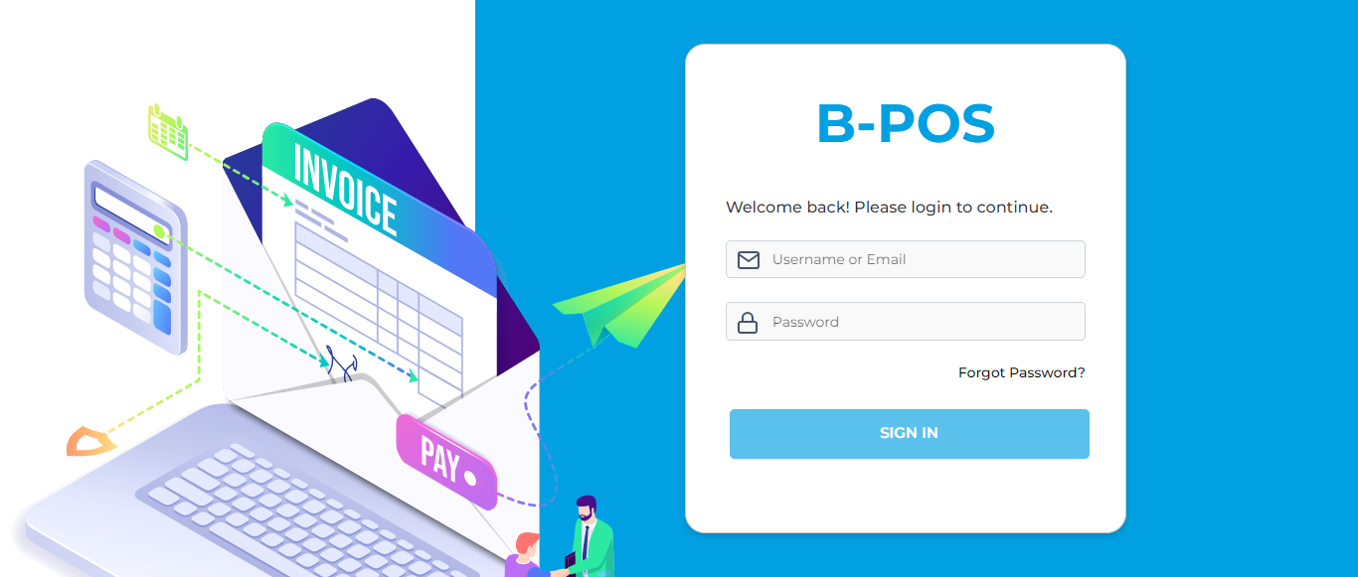

### The Home page with lot of navigation options to navigate different modules and serving as the entry point to the website.

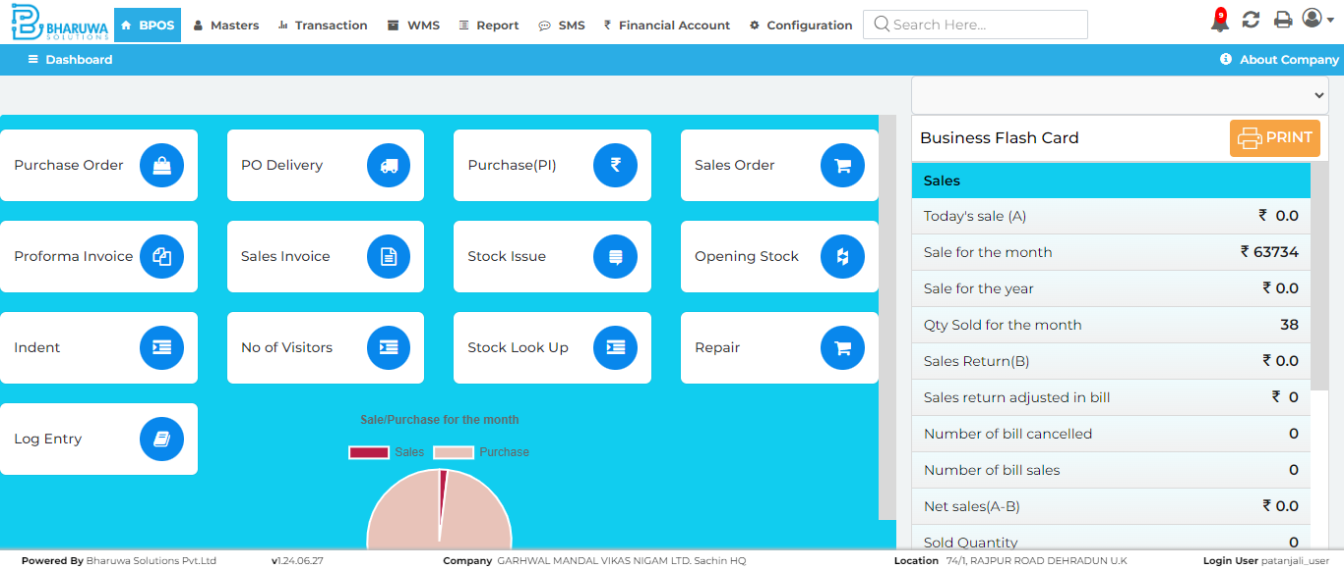

### Transaction module with lot of sub-modules to perform vairous transactinos for user.

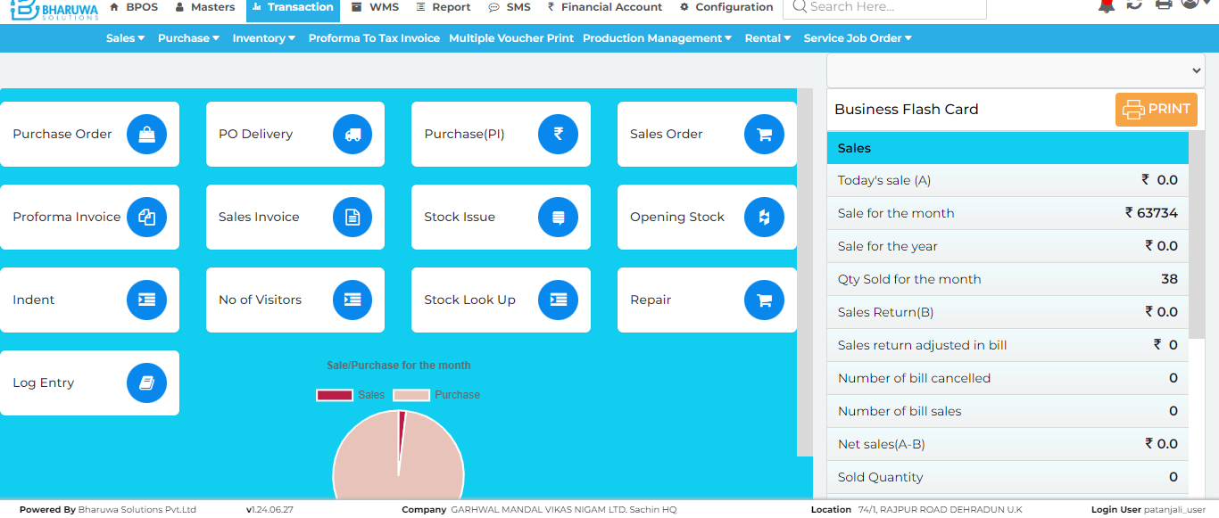

### Purchase Invoice screen where user can purchase stock for selected items.

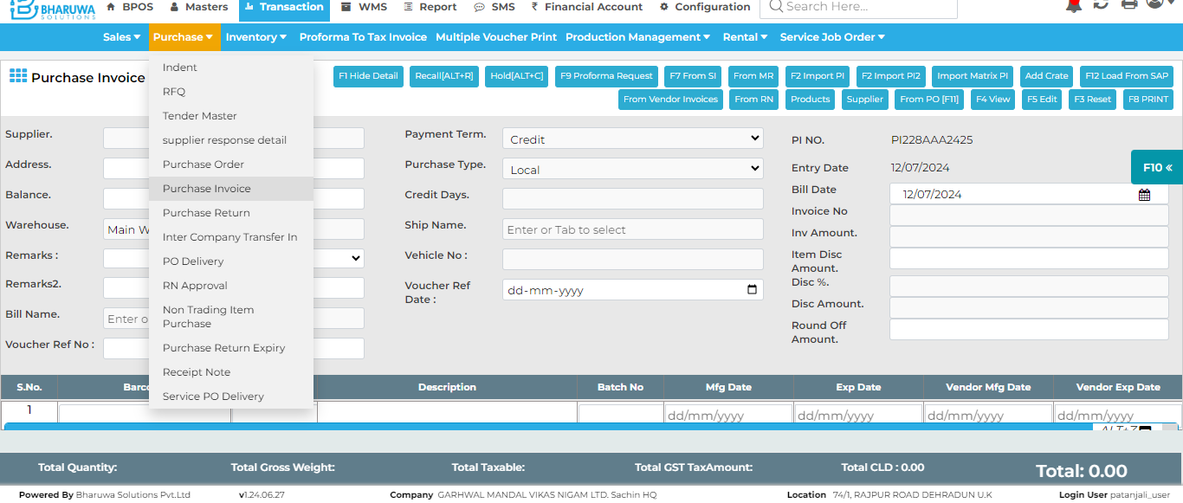

### Message: no such element: Unable to locate element: {"method":"xpath","selector":"//button[text()[normalize-space()='F6 SAVE']]"} (Session info: chrome=126.0.6478.127); For documentation on this error, please visit: https://www.selenium.dev/documentation/webdriver/troubleshooting/errors#no-such-element-exception Stacktrace: GetHandleVerifier [0x00007FF74DC4EEA2+31554] (No symbol) [0x00007FF74DBC7ED9] (No symbol) [0x00007FF74DA8872A] (No symbol) [0x00007FF74DAD8434] (No symbol) [0x00007FF74DAD853C] (No symbol) [0x00007FF74DB1F6A7] (No symbol) [0x00007FF74DAFD06F] (No symbol) [0x00007FF74DB1C977] (No symbol) [0x00007FF74DAFCDD3] (No symbol) [0x00007FF74DACA33B] (No symbol) [0x00007FF74DACAED1] GetHandleVerifier [0x00007FF74DF58B1D+3217341] GetHandleVerifier [0x00007FF74DFA5AE3+3532675] GetHandleVerifier [0x00007FF74DF9B0E0+3489152] GetHandleVerifier [0x00007FF74DCFE776+750614] (No symbol) [0x00007FF74DBD375F] (No symbol) [0x00007FF74DBCEB14] (No symbol) [0x00007FF74DBCECA2] (No symbol) [0x00007FF74DBBE16F] BaseThreadInitThunk [0x00007FFC5940257D+29] RtlUserThreadStart [0x00007FFC5AA8AF28+40]

### Test Case - F A I L E D