# Chrome_TC_01:Purchase_Invoice_Creation

### Orient LED Login Page.

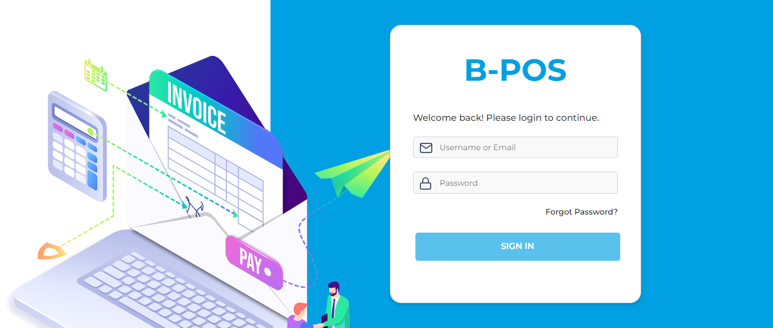

### The Home page with lot of navigation options to navigate different modules and serving as the entry point to the website.

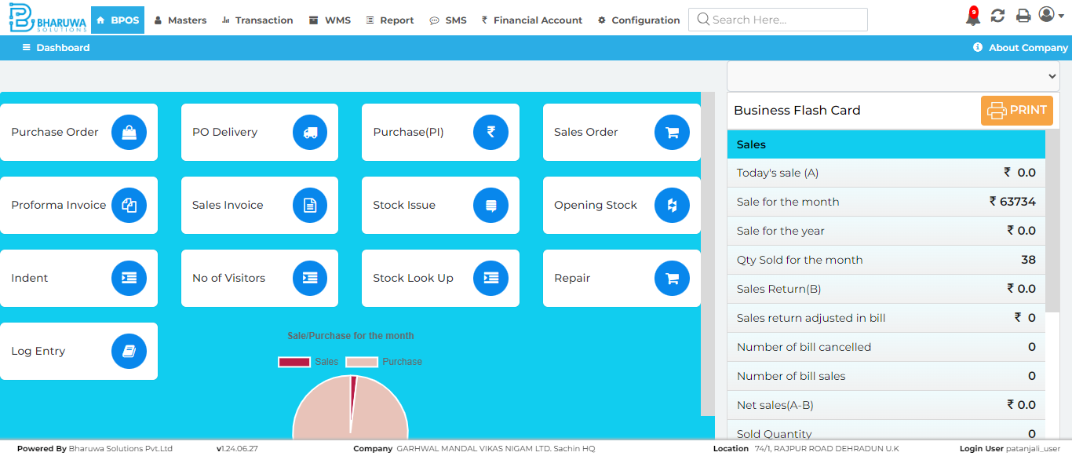

### Transaction module with lot of sub-modules to perform vairous transactinos for user.

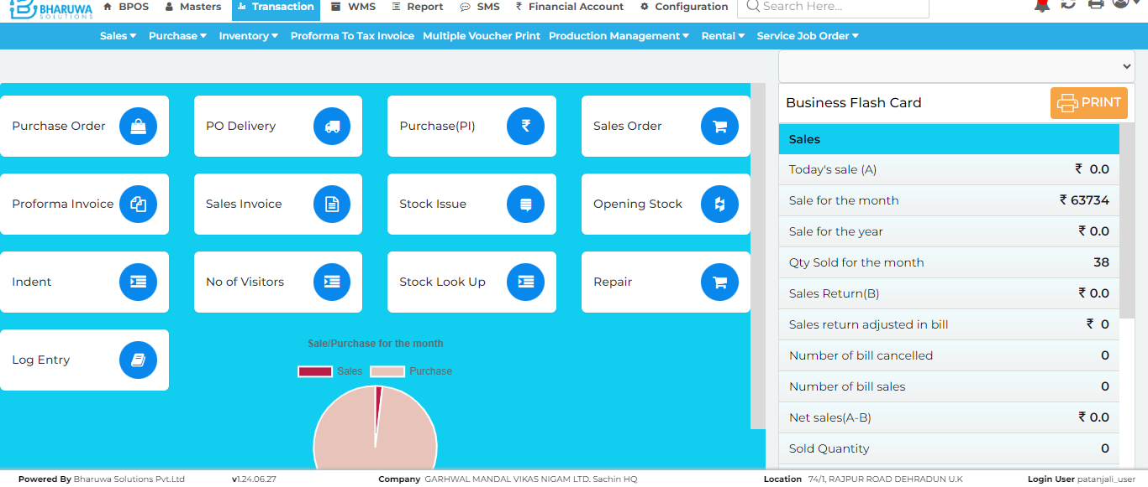

### Purchase Invoice screen where user can purchase stock for selected items.

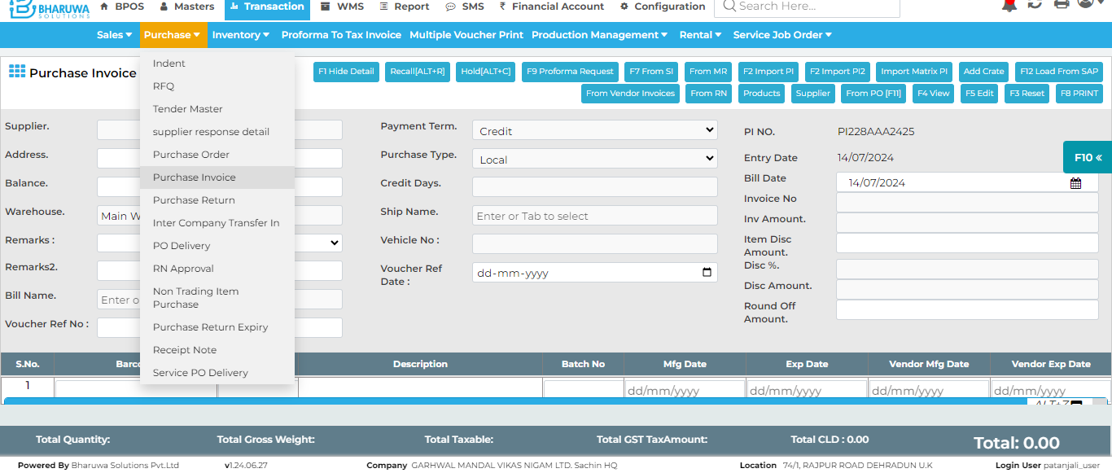

### Message: no such element: Unable to locate element: {"method":"xpath","selector":"//button[text()[normalize-space()='F6 SAVE']]"} (Session info: chrome=126.0.6478.127); For documentation on this error, please visit: https://www.selenium.dev/documentation/webdriver/troubleshooting/errors#no-such-element-exception Stacktrace: GetHandleVerifier [0x00007FF78021EEA2+31554] (No symbol) [0x00007FF780197ED9] (No symbol) [0x00007FF78005872A] (No symbol) [0x00007FF7800A8434] (No symbol) [0x00007FF7800A853C] (No symbol) [0x00007FF7800EF6A7] (No symbol) [0x00007FF7800CD06F] (No symbol) [0x00007FF7800EC977] (No symbol) [0x00007FF7800CCDD3] (No symbol) [0x00007FF78009A33B] (No symbol) [0x00007FF78009AED1] GetHandleVerifier [0x00007FF780528B1D+3217341] GetHandleVerifier [0x00007FF780575AE3+3532675] GetHandleVerifier [0x00007FF78056B0E0+3489152] GetHandleVerifier [0x00007FF7802CE776+750614] (No symbol) [0x00007FF7801A375F] (No symbol) [0x00007FF78019EB14] (No symbol) [0x00007FF78019ECA2] (No symbol) [0x00007FF78018E16F] BaseThreadInitThunk [0x00007FFC5940257D+29] RtlUserThreadStart [0x00007FFC5AA8AF28+40]

### Test Case - F A I L E D