# Chrome_TC_01:Opening_Stock_Entry_Negative_Stock_Testing

### Orient LED Login Page.

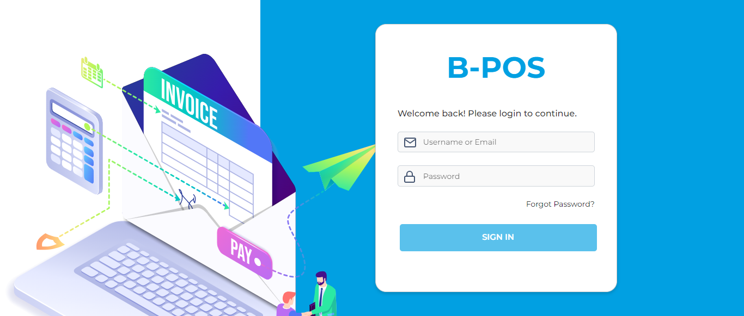

### The Home page with lot of navigation options to navigate different modules and serving as the entry point to the website.

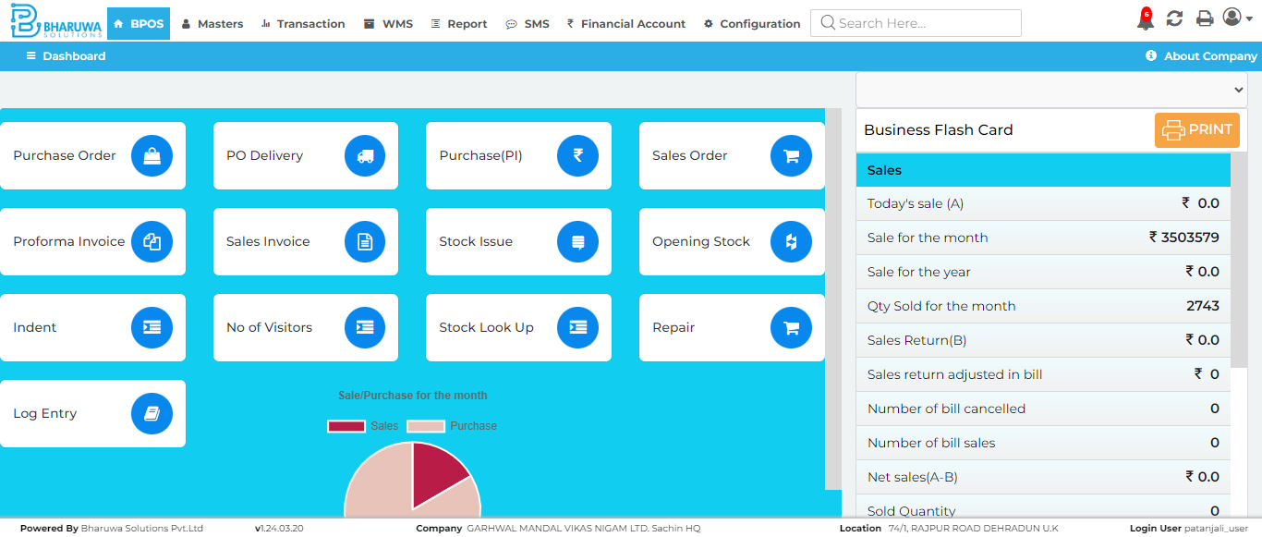

### Product master page which enables users to view, manage, and create new products.

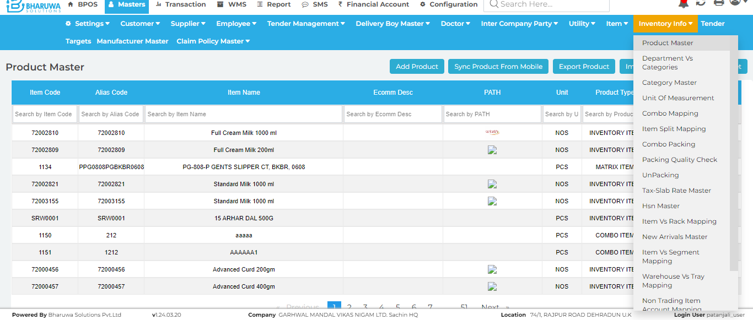

### Product master forum General details page, Product master page with different tabs such GENERAL, ALTERNATIVE UNITS, SALES, GST & CHARGES, CATEGORY, OTHERS, PRICE.

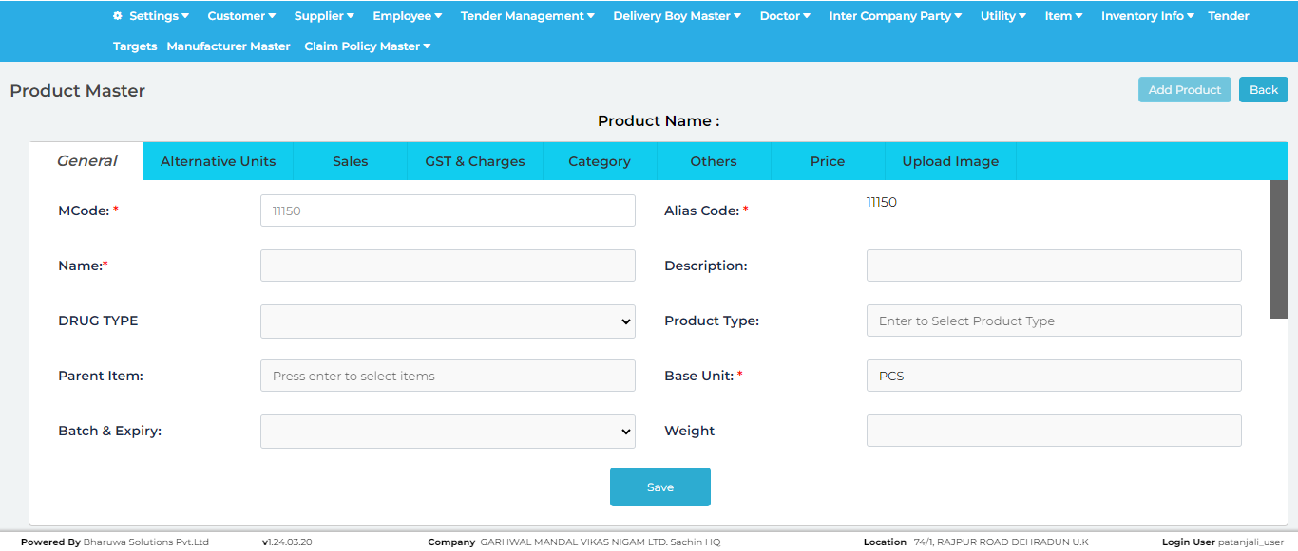

### Successfully created new product, with given details.

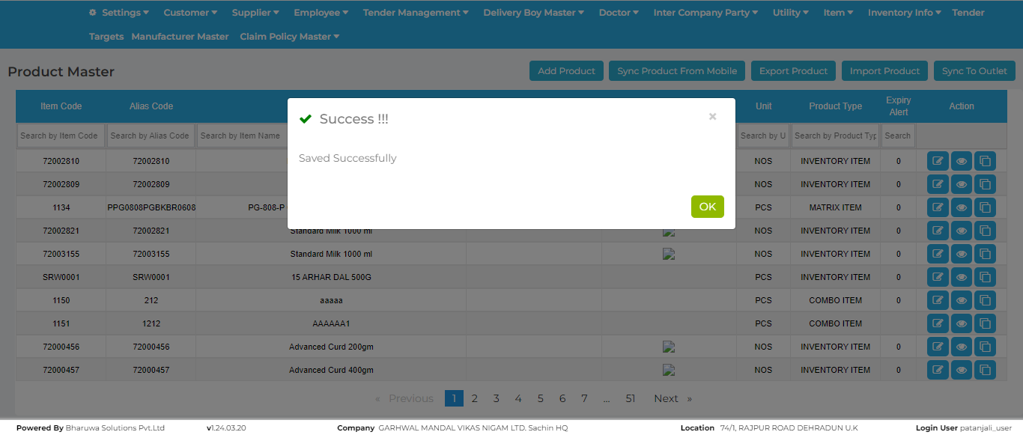

### Purchase Invoice screen where user can purchase stock for selected items.

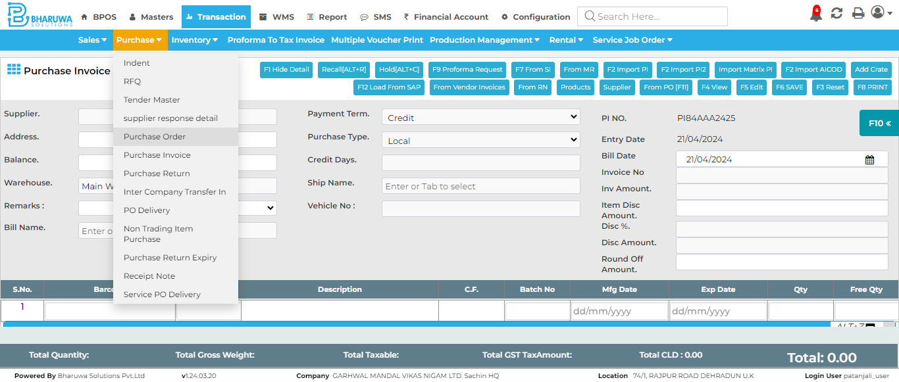

### '<=' not supported between instances of 'int' and 'str'

### Opening stock entry page, where user can create a new stock for preferred items.

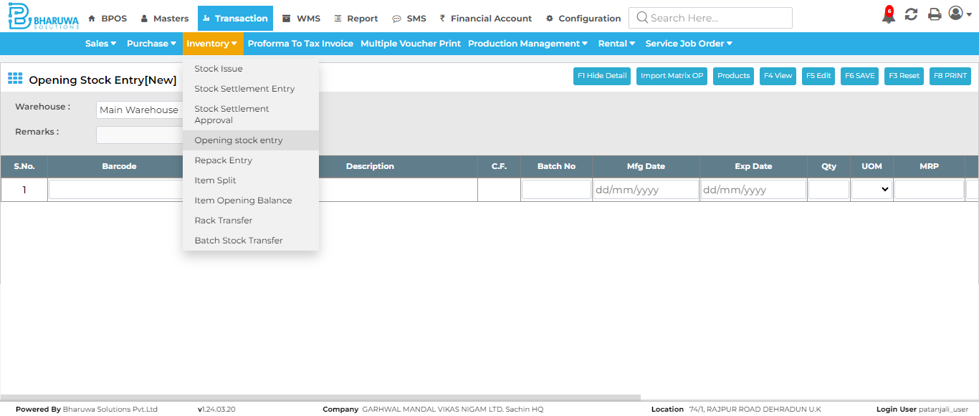

### Successfully created new batch for specified item using Opening Stock Entry.

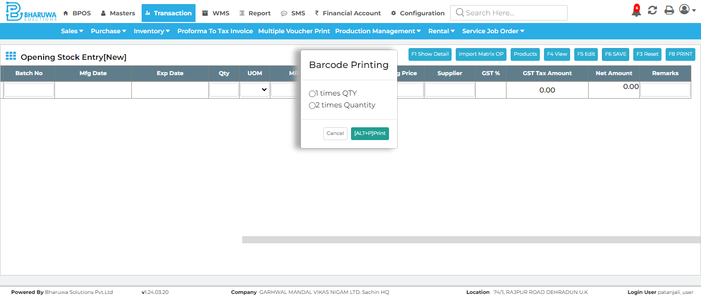

### Sales invoice page, The sales invoice screen is where sales transactions are recorded and processed.

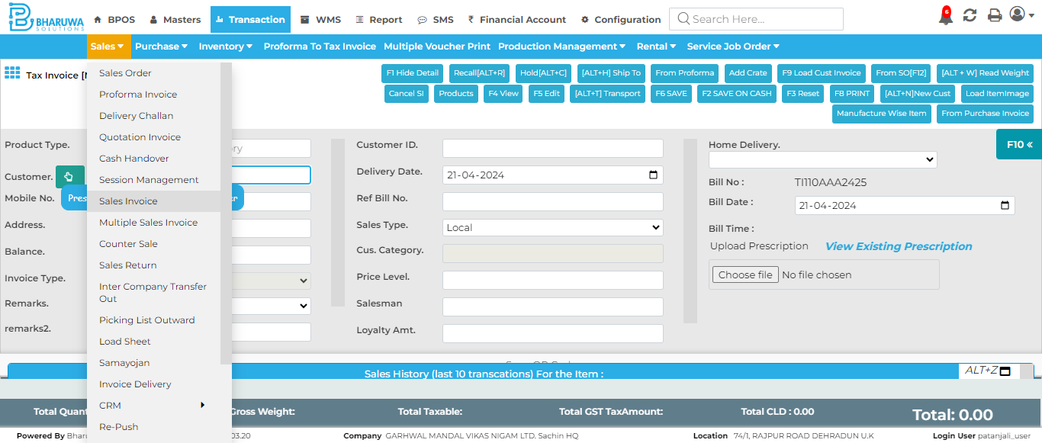

### Successfully created sales invoice for specified product with unbatched batch of items.

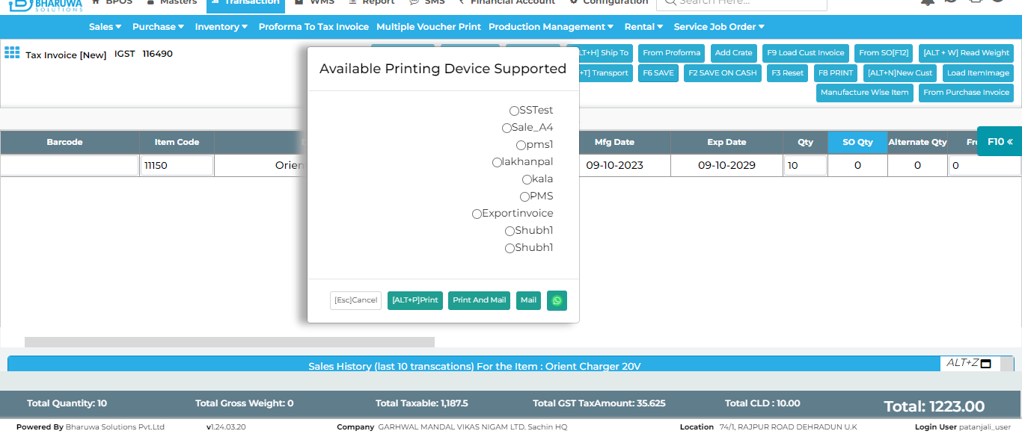

### Closing stock report screen, where user can generate reports for all existing products in application.

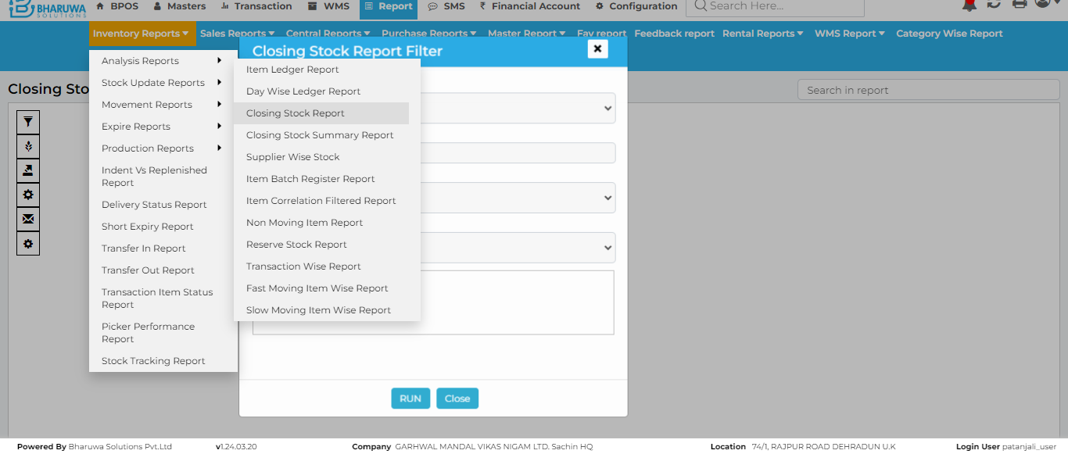

### last 7 days reports for specified product.

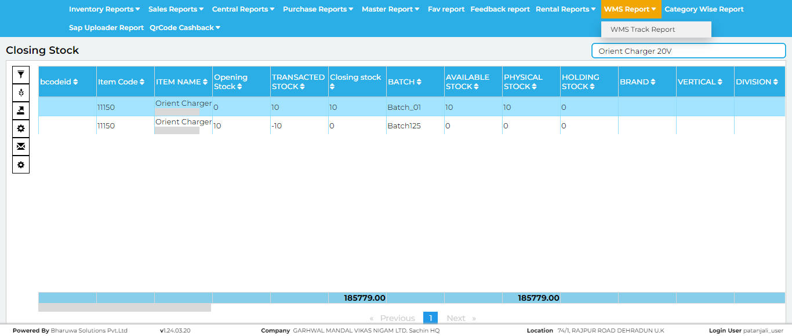

### Navigated to Opening Stock Entry to give batch name for previously created unbatched batch



### System is not allowing to edit and save Opening Stock Entry record which don't have any available stock.

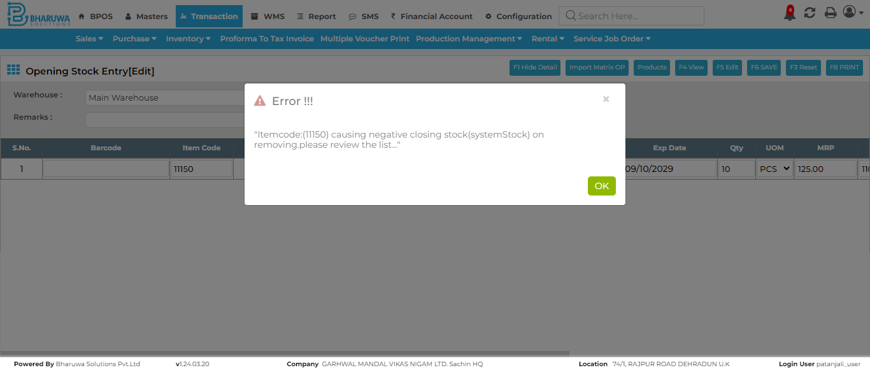

#### TC_01 - TEST PASSED