# Chrome_TC_01:Opening_Stock_Entry_Negative_Stock_Testing

### Orient LED Login Page.

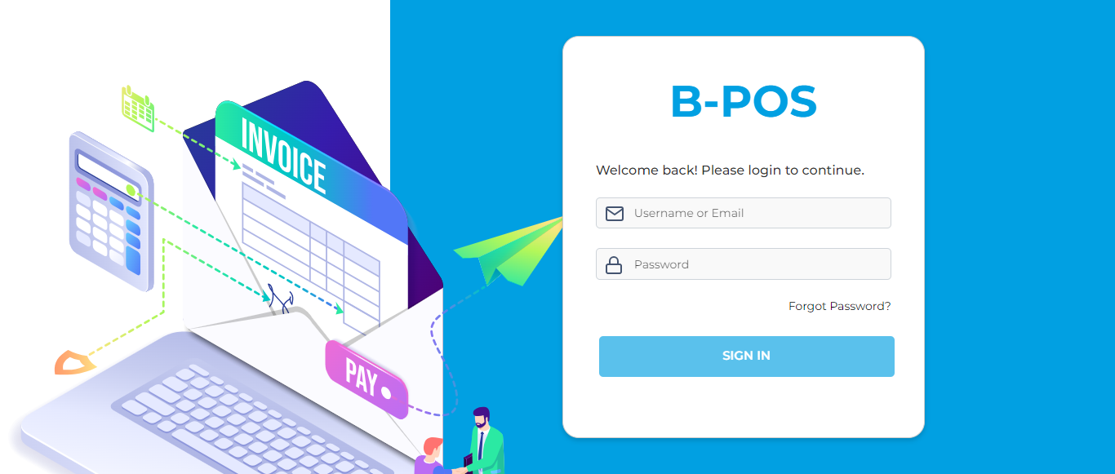

### The Home page with lot of navigation options to navigate different modules and serving as the entry point to the website.

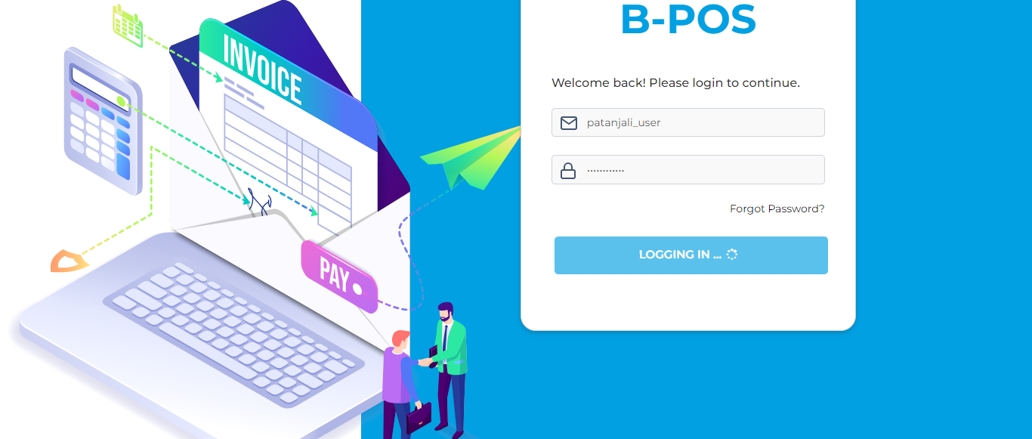

### Message: no such element: Unable to locate element: {"method":"xpath","selector":"//a[@title='Masters']"} (Session info: chrome=123.0.6312.124); For documentation on this error, please visit: https://www.selenium.dev/documentation/webdriver/troubleshooting/errors#no-such-element-exception Stacktrace: GetHandleVerifier [0x00007FF64C4B7032+63090] (No symbol) [0x00007FF64C422C82] (No symbol) [0x00007FF64C2BEC65] (No symbol) [0x00007FF64C30499D] (No symbol) [0x00007FF64C304ADC] (No symbol) [0x00007FF64C345B37] (No symbol) [0x00007FF64C32701F] (No symbol) [0x00007FF64C343412] (No symbol) [0x00007FF64C326D83] (No symbol) [0x00007FF64C2F83A8] (No symbol) [0x00007FF64C2F9441] GetHandleVerifier [0x00007FF64C8B25AD+4238317] GetHandleVerifier [0x00007FF64C8EF70D+4488525] GetHandleVerifier [0x00007FF64C8E79EF+4456495] GetHandleVerifier [0x00007FF64C590576+953270] (No symbol) [0x00007FF64C42E54F] (No symbol) [0x00007FF64C429224] (No symbol) [0x00007FF64C42935B] (No symbol) [0x00007FF64C419B94] BaseThreadInitThunk [0x00007FFF935F257D+29] RtlUserThreadStart [0x00007FFF94E0AA58+40]

### Test Case - F A I L E D