# Chrome_TC_01:Opening_Stock_Entry_Negative_Stock_Testing

### Orient LED Login Page.

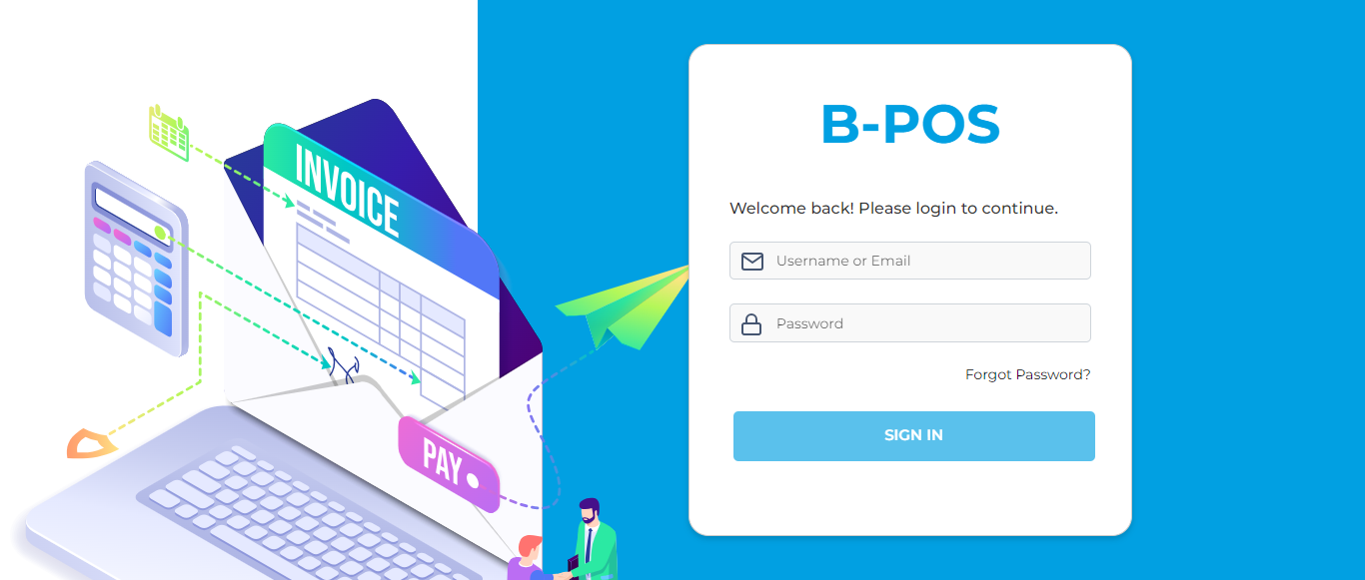

### The Home page with lot of navigation options to navigate different modules and serving as the entry point to the website.

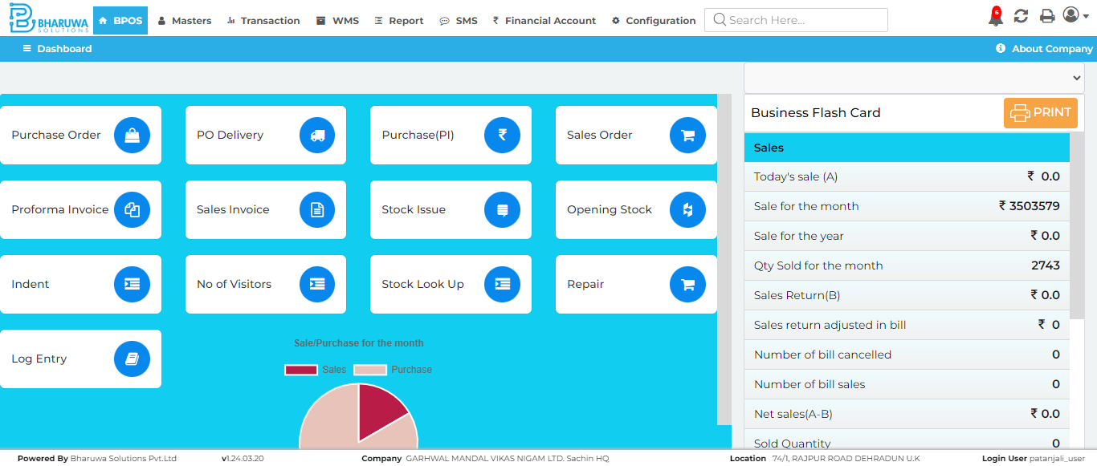

### Product master page which enables users to view, manage, and create new products.

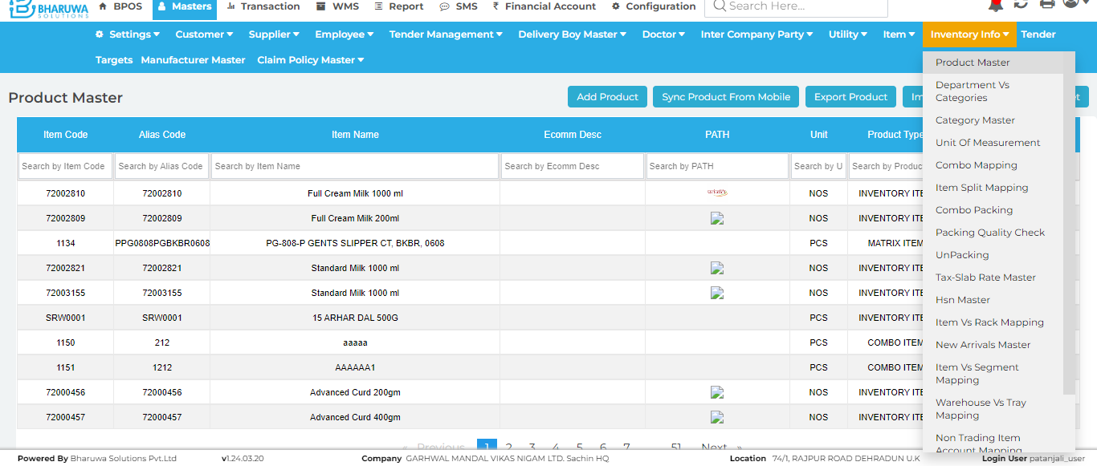

### Product master forum General details page, Product master page with different tabs such GENERAL, ALTERNATIVE UNITS, SALES, GST & CHARGES, CATEGORY, OTHERS, PRICE.

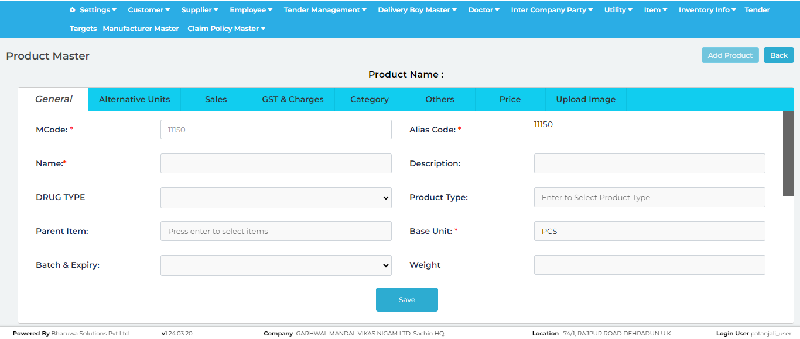

### Successfully created new product, with given details.

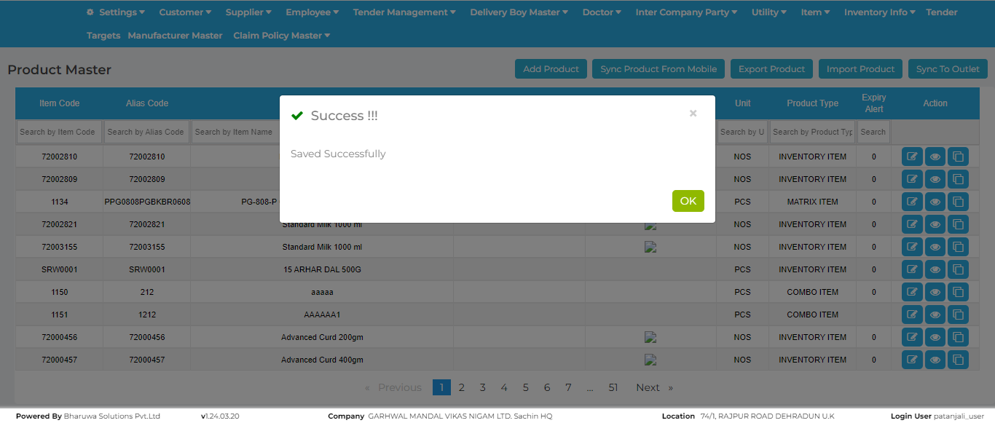

### Purchase Invoice screen where user can purchase stock for selected items.

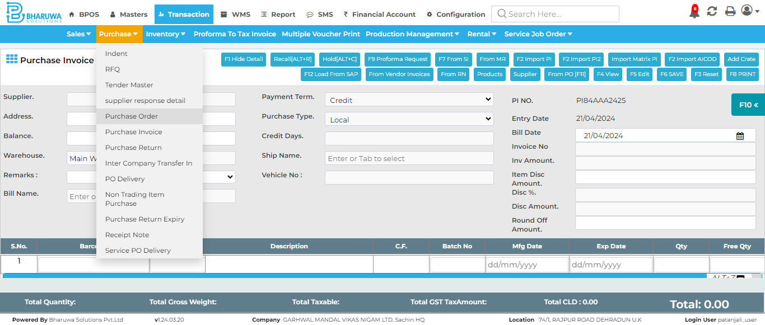

### '<=' not supported between instances of 'int' and 'str'

### Opening stock entry page, where user can create a new stock for preferred items.

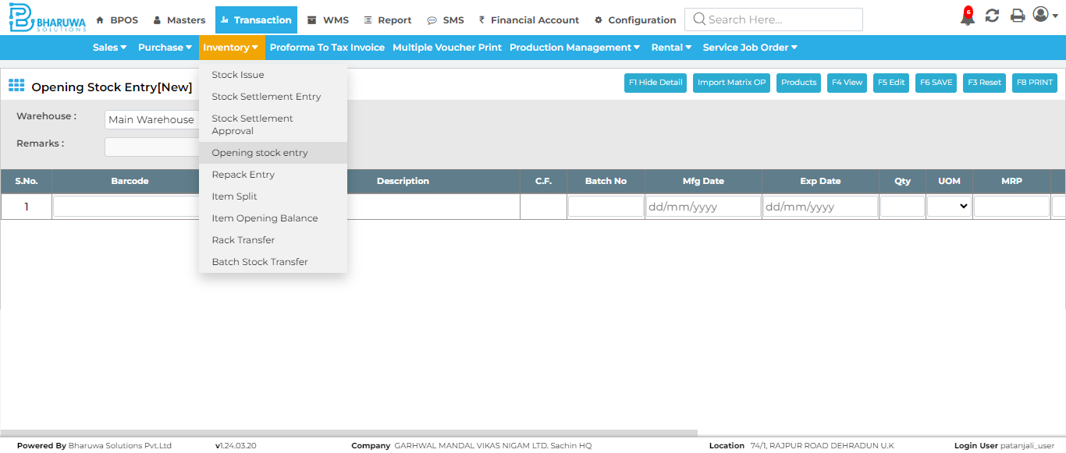

### Successfully created new batch for specified item using Opening Stock Entry.

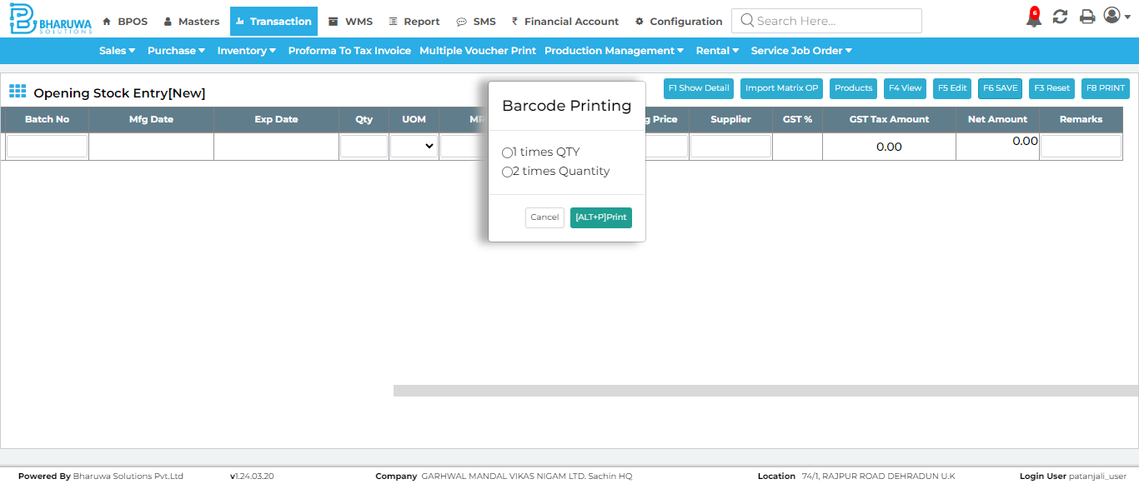

### Sales invoice page, The sales invoice screen is where sales transactions are recorded and processed.

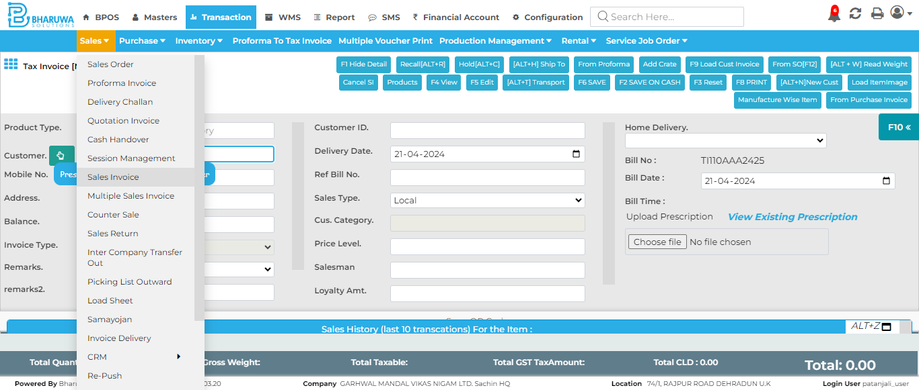

### Successfully created sales invoice for specified product with unbatched batch of items.

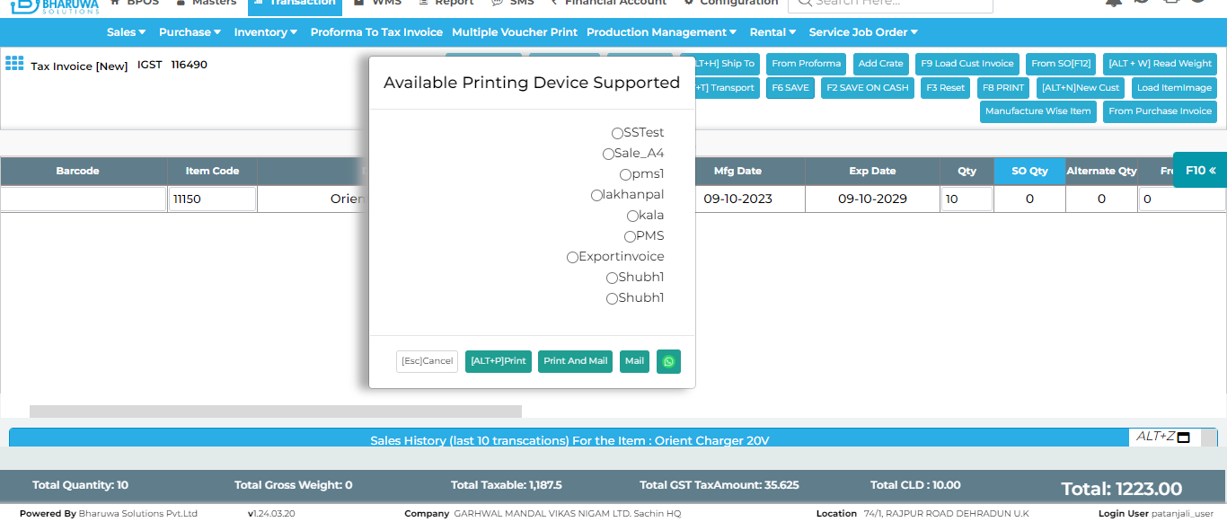

### Closing stock report screen, where user can generate reports for all existing products in application.

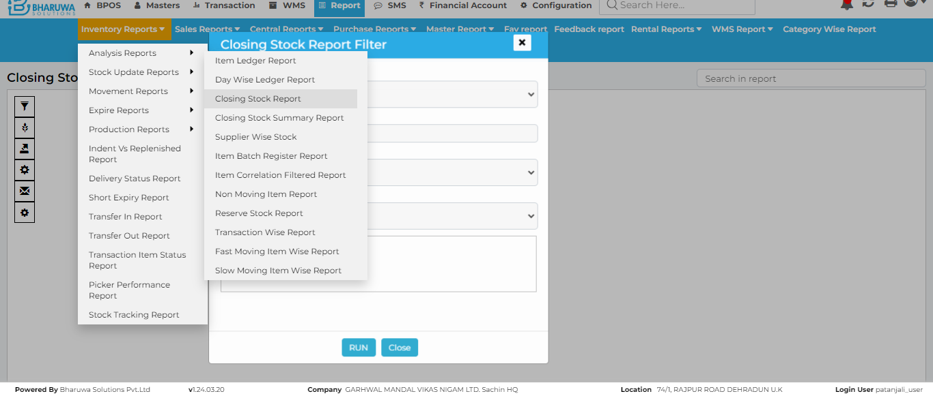

### last 7 days reports for specified product.

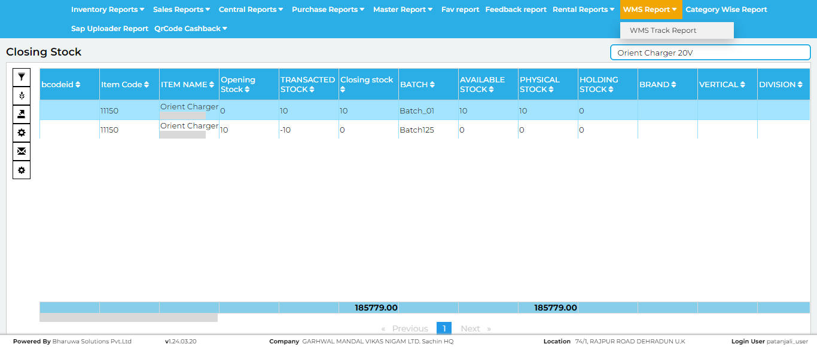

### Navigated to Opening Stock Entry to give batch name for previously created unbatched batch



### System is not allowing to edit and save Opening Stock Entry record which don't have any available stock.

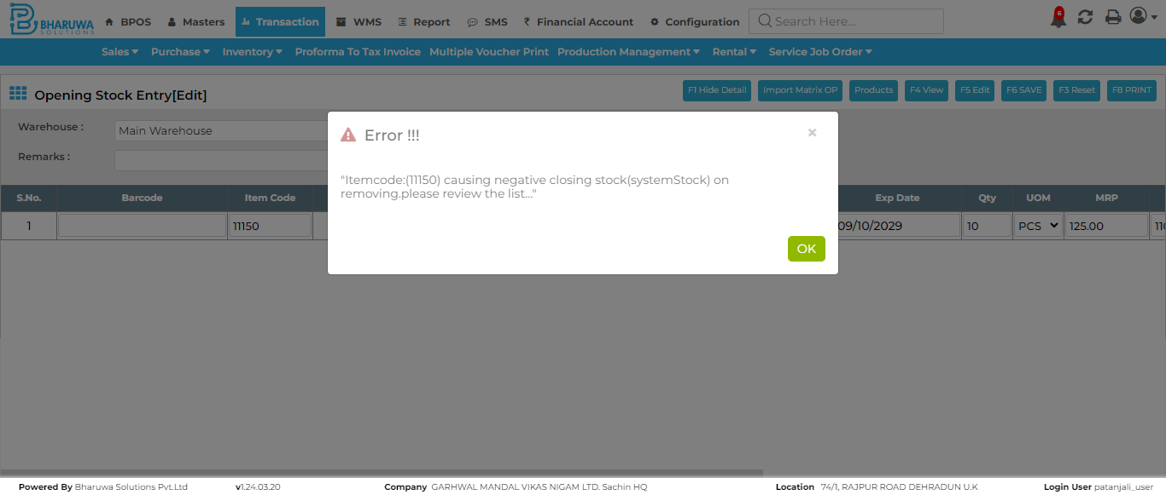

#### TC_01 - TEST PASSED

### Message: element click intercepted: Element <span _ngcontent-c5="">...</span> is not clickable at point (505, 25). Other element would receive the click: <div _ngcontent-c6="" aria-hidden="false" aria-labelledby="mySmallModalLabel" bsmodal="" class="modal fade in" role="dialog" style="z-index: 2147483647; display: block;" tabindex="-1" width="auto">...</div> (Session info: chrome=123.0.6312.124) Stacktrace: GetHandleVerifier [0x00007FF64C4B7032+63090] (No symbol) [0x00007FF64C422C82] (No symbol) [0x00007FF64C2BEC65] (No symbol) [0x00007FF64C30BB34] (No symbol) [0x00007FF64C309954] (No symbol) [0x00007FF64C307164] (No symbol) [0x00007FF64C305EF9] (No symbol) [0x00007FF64C2FA708] (No symbol) [0x00007FF64C326FDA] (No symbol) [0x00007FF64C2FA00A] (No symbol) [0x00007FF64C3271F0] (No symbol) [0x00007FF64C343412] (No symbol) [0x00007FF64C326D83] (No symbol) [0x00007FF64C2F83A8] (No symbol) [0x00007FF64C2F9441] GetHandleVerifier [0x00007FF64C8B25AD+4238317] GetHandleVerifier [0x00007FF64C8EF70D+4488525] GetHandleVerifier [0x00007FF64C8E79EF+4456495] GetHandleVerifier [0x00007FF64C590576+953270] (No symbol) [0x00007FF64C42E54F] (No symbol) [0x00007FF64C429224] (No symbol) [0x00007FF64C42935B] (No symbol) [0x00007FF64C419B94] BaseThreadInitThunk [0x00007FFF935F257D+29] RtlUserThreadStart [0x00007FFF94E0AA58+40]

### Test Case - F A I L E D