ANTRIQUE WEB STUDIO

Master Product Specification
Discovery · IA · Feature Design · Design System · UX · Architecture
Document Status: Consolidated Draft v1.0
Owner: Product & Architecture
Date: July 14, 2026

Contents

How to Read This Document
This master specification consolidates six phases of work into one reference. Each phase was produced and reviewed in sequence; this document is the aggregated, canonical version. Assumptions carried through the work are marked [ASSUMPTION] and remain open for confirmation.
Open decisions carried across all phases
• Business model: hybrid services agency + delivery platform + client portal. Confirm before build.
• Geography & compliance: India-first launch (DPDP), international expansion later.
• Beachhead vertical: recommended to narrow the 15-service / 11-industry scope to one vertical first.
• Named technologies are defaults; the stated category is the real requirement.

1. Product Discovery

Vision & Mission
Vision: to become the most trusted end-to-end web development partner for organizations across sectors — platform-led, not project-led. Mission: deliver secure, scalable, accessible web solutions by combining a productized delivery engine with expert human oversight, lowering time-to-launch and total cost of ownership.

Business Goals
Horizon | Goal | Indicative Metric
0–6mo | Market presence & lead pipeline | 50+ qualified leads/month; portal MVP live
6–12mo | Convert to recurring revenue | 30% revenue from maintenance/SEO retainers
12–24mo | Productization | Self-serve tier contributing measurable revenue
Strategic note: recurring revenue is the enterprise-value driver; the recommended north-star is recurring-revenue mix, not project count.

Personas, Journey & Competitors
Two persona sides: client-side (school admin, SME owner, startup founder, government procurement, hospital IT, enterprise marketing) and internal operators (PM, developer, sales, admin). The customer journey's two make-or-break moments are onboarding (requirement chaos) and the delivery silence gap — both solved by transparency, which is the platform's core value proposition. Against DIY builders, marketplaces, local agencies, and enterprise vendors, the wedge is platform-driven visibility plus productization.

Top Risk
R1 — over-broad scope (15 services × 11 verticals) dilutes brand and delivery quality. Mitigation: choose a beachhead vertical, phase the rest. This is the single most important strategic decision.

2. Information Architecture
Two-surface architecture: a public marketing site (SEO-driven, unauthenticated) and an authenticated client portal, with distinct navigation and footers. The 15 services and 10 industries are delivered through two reusable page templates rather than ~165 bespoke pages — the decision that makes the breadth maintainable.

Navigation System
- Header: Sticky header with logo, primary nav, utility (search, login), and a persistent “Get a Quote” CTA.
- Mega menu: Services mega menu organized into 4 clusters (Web Dev, Commerce & Platforms, Specialized Sites, Growth & Support); Industries mega menu across 10 verticals.
- Breadcrumbs: On all pages except Home and hubs, with schema.org BreadcrumbList markup.
- Footer: Four-column fat footer + full-width CTA band + utility/legal bar.
- Portal nav: Portal uses a left sidebar and minimal chrome — no mega menu, no marketing footer.

CTA Strategy
A layered model: Primary (Get a Quote) persistent in header, hero, and footer; Secondary (Book a Consultation); Tertiary (View Work / Download Guide); Micro (newsletter, chat). Every page ends in exactly one primary CTA block — no dead ends.

3. Feature & Page Design
Every page was specified across 15 dimensions: purpose, business goal, components, sections, interactions, animations, validation, SEO, accessibility, responsive behavior, and the four state families (loading, empty, error, success). Cross-cutting standards — WCAG 2.1 AA baseline, mobile-first breakpoints, reduced-motion, and default state design — are stated once and inherited.

The Quote Wizard (primary conversion)
One question per screen with a visible progress indicator, pre-fill from the referring page, controlled inputs, contact details captured last, and a trust rail throughout. Per-step inline validation never loses entered data; submission is always user-initiated, never automated; failure preserves inputs and offers retry.

4. Design System
Token-first with a single source of truth. Components bind to a semantic token layer (surface, text-primary, action) that points at primitive ramps (Navy, Teal, Slate, feedback). Dark mode reassigns only the semantic layer, so the same markup themes automatically. “Design Tokens” and “Tailwind variables” are the same layer expressed twice: CSS custom properties are the runtime source of truth, mirrored into the Tailwind theme.

Verified Token Output — Both Themes
The implemented tokens (tokens.css) and Tailwind config were verified: 27/27 semantic color tokens matched across light and dark, all variable references resolve, and both themes render coherently.
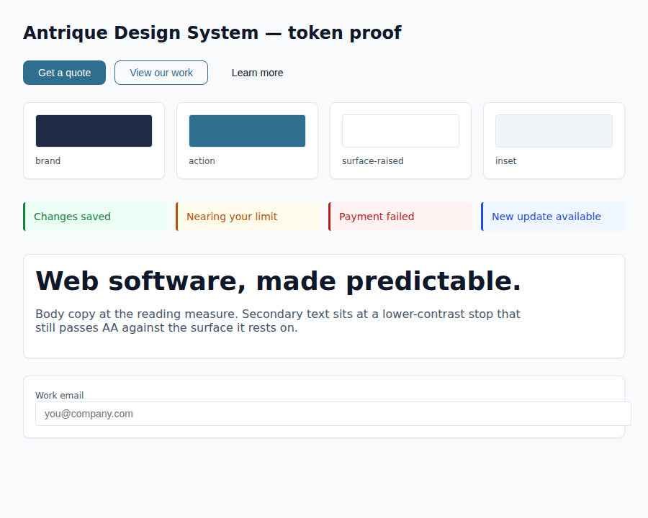
Token proof — light theme
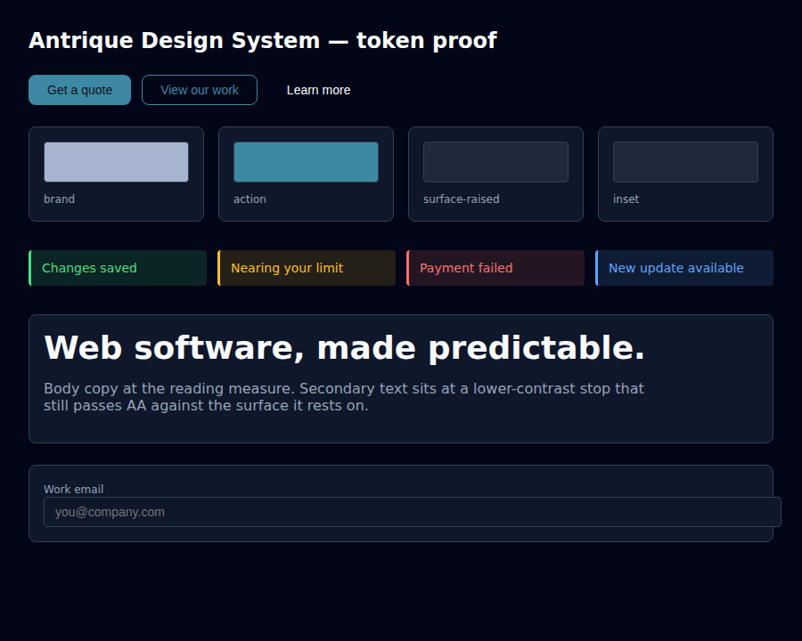
Token proof — dark theme

Component Library
A component library (components.css) built entirely on the token layer: buttons (variants, sizes, loading/disabled states), cards, form fields with validation states, badges/tags/chips, alerts, toasts, a responsive data table, and a confirmation modal. State is always dual-coded (color plus icon/text), focus is always visible, and destructive/irreversible actions require confirmation.
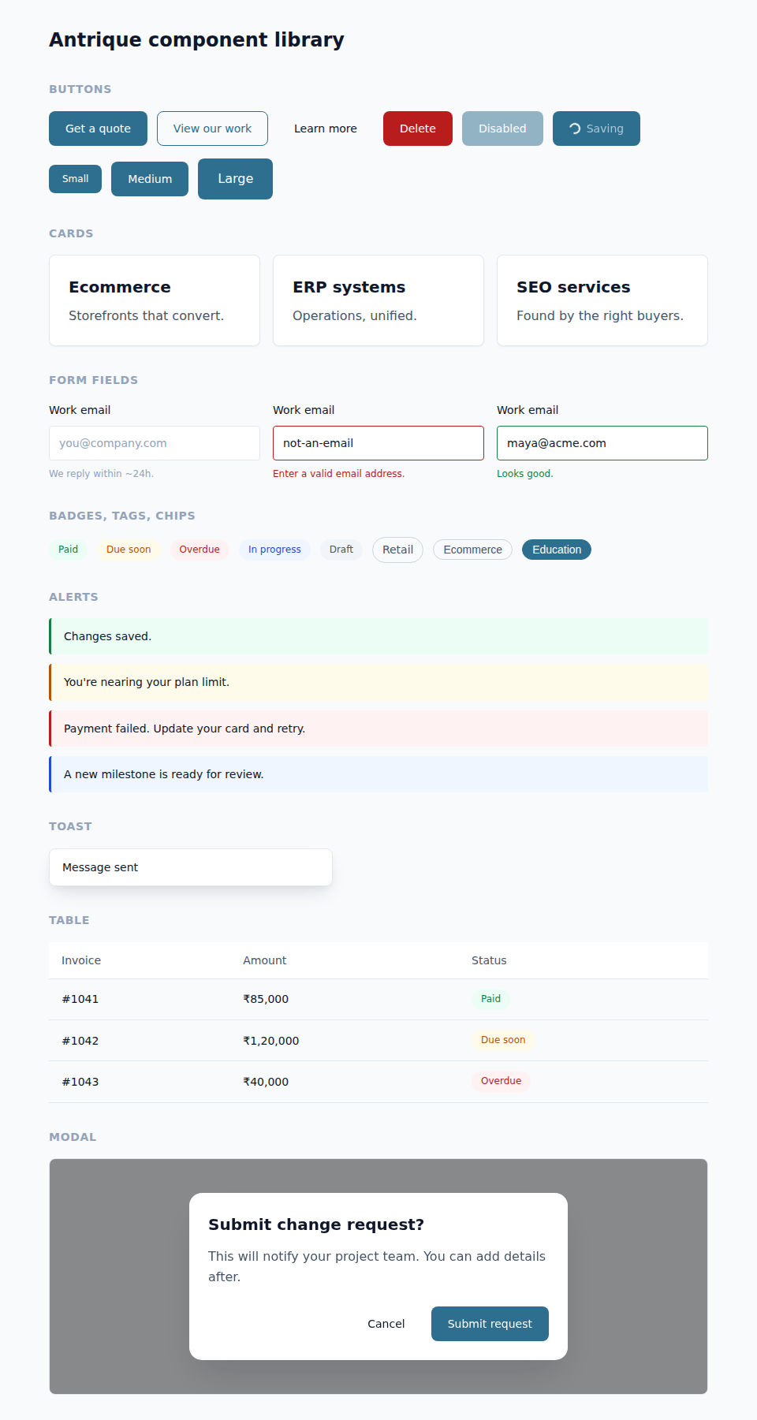
Component library — light theme

5. UX Documentation
Emotion-annotated journeys tie every design decision to a specific user anxiety: the wizard's one-question-per-screen serves the guarded, impatient commit moment; the portal's status-first dashboard serves the “is anything happening?” churn moment. Coverage includes micro-interactions (purposeful, reduced-motion-safe), loading UX (skeletons over spinners), accessibility as an experiential journey (full keyboard completion of the primary path), conversion optimization (one primary action per viewport, trust at the point of hesitation, no dark patterns), and mobile-first responsive design across mobile, tablet, and desktop.

High-Fidelity Home — Both Themes
The Home wireframe rendered with the real brand tokens and component library, verified on desktop (both themes) and mobile.
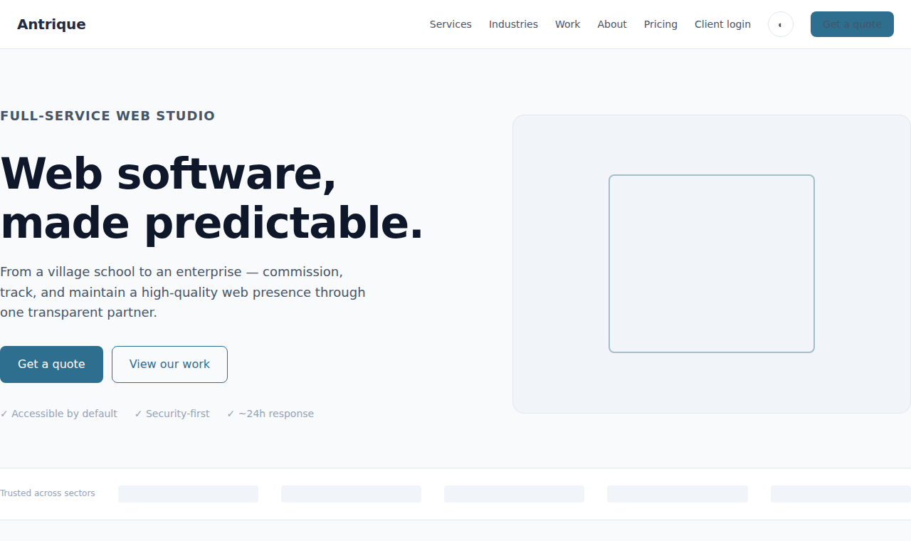
Home comp — light theme (hero)
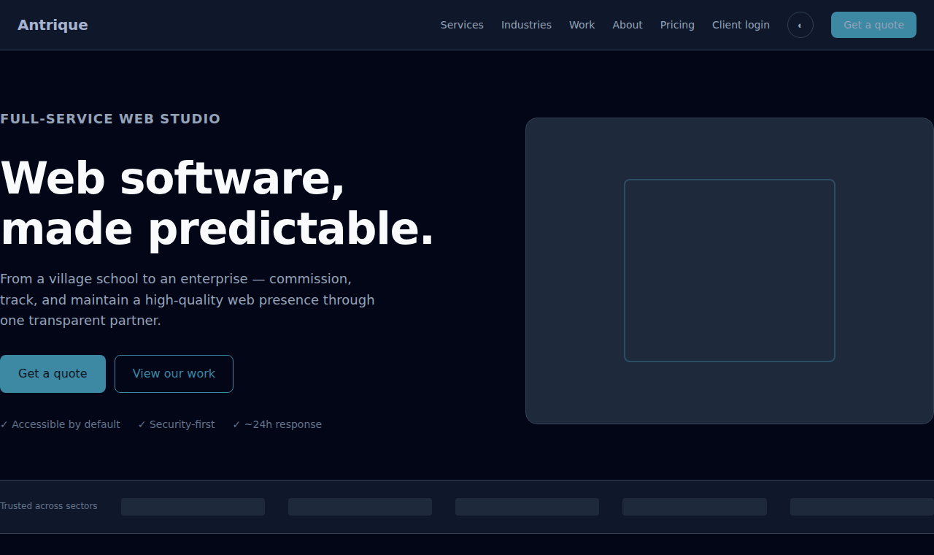
Home comp — dark theme (hero)

6. Production Architecture
Three governing decisions: two workloads on one platform (cacheable SSG/ISR marketing site + authenticated SSR/SPA portal sharing one backend, auth, and database); a modular monolith on managed services rather than microservices and self-hosting; and named technologies as justified defaults with a stated category requirement behind each.

Layer Summary
Layer | Selection | Rationale
Frontend | Next.js + TypeScript + Tailwind | Per-route rendering: SSG/ISR for SEO, SSR/CSR for the portal
Backend | Modular monolith (Node/TS) | Simple to operate, clean seams to extract services later
Database | PostgreSQL + Redis | Relational core, ACID billing, RLS multi-tenancy; Redis cache/queue
Auth | Managed IdP, OIDC, RBAC | MFA/SSO out of the box; never build auth in-house
Hosting/CDN | Edge + managed containers, India region | Workload-matched; global edge WAF + caching
Payments | Hosted PCI gateway | Card data never touches our servers; webhook-driven
CI/CD | PR gates → staging → canary → blue-green | Zero-downtime, instant rollback, feature flags

Diagram Set (produced separately)
Nine architecture diagrams accompany this specification: C4 system context, container, and component views; quote and payment sequence flows; deployment topology; CI/CD pipeline; the data ERD (tenant-isolated); and the auth/token sequence. They form a complete picture from context down to request flows, infrastructure, and delivery.

Consolidated Next Steps
- 1: Confirm the open decisions (business model, geography/compliance, beachhead vertical) — these unblock the entire build.
- 2: Validate Discovery target metrics and pricing with buyer interviews before committing the full service list.
- 3: Bridge the token/component layer into the Next.js codebase and stand up the conversion spine (Home → Service Detail → Quote wizard → Portal dashboard).
- 4: Produce remaining build artifacts: repo/folder structure, OpenAPI outline, and the database schema DDL from the ERD.

