<https://www.youtube.com/watch?v=Ez8F0nW6S-w>

<https://www.youtube.com/watch?v=evknSAkUIvs&list=PLu0W_9lII9agwhy658ZPA0MTStKUJTWPi>

<https://www.youtube.com/watch?v=gwWKnnCMQ5c>

<https://www.youtube.com/watch?v=Ez8F0nW6S-w>

Commit – to finalize changes

Add files/change and then 🡺 commit

History => details of commit made

<br> 🡺 to go to next line in Readme.md file => html code

**Setting up GIT**

Visual Studio Code => <https://code.visualstudio.com/download> => install this

Git Bash (windows) => <https://git-scm.com/download/win> => install this

Terminal (Mac)

Open Git Bash ==>

git --version

ls ==> list of folder

pwd ==> admin

Configuring Git with Git Hub

git config --global user.name “Dileep Korade”

git config --global user.email “[dileepkorade@gmail.com](mailto:dileepkorade@gmail.com)”

git config --list

dileep@DESKTOP-PMPGBRJ MINGW64 ~

here ~ means we are currently at root directory

clone ==> cloning GitHub repository to our local machine

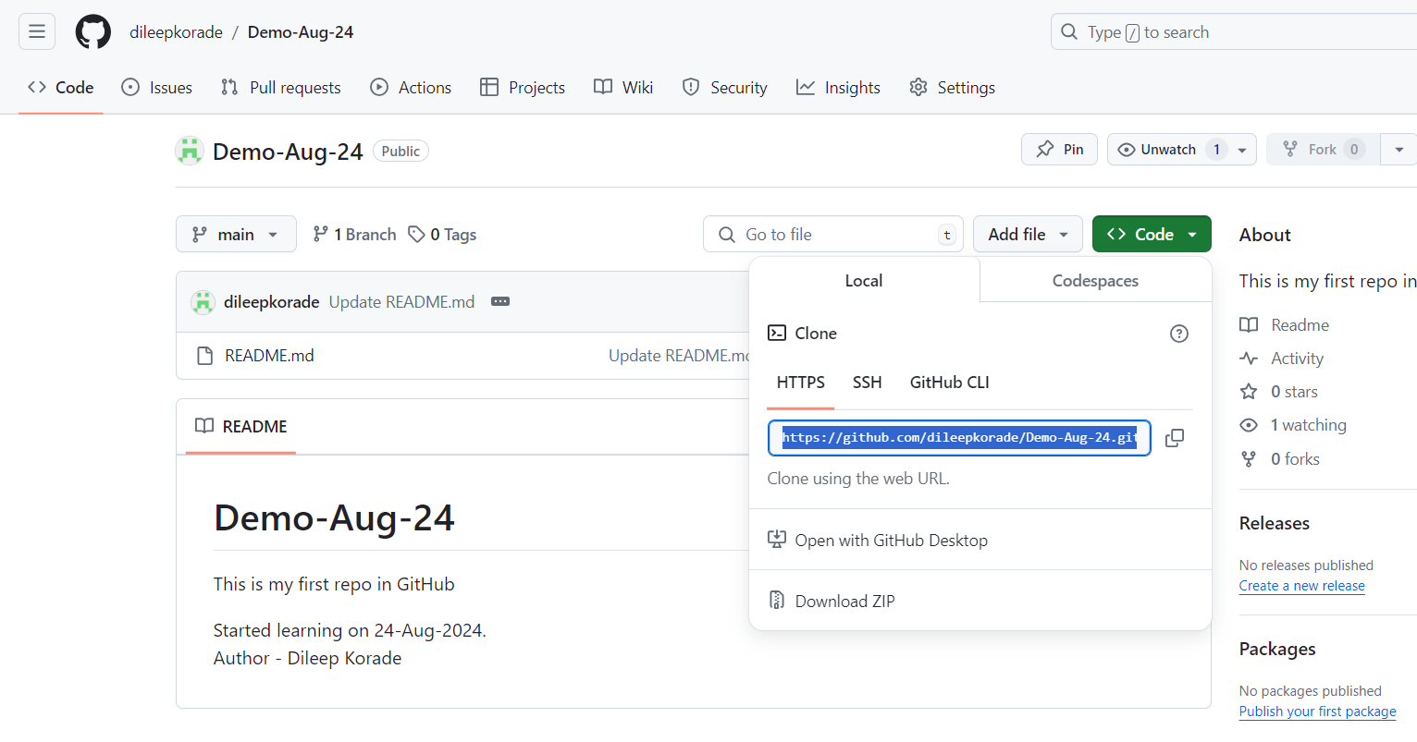

Copy link of GitHub repo and run below command in VScode

git clone <https://github.com/dileepkorade/Demo-Aug-24.git>

this will clone our local folder with git repository

cd ==> change directory (folder)

cd Demo-Aug-24 ==> we will go to this directory (folder) in our local

ls => display the names of files present in directory (folder) where we are currently in vscode/git terminal

ls –a ==> displays all files + hidden files

status==> displays the name of directory/folder of a code

git status ==> to check details of files in cloned folder in our local

untracked ==> new files that git doesn’t tracked yet

modified ==> changes done in tracked files

staged ==> files/file ready to be commited

unmodified ==>

If new files added or if some files are modifiedthen ==>

git add ==> to add all recently added files in staging (files will be staged) ==> step 1

git add <filename> ==> to add single file to staging

git commit ==> to commit changes done in that folder/files ==> step 2

git add/rm <filename> ==> to update what will be committed

git restore --staged <filename> ==> to unstaged

git restore <filename> ==> to discard changes in working directory

remote => GitHub

local => in our laptop