SIMATS ENGINEERING C03 ASSESSMENT TOOL1
COURSE CODE: CSA1610 COURSE NAME: DWDM A.DILEEP KUMAR (192372074)

EXPERIMENTS

Q1 R Code for Covariance and Correlation: CODE:
@relation photo_preference

@attribute Age_of_child {5-6,7-8,9-10} @attribute Photo_A numeric
@attribute Photo_B numeric @attribute Photo_C numeric

@data
5-6,18,22,20
7-8,2,28,40
9-10,20,10,40
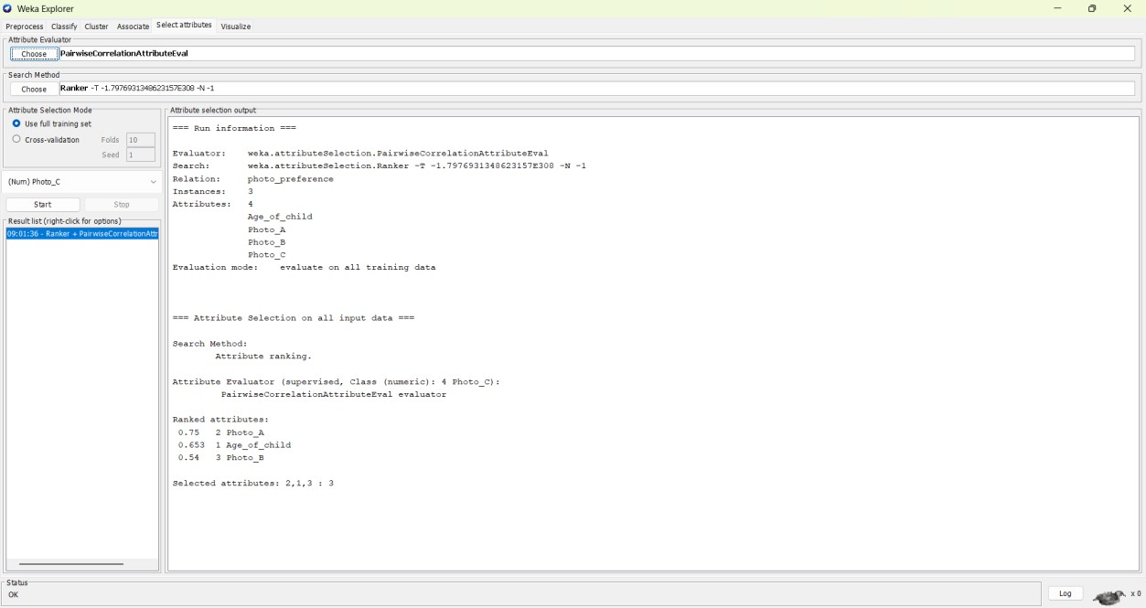

Q2 R Code for Boxplot and Outlier Detection CODE:
@relation tennis_scores

@attribute Player_ID string @attribute Player_Name string
@attribute Points_Scored numeric

@data P1,Player_A,12 P2,Player_B,15 P3,Player_C,14 P4,Player_D,10 P5,Player_E,18 P6,Player_F,20 P7,Player_G,22 P8,Player_H,13 P9,Player_I,11 P10,Player_J,35 P11,Player_K,16 P12,Player_L,17 P13,Player_M,19 P14,Player_N,21 P15,Player_O,23

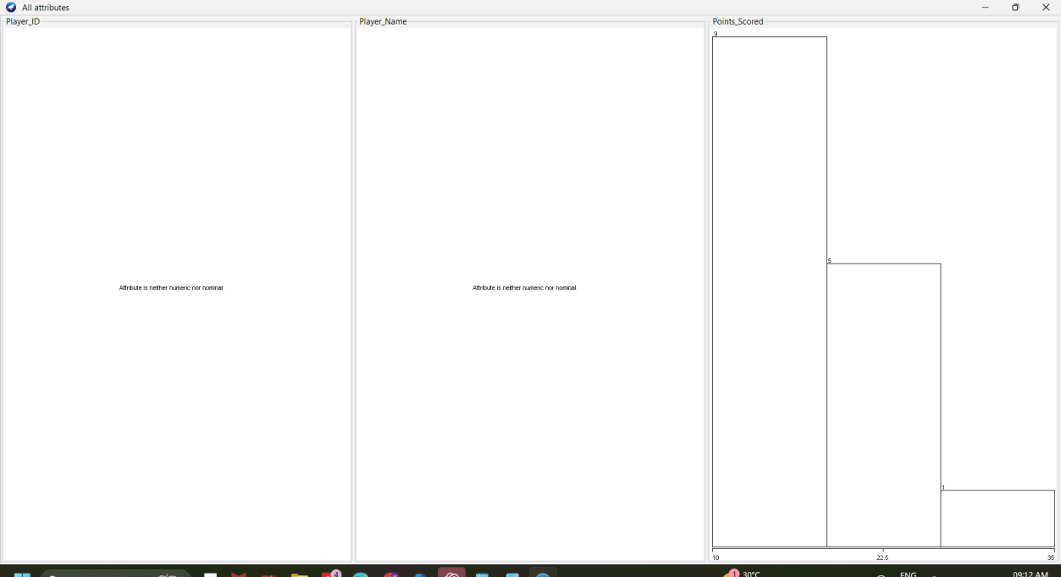

Q3 R Code for Decision Tree Classifier CODE:
@relation loan_approval

@attribute Age {young,middle,old} @attribute Income {low,medium,high}
@attribute Employment_Status {employed,unemployed,self-employed} @attribute Credit_Score {poor,average,good}
@attribute Loan_Approval {yes,no}

@data
young,high,employed,good,yes young,high,self-employed,average,yes middle,high,employed,good,yes
old,medium,employed,good,yes old,low,unemployed,poor,no
old,low,self-employed,average,no middle,low,unemployed,poor,no

young,medium,employed,average,yes young,low,unemployed,poor,no
old,medium,self-employed,good,yes middle,medium,employed,average,yes middle,high,self-employed,good,yes old,medium,unemployed,poor,no
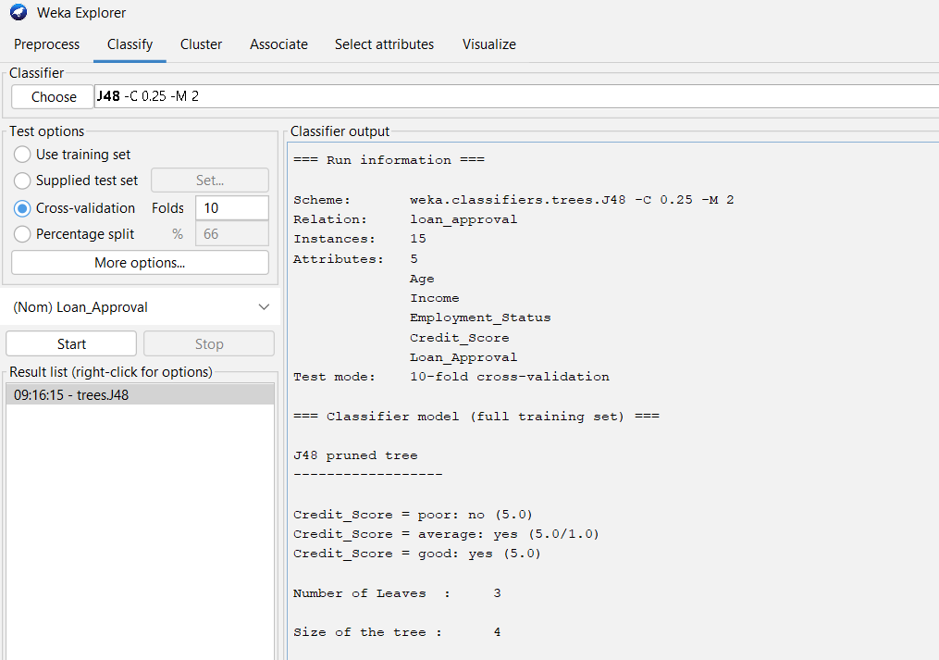
young,medium,self-employed,average,yes middle,low,employed,poor,no

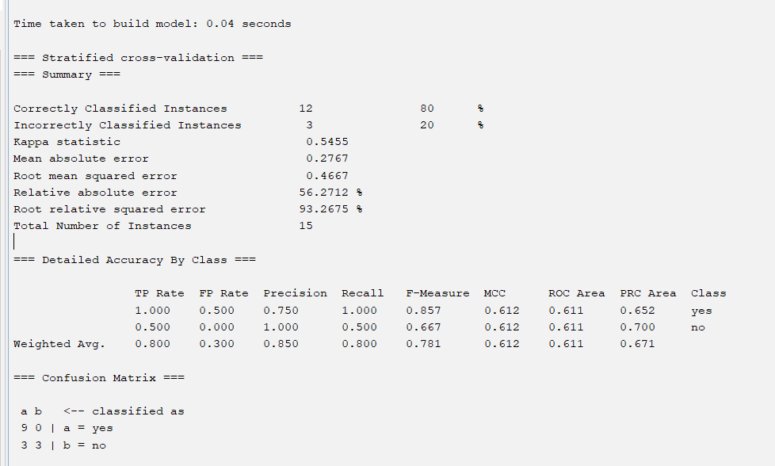

Q4 R Code for Mean, Median, Range, and Boxplot CODE:
@relation exam_scores

@attribute ClassA numeric @attribute ClassB numeric

@data 76,51
35,56
47,84
64,60
95,59
66,70
89,63
36,66

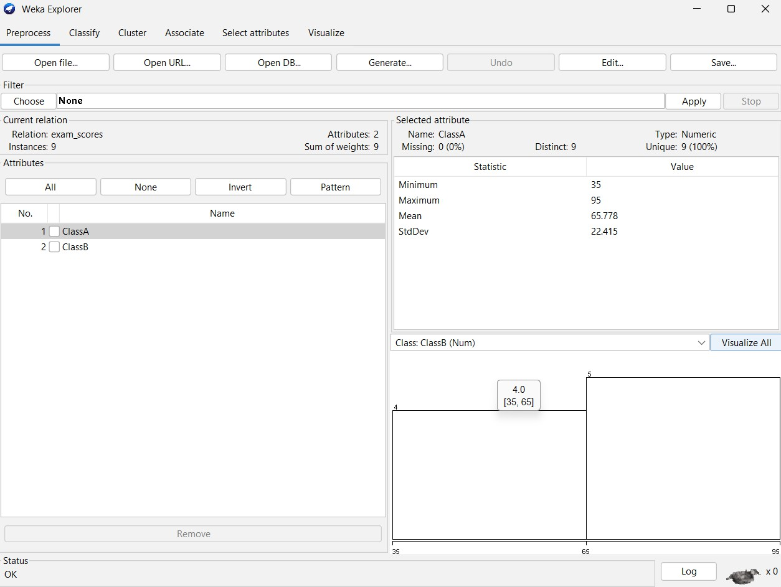
84,50

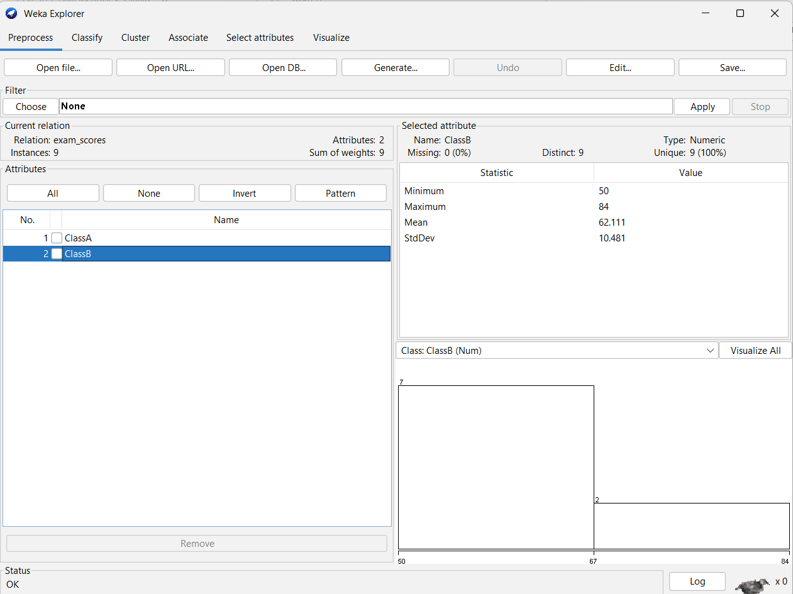
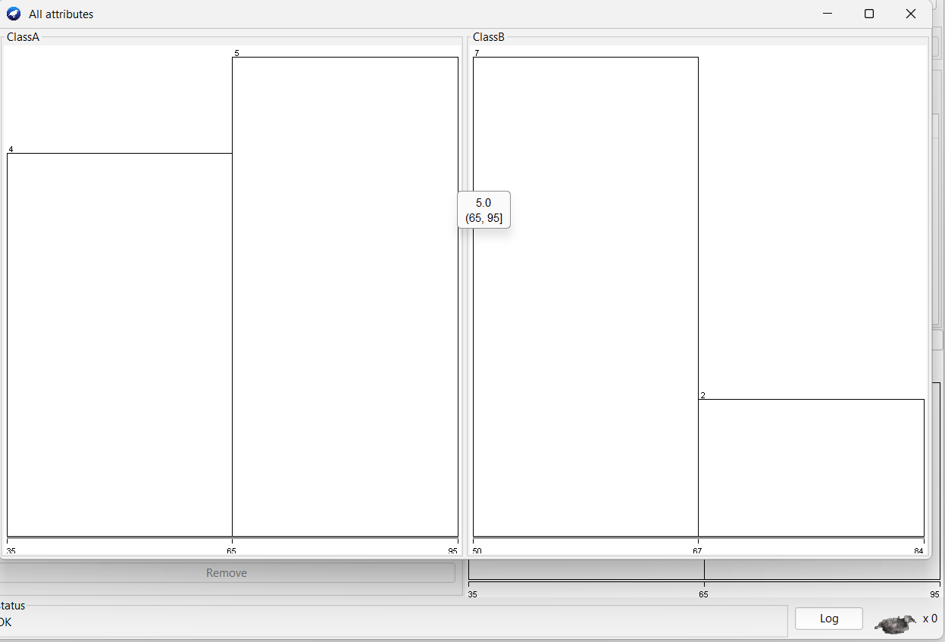

Q5 R Code for Statistical Analysis CODE:
@relation bodyfat_data

@attribute age numeric @attribute fat numeric

@data 23,9.5
23,27.9
27,7.8
37,31.4
41,25.9
47,27.4
49,31.2
50,31.2
34,34.6
42.5,28.8
38,35.2
50,32.8
61,42.5
45,28.8
43,35.2
50,32.8
61,42.5
35.7,31.2

