MEDICAL INSURANCE COST PREDICTION
USING RANDOM FOREST REGRESSION
Application Development-I Report Submitted
In partial fulfilment of the requirement for the award of the degree of

Bachelor of Technology In

Computer Science and Engineering -Artificial Intelligence and Machine Learning

by

P. Dileep Kumar - 22N31A66D8
P. Sai Charan - 22N31A66E7
R. Surya Prakash Reddy - 22N31A66F4

Under the Guidance of

Mr.U.Rakesh

Assistant Professor Computational Intelligence Department
MRCET


DEPARTMENT OF COMPUTATIONAL INTELLIGENCE MALLA REDDY COLLEGE OF ENGINEERING AND TECHNOLOGY
(Affiliated to JNTU, Hyderabad)

ACCREDITED by AICTE-NBA
Maisammaguda, Dhulapally post, Secunderabad-500014.
2024-2025

DECLARATION

I hereby declare that the project entitled “Medical Insurance Cost Prediction Using Random Forest Regression” submitted to Malla Reddy College of Engineering and Technology, affiliated to Jawaharlal Nehru Technological University Hyderabad (JNTUH) for the award of the degree of Bachelor of Technology in Computer Science and Engineering- Artificial Intelligence and Machine Learning is a result of original research work done by me.
It is further declared that the project report or any part thereof has not been previously submitted to any University or Institute for the award of degree or diploma.

P. Dileep Kumar(22N31A66D8)
P. Sai Charan(22N31A66E7)
R. Surya Prakash Reddy(22N31A66F4)



CERTIFICATE

This is to certify that this is the bonafide record of the project titled “Medical Insurance Cost Prediction Using Random Forest Regression” submitted by P.Dileep Kumar(22N31A66D8),P.Sai Charan(22N31A66E7),R.Surya Prakash(22N31A66F4) of B.Tech in the partial fulfillment of the requirements for the degree of Bachelor of Technology in Computer Science and Engineering- Artificial Intelligence and Machine Learning, Dept. of CI during the year 2024-2025. The results embodied in this project report have not been submitted to any other university or institute for the award of any degree or diploma.

Mr. U.Rakesh Dr. D. Sujatha
Assistant Professor Professor

INTERNAL GUIDE HEAD OF THE DEPARTMENT

ACKNOWLEDGEMENT

We feel honored and privileged to place our warm salutation to our college Malla Reddy College of Engineering and technology (UGC-Autonomous), our Director Dr. VSK Reddy who gave us the opportunity to have experience in engineering and profound technical knowledge.
We are indebted to our Principal Dr. S. Srinivasa Rao for providing us with facilities to do our project and his constant encouragement and moral support which motivated us to move forward with the project.
We would like to express our gratitude to our Head of the Department Dr. D. Sujatha, Professor for encouraging us in every aspect of our system development and helping us realize our full potential.
We would like to thank our Application Development-I coordinator Dr. P. Hari Krishna, Associate Professor as well as our internal guide Mr.U.Rakesh, Assistant Professor, for their structured guidance and never-ending encouragement. We are extremely grateful for their valuable suggestions and unflinching co-operation throughout Application Development-I work.
We would also like to thank all supporting staff of department of CI and all other departments who have been helpful directly or indirectly in making our Application Development-I a success.
We would like to thank our parents and friends who have helped us with their valuable suggestions and support has been very helpful in various phases of the completion of the Application Development-I.

By:
P .Dileep Kumar(22N31A66D8)
P .Sai Charan(22N31A66E7)
R .Surya Prakash Reddy(22N31A66F4)

ABSTRACT

Medical expenses are increasing day by day due to unexpected epidemic diseases. Health insurance has become one of the most important areas of study since theCOVID-19 outbreak, and there have recently been various attempts to discover solutions to this problem. To predict insurance prices, the dataset includes age,
BP, Height, Weight, Chronic Diseases, Transplants and other characteristics. Medical insurance cost prediction is a crucial task that can assist people and insurance companies plan their finances and premiums. The model provided more accuracy for predicting medical insurance with the help of regression techniques.
While people are increasingly aware of medical insurance and its claims processes, accurate cost prediction remains pivotal in critical situations. Previous studies on predicting insurance premiums using datasets from Kaggle focused on limited attributes such as age, sex, Height, Weight, BP, Diabetes, Transplants, Allergies, etc .

TABLE OF CONTENTS
S.No. Topic Page No.
- INTRODUCTION 1
  - Purpose 1
  - Background of project 1
  - Scope of project 2
  - Project features 2
- SYSTEM REQUIREMENTS 3
  - Hardware Requirements 3
  - Software Requirements 3
  - Existing System 3
  - Proposed System 4
- SYSTEM DESIGN 5
  - System Architecture 5
  - UML Diagram 6
- IMPLEMENTATION… 10
  - Source Code 10
  - Output Screen………………………………………………………………13
- CONCLUSION & FUTURE SCOPE 15
  - Conclusion……………………………………………………………..15
  - Future Scope…………………………………………………………………15
- BIBLIOGRAPHY 16

CHAPTER 1 INTRODUCTION

Purpose:

Medical Insurance Cost Prediction involves estimating the cost of an individual’s medical insurance based on various factors like age, Height, Weight, BP and Others. Accurate predictions help insurance companies set fair premiums, ensuring that people pay a reasonable amount based on their risk factors. This focuses to predict medical insurance costs based on a comprehensive dataset. The increasing costs of healthcare, predicting medical insurance expenses accurately has become increasingly crucial in managing financial risks and planning for healthcare needs.

Background of project:

Medical insurance cost prediction is a critical task for both insurers and policyholders, as it helps determine fair premiums based on individual risk factors. Traditional actuarial methods often fail to capture the complex relationships between factors like age, medical history, lifestyle, and Height, Weight. Machine learning, particularly Random Forest regression, offers a powerful alternative, as it can handle large, high-dimensional datasets and model non-linear relationships effectively. Random Forest is an ensemble learning technique that builds multiple decision trees and aggregates their predictions, making it robust against overfitting and capable of providing valuable insights into feature importance. Previous studies have demonstrated the potential of machine learning in predicting healthcare costs, but challenges such as data sparsity and model interpretability remain. This project aims to use Random Forest regression to predict medical insurance costs, focusing on improving prediction accuracy and identifying key factors influencing premiums. The results could help insurers optimize pricing strategies
while providing more personalized policies.

Scope of project:

The scope of this project is to develop a machine learning model using Random Forest regression to predict medical insurance costs based on various demographic and health-related factors. The project will focus on analyzing key variables such as age, gender, BMI, Transplants and Surgeries to assess their impact on insurance premiums. The goal is to improve the accuracy of cost predictions over traditional methods by leveraging Random Forest's ability to handle complex, non-linear relationships in large datasets. Additionally, the project will aim to provide insights into which factors are most influential in determining insurance costs. The model will be evaluated for its predictive performance and generalizability across different datasets. Ultimately, the findings could assist insurers in developing more accurate and personalized pricing models.

Project Features:
The system features are as follows:
- Data Collection and Preprocessing:
The project uses relevant medical insurance datasets containing features like age, sex, BMI, number of Surgeries, etc. Data cleaning and preprocessing techniques, including handling missing values and encoding categorical variables.
- Random Forest Regression Model:
A Random Forest Regressor is used for predicting medical insurance costs. This model is chosen for its ability to handle both numerical and categorical data, its robustness to overfitting.
- Feature Importance Analysis:
The Random Forest model provides insight into which features are most predictive of medical insurance costs. This helps in understanding the key factors influencing insurance pricing and aids in improving pricing strategies.
- Model Evaluation and Accuracy:
Cross-validation is also applied to ensure the model generalizes well to unseen data and is not overfitting.
- Cost Prediction and Deployment:
The trained model is used to predict the medical insurance cost for new, unseen data. It is integrated into a user interface or API for real-time predictions, allowing users to input personal details and receive predicted insurance costs instantly.

CHAPTER 2 SYSTEM REQUIREMENTS

Hardware Requirements:
    - HDD 512 GB
    - RAM 4 GB
    - Processor i3
    - Keyboard
    - Mouse

Software requirements:

Backend:
- Python
- Flask
Operating System:
- Windows 10

Existing System:

Currently, medical insurance cost prediction often relies on basic regression models that incorporate limited demographic and health-related variables such as age, BMI, and Medical History. While these models provide a foundational understanding of insurance premium determinants, they often overlook crucial factors that contribute to accurate cost estimation. Some existing systems are Ibm watson health optum, zebra medical vision,google cloud healthcare.

    - Drawbacks of existing system:

- Limited Predictive Power
- Lack of Comprehensive Data
- Inflexibility

Proposed System:

The proposed system aims to address the limitations of the existing approaches by leveraging advanced machine learning regression algorithms and a comprehensive dataset with 24 relevant features. Key advantages of the proposed system include:
- Enhanced Predictive Accuracy: By incorporating a wider range of predictors such as geographical region, lifestyle factors, and detailed health metrics, the proposed system enhances the accuracy of insurance cost predictions.
- Optimized Resource Allocation: Accurate predictions enable healthcare providers and insurers to allocate resources more effectively, thereby improving financial planning and operational efficiency.
- Flexibility and Scalability: Utilizing machine learning algorithms such as Random Forest Regression, Decision Tree Regression, and Neural Network Regression allows for flexibility in model adaptation and scalability to handle large datasets and diverse healthcare contexts.
- Improved Decision-Making: The system provides actionable insights into factors driving insurance premiums, empowering stakeholders to make informed decisions regarding coverage, pricing strategies, and risk management.
- Automation and Efficiency: By automating the prediction process, the system reduces manual effort and administrative overhead, facilitating quicker response times and enhanced service delivery in healthcare finance.

CHAPTER 3 SYSTEM DESIGN

System Architecture

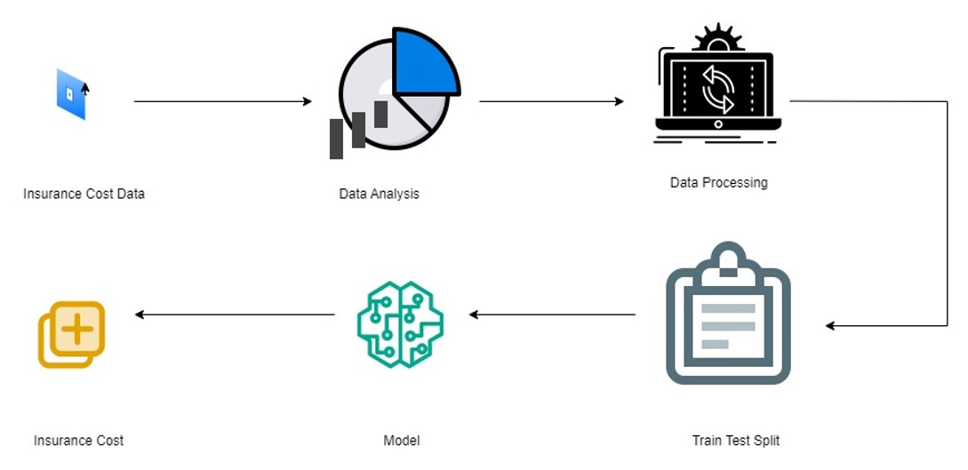

Fig 3.1 System Architecture

UML Diagrams

3.2 Use case diagram

Use Case during requirement elicitation and analysis to represent the functionality of the system. Use case describes a function by the system that yields a visible result for an actor. The identification of actors and use cases result in the definitions of the boundary of the system i.e., differentiating the tasks accomplished by the system and the tasks accomplished by its environment.
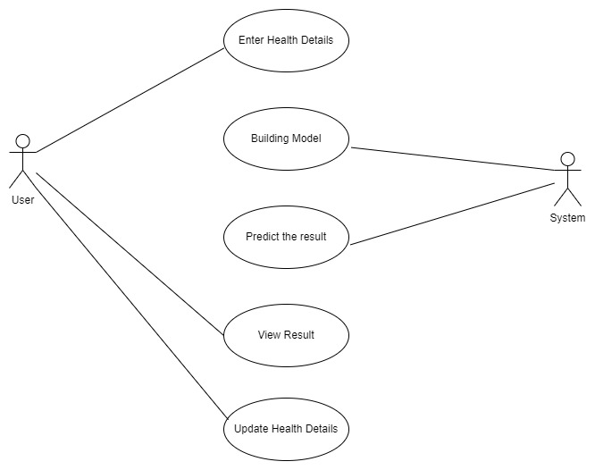
Fig 3.2 Use Case Diagram

  - Class Diagram

Class diagrams model class structure and contents using design elements such as classes, packages and objects. Class diagram describe the different perspective when designing a system-conceptual, specification and implementation. Classes are composed of three things: name, attributes, and operations. Class diagram also display relationships such as containment, inheritance, association etc. The association relationship is most common relationship in a class diagram. The association shows the relationship between instances of classes.

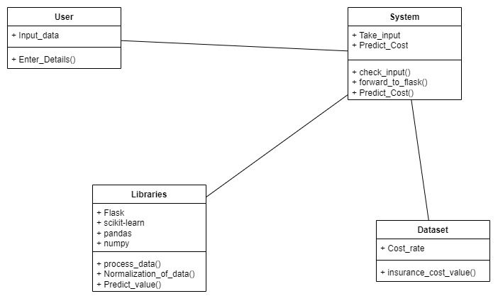
Fig 3.3 Class Diagram

  - Sequence Diagram

Sequence diagram displays the time sequence of the objects participating in the interaction. This consists of the vertical dimension (time) and horizontal dimension (different objects).
Objects: An object can be thought of as an entity that exists at a specified time and has a definite value, as well as a holder of identity. A sequence diagram depicts item interactions in chronological order. It illustrates the scenario's objects and classes, as well as the sequence of messages sent between them in order to carry out the scenario's functionality. In the Logical View of the system under development, sequence diagrams are often related with use case realizations. Event diagrams and event scenarios are other names for sequence diagrams. A sequence diagram depicts multiple processes or things that exist simultaneously as parallel vertical lines (lifelines), and the messages passed between them as horizontal arrows, in the order in which they occur. This enables for the graphical specification of simple runtime scenarios.
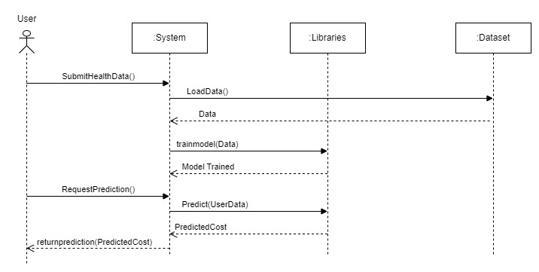

Fig 3.4 Sequence Diagram
  - Activity Diagram

The process flows in the system are captured in the activity diagram. Similar to a state diagram, an activity diagram also consists of activities, actions, transitions, initial and final states, and guard conditions

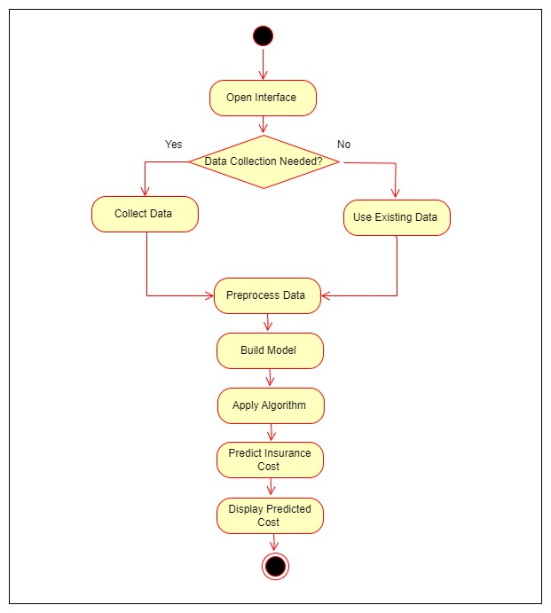

Fig 3.5 Activity Diagram

CHAPTER 4 IMPLEMENTATION

: Output Screens:
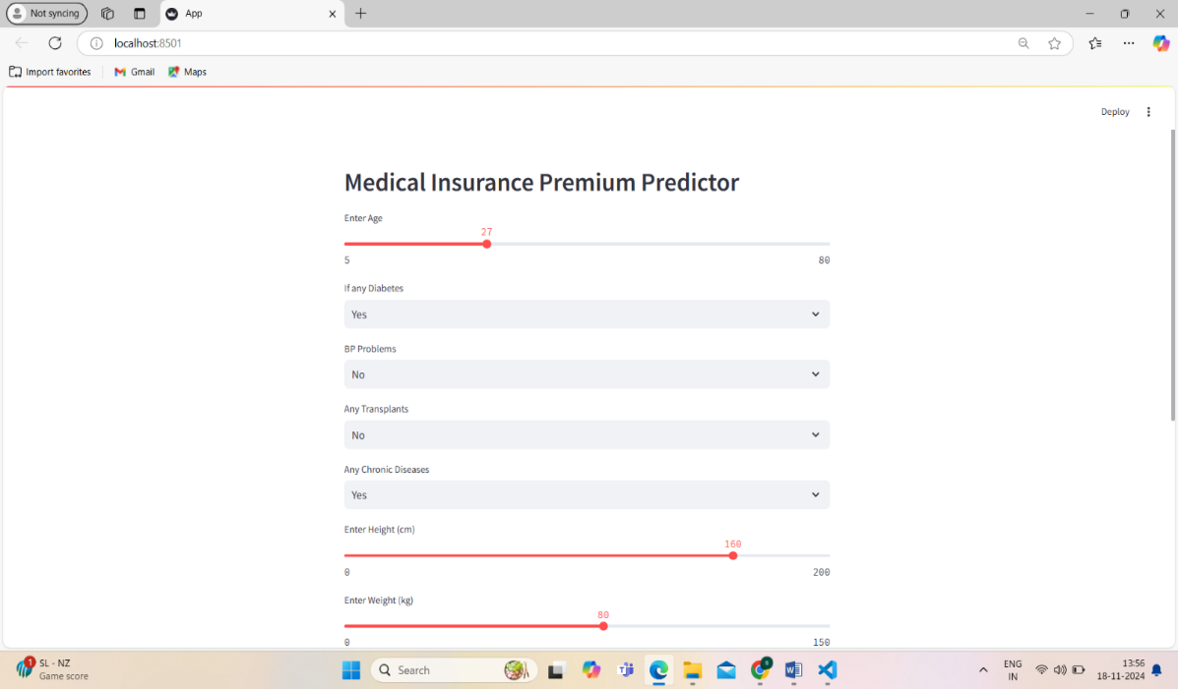

Fig: Medical Insurance Premium Prediction Page

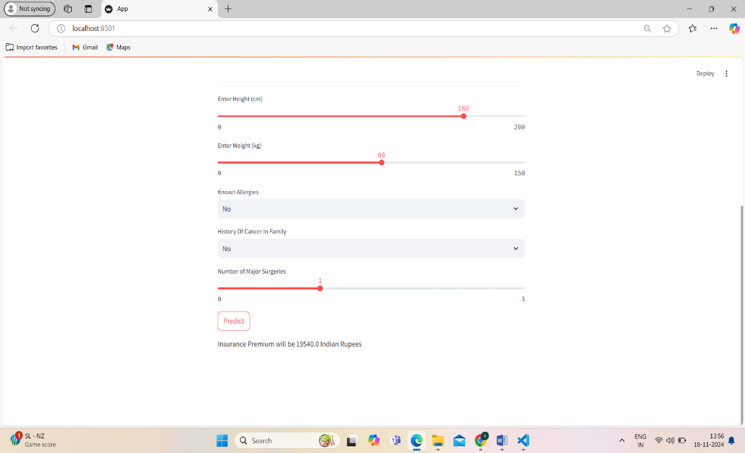

Fig: Model Predicting the Insurance Cost

  - : Testing

Software testing is a critical element of software quality assurance and represents the ultimate review of specification, design and code generation

CHAPTER 5

CONCLUSION & FUTURE SCOPE

: Conclusion:

In conclusion, the project on predicting medical insurance costs using regression algorithms has demonstrated the effectiveness of leveraging advanced machine learning techniques in healthcare finance. By utilizing a comprehensive dataset encompassing 24 relevant attributes, including demographic details, health metrics, and regional factors, the study aimed to enhance the accuracy and reliability of insurance premium predictions. Through rigorous model building and evaluation using algorithms such as Linear Regression, Decision Tree Regression, and Random Forest Regression, the project successfully identified Random Forest Regression as the top-performing model highlighting its superior predictive capability.

: Future Scope
Looking ahead, there are several avenues for further enhancing and extending the project's impact in healthcare finance. Future research could explore the integration of more sophisticated machine learning models, such as ensemble methods or deep learning architectures, to capture complex interactions and non-linear relationships among predictors. Additionally, incorporating real-time data streams and dynamic updating mechanisms would support adaptive models capable of responding to evolving healthcare trends and policy changes. Furthermore, expanding the scope to include additional datasets from diverse geographical regions and healthcare systems could enhance the generalizability and robustness of the predictive models. By continuing to innovate and refine predictive models, this project aims to contribute significantly to advancing data-driven decision-making and improving healthcare outcomes in the years to come.

CHAPTER 6

BIBLIOGRAPHY
- Lahiri and N. Agarwal, "Predicting healthcare expenditure increase for an individual from medicare data", Proceedings of the ACM SIGKDD Workshop on Health Informatics, 2014.
- Ako Muhammad Abdullah, "Advanced Encryption Standard (AES) Algorithm to Encrypt and Decrypt Data", Cryptography and Network Security, 2017.
- 3.M. Petrinco Gregori, S. Bo, A. Desideri, F. Merletti and E. Pagano, "Regression models for analyzing costs and their determinants in health care: an introductory review", International Journal for Quality in Health Care, vol. 23, no. 3, pp. 331-341, 2011.
- 4.M. V. Bjarnadóttir Bertsimas, M. A. Kane, J. C. Kryder, R Pandey, S. Vempala and G. Wang, "Algorithmic prediction of health-care costs", Operations Research, vol. 56, no. 6, pp. 1382-1392, 2008.
- 5.L. Breiman, "Random forests", Machine Learning, vol. 45, pp. 5-32, 2001.
- 6.M. Wiener Liaw et al., "Classification and regression by randomforest", R news, vol. 2, no. 3, pp. 18-22, 2002.
- 7.P. C. Austin, V. Goel and C. van Walraven, "An introduction to multilevel regression models", Canadian Journal of Public Health, vol. 92, no. 2, pp. 150, 2001.
- 8.G. Singh, "A study of encryption algorithms (RSA DES 3DES and AES) for information security", International Journal of Computer Applications, vol. 67, no. 19, 2013.

