**Python for Deep Learning**

**LAB 1 Documentation**

**Lab ID: 7**

**Avinash Ganguri (6)**

**Nikhil Kantipudi(10)**

**Dileep Reddy Peddakam(19)**

**1)**

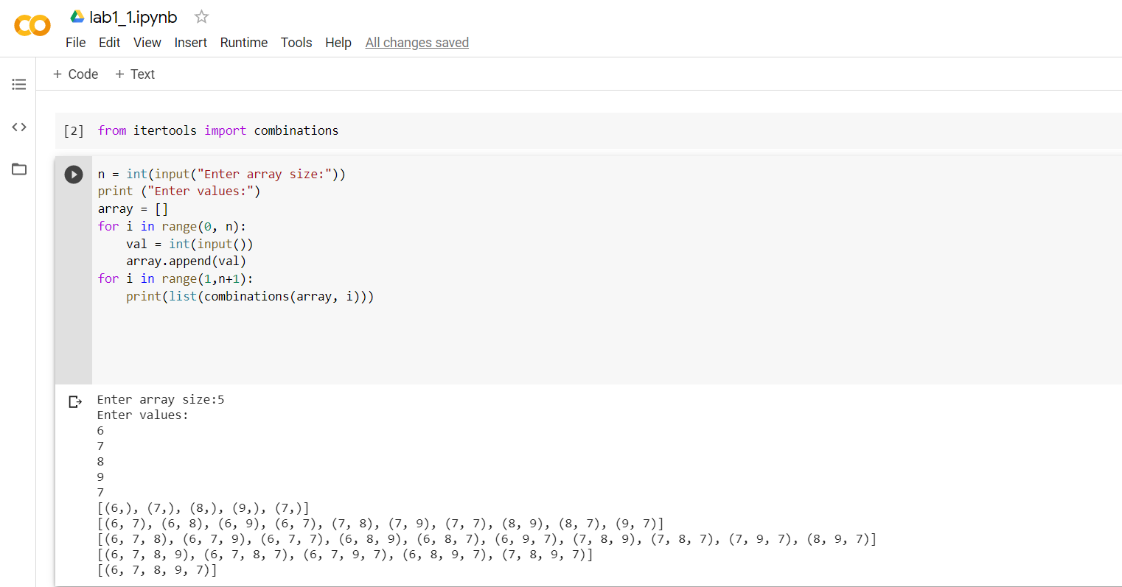

In this program we take values from the user which might contains the duplicate values. By using combinations on the arrays we displayed the subsets of the given numbers. Since we are using the combinations it doesn’t display the null values.

**2)**

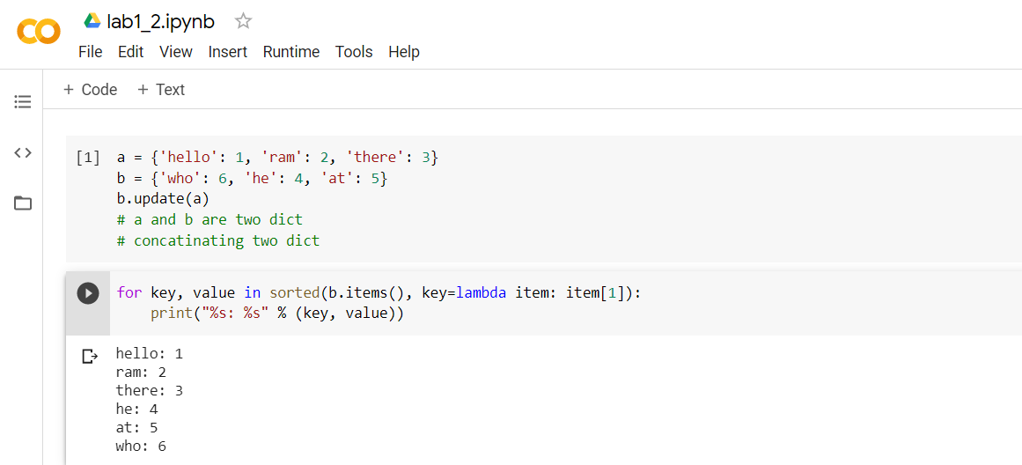

In this program we declared two dictionaries. Update method is used to merge the dictionaries. By using the lamda function and the sorted method we sorted these dictionaries based on the values.

**3)**

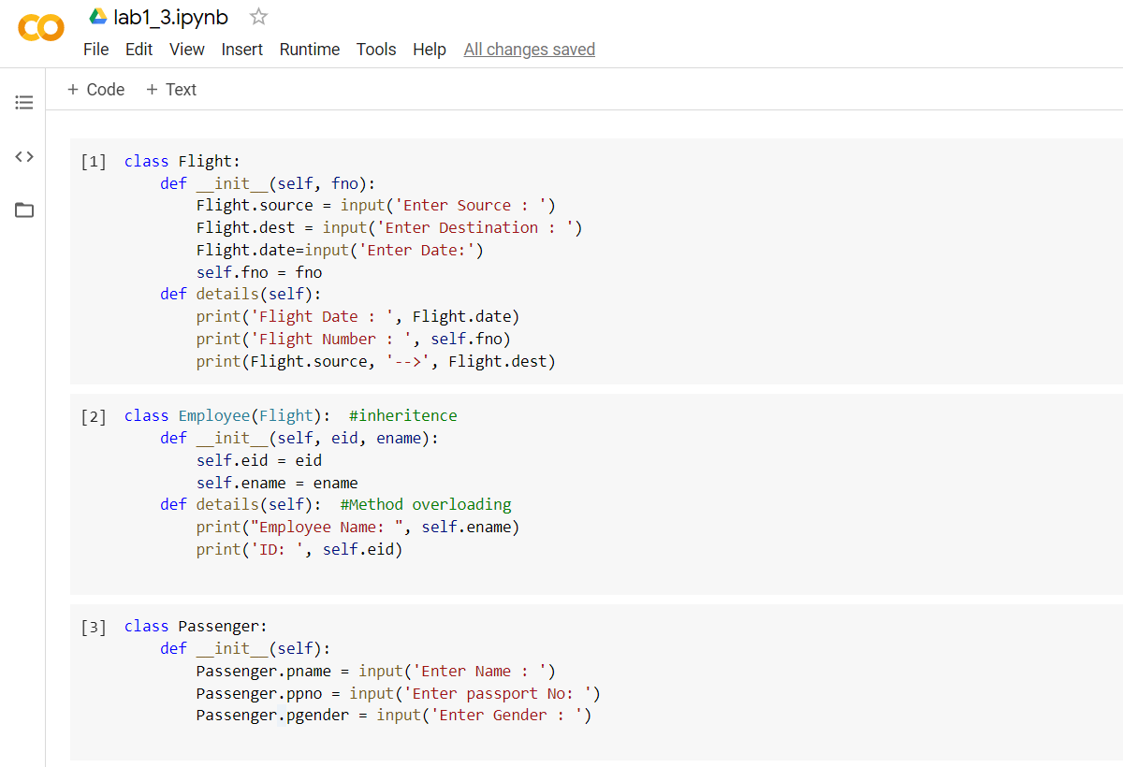

In this program, flight class accepts the input from the user and details method which displays the values and the second class which is employee will display the employee details by using the inheritance and method overloading. The passenger will take the input from the user.

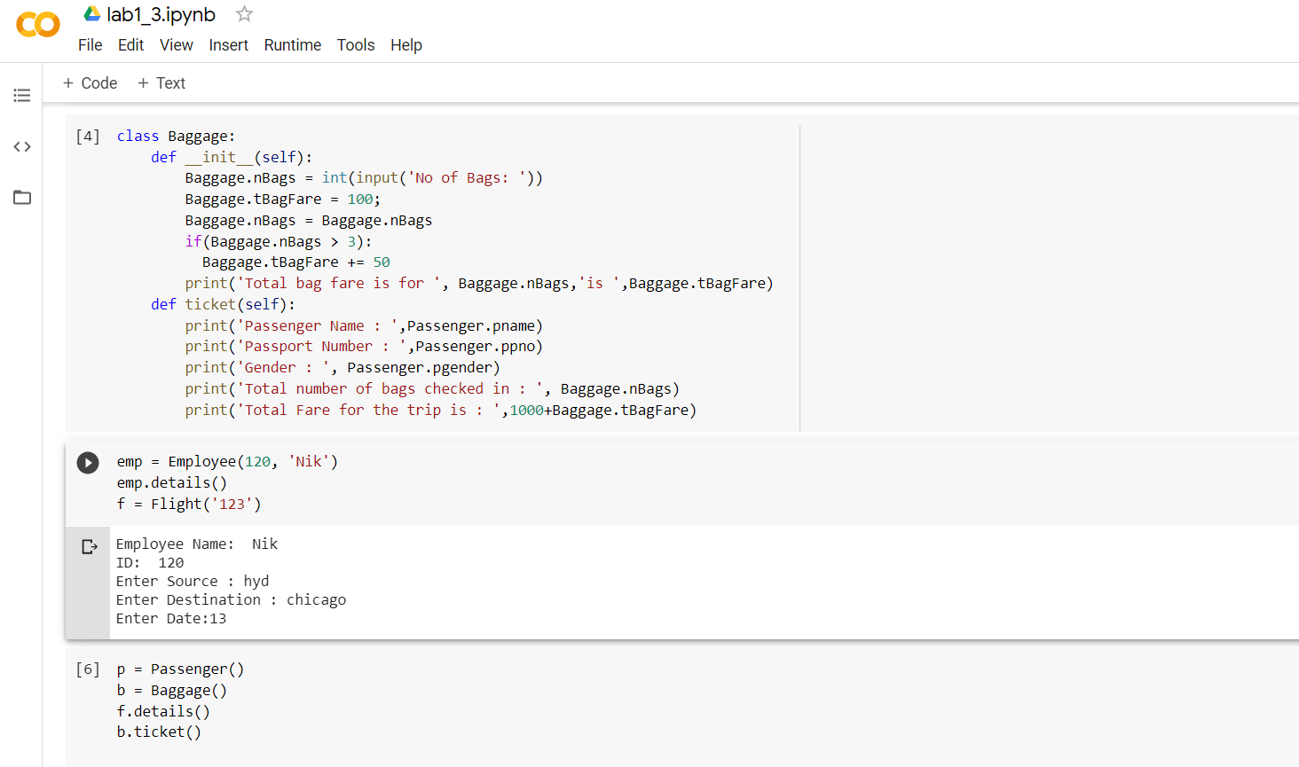

Here Baggage class take the input of number of bags so that it will calculate the fare

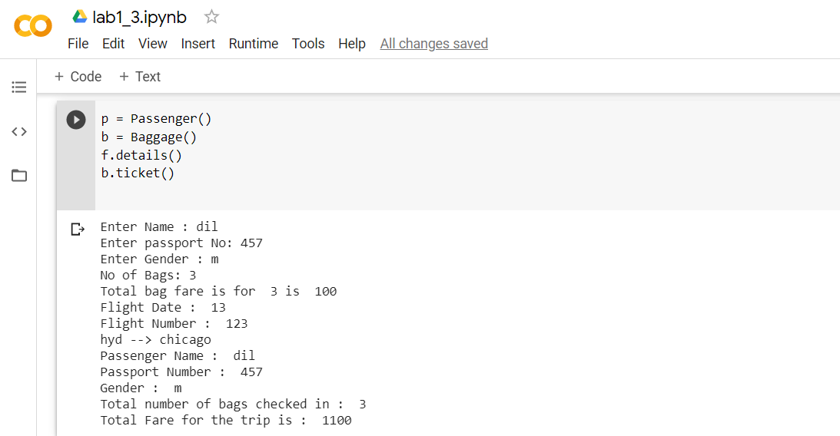

Finally ticket class takes all the details and it will give the fare of the trip.

**4)**

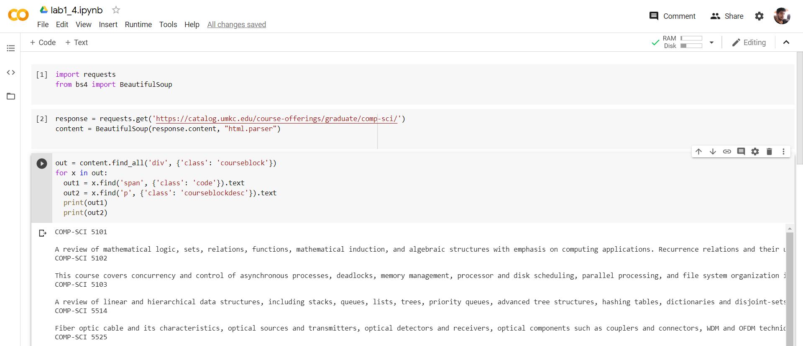

In this program we get the html link with the help of beautifulsoup package and convert that into text we give div tags with class courseblock then in loop to get course names and to display text without tags we use .text and the output is displayed.

**5)**

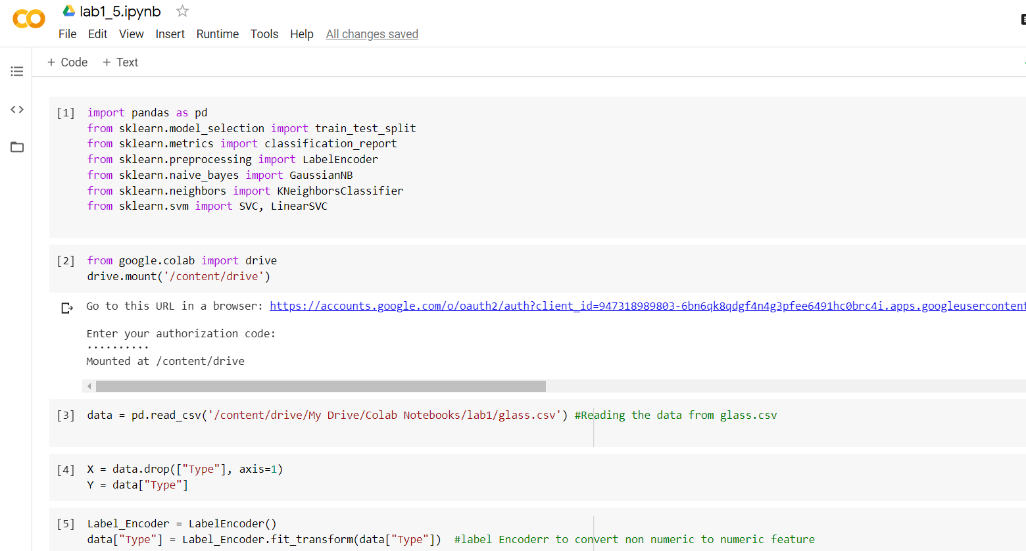

In this program we read the glass.csv from the drive and we drop the type column and we use the label encoder to convert the non numeric to numeric feature

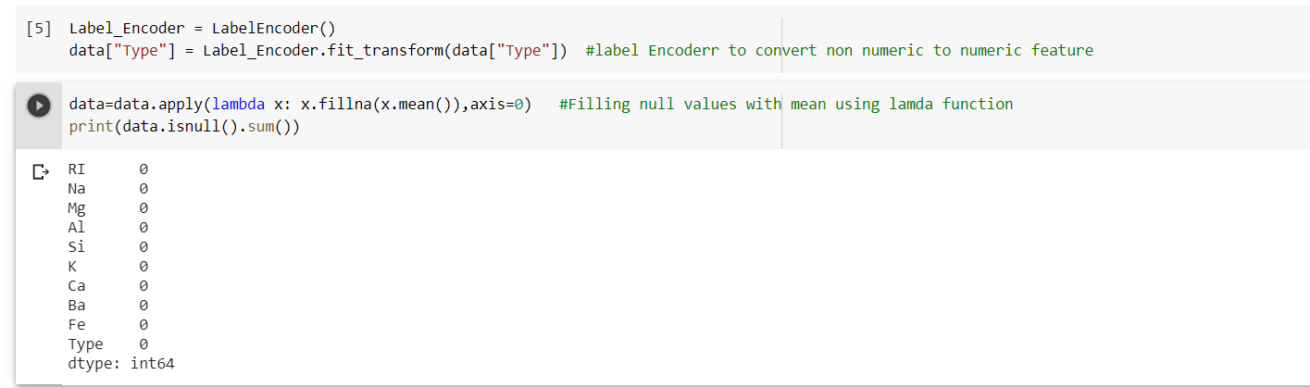

Here we print the data

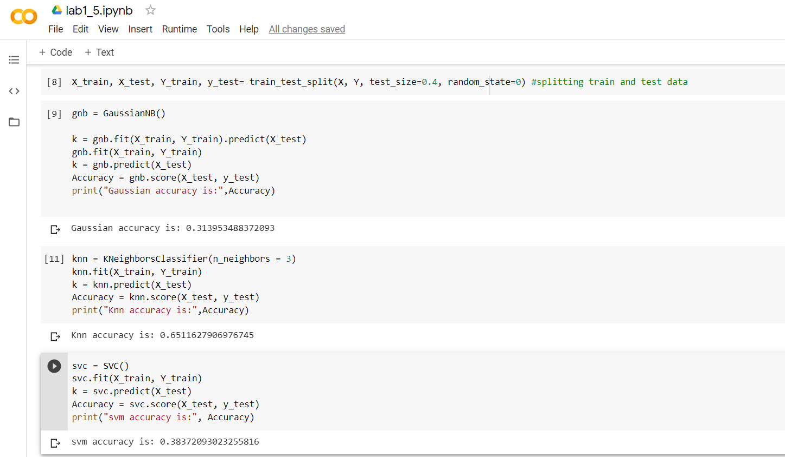

Here we split the train data and test data. And we use fit function to fit the data and we use .predict to predict the data instances and print the outputs for naïve bayes, svm and knn algorithms.

So Here Knn algorithm gives the better result than remaining.

**6)**

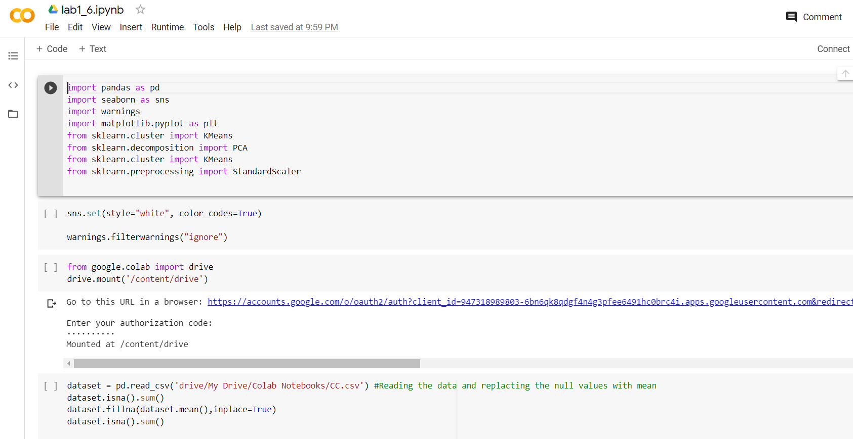

In this program we read the cc.csv from the drive and replace the null the values with mean by using .mean().

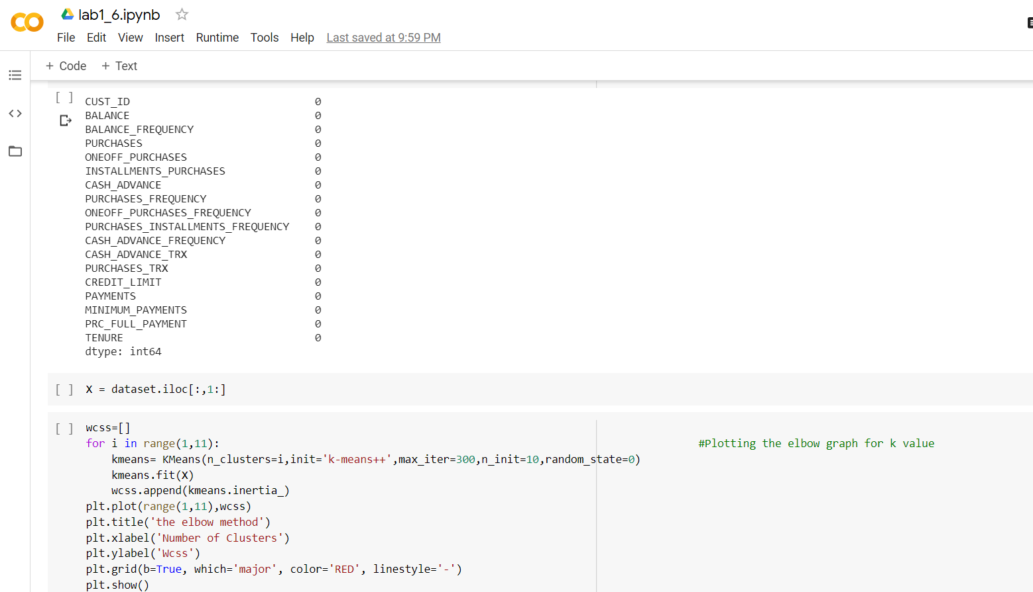

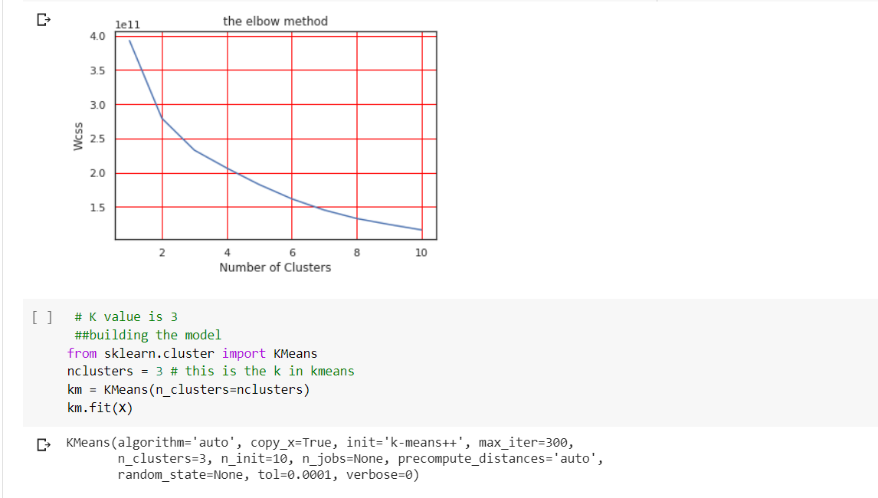

Here we plot the elbow graph for k value by using the .plot(). Once the value of k is known we build the model with the k value.

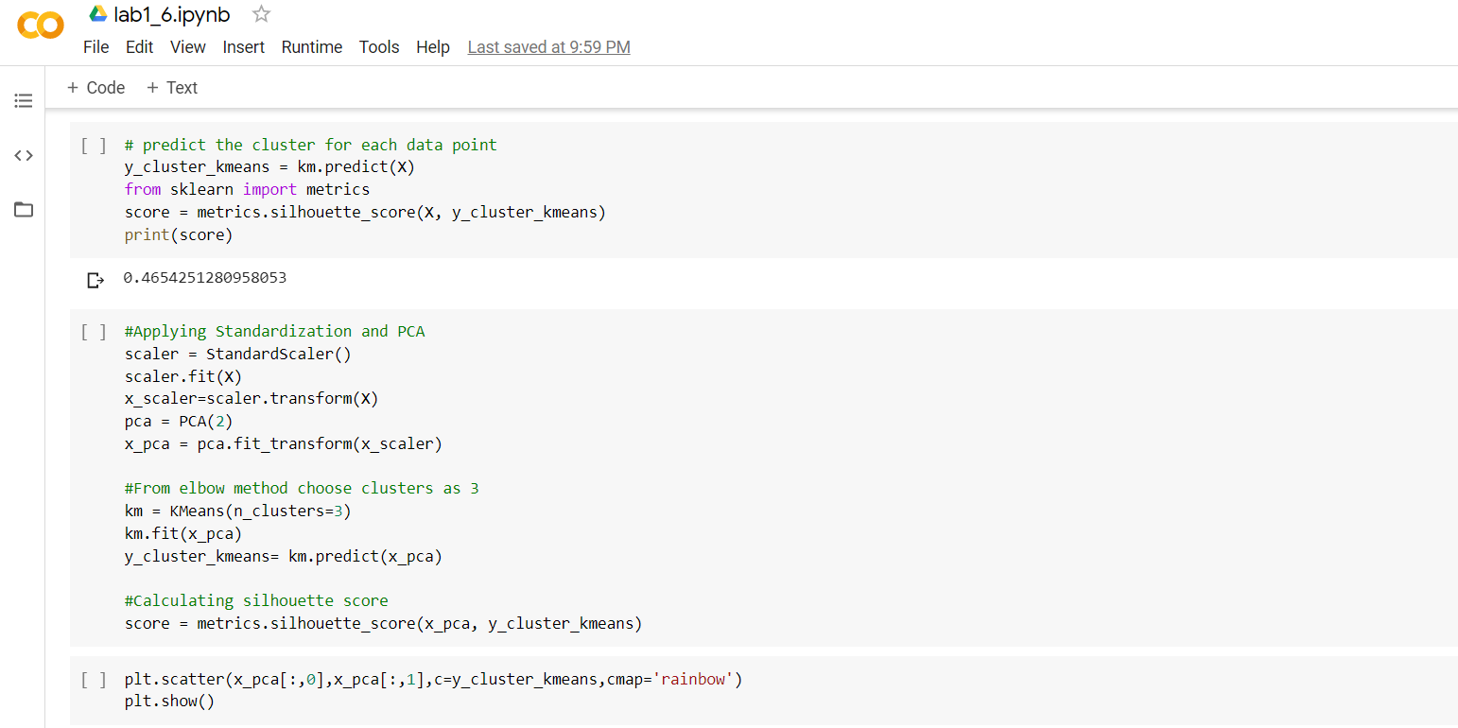

And we evaluate the silhouette score by using the silhouette_score(), and we print the score. After that we apply stardardization and PCA

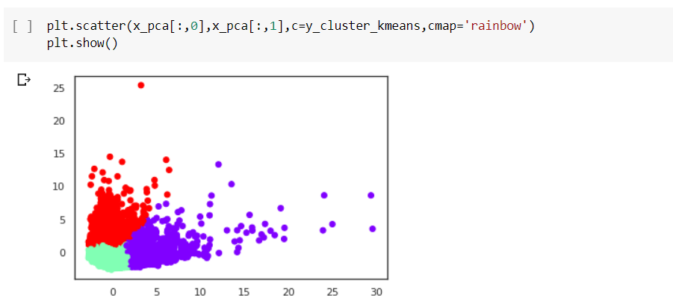

**7)**

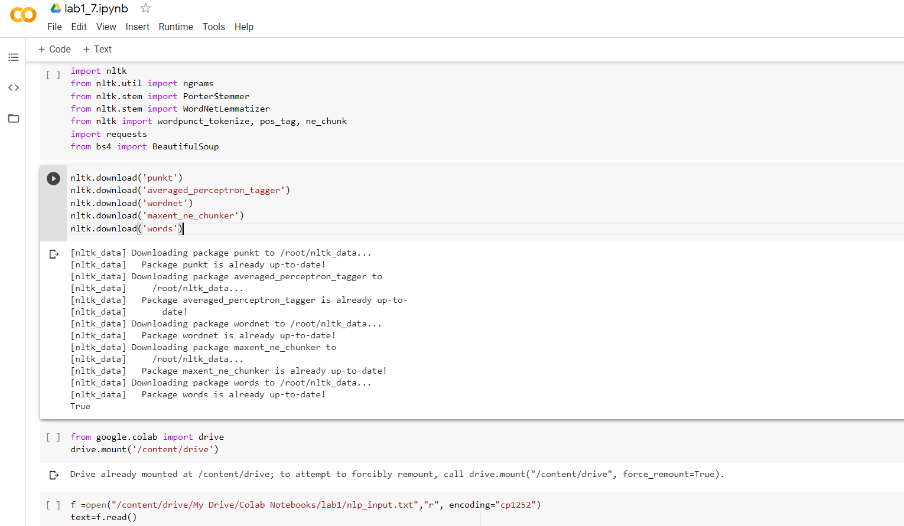

In this program we download nltk files and we read the nlp_input.txt file.

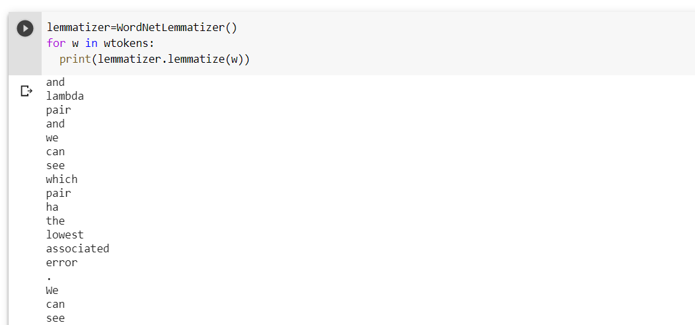

We perform lemmatization which is similar to stemming but gives meaningful words

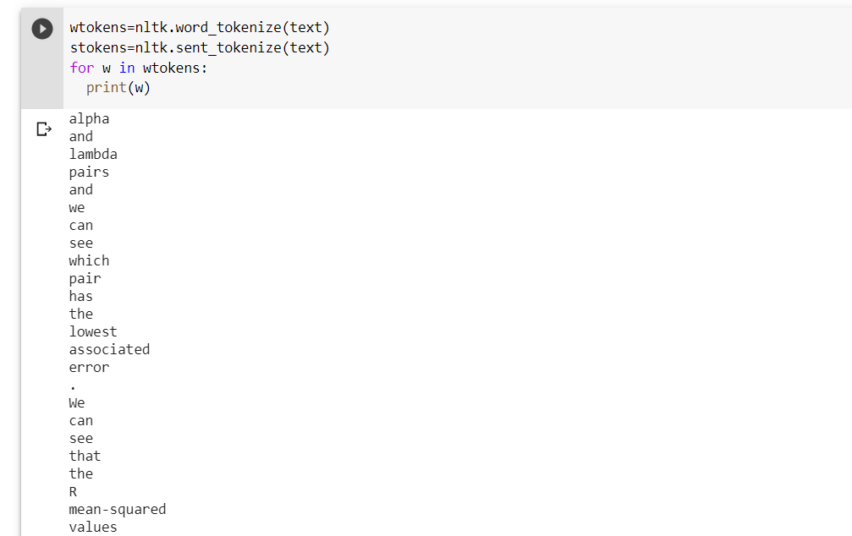Here wtokens gives each word as a token from the text.



Here trigrams gives the consecutive sequence of 3 words from the sentence.

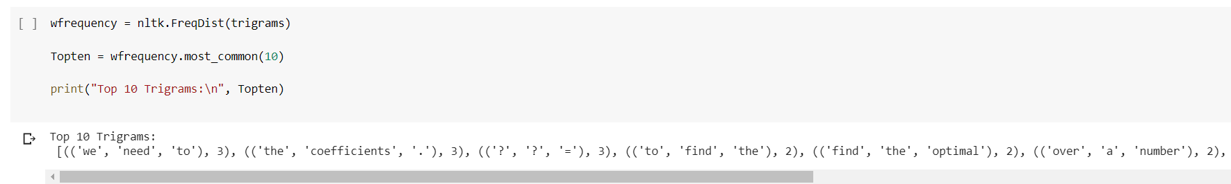

It displays most repeated trigrams with their count.

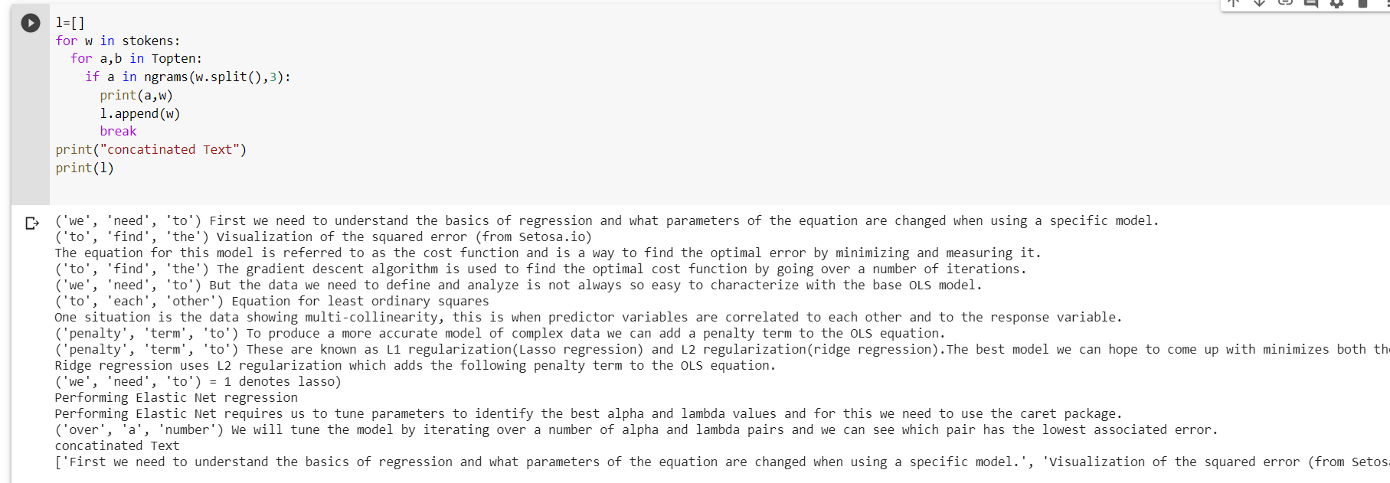

Here the above text file is taken and finding the repeated trigrams and append is used to concatenate. Finally we display the concatenated results.

**8)**

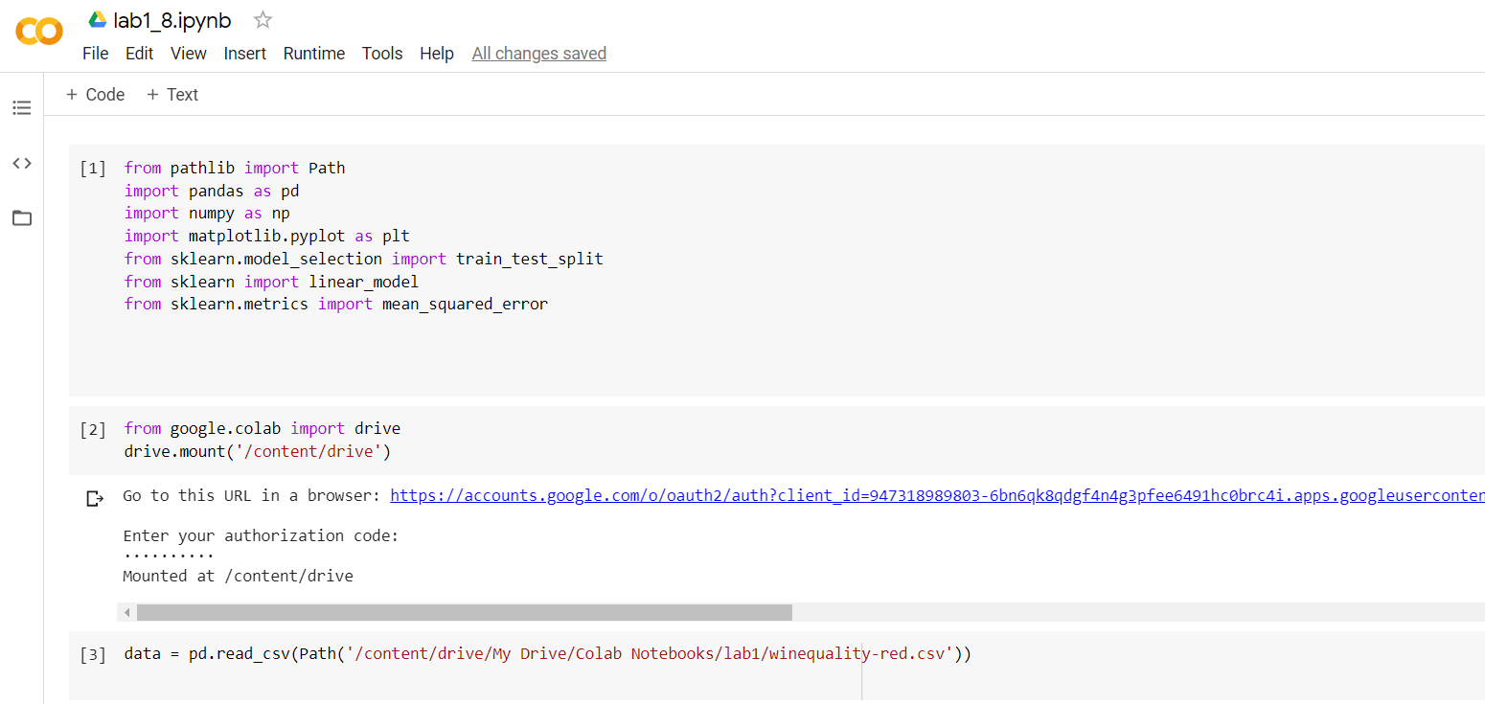

In this program we read the winequality-red.csv from the drive.

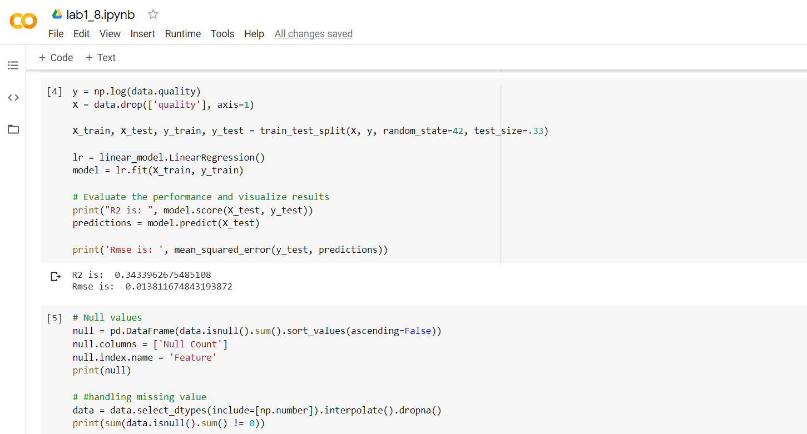

we drop the quality field. And we split the train data and test data. We use .score and .predict to evaluate the performance and visualize the results. Isnull() is used for null values.

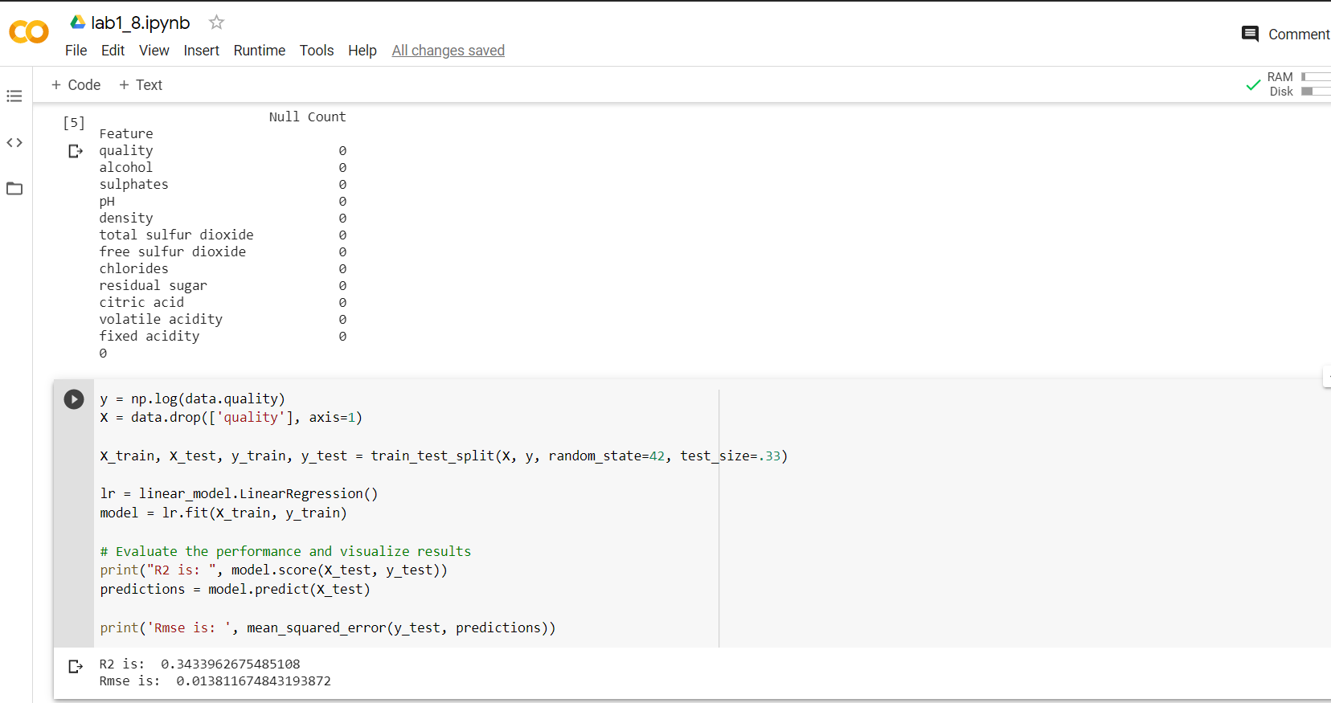

In this field we evaluate the model using RMSE and R2 and the results are same