ICP -2: python & Deep Learning course

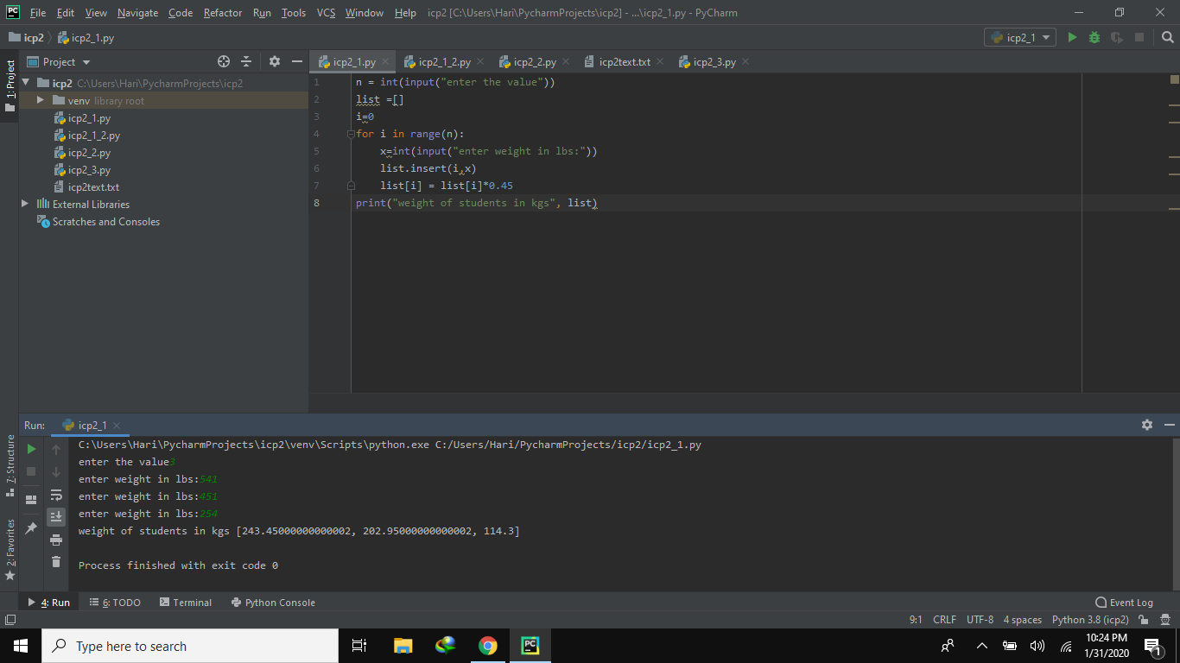 Here we take the values dynamically and pass the values to the list and the list values is multiplied with 0.45 to the values in kgs. the output will be displayed

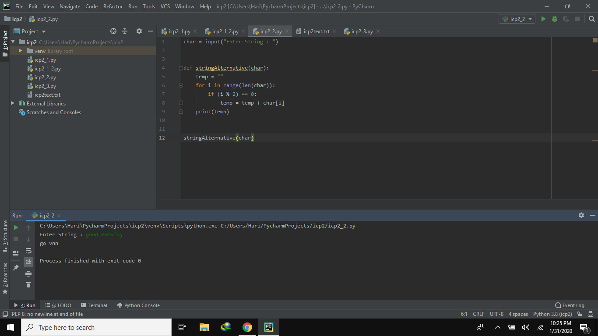

Here we take the string and pass it into the function. where the length of the character performed with modulus and the value in index will be stored in the temp. finally we print the temp

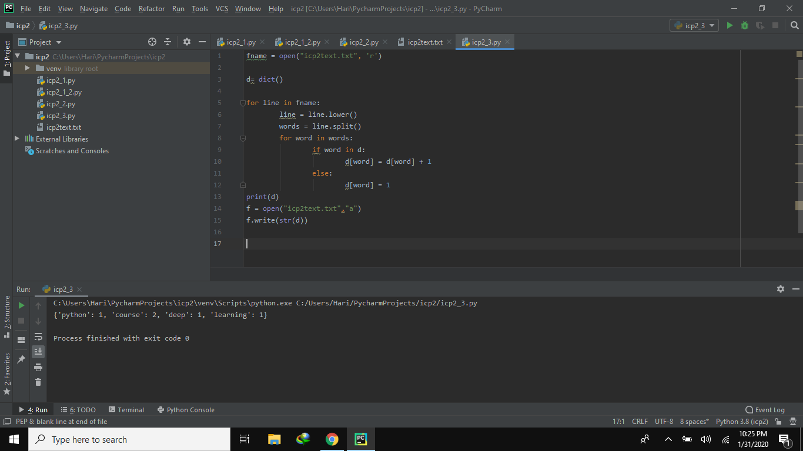

initally we import the text file and we create a dictory to store the words of the text file. In the for loop we convert eac and every word into lower case then we split the words and assign the dictorany values and we print dict

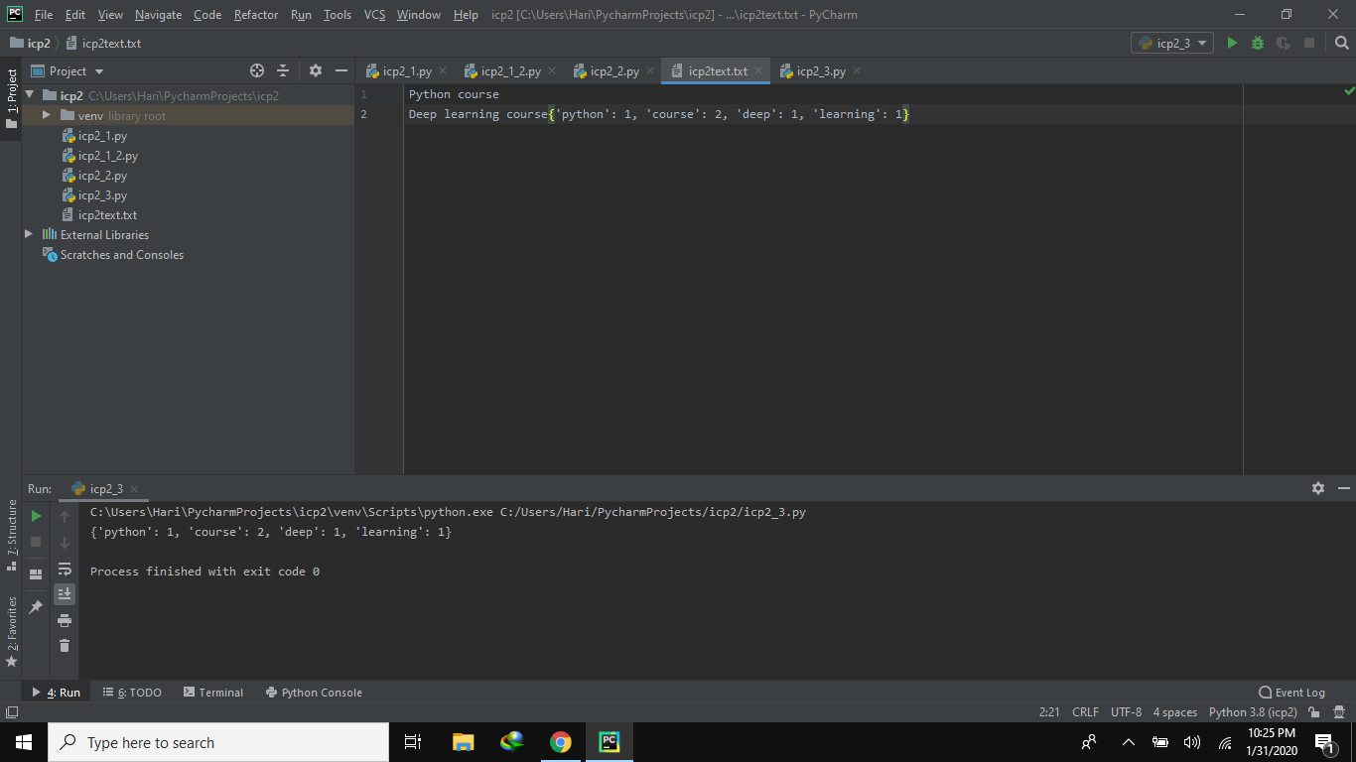

output of the third program will be again stored in the text file