

**MUĞLA SITKI KOÇMAN UNIVERSITY**

**ENGINEERING FACULTY/COMPUTER ENGINEERING**

## **Gender Classification based on Fingerprint by using the Convolutional Neural Networks (CNN) Algorithm**

Dilek KOÇAK - 150709031

Supervisor: Zeynep Filiz EREN DOĞU, PhD

June-2020

## 

**Contents**

1. Introduction.............................................................................................3
2. Motivation...............................................................................................4
3. Method....................................................................................................5
4. Convolutional Neural Networks.............................................................6
   1. Convolutional Layer.....................................................................6
   2. ReLu / Non-Linearity Layer.........................................................7
   3. Pooling Layer...............................................................................8
   4. Flatten Layer.................................................................................9
   5. Fully-Connected Layer.................................................................10
5. CNN Types.............................................................................................10
6. References..............................................................................................11

# 

# **1. Introduction**

The fingerprint is the trace that created by the folds at the end and tip of the fingertips.

It is the most used method in individuals identification. Even if the skin is damaged, the papilla is still enough to detect fingerprints. Again, the marks on the newly released leather are the same as before. Although the discovery of the fingerprint system dates back to very old years, in recent decades, humanity gets benefit from this trace.

Fingerprints have become very important in detecting criminals, especially in gun crimes. Fingerprints are preferred for their uniqueness, immutability and classification. Scientific research has shown that fingerprint is a definitive proof for identification. Since it is an easy and inexpensive method, fingerprinting is used frequently in identification today.

Nowadays, fingerprints are used for identification and verification of identity in cash machines and many areas. In our country, while voting in the past years, fingerprints were counted as the signature of the person. Also, in the field of genetic engineering, many diagnoses are made use fingerprints, and more importantly, in the near future, there will be much more development that it can accomplish with more advanced technology.

Indents that make up our fingerprints and protrusions create patterns. These patterns are classified as loop, spiral, and arc. These classifications are used for identification and comparison. In addition, fingerprints are used by using feature points (minutiae), where it is almost impossible to notice with the naked eye.

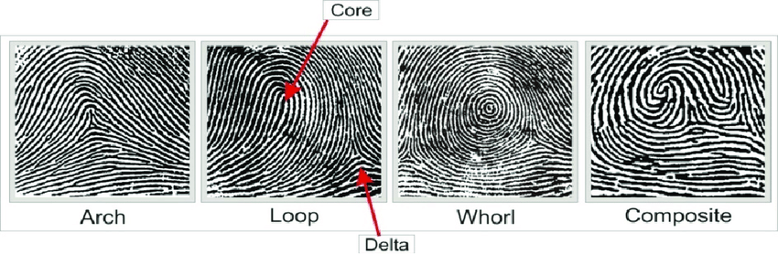

***FIGURE 1.*** *fingerprint ridge patterns [1]*

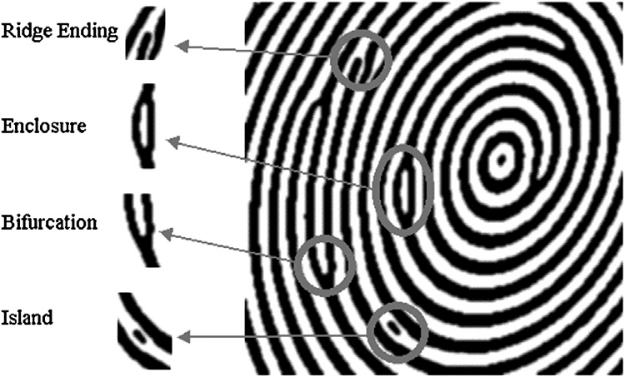

***FIGURE 2.*** *fingerprint ridge characteristics [2]*

# **2. Motivation**

The most important feature that distinguishes people precisely is fingerprint. The patterns and characteristics of the fingerprint make them different from each other. In previous years, fingerprints were used as a person's signature. In the past years, as in phones or computers, fingerprint passes as the password of the person under conditions that require security. Perhaps more importantly, in forensic cases, it is possible to detect criminals by using fingerprints. This step is considered as the most important factor for the criminal world. So, if it is such an important place in our lives, how does it distinguish people and in addition, how does it determine characteristics such as gender? My aim / motivation in this study is to find out how this process has developed.

# **3. Method**

The method we will use consists of three stages. The first stage is data aquisition, the second stage is data preprocessing, and the last stage is the cnn classification.

In this study, the SOCOFING dataset from the kaggle was used. Sokoto Coventry Fingerprint Dataset (SOCOFing) is a biometric fingerprint database designed for academic research purposes. SOCOFing is made up of 6,000 fingerprint images from 600 African subjects and contains unique attributes such as labels for gender, hand and finger name as well as synthetically altered versions with three different levels of alteration for obliteration, central rotation, and z-cut. [3]

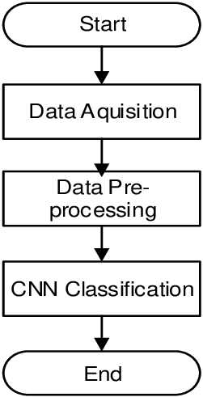

***FIGURE 3.***  *cnn algorithm steps[4].*

# **4. Convolutional Neural Networks Layers**

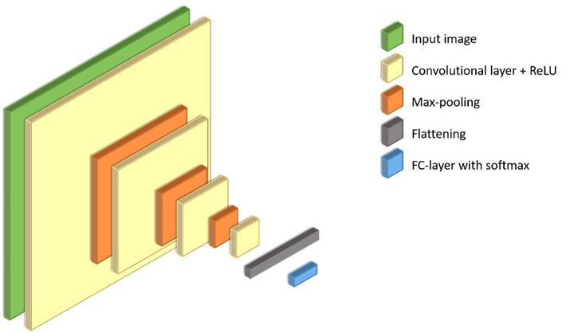

***FIGURE 4.*** *convolutional neural networks structure* [5].

## **4.1 Convolutional Layer**

Convolutional layer is the first and most important step of the CNN algorithm. It is responsible for the detection of the input / picture that we will work in the algorithm. Convolutional layer finds the properties of our input using some filters. This filter can be a filter that will detect the edges, depth or color scale of the input.

The application of the filter is as follows. Initially, the filter we set is located in the upper left corner of our image. In this area, the indices between the two matrices are multiplied by each other and all the results are summed, then the result is stored in the output matrix. Then, move this filter 1 digit to the right and repeat the same process. When the line we started finishes, we move on the next line. In this way, transactions are repeated. After all the matrix lines of the image are processed, the overall output matrix is ​​calculated. The properties obtained from the output matrix is the Feature Map. In summary, the feature map is found by moving the filters step by step on the image we use as input and using the simple matrix product. In the CNN algorithm, convolutional layer is used more than one.

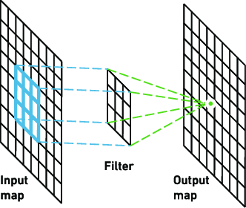

***FIGURE 5.***  *convolutional layer[6].*

## **4.2 ReLu / Non-Linearity Layer**

Non-Linearity layer is generally used after all Convolutional layers. This step can be calculated as a linear combination of outputs.

This layer is also called the activation layer because it uses one of the activation functions. Previously, functions such as sigmoid and tahn were used as nonlinear functions, but since the Rectifier (ReLu) function works best for speed, this function is now used. Black

values ​​in the property map created in the Convolutional layer are negative. After relu function is applied, black values ​​are removed and 0 is replaced.[7]

### ***FIGURE 6.*** *nonlinear function-ReLu* [7].

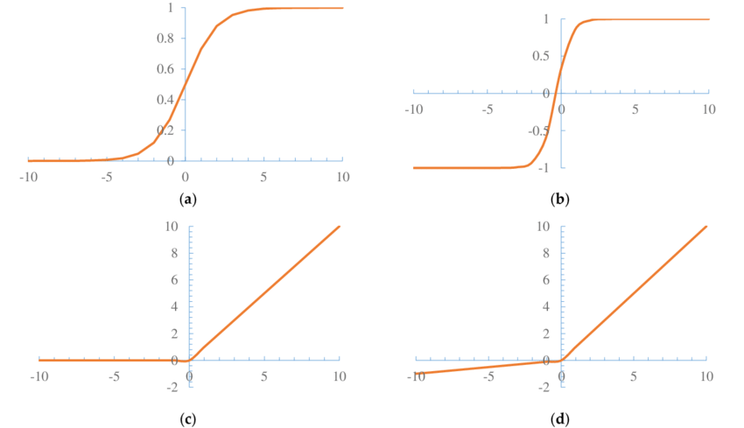

***FIGURE 7.*** *Nonlinear function. (a) Sigmoid function; (b) Tanh function; (c) ReLU function; (d) Leaky ReLU function*[8].

## **4.3 Pooling Layer**

Pooling Layer is a layer that is frequently added between convolutional layers. This layer is used to reduce the shift size of the impression, parameters within the network, and the number of calculations. In this way, mismatch in the network is taken under control. There are pooling types such as max pooling, average pooling, and L2-norm pooling algorithms. The main purpose of the pooling layer is to make the output, which contains enough information for the neural network to make the right decision, smaller output.

As can be understood from their names, while the maximum value is selected in the Max Pooling transaction, the average value is taken in the Average Pooling transaction.

Thus, shrink operation is applied. Different pooling methods are applied for different models. For example, while average pooling is used in LeNET model, AlexNet and

In VGGNet models, max pooling method is used.

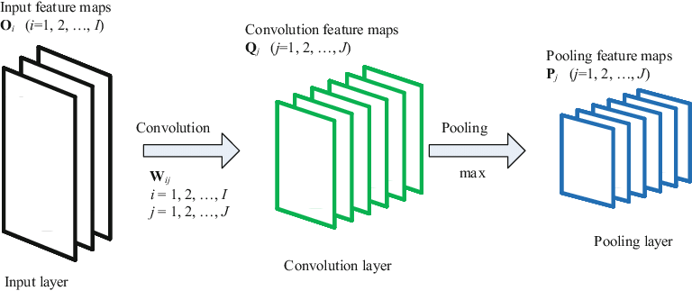

***FIGURE 8.*** *pooling layer*[9].

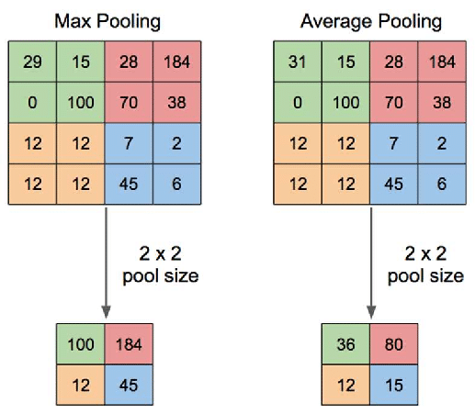

***FIGURE 9.*** *max-average pooling*[10].

## **4.4 Flatten Layer**

The task of the flattening layer is simply to prepare the data at the entrance of the last and most important layer, Fully Connected Layer. The data in this neural network is the one-dimensional array of matrices from the Convolutional and Pooling layer.

### 

***FIGURE 10.*** *flatten layer*[11].

## **4.5 Fully-Connected Layer**

#### Fully connected layer is the last and most important layer of the convolutional neural network. In this layer, the output obtained in the flatten layer is used as input. Later , in this layer, learning process is performed by using neural network. Finally, the output is created after classification.

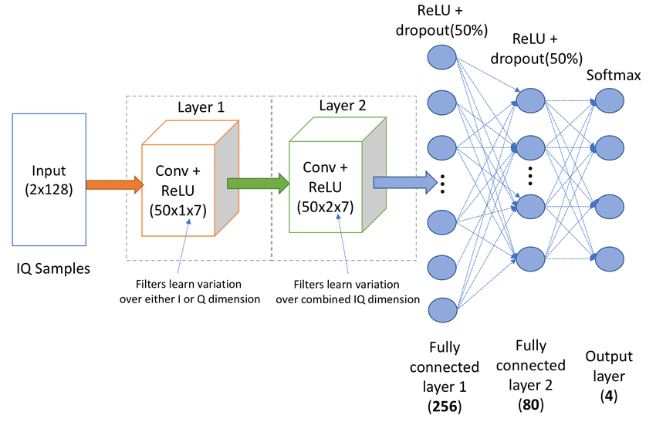

***FIGURE 11*** *fully connected layer*[12].

# **5. CNN Types**

### LeNet - This network is considered the first successful application of Convolutional Networks.

AlexNet - It is the first study to enable convolutional neural network models and deep learning to become popular again. As activation function, ReLU (Rectified Linear Unit) is used in pooling layers and max-pooling is used.

GoogLeNet - Average pooling layers were used to significantly reduce the number of parameters in the network.

VGGNet - This network has proven how important network depth is for neural networks. This network type has 16 convolutional layers.

# **6. References**

[1] Ambadiyil, Sajan & Soorej, K.S. & Pillai, V.P.Mahadevan. (2015). Biometric Based Unique ID Generation and One to One Verification for Security Documents. Procedia Computer Science. 46. 507-516. 10.1016/j.procs.2015.02.075.

[2] Dror, Itiel. (2016). A Hierarchy of Expert Performance (HEP). Journal of Applied Research in Memory and Cognition. 10.1016/j.jarmac.2016.03.001.

[3] [[1807.10609] Sokoto Coventry Fingerprint Datase](https://arxiv.org/abs/1807.10609)t

[4] Sentana, I Wayan Budi & Asri, Sri & Jawas, Naser & Wardani, Anggun. (2018). CNN and SVM Based Classifier Comparation to Detect Lung Nodule In Computed Tomography Images. 10.2991/icst-18.2018.7.

[5] Politz, Florian & Kazimi, Bashir & Sester, Monika. (2018). Classification of Laser Scanning Data Using Deep Learning.

[6] Yakura, Hiromu & Shinozaki, Shinnosuke & Nishimura, Reon & Oyama, Yoshihiro & Sakuma, Jun. (2018). Malware Analysis of Imaged Binary Samples by Convolutional Neural Network with Attention Mechanism. 127-134. 10.1145/3176258.3176335.

[7] <https://rubikscode.net/2018/02/26/introduction-to-convolutional-neural-networks/>

[8] Jing, Yang & Guanci, Yang. (2018). Modified Convolutional Neural Network Based on Dropout and the Stochastic Gradient Descent Optimizer. Algorithms. 11. 28. 10.3390/a11030028.

[9] Vaiciukynas, Evaldas & Gelzinis, Adas & Verikas, Antanas & Bacauskiene, Marija. (2018). Parkinson’s Disease Detection from Speech Using Convolutional Neural Networks. 10.1007/978-3-319-76111-4_21.

[10] Yani, Muhamad & Irawan, S, & S.T., M.T.. (2019). Application of Transfer Learning Using Convolutional Neural Network Method for Early Detection of Terry’s Nail. Journal of Physics: Conference Series. 1201. 012052. 10.1088/1742-6596/1201/1/012052

[11] Ng, Wartini & Minasny, Budiman & Montazerolghaem, Maryam & Padarian, José & Ferguson, Richard & Bailey, Scarlett & Mcbratney, Alex. (2019). Convolutional neural network for simultaneous prediction of several soil properties using visible/near-infrared, mid-infrared, and their combined spectra. Geoderma.

[12] Sankhe, Kunal & Belgiovine, Mauro & Zhou, Fan & Riyaz, Shamnaz & Ioannidis, Stratis & Chowdhury, Kaushik. (2018). ORACLE: Optimized Radio clAssification through Convolutional neuraL nEtworks.