Abdullah Gul University

Math-301

(PROBABILITY & STATISTICS)

Fall 2022

**Homework**

Name & Surname: Dilek Taylı

ID Number: 110510228

|  |  |
| --- | --- |
| Q1 (100) | Total (100) |
|  |  |

Initials: D.T.

|  |
| --- |
|  |

In the question, we are asked to find the mean and variance values when the sample size changes. In order to do this, firstly load the assigned line to a variable and assign a range to represent the different sample sizes. Then, with for loop create samples randomly which have the size of for loop iteration variable. Also, calculate the mean and variance values of this random sample in the for loop. In the end, calculate the mean & variance of the population to compare and to see the difference between variance-sample size & mean-sample size, plot graphs.

As the graph shown below, we can see that when the sample size is 0, the mean & variance value of the sample that has a size of 0 is not close to the actual mean & variance value. However, when the sample size is 30, the mean & variance values get closer to the actual values. For the other sample sizes, the values are changing and the difference is not large as a sample size of 0.

**Graphs:**

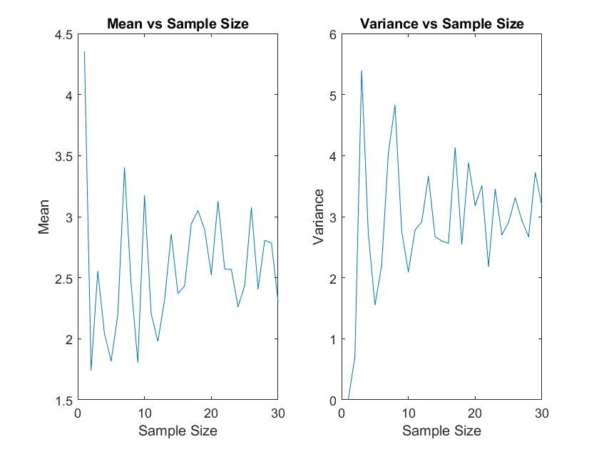

**Matlab Code:**

% read the file and get the related file

excel_file = 'R2.xlsx';

random_population = xlsread(excel_file, 'B31:KO31');

range = 1:30;

%create the mean and variance arrays.

mean_population = zeros(1, numel(range));

variance_population = zeros(1, numel(range));

%create random samples and calculate their mean and variance values

for i= 1:numel(range)

sample = range(i);

rand_sample = population(randi(numel(random_population),1, sample));

mean_population(i) = mean(rand_sample);

variance_population(i) = var(rand_sample);

end

% calculate the mean and variance values of all means and variances of

% different sample sizes

pop_mean = mean(random_population);

pop_variance = var(random_population);

% display the values of mean and variance of the population

disp(['mean of population:', num2str(pop_mean)])

disp(['variance of population:', num2str(pop_variance)])

disp(['means of sample:', num2str(mean_population)])

disp(['variance of sample:', num2str(variance_population)])

% plot the graph to see the changes in the mean and variance when the

% samples size gets larger

figure();

subplot(1,2,1);

plot(range, mean_population);

title('Mean vs Sample Size');

xlabel('Sample Size');

ylabel('Mean');

subplot(1,2,2);

plot(range, variance_population);

title('Variance vs Sample Size');

xlabel('Sample Size');

ylabel('Variance');

**Example output:**

mean of population:2.5899

variance of population:2.6366

means of sample:4.3499 1.7427 2.5543 2.0409 1.8173 2.196 3.4011 2.4395 1.8078 3.172 2.2023 1.9785 2.3174 2.8578 2.3697 2.4336 2.9415 3.0488 2.8938 2.5253 3.1278 2.5698 2.5683 2.2615 2.4359 3.075 2.4081 2.8069 2.7833 2.3032

variance of sample:0 0.70682 5.3954 2.7281 1.5504 2.2009 4.0377 4.8272 2.762 2.0951 2.7807 2.9166 3.6577 2.6716 2.6018 2.5616 4.1316 2.5473 3.8848 3.1822 3.5051 2.1883 3.4464 2.7012 2.9073 3.306 2.9346 2.6702 3.7173 3.1693